**Business Values & Ethics**

**SBS MBA/MSc**

|  |  |  |  |
| --- | --- | --- | --- |
| STUDENT ID | **SBS** | **MBA** | **14110054** |

Name: Nazar Ibrahim Ahmed Nasur

**Submission Date**: 8th, May, 2020

# 

# Executive Summary

In this Assignment, we are going to discuss different topics around the Business Values & Ethics assignment, and the different techniques in the Operation Management across the industries.

We are going to discuss the Lean Production and the effect of this approach in the production and operation management, along with the different inventory and production approaches used by giant company like Boeing.

# Table of Contents

Executive Summary 2

Table of Contents 2

Introduction 3

Case Scenario I 3

a. Will you be ethical in this situation? If yes how? And if no! Why? 3

b. If you be ethical, how you will survive your business. 3

Case Scenario II - Discrimination in the Workplace 3

Case Scenario III: Employee Absence 4

Case Scenario V 5

Case Scenario – VI: Purchasing Ethics 7

References 9

# 

# Introduction

In this part, we will answer the questions related to the Business Values & Ethics assignment Scenario.

## Case Scenario I

### Will you be ethical in this situation? If yes how? And if no! Why?

Yes, I will be ethical and will not open the envelope, because this will not be fair at all, this might be the way around any my envelope might be the one who founded by other, yes they might open it, it depends but I will do what I like other do to me in the same situation, and this will not be ethical to win business by such disgraceful behavior and unfair competition, despite that my business at a tough situation, the same ethical act should be followed in a good and bad situation.

I will hand over the envelope as it closed to the committee to prevent anyone else might found it, and as its sealed envelope, they can make sure that it's not opened when delivered.

### If you be ethical, how you will survive your business.

If the company will lose the deal and the auction. So what, we can try once more for any upcoming deals if we still exist, this will be better more than stay open for business because of unfairly winning a deal, that will a sham point in the company history for as long as its exists.

## Case Scenario II - Discrimination in the Workplace

1. Marian should not quite her job, and she has to prove to everyone that no matter the gender of the employee its all about the qualification of that person to do the job right, she has to do her best to do her job and the result will speak on behalf.
2. They don’t have any rights to judge her or showing any complaint and evaluation for her qualification based on any standards, at the end she got hired based on her qualification and experiences that meet the job requirements and there are the standard performance and KPIs system that should be followed in the defined period to evaluate her performance against the defined KPIs for such job.
3. From my Point of view, I believe its better not to confront the co-workers, just ignoring them will be better, and as mentioned let her success and the result speak on behalf.
4. If that will be supported by local law can be done, but I am not a lawyer, this might end up with nothing, she will continue doing her job and if this repeated by anyhow and there are more witness on that I bevel he has to directly file a discrimination suit through the appropriate channel for that.
5. She should go to her supervisor for sure, and this issue should be addressed internally through the appropriate channel through the HR team and according to the code of conduct of the organization.
6. From My point of view, Marian should work to socialize more with all the co-workers showing the required confidence while conversation, and the same way doing her job and let the success speak on behalf.

## Case Scenario III: Employee Absence

1. The suspension was fair if we are talking about following the law and internal regulation for such a case, however sometime there should be somewhat can be called the spirit of the law and regulation that might ease the actions considering the situation and circumstances.
2. Sylvia acts responsibly following the rules and internal procedures for such an absence case.
3. No Joan shouldn’t be fired, she has to figure out the balance between home and work, and to avoid such situation in the future as much as she can, however, yes she violated the absence rules but that was out of her hand and it was short time to look for an alternative to report to work and leave the baby.
4. No, the babysitter shouldn’t be fired for her absence was out of hand due to sickness, and Joan should keep her but find out alternative and second options for such a situation that might happen in the future.
5. Fair here Sylvia fair is subjective, I believe and it depends on which perspective you look to the situation if it’s following the rules perspective it will be fair that she such followed the rule and procedures and that should be applied on all people, but if we are looking into it from a humanity perspective, I believe it was not that fair due to the situation explained by Joan and the circumstances, Sylvia should have shown some tolerance dealing with the situation with applying the minimum penalties.
6. The working mother might work from home If that possible, and if the job function can be done from home, and I believe after the current COVID-19 pandemic, the perspective of working from office day today will be changed, and this might be an opportunity for the working mother to leverage such option if applicable so they can balance between the work and the home.
7. if the labor law support that within a local country that this might be an option to divide the load between the two parents, and I believe many countries right now provide father FMLA leaves up to 12 weeks that can be used for such staying home for the babies.

## Case Scenario V

1. According to the <https://smallbusiness.chron.com/fraud-hurts-organization-58563.html>, Fraud can have a substantial impact on a business, no matter what size it is. The two most basic types of fraud are misappropriation of assets by employees and fraudulent financial reporting by management, whereby misleading or inaccurate financial information is disseminated to investors, stakeholders, and the public. The first type of fraud often happens without management knowledge, and the second type is often unknown to employees. Both can devastate a company.

The fraud will cause different issues to the company as below:

* Financial loss, when someone misappropriates company assets, the loss is fairly easy to quantify.
* External Confidence, once a fraud has been uncovered, the company faces an ongoing problem of public trust in the organization, the public image might be irreparably tainted. As a consequence, the company may have to pay a higher price for credit, may be refused membership in trade associations, or might not be considered for a strategic alliance.
* Company Morale, the effect of fraud on a company's culture and morale can be shattering. Any association with a company that has perpetrated or suffered fraud can be troubling and embarrassing for the people who work there. Even if employees leave the company, they may carry an association with a fraudulent company into their next place of employment, even if they were not involved with the fraud at all.

1. To answer why the history of accounting fraud repeats itself, and why so many frauds happened since the scandal, we need to understand what motivates people to commit fraud,

as per <https://www.journalofaccountancy.com/issues/2001/feb/whyemployeescommitfraud.html>,

there are two separate but related theories about why employees commit fraud, he first is based on a 20-year-old Hollinger and Clark study of 12,000 employees in the workforce. It found that nearly 90% engaged in “workplace deviance,” which included behavior such as goldbricking, workplace slowdowns, sick time abuses, and pilferage. On top of that, an astonishing one-third of employees had stolen money or merchandise on the job.

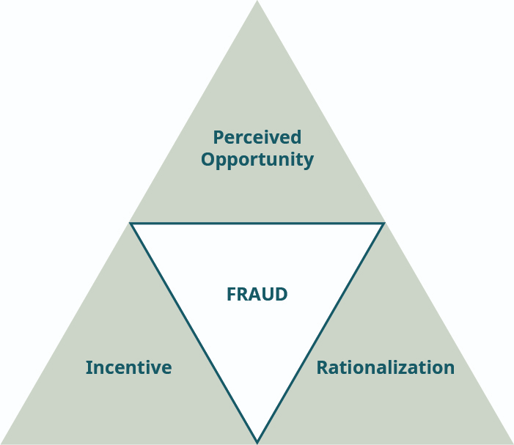

The researchers concluded the most common reason employees committed fraud had little to do with opportunity, but more with motivation—the more dissatisfied the employee, the more likely he or she was to engage in criminal behavior. One criminologist described the phenomenon as “wages in kind.” All of us have a sense of our worth; if we believe we are not being fairly treated or adequately compensated, statistically we are at a much higher risk of trying to balance the scales.

A second theory about why employees commit fraud is related to financial pressures. In the late 1940s, criminologist Donald R. Cressey interviewed nearly 200 incarcerated embezzlers, including convicted executives. He found the great majority committed fraud to meet their financial obligations. Cressey observed that two other factors had to be present for employees to commit fraud. They must perceive an opportunity to commit and conceal their crimes, and be able to rationalize their offenses as something other than criminal activity.

* Perceived opportunity is when a potential fraudster thinks that the internal controls are weak or sees a way to override them. This is the area in which an accountant has the greatest ability to mitigate fraud, as the accountant can review and test internal controls to locate weaknesses. After identifying a weak, circumvented, or nonexistent internal control, management, along with the accountant, can implement stronger internal controls.
* Rationalization is a way for the potential fraudster to internalize the concept that the fraudulent actions are acceptable. A typical fraudster finds ways to personally justify his or her illegal and unethical behavior. Using rationalization as a tool to locate or combat fraud is difficult, because the outward signs may be difficult to recognize.
* Incentive (or pressure) is another element necessary for a person to commit fraud. The different types of pressure are typically found in (1) vices, such as gambling or drug use; (2) financial pressures, such as greed or living beyond their means; (3) work pressure, such as being unhappy with a job; and (4) other pressures, such as the desire to appear successful. Pressure may be more recognizable than rationalization, for instance, when coworkers seem to be living beyond their means or complain that they want to get even with their employer because of low pay or other perceived slights.

Typically, all three elements of the triangle must be in place for an employee to commit fraud, but companies usually focus on the opportunity aspect of mitigating fraud because they can develop internal controls to manage the risk. The rationalization and pressure to commit fraud are harder to understand and identify. Many organizations may recognize that an employee may be under pressure, but many times the signs of the pressure are missed.

## Case Scenario – VI: **Purchasing Ethics**

1. The purchasing should have gone through the normal bidding routine of the university, and J.R shouldn’t let nay personal interests affect the work and the business, by handing the order direct to his son company.
2. No, it not acceptable at all for any executive or employee to bypass purchasing routine to hand any business order to any business family members, however, the family members can participate during the standard purchasing cycle, but at many cases due to the family relative, it should not happen if any business executive has any member inside the organization he is doing business with, and should not participate in such deal. And as per <https://www.procurement-academy.com/ethics-procurement/>, one of the types of Unethical Behaviors in the purchasing is “Conflict of interest: Conflicts of interest arise when buyers or their close family/friends have a direct financial interest in a supplier’s organization. This is a major unethical practice and a serious breach of ethics.”.
3. No, the decision was not ethical by anyway, as per as <https://www.procurement-academy.com/ethics-procurement/>,   
   Types of Unethical Behaviors:

* Conflict of interest: Conflicts of interest arise when buyers or their close family/friends have a direct financial interest in a supplier’s organization. This is a major unethical practice and a serious breach of ethics.
* Accepting supplier favors & gifts: Accepting gifts, favors, and freebies from suppliers is the most common unethical practice. This may affect a buyer’s decision to evaluate and select a supplier.
* Confidentiality of information: Confidential information should be shared only when needed and with the persons who are liable to get the same as part of their profession. Confidential information should be carefully shared with the internal and external world. There are various kinds of information that need to be protected; otherwise, it could hamper the business adversely. Some of the examples are pricing, T&Cs, personnel information of customers, commercial information of suppliers in case of an RFx process, cost break up, any business and trade secrets, etc.
* Fair and unbiased treatment: All suppliers should be treated fairly and in an unbiased manner. Any biased treatment to any particular vendor raises unethical behavior.
* Integrity: Integrity is the quality of being honest and having strong moral principles. Any compromise on integrity has a negative impact on the overall procurement process.

1. The college purchasing agent should follow the standard purchasing cycle and give the fair chances to every supplier to bid at any deal, and evaluate the products or services as per the standard criteria, and should not let any personal interest affect this decision or let any conflict of interests happen within the purchasing cycle.
2. The purchasing committee should have different members from different departments, like the Audit departments as an option to have the visibility about the purchasing transactions and cycle itself, and as well the quality team to assure that the products or services purchased is at the best quality and fit the collage needs.
3. Yes, Tiddley's Cripple Creek franchise should have been involved in this deal.
4. No, Jim was not right to do the deal, due to the conflict of interest in this deal.

# 

# References

1. Small Business. (no date) How Fraud Hurts You & Your Organization [Online]. Available at <https://smallbusiness.chron.com/fraud-hurts-organization-58563.html>.
2. Association of International Certified Professional Accountants. (February 1, 2001) Why Employees Commit Fraud [Online]. Available at <https://www.journalofaccountancy.com/issues/2001/feb/whyemployeescommitfraud.html>.
3. Procurement Academy. (January 5, 2018) Ethics in Procurement: What are you doing to keep procurement ethical? [Online]. Available at <https://www.procurement-academy.com/ethics-procurement/>.