MKT-501 Marketing Management

Lecturer Name: Mr. Clay

Marketing Strategy

Submission Date: 17th May 2020

Student Name: Muna Ali Abdulla Helal

Student ID: SBSMBABAH2002458

Indix

Executive Summary 3

Introduction: 4

What are the stages of the Product Life-cycle? 4

Introduction stage 4

Growth stage 5

Maturity stage 5

Decline 6

Define competition: 7

Position and brand equity: 11

Stage 1: Presence 11

Stage 2: Relevance 12

Stage 3: Performance 12

Stage 4: Advantage 12

Stage 5: Bonding 12

Target Market: 13

Segmentation: 13

SWOT analysis: 17

Strengths: 17

Weaknesses: 18

Opportunities: 18

Threats: 18

PESTEL Analysis: 19

Political 19

Economic 19

Socio-Cultural 19

Technological 19

Environmental 20

Legal 20

BCG matrix 21

Marketing mix: 22

Product: 22

Price: 23

Place: 24

Promotion: 24

Conclusions and Recommendations: 25

Reference 26

# Executive Summary

Marketing management is consider the heart of business world. To survive in a competitive environment you need to under your competitors and customer need then customize your brand products accordingly to continue surviving.

In this assignment I’ve chosen Mackintosh's Quality Street Chocolate as brand to plan a marketing strategy, as part of this assignment requirement I’ve discuss the brand Overview with the use of Product Life Cycle model. Analyze competitors similar to my product brand with my country of living. Based on this analysis I positioned my brand in high quality low price and discuss brand equity stages with the use of Brand dynamic pyramid in other word stages or journey to customer loyalty to the brand. With the use of steps in segmenting markets model I’ve discussed bases of segmentation and chose a target group. SWOT and PESTLE analysis done. BCG matrix used to examine product opportunities of growth or discontinue. Lastly the 4P’s of marketing mix constructed.

In conclusion, marketing is vital in continuity of a brand. It is the reaching message to your customers. Marketing strategy need your understanding of your consumers needs specifically your target group because your target group is your loyal customers at the end.

Recommendations:

Study Bahrain society needs.

Adjust your brand to be suitable to more than one target group.

Consider society health and economic issue while designing your product because at the end your target is human benefits.

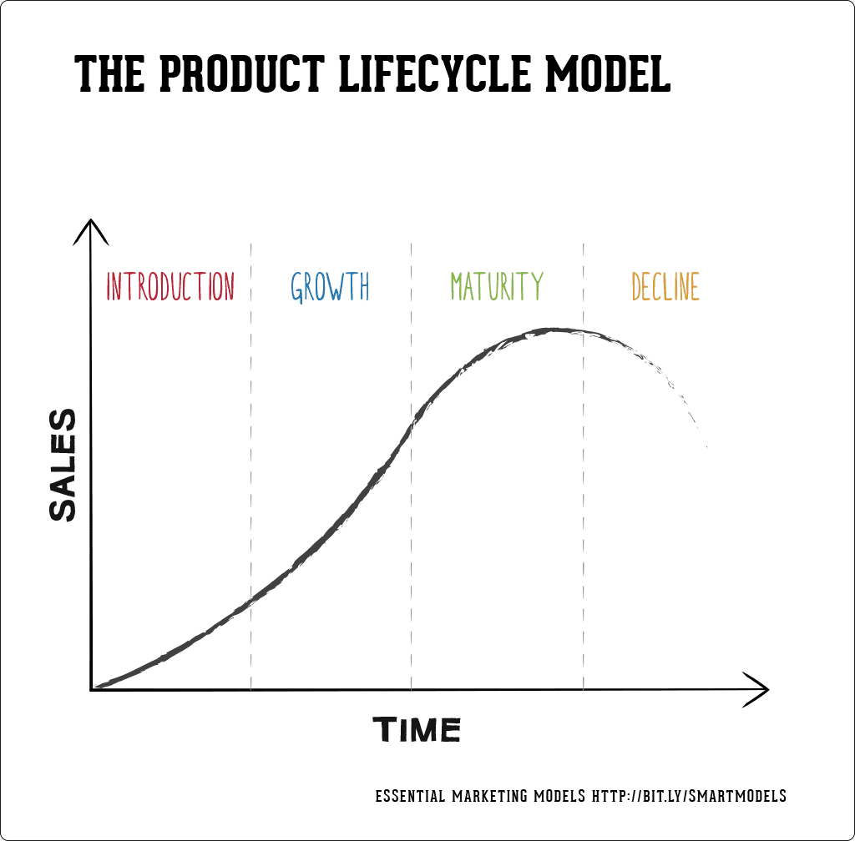

Picture 1The product lifecycle model (Expert Commentator, 2018)

# Introduction:

Mackintosh's Quality Street Chocolate who doesn’t know this famous brand. It was my parents’ favorite choice in special occasions and as this assignment requires us to choose a brand to design marketing plan, my mind was going back to my childhood memory with these delicious chocolates delights that I was surprised reading about, it is more than 100 years old brand and costumed especially for Christmas time now a days. I will discuss the history of the brand along with it current states using product life cycle model stages.

## What are the stages of the Product Life-cycle?

The Product Life-cycle, as seen in picture 1 above, is a strategic tool used by companies to plan for a new products development or enhancement of existing product. This model has 4 stages introduction, growth, maturity and decline (Expert Commentator, 2018).

### Introduction stage

In this stage the company just launched a new product to the market, in small quantity and it is unknown to the consumers. Because of the limited distribution the price of the product would be high with limited personalized promotions (Expert Commentator, 2018). John Mackintosh and his wife in Halifax, Northern England, introduced the Mackintosh quality street chocolate in the market by 1890. It was a new kind of sweet made by inexpensive local ingredients such as milk, sugar beet and eggs, a combination of hard toffee and runny caramel.  At that period of time only few people were able to afford to buy such fancy chocolate, and their brand was limited to high social class people (Nestlé, 2018).

### Growth stage

In the growth stage the popularity of the product grows. The selling volume increase but the price declines. The manufacturer focuses his plan on increasing distribution and promoting on product benefits (Expert Commentator, 2018). John Mackintosh hard toffee and runny caramel product was so successful that in 1898 he expanded the operation by building the world’s first toffee factory.  In 1936 john son Harold inherited the business. As mentioned earlier the factory productions sell was limited to high class wealthy societies at that time period because low class people can’t afford to buy a boxed chocolates made from exotic ingredients from around the world with a luxurious packaging. However, in 1936 Harold focused on reducing the candy production cost by covering different type of toffees with chocolate. He decided to wrap each piece of chocolate individually in colored paper, so he invented the world’s first twist-wrapping machine, then he put the wrapped chocolates into a low cost decorative tin, instead of the cardboard that lower the packaging cost. He added the Quality Street name to the brand and by that Mackintosh Quality Street chocolates were affordable to working families (middle social class). Harold focused on providing enjoyable experience for families with a high quality of chocolate taste. Harold accomplished the increase in sell and lowering of price at this stage (Nestlé, 2018).

### Maturity stage

In maturity stage the product price drop due to alternative competition. Massive distribution of the product the war now is about what make my product distinctive than others (Expert Commentator, 2018). Because of many socioeconomic and political changes through the years Mackintosh Quality Street chocolates brand was merged in with the Rowntree Confectionary Company in York, England in 1969 then,  Nestle purchased Rowntrees in 1988. Now in our days most articles refer to 1936 as the starting year of Mackintosh Quality Street brand and that I guess because Harold the son is the one who made fame of the brand all over the world by making it affordable to all society classes.

Nestlé (2020) is an ancient brand embrace more than 2000 brands under its name. In 2016 Nestlé adopted the tagline for its brands “Good Food Good Life” to keep up with consumer demand of healthier food and life style. Nestlé (2020) purpose statement is to “enhance quality of life and contributing to a healthier future. Our approach creates value not only for our business, but also for individuals and families, for our communities and for the planet”. Mackintosh's Quality Street Chocolate now in the hands of Nestle produced without any artificial colors, flavors or preservatives. As I’ve read the brand in United Kingdom is mainly proposed as a Christmas time candy and each year celebrated it birth with new limited edition flyovers in between like the Honeycomb Crunch in 2016 and Chocolate Caramel Brownie in 2019. Add to that Nestlé has it own Cocoa plants in Africa, farms called [Nestlé Cocoa Plan](http://www.nestlecocoaplan.com/), that contribute in providing jobs for African and missioned to reduce child labor [and](http://www.nestlecocoaplan.com/) aid to improve the quality of life of farmers and their communities (Nestlé, 2020).

I guess by Quality Street is now in safe hands that keep up date with society needs and global trends and also provide innovated ideas for the brand to emphasize it uniqueness and compete with other competitors.

### Decline

Reaching the end with less sales, negative growth, less profits and high competition. The production stops however the company might produce the product as a reminder for the people of it existing in a high price, as it would be consider limited editions (Expert Commentator, 2018).

I think through the years Mackintosh’s Quality street had faced difficult times that might had reach this brand to the decline stage. However, the smart thing to merge with other businesses to face exiting challenges at different time periods made the Mackintosh’s Quality street chocolate brand survive to still be available in the world market and didn’t reach to the decline stage.

# Define competition:

To define competitive brands I consider the same packaging, it specific usage for special occasions like Christmas and Eid, also it availability on the shelf of supermarkets like my brand of choice Mackintosh‘s quality street and of course it availability in my country of Bahrain. Chocolate brands that have the same qualities but are sold in different sweet or chocolate specialty shops were excluded. The chosen brands are Ferrero Rocher, Galaxy Jewels Chocolates and GuyLian. To compare between these 3 brands and my brand of choice I’ve chosen bases of comparisons that are history, taglines, healthy choice, environment friend, mission or purpose statement, and the 4 Ps of marketing mix according to the availability of the information.

FerreroRocher (2020): ancient history started 1942 by Michele Ferrero in Italy. Now for three generation the same family is running the brand operations.

Taglines, “celebrate the Moment”

Healthy choice, nothing mentioned on the Ferrero Rocher brand site about a healthy choice of the product like no sugar, artificial contents or saturated fat.

Environmental side, similar to nestle, Ferrero own it cocoa field in Africa in a Cocoa & Forest Initiative (CFI) program and Ferrero participate in human development in Africa by providing jobs and other training resources.

Mission statement, “High quality, crafted precision, product freshness, careful selection of the finest raw materials, respect and consideration for our customers” (FerreroRocher, 2020).

Marketing mix:

Product: Ferrero Rocher is a chocolate [shell](https://www.marketing91.com/marketing-strategy-shell-shell/) filled with hazelnut praline and wrapped in a golden foil packaging.

Price: Ferrero Rocher is high quality brand that target upper levels of the society, it price would be high compare to other brands. For comparison purpose in Luluhypermarket (n.d.) a box of 300g cost 3.670 Bahraini dinar (BHD).

Promotion: Ferrero Rocher is marketed as luxurious chocolate in advertisement like the one with the “Ambassador’s Reception”. In a period of time tagline ”Share the Magic” seen in Ferrero commercials, the goal was to expand the brand to be beyond of just a formal gift but to be shard in special occasions. Packaging of the chocolate designed to match with different seasons for example a Christmas tree shaped box, an Easter egg format or as in our Arabic countries shaped in a Lantern to match with Ramadan climate.

Place: Ferrero Rocher is available in big stores and supermarkets and wouldn’t be found easily on shelf of regular stores (FerreroRocher, 2020).

Galaxy Jewels Chocolates: no history found about the galaxy jewels chocolate brand the main focus in the company site is the galaxy bar. Galaxy [chocolate bar](https://en.wikipedia.org/wiki/Chocolate_bar) made and marketed by Mars in the [United Kingdom](https://en.wikipedia.org/wiki/United_Kingdom) in the 1960s (Galaxy,2020).

Tagline, “Healthy, active lifestyles” (Galaxy,2020).

Healthy choice: nothing mentioned on the Galaxy brand site about a healthy choice of the product like no sugar, artificial contents or saturated fat.

Environmentally, Galaxy care for farmers whom are responsible of caring for the Cocoa plants in Africa by providing them certificate of benefit for their efforts in the behalf of Rainforest Alliance Certified farm groups (Galaxy,2020).

Marketing mix

Product: Assorted delights bite-size individually wrapped chocolates, Made with Galaxy’s blends of milk, dark and silky smooth chocolate blends.

Price: BHD 2.195, 200gm box (Luluhypermarket, n.d.).

Promotion: Galaxy jewel is promoted in advertisement for ladies as happy sharing moments with friends and family, offers of buy get one sometimes provided. Advertised as an elegant chocolate suitable for snacking, gifting and sharing with loved ones.

Place: Galaxy "Jewels" is a brand limited for the Middle East consumer market and sold online for all over the world (Galaxy, 2020).

GuyLian (2020): a history of a love story to be immortalized in Belgian, by Guy Foubert who was a chocolatier and his wife Liliane. They joined their names to one, Chocolaterie Guylian, and invited the artistic seashell & seahorse shape chocolates.

Tagline, “the world favourite Belgian chocolates”

Health, Guylian In 2018 decided to use shea butter and sunflower as a replacement for palm oil, to have a smoother textured and mainly healthier chocolate, with less saturated fat and less sugar.

Environment, in the purpose statement GuyLian (2020) brand stated, “To improve the livelihoods of cocoa farmers and their communities through the promotion of sustainable, entrepreneurial farming, improved productivity, and community development, which protect nature and children”. GuyLian support African farmers with a program called the Cocoa Horizons providing jobs and personal development for them and their families.

Target consumers, people with past memories enjoying this brand on different occasions especially affection one or memories of past happy childhood.

Mission, “To build one of the leading international premium chocolate brands through a unique combination of creativity, quality and price that will ensure growth, security and beneﬁt for our consumers, our employees, shareholders and trading partners”

Market mix Guylian (2020):

Product: The original Guylian best known for the seashells pralines arranged in a gift boxes. Each peace of chocolate carefully made using a blend of delicious white, milk or dark Belgian chocolate Filled with Guylian roasted hazelnut praline.

Price: BHD 4.590, 180g box (Luluhypermarket, n.d.).

Promotion: different packaging for different occasions. No sugar healthy options available, promoted as a gift of love.

Place: Guylian chocolates are sold in supermarkets, hypermarkets, department stores, specialty food stores, petrol stations and online, in over 120 countries across Europe, Asia, Australia and America, and are available in countless retailers across the World.

|  |  |  |  |  |  |  |  |
| --- | --- | --- | --- | --- | --- | --- | --- |
| **Brand name** | **Current state on the Product Life Cycle** | **Position** | **Market mix** | | | | **Target market** |
| **Product** | **Price** | **Promotion** | **Place** |
| Mackintosh’s Quality Street | Mature | High quality Low price | A variety of chocolates and toffees in exceptional shapes, wrapped like sparkling jewels and contain no artificial colors or preservative and no hydrogenated vegetable oils | Box of 200g, BHD 1.680  Box of 375g, BHD 2.625 | “The taste of hospitality” | 187 countries all over the world | Housewives in Bahrain |
| Ferrero Rocher | Mature | High quality High price | A chocolate [shell](https://www.marketing91.com/marketing-strategy-shell-shell/) filled with hazelnut praline and wrapped in a golden foil packaging | Box of 300g BHD 3.670 | Luxurious chocolate | All over the world, limited to big stores and supermarkets and wouldn’t be found easily on shelf of regular stores | High social class |
| Galaxy Jewels Chocolates | Mature | High quality  Low price | Mixed bite-size individual wrap blends of milk, dark and silky smooth chocolates | Box of 200gm BHD 2.195 | Snacking, gifting and sharing with loved ones | Middle East | Ladies to share happy moments with friends and family |
| Guylian | Mature | High quality  High price  Refer to picture3 | Chocolate made with blend of white, milk or dark Belgian chocolate Filled with hazelnut praline | Box of 180g BHD 4.590 | A gift of love | Over 120 countries across Europe, Asia, Australia and America | People with past memories enjoying this brand on different occasions especially affection one or memories of past happy childhood. |

Table 1



Picture 2 Brand dynamic pyramid (Kotler & Keller, 2012)



Picture 3 Positioning

# Position and brand equity:

Picture 3 is a conceptual model to map the position of the brand in the market. The bases used in the picture are quality and price. From the competition analysis done earlier it can be concluded that Mackintosh's Quality Street chocolate high quality but lower in price compare to the other brands. A consumer research might be needed to study consumer opinion of the brand price and quality because though the positioning mapping can help understand the market from competitive side, but it based on assumptions mainly. Consumer chose product based on their perception of a product’s value that needs to be studied.

Brand equity: “The added value endowed on products and services because of the brand”. It is customer loyalty to the brand; it is an emotional connection that you have to build in consumer mind (Kotler & Keller 2012).

Picture 2 is Brand dynamic pyramids Kotler & Keller (2012) The Brand Pyramid is a useful tool that can help identify where the customers are in their journey to loyalty for a Brand. Business uses this model to increase consumer loyalty to a product.

### Stage 1: Presence

The bottom of the pyramid as seen in picture2 the customers knows about the product might even tried it but they have no attachment to it (Kotler & Keller 2012).

### Stage 2: Relevance

At this stage, consumers evaluate and compare your product against their needs, and other product in the market (price wise and effectiveness) (Kotler & Keller 2012).

At these two stages presence and relevance, your consumers need you to build their awareness of the brand that by implementing the strategy of product mix. Also choosing a target group would be much easier to send the message for. Segmentation and 4Ps mix will be discussed later on in this assignment for the chosen product. It is helpful too to study your consumer experience with your product and similar products with a simple survey to know exactly their need and adjust your mix strategy according to their value of need.

Keep in mind, that consumers still have doubts about your brand value and price, and still have no emotional attachment (MindTools, 2020).

### Stage 3: Performance

The consumers her look to if this brand have delivered its promises. Is the value received from this product is better than other. Consumers might associate the product with a specific characteristic and emotion connection (Kotler & Keller 2012).

To reach this stage as marketing manager you need to show your brand is better than your competitors' brands. Make sure your marketing materials show your customers the information they need to compare your product with competitor products. Study your market audience, and communicate with them accordingly. Here your main concern is to communicate the benefits of your brand product and not the features of the product. Articles advise of Unique selling proposition (USP) analysis to help in identify the brand uniquely valuable features to aid you in this stage (MindTools, 2020).

### Stage 4: Advantage

At this stage, consumers confirm their need to this product and can see the advantages of using this brand. Consumers’ starts associate the brand with emotions and identity (MindTools, 2020).

### Stage 5: Bonding

The consumer here are loyal to your brand they’ve established a strong bond with the brand. They measure advantage and performance before cost. The brand now is part of their identity and formed a strong emotional attachment to them. Your brand would benefit by word of mouth from these loyal customers that might build more of brand awareness within their social and family circles (Kotler & Keller 2012).

During these 2 final stages you need to enhance or promote the emotional bound between customers and your brand. Give special discount promotions in between. Study what kind of emotion your product gives to your consumer pride, fun, excitement or peer approval. Try to plan your advertisements accordingly. Also try to reach your customers on personal level that might be by hosting events that are important to your key customer base. Lastly, provide reinforcing rewards and motivations to your most loyal vocal advocates (Kotler & Keller 2012 & MindTools, 2020).

# 

# Target Market:

Target group are all Bahraini females above 18 years old mainly housewives middle, working and lower social class levels.

Housewives were chosen because of their major responsibility of arranging households and their influence on decision-making and purchases. Mackintosh's Quality Street Chocolate is affordable to all social classes but specifically from working and lower classes have limited income plus most Bahrainis have financial commitments toward their family needs and obligations toward different loans. Add to its affordability the luxuries packaging of the Mackintosh's Quality Street Chocolate brand that make it best choice for them to be in their special time celebration. Currently sweet shops chocolate brands in market are the trend people compete to buy from for luxuries appearance. However, Mackintosh's Quality Street Chocolate is on the shelves of super market and easy to reach and taste quality wise better than some of these sweet shops chocolates. There is no significance choosing urban areas but I guess famous supermarkets are more concentrated on these regions but as Bahrain is a small country all people from different area can reach to any supermarkets in the regions.

# 

# Segmentation:

Market segmentation is the first step in selecting a target market; it is a key element in strategy development. In order to choose the target group to focus on for marketing the product, the first process is segmenting the market in groups and sub groups according to certain bases. The purpose is to find common characteristics in heterogeneous group and try to homogenize it to a target population.



Picture 4 (Al Tareeqah Management Studies, 2020)

The above picture 4 shows common bases of segmentations. Geography segmentation means dividing consumer on the basis of country, region, city or other geographic. Demographic segmentation is dividing population based on identifiable characteristics for example age, gender, occupation, ethnicity, and education. etc. Psychographic is segmentation base on understanding the consumer’s lifestyle, interests and opinions. Benefits sought segment consumer based on certain benefits they seek from the product, for example convenience, status, value…etc. usage rate is segmenting consumer according to their frequency usage of the product i.e. light users, average users and heavy user (Al Tareeqah Management Studies, 2020).

 Picture 5 steps in segmenting markets (Al Tareeqah Management Studies, 2020)

For me to easily segment and chose my target market I’ll use steps in segmenting markets as seen picture 5.

First is to select a market for study, my market is selling of Mackintosh's Quality Street Chocolate in my home country Kingdom of Bahrain.

Second choose bases for segmentation, I’ll discuss all the bases of segmentation to select my target group and then I’ll try to chose the best one.

The market geographically is in kingdom of Bahrain, which is in gulf of Arabia region. Bahrain is a small island that can be targeted as whole easily, but specifically chosen all urban areas of Manama, Riffa, Isa town, Hamad town and Muharraq to be a main target of distribution.

Demographically, I’m not targeting young age I’m targeting adults, as they are the decision makers. As Quality Street is supermarket shelf brand come in different size packaging and prices it is suitable for middle and low class social income population, also high-class income people can enjoy it too. Bahrain is a Muslim society and Quality Street uses of natural ingredients mainly vegetarian make it suitable for this society. Quality Street is brand of celebration of special occasion like Christmas in the west in Bahrain it would be the 2 Eids or any special personal celebrations. I guess the main decisions makers in these occasions are the housewives not only Bahraini nationality but all residents of different nationality and ethnicity.

Psychographic segmentation, consumers would buy this treat for celebration time. The trend globally now a day is healthy food, that advantage to my selling brand as is free from artificial coloring, flavors, preservatives and no hydrogenated vegetable oils.

For the benefits sought segmentation I think mainly because of the healthier choice of not having artificial content people would pursue this product type. Also price wise with luxurious packaging would make it affordable to all levels of society.

For usage rate Quality Street chocolate demand in the market is irregular, though, it is available on supermarket shelves all the time of the year but people buy it more during special occasions like Eids.

Demographic and geographic segmentation can be easily predicted. However, psychographic segmentation requires careful planning and data collection that can be collected through surveys, questioner, interviews and observation. For the sack of doing this assignment the author predicted each segment data according to her Bahraini lifestyle.

Target group: Based on the above considers of data, my target group would be females in Bahrain above 18 years old mainly housewives middle and working social class levels.

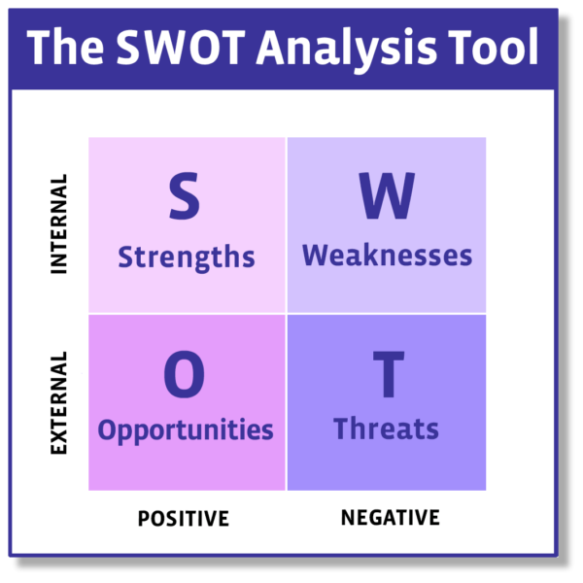

Picture 6 SWOT analysis (Coaching Tools, 2013)

# SWOT analysis:

Mackintosh’s Quality Street chocolate as a brand made by Nestle a leading industry. The writer will relate the analyses to Bahrain community as per assignment requirement to market the product in our home country.

## Strengths:

Mackintosh’s Quality Street produced by a highly trusted company in today’s world, which is Nestle. Quality Street is famous all over the world for it quality of taste and luxury shape of chocolates where ever you buy it in the world.

An old popular [brand](https://www.marketing91.com/what-is-a-brand/), Mackintosh’s Quality Street has the nostalgic effect through generations. Mackintosh’s Quality Street has great distribution far and wide, the chocolate boxes are almost available everywhere even in regular stores. Available in a different size and price that is suitable to be bought by different social class. Considered as an ideal product for home hospitality with Arabic coffee. Mackintosh’s Quality Street chocolate maintains the sold texture at room temperature of 25C. Available in variety of packages according to season and special [events](https://www.marketing91.com/event-marketing-brand-equity/). Healthy choice, contain no artificial colors or preservative and no hydrogenated vegetable oils (Nestle, 2020).

## Weaknesses:

Can be considered of high price for some social classes. Mackintosh’s Quality Street rarely advertise in the media of that might lead to loss of market share. Today trend of healthy food rank chocolates products to be unhealthy in majority of masses.

Not available easily at regular stores (Coaching Tools, 2013) .

## Opportunities:

Innovation of new flavors aid in gaining more market share (maybe a new Arabic flavor of coffee or dates).

Social media, Internet advertisements and contraction with internet fame blogers can increase [demand](https://www.marketing91.com/types-of-demand-2/).

Use of famous or popular actors, or social media personals to share their experience with Mackintosh’s Quality Street.

Innovation of small packaging could increase the consumer buying demands of Mackintosh’s Quality Street.

Limited edition of old packaging tin, return to people old memories and encourage them to collect such antic.

Use of new technologies to produce [heat-resistant chocolate](http://newsfeed.time.com/2012/11/30/cadbury-develops-chocolate-that-doesnt-melt/) that doesn’t milt easily in higher than room temperature, it would be a good advantage in a country like Bahrain with high summer temperature.

## Threats:

Imitation of Mackintosh’s Quality Street by other unpopular brands.

Bad economy due to many reasons, like what we have now of epidemic.

High chocolate brands competition.

Healthier choices replacement brands other than chocolates.

Increase of price due to increase in manufacturing and distribution cost. Again it can be due to economical crises.

# PESTEL Analysis:

## Political

Merging an ancient historical brand of Mackintosh’s Quality Street to a strong trusted industry of Nestle aided in continuity of production of such unique brand. The major political issue is faced by the main company Nestle in obtaining raw materials for production and faced at the origin country of the company would not be discussed in this assignment the writer will focus on political issues in Bahrain (Nestlé, 2020).

Since 2019 Bahrain government imposed 5% add value tax (VAT) that increased price of many market products. Also, ministry of health in Bahrain imposed another increase of VAT on unhealthy food products, such as high fat high sugar, that the price of some of these products doubled like of some of the fast foods. Mackintosh’s Quality Street considers of unhealthy food rank and the price of product was increased (eGovernment, 2020).

## Economic

Talking about 2020 a year of epidemic shut down of most business and manufacturing.

Might lead to global financial crisis that could impact on the cash flows of all industries.

## Socio-Cultural

Bahrain is Muslim majority country, Mackintosh’s Quality Street production by Nestle consider the production to be Halal and use vegetarian ingredients to make sure the suitability of consumption of it product by different ethnicity. The globule trend is healthy life for that Nestle production is free from artificial colors, flavors or preservatives. Add to that there is concern of increase of obesity problem in our gulf societies that I think sugar free should be considered in the production of Nestle products.

Talking again about 2020 epidemic year and social distances policy that might effect Eids this year as no gathering celebration which means drops in the sales of celebration sweets.

## Technological

The technologies helped in innovation of product packaging and reduce cost of production. Internet and social medias now plays a vital role in creating creative marketing campaigns (Professionalacademy, n.d.). Scientist with the use of certain type of pathogens invited a [heat-resistant chocolate](http://newsfeed.time.com/2012/11/30/cadbury-develops-chocolate-that-doesnt-melt/) that doesn’t melt even in higher than the room temperature that is conceder to be a new technology in the chocolate market (Nestlé, 2020).

## Environmental

The ozone depletion and global warming with no doubt affected the entire world but specifically Arab gulf countries have the highest temperatures during the summer time that might reach to more that 55c. That makes it a must for industries to have appropriate conditioning for storing the chocolate products in appropriate temperature.

The issues surrounding global warming, ozone depletion, and recycling have become highly impactful on business around the globe (Professionalacademy, n.d.).

## Legal

Globally companies were affected by facing issue with emerging economies of China, and India, which now face the issue of low cost or fake brands that use almost similar packaging for their products as the fame brand that is consider illegal and action can be take against the fake brand (Professionalacademy, n.d).

# BCG matrix

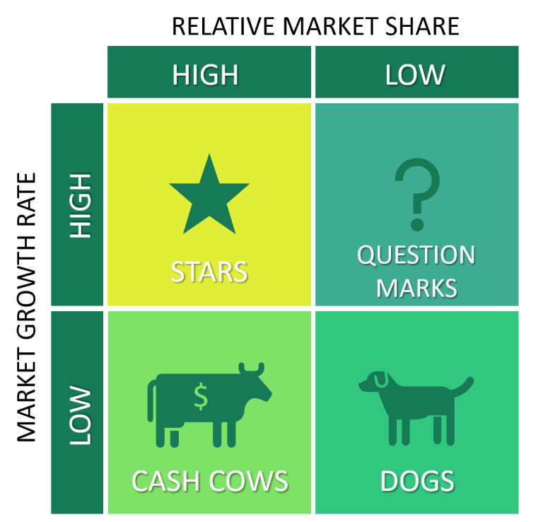

Picture 7 BCG Matrix (Business-to-you, 2017)

The Boston Consulting group’s product portfolio matrix (BCG matrix) also know of growth/share matrix, see picture 7; is designed for strategic planning, to aid a business to predict its growth opportunities by examining its range of products according to certain standers to decide investment on product, discontinue or development of products (Business-to-you, 2017 & Hanlon, 2019).

As can be seen form picture 7 there are 4 quadrants based on market analysis of growth and relative market share:

Dogs**:** products with low growth and market share. It is better to remove this product from the portfolio because it drains resources with low income. However, some of these products could generate high revenues with little cost and appropriate promotion (Hanlon, 2019). I don’t think Quality street have such kind of product in it portfolio, but at a period of time there was boxes with limited flavors in the market and now disappeared. I think promoting one flavor box is a good idea that needs a plan for sale and appropriate promotion. It is better to be in limited editions or in personal order by maybe online. It can be more than one flavor according to consumer order and taste.

Question marks: Products with high growth but low market share (Business-to-you, 2017). It might be a new product in the brand in my case a new flavor of chocolate as suggested in product mix maybe a cardamom or coffee. If people palates the taste of these flavors it can become a star. That might need some promotions to get people to know the product of your especially if competitors started planning to introduce the same ideas. The star can be a new packaging or return of an old product. However, it is hard to predict the success of a question mark products and if not it might turn to a dog.

Stars: Products with high growth and high market share. These products can generate high return on investment than the other product and it can be a product, which is at the question mark as explained earlier (Hanlon, 2019).

Cash cows: low growth with high market share products (Business-to-you, 2017). Quality Street is a mature well-established brand, the traditional purple packaging with the mix of12 flavored chocolates. The high revenue of cash cow product can be used in the innovations of future star products.

# Marketing mix:

The writer would craft the product mix that suitable for Bahrain market and mainly for the target group of choice mentioned earlier.

## Product:

A collection of 12 assortments different flavors of classic Quality Street chocolate each flavor shaped and wrapped tightly in a sparkling wrap. Packed in a decorated tin or card box of different sizes. The main flavors of Quality Street chocolates are Toffee Penny, Toffee Finger, Toffee Deluxe, Caramel Swirl, Milk Choc Block, Fudge, Coconut Éclair, Orange Chocolate Crunch, Strawberry Delight, Orange Crème, The green triangle and The Purple One. New limited edition flavors for special seasons can be created as has been done in the past for new years editions like Gingerbread & brownie (Telegraph Media Group, 2020 & Nestlé, 2020). Bahrain mainly is an Arabic gulf region, Muslim society. Creation of flavors to accommodate the taste of this community can be according to it tradition. Spices like saffron and cardamom or their tradition in special occasion of serving dates and coffee. Add to that content of the product is mainly vegan and Halal. The Quality Street chocolate can be presented all yearlong according to different festive or occasion, for example Eids, Halloween and Christmas. Mainly Quality Street chocolate are branded as Christmas brand in it home country and almost all the packing of the Quality Street chocolate says that (Nestle, 2020), the plan is to change the packaging according to the occasion for example crescent picture as an indication of Eid, lantern picture as indicator of Ramadan, picture of carved pumpkins as indicator of Halloween and of course Christmas decoration as indicator of Christmas time. The packaging it self can be designed in shapes of the pictures stated earlier. In order to create these new flavors and packaging designs needs cooperation and team efforts with the mother company brand nestle. The packaging will come in different sizes and price that will be discussed later in this assignment, to be suitable for all social classes.

## Price:

Mackintosh’s Quality Street chocolate is ancient old brand, when it was first released before more than 80 years ago it was a new innovation. Mackintosh used the price skimming strategy. Quality toffees in a luxurious packaging only for niche segment who are able to afford buying such high price brand. In now days Mackintosh’s Quality Street is a mature old brand (Nestlé, 2018). My strategy is to use penetration and competitive pricing strategy and try to use skimming strategy in between. Competitive price is to keep up your price with your competitors. It is based on market price researches using software and then calculating price based on this information. This is done because you don’t want people to think your brand is cheapest. Add to that the product compete mainly by adding value to consumers and product quality in the market. Competitive pricing is used by old business with a lot of competitors in the market like Quality street brand (Dey, 2016 & Intelligence Node, 2019).

Penetration pricing strategy is to sell your product less than your competitors to attract consumers and gain market share that can be achieved with promotions like buy one get one free. If you see table 1 above compare to other listed brands Quality Street has a reasonable lower price than other brands (Singh, 2016). Skimming pricing strategy, is planed to be used at the beginning of introducing new flavor of Quality Street chocolates with new special packaging or on seasonal bases when new packaging introduce (Doyle, 2019). At one year limited edition of old Mackintosh’s Quality Street tin were sold. Lets keep in mind the target group, which are the housewife of middle and working class. The introduction of each price strategy must consider the main target group that is why there are different sizes, packaging and prices.

## Place:

Nestle Middle East owns 18 factories in the region; in Bahrain the manufacture was established in 2004 (Nestle, 2020). The main distributor of nestle product are these companies. Mackintosh’s Quality Street chocolate is available in supermarket and hypermarket shelves, mainly in urban Bahrain cities and can be found in small shops some time. However, Bahrain is a small country and people from different urban and rural areas can reach to obtain the product.

## Promotion:

Through the years Quality Street had numerous advertisements on newspapers, radio, television, posters and now days online. Various taglines for example in 1960 “for people with a taste for living”, 1979 “Made for sharing”, 1994 “magic moments with Quality Street”. For the purpose of this assignment as I’m the one preparing a marketing strategy I’ll chose a tagline appropriate for my target group and our culture of Bahrain that would be “The taste of hospitality”. Through years Quality Street marketed as a gift brand then for share in happy moment ([Laakso](https://www.pinterest.com/palaakso/), n.d.). My plans as my target audience are house wife mainly Bahrainis they are responsible for preparing the hospitality table in especial occasions, my aim is to convince them the availability of my brand is a must to complete this table by various advertisements. Most articles advise to use a mix of pull and push strategy in promoting for a brand (Singh, S. 2016). For the push strategy for now a day is online advertisements mainly the few seconds of adverse before the starting of your video of choice, also, street posters can be effective in reaching large audience with the tagline message. My idea is to show the happiness for example of Eid moment in a house where the housewife if preparing the hospitality table then when every one sets and at the end, one of the children or a guest ask where is the sweet that when magical moment start with reveling of Quality street chocolate and each start to compete to reach to his favorite flavor and maybe ask about one of the limited editions. For the pull strategy we can cooperate with bloggers maybe a house with that speak about how she prepare for Eid and why she choice the Quality street brand. Bloggers who share their happy moments of Eid and explain hospitality in Bahrain and why his they’ve chose the Quality Street to be in their table.

# Conclusions and Recommendations:

In this assignment I’ve designed marketing strategy for my brand of choice, which is Mackintosh’s Quality Street. In the introduction part product life cycle discussed that it was discovered my brand of choice Mackintosh’s Quality Street and all its competitor were ancient brands and in the maturity stage. The competitors were choose based on the similarity of packaging and availability on the shelves of super market in Bahrain. Each competitive brand was analyzed based on history, taglines, healthy choices, environment and I tried with market mix. The positioned according to price and quality. Mackintosh’s Quality Street was in high quality low price rank. Brand equity discussed in form of Brand dynamic pyramid and ho to reach the consumer to brand loyalty through the pyramid stages. Segmentation done and the target group was Bahraini females above 18 mainly housewives because they are the decision maker in celebration times like Eid, and the marketing strategy in this assignment is to brand Quality street as “The taste of hospitality”. BCG matrix used to analyzes opportunities of products development and growth or decline and dismiss. Lastly, the 4P’s marketing mix done to subtilize the target group.

My recommendation is to build a marketing plan for more than one target group. To study Bahrain community economic and health needed and build the brand on these bases. Also, if this marketing plan implemented, in the equity part unique selling proposition (USP) analyses is recommended to study the consumers emotions and build the brand on it. consumer satisfaction surveys at the beginning of marketing strategy can help in building your product for their satisfaction.

# Reference

Al Tareeqah Management Studies. 2020. *Chapter 8: Segmentation, Targeting and Positioning* [PowerPoint presentation].

Business-to-you. 2017. *BCG Matrix: Portfolio Analysis in Corporate Strategy.* [Online]. Available from: https://www.business-to-you.com/bcg-matrix/ [Accessed 12th May 2020].

Coaching Tools.2013. *Everything you need to know about SWOT Analysis!.* [online]. Available from: https://www.thecoachingtoolscompany.com/what-is-a-swot-analysis-everything-you-need-to-know/ [Accessed 19th April 2020].

Dey, S. 2016. *Competitive pricing strategy & pricing strategy examples.* [online]Available from: https://www.youtube.com/watch ?v=lLCee_VDGZ0. [Accessed 1st May 2020].

Doyle, C. 2019. *Price Skimming Strategy.* [online].Available from: https://www.youtube.com/watch?v=kLymCjKN2IA [Accessed 11th May 2020].

eGovernment. 2020. *Value Added Tax in Bahrain***.** [online]Available from: https://www.bahrain.bh/wps/portal/!ut/p/a1/lZJdT8IwFIb_ilzscvRs3UfxbhJECR8GRFlvSLd1ZWa0Y1TAf2 /. [Accessed 14th May 2020].

Expert Commentator. 2018. *How to use the Product Life-cycle model.* [online]. Available from: https://www.smartinsights.com/marketing-planning/marketing-models/product-life-cycle-model/ [Accessed 29th April 2020].

Ferrerorocher. 2020. Ferrerorocher ,*The Golden Experience.* [online].Available from://www.ferrerorocher.com/us/en/[Accessed 19th April 2020].

Galaxy. 2020. *Galaxy Choose Pleasure.* [online].Available from: https://www.galaxychocolate.co.uk [Accessed 19th April 2020].

Guylian. 2020. *Guylian Belgian Chocolates.* Available from: https://www.guylian.com/history/ [Accessed 19th April 2020].

# Hanlon, A. 2019. *How to use the BCG Matrix model.* [online]. Available from: https://www.smartinsights.com/marketing-planning/marketing-models/use-bcg-matrix/[Accessed 3th May 2020]

Intelligence Node. 2019. *Competitive Pricing Strategy – See How Products Are Priced*. [online]. Available from: https://www.intelligencenode.com /blog/competitive-pricing-strategy-see-products-priced/ [Accessed 12th May 2020].

Kotler, P. & Keller, K. 2012. *Marketing Management*. 14th ed., Upper Saddle River, NJ: Prentice Hall.

[Laakso](https://www.pinterest.com/palaakso/), P. n.d. *Mackintosh's Quality Street*. [online].Available from: https://www.pinterest.com/palaakso/mackintoshs-quality-street/ [Accessed 11th May 2020].

Luluhypermarket. n.d. *online-shopping*. [online].Available from: https://www.luluhypermarket.com/en-bh/ [Accessed 9th May 2020].

MindTools. 2020. *The Brand Pyramid: Building Customer Loyalty*. [online].Available from: https://www.mindtools.com/pages/article/brand-pyramid.htm/ [Accessed 9th May 2020].

Nestlé. 2018. *A Quality History*. [online]. Available from: https://www.nestle.co.uk/en-gb/media/newsfeatures/a-quality-history [Accessed 20th April 2020].

Nestlé. 2020. *Enhancing quality of life and contributing to a healthier future.* [online]. Available from: https://www.nestle.co.uk/en-gb/aboutus [Accessed 20th April 2020].

Professionalacademy. n.d. *Marketing Theories– PESTEL Analysis.* Available from: https://www.professionalacademy.com/blogs-and-advice/marketing-theories---pestel-analysis [Accessed 19th April 2020].

Riley, J. 2020. *Market Positioning*. [online]. Available from: https://www.tutor2u.net/business/reference/market-positioning [Accessed 1st May 2020].

Singh, S. 2016. *Pull* vs. *push strategy, meaning/difference/promotion mix/marketing management/ppt.* [online].Available from: https://www.youtube. com/ watch?v=z_YWgN5TIUA [Accessed 1st May 2020].

Telegraph Media Group. 2020. *The votes are in! All 12 Quality Street chocolates ranked from worst to best*. [online].Available from: https://www.telegraph.co.uk/christmas/2018/12/26/votes-12-quality-street-chocolates-ranked-worst-best/ [Accessed 11th May 2020].