SBS – MBA / MSC

LECTURER NAME: DR. SYED FARHAN ALAVI

TOPIC NAME: STRATEGIC MANAGEMENT

SUBMISSION DATE: 14 MAY 2020

STUDEN NAME: DZHULIIA SHALKHUB

STIDENT ID: 10137

**EXECUTIVE SUMMARY**

The Company chosen for below research is first Qatari company that offers fast and cost-effective delivery service through an ecommerce mobile application as well as personal concierge service.

The Company is inspired by the punctuality and scheduled character traits of a Swallow Bird. The main focus of the company is to become a super application offering one stop solution for swift and affordable shopping and delivery services throughout Qatar.

The Company was established in 2019 when it started of as an offline personal concierge and delivery service company. During one year The Company overgrew to an online ecommerce platform - mobile application that has restaurants, local shops that are using The Company as preferred delivery company. The uniqueness of The Company is that it diversified delivery scale from restaurants to gifts, flowers, grocery, laundry, books, health and beauty products. Distinctive feature of The Company is that, unlike all the competitors, it has unlimited delivery diapason within Qatar.

The Company makes very important input to the local economy by supporting other startups and home-based businesses – apart from delivery, The Company offers new concept which did not exist in Qatar before - storage and logistic/delivery solutions.

The Company main focus is to offer high-quality services and exceed customer’s expectations through customer centered strategy.

**The Company Mission**

To provide individuals and local businesses with the fastest super application, expedient concierge and delivery services. The Company exists to attract and maintain customers through offering services that exceed their expectations.

**The Company Vision**

To create economic opportunity in Middle East through innovation technology where customer can buy anything, they want online.

E-commerce is one of the most perspective directions for majority of businesses. If to take China as an example, WeChat is a super app that has numerous functions – messaging, food delivery, shopping, grocery, all types of tickets purchases, daily payments – phone, internet etc., utility payments and, in addition, it can be used instead of bank card.

Qatar has started moving towards e-commerce recently and, considering current situation with COVID – 19, e-commerce is the only way for people to keep living despite self-isolation.

There are numerus strong companies on the market – Talabat, Rafeeq, Carriage, Fingertips which are direct competitors of The Company. Despite their long experience in the market, The Company has it’s market share when it comes to shopping – grocery, technology, games, toys and fashion. Considering the closure of the shopping malls, The Company is one of the leaders in fashion and beauty delivery.

Having analyzed the current situation in Qatar, we can come to the conclusion that Delivery/E-Commerce market became highly competitive and very dynamic. Despite being new player on the market, The Company has capacity to remain on of the leaders due to diversification of services and products.

**TABLE OF CONTENT**

|  |  |
| --- | --- |
|  |  |
| 1. Identify the firm’s existing vision, and mission statement (also mention why it is important) 2. Develop vision and mission statements for the organization, what you think it should be as, per knowledge developed in your study 3. (a) Identify the organization’s external opportunities and threats   (b) Develop PESTEL   1. Construct a Competitive Profile Matrix (CPM) 2. Construct an External Factor Evaluation (EFE) Matrix 3. Identify the organization’s internal strengths and weaknesses 4. Construct an Internal Factor Evaluation (IFE) Matrix 5. Recommend long-term objectives and specific strategies to achieve them. Compare your recommendations to actual strategies planned by the company 6. **Choose (as many as you can) matrix from question 9.** Prepare a Strengths-Weaknesses-Opportunities-Threats (SWOT) Matrix, Strategic Position and Action Evaluation (SPACE) Matrix, Boston Consulting Group (BCG) Matrix, Internal-External (IE) Matrix, Grand Strategy Matrix, and Quantitative Strategic Planning Matrix (QSPM) 7. Specify how your recommendations can be implemented and what results you can expect. What Management, Marketing, Finance/Accounting, R&D and CIS issue, if any you foresee. Your recommendations to address them 8. Recommend procedures for strategy review and evaluation | 4  5  6  7  9  10  12  13  14  17  21  25 |
| Conclusion | 28 |
| Reference list | 31 |
|  |  |

1. Identify the firm’s existing vision, and mission statement

**The Company Mission**

To provide individuals and local businesses with the fastest super application, expedient concierge and delivery services. The Company exists to attract and maintain customers through offering services that exceed their expectations.

**The Company Vision**

To create economic opportunity in Middle East through innovation technology where customer can buy anything, they want online.

**The Company Aim**

To deliver customer satisfaction with creativity, innovation, sincerity and gratitude.

It is extremely important that company has clear mission and vision statement to have clear goals and purpose. In other words, mission and vision provides company with directions and gives the feeling of cohesiveness to the employees (Kirkpatrick, 2017; Chron.com, 2019).

Mission identifies current state of the company and answers three important questions - what the company does, who are target customers and why company is different from the competitors. Company’s culture has to be connected with mission. Considering that it is resent-focused, it can change depending on how fast prior set mission is accomplished. Mission provides employees with goals, behavioral framework and helps to understand the value of their work. It also identifies relations and connections between employees, customers, suppliers, shareholder and investors. Mission identifies what company is and why it is special (James Tallant, 2015).

Vision describes where the company wants to be, desirable state of the company in the future or, in other words, how organization will look once it’s mission is accomplished. The vision can be considered achieved when the statement can be read in present tense. Vision encourages employees to share innovative ideas that can lead organization to accomplish it’s goals and sets the standard for excellence (Craig, 2017; wmkagency.com, 2017).

The purpose of mission and vision is to form corporate strategy of an organization which is the last stage in the process of establishing the organization. Strategy identifies the list of short- and long-terms objectives as well as detailed procedures of how to achieve the vision of the company (HR Daily Advisor, 2014; ukessays.com, 2018; Managementstudyguide.com, 2015).

1. Develop vision and mission statements for the organization, what you think it should be as, ‎per knowledge developed in your study.

**The Company Mission** is to connect more people to more local businesses in different sectors through interactive app and with faster delivery without destination limits.

**The Company Vision** is to expand to a superapp and logistic platform that will allow people to have all kinds of services in their phone – from all kinds of deliveries to payment services.

As recent tendencies show, simple food delivery app can’t succeed – dynamic life style result in people having need to have all services in their phone.

The Company became first in Qatar to do personal concierge services as well as delivery of various items including sports equipment, clothes, pharmaceutical products and others. However other local companies started expanding their delivery items range from food to grocery, flowers and electronics changing buying habits of customers in Qatar.

At the same time, all delivery companies in Qatar have small delivery radius limiting customers to order from restaurants they like due to being out of delivery range for that particular restaurant or another shop. The Company saw this opportunity and ceased it.

To sum up, especially in recent situation and, on the long run, vast variety of merchants that allow customers to buy anything they want and no delivery destination limitations will be the strongest competitive advantages for The Company and have to be mentioned in its mission (Paul Clayton Smith, 2017; Insights, 2019).

As for the vision, Asian countries like China have already developed SuperApps like WeChat that has all possible services that can be paid online including it’s own WeChat Pay function and it became inevitable part of life of big part of the population – over 1 billion users. Through WeChat users can hail a cab, pay for tickets (including cinema, train, flights), pay for apartment and utilities, book a hotel and transfer money.

The Company vision has to aim at becoming the app that will make everyday life easier using only the mobile phone (Sapra, 2019; Arjun Kharpal, 2019).

1. ‎(a) Identify the organization’s external opportunities and threats.

**Opportunities**

• Current Coronavirus (COVID-19) will continue changing how people shop. More ‎dependence will be on e-commerce

• Government support to local companies who support other startups and home businesses

• Qatar is just an entry point into the region and there is a potential to expand to Oman, ‎Kuwait and Lebanon.‎

• Ability to steal market share from a fragmented market due to competitive pricing and ‎superior service quality and fast delivery.

• Opportunity to be noticed and acquired by international company

**Threats**

• Qatar is sensitive to oil and gas prices fluctuations and a drop in the same would cause a drop in overall ‎spending in the economy ‎

• Possible decrease in economic activity after the 2022 FIFA World Cup which would curtail ‎spending. ‎

• Increased promotions by competitors is a threat for the company.

• Advanced technological developments by competitors. Customers who are attracted to ‎new and more convenient technology can be lost to competitors, decreasing the company’s overall market share

• Delivery services market is saturated with strong companies resulting in complications in market penetration

Having analyzed all external opportunities and threats we can make the conclusion that The Company is acting in the market that is not fully saturated but has strong leaders with good reputation and strong competitive advantages.

At the same time, there are many opportunities that The Company can use in it’s favor in order to increase it’s market share and a unique proposition to attract more customers.

‎ (b) Develop PESTEL – explain what PESTEL is about and each factor

PESTEL analysis is a very important tool that helps organization to analyze it’s macro environment. It is important for both – new and functioning business owners to understand the changes that are happening in the external environment.

When having detailed information regarding the macro environment company is able to adjust its strategy in order for business to be successful or to avoid negative affect of external factors on the company (Frue, 2016).

The outcomes of PESTEL analysis will allow organization to timely and successfully react to the external changes. It gives opportunity to understand the external forces that affects the business and do proper assessment of how those factors can influence the business (Oxford College of Marketing Blog, 2018).

*Political*

* In the time of COVID-19 government increased its interference in business activities in order to avoid the situation where companies us current situation for self-beneficiation.
* Mandatory protection measures that have to be used by delivery companies – drivers are obliged to wear masks and gloves and if fail to do so – they can be reported and company will be either shut down or given a fine
* Fixed food delivery fee of 10 QAR that is mandatory for all delivery companies
* Strict control over discounts and promotions during Ramadan and Aid – all promotions have to be reported in order to obtain license otherwise fines are applied
* Recent decree that forbids people from getting a take out from restaurants or shops in order to inforce using delivery company services instead

*Economical*

* Government support of local businesses
* Government interference in businesses
* Low fuel prices
* Low inflation rate
* Low cost of labor and accommodation
* High level of unemployment
* Small number of local tech-companies
* Highly competitive delivery services market

*Social*

* Majority of population are active users of mobile applications
* Food delivery services are very common and widely used by the population
* Constantly increasing interest in e-commerce
* Previously unpopular online shopping for groceries and non-food items
* Changing buying habits

*Technological*

* Increasing number of people using technology
* Older generation start to use mobiles
* Development of super apps with vast diversity of services
* Delivery apps become more sophisticated and interactive
* Consumers become more demanding to quality of technology

*Environmental*

* Corporate social responsibility became a cornerstone of every company
* Environment-friendly practices became mandatory for companies
* Recycling and use of eco-technologies gives competitive advantage

*Legal*

* Copyright, patents and intellectual property laws
* Very strong consumer protection lows in Qatar
* Improvement in employment and transfer lows
* Improvement in labor rights and employees protection

1. Construct a Competitive Profile Matrix (CPM)

The Competitive Profile Matrix is an effective tool to compare The Company’s critical success factors to its competitors and understand strength and weaknesses of the company (Ovidijus Jurevicius, 2013).

CPM helps the company to understand the external environment and competitors in order to improve its strategy and see the shortfalls inside the organization based on calculation the score of critical success factors.

Critical success factors are key areas where the company has to perform at the highest level in order to have advantage on the market (Sridharan, 2019).

CPM is an extremely important tool for The Company to analyze its competitors because it gives a clear picture of the full package that competitors are bringing to the market. And this allows the company to identify strongest competitors on the market and work on the areas that need improvement in order to outstrip the competitors (smallbusiness.chron.com, 2018; Maxi-Pedia.com, 2017)

**Competitive Profile Matrix of The Company**



Figure 1

As CPM analysis showed, Carriage is the strongest player on the market having the score of 3.25. Carriage and Talabat has advantage in most important factors like market share, customer service and strong marketing. Carriage has obvious advantage in front of both companies in terms of delivery speed.

The Company score is higher than average but it is still behind the competitors in majority of factors. However, The Company has obvious advantage in terms of product range and delivery area which shows that it has the unique offer on the market and can use those two factor as a competitive advantage.

At the same time, in order to increase its market share, The Company has to work on delivery speed, app convenience, customer care and promotions. Once it reaches same level of competitors and considering unique proposition, The Company will become one of the leaders on the market.

Considering all mentioned above, The Company already became direct competitor of leading companies in delivery apps market – of Talabat and Carriage.

1. Construct an External Factor Evaluation (EFE) Matrix

External factor evaluation matrix allows the management to identify external opportunities and threats and see how effective and efficient chosen strategies are based on score calculation.

EFE matrix is based on SWOT and PESTEL analysis as it includes the external factors that affects the organization and it shows which opportunities and threats organization is facing at the present time.

EFE is part of a bigger analysis that allow to either evaluate existing strategies or compare different strategic intentions in order to choose the most efficient in current situation (ManagementMania, 2012).

**External Factors Evaluation Matrix**



Figure 2

The Company overall score is well beyond average and is 3.36. The Company has chosen correct strategy in order to use opportunities and to avoid threads. The company has reacted on time to the opportunities that came with the COVID-19 and gained competitive advantage. However, The Company has to work harder on its technology quality as well as on getting stable market share as entrance of new competitors can have a negative impact on the organization.

Overall, The Company has all suppositions in order to become one of the leaders on the market through successfully chosen strategies.

CPM and EFE Matrix are effective tools in evaluating firm’s strategies. The difference is that CPM is based on comparison of the firm with competitors where EFE evaluates how well the organization reacts to the impact of external forces. Unlike EFE, factors listed in CPM matrix are not grouped into opportunities or threads (Kie, 2019).

The main target of CPM is to allow owners, stakeholders and investors to understand strength and weaknesses of major competitors and to see where the organization stands among them. It also shows the fields of improvement in order to have competitive advantage.

On the other side, EFE shows external position of an organization and how efficient chose strategies are or, in other words, how well the organization responds to the external opportunities and threats (strategic-management, 2017).

CPM and EFE matrix allowed to understand where The Company stands in comparison with its competitors as well as environment where The Company is operating and how external factors affect the business success.

The two matrix allowed to see a clear picture of external environment in Qatar market.

1. Identify the organization’s internal strengths and weaknesses.

Strengths

* Delivery fee and commission from restaurants are lower comparing to other competitors allowing market penetration from the perspective of both restaurants and the end user.
* Broad delivery area that allows people to order from restaurants they like or do shopping regardless the location
* Diverse product portfolio gives competitive advantage especially during quarantine where all stores are closed. It has several unique product offerings (laundry, scuba diving and camping equipment) which are not provided by competitors.
* Low merchant commission percentage when compared to local competitors
* Strong management – Strong founder base from the Co-Founder who has local and international business experience which has led to traditional star-up hurdles being avoided.
* Constant technical development of the app based on occurring needs
* Investors (government and individuals) are interested in The Company
* Big amount of average order

Weakness

* Due to strong competitors with broad customer base, company needs to expend a high marketing cost in order to raise its brand awareness.
* Not enough drivers to handle increasing number of orders
* Limited number of customer care agents
* Inconvenient dashboard used by operations department that doesn’t allow automatic drivers allocation
* No call center software in order to serve customers better
* Non availability of debit card refund of the amounts below 200 QAR
* Unexperienced team
* App interface needs improvement

Having analyzed internal strengths and weaknesses we can come to the conclusion that The Company has many strong sides that allow it to become a relevant player in the field of delivery services in Qatar. But, at the same time, it has weaknesses that makes The Company vulnerable to strong competition that already exists on the market. However, weaknesses listed above are already being fixed by the company and can be rectified in the nearest future with the right guidance of the experiences Management and CEO.

1. Construct an Internal Factor Evaluation (IFE) Matrix.

Internal Factor Evaluation is an important tool for management to evaluate major strength and weaknesses of an organization. IFE shows the relationship between the functional areas of organization.

IFE is used on the stage of strategy formulation along with EFE and gives a very precise picture of an organization internal environment and its strength and weaknesses (Maxi-Pedia.com, 2017; StuDocu, 2018).

Internal Factors Evaluation Matrix



Figure 3

The Company has a score of 2.68 which is slightly above average. As we can see from the matrix, company has a lot of strength that give it the competitive advantage, however, it needs to work on weaknesses. It is very important for the company to increase number of drivers and improve the customer care. In addition, technological development is needed in terms of dashboard improvement as well as obtaining additional software in order to make operations and customer care department more efficient and increase customers satisfaction, response rate and problem solving.

Financial process has to be improved as well as competitors also have Debit Card payment tool and have very fast refund process.

The company has high marketing cost due to strong competitors on the market with established clientele and high quality apps. It has to be optimized in order to have the highest productivity of marketing employees with optimal cost.

1. Recommend long-term objectives and specific strategies to achieve them. Compare your recommendations to actual strategies planned by the company.

When The Company entered the market, the main strategy chosen was Growth Strategy that included:

1) *Market Penetration* – high marketing cost in order to enter almost saturated market with strong players. Based on active promotions, attractive marketing campaigns and strong specialists in the field.

2) *Product differentiation* – The Company started offering wide range of non-food products as well as launched the service of personal concierge (delivering any item from one customer to another).

The second strategy Chosen by The Company was Cost Leadership - reasonable delivery fees and distance-based delivery fees on one side and flexible competitive commission for merchants with various choice of commission schemes.

Based on Research conducted, below long-term objectives are suggested:

* Reach breakeven point by the first quarter of 2021
* Increase market share to 30% by 2022
* Increase share of wallet usage (maximum depression of direct refunds by using wallet)
* Introduce SuperApp by 2022
* Improve customer service ad customers retention
* Fastest delivery of all kinds of products (including non-food items)
* Become leader in supporting home businesses
* Reduce cost by improving technology
* Improve cooperation process with all merchants
* Improve employee retention and talents development in order to build high-performing team
* Enhance corporate culture and work satisfaction
* Become a leading e-commerce company in Qatar
* Take The Company public

Recommended strategies are:

***Cost leadership*** – in order to implement this strategy successfully, The Company has to act in several directions:

1 – to be a leading company in terms of delivery fees

2 – outsource customer care department (e.g. – establish department in on of the countries to cut cost - Egypt / Jordan / Lebanon)

3 – optimize cost of drivers by reducing the amount of drivers employed directly by the company and have casual drivers working for the company

4 – improvement of technology in order to increase the percentage of processes that can be automated

***Growth Strategy***:

*Product Differentiation* – The Company already have diverse products proposition. As example – it has agreement with one shopping mall in Qatar – all stores inside the mall are online. Main objective is to work on bringing more shopping malls and stores in order to become the app where person can buy everything he needs without leaving the house

*Market segmentation* by Psychographic, Demographic and behavioral differentiation.

Above strategy is very useful for The Company considering that it offers very big variety of products. In order to increase sales and strengthen the influence on the market, The Company has to enhance market segmentation and build marketing campaigns, promotions and various posts based on the market to be targeted.

The Company has to become trend-setter by advertising the lifestyle for certain products.

Qatar has customers in all segments – from those who are cost-oriented and have low buying capacity to customers who have high spending and prefer luxury products. The Company already has diverse range of merchants that cater all types of audience – low cost options, medium range and high end luxury products.

Most important outcome of successful implementation of Market segmentation strategy has to be smart marketing that will have different approach to different type of customers.

***Joint Venture*** – considering that one of the objectives of The Company is to become super app – it is necessary to have very strong financial position and sufficient funds in order to develop unique software. Various investors will not only help the company to be strong financially, but also will give an opportunity to invest more in marketing, technology and, as a result, after introducing first super app in the region, The Company can go public and strengthen its position on the market.

***IT strategy*** – to concentrate on improving The Company IT Capabilities and build the technology that in the end will create value for the company, investors, shareholders and customers. The Company has to concentrate on below:

* Improving of the APP targeting to become most convenient to use and esthetically attractive with interactive search algorithm and filters
* Improvement of software used by - company operations department and drivers – automatic allocating and tracking of drivers
* Improvement of dashboard used by merchants in order to ensure easy process of receiving order by merchant (including sound when receiving the order from The Company), visibility of items ordered and easy status changing process.

To sum up, by implementing strategies listed above, The Company can successfully attain all long-term objectives and become highly competitive leader on the market as well as have an opportunity to grow outside Qatar and become one of the leaders in the industry in GCC Region (Wright, 2019; Ltd, 2019; Keating, 2018; Yesbeck, 2019; Cox, 2016).

1. **Choose (as many as you can) matrix from question 9.**

Prepare a Strengths-Weaknesses-Opportunities-Threats (SWOT) Matrix, Strategic Position and Action Evaluation (SPACE) Matrix, Boston Consulting Group (BCG) Matrix, Internal-External (IE) Matrix, Grand Strategy Matrix, and Quantitative Strategic Planning Matrix (QSPM).

**SWOT analysis**

**Strengths Weaknesses**

|  |  |
| --- | --- |
| -Delivery fee and commission from restaurants are lower comparing to other competitors allowing market penetration from the perspective of both restaurants and the end user.  -Broad delivery area that allows people to order from restaurants they like or do shopping regardless the location  -Diverse product portfolio gives competitive advantage especially during quarantine where all stores are closed. It has several unique product offerings (laundry, scuba diving and camping equipment) which are not provided by competitors.  -Low merchant commission percentage when compared to local competitors  -Strong management – Strong founder base from the Co-Founder who has local and international business experience which has led to traditional star-up hurdles being avoided.  -Constant technical development of the app based on occurring needs  -Investors (government and individuals) are interested in The Company  -Big amount of average order | -Due to strong competitors with broad customer base, company needs to expend a high marketing cost in order to raise it’s brand awareness.  -Not enough drivers to handle increasing number of orders  -Limited number of customer care agents  -Inconvenient dashboard used by operations department that doesn’t allow automatic drivers allocation  -No call center software in order to serve customers better  -Non availability of debit card refund of the amount below 200 QAR  -Unexperienced team  -App needs improvements |
| -Current Coronavirus (COVID-19) will continue changing how people shop. More ‎dependence will be on e-commerce  -Government support to local companies who support other startups and home businesses  -Qatar is just an entry point into the region and there is a potential to expand to Oman, ‎Kuwait and Lebanon.  -Ability to steal market share from a fragmented market due to competitive pricing and ‎superior service quality and fast delivery.  -Opportunity to be noticed and acquired by international company | -Qatar is sensitive to oil and gas prices fluctuations and a drop in the same would cause a drop in overall ‎spending in the economy ‎  -Possible decrease in economic activity after the 2022 FIFA World Cup which would curtail ‎spending. ‎  -Increased promotions by competitors is a threat for the company.  -Advanced technological developments by competitors. Customers who are attracted to ‎new and more convenient technology can be lost to competitors, decreasing the company’s overall market share  -Delivery services market is saturated with strong companies resulting in complications in market penetration |

**Opportunities Threats**

Figure 4

**Porter’s Five Forces**

Figure 5

Having analyzed different factors that can have an impact of the Company along with competitors, the following conclusions were made:

1. The threat of new entry is average. There are already many delivery companies on the market that have stable market share and diverse offer of products.

2. Buyer power is very strong due to availability of many companies on the market. They can switch to different delivery app in case the service was not satisfactory. On the other hand, some customers are loyal to certain delivery company.

3. Threat of substitution is in The Company favors due to availability of wide range of restaurants and other merchants within different price rage and with big variety

4. Competitive rivalry is very high. Many competitors with similar or same offerings are available on the market. The Company has to maintain the quality of services and add unique offerings to distinguish from competitors and add value to customers.

To sum up, The Company has very good potential on the market but it has to follow it’s vision and mission by offering unique products with superior service quality (Mindtools.com, 2009; CGMA, 2013).

**Strategic Position and Action Evaluation (SPACE) Matrix**

|  |  |  |
| --- | --- | --- |
|  | Internal Strategic Position | External Strategic Position |
| Axis X | Competitive (CA) | Industry (IS) |
| -3 Product Quality  -4 Market Share  -2 Brand and Image  -2 Product life cycle  Average -2.75 | +3 Barriers to entry  +5 Growth potential  +5 Access to financing  +4 Consolidation  Average +4.25 |
| Total Axis X score: 1.5 | |
| Axis Y | Financial (FS) | Environmental (ES) |
| +2 ROA  +2 Leverage  +3 Liquidity  +4 Cash Flow  Average +2.75 | -1 Inflation  -2 Technology  -2 Demand elasticity  -1 Taxation  Average -1.5 |
| Total Axis Y score: 1.25 | |

Figure 6

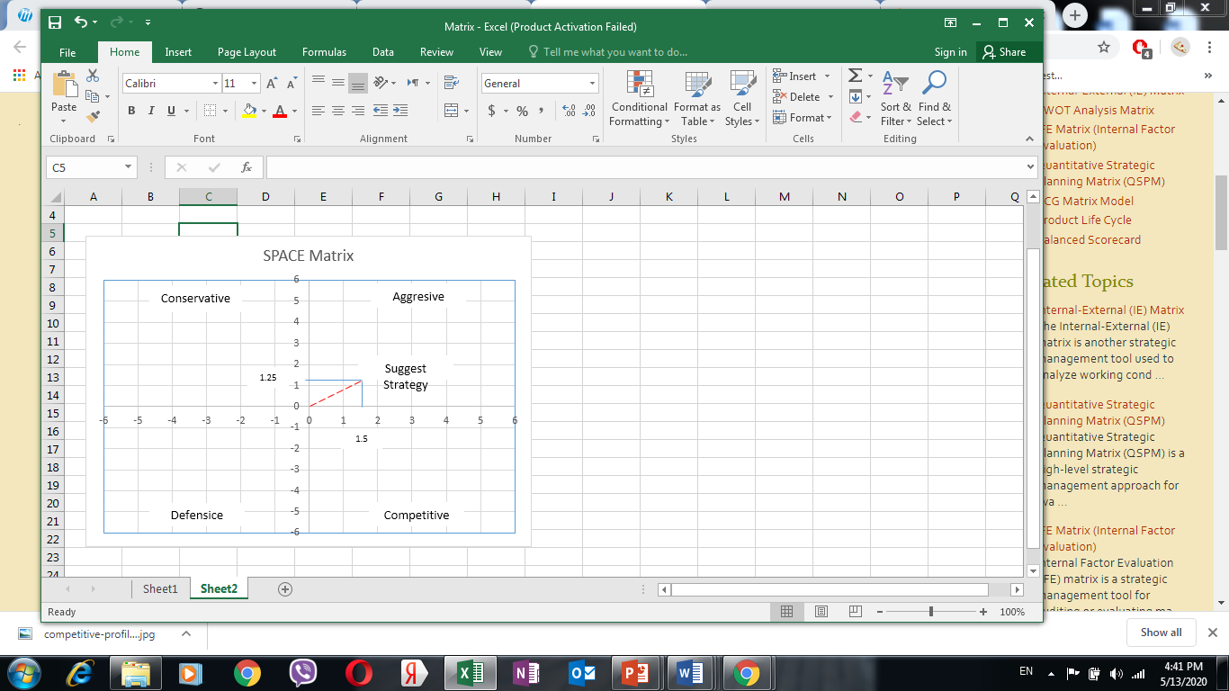

Figure 7

SPACE Matrix of the company shows that Aggressive Strategy has to be used. The company has all the capabilities to gain strong competitive position on the market. It needs to use it’s internal strengths in order to follow the strategies of market penetration and product development.

**IE Matrix**

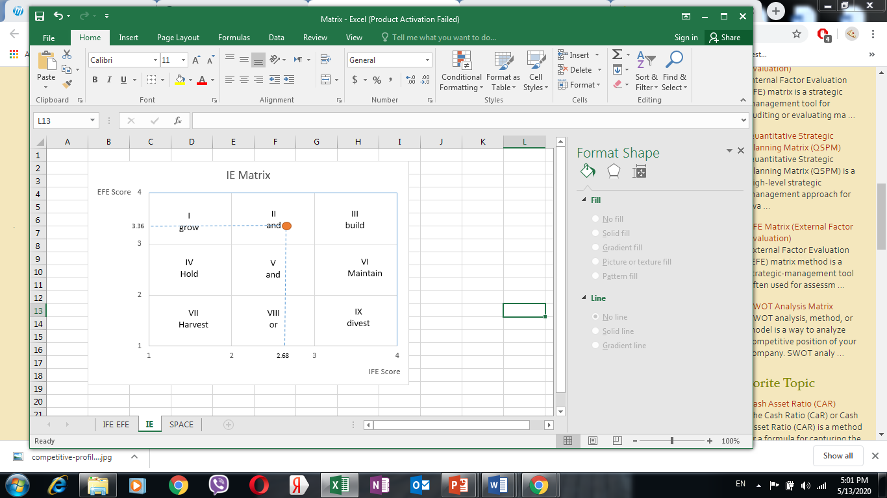

Figure 8

Based on IE matrix we can come to the conclusion that The Company has to follow aggressive strategies that will include market penetration and product development. Most important is to follow the mission and vision and have a unique proposition on the market in combination with superior quality.

1. Specify how your recommendations can be implemented and what results you can expect. What Management, Marketing, Finance/Accounting, R&D and CIS issue, if any you foresee. Your recommendations to address them.

Recommendations on how the suggested strategies can be implemented:

***Cost leadership***:

* Apply minimum delivery fees for food and other items delivery in the delivery radius of 10km.
* Outsource customer care department (to reduce recruitment cost, salaries, accommodation, insurance and office space rental)
* Optimize cost of drivers by reducing the amount of drivers employed directly by the company and have casual drivers working for the company. Use different approach towards drivers recruitment - US delivery companies model – like ubereats, grubhub, postmates, dordash – having drivers delivering part time by taking time blocks and working based on commission.
* Improvement of software used by Customer Care, Operations Department and Drivers in order to maximize productivity and minimize cost of each process.

***Growth Strategy*** - *Product Differentiation* –bringing more shopping malls and stores and focus on become the app where person can buy everything he needs

***Market segmentation*** by Psychographic, Demographic and behavioral differentiation.

* Concentrate marketing efforts on thorough market segmentation in order to create advertising and promotions that will be addressed to each segment separately.
* Marketing team needs to work on creating quality content which will be different from competitors – to advertise the lifestyle rather than product itself.
* Marketing team to concentrate on positioning the app more like e-commerce platform rather than food delivery company

***Joint Venture*** – Higher management to concentrate on seeking Government support as well as to search for local and international investors in order to have sufficient funds to deliver the first SuperApp in MENA region.

***IT strategy*** – keep very strict and constant follow up on improvements done by the team of the developers. Make sure to have developers to fix at least one functional issue that will positively improve the operational process:

* App has to be worked on regularly in order to improve its functionality and convenience for end users
* Operational dashboard has to be changed completely – improvement of drivers tracking and auto-allocation.
* Merchants dashboard has to give sound once order received even if another page is opened.

Certain restrains and complications might occur while implementing the strategies suggested above.

**Management issues:**

Lack of cooperation between managers

Lack of motivation

Employees do not follow or understand the Corporate Culture and Values of The Company

No set control mechanism and performance review tools

***Solutioons***

- As been notices, organizational structure has to be improved and section heads have to be allocated in order to make sure that each section understands its part in achieving long- and short-term objectives of an organization. Management team has to be coached and guided by the CEO.

- Incentives and bonus program has to be in place in order to motivate employees as many are working overtime. Also The Company is developing in high speed and changes are done on weekly basis which implicates fast action from managers and employees.

- Corporate culture and values have to be reviewed by CEO, management and HR team in order to set clear directions for the team as well as engage all the employees to embrace the corporate culture

- Encourage employees to embrace change and adopt new processes. Management team to work closely with employees and monitor their progress as well as do timely evaluation and performance reviews.

- Set strict policies regarding subordination, following the instruction and undeniable cooperation with other departments.

- Clear tasks and targets have to be given to all employees, regular meetings on progress have to be conducted along with discussions on how to improve communication and cooperation in order to increase value each department brings to the company.

- Make sure that strategies in place are linked with organizational culture

- Ensure an effective L&D and performance evaluation process is in place, as well as all the procedures have to be documented as SOPs so everyone follow the same standard.

- Very important to embrace the work-life balance of the employees, follow extra hours and overtime, embrace the culture of reaching excellent performance during working hours and giving employees personal space out of working hours.

**Marketing Issues**

Lack of experience of marketing team

No thorough market analysis conducted

Unclear marketing actions program

Lack of clear set directions

***Solutions***:

- Concentrate on setting major direction of marketing style and company brand image in order to follow it when creating the content.

- Make sure to work on individual approach to every market segment that company is targeting.

- Have team working on different marketing channels in order to enhance company presence on different platforms.

- Monitor the reaction of target audience on the campaigns and promotions to understand what is working best for each target group.

- Do constant analysis and research of new tendencies that international leading companies are following.

**Finance/Accounting**

Weak finance team

Absence of strict control

Lack of financial data analysis

Delays in taking actions

***Solutions***:

- Allocate strong finance manager who will be in control of all accounting procedures as well as being able to set clear financial goals, analyze financial data in order for the management to have clear picture of how the firm is performing financially, what are the perspectives of reaching breakeven point, calculate and analyze all the important financial ratios like ROI, ROA, Profitability etc.

- Make sure to work on Pro Forma financial statements.

- Work on annual budget and forecasts and include changes when necessary I order to follow the expenditure of the company and its costs.

- Implement strict control mechanism to monitor timely payments to merchants, salary payments.

- Work on financial wellbeing and stability of the company in order to attract investors.

**R&D Issues:**

Developers lack experience

Difficulties in setting priorities

Delay in addressing issues

***Solutions***:

Research and Development issues have a direct link with the team of developers.

- Constant software improvement based on The Company operation, suggestions from different teams who are in the field.

- Following recent trends in the industry outside Qatar, appropriation of the findings of world leading and widely acknowledged delivery companies.

1. Recommend procedures for strategy review and evaluation.

Need to recommend procedures only, Need to come up with numbers -

Strategy evaluation is extremely important for The Company. Business environment in Qatar has been changing drastically and many changes has been happening in The Company over past several months.

Strategy evaluation has to be in place during and after strategy implementation in order to tackle any short falls on time and take corrective measures based on them as well as based on dynamic changes in business environment.

*There are two levels of strategy evaluation:*

1st – Strategic Control – whether need to make sure that the strategies chosen are consistent with environment.

2nd – Operational Control – whether the organization is moving towards achieving long-term objectives though the strategy recommended

In order to conduct the strategy review that will reflect real situation, the following tools can be used:

1. BCG matrix in order to see in which quadrant is the company, management will see the progress of The Company growth on the market. It is very important that The Company has increased its market share at least by 10% in one year in order to be one of the leaders in Qatar.

2. EFE matrix – by conducting this analysis after strategies implementation, management will see whether The Company has utilized the opportunities and if there are any new opportunities The Company can cease. Also, it will be clear whether company managed to address successfully the threats and whether the number of threats decreased as a result of new strategies implementation.

If the new score is between 3.5 to 4 – strategy implementation brought positive results.

3. IFE matrix – will give clear picture of whether the company still have same strengths or new strengths appeared. Also, it will be clear whether all weaknesses were addressed and resolved in proper manner and whether there are new weaknesses The Company has and has to address to.

Initially company score was a little bit higher than average. If the new score is above 3 – it means strategy implemented positively affected internal environment of The Company.

4. CPM matrix – will allow to see whether The Company position comparing to the Competitors changed based on critical success factors.

Initially The Company fell behind the two main competitors in the field with the score of 2.65. Strategies implementation can be considered successful only if The Company Score will be 3.2 and above to reach the score of Carriage.

5. PIMS (profit impact of marketing strategy) to be conducted in order to understand whether actions taken by marketing department based on chosen marketing strategies has been efficient and increased the value. The higher the market share is – the higher is profitability or ROI.

It is crucial that control over strategies implementation was very precise and timely. Short- and long-term control has to be in place. Corrective measures have to be taken fast.

Strict and constant financial evaluation has to be conducted in order to see the improvement of profitability and understand when The Company can reach breakeven point and start making profit. Financial control is crucial also because based on financial stability and availability of cash float as well as funds, management will be able to plan corrective measures according to the financial capacities of the Company.

The Company management has to follow below **Strategy Evaluation Framework**:

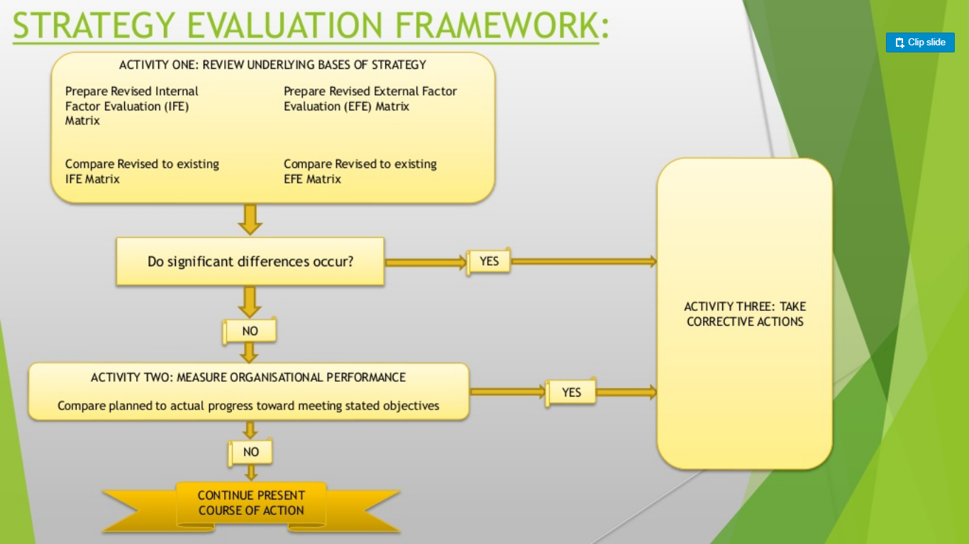

Figure 9 (Ahmed, 2015)

(iEduNote.com, 2019; sites.google.com, 2019; introduction-to-management.com, 2019; docsity.com, 2018).

CONCLUSIONS

As relatively new company and tech start-up, The Company is facing a lot of challenges on daily basis in all the departments.

Above strategies recommendations as well as suggestions of how to tackle various issues will definitely result in taking over significant market share in Qatar market as well as will create supportive environment for the company to go international.

First step to be taken by the company is to reconsider its mission and vision statement in order to be more attractive, precise and reflect future of the company and an impact the company will have on the industry in Qatar and, later, in MENA region.

SWOT analysis showed that The Company has a lot of strengths and opportunities, but, at the same time, its weaknesses are significant and may have negative impact on organizational development as well as make the company more vulnerable to external threats.

PESTEL analysis gave a very clear picture of the external environment The Company is operating in. The environment is extremely dynamic and, on one side, has all prerequisites for The Company development, but on the other side, there are many strong external forces that can be an obstacle for the company to reach it’s long-term objectives.

Strategies suggested for implementation has been thoroughly thought though and external environment and firms internal environment has been considered.

Based on CPM analysis, it was possible to identify the position of The Company in comparison with its competitors and suggestions has been given on what to work on in order to improve the competitive position.

EFE showed where The Company stands externally and how external factors are addressed by the company.

IFE showed internal situation in the company and how efficient company strengths are used in order to work on weakness, use external opportunities and react to external threats.

To sum up, The Company has a lot of advantages and strong points but it’s weakness has significant negative impact. It also showed that a lot of corrective and improvement measures are required in order for the company to have strong competitive advantage.

Long-term objectives has been suggested for The Company. Different types of analysis have been conducted in order to choose the most efficient and forceful to reach those objectives.

* Reach breakeven point by the first quarter of 2021
* Increase market share to 30% by 2022
* Increase share of wallet usage (maximum depression of direct refunds by using wallet)
* Introduce SuperApp by 2022
* Improve customer service ad customers retention
* Fastest delivery of all kinds of products (including non-food items)
* Become leader in supporting home businesses
* Reduce cost by improving technology
* Improve cooperation process with all merchants
* Improve employee retention and talents development in order to build high-performing team
* Enhance corporate culture and work satisfaction
* Become a leading e-commerce company in Qatar
* Take The Company public

Above long-term objectives have been suggested for The Company to pursue and based on the numerous analysis tools, below strategies has been suggested:

Cost Leadership – this strategy has been suggested due to availability of numerous competitors on the market with strong position on the market and significant market share.

Growth strategy – product development – this strategy has been suggested in order to take leadership position and because this strategy is the only way to obtain our objective of being one of the leaders on the market and supporting home business. Those can only been achieved by having unique proposition that distinguish The Company from Its competitors.

Market segmentation – has been suggested in order to support growth strategy and find unique approach to address each target group. This strategy has been suggested also because recent tendencies showed that unique marketing is one of the most effective tools in creating recognizable brand and in attracting wider audience.

IT strategy – as a tech start up The Company has a lot of technical issues in various departments. This strategy will allow the company to strengthen it’s technical capacity and support the Growth strategy by supporting diversity of services with strong technical platform.

Recommendation section gives detailed instructions and suggestions of actions to be taken in order to implement above strategies. A lot of issues has been analyzed as well – management, financial, marketing and R&D and effective suggestions on how to tackle them has been given.

To sum up, The Company has very big potential of becoming the leader and offer unique value to customers. However, ground changes and improvements have to be done:

* Organizational structure has to be revised to be more efficient to implement the strategies
* Corporate culture and values has to be enforced
* Employees training, development and evaluation is crucial at this point
* Management team has to work hard and be more organized in order to conduct regular strategy implementation evaluation
* Finance department has to undergo ground changes starting from employing strong manager
* Marketing team has to increase their efforts and start with conducting very detailed market research and segmentation in order to have unique advertisement and company positioning.

REFERENCE LIST

1. Ahmed, T. (2015). *Strategy Evaluation*. [online] Slideshare.net. Available at: https://www.slideshare.net/taher666/strategy-evaluation-48194660/[Accessed 22 April 2020].
2. Arjun Kharpal (2019). *Everything you need to know about WeChat — China’s billion-user messaging app*. [online] CNBC. Available at: https://www.cnbc.com/2019/02/04/what-is-wechat-china-biggest-messaging-app.html/[Accessed 9 May 2020].
3. CGMA. (2013). *Porter’s Five Forces of Competitive Position Analysis*. [online] Available at: https://www.cgma.org/resources/tools/essential-tools/porters-five-forces.html/[Accessed 6 May 2020].
4. Chron.com. (2019). *Importance of Mission Vision in Organizational Strategy*. [online] Available at: <https://smallbusiness.chron.com/importance-mission-vision-organizational-strategy-16000.html>/[Accessed 28 April 2020].
5. Cox, I. (2016). *Developing the right IT strategy - How to support business strategy with technology*. [online] CIO. Available at: https://www.cio.com/article/3526736/developing-the-right-it-strategy-how-to-support-business-strategy-with-technology.html/[Accessed 23 April 2020].
6. Craig, W. (n.d.). *The Importance Of Having A Mission-Driven Company*. [online] Forbes. Available at: https://www.forbes.com/sites/williamcraig/2018/05/15/the-importance-of-having-a-mission-driven-company/#3d0d12123a9c/[Accessed 9 May 2020].
7. docsity.com. (2018). *Strategic Evaluation and Control - Docsity*. [online] Available at: https://www.docsity.com/en/strategic-evaluation-and-control/810449/[Accessed 8 May 2020].
8. Frue, K. (2016). *The Advantages of PESTLE Analysis*. [online] PESTLE Analysis. Available at: https://pestleanalysis.com/advantages-of-pestle-analysis/[Accessed 3 May 2020].
9. HR Daily Advisor. (2014). *Strategy, Mission, and Vision: How Do They All Fit Together?* [online] Available at: <https://hrdailyadvisor.blr.com/2014/09/09/strategy-mission-and-vision-how-do-they-all-fit-together/>[Accessed 20 April 2020].
10. iEduNote.com. (2019). *Strategy Evaluation: Necessity, Requirements, Strategy Evaluation Framework*. [online] Available at: https://www.iedunote.com/strategy-evaluation/[Accessed 29 April 2020].
11. Insights - Web and Mobile Development Services and Solutions. (2019). *Top 10 Successful Online Food Delivery Apps in the World*. [online] Available at: <https://www.netsolutions.com/insights/top-10-successful-food-delivery-apps-in-the-world/>[Accessed 5 May 2020].
12. introduction-to-management.24xls.com. (2019). *Strategic Management :: Strategy Evaluation And Control*. [online] Available at: https://introduction-to-management.24xls.com/de224/[Accessed 7 May 2020].
13. James Tallant (Author (2015). *GRIN - Importance of Vision, Mission, and Values in Strategic Direction*. [online] Grin.com. Available at: <https://www.grin.com/document/167258>/[Accessed 7 May 2020].
14. Keating, E. (2018). *21 innovative growth strategies used by top growth teams*. [online] www.appcues.com. Available at: https://www.appcues.com/blog/growth-strategies/[Accessed 4 May 2020].
15. Kie, C. (2019). *STRATEGIC MANAGEMENT Lesson 3: EFE & CPM Matrix*. [online] Available at: http://ocw.ump.edu.my/pluginfile.php/7019/mod_resource/content/1/Lesson%203%20-%20EFE%20%20CPM%20Matrix.pdf /[Accessed 3 May 2020].
16. Kirkpatrick, N. (2017). *The Difference Between Vision And Mission | BetterHelp*. [online] Betterhelp.com. Available at: <https://www.betterhelp.com/advice/general/the-difference-between-vision-and-mission/>[Accessed 1 May 2020].
17. Ltd, O.I.S.P. (2019). *Things to Consider While Opting for Food delivery app Development*. [online] Medium. Available at: https://smallbusinessforum.co/things-to-consider-while-opting-for-food-delivery-app-development-86de6d9774eb/[Accessed 30 April 2020].
18. ManagementMania (2012). *EFE Matrix*. [online] ManagementMania.com. Available at: https://managementmania.com/en/efe-matrix/[Accessed 4 May 2020].
19. Managementstudyguide.com. (2015). *Strategic Management: Importance of Vision and Mission Statements*. [online] Available at: <https://www.managementstudyguide.com/importance-of-vision-and-mission-statements.htm>/[Accessed 5 May 2020].
20. Maxi-Pedia.com (2017). *EFE Matrix (External Factor Evaluation)*. [online] Maxi-pedia.com. Available at: <http://www.maxi-pedia.com/EFE+matrix+external>/[Accessed 8 May 2020].
21. Maxi-Pedia.com (2017). *IFE Matrix (Internal Factor Evaluation)*. [online] Maxi-pedia.com. Available at: <http://www.maxi-pedia.com/IFE+EFE+matrix+internal+factor+evaluation>/[Accessed 8 May 2020].
22. Mindtools.com. (2009). *Porter’s Five ForcesUnderstanding Competitive Forces to Maximize Profitability*. [online] Available at: https://www.mindtools.com/pages/article/newTMC_08.htm/[Accessed 28 April 2020].
23. Ovidijus Jurevicius (2013). *What happens when you don’t analyze your competitors?* [online] Strategic Management Insight. Available at: https://strategicmanagementinsight.com/tools/competitive-profile-matrix-cpm.html/[Accessed 26 April 2020].
24. Oxford College of Marketing Blog. (2018). *What is a PESTEL analysis? - Oxford College of Marketing Blog*. [online] Available at: https://blog.oxfordcollegeofmarketing.com/2016/06/30/pestel-analysis/[Accessed 20 Aplri 2020].
25. Paul Clayton Smith (2017). *How We Design on the UberEATS Team*. [online] Medium. Available at: <https://medium.com/uber-design/how-we-design-on-the-ubereats-team-ff7c41fffb76>/[Accessed 4 May 2020].
26. Sapra, B. (2019). *This Chinese super-app is Apple’s biggest threat in China and could be a blueprint for Facebook’s future. Here’s what it’s like to use WeChat, which helps a billion users order food and hail rides.* [online] Business Insider. Available at: https://www.businessinsider.com/chinese-superapp-wechat-best-feature-walkthrough-2019-12/[Accessed 5 May 2020].
27. sites.google.com. (2019). *13. STRATEGY EVALUATION AND CONTROL - CEMBA KNUST 2009*. [online] Available at: https://sites.google.com/site/cembaknust2009/home/cemba-2-sem1/strategic/12/[Accessed 5 May 2020].
28. smallbusiness.chron.com. (2018). *What Does the CPM Matrix Do?* [online] Available at: https://smallbusiness.chron.com/cpm-matrix-do-67032.html/[Accessed 20 April 2020]
29. Sridharan, M. (2019). *Competitive Profile Matrix (CPM): A tool for rivals analysis*. [online] Think Insights. Available at: <https://thinkinsights.net/strategy/competitive-profile-matrix/>[Accessed 19 April 2020].
30. strategic-management. (2017). *CPM & EFE MATRIX*. [online] Available at: https://mariagova.wixsite.com/strategic-management/blank-uf8eu [Accessed 3 May 2020].
31. StuDocu. (2018). *IFE Matrix - Project Management*. [online] Available at: https://www.studocu.com/en-gb/document/pokhara-vishwavidalaya/project-management/lecture-notes/ife-matrix/3643096/view [Accessed 18 April 2020].
32. ukessays.com. (2018). *Importance of Vision and Mission Statement*. [online] Available at: https://www.ukessays.com/essays/business/vision-and-mission-statement.php [Accessed 18 AprilMay 2020].
33. wmkagency.com. (2017). *The Importance of a Strong Business Mission and Vision*. [online] Available at: https://wmkagency.com/blog/the-importance-of-a-strong-business-mission-and-vision [Accessed 3 May 2020].
34. Wright, T. (2019). *The 6 Best Business Strategies I’ve Ever Seen*. [online] Executestrategy.net. Available at: <https://www.executestrategy.net/blog/the-5-best-business-strategies-ive-ever-seen>/[Accessed 1 May 2020].
35. Yesbeck, J. (2019). *4 Types of Market Segmentation With Examples*. [online] Alexa Blog. Available at: https://blog.alexa.com/types-of-market-segmentation/[Accessed 1 May 2020].