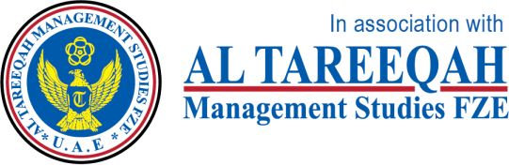

**MARKETING MANGEMENT**

**SBS MBA/MSc**

**Assignment – Bahrain 2020**

|  |  |  |  |  |  |
| --- | --- | --- | --- | --- | --- |
| STUDENT ID | 1 | 0 | 9 | 4 | 0 |

UNIT TITLE / CODE: MKT 501

NAME (in Full): Taghreed Abdullah AL-Qatari

**Table of Contents**

**Executive Summary** 3

**Almarai Overview** 3

**Competition Definition (Comparison Between Almarai & Nadec)** 6

**Target Market of Almarai** 7

**Almarai Market Segmentation** 9

**Almarai SWOT Analysis** 10

**4 p's of Almarai** 13

**Conclusion** 18

**Recommendations** 18

**Appendix** 19

**References** 22

# **Executive Summary**

A marketing strategy relates to a work's overall game scheme to extent view consumers and flexure them into customers of the products or benefits the business stipulates. A marketing strategy holds the corporation’s worth statement, key kind messaging, data on target consumer demographics, and other great-stage elements. (Kotler, 2012)

A carefully-artificial marketing strategy should be primarily fixed in a corporation’s importance declaration, which recapitulates the competitive advantage a corporation sustains over emulator businesses. For instance, Walmart is extensively given as a deduction retailer with “everyday low prices,” whose transaction trading operations and marketing efforts return around that conception.

Whether it's a print ad project, mass customization, or a social media crusade, a marketing asset can be umpire supported on how powerfully it reveals a corporation's assemblage worth statement. Market research can be useful in tabulating the potency of a granted movement and can serve to recognize untapped audiences, in arrangement to fulfill bottom-direction goals and extend sales.

Almarai Company is a Saudi company that applies a wonderful and effective marketing strategy in all branches of the company in a large way, and we will study in this research many issues related to the marketing strategy of Almarai Company in detail, such as a summary about Almarai Company, touching on the concept of competition and comparing it with Nadec, which is a Strong competitor for Almarai, then talk about the marketing mix that includes the SWOT Analysis as well as the 4ps' for Almarai. At the end of the research, some conclusions and recommendations are drawn in order to increase the efficiency of the company's work significantly.

# **Almarai Overview**

They have earned the faith of consumers through their constant commitment to the profession.

Almarai is the Middle East’s guiding food and potation manufacturer and distributor – and the globe biggest perpendicularly incorporates the dairy corporation. Since their basis in 1977, consumers across the station have coming to recognize the Almarai grade as interchangeable with the profession. Every day, they exist and product by the axiom: ‘Quality you can expect.’ (Baker, 2014)

A professional civilization lives throughout the Company. It starts with strategic determination-manufacture by the Board of Directors and superior control, enlarges across their farming, manufacturing, and disposal trading operations and is complete to the growth of their employees’ professional ability. They have likewise supercilious expectations of their suppliers and vendors and practice exact profession restraint measurement across their attainment activities. (Almarai, 2020)

* **Almarai life cycle**

With HQ in Riyadh, Saudi Arabia, they are sprightly in five categories across the Middle East and North Africa (MENA) place: Dairy, Juice, Bakery, Poultry, and Infant Nutrition. In Egypt and Jordan, they work through their connect hazard International Dairy & Juice (IDJ) for Dairy and Juice Products. In augmentation to their principal Bakery section, L’usine products, they work through their connect hazard, Modern Food Industries (MFI), for 7Days products. (Almarai, 2020)

Almarai is the Middle East’s biggest food and drinkable manufacturer and distributor. Their mission is to contribute to the exalted profession, nourishing food, and beverages that instruct consumers alive every day. Focused on quality, they are the consumer’s elect precious for higher products that congregate their necessarily. They sustain market chieftaincy across their assemblage production categories by hold consumer insights and through their appropriation to commit supercilious quality products and services.

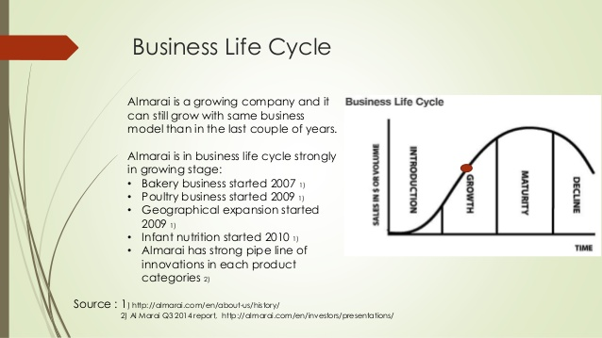

* **Almarai Vision**

To afford peculiarity and alimental food & beverages that adorn consumers’ lives every day. (Almarai, 2020)

* **Almarai Mission:**

To be the consumers’ advanced election by guiding in preferred markets with higher food & drinkable products. (Almarai, 2020)

* **Almarai Values**

1. **Adaptable**

They are quick and manageable in their performance, positively attracting brave decisions that help their stakeholders.

1. **Sharing**

They performed together as one, publicly cooperate and allotment expertness & cognition to empower their followers to be the elite. (Almarai, 2020)

1. **Passionate**

They are haughty of the performance they do and aim for superior termination.

1. **Innovative**

They are driven to mend their profession workaday and to increase the creative efficacious of their people. (Almarai, 2020)

1. **Respect**

They obtain honor by inclosing fairness, faith, and honesty in all their relationships.

1. **Excellence**

They are laborious in their performance and consistently commit the most attribute in everything they do. (Almarai, 2020)

* **Chief Executive Officer – CEO**

Majed Nofal concorporate Almarai in 2010 and was ordained as CEO in January 2020. Before this Majed held a scalar of the station within the Almarai assembly hold Deputy CEO, VP New Businesses, Head of Central Procurement, CEO, and CFO of Western Bakeries Co.

Before associate Almarai, Majed held mail within Audit and Assurance benefit at Ernst & Young. (Almarai, 2020)

He has a Bachelor of Arts in Business Administration from King Saud University (KSA).

# **Competition Definition (Comparison Between Almarai & Nadec)**

Competition is a reality of doing trade. Businesses see competition in the formula of cost, profession, sketch, sales, situation, and almost every profession procedure.

Many people regret touching it, many learn from it, and many run away from it. But most don’t recognize the correct aim of trade competition, its character, style, and even significance.

Competition in trade is the argument or emulation among the corporation selling homogenous products and/or aim the same target spectators to get more sales, extension income, and convenient more market share as acquire to others. (Graham, 2008)

**Almarai Company is one of the first Arab and local companies that excelled in the food industries, as its industry expanded to include various products, and with the increase of its industries and products, it found many competitors in the market and among these competitors is the Saudi Nadec Company, so they will make a comparison between Nadec and Almarai in the following table:**

**(Almarai, 2020) (Nadec, 2020)**

|  |  |
| --- | --- |
| Almarai | Nadec |
| Almarai Company shares in the making and commerce of dairy, juice, bakery, poultry, and nutrition products. It works through distinct kinds such as Almarai, Alyoum, L’usine, 7Days, and Nuralac but Almarai is the principal kind in Almarai Company. Each kind concentrate on exhibits a precise outcome. Thus, Almarai manufacture dairy and juice products under Almarai, bakery products under the kind L’usine and 7 Days, fowl products under the Alyoum brand, and Baby nutritious products under Nuralac kind. | The National Agricultural Development Company (NADEC) is one of the biggest praedial and food-procedure share stock corporation in the Middle East and North Africa. Established in 1981 by imperial ordain, it is a connect stock public corporation – 20% owned by the Government, with the arrest openly practiced on the Saudi Stock Exchange. It is one of the very few and biggest perpendicularly incorporated dairy businesses around the globe.  NADEC stipulates the tastiest, finest, and healthiest nutritional products through two essential businesses – NADEC Foods for consumer products and NADEC Agriculture for praedial gain. |

# **Target Market of Almarai**

After separating the huge variegated customer market into smaller assembly with similar characteristics, Almarai Company Milk and Modernization in the Kingdom of Saudi Arabia should judiciously select the target segment/segments whose indispensably and expectations suit the association’s expedient and capabilities. (Leonard, 1992)

The goal can be done by appraising the mercurial winsomeness and growth influential of recognized segments. Almarai Company Milk and Modernization in the Kingdom of Saudi Arabia can select one or more segments to rely on the segments’ characteristics and the association's means, capabilities, and advancement objectives. (Leonard, 1992)

The mercantile and growth efficacious of each segment can be appraised by using the following indicators:

* Identified segments have a suitable size
* Have composite differences.
* The estimated benefit should outvie extra marketing costs.
* Segments are readily approachable.

After segmenting the customer market and elect the direct target market, Almarai Company Milk and Modernization in the Kingdom of Saudi Arabia now demand to determine an obvious positioning recital that could constitute a positive image of the immolate product in the customers' opinion. Almarai Company Milk and Modernization in the Kingdom of Saudi Arabia can go after the following track to evolve an efficient condition strategy:

* Develop the positioning statement for Almarai Company Milk and Modernization in the Kingdom of Saudi Arabia Marketing Strategy by answering the sequent questions: (Leonard, 1992)
* What your kind stands for?
* What are the indispensably and wants of your target market?
* How your kind succor those indispensably?
* How distinct is your proffering from competitors?
* Answers to these questions will afford enough instruction to evolve a posture recital. (Leonard, 1992)
* The illustration of their connection and messaging strategy with competitors will discover the influential areas that could be addressed with targeted attitude communication.
* Identify the strengths/weaknesses of a trade by comparing with competitors to find that gaps that propose product can fill. (Leonard, 1992)
* Analyze the proposition of competitors and appraise their own posture in the market.
* By using the separative data composed from a separate market, customer and competitor surveys, develop a positioning statement and periodically test its efficaciousness by accumulate qualitative and quantitative data (like concentrate assembly, polls, interviews, etc.) (Leonard, 1992)

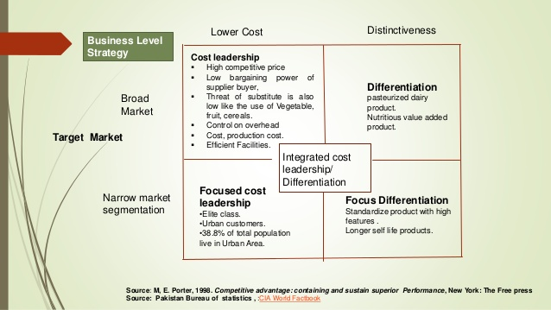

# **Almarai Market Segmentation**

The elaboration of Almarai Company Milk and Modernization in the Kingdom of Saudi Arabia Marketing Strategy need distinguishing segmentation base to explain the precise buying behavior of customers. The indispensably, expectations and buying behavior of customers are dissimilar and rely on multifaceted elements- as (Schlegelmilch, 2016)

* Age
* Gender
* Income
* Lifestyle
* Values etc. (Schlegelmilch, 2016)

By using the division technique, Almarai Company Milk and Modernization in the Kingdom of Saudi Arabia can close down the huge, variegated target spectators into precise and closely explain assembly. Market segmentation examine are usual methods of obtaining the customer-precise instruction that could be used to constitute assembly sharing usual characteristics. (Schlegelmilch, 2016)

After knowing the one of a kind purchasing behavior of customers and acquisition the order instruction through surveys, Almarai Company Milk and Modernization in the Kingdom of Saudi Arabia can divide the market into small like assembly. It can be done by exploring the geographic, demographic, behavioral, and psychographic characteristics of customers.

The association can utilize one or more of these segmentation strategies to elect the correct market segments and develop an efficient Marketing Strategy. (Schlegelmilch, 2016)

* The geographic segmentation disunites the market correspondingly to geographic areas, like- city, country, and region.
* The demographic segmentation will ask Almarai Company Milk and Modernization in the Kingdom of Saudi Arabia to divide the market correspondingly to demographic characteristics, like- gender, age, income, and ethnicity.
* If Almarai Company Milk and Modernization in the Kingdom of Saudi Arabia elect behavioral division, then customers will be distributed correspondingly to their buying design like usage crowd, advantage sought to conduct opportunity, and grade fealty.
* The use of psychographic segmentation will arise in customers' grouping correspondingly to their lifestyles, benefits, attitudes, values, and traits.

Almarai Company Milk and Modernization in the Kingdom of Saudi Arabia can confederate the distinct segmentation strategies for more precise targeting as expound in the next part. (Schlegelmilch, 2016)

**-To know more about the segmentation, we need to discuss the competitive advantage of Almarai company, for more information see appendiex1.**

# **Almarai SWOT Analysis**

Almarai Company Milk and Modernization in the Kingdom of Saudi Arabia SWOT analysis incline down the strengths, weaknesses, opportunities, and threats to any organization, but does not inform administration what can be done by these. To conquer this restriction and serve to evolve strategies that are peculiar, progressive SWOT analysis or TOWS matrix is a necessity. This lists down the Strengths-Opportunities (SO) strategies that cover using strengths to take benefit of opportunities. It lists the Strengths-Threats (ST) strategies that entwine using strengths to strive for threats. It entangles the Weaknesses-Opportunities strategies that entangle appropriate weaknesses to strengths by using opportunities. Lastly, Weakness-Threats (WT) strategies complicate conquering weaknesses to eschew threats. (Rauch, 2007)

|  |  |
| --- | --- |
| STRENGTHS   * Almarai Company Milk and Modernization in the Kingdom of Saudi Arabia has a Strong Distribution reticulation with a huge number of outlets. * It has a low-cost construction, which affords it with a benefit over the rivalry. * It has a strong financial station with actual profits describe in the past few years. It also has a valid asset foundation. * It has an expert labor force that is highly adapted, innovative, and variegated. * It has a valid presence on social media. | WEAKNESSES   * A high rate of characteristic in use by Almarai Company Milk and Modernization in the Kingdom of Saudi Arabia is on rupture, and rental accuse needs to be paid. * Low ascend of expenditure on examination and elaboration as compared to the rivalry. * It has a high employee turnover scold, with low employee need and practical spirit. * It has fusion problems with a low rapid ratio; the flat of current assets is less than current liabilities. It also faces cash flow problems. |
| OPPORTUNITIES   * Internet users are growing(prenominal) around the globe. E-commerce is also developed with the growth in internet methods. * Social media users are growing universal. * Household proceeds are growing and so is the consumer expenditure. Inflation in the economy is anticipated to stay low. * Growth in environmentally favorable products and services. The government is proffering subsidies on these. * Interest rates are moderate, which supply an investment chance for the huge plans. | **THREATS**   * There is a threat of modern entrants' advent into the market. * The interchange rate has been devalued. * Fuel cost has risen in new year's making inputs costly. * Competition within the assiduity is growing. * More exchange products are now valid. |

* **SO. Strategies**

Increase marketing to invite consumers to consume (S1, S3, O3).

Use its presence on social media for marketing and to influence customers towards its website (S5, O2, O3). (Rauch, 2007)

Develop environmentally favorable products through eulogization, at a low cost so that they could be solitary at a low cost (S2, S4, O4). For more information see appendix 4.

Market products at low cost by sacrifice discounts. This would serve to grow sales in volumes and is practicable due to low expansion and cost (S2, O3). (Rauch, 2007)

* **WO. Strategies**

Finance possession of the attribute through low interest scold to grow the symmetry of owned attribute to the rented characteristic (W1, O5). (Rauch, 2007)

Increase payrolls, supply a simulative packet, and advantage to employees to lower turnover and mend business morale. This could be practicable as costs are low currently. (W3, O3).

* **ST. Strategies**

Use a valid apportionment network to gain out to customers and strive off recent entrants into the market (S1, T1). (Dyson, 2004)

Use its valid financial station to dress in intellectual propriety suitable. This would assist strive with growing rivalry in the market (S3, T4).

Use its innovative teams to find cheaper alternatives to fuel so that these could be conducted, thereby reducing costs (S4, O3). (Dyson, 2004)

* **WT. Strategies**

Increase expenditure on examination and evolution to empower Almarai Company Milk and Modernization in the Kingdom of Saudi Arabia to improve content with rivalry (W2, T4). (Dyson, 2004)

Provide incentives, enhance employment, or supply a reform work surrounding to hold genius. This will ensure that employees don’t leave and connect competitors (W3, T4).

**-There are some limitations that facing SWOT analysis in Almarai, for more details see Appendix 2.**

# **4 p's of Almarai**

* **product**

This Marketing Strategy constitutes ruminate the explanation to the customers’ indispensably. Almarai Company Milk and Modernization in the Kingdom of Saudi Arabia should evolve one of a kind outcome plans, names, and characteristic to pause out in the competitive market. The following elements should be examined to evolve the outcome strategy- peculiarity, diversity, characteristic, packaging, kind name, and increase benefits.

Almarai Company Milk and Modernization in the Kingdom of Saudi Arabia should continuously appraise its performance line by charged its growth efficacious and share in the market. The products can be categorized into the categories: (Khan, 2014)

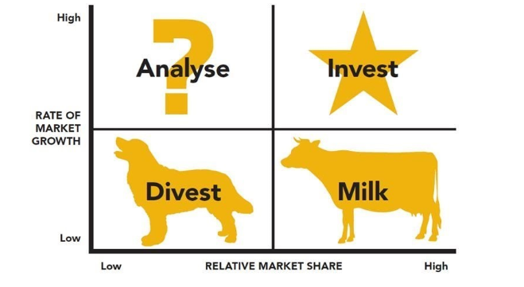

* The products with high advancement and high market share are categorized as stars. Almarai Company Milk and Modernization in the Kingdom of Saudi Arabia should grow the investment after distinguishing the stars in its outcome lines.
* Products with supercilious market growth but low share are categorized as question marks. Almarai Company Milk and Modernization in the Kingdom of Saudi Arabia should analyze why market share is low malignity the high growth ratio.
* Products with low growth but high market share are cash cows that want to be milked for protracted kind accomplishment in the market with low growth and restricted opportunities.
* Lastly, products with low growth and low market share are dogs’ Almarai Company Milk, and Modernization in the Kingdom of Saudi Arabia should deprive as it is hard to companion benefit and get a sufficient response by investing in dogs.

The supercilious number of stars and cash cows will discover useful work, whereas, a high number of question marks and dogs will be a reason of interest for Almarai Company Milk and Modernization in the Kingdom of Saudi Arabia. The outcome assortment is inevitable for appraise the success of the Marketing Strategy of Almarai Company Milk and Modernization in the Kingdom of Saudi Arabia. (Khan, 2014)

* **price**

This Marketing Strategy rudiments need an appraisement of the esteem of products for targeted customers. The reward strategy of the Almarai Company Milk and Modernization in the Kingdom of Saudi Arabia will concentrate on congelation the list cost, credit terms, payment period, and deduction.

If Almarai Company Milk and Modernization in the Kingdom of Saudi Arabia determine to elect the cost acuteness strategy, it will have to put a lower cost than competitors. The corporation will be capable to reach market share supported on the discounted reward. However, guidance should be apprised of the efficacious retortion from competitors in the configuration of an undesired cost war. (Khan, 2014)

The election of the skimming strategy will demand visible correspondence of differentiation basis and how such differentiation vindicates the additional price.

Today's customers are not interested in skillful the ‘price' but a whole cost involved in attain, overwhelming, and fit of the product. (Khan, 2014)

* **place**

This Marketing Strategy rudiments need Almarai Company Milk and Modernization in the Kingdom of Saudi Arabia to constitute some essential decisions when developing its classification plan. It should determine: (Khan, 2014)

* Whether the corporation wants to constrain the product effectual to the targeted customer section through its channels, or it indispensable an apportionment participator to assist the customers' needs.
* Whether the apportionments will be direct (involving no middlemen) or squint. If squint apportionments strategy is adopted, the number of middlemen must be choice (wholesalers, retailers, etc.) (Khan, 2014)
* Whether it is interested in: old-fashioned clinker and mortar apportionments network, online apportionments, or an alliance of both. Certain online retailers like Amazon are effectual if online apportionment strategy is preferential. The corporation can also evolve its online website to sell the product. (Khan, 2014)

Modern customers give high significance to the ‘commodiousness’ and ‘easy accessibility’. The quotation of ‘suitable’ apportionment channels will need Almarai Company Milk and Modernization in.

* Firstly, examine the performance characteristics. Involving different middlemen to divide destructible products will not be a knowing conclusion if the product is decomposable.
* Analyze the market dynamics, customers' preferences, and own means and capabilities. If customers site high significance to personalized services and advanced store from old-fashioned shops rather than online channels and constant also has enough means to open their outlets than apportionment strategy should be put correspondingly. (Khan, 2014)
* The competitors’ apportionment strategies also want to be planned. An extensive cost-advantage analysis of each channel and illustration with its own means and capabilities will serve Almarai Company Milk and Modernization in the Kingdom of Saudi Arabia to evolve an efficient apportionment scheme.
* **promotion**

Almarai Company Milk and Modernization in the Kingdom of Saudi Arabia can blend above and below the line promotional strategies to achieve its marketing objectives. The above direction advancement selection for Almarai Company Milk and Modernization in the Kingdom of Saudi Arabia are- television, radio, and print ad. Below the direction advancement selection is- schedule, tradeshows, and straight mail movement. (Khan, 2014)

The promotional project of Almarai Company Milk and Modernization in the Kingdom of Saudi Arabia Marketing Strategy needs the corporation to examine the following elements:

* Start with clearly explain your unequaled selling statement and interpret why customers necessity the outcome and how it is distinct from effectual alternatives.
* Craft the letter capacity and appraise how the guild letter will serve customers in composed an obvious show of the immolate outcome. Consider the AIDA (cognizance, interest, entreat, operation) when developing the letter.
* The promotional strategies like straight selling or supercilious outline ad will befit if the corporation wants to tease the performance. However, the pull strategy will need the evolution of a juggling kind picture that could influence the customers towards the sacrifice outcome.
* Collect the sequent target market instruction- who will buy the product? (Age, engender, salary and sociable condition), what is cost sensitivity flat? And what are customers require correspondence modes? Incorporate this enlightenment into the promotional scheme. (Khan, 2014)
* Filter out the promotional preference supported on the above instruction and guidance a price-profit analysis of choosing promotional alternatives. (Khan, 2014)
* For instance, the choice of TV ad as a promotional tactic will permit the corporation to slice the assemble market, advance kind knowingness, and kind withdraw. However, it is an extravagant promotional tactic and befits if the corporation has sufficient means effectual for the promotional efforts.
* The inferiority of social media marketing has leavened significantly during the last few years. The use of these promotional tactics will empower Almarai Company Milk and Modernization in the Kingdom of Saudi Arabia to gain the bulk market economically. It will also sacrifice a chance to energetically interlude with customers, evolve a personalized relationship, and conduct e-WOM to get more effect. However, the danger of ungovernable denying e-WOM abides there.
* Lastly, examine the accumulation constraints and apportion accumulation to select promotional strategies correspondingly to their character, significance, and crowd. (Khan, 2014)

**-We need to have more information about brand equity development for a clear explanation of 4ps' of Almarai co., so for more details about it see appendix 3.**

# **Conclusion**

Almarai concentrates on extended advance and variegation of their oblation across existing categories. To realize this, they chase an exact procedure of examination, growth, and peculiarity certainty. Their consumers can thus be certain that their Dairy, Juice, Bakery, Poultry, and Infant Nutrition products have been understanding and improved to join their precise indispensably.

Vertical integration needs Almarai’s restrictive profession standards to be met or exceed at every station. First-set ingredients are sourced from around the globe before exceeding through business guiding manufacturing facilities in Saudi Arabia, Egypt, and Jordan. They signify 1.5 million tons of animals satisfy yearly, a growing scale of which is supplied from their own plowable agriculture property around the globe. These are concert correspondingly to international prime manner principles, betroth that their dairy and fowl farms waste only the maximum peculiarity feed.

Almarai attached to the progressive advancement of their presence in existent categories – and enlarging their gain across the place. In 2016 they extended to enlarge sales across assemblage categories and through their concerted venture, IDJ (International Dairy & Juice), in Egypt and Jordan. The enlargement of their geographic prick since listing on Tadawul in 2005 has diminished their confidence in sales in the Saudi market, while outcome modification has diminished reliance on their Dairy sift. Innovation and ability cheap will propagate stronger cash flow and reprove Working Capital administration to assist Capital Expenditure for coming advancement.

# **Recommendations**

* Share in the growth of recent strategic scheme and appraise proposals from executive administration for such scheme, hold practicable mergers or acquisitions, and cause recommendations to the provision.
* Review corporation achievement at each executive guardian assembling and assess accomplishment against targets, dissect and require inquiries about the fundamental elements, trends, and greater developments, and assess achievement against management correspondingly.
* Review, appraise and require recommendations to the board on the approbation of yearly accumulation.
* stipulate advice to the board on the settings of dividends, taking into account any recommendations made.
* Carry out precise from the board of directors.

# **Appendix**

1. **Competitive Advantage**

Following the plan explain how Almarai Company Milk and Modernization in the Kingdom of Saudi Arabia can evolve an efficient Marketing Strategy by appraising its means and capabilities, distinguishing characteristic competencies and hold those competencies by adopting either price or differentiation orientation:

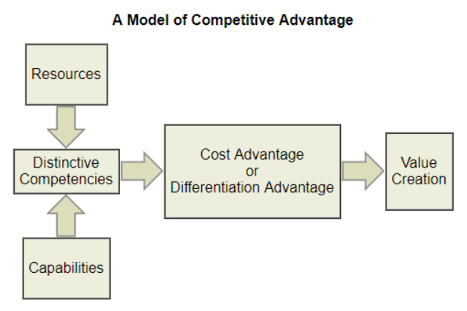

1. **Limitations of SWOT analysis**

* Its greater restriction is the circumstance that there can be a ride of strengths and imbecility, with a weak element being both a strength and a weakness. For instance, a huge number of outlets can be a strength in a development economy or a weakness if the economy is going through withdrawal.
* The matrix is not a termination as it does not show how to realize the objectives. It should be used as a starting point to make strategic decisions.
* The assessment done through a SWOT analysis is a stable one and does not take into examination the diversify that take the site in the competitive surrounding.
* The element enrolled down in a SWOT analysis may be emphasized by the corporation.
* There are stated interrelationships between the inward and outward element that the SWOT Matrix inspect.

1. **Brand Equity Development**

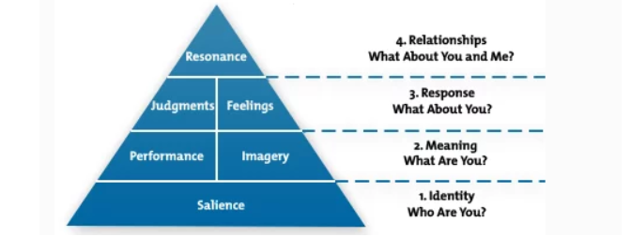

In publicity of Keller kind equity model (shared above), the Almarai Company Milk and Modernization in the Kingdom of Saudi Arabia can take the subsequent action to evolve the kind equity:

* Develop the kind sameness by construction kind leaping/cognizance.
* Identify and reveal the signification of Almarai Company Milk and Modernization in the Kingdom of Saudi Arabia kind. How it succors to the customers’ tactile needs (accomplishment) and sensational/psychological needs (imitation).
* Evaluate the customers’ feelings and judgments of Almarai Company Milk and Modernization in the Kingdom of Saudi Arabia kind to assess their response.
* Lastly, concentrate on edifice- behavioral allegiance, recognition of community, attitudinal affection, and active employment to evolve kind roar that befits on pyramid top.

1. **Growth opportunities for Almarai**

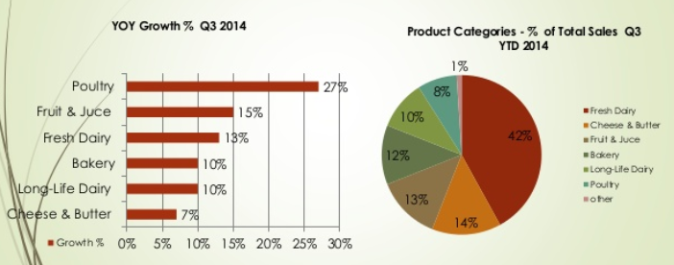

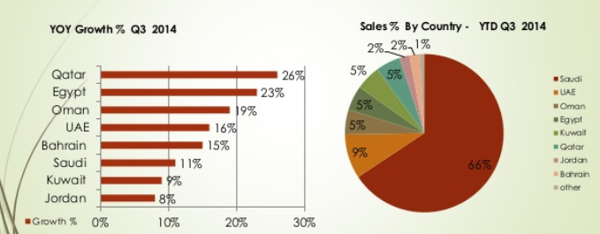

# **References**

1. Almarai. (2020). About us. <https://www.almarai.com/>
2. Baker, M. J. (2014). Marketing strategy and management. Macmillan International Higher Education.
3. Dyson, R. G. (2004). Strategic development and SWOT analysis at the University of Warwick. European journal of operational research, 152(3), 631-640.
4. Graham, H. (2008s). Marketing strategy and competitive positioning. India: Pearson Education India.
5. Khan, M. T. (2014). The concept of 'marketing mix' and its elements (a conceptual review paper). International journal of information, business, and management, 6(2), 95.
6. Kotler, P. (1991). Marketing Management, 7th edition. Englewood Cliffs, NJ: Prentice-Hall.
7. Kotler. Ph. & others. (2012). Marketing management. library of Congress Cataloging in Publication Data. Kotler, Philip.
8. Nadec. (2020). About us. <https://nadec.com/>
9. Rauch, P. (2007). SWOT analyses and SWOT strategy formulation for forest owner cooperation in Austria. European Journal of Forest Research, 126(3), 413-420.
10. Schlegelmilch, B. B. (2016). Segmenting Targeting and Positioning in Global Markets. In Global Marketing Strategy (pp. 63-82). Springer, Cham.