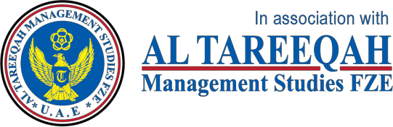 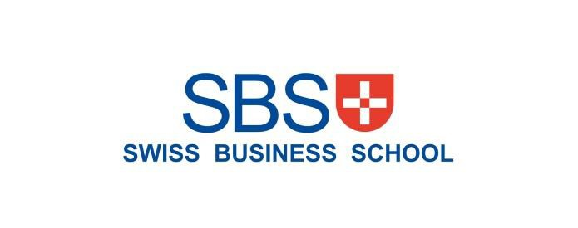

# MARKETING MANAGEMENT SBS MBA/MSc

**Assignment – Bahrain 2020**

|  |  |  |  |  |  |  |  |
| --- | --- | --- | --- | --- | --- | --- | --- |
| STUDENT ID | 1 | 1 | 3 | 1 | 7 |  |  |

UNIT TITLE / CODE: MARKETING MANAGEMENT / MKT 501

NAME (in Full): HOSSAM HAMDY ABDELHAMIL IBRAHIM

## GENERAL INSTRUCTIONS

* All assignments are to be submitted **14th May 2020** on to [examinationboard@atmsedu.org](mailto:examinationboard@atmsedu.org) and cc to [azrafatima@atmsedu.org](mailto:%20azrafatima@atmsedu.org),  [assignmentsubmission2019@gmail.com](mailto:assignmentsubmission2019@gmail.com)
* If assignment is not submitted on date, will follow with penalty of 10% deduction of marks for every day.
* Similarity between students work is strictly not accepted, any student found with similar work will be graded Zero and fail for the course. However, Plagiarism is an academic offence and will not be tolerated under SBS
* Assignment once submitted to exam board is final for marking.
* Total 100 marks

## GUIDELINES FOR ASSIGNMENT

* 1. If assignment is Question & Answer based then.
     + Introduction is needed for each question.
     + Question has to be answered based on the mark allotted for each question with references if any idea or information is taken from other source.
  2. If assignment is case based then,
     + Executive summary
     + Table of content
     + Body of assignment (questions related to case need to be answered)
     + Conclusion / Recommendation if any
     + References (in-text + citation) to be used

## Total Marks / 100

**PLAGIARISM**

Plagiarism is a form of **cheating**, by representing someone else's work as your own or using someone else's work (another student or author) without acknowledging it with a reference. This is a serious breach of the Academic Regulations and will be dealt with accordingly. Students found to have plagiarised can be **excluded from the program**.

Plagiarism occurs whenever you do any of the following things without acknowledging the original source:

* Copy information from any source (including the **study guide**, books, newspapers, the internet)
* Use another person's concepts or ideas
* Summarise or paraphrase another person's work.

## How do I avoid plagiarism?

To ensure you are not plagiarising, you must acknowledge with a reference whenever you:

* use another person's ideas, opinions or theory
* include any statistics, graphs or images that have been compiled or created by another person or organization
* Paraphrase another's written or spokenword.

## What are the penalties?

The penalties for plagiarism are:

* Deduction of marks,
* A mark of zero for the assignment or the unit, or
* Exclusion from the program.

Plagiarism is dealt with on a case-by-case basis and the penalties will reflect the seriousness of the breach.

## Please note: claiming that you were not aware of need to reference is no excuse.

**Marketing Management Assignment Structure – Marketing Strategy (Brand)**

For your brand of choice please prepare a marketing strategy on the below guidelines. This should clearly reflect the marketing mix – product, place, price, promotion and packaging as discussed in the class. The learnings on Brand Equity in the class should be the emphasis of the assignment.

Please note the brand should have linkage in the UAE – must be an existing brand or a brand that intends to be introduced in the UAE.

1. Executive Summary – summarizing points 2-8.
2. Brand Overview – describe the current status of the brand with a brief historical background. Also define the brand’s current state on the Product Life Cycle.
3. Competition Overview – Define competition
4. Target Market – Define who is being targeted
5. Segmentation – Demographic, Behavior, Psychographic
6. SWOT – on brand or industry
7. Market Research if any carried out – if no research carried out then suggest a need if any
   1. Product – BCG matrix. Also include packaging plans if any.
   2. Place – Choice of retail strategy
   3. Price – penetrative or skimming or competitive
   4. Promotion – pull or push strategy including choice of medium – digital or traditional
8. Conclusions and Recommendations – suggestions for change in current practices if any to make it more effective should be discussed.
9. Appendix – Any other information you may provide.
10. **Executive summary**

# Schlumberger Limited (NYSE: SLB) is the world’s biggest oil and gas services company, established by the innovative brothers, Conrad and Marcel Schlumberger in 1926. The history and culture of Schlumberger are founded on leadership, science, and innovation. Schlumberger people for over 90 years created and still creates amazing technology that unlocks access to energy for the benefit of all, which made Schlumberger by far the technology leader of the oil and gas services sector.

# Resilient over its course of history, Schlumberger has seen – and mastered – many challenging moments and has survived world economic crashes, global rescissions, oil market turmoil’s and recently the corona virus pandemic COVID19 market disruption. By being adaptive to market changes and a pioneer in setting new marketing strategies while being governed by a strong financial management team it will overcome any market and economic disruptors.

# In the course of this research, we will create a comprehensive set of guidelines for an enhanced market strategy in one of the biggest Oil and Gas markets in the world, Saudi Arabia.

# Our research’s target market is Saudi Arabia as it is the world’s second biggest oil producer and one of the main global oil price influencers, with 17% of the world oil future reserves, making the country a guaranteed market for business growth.

# In such mature market, Schlumberger is faced with fierce competition from major market players of other oil and gas services companies, on top of them are Halliburton (NYSE: HAL) and Baker Hughes (NYSE: BKR).

# The research paper evaluates the marketing strategy of Schlumberger while analyzing our target market key concepts like positioning of the brand, marketing mix, market segmentation and marketing communication. As well focusing on how to overcome competitive threats in the same target market of companies like Halliburton, Baker Hughes and Weatherford as well as smaller companies trying to infiltrate the market using the current customer’s behavior changes. The marketing strategy and analysis is guided by the insights of the latest years’ financial performance of the company and its main rivals by taking into account revenue, working capital management, free cash flow and other operation ratios.

# The world we know is changing very fast, the economy we are used to may not be back any time soon. Drastic measures and complete reforms must be adopted by all companies in order to survive and grow. In our research we will focus on the company’s strengths and capitalize on its differentiative edge and strong financial health in order to set its new marketing strategy.

**Table of Contents**

1- Executive Summary 4

2- Brand Overview 6

3- Competition Overview 9

4- Target Market 10

5- Segmentation 12

6- SWOT 14

7- Market Research 17

7.1- Product - BCG matrix 18

7.2- Place 21

7.3- Price 22

7.4- Promotion 23

8- Conclusion and Recommendations  24

9- Appendix 27

References 31

1. **Brand Overview**

Schlumberger Limited (NYSE: SLB) is one of the world’s largest companies in the oil & gas industry and it is considered the largest in the oilfield services sector, closing the year 2019 with a reported full year revenue of $32.9 billion while generating $2.7 billion in free cash flow, a full year pretax segment operating margin of 12%. (SLB Financial Report)

Schlumberger is a multinational company accommodating approximately 105,000 employees representing 140 nationalities with products, sales and services in more than 120 countries. It supplies the oil & gas industry’s most comprehensive range of products and services, from exploration through production, and integrated pore-to-pipeline solutions that optimize hydrocarbon recovery to deliver reservoir performance sustainably.

Schlumberger story begins with what it truly means to be a technology innovator. In the early decades of the 20th century, Conrad and Marcel Schlumberger set out to understand the Earth’s subsurface structure using geophysical measurements. In 1912, using very basic equipment, he recorded the first map of equipotential curves at his estate near Caen in Normandy before extending his surveys to iron mines in the area. The resulting mapping of equipotential curves not only confirmed the method’s ability to detect metal ores but also revealed features of the subsurface structure, such as bed boundaries and the direction of formation layer dips. That Schlumberger’s technique could provide this extra information was highly significant, as it meant that it might be useful for locating subsurface structures that could form traps for minerals such as oil and gas.

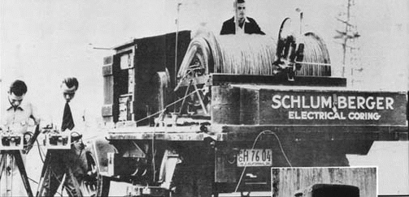

*The original geophysical logging equipment used by the Schlumberger brothers in the late 1920's (Source: Schlumberger2000)*

Their pioneering spirit enabled them to grow Schlumberger into the world’s first well logging company with a worldwide presence. That technology debut has built a 90-year legacy that still thrives on industry leadership and innovation—a clearly defined identity based on dedicated people “figuring it out."

While the history of oil discovery in Saudi Arabia goes back to the late 30’s from the 20th century when Dammam well No. 7 started producing commercially for the first time in 1938, Schlumberger made their first well log in Saudi Arabia only three years after in 1941 establishing a historical relationship with the kingdom that flourished for 79 years till report date.

Now Schlumberger is offering a wide range of oil & gas related products and services, from seismic acquisition and processing, drill bits and drilling fluids, directional drilling and drilling services, formation evaluation and well testing to well cementing and stimulation, artificial lift and well completions and consulting, software and information management, all under the major segments of Reservoir Characterization, Drilling and Production as well as their newly acquired company in 2016 “CAMERON”.



*Schlumberger Team on the Rig Floor (Source:* [*www.slb.com*](http://www.slb.com)*)*

Product Life Cycle:

Schlumberger hypothetical Product Life Cycle for the Services offered to the oil & gas sector from exploration, drilling, completion to production stages of oil & gas wells is described below.

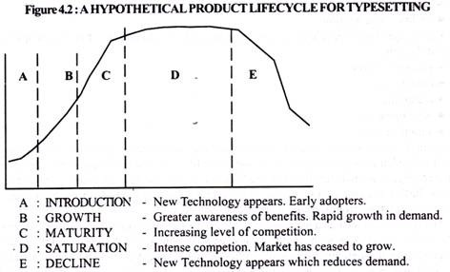

Schlumberger services since introduced in the late 20’s of the last century has passed by the first three stages of the Product/Services Life Cycle, currently Schlumberger is in the Maturity to Saturation stage where sales growth slows down with market acceptance and even market saturation. Growth is still slowly increasing with world population growing & thus the continuous demand for energy increase, yet profits are declining because of fierce competition and cost reductions.

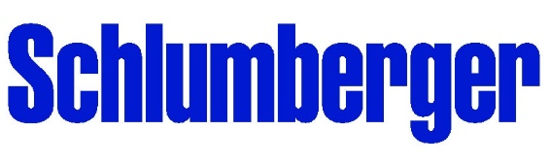

1. **Competition Overview**

Competition is the rivalry among corporations offering similar products and services with the aim of achieving better revenue, profit, and market share by varying the elements of the marketing mix, or the 4 P’s: Product, Place, Promotion, and Price. Understanding your competitors is an important step in planning a successful marketing strategy. Studying competitors’ strengths and weaknesses will allow you to provide a competitive advantage, such as offering products at lower prices or value-added services. There are two types of competition, direct and indirect. Direct competitors are offering the same products and/or services, targeting the same market with the same direct goals of growth. Indirect competitors usually have different products/services but would satisfy the same market base needs and thus would still capture some of your market share.

Schlumberger major competitors worldwide and in Saudi Arabia in terms of services provided to the oil & gas sector are Halliburton, Baker Hughes and Weatherford International.

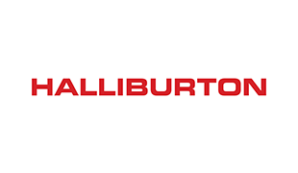  

Halliburton and Baker Hughes of all the oilfield services’ competitors represent the fiercest competition to Schlumberger. Halliburton has reported end of year 2019 full year revenue of $22.4 billion and Baker Hughes has reported $23.8 billion while Weatherford International on the other hand has only reported $5.2 billion.

The first two share their vision focus mainly on providing superior customer service in the wide array of services and solutions provided to the same market clients. Yet Schlumberger differ through their historical goal to be the leading developer of technology. As the market is saturating, the technology edge is on the top priority of all those companies.

Beside technology all the competitors are trying to develop some of the success key factors, such as their specialized, trained and skilled workforce. The low capital investment in R&D from the major competitors to Schlumberger is indeed a weakness, also the lower market share is a challenge they are trying to overcome by increasing operations expenditures.

1. **Target Market**

Increasing exports and imports of oil and gas on the account of surged demand across the world are fueling the market growth. Global oil demand is estimated at 104 MMbbl/d in 2025 and natural gas continues to expand its share across major markets. Oil and gas companies will need to expand their production to meet emerging demand in the foreseeable future. (Research and Market).

The challenging competition among oil companies have made the oil and gas industry undergoing fast transformations across the world by innovating new technologies that has paved the way for unconventional drilling that enhances oil & gas production. Novel business models and advanced services are rapidly evolving and working to reduce the cost of production in upstream oil & gas, and thus promoting the market growth.

Saudi Arabia is the world’s second biggest oil producer with 12 million bbl/day of crude oil. Also, Saudi Aramco; Saudi Arabia’s giant oil company possess the biggest oil reserves estimated at 17% of the total world’s oil reserves. Sustained growth in the consumption of natural gas, petroleum, and petrochemical products is one of the major growth drivers for oil and gas companies in **Saudi Arabia**. Companies operating in the industry can benefit from this opportunity through investing and participating in the oil and gas trade. The major Saudi Arabia companies are undertaking various oil and gas pipeline projects and contracts to expand their production capacities and sustain their position in the oil and gas industry

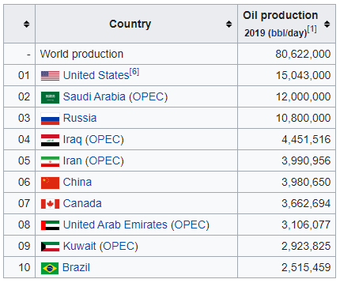

*Top 10 World’s Oil Producers (Wikipedia)*

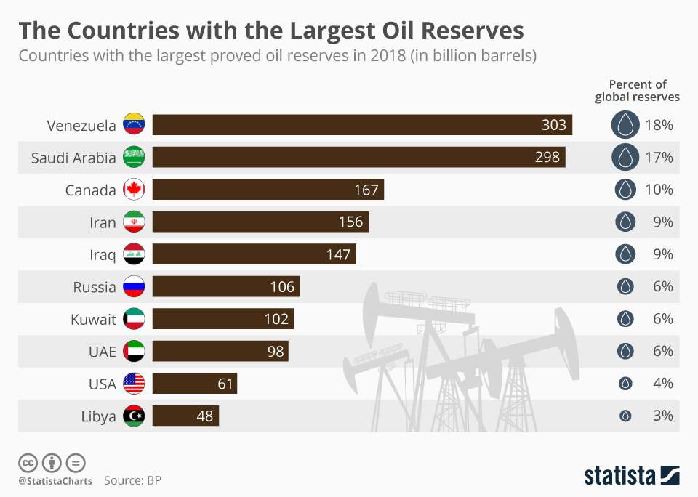

The target market in Schlumberger’s priority for the middle east is Saudi Arabia, as we see in below table the market growth by the spending on drilling rigs & wells for the oil and gas through years from 2010 till 2020 has grown from $6.1 to $9.1 billion, that’s why the marketing strategy for matured companies like Schlumberger shall focus on Saudi Aramco aiming at acquiring the biggest market share in this growing market.



*(Sources: Baker Hughes GE, Spears and Associates Report)*

1. **Segmentation**

In the oil & gas services industry a B2B model prevails, in business to business customer segmentation exists as the transactions occur directly between Schlumberger and their Saudi Arabia customers (in our case Saudi Aramco hold all the upstream market in the country) where services are provided.

Schlumberger revenue in Saudi Arabia is received from almost one customer (other Schlumberger B2B transactions with other oil service companies in the kingdom still occur).

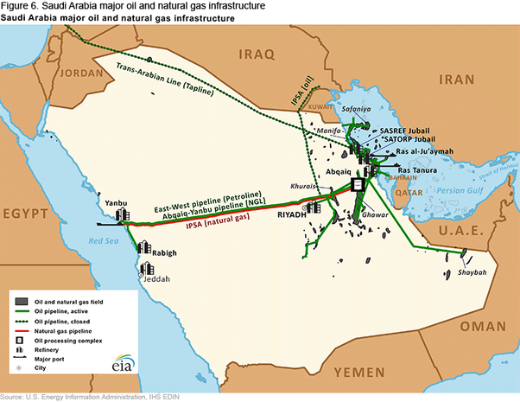

*Saudi Arabia oil and gas fields and infrastructure (Source U.S. EIA)*

Partial Market segmentation can be done among Saudi Aramco different divisions in order to capitalize on different behavioral trends as per the working teams in every division and also according to the challenge’s different divisions face in their operations and thus various product and technologies from Schlumberger can be positioned in a proper way for every Aramco division or field in order to achieve the maximum competitive advantage with Rivals and capture the best market share.

As Schlumberger provides different services and products, from seismic to reservoir characterizations and logging, also from drilling, completion, production to the holistic Integrated Project Management services. Schlumberger teams interacts with various buying trends within the same company of Aramco, for example as per my research per geographic, demographic, behavior and psychographic trends:

* Offshore Drilling Department: logistic and mobilization challenges, offshore hard mindset of Aramco teams spent most of their lives in the sea, that requires fast actions as the fear of weather changes and shutdowns persist, added to that Aramco’s ambition drilling market expansion in the offshore.
* Gas fields drilling in Udhaileya and Unaiyza: hard abrasive formations, a tough demanding team with big challenge and burden of delivery to improve the kingdom’s gas production, higher cost of drilling force certain techniques and negotiation skills.
* Exploration and Unconventional Drilling Department: Exploration by its nature offer huge challenges of the unknown, highly trained expats working for Aramco from different international backgrounds, many from the USA and Latin America.
* LSTK Department (Lum Sum Turnkey): managing and streamlining complex projects with tailored, integrated solutions, dealing with a holistic scope of work.
* Workover Department: Challenges in working in older wells to improve production and avoid exiting the service, more relaxed teams and easier to handle.
* Digitization, Global Research Centers: R&D edge required, dealing with sophisticated professors & intellectuals.

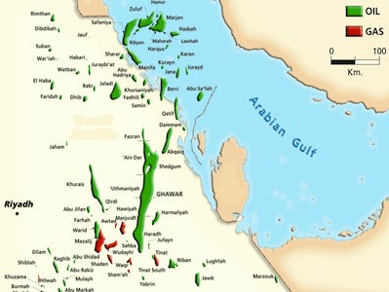

We shall talk in more details about the products and service offerings from Schlumberger in our research in the Marketing Mix

*Oil and Gas Fields of Saudi Arabia (Source: U.S EIA)*

1. **SWOT Analysis on Schlumberger**

Based on extensive research and analyzing external and internal aspects of the brand, the strengths, weaknesses, opportunities and threats of Schlumberger are summarized below and further detailed SWOT

Strengths:

* Relatively stable and strong financial performance. Schlumberger is the biggest oil and gas services company in the world with $32.9 billion in 2019 revenue while generating a free cash flow of $2.7 billion and cash flow from operation of $5.4 billion, the second & third in line are Baker Hughes and Halliburton with reported 2019 revenue of $23.8 billion and $22.4 billion respectively. This means Schlumberger is a company Saudi Aramco can trust in handling mega projects.
* Highest investments in Research, Development and technology, Schlumberger brands itself as a technology leader, maintaining this edge needs a continuous financing to R&D, as a percentage of revenue, Schlumberger spent 2.2% or $717 million of its 2019 total revenues on R&D; while its main competitors spent less, Baker Hughes $ 687 million, Halliburton spent $404 million. (Financial Annual Reports 2019)
* Highly innovative, Schlumberger is a pioneer in introducing new solutions to oil and gas challenges that are followed by its competitors, this is a result of the continuities excessive spending on R&D for many years.
* Highly trained workforce of 105,000 employees, Schlumberger is known of its huge learning centers worldwide like Sugarland Learning Center in USA, Middle East Learning Centre in UAE, others are highlighted in the image below. Schlumberger invests greatly in developing the skills and knowledge of its engineers and employees, where a company that believes in science and technology it’s of no surprise, a huge edge over its competitors regarding the skills and knowledge of their work force.

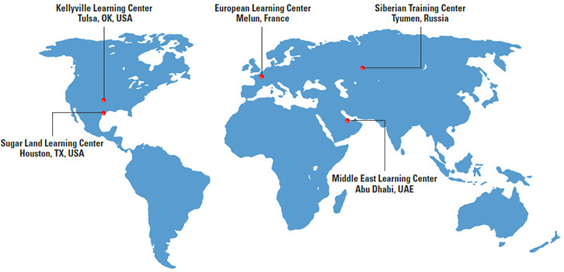

* Role model in HSE culture, Health, Safety and Environmental awareness are of the main concern of Schlumberger, its safety standards and procedures are recognized and followed by its competitors and clients as well. As Aramco is one of the biggest oil operators who puts safety ahead of anything, Schlumberger becomes one of the preferred suppliers.

Weaknesses:

* High cost of services, Schlumberger is a technology leader and technology comes at a cost, the investment in R&D to provide innovative solutions to the clients is appreciated until the bill comes along, that’s why Schlumberger is working on their cost effectiveness at a currently tough oil market where cost comes before technology
* Autocratic and Systematic leadership style, Schlumberger is a huge company of around 105,000 employees, managing those thousands of workforce efficiently can be of a big challenge, the policies & standards in Schlumberger come to be known as tough and sometimes rigid, it has helped the company to grow but it also can put sometimes an obstacle in faster response to problems and decision making as it lacks flexibility.
* Communication and Multi-national culture barriers exists broadly in Schlumberger, as a company that works in over 120 countries worldwide, with a multi-national workforce and management, where the only differentiator is their skills and performance, still it’s not easy to sustain a nominal understanding between all & it affects sometimes the performance in certain locations.
* The lower employee morale, first because of the oil price drop and tough market conditions and the continuous salary cuts and layoffs, also for those working in Saudi Arabia, Saudi Arabia is a country of strong conservative culture, as Schlumberger workforce comes from a multi-cultural background, moving to Saudi Arabia in a hot weather and conservative life style is a tough challenge, performance of employees is affected and more programs are needed to be put in place to keep morality higher.

Opportunities:

* Positive brand equity, Schlumberger enjoys a very high respect worldwide from clients, competitors and job seekers, it’s quite familiar to everyone in the industry, this can facilitate a company's long-term growth through leveraging the value of its brand, adding new products and technologies to the business line is much appreciated and clients like Aramco will be more willing to try your new product. Leading to achieving more market share & increase sales returns.
* IKTVA Program, “In Kingdom Total Value Add” a program introduced by Saudi Aramco to drive additional domestic value creation to support a rapidly changing economic environment and foster future prosperity. By driving domestic value creation, IKTVA prioritizes consistency and transparency to create a level playing field for more than 1000 suppliers we are engaged with across our local and international network. Schlumberger has the capability to capture the opportunity to use the governments incentives to improve local manufacturing and to maximize long-term economic growth and diversification.
* The strong Intellectual Property existing laws help technology leading companies like Schlumberger to capitalize on their investments in R&D, thousands of patents issued by Schlumberger every year will give it an edge to make more revenue and enhance reputation if managed properly.
* Strong free cash flow, is an opportunity for acquisitions and market share expansion, in the oil price crashes and current tough market times, many small but pioneer companies fail to survive, there is an opportunity for well established companies like Schlumberger to acquire new technologies and to grow market share by taking over existing companies.
* Digitization and global technological progress offer new opportunities to facilitate operation while reducing relative costs and manpower by providing digital solutions and remote operations controls.

Threats:

* The volatility of the global energy market, few hits occurred on a frequent bases recently to the oil and gas market leading to collapse in oil and gas prices. Lately 2009 downturn, 2015 market collapse and this year 2020 the crash of market prices due to the spread of novel corona virus pandemic covid-19. Drastic measures every time is taken by Schlumberger due to reduced operations, dropped services prices.
* Increased taxation in operating countries, in Saudi Arabia a VAT is applied on the services and products, The Vat is expected to keep increasing as the country aims at covering the deficit in their budget to support their big spending plans on development projects. This implies a burden on Schlumberger balance sheets and decrease overall net income.
* Localization of workforce laws in Saudi Arabia. Schlumberger is a multi-national company with skills and talents spread across the world, Saudi Arabia has ambition programs in reaching 70% Saudization by 2021 as stated by Aramco IKTVA program, localization means higher salary benchmarks to employees and more excessive training programs expenditure to elevate the level of the local candidates
* The increase in expenditure on R&D by competitors would increase competition, as mentioned in the financial report for Schlumberger competitors, Baker Hughes and Halliburton has increased their investments in R&D to 2.8% and 1.8% from their revenues in 2019 respectively. More patents are released every year by those companies, and this may act as a threat to the technology leading company Schlumberger & would jeopardize their edge and thus their market share.
* Changing clients’ buying behavior, as the market has matured for many years with so much competition, the consumer behavior has grown into a tight cost efficient mentality with low interest in advanced technology that won’t push in the direction of cost reduction, lately Saudi Aramco is allowing many small players to enter the market which may cause a threat in the market share of Schlumberger.

1. **Market Research**

A profound market research was conducted on the brand “Schlumberger”, its competitors and on all the oil and gas services industry, in that research an overview of what consumers' want, need, believe and how they act was covered. The research on how a products and services provided by Schlumberger could be marketed within a certain target market. Quantitative and qualitative data were gathered through many resources including physical interviews with stake holders, studying financial and annual reports of Schlumberger, its competitors and clients in the last few years, also by researching the technology, products and services from the company’s online hub, competitors’ and clients’ hubs, as well from technical analysis portals and industry excessive researches.

Factors investigated through the market research include:

* Market information, through which one can know the prices of different commodities in the market, as well as the supply and demand situation.
* Market segmentation: where the division of the market or stakeholders into subgroups with similar motivations as described in the previous question no. 5.
* Market trends where the upward/downward movement of a market along with market volatility through intervals of time while studying market size and potential growth in Saudi Arabia, Aramco expenditure plans in the coming years.
* Conducting SWOT analysis of the Strengths, Weaknesses, Opportunities and Threats to a business entity. SWOT method helps to determine and reassess strategies to analyze business process
* PEST analysis about external environment affecting the business where made, while studying political, economic and social external factors in Saudi Arabia as discussed throughout the previous questions. which may impact Schlumberger business in the kingdom and affect its objective and profitability.
* Brand health tracking is way of continuously measuring the health of a brand, both in terms of consumers’ usage of it by studying brand awareness, and brand equity as profoundly described in previous question in the SWOT analysis.
* **Marketing Mix 4P’s** is another factor that will help improve marketing effectiveness which will be covered next in more details

# 7.1- Product

# BCG Matrix | Case Interview Framework | Management Consulted

# BCG Matrix is a model created by Boston Consulting Group to understand and evaluate the strategic position of the business brand portfolio and its potential. It classifies business portfolio into four categories based on industry attractiveness - growth rate of that industry and competitive position - relative market share.

# Schlumberger as a whole business brand is considered a Cash Cow, as the oil and gas services industry has matured, while Schlumberger is one of the oldest and biggest players in that market with a substantially high market share. It should be “milked” to provide as much cash as possible as it’s indeed with 2019 reported free cash flow of $2.7 billion.

# Schlumberger is a large corporation that is capable of innovating new products or processes, which may become new Stars with the support of the cash cow’s revenue to spend on technology and innovations.

# We will classify some of Schlumberger products and services offered in the Saudi Market as per the BCG matrix

# Question Marks:

# MASTER'S THESISSchlumberger TrackMaster OH-C Openhole Whipstock sidetracking system eliminates uncertainty while kicking off with a cement plug by enabling setting the whipstock and cementing in a single trip—saving up to 24 hours when compared with traditional openhole sidetracking with a cement plug. TrackMaster is an innovative tool that since deployed in Saudi Arabia has been gaining substantial market share, its market has a lot of growth potential in Saudi Arabia and the tool market share will grow on the expense of other openhole whipstock competitors.

# Stars:

# The RheGuard flat rheology drilling fluid system specifically designed as a cost-effective solution for wells drilled in critical hydraulic windows, the RheGuard is innovative single-fluid solution ensures enhanced ROP, trouble-free pipe running, and high-integrity casing and liner cementing while minimizing losses. Even where hydraulic windows are not challenging, the RheGuard system helps you drill faster to reach TD earlier, saving time and money for your operation. Since introduced it captured 80% of market share in unconventional wells with challenging drilling problems, its market is growing as Saudi Aramco has increased expenditure in exploration and unconventional wells.

# Cash Cows:

# The PowerDrive Xceed Rotary Steerable System provides strength and agility in challenging, rugged, soft, or abrasive environments and drills extended-reach wells within rig pressure limits. Engineered for trajectory accuracy and reliability, its internal steering mechanism does not require pressure drop across the bit. It enables real-time well placement, keeping the wellbore in the target window.

# Xceed has been in the market for many years and has proved itself, gaining a big marketshare and providing revenue but without much potential for market growth as Schlumberger technology center is producing new technology for other types of challenges to push it to the Stars interval.

# 

# Sample log showing the various outputs of the EcoScope multifunction LWD serviceEcoScope is a multifunction logging-while-drilling service integrates a full suite of formation evaluation, well placement, and drilling optimization measurements into a single collar that can be deployed faster than conventional LWD tools.

# EcoScope is a well-positioned tool that has been in Schlumberger fleet for a long period with proven success and high market share, new models are produced with some modifications but it’s stable in a market that provides good cash for a needed data evaluation services as per the left gragh.

# Dogs:

# Straight Bent-Housing Powerpak Motor, vertical drilling performance application motor that has a limited market in Saudi Arabia and highly competitive from big and smaller companies, Schlumberger can save the maintenance cost and workshop overhead by renting motors when needed from other service companies.

# 7.2- Place

# Schlumberger has a strong existence in 120 countries in the world with 105,000 workforces, governed by Houston’ headquarter in USA and spread out operational facilities such as brance offices, workshops, engineering and manufacturing facilities, sales hubs, training and development centers and R&D centers all over the world..

# Geothermal Services | Schlumberger

# *(Source: Schlumberger)*

# Schlumberger marketing strategy element “Place” has being defined based on the company B2B direct service model, where Schlumberger is directly operating and distributing its products and services to its clients, distribution channels are internal services covered by Schlumberger divisions as it includes trained workforce required to operate those services.

Schlumberger has a strategic system to improve the supply chain management of the company which enables better movement of supply from the manufacturer to the end-customers. The company uses the advancement of technology in the improvement of logistics.

By analyzing the market dynamics, customers' preferences and own resources and capabilities. Customers place high importance to personalized services, that’s why Schlumberger teams are in direct contact with Client stakeholders in their own facilities on a daily basis

# Schlumberger operates in Saudi Arabia for almost 80 years, it has currently one main headquartering Dhahran Techno Valley and few operational and engineering facilities.

# 7.3- Price

# Below is the pricing strategy in Schlumberger marketing strategy:

# Schlumberger is the largest oilfield services company by sales, market cap and technology. Product differentiation is a marketing strategy that Schlumberger has been using to distinguish its products from similar offerings in the market due to its technological edge over its competitors like Halliburton and Baker Hughes, thus a Skimming Pricing Strategy was adopted for many years.

# As long as the oil and gas market were booming, the skimming pricing strategy was successful as Schlumberger had a well distinguished brand equity and known reputation of innovation and high quality service delivery, also its expenditure on R&D were appreciated and often rewarded by its clients.

# Near the end of last decade and after 2008 economic turmoil and despite Schlumberger reputation that its services and products are more costly than competitors but yet favored, the company had to change its pricing strategy to competitive. Because of the oil market downturn, competitors like Halliburton and Baker Hughes had dropped their prices dramatically under the pressure of the clients and to seek a bigger market share in a changing customer behavior to a more cost oriented.

# Followed by another crisis during the year 2014-16, the company suffered a massive loss because of the fall of the rate of crude oil from over $100 to $30. In 2016, the overall sales declined to $27.8 billion from $45.3billion in 2013 (on avg. 40% drop). During this period, the company restructured the pricing strategy and laid off over 70,000 of its workforce due to fierce market conditions and dropped revenue, While the 70,000 job loss number is shocking, Schlumberger's employee headcount has only fallen from a mid-2014 peak of 126,000 workers to about 100,000 people today. That's because of some recent new hiring as well as the acquisitions of big companies like Houston-based Cameron International and, most recently, Weatherford International's hydraulic fracturing business in the U.S. and has written off.

# Today, Schlumberger is well capitalized and positioned in the market to proliferate revenue yet as being hit again this year 2020 by the corona virus pandemic crisis, new measures are being put in place.

# Analysts expect over 2018 rising revenue Schlumberger ...

# 7.3- Promotion

# Schlumberger promotional strategy is based on marketing itself as the world’s technology leader in the oil and gas services sector, Its promotional and advertising strategies deal with both online and offline marketing. The company organizes various campaigns and events to promote its advanced services and innovation. It conducts and participates in many offline events such as conferences, tradeshows, and industry summits to keep the current technology intact with the innovation of the company. It partners in many international conferences like International Petroleum Technology Conference (IPTC) in Dhahran, Saudi Arabia, Abu Dhabi International Petroleum Exhibition & Conferences (ADIPEC) in UAE, Offshore Technology Conference (OTC) in Houston, USA, Gulf Downstream Association (GDA) in Bahrain, etc. to increase the industry awareness of the innovative products and services provided by them.

# Schlumberger has an excellent digital marketing communication, its wealthy website, designed and loaded with a lot of information and case studies of its innovative tools and products aiming at promoting their capabilities and also to educate students and market researchers, giving value and sharing knowledge is always appealing in the eyes of stakeholders and tomorrow’s potential customers.

# Schlumberger soft marketing appears in conducting many environmental awareness and health care campaigns to connect to the societies it works within. (Schlumberger Global Stewardship)

# Conclusion and Recommendations

# Schlumberger’s long-established values “People, Technology and Profit” guarded by a strong code of conduct have always kept the company in the front lead of the oil and gas services sector for over 90 years since it was established by innovative dreamer brothers Conrad and Marcel Schlumberger in 1926. By applying those high standards of conduct company-wide, it helps creating a highly positive impact on Schlumberger employees, contractors, suppliers, and customers as well as the communities in which Schlumberger operates.

# The potentials for the company are endless worldwide, and if we want to discuss in particular the Saudi Arabian oil and gas market then we will introduce some recommendations based on the breakdown of our research regarding the target market, segmentation, marketing mix 4P’s and technical analysis while capitalizing on the company strengths and capturing opportunities.

Schlumberger provides services and products, from seismic to reservoir characterizations and logging, also from drilling, completion, production to the holistic Integrated Project Management services. Schlumberger teams interacts with various buying trends within Aramco departments as discussed and here are some of our recommendations:

* Offshore Drilling Department: logistic challenges and mobilization, thus continuous support is always required by having an equipped 24/7 working support base in Tanajib port, Schlumberger can provide the required support to offshore rigs, also in the offshore drilling sticky type of formation requires a good performance from Schlumberger drilling service Rotary Steerable System drilling tool and operational continues support to monitor stick slip and vibrations and provide the field team with the continuous advise instantly. Utilizing new Schlumberger technologies to drill a multi-lateral well from a single slot with the TrackMaster OH-C Openhole Whipstock sidetracking system along with the new coming star NeoSteer at-bit steerable system, a design that integrates a unique cutting structure and steering mechanisms

*NeoSteer at-bit steerable system (Schlumberger)*

* Gas fields drilling in Udhaileya and Unaiza: hard abrasive formations required certain types of drilling bits with durable diamond cutters, Smith; a Schlumberger company is providing a competitive technology of Enduroblade bits to the drilling market to compete with Baker Hughes’ and Halliburton Security bits

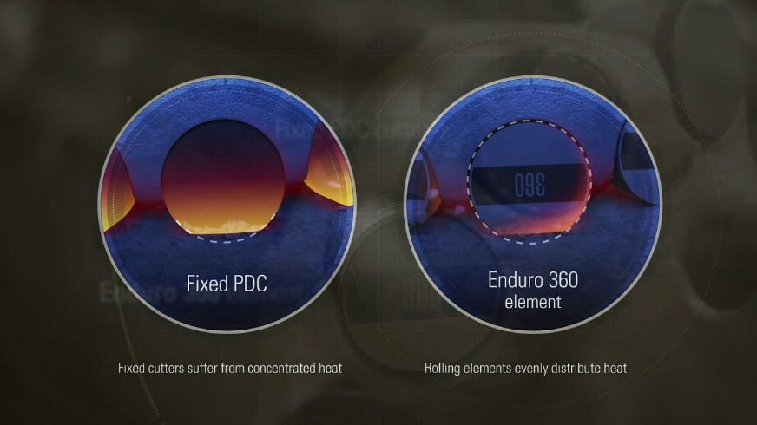

*EnduroBlade bit rotating cutter vs normal PDC bit (Source: Schlumberger)*

* Exploration and Unconventional Drilling Department: Exploration by its nature offer huge challenges of the unknown, which requires a qualified advanced team to deal with the surprises that may impact the drilling operations and cause a lot of loss in assets and money, Schlumberger offers the advanced digitized technology to anticipate the risks and provide solutions to coming problems. Introducing the RheGuard flat rheology drilling fluid system specifically designed as a cost-effective solution for wells drilled in critical hydraulic windows has a successful record in helping to drill those unconventional wells and thus more market share can be acquired by capitalizing on this technology
* LSTK Department (Lum Sum Turnkey): Schlumberger Integrated Project Management (IPM) undertakes collaborative projects for oil and gas operators, managing and streamlining complex projects with tailored, integrated solutions. With an existing portfolio of over 50 projects in 30 countries (both onshore and offshore), IPM provides the expertise and processes to improve performance and increase efficiency by integrating all the services and technologies a project requires, including operations support, logistics, and third-party management. (Source: IPM Services, Schlumberger)

IPM division is a solution to many of Aramco problems to take off its shoulder many of its fields’ development, Schlumberger should promote such service as it eliminates any small companies competition and by growing the turn key market within Aramco operation, Schlumberger can secure a big chunk of a market share that will only grow.

* Saudi Vision 2030 & Aramco IKTVA Program (In Kingdom Total Value Add): Schlumberger has a great opportunity joining Saudi ambitious vision 2030. With the many incentives given by the government and by cooperating with Aramco, Schlumberger can start with local partnership manufacturing rig equipment’s and supplies including oil & gas skids where a big market of rig manufacturing is growing in the city of Ras Al-Khair and nearby support industrial areas in Jubail Industrial City.

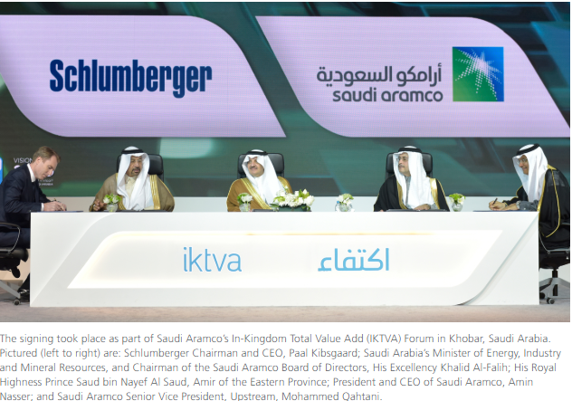

*(Source: Aramco News & Media)*

* Digitization, Global Research Centers in Aramco can utilize Schlumberger as it is a technology leader that provides the best edge over its competitors when dealing with the research and innovative solutions. Schlumberger is developing digital solutions aiming at generating richer data and better insights to achieve enhanced performance that is not taking its first footsteps of digital new era, Schlumberger has been building the digital technology for the future. Schlumberger is leveraging technologies that have transformed other industries by applying them in E&P, enabling its customers to make better decisions and make them faster. “Driving Performance with Digital” as said by Schlumberger new CEO Olivier Le Peuch.

# 

# Appendix

# Schlumberger Financial Highlights

# 

# 

# Halliburton Financial Highlights

# 

# iii- Baker Hughes Financial Highlights

# 

# References

# ARAB NEWS, *Well No.7 that established KSA on world oil map* [online], Available at https://www.arabnews.com/saudi-arabia/news/784846, Accessed on 4th May 2020

# ATMS Learning Material (*KOTLER, KELLER, Marketing Management, 14th Edition*)

# Baker Hughes, *2019 Annual Report* [online], Available at https://www.bakerhughes.com/sites/bakerhughes/files/2020-03/Baker%20Hughes%202019%20Annual%20Report_1.pdf, Accessed on 6th May 2020

# Baker Hughes, *Baker Hughes Company Announces Fourth Quarter and Total Year 2019 Results* [online], Available at https://investors.bakerhughes.com/news-releases/news-release-details/baker-hughes-company-announces-fourth-quarter-and-total-year, Accessed on 5th May 2020

# Chron, *Schlumberger rebounding after cutting 70,000 jobs* [online], Available at https://www.chron.com/business/energy/article/Schlumberger-rebounding-after-cutting-70-000-jobs-12731802.php, Accessed on 9th May 2020

# Conoco Philips, *The Life Cycle of a Well* [online], Available at https://www.youtube.com/watch?v=0r4J34FEsTk, Accessed on 4th May 2020

# Halliburton, *2019 Annual & Sustainability Report* [online], Available at https://ir.halliburton.com/static-files/672562d9-0e6c-442e-a3b5-69e9418dd7b6, Accessed on 6th May 2020

# IKTVA, *The In-Kingdom Total Value Add* [online], Available at https://iktva.sa/introduction/, Accessed on 6th May 2020

# Revenues and Profits, *Business Analysis of Schlumberger* [online], Available at https://revenuesandprofits.com/schlumberger/, Accessed on 6th May 2020

# Schlumberger, *2019 Annual Report* [online], Available at http://www.annualreports.com/HostedData/AnnualReports/PDF/NYSE_SLB_2019.pdf, Accessed on 6th May 2020

# Schlumberger, *EcoScope - Multifunction logging-while-drilling service* [online], Available at https://www.slb.com/drilling/surface-and-downhole-logging/logging-while-drilling-services/ecoscope-multifunction-lwd-service, Accessed on 8th May 2020

# Schlumberger, IPM Integrated Services, *Pulling It All Together* [online], Available at https://www.slb.com/-/media/files/ipm/brochure/ipm-integrated-services-br, Accessed on 6th May 2020

# Schlumberger, *Global Stewardship Report 2018* [online], Available at https://www.slb.com/globalstewardship/pdf/Schlumberger_GlobalStewardship_2018.pdf, Accessed on 10th May 2020

# Schlumberger, *PowerDrive Xceed* [online], Available at https://www.slb.com/drilling/bottomhole-assemblies/directional-drilling/powerdrive-xceed-rotary-steerable-system, Accessed on 7th May 2020

# Schlumberger Press Release, *Schlumberger Announces Fourth-Quarter and Full-Year 2019 Results Conference Call* [online], Available at https://www.slb.com/newsroom/press-release/2019/pr-2019-1206-q4-earnings-call-announcement, Accessed on 4th May 2020

# Schlumberger, *RheGuard - Flat rheology drilling fluid system* [online], Available at https://www.slb.com/drilling/drilling-fluids-and-well-cementing/drilling-fluids/nonaqueous-drilling-fluid/rheguard-flat-rheology-rdf, Accessed on 7th May 2020

# Schlumberger, *Schlumberger Production Management* [online], Available at https://www.slb.com/business-solutions/schlumberger-production-management, Accessed on 4th May 2020

# Saudi Aramco, News & Media, Saudi Aramco awards Schlumberger contracts for drilling rigs and services for oil and gas wells [online], Available https://www.saudiaramco.com/en/news-media/news/2017/schlumberger-contracts, Accessed on 11th May 2020

# The Motley Fool, Schlumberger: Is the Worst Over? [online], Available at https://www.fool.com/investing/2020/02/03/schlumberger-is-the-worst-over.aspx, Accessed on 8th May 2020

# Weatherford International, Weatherford Announces Fourth Quarter and Full Year 2019 Results [online], Available at https://weatherford.gcs-web.com/static-files/e4650520-91f3-430e-a649-3336ec557bd6, Accessed on 5h May 2020

# Your Article Library, Hypothetical Product Life-Cycle of Services [online], Available at https://ir.halliburton.com/news-releases/news-release-details/halliburton-announces-fourth-quarter-2019-results, Accessed on 5th May 2020