 

# MARKETING MANAGEMENT SBS MBA/MSc

**Assignment – Bahrain 2020**

STUDENT ID

|  |  |  |  |
| --- | --- | --- | --- |
| 9 | 6 | 3 | 9 |

UNIT TITLE / CODE: Marketing Management/MKT-501

NAME (in Full): Khalid Ibrahim AlHamed

## GENERAL INSTRUCTIONS

* All assignments are to be submitted 14**th May 2020** on to [examinationboard@atmsedu.org](mailto:examinationboard@atmsedu.org) and cc to [azrafatima@atmsedu.org](mailto:%20azrafatima@atmsedu.org), [assignmentsubmission2019@gmail.com](mailto:assignmentsubmission2019@gmail.com)
* If assignment is not submitted on date, will follow with penalty of 10% deduction of marks for every day.
* Similarity between students work is strictly not accepted, any student found with similar work will be graded Zero and fail for the course. However, Plagiarism is an academic offence and will not be tolerated under SBS
* Assignment once submitted to exam board is final for marking.
* Total 100 marks

## GUIDELINES FOR ASSIGNMENT

* 1. If assignment is Question & Answer based then.
     + Introduction is needed for each question.
     + Question has to be answered based on the mark allotted for each question with references if any idea or information is taken from other source.
  2. If assignment is case based then,
     + Executive summary
     + Table of content
     + Body of assignment (questions related to case need to be answered)
     + Conclusion / Recommendation if any
     + References (in-text + citation) to be used

## Total Marks / 100

**PLAGIARISM**

Plagiarism is a form of **cheating**, by representing someone else's work as your own or using someone else's work (another student or author) without acknowledging it with a reference. This is a serious breach of the Academic Regulations and will be dealt with accordingly. Students found to have plagiarized can be **excluded from the program**.

Plagiarism occurs whenever you do any of the following things without acknowledging the original source:

* Copy information from any source (including the **study guide**, books, newspapers, the internet)
* Use another person's concepts or ideas
* Summaries or paraphrase another person's work.

## How do I avoid plagiarism?

To ensure you are not plagiarizing, you must acknowledge with a reference whenever you:

* use another person's ideas, opinions or theory
* include any statistics, graphs or images that have been compiled or created by another person or organization
* Paraphrase another's written or spoken word.

## What are the penalties?

The penalties for plagiarism are:

* Deduction of marks,
* A mark of zero for the assignment or the unit, or
* Exclusion from the program.

Plagiarism is dealt with on a case-by-case basis and the penalties will reflect the seriousness of the breach.

## Please note: claiming that you were not aware of need to reference is no excuse.

**Marketing Management Assignment Structure – Marketing Strategy (Brand)**

For your brand of choice please prepare a marketing strategy on the below guidelines. This should clearly reflect the marketing mix – product, place, price, promotion and packaging as discussed in the class. The learnings on Brand Equity in the class should be the emphasis of the assignment.

Please note the brand should have linkage in the UAE – must be an existing brand or a brand that intends to be introduced in the UAE.

1. Executive Summary – summarizing points 2-8.
2. Brand Overview – describe the current status of the brand with a brief historical background. Also define the brand’s current state on the Product Life Cycle.
3. Competition Overview – Define competition
4. Target Market – Define who is being targeted
5. Segmentation – Demographic, Behavior, Psychographic
6. SWOT – on brand or industry
7. Market Research if any carried out – if no research carried out then suggest a need if any
   1. Product – BCG matrix. Also include packaging plans if any.
   2. Place – Choice of retail strategy
   3. Price – penetrative or skimming or competitive
   4. Promotion – pull or push strategy including choice of medium – digital or traditional
8. Conclusions and Recommendations – suggestions for change in current practices if any to make it more effective should be discussed.
9. Appendix – Any other information you may provide.

 

BRAND MARKETING MANAGEMENT: PAMPERS CASE STUDY

Marketing Management (MKT-501)

Swiss Business School (SBS)

Lecturer Names: Umesh Kothari and Clay

May 14th, 2020

Khalid I. AlHamed

Student ID: 9639

Phone: +966-555-922-119

Dammam, Saudi Arabia, 34251

Word Count: 3,200 words

# 

# Executive Summary

Pampers is a brand of baby diapers affiliated to the Procter & Gamble (P&G) company. The brand is extensively distributed throughout the world, with production facilities also dispersed widely, and the United Arab Emirates (UAE) is one of the production hubs. The brand was introduced into the UAE in the 1950s and it currently competes with key players in the UAE market, including Huggies from Kimberly-Clark and other local brands produced by companies, such as Kao Corporation. The target market for the products comprises of mothers and young fathers with children from 0 to 3 years of age, and the company has leveraged its strengths effectively to ensure growth. The Pampers brand targets the middle-class parents’ market category by a combination of product characteristics and price. P&G still has many opportunities in the growing population and birth rates, and threats such as competition and changing customer preferences. Over the years, the marketing mix for Pampers has been centred on customer needs, taking a combination of product qualities, competitive pricing, traditional and digital promotion, and effective distribution. It is recommended that Pampers should additionally focus on customer retention to be sustainably successful.

Table of Contents

Executive Summary 5

Introduction 7

2. Brand Overview 8

3. Competition Overview 9

4. Target Market 10

5. Segmentation 10

6. Strengths, Weaknesses, Opertunities and Threats (SWOT) Analysis 11

7. Market Research 13

7.1 Product 13

7.2 Place 14

7.3 Price 14

7.4 Promotion 15

8. Conclusions and Recommendations 16

References 17

Appendix 19

Appendix A: BCG Matrix Data (U.S SEC 2020) 19

# Introduction

Pampers is an American brand of baby and toddler products marketed by Procter & Gamble (P&G) company with operations across the world. The brand was introduced into the United Arab Emirates (UAE) in the 1950s and currently UAE is one of the Pampers main production hubs. most of the products of the Pampers brand distributed to African countries are also manufactured in the UAE.

The report evaluates the marketing strategy of Pampers Company by defining the competition in the baby diapers sectors. In addition, it will define who is being targeted, the customer behaviours in terms of product choice and it will analyse in details the company’s strengths, weaknesses, opportunities and threats (SWOT Analysis) along with Boston Consulting Group (BCG) matrix. Not only that, but this study will go over the Product, Place, Price and Promotion (4P’s). Finally, this study will also suggest recommendations that can be implemented in order to increase its market share.

# 2. Brand Overview

Pampers is a brand affiliated to Procter & Gamble (P&G) Company, with operations across the world. P&G has several production lines in the United Arab Emirates (UAE) and distributes its products in the country. Moreover, most of the products of the Pampers brand distributed to African countries are also manufactured in the UAE. The brand was introduced into the UAE in the 1950s (Pampers 2020) and has been marketed extensively over the years, resulting in the second-highest market shares after Huggies, due to the high brand loyalty associated with the UAE customers. The brand faces competition from various other organizations and newer diaper technologies, but it is expected to continue in its growth trend. It has been marketed effectively through a marketing mix that reflects significant strength and is aimed at pulling customers to the product, rather than pushing the product to the customers.

Following the growth over the years, the Pampers brand is currently in the growth phase of the product life cycle in the Middle East region, in which the UAE is situated. Figure 1 below shows the positions of Pampers baby diapers in the product life cycle across the world. The growth of the brand has been attributed to various factors, including greater recognition of the need for hygiene, high birth rates in the Middle East, changing demographic patterns, changes in disposable income levels among consumers, and changing consumer preferences (Sharma 2019). The current market of the Middle East comprises nearly 33% of the total diaper market in the world, part of which is owned by the Pampers brand (Sharma 2019). Although many alternative products are coming up, Pampers brand should be able to compete with favourably. The effectiveness of the marketing practices for the brand will determine its potential growth over the coming years. With an effective marketing mix and sufficient innovation and diversity, it is expected that the brand will grow significantly over the coming years.

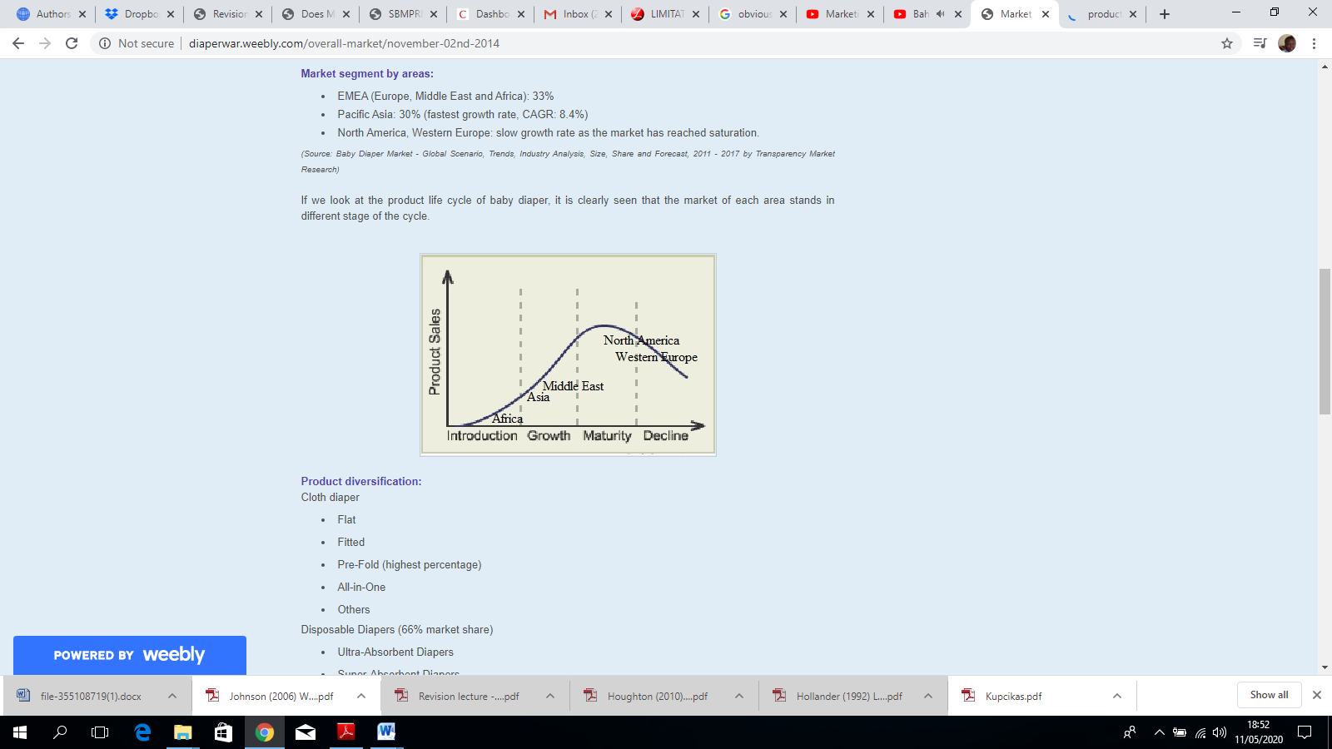

*Figure 1:* Product Development Life Cycle for Pampers (Sharma 2019)

# 

# 3. Competition Overview

The international baby diaper market in which Pampers brand operates has many players. While the baby diaper market is continuously growing because of the mentioned reasons, the number of players in the industry is also growing, alongside the variety of products in the category. Pampers brand deals with baby diapers that suit different needs for different ages of children. In this particular product category, the key competitor in the same middle-income market category is Kimberly-Clark’s Huggies (Trefis Team and Great Speculations 2016). Besides Huggies, other baby diaper brands that are common in the UAE include those by Johnson & Johnson, Kao Corporation, and Unicharm Corporation. The competitive landscape is thus described as a consolidated one, due to the limited number of competitive players possessing large market shares. Huggies and Pampers collectively possess more than 43% of the market shares in the UAE baby diaper markets, while the other players possess the remaining market shares (Trefis Team and Great Speculations 2016). The competitive landscape is, however, becoming more innovation-driven.

The competition faced by the Pampers brand in the baby diaper market is not limited to the variety of players in the industry. Disposable diapers, which are the most common Pampers diaper types, comprise of nearly 66% of the total used diapers in the UAE (Mendoza et al. 2019). There are varieties of disposable diaper types, including swim pants, super-, ultra- and regular absorbent diapers. The other type of diapers that is becoming more common, especially because of the emphasis on climate change prevention, is biodegradable. The growing popularity of the Biodegradable diapers, which are made from natural fibers, has pushed most of the larger producers to begin actively thinking about innovation towards them (Khan 2009). By focusing on quality and the need for customer loyalty, Pampers brand is most likely to realize continued competitive advantage and to grow significantly in terms of market shares. The competitive environment is best described through the diagram below. Customer decision making is based on their perception and placement of the products, which is presently characterized as shown in the diagram. Customers consider the awareness, availability, price, and target market of the respective brands before making their choice.

Total Set

Awareness set

Consideration set

Choice set

Decision set

Pampers

Huggies

J & J

Sanita bambi

Pure born

Fine baby

Pampers

Huggies

J & J

Confy Baby

Baby joy

Teemo,

Fine baby

Sanita Bambi

Pure Born

Pampers

Huggies

Fine baby

Pampers

Huggies

Fine baby

Sanita bambi

Pure born

*Figure 2.* Customer Decision Making Sets for Diaper Brands in the UAE

# 

# 4. Target Market

The main target market for the Pampers brand is mothers with babies of different ages. The products are categorized into the different market segments based on the ages of children, namely, from 0-3 months, 3-12 months, and toddlers (grouped under all children above 12 months in age) (Sharma 2019). The target market also expands to young fathers who are likely to have small children. The market segmentation is based on the expected safety and quality of products for the different age groups. The infants from 0-3 months of age have the most sensitive skin; thus, their products are made for comfort and protection using plant-based materials that are intended to protect their delicate skin and are easy to clean (Pampers 2020). For those aged 3-12 months, the product variety is wider: there are both pants and wrapper diapers for this category of products and products that can be used in a wet environment, such as in a pool. This versatility serves the needs of the category due to their activity. While the products that serve this customer segment are also made from plant-based materials, the emphasis is more on ensuring dryness over a long period of time (Pampers 2020). The products targeting children above 12 months of age are also versatile for the needs of the group. The choice of the product thus depends on the needs of parents at distinct ages of children.

# 5. Segmentation

Pampers has segmented the market in several ways. They have segmented the market geographically as urban and rural markets. Pampers have concentrated more on the urban than the rural customers. Pampers has further segmented the market based on income and development stages of the babies and life-stage of people.

The Pampers brand targets the middle-class parents’ market category, mostly comprised of individuals between 27 and 40 years of age. The products are made to fit this customer segment by a combination of product characteristics and price that they said customer groups could afford. The group is characterized by the preference for ease of work, which is enhanced by disposable diapers rather than washable diapers. Furthermore, the customer behaviours, in terms of product choice, is influenced by various factors, including the cost of the products, the comfort associated with them, functionality, size, convenience, absorbency, and the baby's reactions to the products (Shrestha 2018). The responses to the products among this customer category are influenced mostly by their post-purchase experiences as a function of the expectations held before the purchase, as reported by Gichuru and Limiri (2019). The brand characteristics, therefore, have to fit their needs and preferences.

# 6. Strengths, Weaknesses, Opportunities and Threats (SWOT) Analysis

The brand is associated with several strengths, which can be leveraged to increase market shares. Shrestha (2018) reports that the brand image is one of the considerations customers make in purchasing baby diapers, whereby a superior brand name attracts more customers than a relatively weak one. First, Pampers is one of the two most popular brands for baby diapers and wipes across the world. Therefore, it is easy for the brand to be recognized even by those who have not used it previously. Secondly, the multinational distribution of the brand increases its accessibility relative to major competitors, such as Huggies. The product variety, which comprises of different categories serving the needs of different customers, is another strength associated with Pampers. The fact that the products are geared towards satisfying the needs of children, for which they are made, is another positive attribute that contributes to its preference over other local brands in the UAE. Furthermore, the brand is commonly associated with high hygiene, given that the other household brands such as aerial, tide, and downy, are all associated with P&G. The evidence of customer need is available in the form of increasing population growth. According to Xu, Zhang, and Jun (2013), one of the ways of increasing demand for products is by identifying and addressing customer needs. For Pampers, the customer need already exists and is visible. The manufacturer has also identified the diverse needs of the targeted customer segments, increasing its ability to access market shares. Since customer needs are already evident, adding a good advertising strategy can be helpful towards attracting more customers. However, the brand’s focus on customer attraction rather than retention is a limiting factor to the effectiveness of advertising. The manufacturer can leverage these strengths to increase its market shares.

Pampers brand is associated with various weaknesses, most of which can be addressed through incremental innovation. The main weakness is the low innovation when it comes to the development of biodegradable products. Currently, biodegradable baby diapers possess approximately 33% of the market across the globe, and the percentage is expected to increase even further as more people shift towards environmental consciousness in consumption (Mendoza et al. 2019). Additionally, the Pampers brand sells at relatively higher prices compared to brands that are more local to the UAE, such as those from Kimberly-Clark Corporation and Kao Corporation, which makes it less affordable for those in the low to middle-income categories (Trefis Team and Great Speculations 2016). P&G can resolve the expensiveness weakness using innovative practices for lowering production costs and subsequently lower product prices. The brand is also associated with low awareness in rural environments, probably because the rural environments are characterized by low-income communities and potentially opt for the local and cheaper diaper brands. From these weaknesses, it is evident that innovation can be the most effective approach towards minimizing the impacts of brand limitations.

The opportunities for Pampers brand lie in the huge customer base and the changing customer preferences, although threats also exist. The customer base for baby diapers has been expanding, and the trend is set to continue due to population growth prospects (Sharma 2019). while a focus on more effective innovation and advertisement targeting customer retention can enable Pampers to build a stronger market share, the mentioned move can be threatened by the increasing need for biodegradable products. The need for biodegradable products is both an opportunity and a threat in that its outcomes depend on the manufacturer’s reaction (Mendoza et al. 2019). A positive reaction to change will help realize profitability from biodegradable products, while a lack of innovation in this area will pose a threat to Pampers in terms of increasing competition. Since competition is already available as a threat to the sale of the Pampers brand, the competitors becoming first entrants into the biodegradable diapers market can worsen the competition prospects for Pampers.

# 7. Market Research

The Pampers brand marketing mix has worked for the manufacturer over time, resulting in high brand awareness and high brand loyalty in spite of limited efforts to advertise for customer retention. As such, the company has not only addressed the factors that are commonly considered by customers when purchasing diaper brands but is also to create awareness to the customers concerning the scope of benefits accorded by the products.

# 7.1 Product

The products offered under the Pampers brand, namely, baby diapers and wipes, are produced based on the needs and key considerations of customers. According to Pavithra, Nithya, and Shivany (2016), the key considerations of customers with respect to diaper brands include convenience, quality, absorbency, baby reactions, wetness indicators, and aesthetic characteristics, among others. The Pampers brand products have been made to fit these diverse customer needs; for instance, the different products are available for children of different ages depending on the skin sensitivity associated with those ages. The products are classically packaged to attract customers of the middle to high-income levels as a premium product for which they are willing to pay more than the prices of other local diaper brands in the UAE. Additionally, considerations for comfort are made, guiding the development of a range of products such as disposable diapers for infants of 0-3 months, and wearable pants for children above three months, both of which are convenient and easy to use for the different customer categories. Because of the product characteristics, the Pampers brand is currently in the high relative market shares and average growth rate, which indicates its position as somewhere in between a star and a cash cow in the Boston Consulting Group (BCG) matrix, as reported by (Reeves, Moose, and Venema 2014). The BCG matrix generated for pampers diaper brands are as shown in Figure 3 below. The matching data is shown in the appendix. From the appendix, the relative market share is shown to be 1, as it is obtained from the ratio of the division revenues for Pampers in the UAE to that of a similar division in the industry top firm. Sharma (2019) reports that in 2019, pampers brand was the leading brand sales in the diaper category, so the baby and healthcare products division, which includes Pampers, is also the top division in the category, hence the similarity between the division revenues and those of the top firm in the category. P&G should, therefore, aim at increasing the number of question markets pertaining to the Pampers brand and to giving answers to these questions as a strategy for sustaining existing customers.

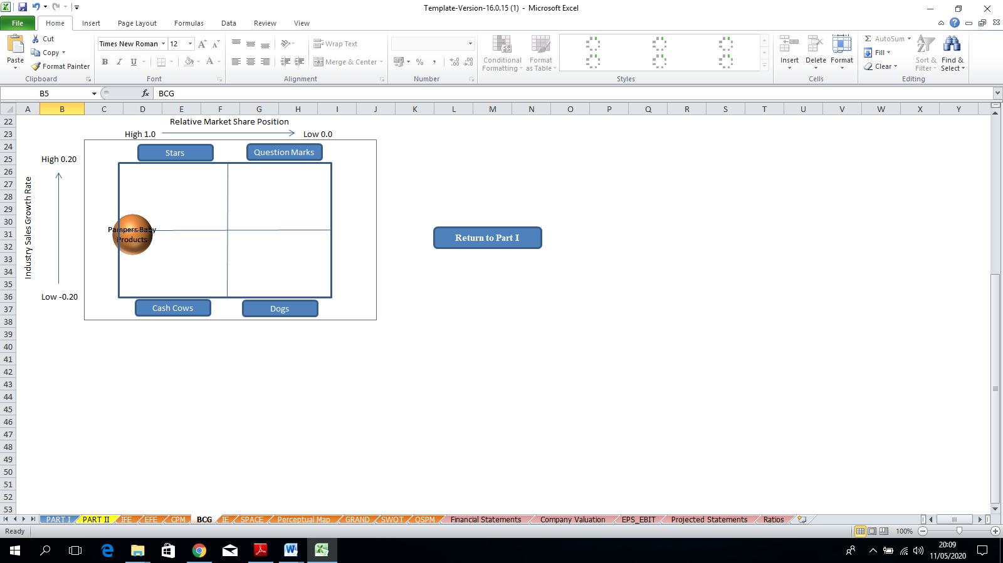

*Figure 3:* BCG Matrix indicating the position of the Pampers brand

# 7.2 Place

The choice of retail outlet for products also affects the probability of purchase and the characteristics of customers attracted. Pampers uses intensive retailing and the brand has been extensively marketed across the world; the UAE is particularly widely recognized as one of the production locations of the different products associated with the brand. Intensive retailing in this context, refers to the use of every available outlet (Yeboah et al. 2013; Kotler and Keller 2011). As such, Pampers brand is widely available and thus the most common besides other brands produced by companies that are domiciled in the UAE, such as Kao Corporation and Kimberly-Clark Corporation. The products are, therefore, widely available.

# 7.3 Price

The pricing strategy used for Pampers is more of competitive pricing. Pampers brand is characterized as a high-end competitive product, hence quite differentiated from the other local products in the UAE. Penetrative or skim pricing do not work well with such product differentiation since the customers who can identify the differences between the products can usually afford to pay more for their intended products (Ko 2011). As observed for the Pampers brand, there is a high level of customer loyalty in spite of the relatively high price in a price-sensitive market, and in the absence of deliberate efforts in pushing for customer retention. The competitive pricing, therefore, places Pampers brand at par with its main competitor, Huggies.

# 7.4 Promotion

Pampers brand is promoted using many strategies, and the promotion can be deemed effective. P&G has used a combination of digital and traditional marketing approaches and both push and pull strategies to attract customers. Pampers is associated with both broadcast and print media adverts, as well as various online run promotions, such as the Pampers rewards promotion, in which potential customers are rewarded based on points accumulated following product purchase through the online Pampers rewards app (Pampers 2020). The Pampers Rewards app is one type of push strategy used by P&G, while other forms of promotion, such as dependence on social media and broadcast advertisement, reflect the pull strategy as used by P&G. There is, however, still a gap in promotion as there is no active evidence that the company focuses on customer retention in addition to the initial customer attraction efforts.

# 8. Conclusions and Recommendations

Pampers brand has gained significant recognition not only in the UAE but also across the world. The brand includes products such as baby diapers and baby wipes, which are mostly marketed to the middle to high-income populations. The marketing strategies of Pampers brand have been analysed in this study and summarized as follow: The brand has significant strengths, such as the pre-existing brand recognition, and increasing awareness and need for disposable diapers, which currently possess about 66% of the market shares. P&G, the manufacturing company behind the Pampers brand, has marketed the brand extensively through a combination of push and pull strategies, relying on both traditional and digital media.

In spite of the significant efforts that P&G has placed on marketing Pampers brand, there is still a gap in customer retention efforts. The brand can increase its market shares by deviating from dependence on the natural customer loyalty generated through experiences with products, to incremental loyalty attributed to brand marketing. It is therefore recommended that Pampers should use additional promotion methods that reward customer loyalty rather than purchase.

# References

Gichuru, M.J. & Limiri, E.K. (2017). Market segmentation as a strategy for customer satisfaction and retention. *International Journal of Economics, Commerce and Management,* V(12), pp. 544-553. Available at https://[ijecm.co.uk/wp-content/uploads/2017/12/51231.pdf](http://ijecm.co.uk/wp-content/uploads/2017/12/51231.pdf). Accessed on 7th May 2020.

Khan, R. (2009). ‘Raising Eco Baby.’ *Gulf News,* 25th June*.* Available at https://[gulfnews.com/uae/raising-eco-baby-1.502628](https://gulfnews.com/uae/raising-eco-baby-1.502628). Accessed on 24th April 2020.

Ko, S. Y. (2011). Price strategy for product launch – from the customer value perspective. *The Swedish School of Textiles, Master’s Thesis*. Available at https://[www.diva-portal.org/smash/get/diva2:1309354/FULLTEXT01.pdf](http://www.diva-portal.org/smash/get/diva2:1309354/FULLTEXT01.pdf). Accessed on 10th May 2020.

Kothari, U. & Clay, (2020). *Marketing Management*

Kotler, P. & Keller, K. L. (2011). *Marketing Management, 14th Ed.* Pearson Publications.

Mendoza, J.M., D’Aponte, D., Gualtieri, D. & Azapagic, D. (2019). Disposable baby diapers: life cycle costs, eco-efficiency, and circular economy. *Journal of Cleaner Production*, 211, pp. 455-467. Available at https://[www.sciencedirect.com/science/article/pii/S0959652618335492](http://www.sciencedirect.com/science/article/pii/S0959652618335492). Accessed on 28th April 2020.

Pampers. (2020). Pampers-rewards. *Procter & Gamble*, [Online]. Available at https://[www.Pampers.ae/Pampers-rewards](http://www.pampers.ae/pampers-rewards). Accessed on 3rd May 2020.

Pavithra, S, Nithya, N. & Shivany, S. (2016). Exploring the Factors Influencing Mothers' Brand Choices on Baby Diaper Brands. *International Conference on Contemporary Management at Sri Lanka*, pp. 579-592. Available at https://[www.researchgate.net/publication/336512935_exploring_the_factors_influencing_mothers'_brand_choices_on_baby_diaper_brands](http://www.researchgate.net/publication/336512935_exploring_the_factors_influencing_mothers'_brand_choices_on_baby_diaper_brands). Accessed on 20th April 2020.

Reeves, M., Moose, S. & Venema, T. (2014). The growth share matrix. *Perspectives, the Boston Consulting Group*. Available at https://[image-src.bcg.com/Images/BCG_Classics_Revisited_The_Growth_Share_Matrix_Jun_2014_tcm91-84453.pdf](https://image-src.bcg.com/Images/BCG_Classics_Revisited_The_Growth_Share_Matrix_Jun_2014_tcm91-84453.pdf). Accessed on 1st May 2020.

Sharma, A. (2019). Baby diapers market size, trends, product types, age group & industry research report 2018-2025. Available at https://[www.researchgate.net/publication/332189932_Baby_Diapers_Market_Size_Trends_Product_Types_Age_Group_Industry_Research_Report_2018-2025](http://www.researchgate.net/publication/332189932_Baby_Diapers_Market_Size_Trends_Product_Types_Age_Group_Industry_Research_Report_2018-2025). Accessed on 17th April 2020.

Shrestha, S.K. (2018). Brand loyalty of baby diaper products. *Management Dynamics*, 21(1), pp. 79-88. Available at https://[www.google.com/search?q=environmental+factors+affecting+customer+preferences+for+baby+diapers&oq=environmental+factors+affecting+customer+preferences+for+baby+diapers&aqs=chrome..69i57.13437j0j7&sourceid=chrome&ie=UTF-8#](http://www.google.com/search?q=environmental+factors+affecting+customer+preferences+for+baby+diapers&oq=environmental+factors+affecting+customer+preferences+for+baby+diapers&aqs=chrome..69i57.13437j0j7&sourceid=chrome&ie=UTF-8). Accessed on 30th April 2020.

Trefis Team and Great Speculations. (2016). Procter & Gamble and Kimberly Clark compete sharply in the diaper battlefield. *Forbes Magazine*. Available at https://[www.forbes.com/sites/greatspeculations/2016/09/23/procter-gamble-and-kimberly-clark-compete-sharply-in-the-diaper-battlefield/#4bc2339a6f78](http://www.forbes.com/sites/greatspeculations/2016/09/23/procter-gamble-and-kimberly-clark-compete-sharply-in-the-diaper-battlefield/#4bc2339a6f78). Accessed on 4th May 2020.

U.S. SEC (2020). The Procter & Gamble Company- 10K Form. United States Securities and Exchange Commission. Available at <https://www.pginvestor.com/Cache/IRCache/c81a4a01-2a87-aa2b-eaaf-3280af2dcb05.PDF?O=PDF&T=&Y=&D=&FID=c81a4a01-2a87-aa2b-eaaf-3280af2dcb05&iid=4004124>. Accessed on 22nd April 2020.

Xu, W., Zhang, Q. & Ma, J. (2013). The relationship among customer demand, competitive strategy, and manufacturing system functional objectives. *Journal of Industrial Engineering and Management*, 6(4), pp. 1238-1254. Available at https://[upcommons.upc.edu/bitstream/handle/2099/14172/Wei%20Xu.pdf](https://upcommons.upc.edu/bitstream/handle/2099/14172/Wei%20Xu.pdf). Accessed on 26th April 2020.

Yeboah, A., Owusu, A., Boakye, S., & Owusu-Mensah, S. (2013). Effective distribution management, a pre-requisite for retail operations: A case of Poku trading. European Journal of Business and Innovation Research, 1(3), pp. 28-44. Available at: <http://www.eajournals.org/wp-content/uploads/EFFECTIVE-DISTRIBUTION-MANAGEMENT-A-PRE-REQUISITE-FOR-RETAIL-OPERATIONS-A-CASE-OF-POKU-TRADING.pdf>. Accessed on 6th May 2020.

# Appendix

## Appendix A: BCG Matrix Data (U.S SEC 2020)

