|  |
| --- |
| **Unit Code** : MKT 501  **Topic Name** : Marketing Management  **Lecturer Name** : Mr. Clay  **Submission Date** : May 14th, 2020  **Student Name** : Nada Nasser Al Ghamdi  **Student ID** : 11005 |

**Table of Contents**

**Executive Summary** 3

**Nestle Overview** 3

**Competition Definition (Comparison Between Nestle & Unilever VN)** 6

**Target Market of Nestle** 7

**Nestle Market Segmentation** 8

**Nestle SWOT Analysis** 9

**4 p's of Nestle** 12

**Conclusion** 14

**Recommendations** 15

**Appendix** 16

**References** 18

# **Executive Summary**

"Good food, Good life. It is a good business. Consumer expectations, competition, trade landscapes, and society are all evolving at an unprecedented pace. Our company must respond to deliver good food in ever more relevant, accessible, and sustainable ways. Every choice we make reflects our commitment to deliver Good food, Good life. Good is about holding ourselves to high standards and always striving to be better."

This is the motto on which Nestlé depends on its marketing strategy in order to spread more and broadly in the market, as it is a food company that works to export healthy, nutritious foodstuffs in the body, and Nestlé is considered a world leader in its industry and products that are difficult to compare or compete with others.

In this research, we will study the Swiss food company Nestle, and we will focus on this research on the marketing strategy adopted by Nestlé. This study includes an overview of the life of the product in Nestlé, distribution of products and the target market, SWOT analysis and the study of the marketing mix, and at the end of the research, some Recommendations that will modify the marketing strategy in order to increase its production.

# **Nestle Overview**

Nestlé was founded in 1866, where its beginnings were through the establishment of two companies that were separate from each other and then they became one company called Nestlé, and the company has done much work to expand the distribution of its products throughout Europe and the United States. (Immonen, 2008)

In 1867, two brothers from the United States, Charles and George Page, founded the Swiss Condensed Milk Company, the first opening in Britain in 1873.

In 1866, Henri Nestlé developed baby food that is based on milk and health products, then began marketing and promoting his products, and he succeeded in making Nestlé a large, global, and worldwide brand. (Immonen, 2008)

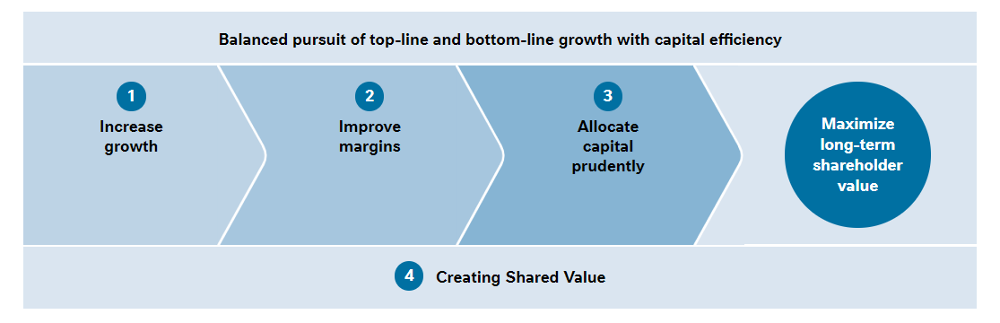

* **Nestle life cycle**

The Swiss company Nestlé is the leading nutrition company in the field of food, health, and wellness in the world, and the company's revenues are close to millions of revenues.

The company's products are based on many foods such as breakfast cereals, sweets, baby food, coffee, frozen foods, snacks, and milk. (Immonen, 2008)

Nestlé is a brand and has many brands like Stouffers, Nescafe, Kit-Kat, Carnation, Nestlé Water, and many others. (Immonen, 2008)

|  |  |
| --- | --- |
| Name | Nestle S. A |
| Logo |  |
| Industries served | Food Processing |
| Geographic area served | Worldwide |
| Headquarters | Switzerland |
| Current CEO | Paul Bulcke |
| Revenue | CHF 92.2 Billion (2012) |
| Profit | CHF 10.6 Billion (2012) |
| Employees | 328000 (2012) |
| Main Competitor | Unilever VN, Hershey Foods, Kraft Foods, Cadbury Schweppes, Group Danoe |

* **Moto of Nestle**

"Good Food, Good Life." (Nestle, 2020)

* **Nestle Vision**

The primary goal of Nestlé is to meet every day different needs of the consumer through marketing and selling of its products, which are characterized by efficiency and consistently high quality. (Nestle, 2020)

* **Nestle Mission**

Nestlé strives to provide consumers with safe food and optimal nutritional elements in order to meet physiological desires and needs and work to provide many foods of choice for all individual tastes and lifestyle preferences. (Nestle, 2020)

* **Growth Strategy of Nestle**

The commercial power that its brand has given it to Nestlé is the continuous reason for its success, as it is considered an unparalleled company in its industry on a global level, in addition to many other companies that contribute to Nestlé, such as Nescafe, Nastia, Maggie, Betony and Friskies, and their share is about 70% Of the company's sales, and 40% is left in favor of Nestlé, For more information see appendix 1. (Kotler, 2012)

Nestlé, its products and the industry in it are considered to be major companies that are interested in innovation and continuous renewal so that they are relevant, attractive, and renewable in order to make the consumer always want them.(Nestle, 2020)

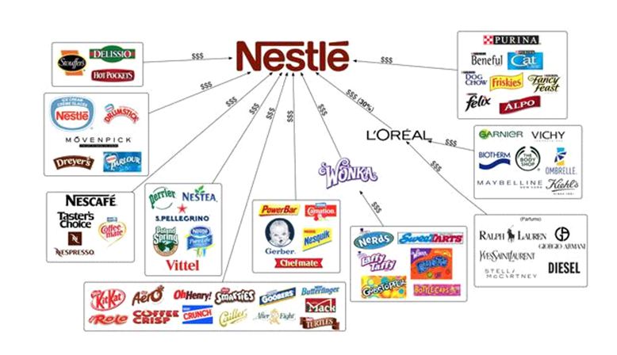

# **Competition Definition (Comparison Between Nestle & Unilever VN)**

Competition is a reality of doing trade. Businesses see competition in the formula of cost, profession, sketch, sales, situation, and almost every profession procedure. (Fleisher, 2015)

Many people regret touching it, many learn from it, and many run away from it. But most don’t recognize the correct aim of trade competition, its character, style, and even significance, for more information see appendix 2.

|  |  |
| --- | --- |
| Nestle | Unilever VN |
| Nestlé is its primary goal is to contribute to a better quality of life and to improve the quality of life, as it works to provide products with high features for all stages of life, and to help maintain a healthy lifestyle.  Today, Nestlé is one of the international companies whose products are spread all over the world, and it is difficult to compete because it dominates the global markets extensively, because of its products a great desire among customers. | A Unilever VN company is a company with an international brand as well and its products are distinguished as diverse as shampoo, ice cream, soap, and home care products, and they have appropriate prices that are suitable for everyone. Be at the desire of the consumer.  Be part of the world’s most successful, purpose-led business. Work with brands that are well-loved around the world, that improve the lives of our consumers and the communities around us. They promote innovation, big and small, to make our business win and grow; and they believe in business as a force for good. Unleash your curiosity, challenge ideas, and disrupt processes; use your energy to make this happen. Their brilliant business leaders and colleagues provide mentorship and inspiration, so you can be at your best. |

Competition in trade is the argument or emulation among the corporation selling homogenous products and/or aim the same target spectators to get more sales, extension income, and convenient more market share as acquire to others. (Nestle, UN, 2020)

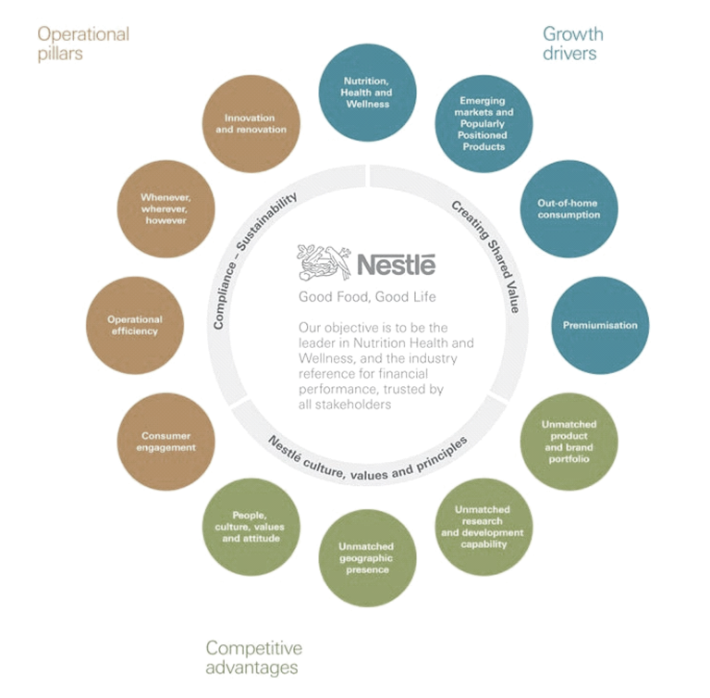

# **Target Market of Nestle**

Nestlé must choose the target sectors that suit the company’s needs and expectations, and define the company's resources and capabilities as well. (Aerk, 2009)

This can be done by doing a commercial gravity assessment and knowing the potential for the growth of some specific segments. (Aerk, 2009)

Where it can be divided into several sections, including:

* Tangible differences.
* Estimated earnings should be increased.
* Easily access market segments.
* And identify the appropriate parts. (Aerk, 2009)

Now Nestlé must define the clear position in creating the required image of its products in a positive way for the consumer who will purchase this product, therefore Nestlé must follow many steps in order to develop a strategy of how to determine effective and good sites through many questions Such as:

* How is your offer different from Nestle and its competitors?
* How does the brand serve the required needs?
* What strategy should be used to communicate with competitors?
* What are the strengths and weaknesses and how to develop them for the benefit of Nestlé? (Aerk, 2009)

Answering such questions will provide sufficient information for positioning.

Nestlé must analyze competitors well and evaluate their own situation through analytical data obtained from various markets and through surveys that employees of the company do with customers and competitors. (Aerk, 2009)

Carrying out sites and working to test the site’s effectiveness in a renewed manner by analyzing quantitative and qualitative data.

Using the test results to make the necessary adjustments to the trademark. (Aerk, 2009)

# **Nestle Market Segmentation**

The development of Nestlé's marketing strategy relies fundamentally on defining the retail basis to understand the extent of understanding the specific buying behavior of customers, and knowing the needs of the customer and expectations, based on several factors that are determined through lifestyle, gender, revenue, age, and values. (Pride, 2015)

Through division technology, Nestlé can narrow down the diverse target audience to many groups that differ from each other. Market segmentation surveys are the most frequently used methods to obtain the largest number of customer-related information, through which sets of properties are created. Shared. (Pride, 2015)

* Geographical division and its multiple divisions, based on geographical regions such as the region, country, and city.
* Or as for the demographic division, it requires Nestlé to divide the market according to gender, age, income, and race. (Pride, 2015)
* As for behavioral division, it depends on their purchasing styles, such as frequency of use, desired benefits, brand loyalty, and occasions of use.
* The psychological division will result in grouping clients based on their lives, interests, attitudes, values, and characteristics. (Pride, 2015)

# **Nestle SWOT Analysis**

Nestlé is one of the largest and most powerful companies in the world in the consumer goods market, Nestle Maggie's & coffee is the cash cow, so there are many brands in Nestlé that have achieved great success. (Campbell, 2015)

* **Strengths**

**1. World-renowned brands:**

Nestlé is one of the largest companies in the world in terms of its revenues, and Nestlé takes advantage of the success achieved through its trademarks and places its brands on its products, and this helps it to create a different awareness among people, as some of the products in Nestlé are affected and does not affect others of them. (Campbell, 2015)

**2. A large-scale distribution system:**

Nestlé has penetrated the civilized and rural markets and helped the distribution methods that it uses to expand its distribution chain across the world, as well as its distribution through itinerant sellers and door to door distributors. (Campbell, 2015)

**3. Wide product range:**

Nestlé is one of the companies that consist of more than 8000 brands under its name, which vary as mineral water, coffee, soup, sauces, and breakfast cereals. (Campbell, 2015)

**4. The large workforce:**

Nestlé is a company with a global product of diverse companies that works continuously to make its products available in all places in the world. (Campbell, 2015)

**5. Research and Development Centers:**

The Nestlé Food and Nutrition Research Organization is considered one of the largest research and development centers in the field of food, along with nearly 5,000 people, along with joint venture funds and research partnerships that Nestle undertakes with businesses and universities, where the number of its centers in research and development is about 21 centers around the world. (Campbell, 2015)

**3. Trademark ownership:**

The Nestlé brand is ranked 37th in the world rankings, which proves the continuous success. (Campbell, 2015)

* **Weaknesses**

**1. Maggie's Controversy:**

It has been discovered that Maggie, which is produced for Nestlé, is harmful to health and contains additives, which affected Nestlé, but it re-manufactured it again and demonstrated that it is of high quality. (Campbell, 2015)

**2. Brand Structure:**

There are multiple brands manufactured in Nestlé under the same name, and this may create problems such as conflicts of interest. (Campbell, 2015)

**3. Legal and consuming issues:**

Although Nestlé is a large company, it has suffered from controversy due to the boycott of Nestlé Milk, child labor by suppliers, and the price of chocolate has been determined.

* **Opportunities**

**1. Healthy breakfast:**

Most of the breakfast products are heavy and people become more health-conscious, so Nestlé needs to expand in the market in order to spread the culture of the importance of breakfast cereals more widely. (Campbell, 2015)

**2. Market expansion:**

Nestlé must expand the market by entering all types of rural and civil markets, through a strong supply chain, the transition to organized business, and further expansion.

**3. Increase income levels:**

The income available to people increases due to many reasons due to political stability and literacy, and this increases the demand and changes the lifestyle. (Campbell, 2015)

**4. Strategic alliances:**

Nestlé company participates with many large partnerships, including Coca-Cola, which opens up great opportunities for it, and is also considered one of the largest contributors to L'Oréal specialized in cosmetics in the world, so the partnership with international giant companies will increase its expansion. (Campbell, 2015)

**5. Focusing heavily on research and development to deal with ethical issues:**

In order to address some of the health issues, Nestlé must do a lot of research and development. (Campbell, 2015)

* **Threats**

**1. Market competition:**

With many competitors making competition for Nestlé extremely difficult, the threat from counterfeit products that threaten the Nestlé brand in the market is a major loss for them.

**2. Commodity price:**

Higher prices will increase the prices of other products, and the increase in price will lead to lower sales and work to replace the brand. (Campbell, 2015)

**3. Buyers' Power:**

It is very difficult to adhere to customers, as the customer has the great ability to choose a brand through availability factors, reference group recommendation, preference, and price.

# **4 p's of Nestle**

* **product**

**1. Beverages:**

It is considered one of the most famous beverages for the benefit of Nestlé Company is the Nescafe brand, and it is considered one of the most cash-generating products in favor of Nestlé Company all over the world, and it has many backward variants.

**2. Milk and milk products:**

milk nestle, nestle every day, and nestle milkmaid. (Pruschkowski, 2018)

**3. Prepared dishes and cooking assistants:**

The main cash cow in this category of food is considered to be one of the most popular Maggie noodles, and the noodles product is the most widely spreadable, so it sold a wide brand of Maggie, thus creating an umbrella of different products such as Maggie pasta, Maggie clay, and Maggie cubes. (Pruschkowski, 2018)

**4. Chocolate:**

Chocolate products from Nestlé are among the largest products that increase revenue, such as Nestlé KitKat, Munch, Milky Bar, Eclairs, and Polo.

**BGC:**

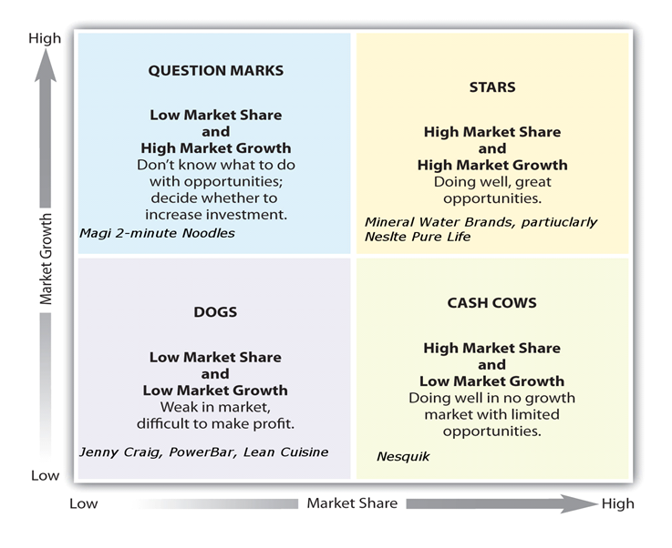

* **Question marks:**

Products in this area are distinguished by a high market but with a low market share, such as Maggie Noodles. (Pruschkowski, 2018)

* **stars:**

A high market share and a high growth market, such as mineral water, because such products require large sums and a large amount of investment, in order to distinguish between brands and competitors in mature markets, and increase brand awareness in emerging markets. (Pruschkowski, 2018)

* **Dogs:**

Products here enjoyed low market share and low markets, such as the brand Jenny Craig and Lynn Cousin which was intended for weight loss to expand outside the United States.

The products here have a high market share but a low growth market, so you must invest to generate revenue or allow the production of money invested by stars or question marks.

* **price**

The market for each product is what determines the price, Products such as Nescafe and Maggie are the leaders in the competition, and this is evident in the quality of the product, and thus the customer will not cause the brand to change. Through reliance on packaging, packaging, and consumption comes the power of hardening. Products such as Nescafe and Maggie provide them with Nestle's many sizes and package options.

Consequently, the customer can make the right decision regarding his consumption of the product based on the available diversity. Therefore, the company provides suitable prices according to the competition with the product. (Pruschkowski, 2018)

* **place**

Manufacturing >> C & F agent >> Distributors >> Retailers >> Consumer

Manufacturing >> Bulk buyers >> Consumer

These two types are the primary distribution factors for Nestlé, and they are typical of FMCG companies. (Pruschkowski, 2018)

Nestlé offers commercial discounts and various methods to maintain its motives.

The main challenge for Nestlé is Maggie as it is considered the most in-demand with Nescafe, and due to these products, Nestlé is considered able to lead the market.

The main challenge for Nestlé is in the chocolate sector, where it faces many competitors, most notably Cadbury, and thus converting retail to sell Nestlé instead of Cadbury is a difficult task for Nestlé. (Pruschkowski, 2018)

* **promotion**

One of the most successful promotional ads is the melody of the brand Nescafe.

The main factor in the progress of Nestlé is the presence of Maggie in it and the innovative campaigns of Maggie, where Nescafe relied on value and good things in life, and Maggie focused on the moments that the customer lived with. (Pruschkowski, 2018)

Promotion is the foundation of the brand’s success. The KitKat product is based on “taking a break”, Nestlé focuses on its strength, Maggie, Nescafe, and KitKat, which are the most popular promotional brands in the world. (Pruschkowski, 2018)

# **Conclusion**

The emergence of consumer food products is the reason behind the tremendous change in the food habits of consumers, as Nestlé has complied with the most appropriate provision of its products in order to enhance the loyalty of its customers to be able to compete in the global markets.

Nestlé is one of the largest food companies, as its products rely heavily and essentially on experience, efficiency, and quality at work, as it believes in the importance of quality products in order to enhance customer loyalty to them.

Nestlé has segmented the market based on some preferences among people in order to meet their needs.

The challenge for Nestlé is to introduce new products that are taught to bridge gaps in the market and ensure customer desire and satisfaction.

# **Recommendations**

1. Nestlé must further study the market and find out why some products do not spread.
2. The use of new strategies in the promotion and marketing of its products in order to fully support its industry.
3. Exploiting the success of some brands, such as Nescafe and Maggie, for the success of other brands.
4. Doing customer questionnaires about their desire and acceptance of the products that Nestlé offers in the market, and explaining their satisfaction with these products.
5. Focusing on competing companies and tying up the methods that Nestle uses to compete with and beat these companies in global markets.
6. Acquiring the largest place in the market share and increasing its market revenue in order to provide the largest number of products that customers want.

# **Appendix**

1. **Developing a Marketing strategy**

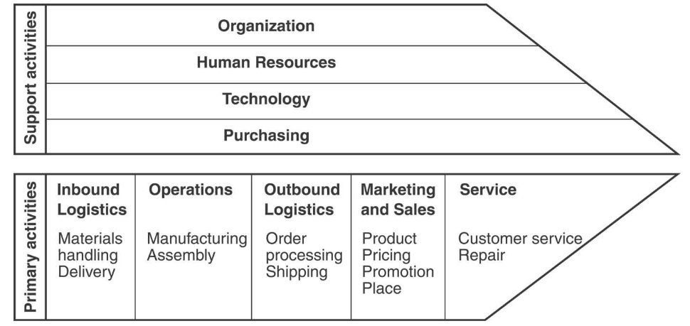

1. **Nestle Competitive advantage**

With increasing competition, survival in global markets is increasing, and therefore it is worth noting that Nestlé must put a competitive advantage that distinguishes it from others in the global markets by identifying unique selling offers such as providing the highest quality, the lowest cost or the uniqueness of the idea, but For Nestlé, determining sales offers is not sufficient because the effectiveness of the marketing strategy depends on the ability of the management to deliver specific sales offers.

Nestlé can implement Porter's strategy model to benefit from it in exploring how to create a competitive advantage, as shown in the following diagram:

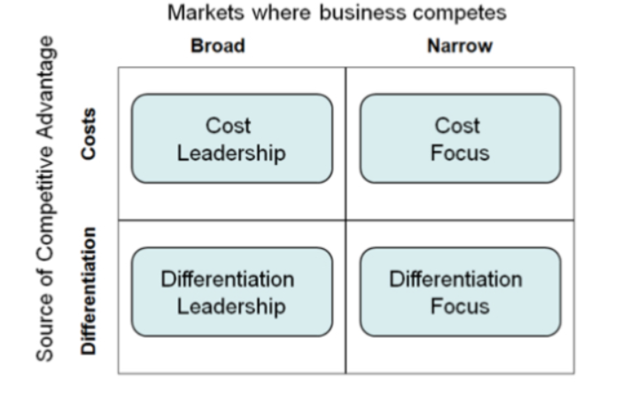

# **References**

1. Aerk, D. A. (2009). The target market of Nestle: Creating relevance, differentiation, energy, leverage, and clarity.
2. Campbell, P. (2015). SWOT analysis in a day. CreateSpace Independent Publishing Platform.
3. Fleisher, C. S., & Bensoussan, B. E. (2015). Business and competitive analysis: Effective application of new and classic methods.
4. Immonen, A., & Saaksvuori, A. (2008). Product lifecycle management.
5. Kotler. Ph. & others. (2012). Marketing management. library of Congress Cataloging in Publication Data. Kotler, Philip.
6. Nestlé. (2020). About us. <https://www.nestle.com/>
7. Pride, W. M., Ferrell, O. C., Lukas, B. A., Schembri, S., & Niininen, O. (2015). Segmentations of co.
8. Pruschkowski, M. (2018). The BCG matrix and its support for management decision making.
9. Unilever. (2020). About us. <https://www.unilever.com/>