Create a VPC with Public and Private Subnets — Step-by-step

1. Open the VPC Console
- Sign in to the AWS Management Console.
- In the search bar at the top, type VPC and click VPC from the results.

2. Create the VPC
- In the left menu, click Your VPCs → Create VPC.
- Choose VPC only.
- Fill fields:
  - Name tag: My-VPC
  - IPv4 CIDR block: 10.0.0.0/16
- Click Create VPC

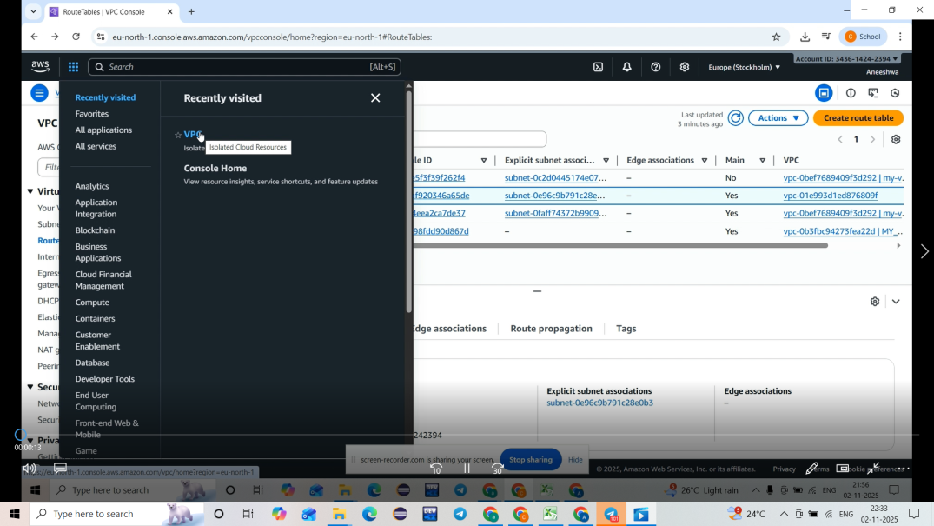

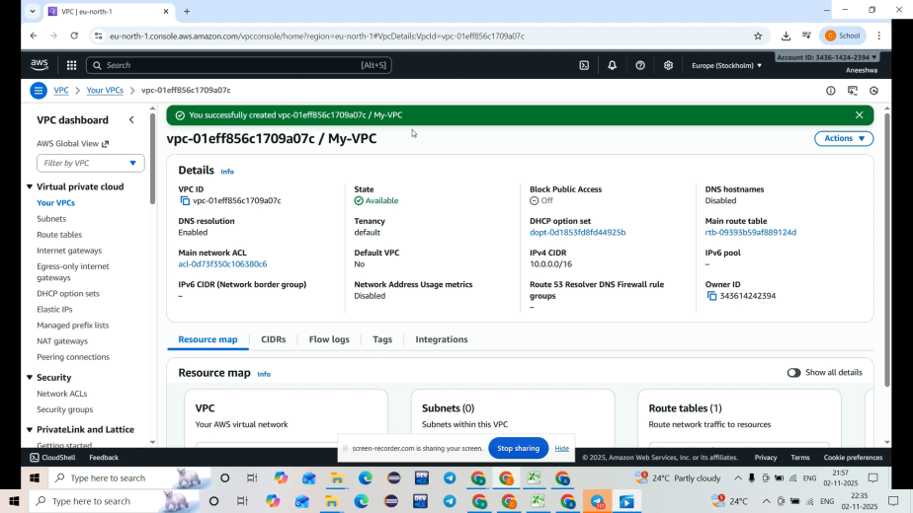

3. Create the Public Subnet
- In the left menu, click Subnets → Create subnet.
- Fill fields:
  - VPC: My-VPC
  - Subnet name: Public-Subnet
  - Availability Zone: e.g., ap-south-1a
  - IPv4 CIDR block: 10.0.1.0/24
- Click Create subnet.
- Select the Public-Subnet → Actions → Edit subnet settings → enable Auto-assign IPv4 public address → Save.

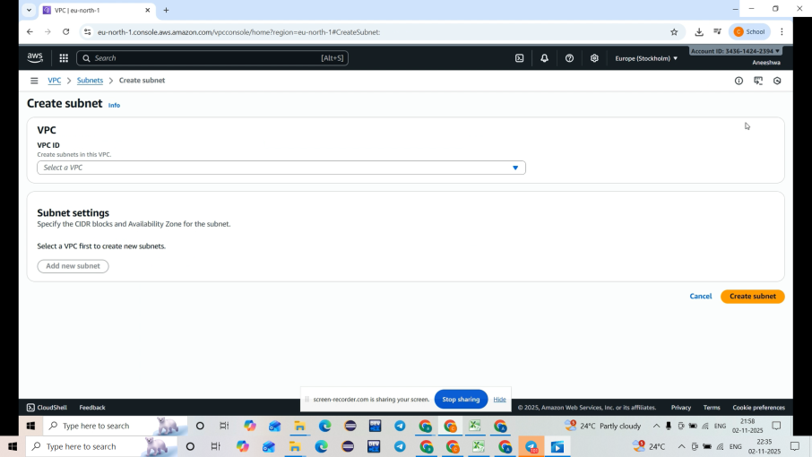
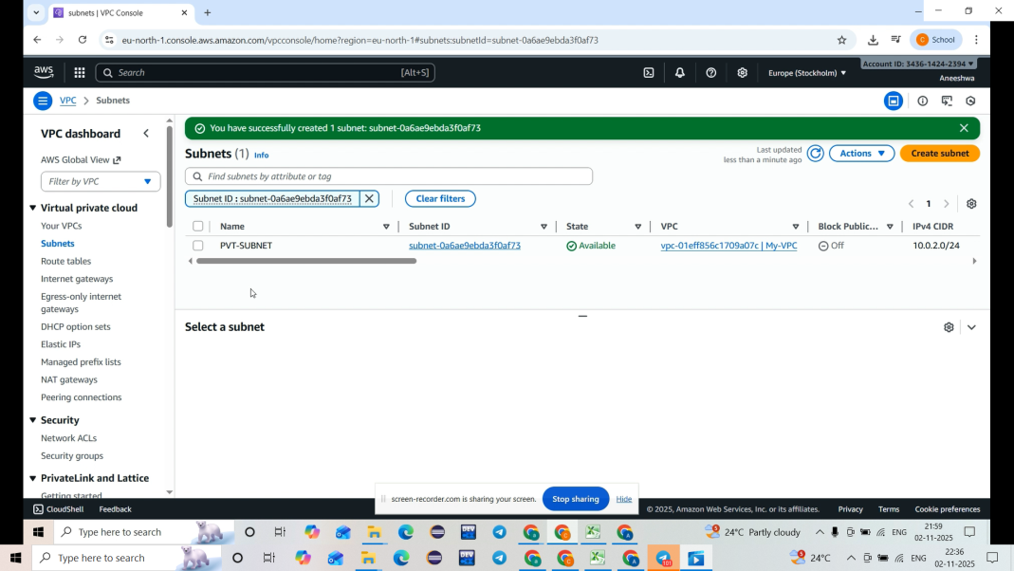

4.Create the Private Subnet
- Click Create subnet again.
- Fill fields:
  - VPC: My-VPC
  - Subnet name: Private-Subnet
  - Availability Zone: e.g., ap-south-1b
  - IPv4 CIDR block: 10.0.2.0/24
- Click Create subnet. (Do not enable public IP auto-assign.)

5.Create and Attach an Internet Gateway (IGW)
- In the left menu, click Internet Gateways → Create internet gateway.
- Enter Name: My-IGW → Create Internet Gateway.
- Select My-IGW → Actions → Attach to VPC → select My-VPC → Attach.

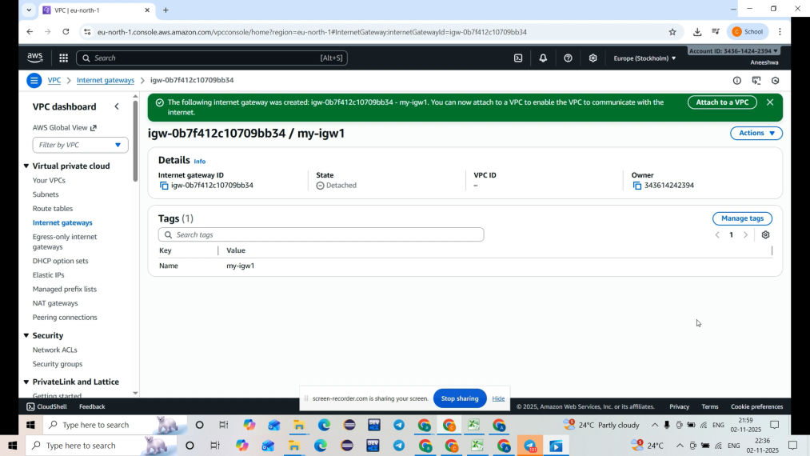

Create Route Tables and Associate Subnets

Public Route Table
- Click Route Tables → Create route table.
- Name: Public-RT, VPC: My-VPC → Create route table.
- Select Public-RT → Routes → Edit routes → Add route:
  - Destination: 0.0.0.0/0
  - Target: Select Internet Gateway (My-IGW) → Save.
- Subnet associations → Edit subnet associations → select Public-Subnet → Save.
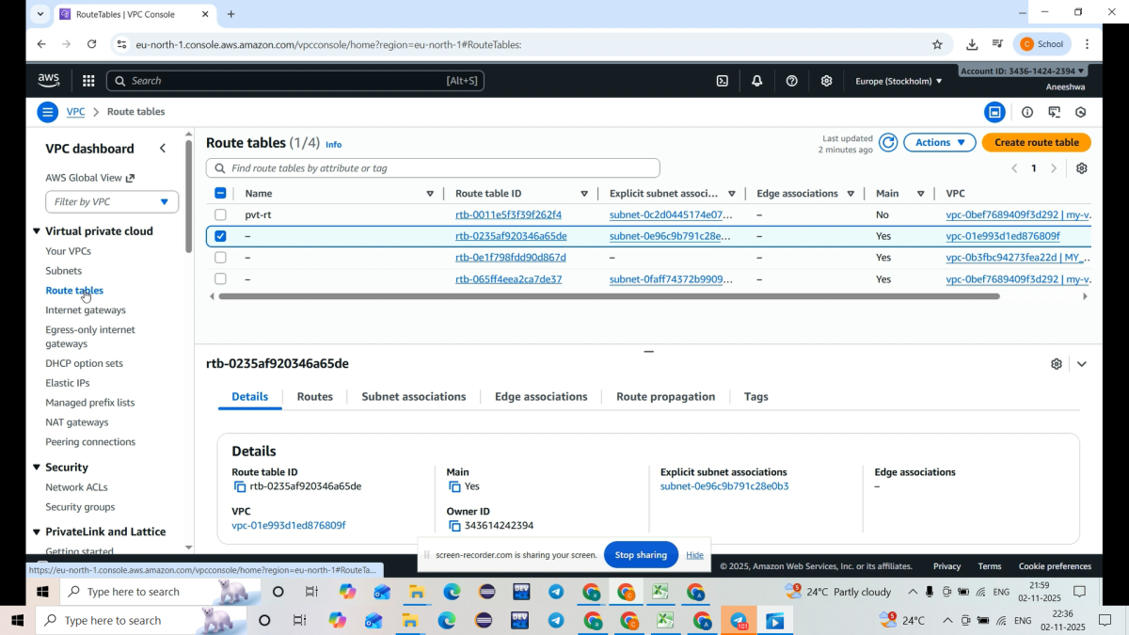
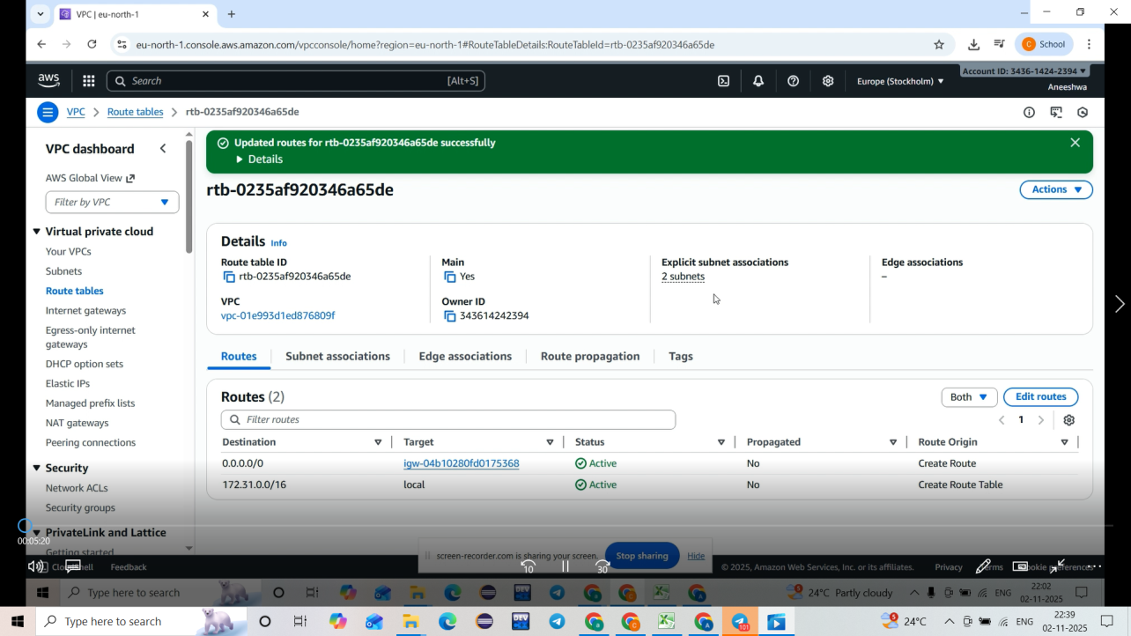

Private Route Table
- Create another route table: Name: Private-RT, VPC: My-VPC → Create.
- Do not add an internet route; keep the default local route only.
- Subnet associations → select Private-Subnet → Save.

