IT-SIMPLERA INSTITUTE
Network Administration Internship Program

WEEK 01 INTERNSHIP TASK REPORT
Networking Fundamentals & Network Simulation Tools

Submitted By | M Anees Zeb Khan
Internship Domain | Network Administration
Institute | IT-Simplera Institute
Supervisor | Jawad Qayum (Senior Network Administrator)
Submission Date | 28 June 2026
Deadline | 3 July 2026
Week | Week 01

Confidential – For Internal Assessment Purposes Only

1. Introduction

This report documents the completion of Week 01 of the Network Administration Internship at IT-Simplera Institute. The primary objective of this week was to gain foundational knowledge of computer networking concepts and to acquire practical, hands-on experience with two industry-standard network simulation platforms: Cisco Packet Tracer and GNS3.
Under the guidance of Senior Network Administrator Jawad Qayum, I studied core networking principles, installed and explored both simulation tools, designed Local Area Network (LAN) topologies, configured static IP addressing on virtual machines, and verified end-to-end connectivity using the ping command. This report presents a structured account of all concepts learned, activities performed, screenshots captured, and challenges encountered throughout the week.

2. Networking Concepts Learned

2.1 What is a Computer Network?
A computer network is a collection of interconnected devices (nodes) that communicate and share resources. Networks are categorized by geographic scale: LAN (Local Area Network), MAN (Metropolitan Area Network), and WAN (Wide Area Network). This week focused on LAN environments.

2.2 Network Devices
- Switch – A Layer 2 device that forwards frames based on MAC address tables, enabling multiple devices to communicate within the same network segment.
- Router – A Layer 3 device that routes IP packets between different networks.
- PC / End Device – The source or destination of network traffic.
- Hub – A legacy Layer 1 device that broadcasts traffic to all ports (not used in modern networks).

2.3 IP Addressing
IP addressing is the mechanism by which devices are uniquely identified on a network. This week, static IPv4 addressing was used:
- IP Address: A 32-bit identifier written in dotted-decimal notation (e.g., 192.168.1.1).
- Subnet Mask: Defines the network and host portions of an IP address (e.g., 255.255.255.0 for /24 networks).
- Default Gateway: The IP address of the router that traffic is forwarded to when the destination is outside the local subnet.

2.4 The OSI Model
The Open Systems Interconnection (OSI) model is a conceptual framework with 7 layers — Physical, Data Link, Network, Transport, Session, Presentation, and Application — that standardizes how different network protocols communicate. Understanding this model is foundational for troubleshooting and design.

2.5 The ping Command
The ping command uses ICMP (Internet Control Message Protocol) Echo Request/Reply messages to test reachability between two hosts. A successful ping confirms Layer 3 connectivity and proper IP configuration. Packet loss or timeouts indicate network or configuration issues.

3. Tools Installed & Overview

3.1 Cisco Packet Tracer
Cisco Packet Tracer is a free, beginner-friendly network simulation tool developed by Cisco Systems. It allows users to design, configure, and troubleshoot virtual network topologies using a drag-and-drop graphical interface without requiring physical hardware.
Key features include: a rich library of Cisco devices (routers, switches, PCs, servers), real-time and simulation modes, built-in terminal access, IP configuration GUI, and PDU (Packet Data Unit) tracking for visual packet analysis.

3.2 GNS3
GNS3 (Graphical Network Simulator-3) is a powerful, open-source network simulation platform used by professionals and certification candidates. Unlike Packet Tracer, GNS3 runs actual network operating system images (IOS, etc.) and supports VPCS (Virtual PC Simulator) for end-host emulation.
Key features include: support for real Cisco IOS, Juniper, and other device images; VPCS for lightweight PC simulation; telnet-based console access; integration with real hardware; and a topology canvas with detailed node management.

4. Cisco Packet Tracer – LAN Topology

4.1 Topology Design
A simple star-topology LAN was designed in Cisco Packet Tracer consisting of three PC-PT end devices (PC0, PC1, PC2) connected to a single 2960-24TT Layer 2 switch (Switch0). All devices were placed in the logical workspace.
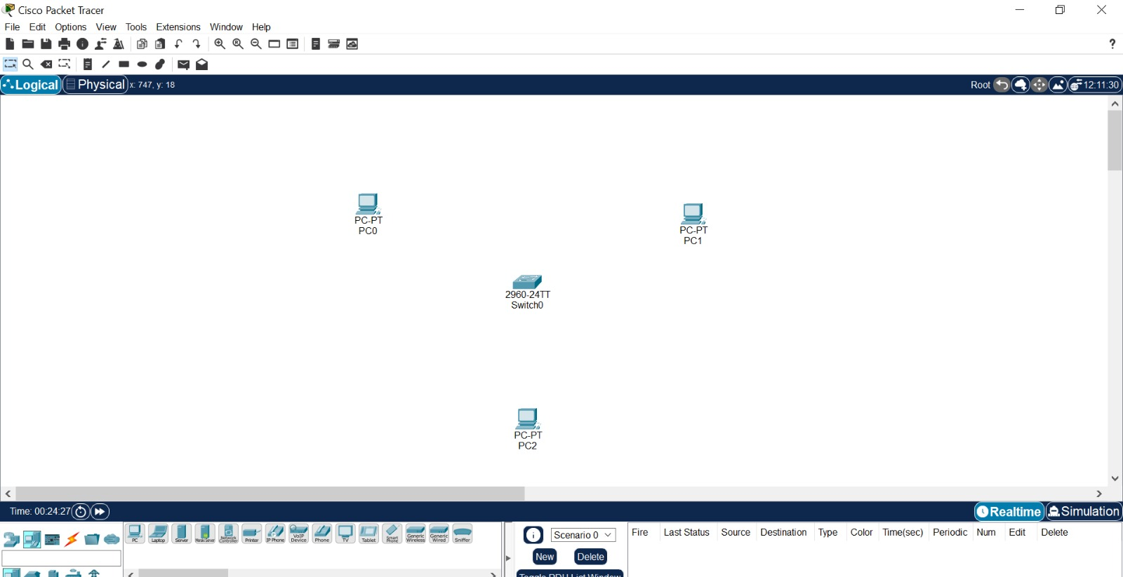
Figure: Cisco Packet Tracer – Logical workspace with Switch0, PC0, PC1, PC2 placed

The switch (Cisco 2960-24TT) was selected from the Switches category in the device toolbar. Three PC-PT devices were selected from the End Devices category and placed on the canvas.
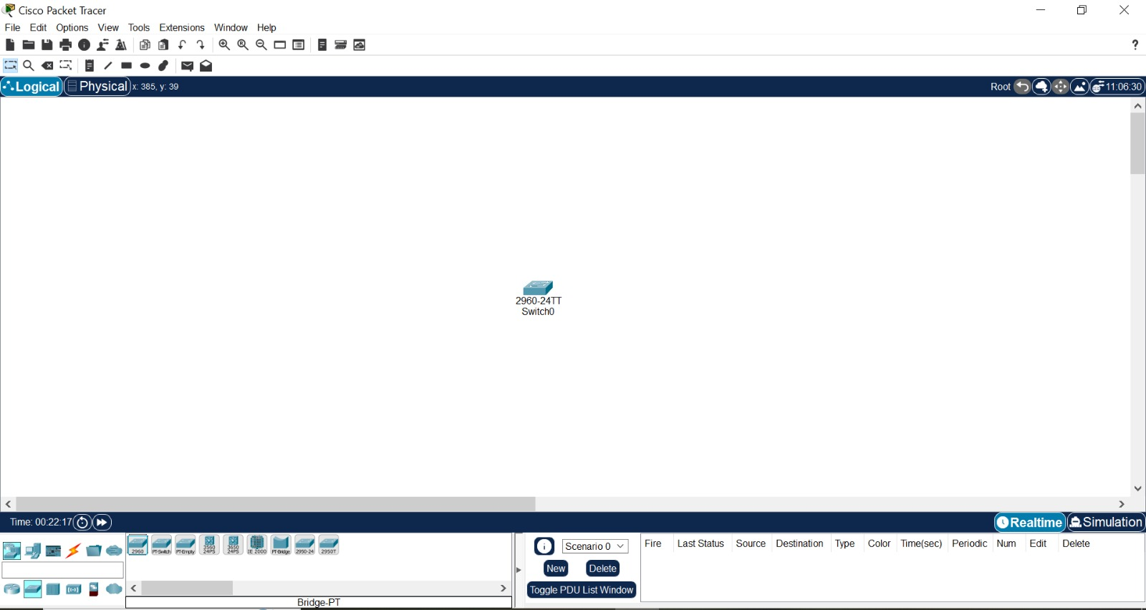
Figure: Cisco Packet Tracer – Switch added to workspace (2960-24TT)

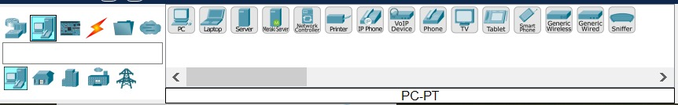
Figure: Cisco Packet Tracer – End device selection toolbar (PC-PT highlighted)

4.2 Connecting Devices
Straight-through Ethernet cables were used to connect each PC to the switch using the auto-connect feature. After connecting the cables and waiting for STP to converge, all interface status indicators turned green, confirming active links.
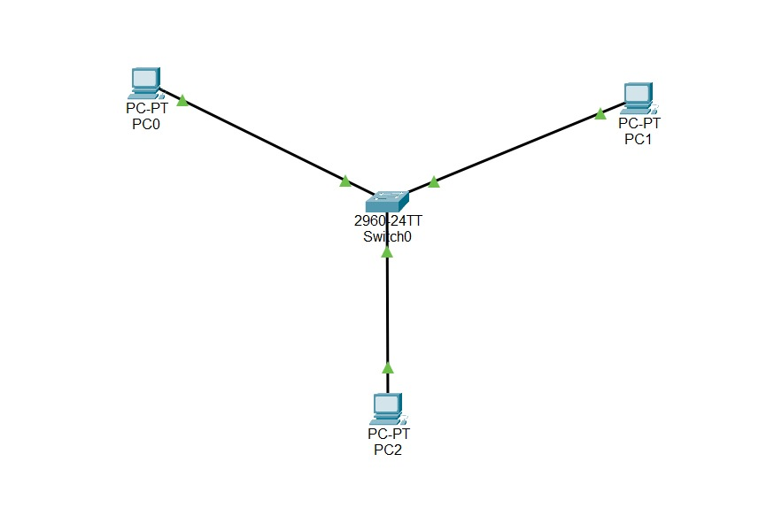
Figure: Cisco Packet Tracer – Fully connected star topology with active green links

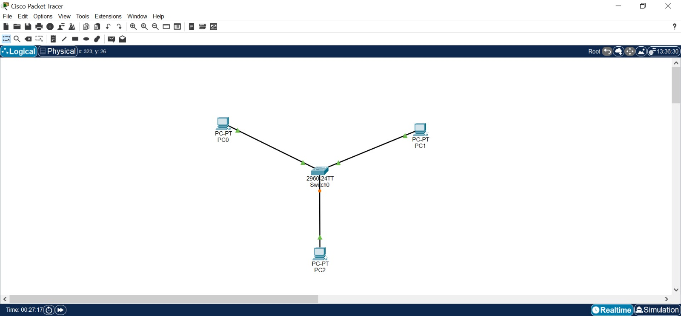
Figure: Cisco Packet Tracer – Complete LAN topology (PC0, PC1, PC2 connected to Switch0)

4.3 IP Address Configuration
Static IP addresses were assigned to each PC via Desktop > IP Configuration. The following address scheme was used:
Device | IP Address | Subnet Mask
PC0 | 192.168.1.1 | 255.255.255.0
PC1 (shown as PC1 in config) | 192.168.1.2 | 255.255.255.0
PC2 | 192.168.1.3 | 255.255.255.0

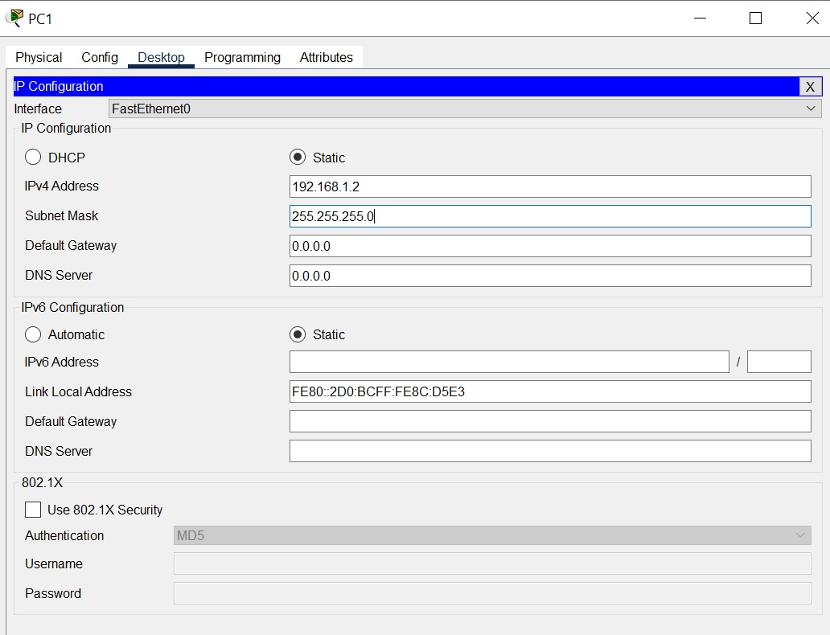
Figure: Cisco Packet Tracer – IP Configuration screen on PC1 (192.168.1.2 / 255.255.255.0)

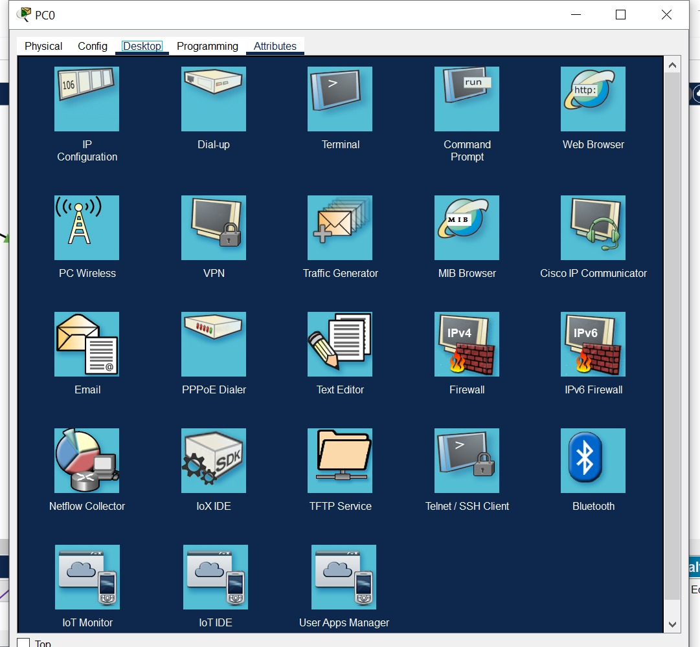
Figure: Cisco Packet Tracer – PC Desktop tab showing IP Configuration, Command Prompt and other tools

4.4 Connectivity Verification – Ping Test
After configuring all IP addresses, connectivity was verified from PC0 using the Command Prompt (Desktop > Command Prompt). PC0 successfully pinged both PC1 (192.168.1.2) and PC2 (192.168.1.3) with 0% packet loss.
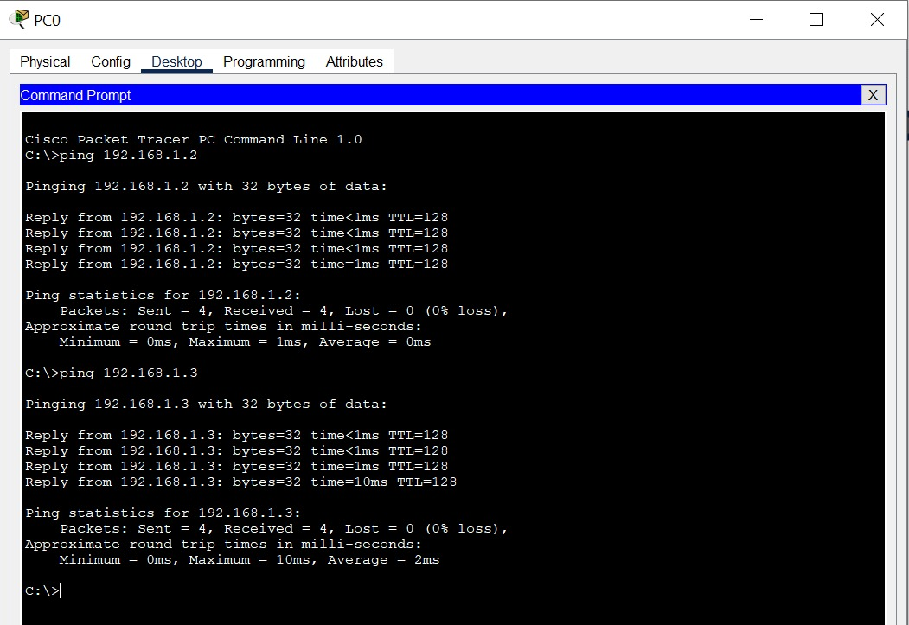
Figure: Cisco Packet Tracer – Ping from PC0 to PC1 (192.168.1.2) and PC2 (192.168.1.3) – 0% loss

5. GNS3 – LAN Topology

5.1 Project Setup & Topology Design
A new GNS3 project named "Week1_LAN" was created. Three VPCS (Virtual PC Simulator) nodes — PC1, PC2, PC3 — and one Ethernet Switch (Switch1) were added to the topology canvas. The project ran on GNS3 version 2.2.40.1 on Windows 64-bit.
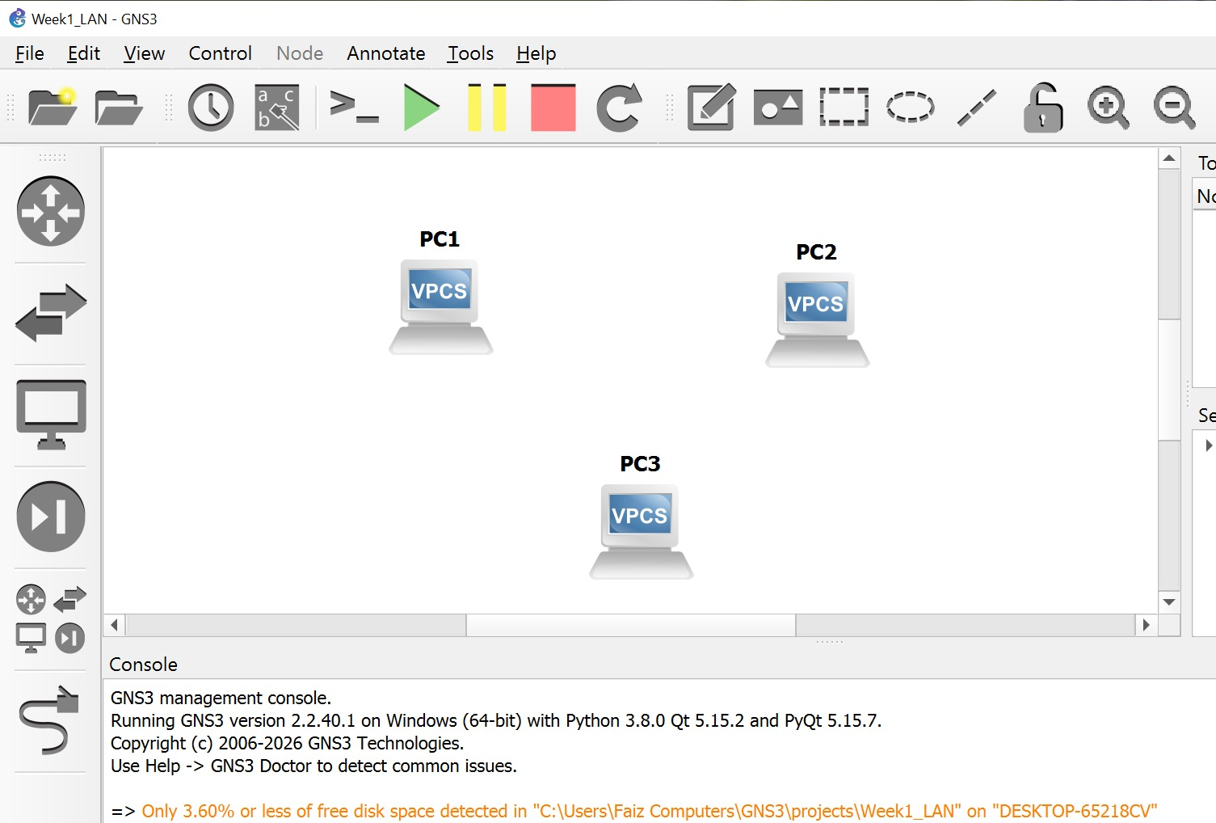
Figure: GNS3 – Initial workspace: PC1, PC2, PC3 (VPCS) placed without connections

The Topology Summary panel on the right confirmed all three VPCS nodes (PC1 on telnet localhost:5000, PC2 on :5002, PC3 on :5004) and Switch1 were registered. All nodes showed green (active) status after starting.
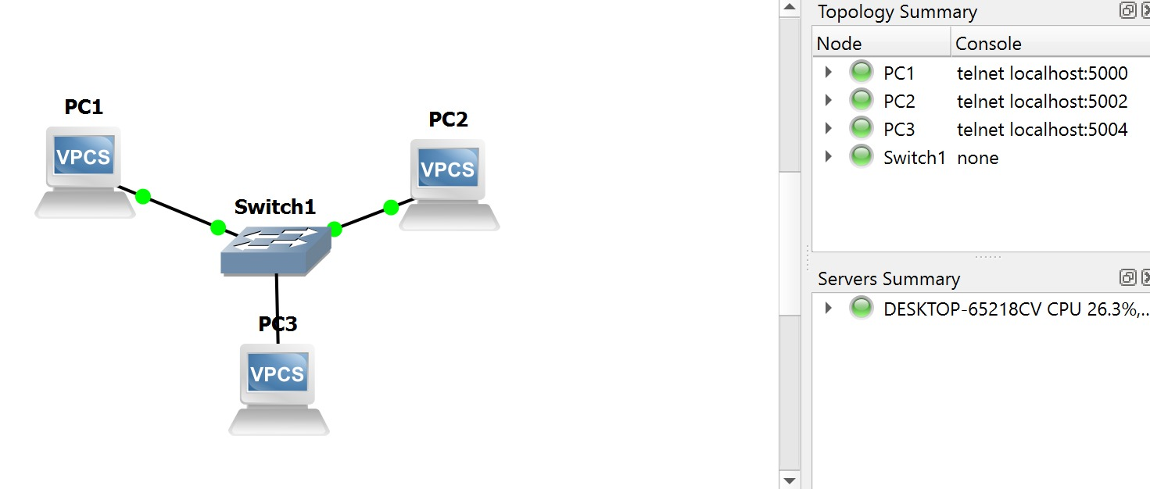
Figure: GNS3 – Topology with Switch1, PC1, PC2, PC3 connected; Topology Summary panel visible

5.2 Connecting Devices
Ethernet links were drawn between each VPCS and Switch1. Green dot indicators on all links confirmed successful link-up after the topology was started (Play button). The connections were:
- PC1 → Switch1 (e0)
- PC2 → Switch1 (e1)
- PC3 → Switch1 (e2)
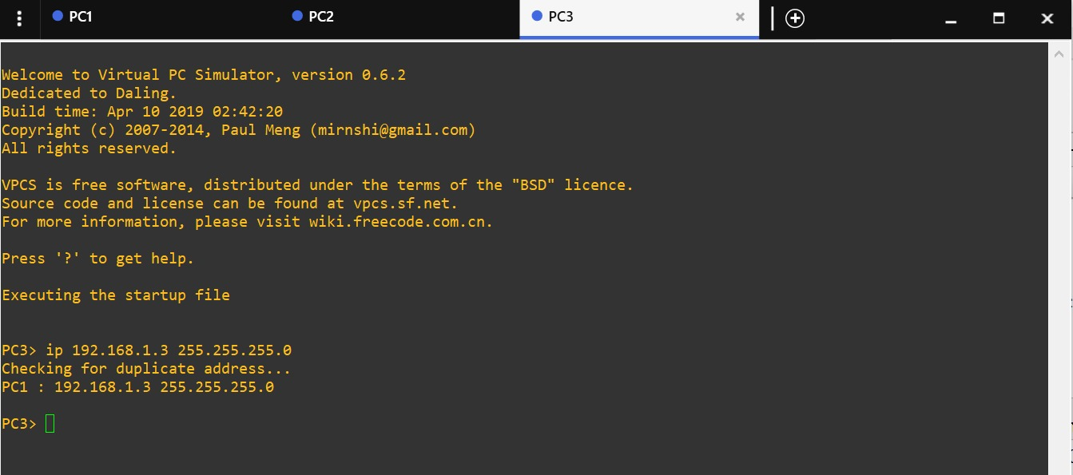
Figure: GNS3 – All VPCS nodes connected to Switch1 with active green link indicators

5.3 VPCS IP Address Configuration
Each VPCS console was accessed individually via the telnet localhost ports listed in Topology Summary. Static IP addresses were assigned using the VPCS "ip" command:
PC1> ip 192.168.1.1 255.255.255.0
PC2> ip 192.168.1.2 255.255.255.0
PC3> ip 192.168.1.3 255.255.255.0
During configuration of PC3, a duplicate address warning appeared: "PC1 : 192.168.1.3 255.255.255.0" – indicating that the system detected a possible conflict. However, since PC1 in VPCS was assigned .1 and the warning referred to a VPCS internal check, the configuration proceeded and connectivity was still verified successfully.
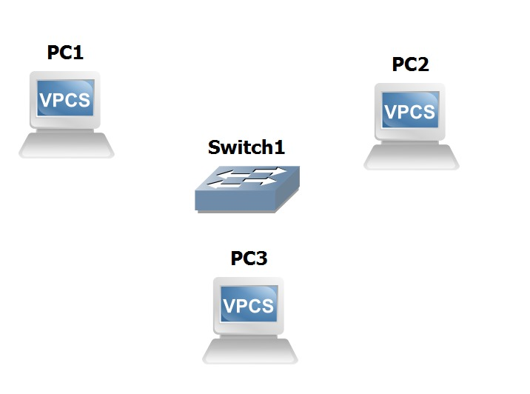
Figure: GNS3 – VPCS PC3 terminal: ip 192.168.1.3 assigned, duplicate-address check message shown

5.4 Connectivity Verification – Ping Test
From the PC3 VPCS console, a ping was issued to 192.168.1.1 (PC1). All 5 ICMP echo replies were received successfully with TTL=64 and response times ranging from 1.7ms to 2.0ms, confirming full LAN connectivity.
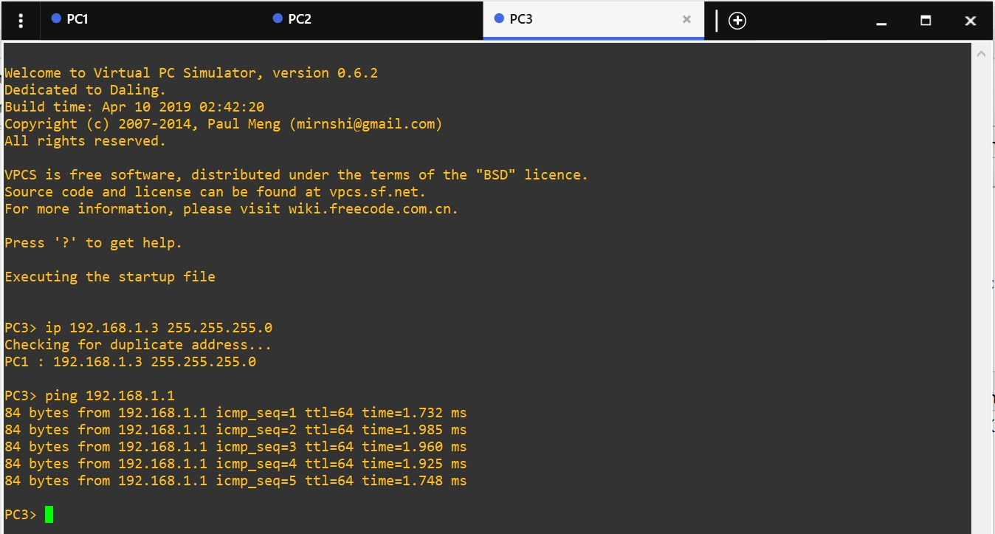
Figure: GNS3 – PC3 pinging 192.168.1.1 (PC1): 5/5 replies received – 0% packet loss

6. Comparison: Cisco Packet Tracer vs GNS3

Feature | Cisco Packet Tracer | GNS3
Target Users | Beginners, Students | Professionals, CCIE candidates
Device Emulation | Simulated (virtual) | Real IOS images
End Hosts | PC-PT (GUI-based) | VPCS (CLI-based)
Console Access | Built-in terminal | Telnet via localhost ports
Resource Usage | Low | Higher (runs real OS)
IP Config Method | GUI (IP Configuration) | CLI (ip command)
Cost | Free (Cisco NetAcad) | Free (open source)

7. Challenges Faced

- Duplicate Address Warning in GNS3: When assigning 192.168.1.3 to PC3, VPCS displayed a warning referencing PC1. This was understood as an internal VPCS ARP check rather than a true conflict; the ping test confirmed connectivity was intact.
- GNS3 Disk Space Warning: GNS3 reported that only 3.60% or less free disk space was detected on the project drive. This required cleanup of temporary files before proceeding with the project.
- STP Convergence Delay in Cisco Packet Tracer: After connecting all devices, the switch interfaces initially showed orange indicators. It was necessary to wait ~30 seconds for Spanning Tree Protocol to converge before the links turned green and pings succeeded.
- Understanding VPCS CLI vs GUI: Transitioning from the graphical IP Configuration tool in Cisco Packet Tracer to the VPCS command-line interface in GNS3 required careful attention to syntax and command structure.

8. Conclusion

This first week of the Network Administration Internship at IT-Simplera Institute provided a solid foundation in computer networking principles and practical experience with two leading simulation platforms. By successfully designing, configuring, and verifying a three-host LAN topology in both Cisco Packet Tracer and GNS3, I demonstrated the ability to apply IP addressing concepts, work with Layer 2 switching, and use diagnostic tools to confirm network connectivity.
The experience highlighted the complementary nature of both tools — Cisco Packet Tracer for rapid visual learning and GNS3 for realistic, production-grade emulation. The challenges encountered, including the VPCS duplicate-address check and STP convergence wait, deepened my understanding of real-world networking behaviour.
I am confident that the skills and knowledge gained this week form a strong base for the more advanced topics and configurations that will be covered in subsequent weeks of the internship.

M Anees Zeb Khan
Network Administration Intern | IT-Simplera Institute | June 2026

