Student Id: 25038579
Student name: Aneet Kaur
Assignment: Assessment Task 2
Advanced Data Visualisation

- Introduction
The Australian Open is one of the four major tennis tournaments, known as the Grand Slams. It has been held since 1905 and has changed a lot over the years — from who dominates the game to how long matches last and which countries players come from. Analysing these trends provides valuable insights into the sport’s progression and the performance of top athletes. This report focuses on key trends in the Australian Open, particularly highlighting players who have won five or more titles.
This report uses a dataset with detailed match information like the year, gender, names and nationalities of the champion and runner-up, seedings, match length, and scores for each set. To find interesting patterns, advanced data visualisations are used, including interactive charts like geographic maps, parallel coordinates, treemaps, and scatter plots. Additionally, the report evaluates the advantages of Tableau as a tool for high-dimensional sports data analysis.
- Dataset Overview and Preprocessing
Dataset Overview
The dataset used for this analysis contains historical match data from the Australian Open tennis championships, covering 120 years of competition. It provides detailed information about match outcomes, including the champion, runner-up, match scores, durations, and player nationalities. Key variables in the dataset include player details (names, nationality, seed ranking), match statistics (scores, duration), and year-wise tournament records. The data also separates men's and women's matches, which helps with gender comparisons. The match scores have also been pre-processed, with each set recorded separately to support detailed performance analysis.
The attributes of the dataset with the appropriate data types, along with justifications for each classification are shown below:
Column Name | Data Type | Justification
Year | Quantitative (interval-scale) | The “Year” column represents the year in which the tournament took place. The difference between years is meaningful (e.g., 2025 - 2020 = 5 years), but there is no true zero (there is no “year zero”), so it is classified as interval-scale data.
Gender | Categorical nominal | The “Gender” column categorizes matches as either “Men’s” or “Women’s.” Since these categories do not have a ranking, this is nominal data.
Champion | Categorical nominal | The names of players who won or reached the finals are unique identifiers. Since they do not have an inherent ranking, they are classified as nominal data.
Champion Nationality | Categorical nominal | Players' nationalities are descriptive labels without a ranking system. Therefore, they are nominal data.
Champion Country | Categorical nominal | Like champion nationality, country also represents categories without a natural ranking.
Score | Categorical nominal | The “Score” column records match results in a text format (e.g., “6-4, 3-6, 7-5”). Since the values cannot be directly analysed numerically, this is classified as nominal data.
Champion Seed | Categorical ordinal | Seeding represents a player’s ranking in the tournament (e.g., Seed #1 is ranked higher than Seed #2). However, the difference between rankings is not always equal (e.g., the performance gap between Seed #1 and #2 may not be the same as between Seed #10 and #11). Therefore, it is classified as ordinal data.
Mins | Quantitative (ratio-scale) | The match duration is measured in minutes. Since a match can last 0 minutes (if not played), and we can meaningfully compare durations (e.g., a 120-minute match is twice as long as a 60-minute match), this is classified as ratio-scale data.
1st-won, 1st-loss | Quantitative (ratio-scale) | The columns like 1st-won, 1st-loss, 2nd-won, 2nd-loss, etc. count the number of points won or lost in each set. Since the values start from zero and comparisons between numbers are meaningful, they belong to the ratio scale.
2nd-won, 2nd-loss | Quantitative (ratio-scale) | This column counts the points won/lost by the champion in the second set. Since it has a meaningful zero and allows arithmetic operations, it is classified as ratio-scale data.
3rd-won, 3rd-loss | Quantitative (ratio-scale) | This column records the number of points won or lost by the champion in the third set. Like previous set-related columns, it is ratio-scale data.
4th-won, 4th-loss | Quantitative (ratio-scale) | This column captures the number of points won or lost by the champion in the fourth set. It is ratio-scale since it has a clear zero point and allows for meaningful numerical comparisons.
5th-won, 5th-loss | Quantitative (ratio-scale) | This column represents the number of points won by the champion in the fifth set (if applicable). Since it follows the same logic as the other set-based columns, it is ratio-scale data.
Runner-up | Categorical nominal | The “Runner-up” column contains the names of players who lost in the final match. Like “Champion,” this column consists of unique identifiers and is nominal data.
Runner-up Nationality | Categorical nominal | This column represents the nationality of the runner-up, which is a descriptive category without ranking, making it nominal data.
Runner-up Country | Categorical nominal | Like “Champion Country,” this column represents the country of the runner-up, classifying it as nominal data.
Runner-up Seed | Categorical ordinal | The “Runner-up Seed” column represents the ranking of the runner-up before the tournament. Like “Champion Seed,” it follows an ordinal scale because the rankings have an order, but the gaps between them are not necessarily equal.
Total Games Won | Quantitative (ratio-scale) | The “Total Games Won” column represents the number of games a player has won. Since it is a count with a meaningful zero (a player can win 0 games) and allows for meaningful comparisons and ratios, it is considered ratio-scale data.
Total Games Lost | Quantitative (ratio-scale) | The “Total Games Lost” column represents the number of games a player has lost. It is a numeric value with a true zero and supports meaningful mathematical operations, so it is classified as ratio-scale.
Total Games Played | Quantitative (ratio-scale) | The “Total Games Played” column represents the total number of games a player has participated in during the Australian Open tennis championships of that year. While it is extremely rare for this value to be zero (except in cases like withdrawal or walkover), it is still possible. Since it is a count of games, has a true zero (meaning a player can play no games), and supports meaningful mathematical operations, it is classified as ratio-scale data.
Game Win Rate | Quantitative (ratio-scale) | The “Game Win Rate” column represents the proportion of games won by a player out of the total games played (e.g., 75%-win rate). As it is a derived numeric value with a meaningful zero, it is treated as ratio-scale data.

Preprocessing Steps and Exploratory Analysis
The Australian Open dataset contains information across 120 years of championships, with columns including Year, Gender, Champion, Runner-up, Nationality, Seed, Mins (match duration), and individual set scores. The dataset consists of a mix of categorical and numerical data, such as player names and nationalities, along with numeric match statistics. It can be observed that the "Score" column represents results of various sets, with values reflecting the number of games won and lost in each set. The columns "1st Won", "1st Lost", etc. are derived from this structure, representing the number of games won and lost in each set separately. This structure allows for direct analysis of player performance across sets without additional transformations. Hence, no preprocessing is required for the score column.
A clear trend in the dataset is the early dominance of champions from Australia and the United States, which has shifted in recent years to players from countries such as Serbia, Switzerland, and Spain. This is one of the trends identified in the dataset. Outlier detection was initially considered during the data analysis process. Although no significant outliers were immediately apparent, potential outliers may be depicted through more in-depth visualisations presented later in the report.
Handling Missing Values:
Missing values of the dataset were addressed systematically:
- Set Score columns:
The missing values in the set score columns are normal and make sense based on how tennis matches are played. For the 1st and 2nd sets (won and lost), there is only one missing value in each, which might be due to a rare error when the data was recorded. The 3rd set has 66 missing values, but that’s expected because those matches finished in just two sets, so there was no 3rd set played. The 4th set is missing in 146 matches, which is also expected, since it only appears in matches that go past three sets. The 5th set is missing in 187 matches, which is again normal, because not all matches go to a 5th set. Only matches that are very close and long need all five sets. So overall, these missing values are not a problem. They are expected based on match length and format, and do not indicate bad data.

- Seed Columns:
The dataset includes some missing values and inconsistencies in the Champion Seed and Runner-up Seed columns. The dataset includes some missing values and inconsistencies in the Champion Seed and Runner-up Seed columns. These missing or “U” values indicate that the player was unseeded or that the seed ranking was not recorded, especially in older records when official seeding systems were not always in place. To handle this inconsistency and ensure clean visualisation and analysis, all “U” values were standardised to "Unseeded”, and all blank cells were also filled with "Unseeded". Therefore, this is the preprocessing done to handle the missing seed values.

- Match Duration (Mins):
The "Mins" column, which shows the duration of each match in minutes, has 208 missing values out of 213 rows. This was calculated using the Excel formula =COUNTBLANK (H1:H213).

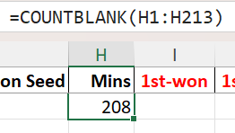
Most of these missing values are from older matches where match time was not consistently recorded. Because only 4 rows have valid data, any attempt to fill in missing values—such as using average durations by gender—would not be reliable or accurate. As a result, we decided not to impute the missing values. Instead, the "Mins" column was excluded from further analysis to maintain the integrity and accuracy of our findings.

New Columns Added:
Four new columns were added to enhance the analysis of the final match in each Australian Open tournament. These new columns are:
- Total Games Won
- Total Games Lost
- Total Games Played
- Game Win Rate
- Total Games Won:
This column represents the total number of games won by the champion. It is calculated by summing the values from the columns 1st-won, 2nd-won, 3rd-won, 4th-won, and 5th-won, which indicate how many games the champion won in each set of the final match. The formula used in the excel to calculate this column’s value was:
Total Games Won = 1st-won + 2nd-won + 3rd-won + 4th-won + 5th-won
- Total Games Lost:
This column represents the total number of games lost by the champion. It is calculated by summing the values from the columns 1st-loss, 2nd-loss, 3rd-loss, 4th-loss, and 5th-loss, which indicate the number of games the runner-up lost in each set of the final match and the formula can be written as below:
Total Games Lost = 1st-loss + 2nd-loss + 3rd-loss + 4th-loss + 5th-loss
- Total Games Played:
This column represents the total number of games played by the champion. It is calculated by adding the Total Games Won and the Total Games Lost. The formula to calculate this column is shown below:
Total Games Played = Total Games Won + Total Games Lost
- Game Win Rate:
This column represents the percentage of games won by the champion out of the total games played by him/her. It is calculated by dividing the Total Games Won by the Total Games Played and then multiplying the result by 100 to express it as a percentage. Therefore, the formula used was:
Game Win Rate = (Total Games Won / Total Games Played) * 100

3. Overall Trends & Exploratory Visualisations
Several visualizations were created to explore the main trends in the Australian Open dataset. These visualisations help understand player performance, country representation, and how the tournament has changed over time, offering useful insights into the overall competition.
3.1 Geographic Map
The geographic map, created using Tableau, shows the distribution of Australian Open tennis champions by country across two time periods: “Before 1970” and “1970 and After.” It highlights a clear shift from national dominance to a more global spread of champions and reveals key patterns related to nationalities and changes over time. Before 1970, Australia dominated the tournament with 37 championships. This is shown on the map by the darkest shade, reflecting the country’s strong performance during that era. After 1970, the range of countries represented by Australian Open champions expanded significantly. The United States stands out with 18 titles in this period. Other countries, such as Russia, Switzerland, and Spain, also appear on the map, showing the sport’s growing international reach and popularity.
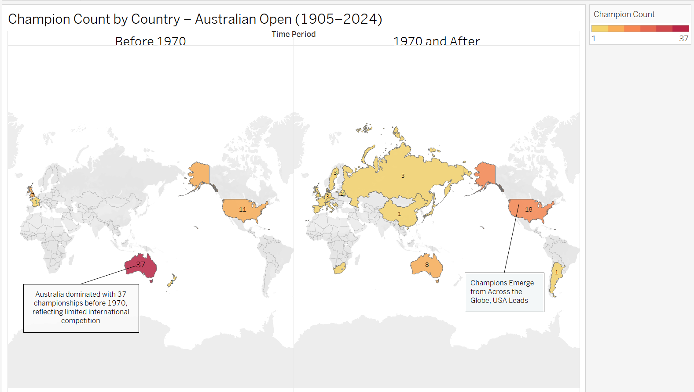
The map uses a colour gradient legend (top right corner) labelled “Champion Count”, which visually communicates the number of titles each country has won. Countries are shaded from light yellow (fewer wins) to deep red (most wins), making it easy to spot dominant nations immediately. This colour scale enhances contrast and draws attention to the top countries. Additionally, when one hovers over any country, a tooltip appears showing the country name and the exact number of championships won, providing quick access to detailed information. For instance, when one hovers over the USA on the left-hand map (“Before 1970”), Tableau displays a tooltip as shown below:
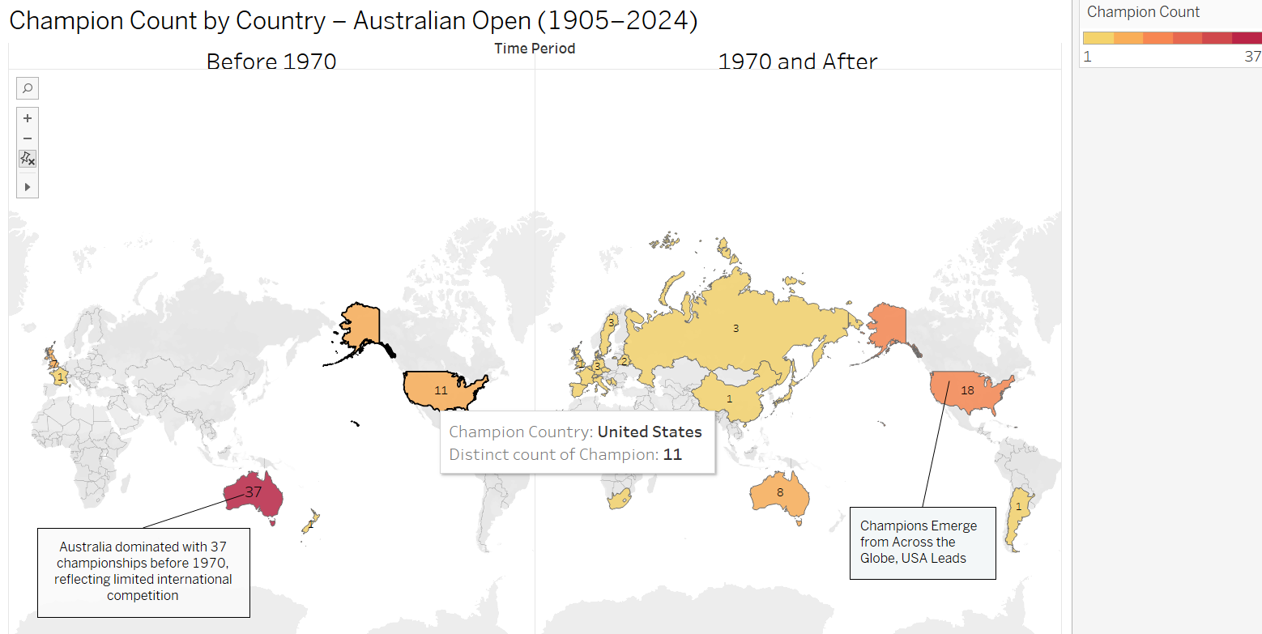
To create this geographic map in Tableau, the Australian Open dataset was first loaded, and a calculated field viz. “Time Period” was created to split the “Year” data into two time periods: “Before 1970” and “1970 and After.” The Champion Country field was then dragged to the detail, enabling Tableau to plot each champion’s country geographically on the world map. The number of championships won was calculated using the Champion field, aggregated as Count, and applied to the Colour shelf. A colour gradient was used to visually differentiate the totals, with light yellow indicating fewer wins and deep red indicating the highest number of wins. The Time Period field was placed on the Columns shelf to compare the two periods side by side. Finally, Tableau's tooltip features were used to enhance interactivity by hovering over each country reveals the name and total number of championships won.
3.2 Treemap Analysis
The treemap below presents a gender-based breakdown of Australian Open champions by country, with each rectangle representing a combination of gender and country (e.g., “Men’s Australia” or “Women’s United Kingdom”). The size of the rectangle is proportional to the number of championships won, while the colour indicates the champion’s country. Larger rectangles signify countries with more champions, highlighting Australia’s dominance in both men’s and women’s categories, followed by other countries like Spain and Switzerland. This visualization allows for an easy comparison of national and gender-based dominance over time. Hovering over any rectangle reveals a tooltip showing the gender, country, and total championships won, providing quick and detailed insights.
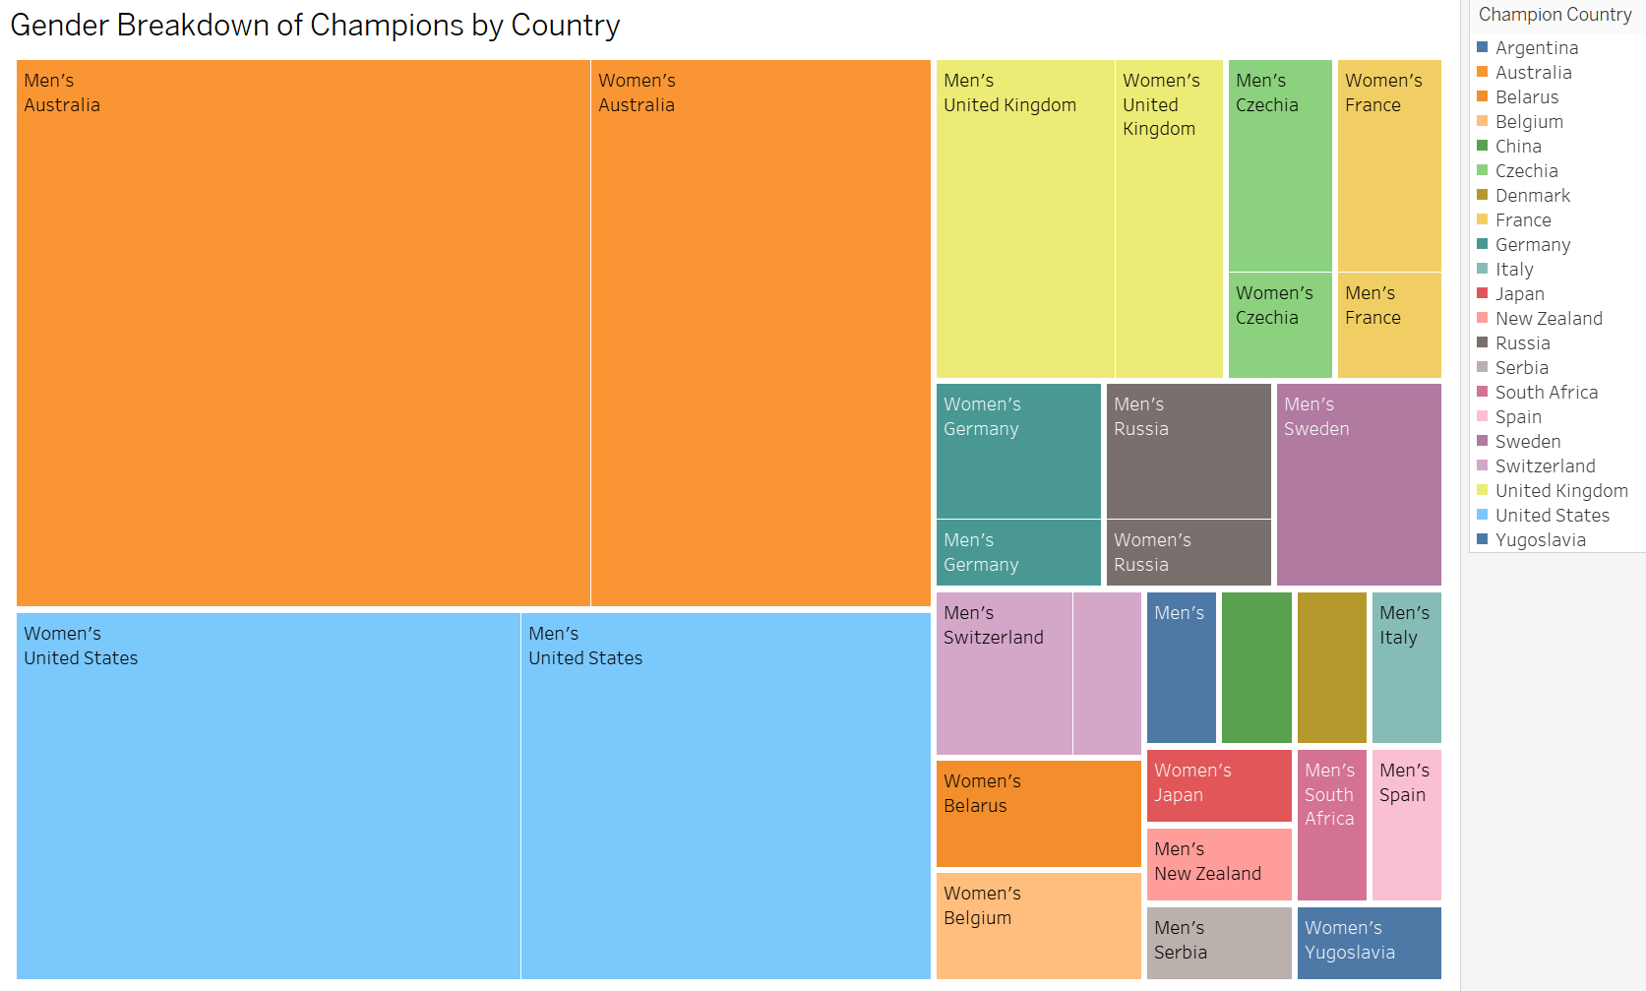
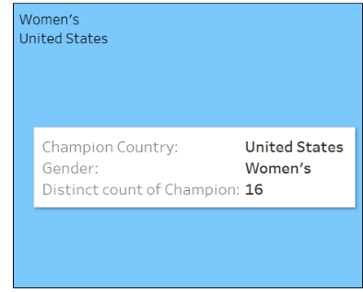
To create this treemap in Tableau, the Australian Open dataset was loaded. The Champion field was placed on the Size shelf to count the number of titles, determining the size of each block in the treemap. Additionally, the Measure was changed to Count Distinct for the Champion field to ensure each championship count was accurate. The Champion Country field was placed on the Colour shelf, so each country was visually distinguished by a different colour. After that, gender was added to the Detail shelf and each block in the treemap was divided by both Champion Country and Gender, allowing each rectangle to represent a unique combination of country and gender. Tooltip was enabled, so when hovering over any section, details about the gender, country, and the total number of championships were displayed, as shown above.
3.3 Scatter chart
The scatter plot titled “Match Performance: Games Played vs Win Rate by Gender” shows the relationship between the total games played (X-axis) and the average win rate (Y-axis) for Australian Open champions. From the graph, each dot represents a player, with colour distinguishing gender (blue for men, pink for women) and the size of the circle indicating the number of championships won. Larger circles on the right side of the graph represent players who have played more games and won multiple titles, indicating dominant champions with consistent performance. Both genders show similar win rates, but more male players appear on the right side due to the best-of-five match format in men’s matches, which leads to more games played. Most champions are clustered between 40-80 games played and a win rate of 55-70%, suggesting these are short-term or single-title winners. A few outliers, who have played over 150 games with high win rates, stand out as long-term dominant champions. Overall, the graph highlights patterns in player performance, gender differences, and the number of games played.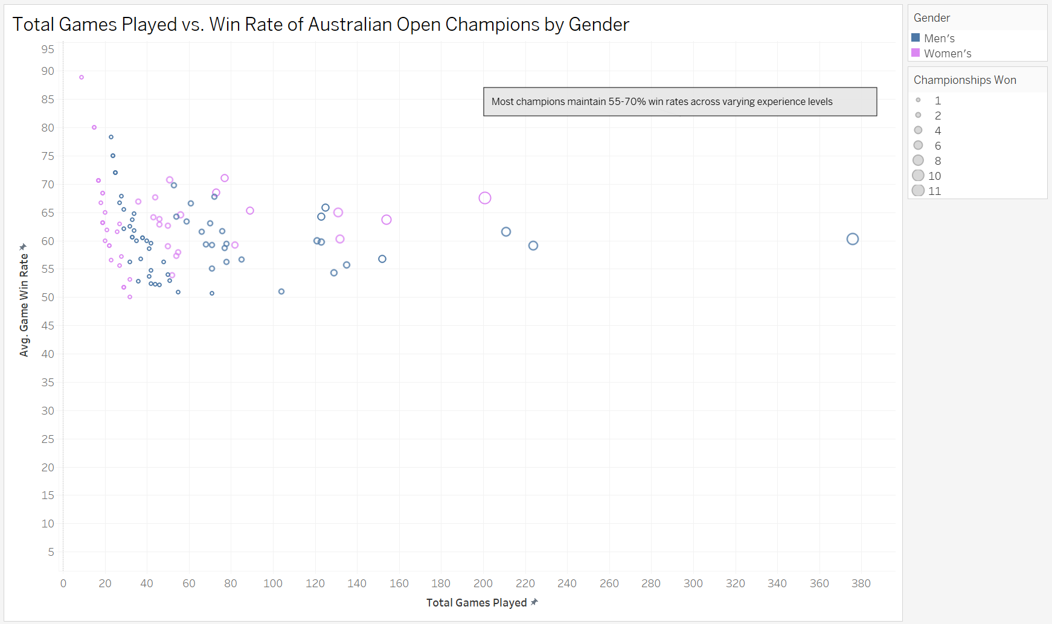
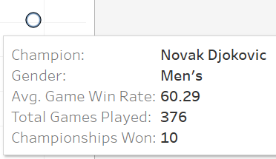
To create the scatter plot in Tableau, the Australian Open dataset was first loaded into the workspace. Total Games Played was dragged onto the Columns shelf and automatically aggregated as a SUM, representing the total number of games played by each player. Game Win Rate was placed on the Rows shelf and aggregated as an AVG, showing the average percentage of games won. These aggregations helped define the X and Y axes of the scatter plot respectively. Gender was added to the Colour shelf to differentiate players visually by gender. A calculated field called Championships Won was created which counts the number of distinct years each player appears as a champion, effectively measuring how many times they won the Australian Open and Championships Won was dragged onto the Size shelf to reflect the number of championships won through bubble size. Tooltip details were customized to display player name, gender, total number of games played, championships won and average game win rate on hover for quick reference, shown on the right.

3.4 Parallel Coordinates Chart
The parallel coordinates chart titled “Performance Metrics of Australian Open Champions (2000–2025)” provides a clear multi-dimensional comparison of champions' performance across four key metrics: Total Games Played, Total Games Lost, Total Games Won, and Average Game Win Rate. Each line represents a champion, showing how they performed across these different axes. The standout observation is the line representing Novak Djokovic from Serbia, whose path begins significantly higher than the others, starting with 376 games played and ending with an impressive win rate of 88.9%. His line sharply dips and then rises again, reflecting few games lost and a high number of games won — showing both endurance and dominance. In contrast, most other lines are much lower and more closely grouped, indicating that most champions had relatively fewer matches and more average win rates. This chart conveys not only the sheer dominance and consistency of top players like Djokovic but also highlights the gap between them and other champions, making it a powerful tool to visually analyse long-term performance in the Australian Open.
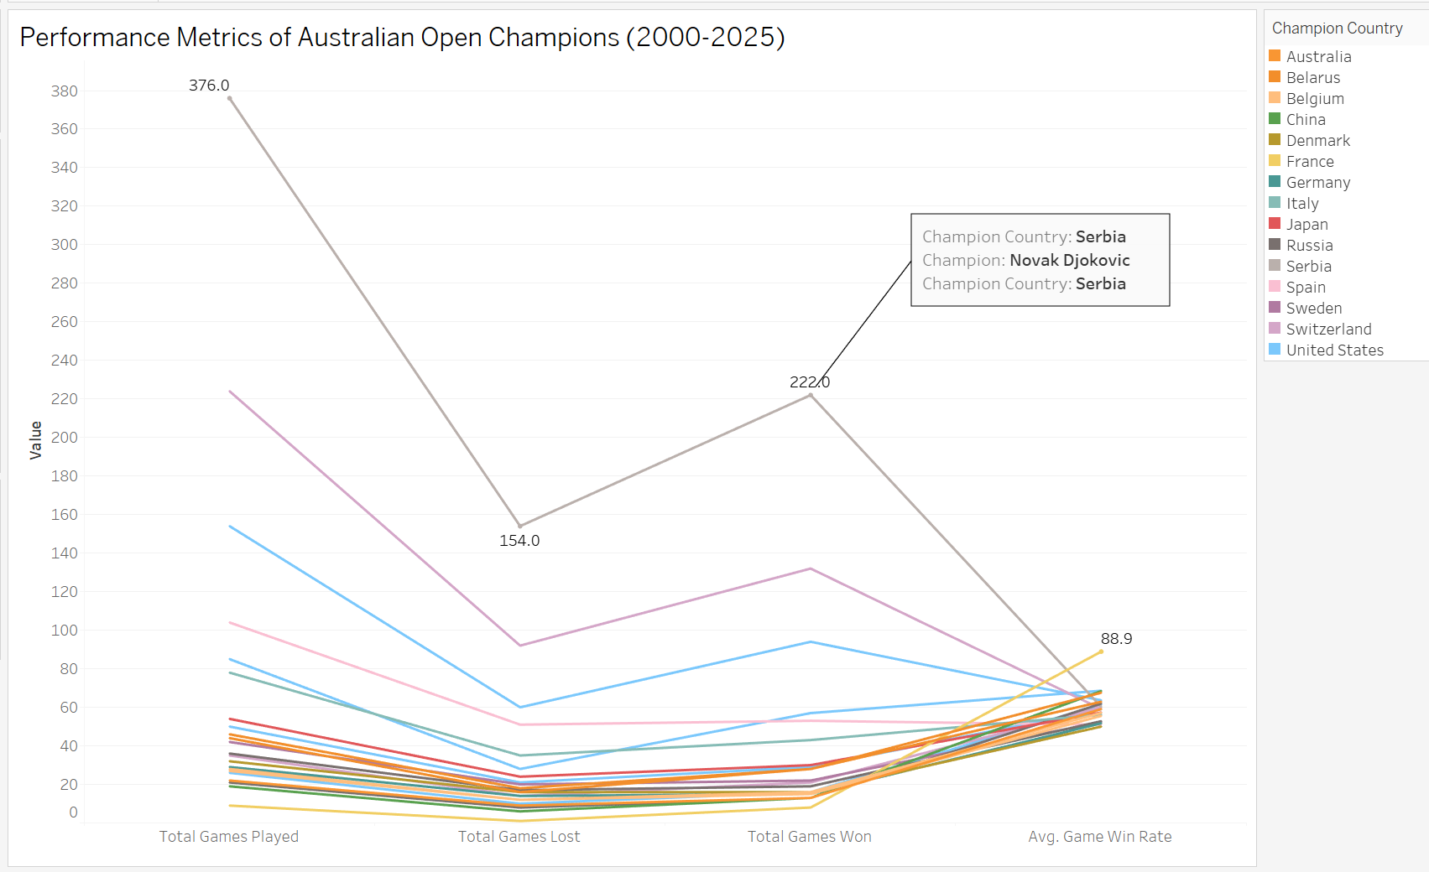
To create the parallel coordinates chart in Tableau, the dataset containing Australian Open champions' performance metrics was imported. Measure Names was placed on the Columns shelf to display the performance metrics (Total Games Played, Total Games Lost, Total Games Won, and Game Win Rate) along the horizontal axis. Measure Values was placed on the Rows shelf to represent the numerical values on the vertical axis. Only the relevant fields were selected from the Measure Values shelf to focus the analysis on key metrics. The Marks type was set to "Line" to visualize and compare each champion's performance. To differentiate performances by country, the Champion Country field was added to the Colour shelf, and Champion was added to the Detail shelf for player-specific context. The Year field was placed on the Filter shelf to select data from 2000 to 2025, focusing on recent trends. Finally, titles, labels, and tooltips were adjusted for better insights.

- Top Player Analysis (5+ wins)
The bar chart titled “Top Player Analysis” shows the average game win rate of tennis champions who have won five or more Australian Open titles. Each bar represents a player, with the height indicating their average win rate and the colour gradient representing the number of championships won (starting from 5). This chart highlights both the consistency and success of top players, such as Margaret Court, Serena Williams, Novak Djokovic, Roger Federer, Roy Emerson, Nancye Wynne Bolton, and Daphne Akhurst. Margaret Court stands out with the most titles (11) and a win rate of around 67.5%, while most other champions have an average win rate near 60%.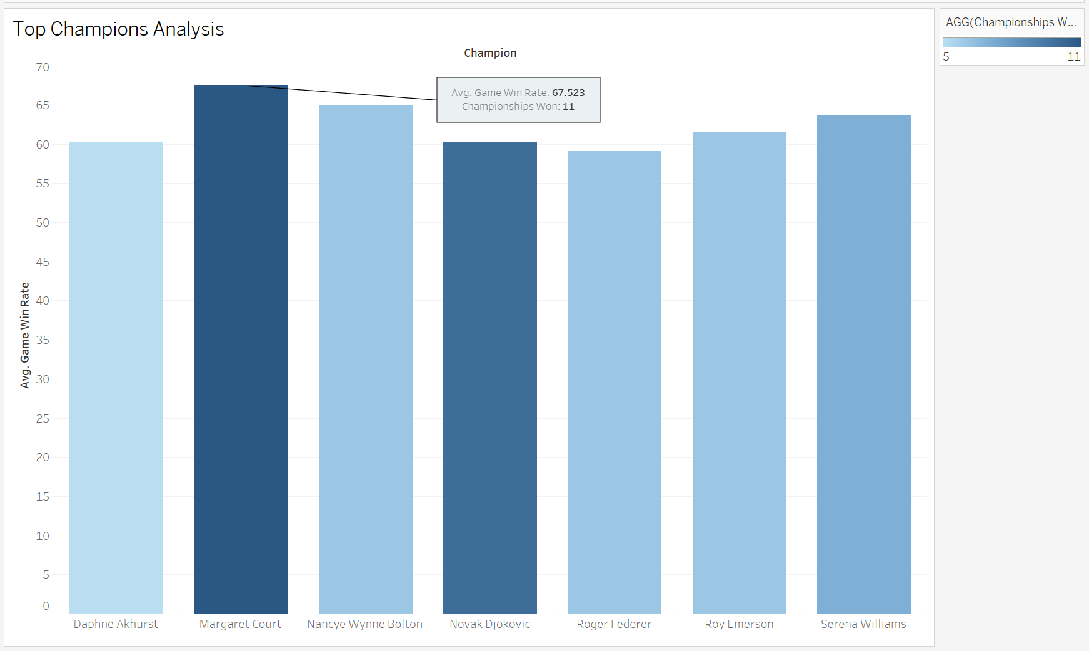
To create this bar graph in Tableau, the Champion field was placed on the Columns shelf, and the Game Win Rate was added to the Rows shelf with an AVG aggregation. Championships Won was placed on the Colour shelf to visually represent title counts and on the Filters shelf to focus on champions with 5 or more wins. Tooltips were customized to show additional details, such as country, total titles, and win rate for better interactivity. A Treemap was also used to visualize the top players and their championship totals. Each box in the Treemap represents a player, with the size of the box indicating the number of titles they have won, making it easy to compare the most successful players.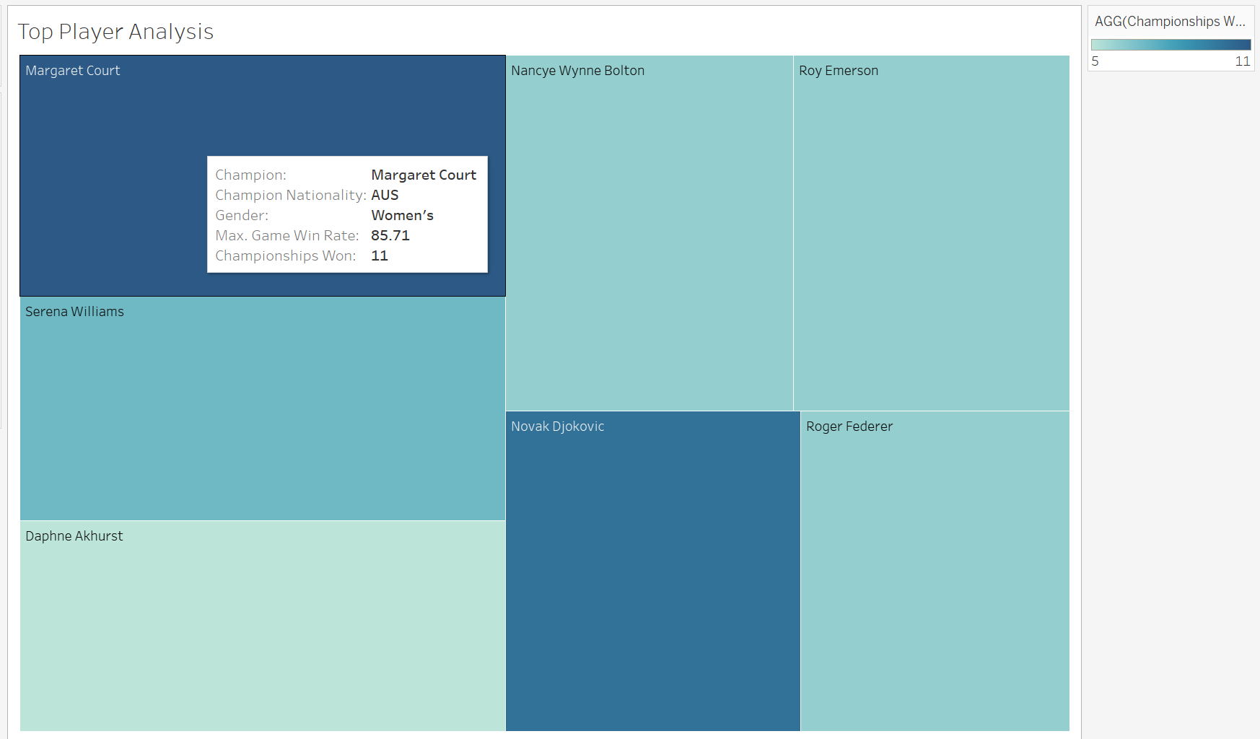
The attached Treemap screenshot also shows a tooltip when hovering over each player, which makes it easy to get detailed information about each champion who has won more than five times. This can help compare the champions who won more than 5 times with one another. Overall, the Treemap clearly shows all the top champions in a compact and easy-to-understand way. The steps to create the Treemap were simple: drag Champion to the Label and Detail shelves, drag Championships Won to Size and Colour, apply a filter to show only players with five or more titles.
These two figures help identify the top players with more than five championships: Margaret Court, Serena Williams, Novak Djokovic, Roger Federer, Roy Emerson, Nancye Wynne Bolton, and Daphne Akhurst.

- Insights, Trends & Outliers
The dataset reveals several important trends in the Australian Open tennis championships. To evaluate player performances at the Australian Open, various visualisation techniques were used to highlight trends, comparisons, and outliers. The analysis revealed that players like Novak Djokovic, Serena Williams, and Margaret Court have achieved exceptionally high win rates, showcasing dominance across different eras. The geographic map showed a shift in champion nationalities, moving from primarily Australian and American players before 1970 to a more globally diverse set of winners in recent decades. One significant trend is the increase in the overall number of international players participating in the tournament. Over the years, countries from all continents have seen representation, with nations like Spain, Switzerland, and Serbia emerging as strong competitors. A parallel coordinates chart identified performance outliers, including players with high game counts but comparatively lower win rates, suggesting participation in many games but limited championship wins. Additionally, the scatter plot comparing games played and win rates (by gender) revealed that both male and female champions have similar win rates, though more male players appear on the right side due to the best-of-five match format in men’s matches, which leads to more games played.
To present these insights effectively, various graphic techniques were used to improve data clarity and understanding. Treemaps displayed the distribution of champions by gender and country, while geographic maps provided both spatial and historical context. Parallel coordinates allowed for easy comparison of multiple performance metrics, highlighting patterns and anomalies. The scatter plot visualized the relationship between games played and win rates by gender, offering insights into player consistency and dominance. The Win Rate Performance Chart facilitated direct comparison of top champions’ win rates, making it easier to understand how players performed across different years. These visual tools helped simplify complex data, making the analysis more accessible and engaging for readers.

- Advantages and Limitations of Tableau
Advantages:
One of the most significant advantages observed during the use of Tableau was its ease of use in building visualisations. Tableau proved to be a highly effective tool for developing interactive and insightful charts. Without the need for any coding, drag-and-drop functionality allowed for the creation of complex visualisations that effectively highlighted patterns, trends, and comparisons. The platform's filtering features enabled focused analysis on specific players, time periods, or performance metrics, which was particularly useful during the data exploration phase. Additionally, Tableau’s seamless integration with Excel allowed for smooth data updates and saved time when switching between tools. The visual output was not only informative but also visually appealing, which contributed to clearer communication of insights.
Disadvantages:
Despite its advantages, Tableau had some limitations. Despite its many advantages, Tableau presented some limitations during the assignment. Customising certain visual elements, such as labels, axis formatting, and chart styles, was somewhat restricted. Additionally, performance could lag with larger dashboards. Despite these limitations, Tableau was immensely helpful in completing the assignment, offering a user-friendly interface for powerful data visualisation and exploration.
- Conclusion
To conclude, this report has explored key trends in the Australian Open over the past century, highlighting shifts in global dominance, champion performance, and gender-based participation. Advanced visualisations such as geographic maps, treemaps, and parallel coordinate plots revealed insights into country-wise champion distribution, elite player performance, and historical changes in seeding effectiveness. Champions with 5 or more titles showed strong and dominant performances over the years. Tableau was instrumental in enabling a deep, visual exploration of the dataset, providing clarity and accessibility to complex patterns in tennis history.

