Student Id: 25038579
Student name: Aneet Kaur
Assignment: Assessment Task 3
Visual Analytics
1. Introduction
This report presents an analysis of Australian international trade data covering 35 years (1988-2024). It aims to identify important patterns and insights in Australia's trade performance to support informed policy discussions. Through interactive visualizations and dashboards, this analysis aims to communicate complex trade trends in a clear format suitable for government officials and policy professionals.
The analysis uses detailed trade data provided by the Australian Bureau of Statistics (ABS). This dataset records the value of goods that Australia imports and exports, organised into 10 main product categories and 67 more specific subcategories. By examining this data, a clearer understanding of how Australian industries have been involved in international trade since 1988 can be obtained, including what types of products are traded and how trade patterns have changed over time.

2. Data Overview and data preparation
The dataset provides a detailed summary of Australia’s international trade from 1988 to 2024, covering both imports and exports. It includes key information such as Trade Type (whether the trade is an Import or Export), Main Category (10 broad groups like Mineral Fuels, Machinery, Food, etc.), and Subcategory (67 specific items such as Coal, Dairy, and Pharmaceuticals). The Year column shows trade activity over time, allowing analysis of trends and changes. This dataset shows the value of trade (in AUD millions) across different columns representing product categories. The dataset is large, with several rows, offering useful insights into Australia’s trade over the past 37 years.
To prepare the Australian international trade dataset for analysis, I used Excel to generate statistical and analytical patterns for both imports and exports. First, I copied the original data into new sheets for statistical analysis and duplicated the headers and time series to match the required format. I then calculated the percentage each main category contributed to the total annual trade value and similarly calculated the proportion of each sub-category within its main category. For analytical patterns, I created a new sheet and calculated the year-on-year change for each category and sub-category starting from 1989, formatting the results as percentages. The year 1988 was excluded as it lacked a previous year for comparison. After validating the results, I merged the import and export data by adding a “Trade” column, labelling each entry as either “Import” or “Export.” This was done for all three datasets, statistical combined, analytical combined, and dollar combined, resulting in combined sheets ready for Tableau. In Tableau, I linked the datasets using shared fields like “Time” and “Trade” to support effective dashboard creation and visualisation.

3. Analysis of All Main Categories
- Raw Dollar Import Trends Analysis
The below line chart shows a major change in Australia’s trade patterns, with machinery and transport equipment becoming the top import category. Imports in this category grew from around $17 billion in 1988 to nearly $180 billion by 2024, showing a slight drop before that. This nearly nine-fold increase is much higher than in any other category and points to Australia’s growing dependence on advanced manufactured goods and technology.
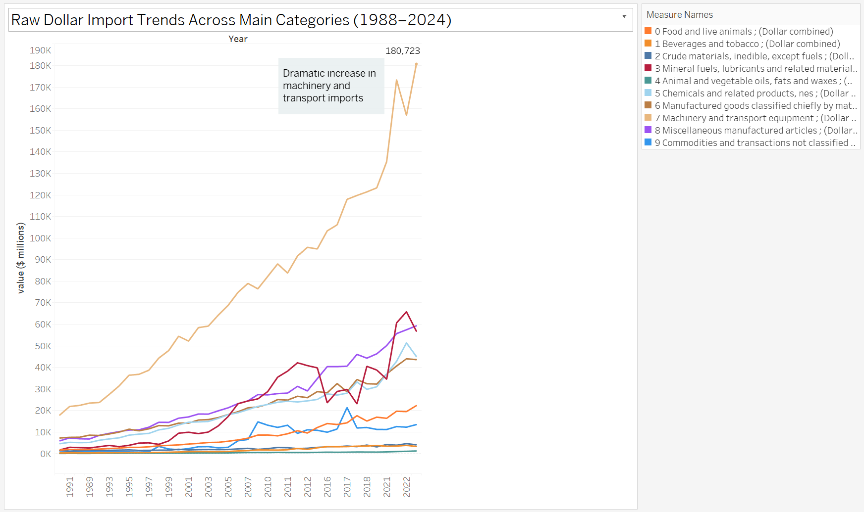
Chart 1: Raw dollar import trends across main categories (1988-2023)
Other categories also grew but at smaller levels. Imports of mineral fuels, lubricants, and related materials were more volatile but generally increased, showing ongoing demand for energy products even though Australia is a major energy exporter. Categories like food and live animals, beverages and tobacco, and miscellaneous manufactured items also rose steadily, showing ongoing growth in consumer goods imports.

- Raw Dollar Export Trends Analysis
The line chart below shows important changes in Australia’s exports from 1988 to 2024. One of the most noticeable trends is the strong growth in mineral fuels, lubricants, and related materials. This category rose sharply, starting from low values in the 1990s and reaching over $250 billion by 2022. A large part of this increase happened after 2010 and during the same period, exports in almost all main trade categories also grew significantly compared to their 1988 levels, showing how Australia’s exports developed across multiple sectors over time.
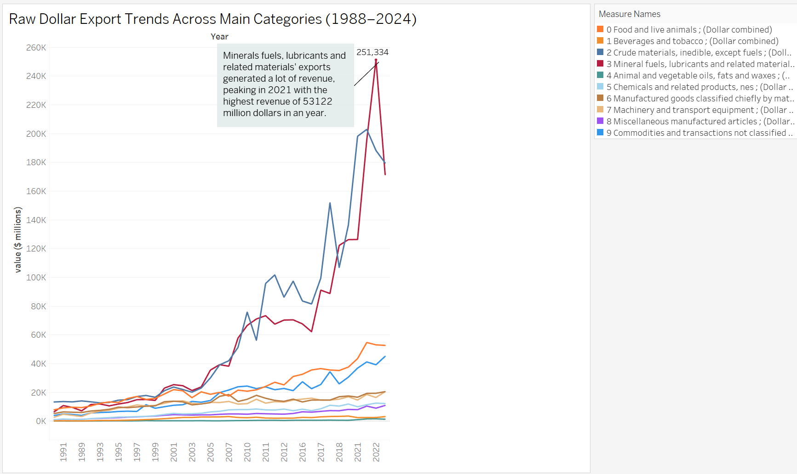
Chart 2: Raw dollar export trends across main categories (1988-2023)
Crude materials, inedible except fuels also showed strong growth over the years. Their export value increased from about $17 billion in 1989 to around $180 billion by 2024. This growth, along with the rise in mineral fuel exports, highlights how Australia has become a major exporter of natural resources. In contrast, other categories stayed more stable. For example, exports of food and live animals grew slowly but steadily, reaching around $52 billion, which reflects Australia's strong agricultural industry.

- Import Statistical Trend Analysis
The area chart below shows that machinery and transport equipment has been the largest part of Australia’s imports for most of the last 35 years. It made up about 40% of total imports, staying strong with only small changes over time. This steady trend suggests that Australia relies heavily on importing machines, vehicles, and technology.
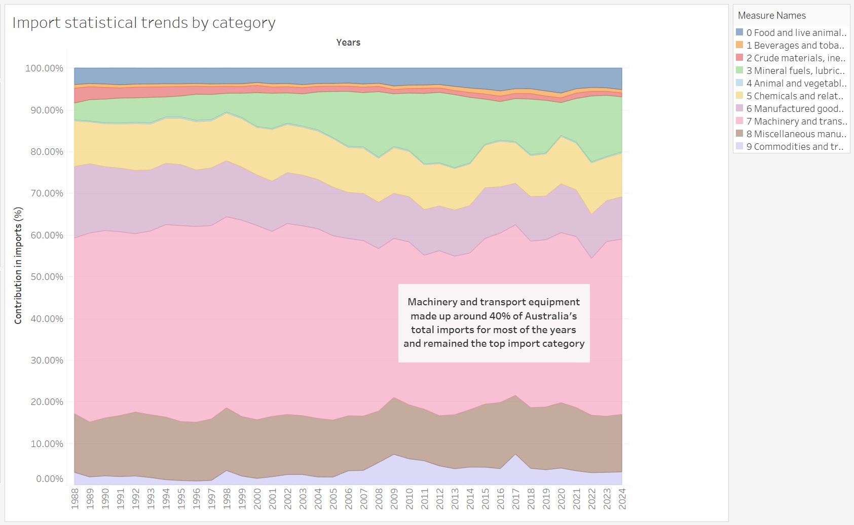
Chart 3: Import Statistical Trends by Category
The other import categories stayed mostly steady over time, keeping similar shares of the total. Items like miscellaneous manufactured goods, mineral fuels, and chemicals each made up about 10–15% of imports, while smaller categories remained steady as well. Even though the total value of imports grew a lot, the share of each category did not change much. This shows that Australia’s import patterns have stayed consistent over the years.

- Export Statistical Trend Analysis
The area chart below shows a major change in Australia’s trade over the years. ‘Crude materials, inedible except fuels’ and ‘Mineral fuels, lubricants, and related materials’ have become the largest parts of Australia’s exports. Since 2010, these two categories together have made up nearly 60% of total exports. In the past, exports were more spread out across different categories, but now they are more focused on natural resources. This big change shows how Australia has become an important global supplier of things like coal, iron ore, and gas.
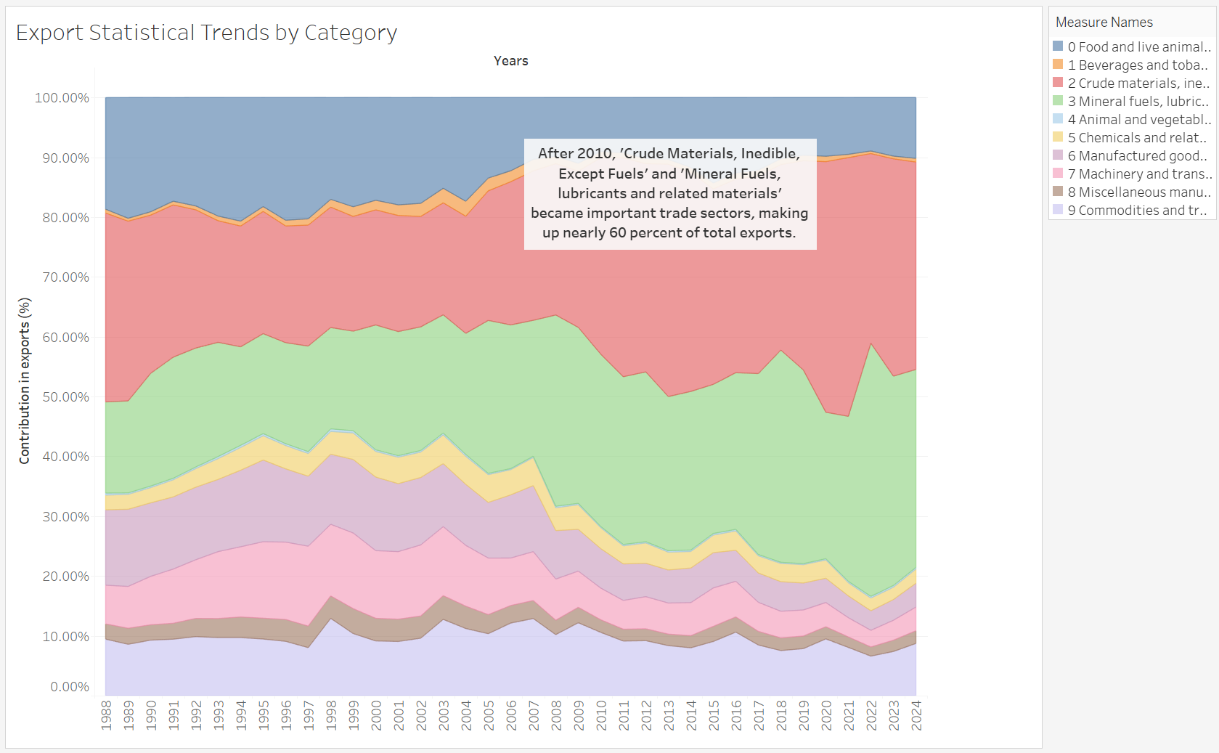
Chart 4: Export Statistical Trends by Category
The data also shows that manufactured goods and other traditional exports have become less important over time. For example, food and live animals used to make up a bigger share of exports, but by 2024, their percentage has gone down, even though the actual value has grown. The same is true for manufactured goods, which have been pushed aside as resource exports like coal and gas have taken over.

- Yearly Percentage Changes Analysis
The chart below shows that many trade categories went up and down a lot over the years. Some categories had very big changes from one year to the next. One of the most noticeable events was in 1998, when Miscellaneous Commodities had a huge spike, growing by 344.14% in exports. This shows how some categories can suddenly change a lot due to special events, new regulations, or demand shifts. Moreover, other categories like Mineral Fuels and Crude Materials also showed noticeable fluctuations.
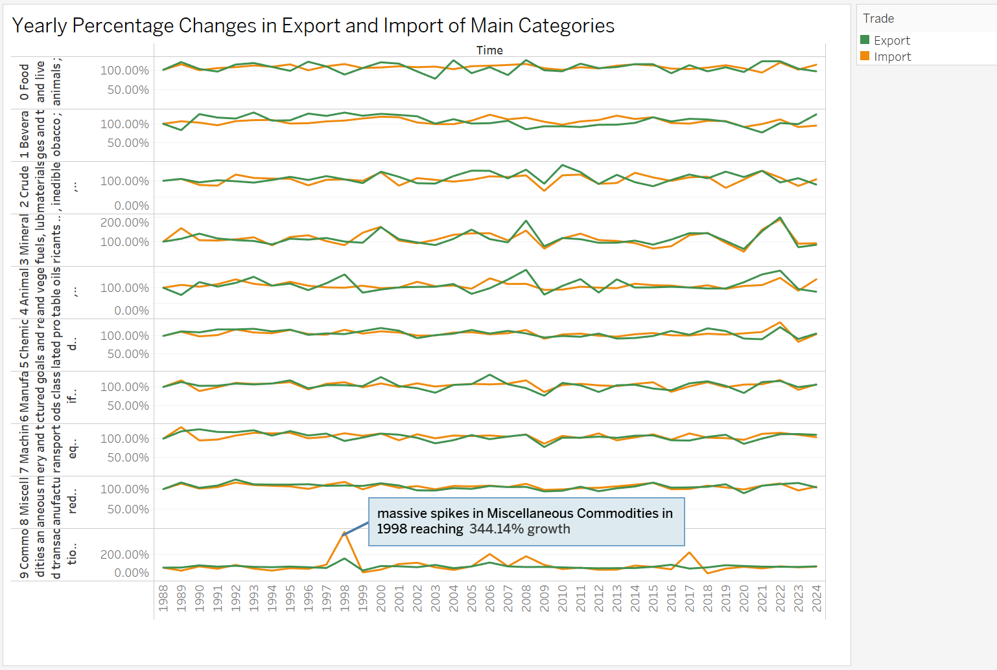
Chart 5: Yearly percentage changes in export and import of main category
Categories like Machinery and Transport Equipment showed more consistent changes, suggesting a stable demand. On the other hand, Mineral Fuels and Crude Materials had more frequent ups and downs, especially after 2010. This chart depicts that the size of the economy or value of exports does not always mean stable growth and categories with smaller total trade (like Miscellaneous) can still have the largest swings.

4. Main vs Subcategory Analysis
The relationship of the Food & Live Animals main category was analysed along with all its nine subcategories, which are illustrated in the charts below:
- Food & Live Animals Export Breakdown (1988-2024)
The bar chart presents a comparative analysis of nine sub categories of food and live animal exports, namely: 00 Live animals (excl. fish (not marine mammals) crustaceans, molluscs and aquatic invertebrates of SITC Division 03), 01 meat and meat preparations, 02 dairy products and birds' eggs, 03 Fish (excl. marine mammals) crustaceans, molluscs and aquatic invertebrates, and preparations thereof (excl. extracts and juices of fish, crustaceans, molluscs or other aquatic invertebrates, prepared or preserved of SITC 01710), 04 cereals and cereal preparations, 05 vegetables and fruit, 06 sugars and sugar preparations including honey, 07 Coffee, tea, cocoa, spices, and manufactures thereof, 08 Feeding stuff for animals (excl. unmilled cereals) and 09 Miscellaneous edible products and preparations. These subcategories illustrate many variations in export composition between 1988 and 2024.
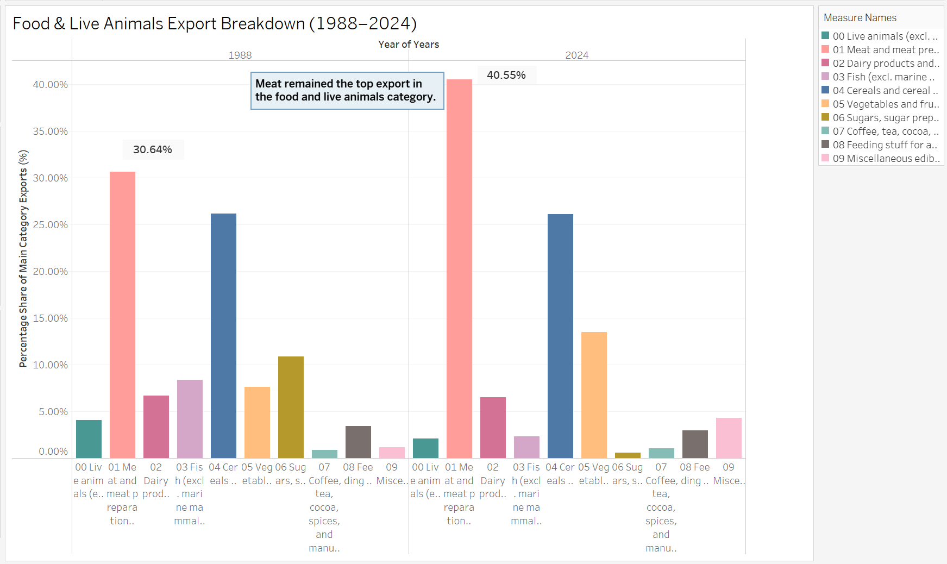
Chart 6: Food & Live Animals Export Breakdown (1988-2024)
The bar chart above shows how the types of food and live animal exports changed from 1988 to 2024. During this time, "01 Meat and meat preparations" stayed the biggest export, growing from 30.64% in 1988 to 40.55% in 2024, showing more global demand for meat. In 1988, fish were important exports, but by 2024, "05 Vegetables and fruit" became more popular. Overall, the chart reflects how export trends have shifted over the years.
- Import Values: Food and Live Animals – 2024
The bar chart below shows that miscellaneous edible products and preparations are the top import category in 2024, worth $4.48 billion. This suggests that Australia brings in many processed and special food items, either because they are not made locally or to suit different consumer tastes. It also shows that Australian shoppers want a wide range of international foods, special ingredients, and convenient meals. In imports, both fish and dairy products had values of $24,000- $2500 millions in 2024, showing they contributed equally to overall trade.
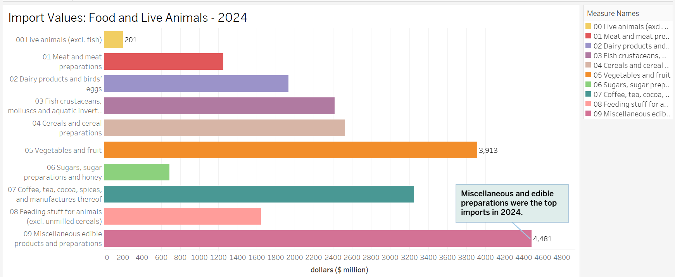
Chart 7: Import Values: Food and Live Animals - 2024
Australia imported $3.91 billion worth of vegetables and fruits, and the Coffee, tea, cocoa, and spices imports were around $3.25 billion in 2024. Meat and dairy imports are much lower (meat at $1.2 billion), which means Australia exports more of these products than it imports. Overall, the bar chart gives a clear picture of Australia’s import values across different food categories.
- Export Values: Food and Live Animals – 2024
The chart below shows that meat and meat preparations are the biggest part of Australia’s food exports, making $21.38 billion, or 40% of the total $52.72 billion in food and live animal exports. This shows how important meat is to Australia’s trade. On the other hand, sugars, sugar preparations and honey, and coffee, tea, cocoa, spices and manufactures thereof exports stayed very low, as shown in the chart by green circles just above zero.
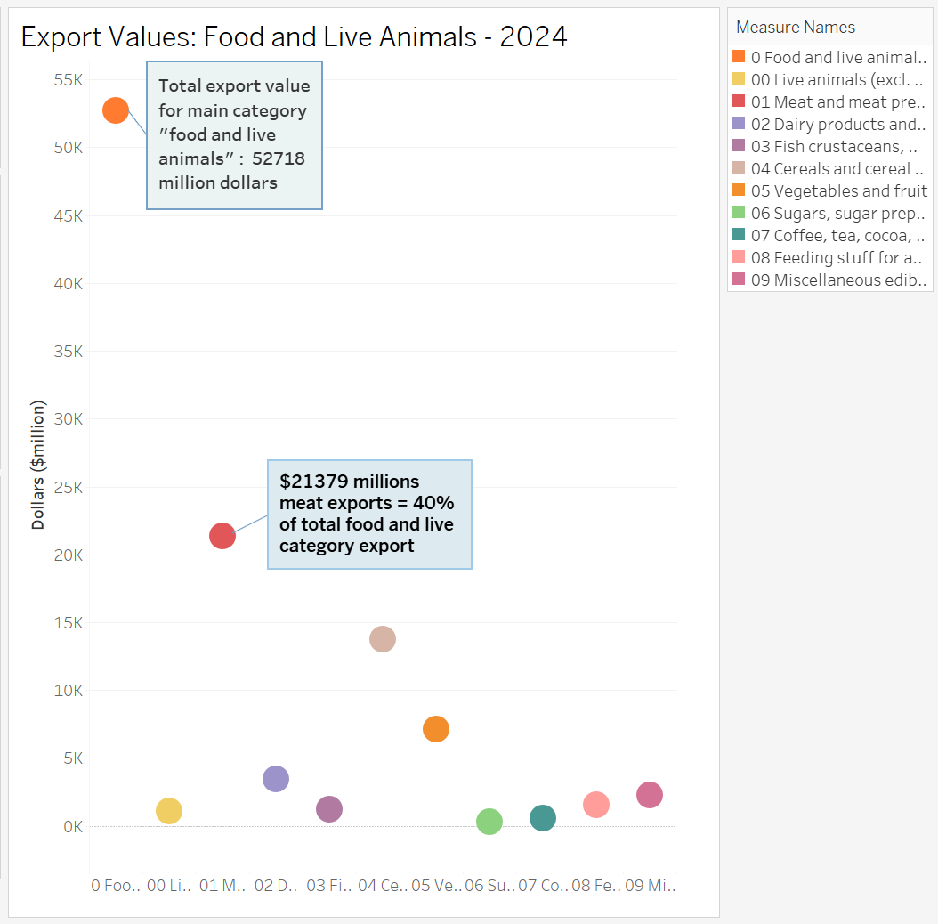
Chart 8: Export Values: Food and Live Animals – 2024
Cereals make up 26% of Australia’s food exports, showing that grains, especially wheat, are still a big part of the farming industry. Other categories like vegetables and fruit bring in less (about $7 billion), which shows there’s room to grow in these areas. The data suggests that while meat exports are strong, Australia could still grow its exports of fruits, vegetables, and processed food. Overall, the chart provides clear information about export values of all subcategories of Food and live animals category, which has total export value of $52718 million in 2024.
- Comparative Analysis of Food and Live Animal Trade: 1988 vs. 2024
The area chart below shows the strong growth in both exports and imports of food and live animals over the past few decades. Exports rose sharply from under $10,000 million in 1988 to $52,718 million in 2024. This increase is mainly due to large growth in two key subcategories: 01 Meat and meat preparations, and 04 Cereals and cereal preparations, which make up the top part of the export chart. The growth trend becomes much steeper after 2010, showing a clear rise in trade volume over the last 15 years.
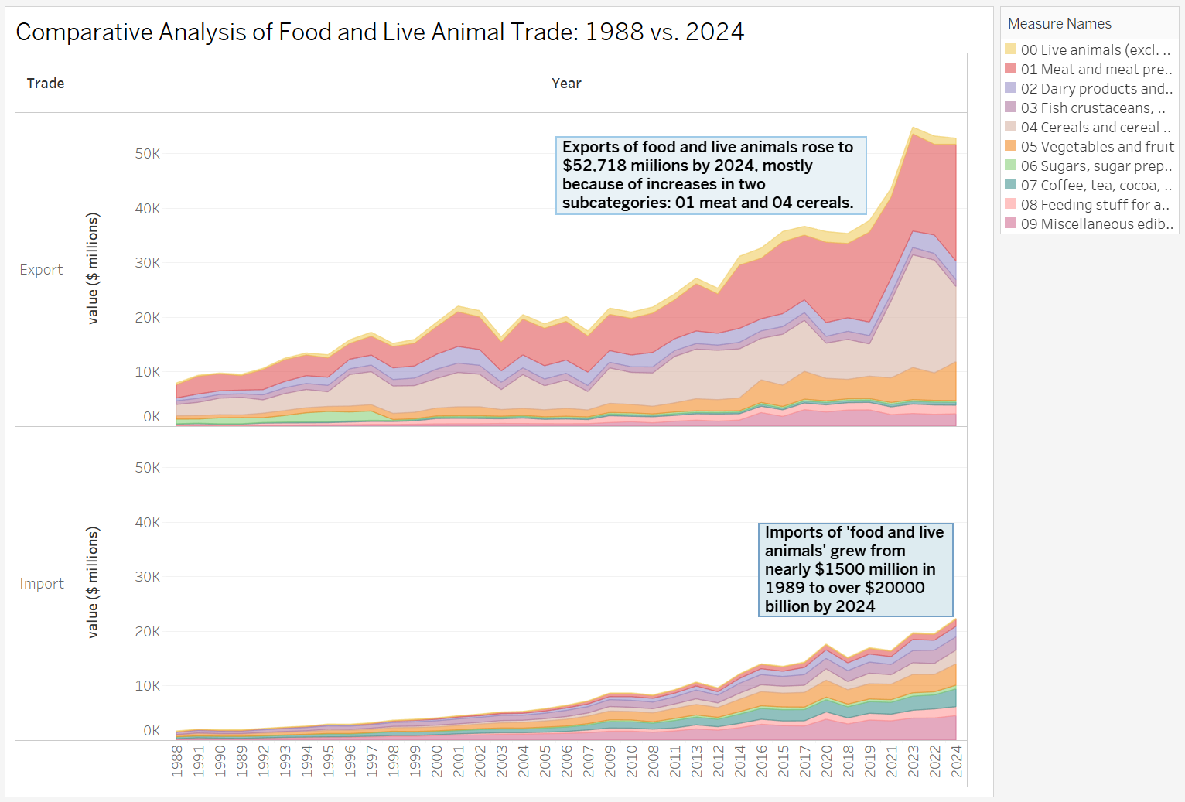
Chart 9: Comparative Analysis of Food and Live Animal Trade: 1988 vs. 2024
On the import side, the chart shows a large increase, with values rising from around $1,500 million in 1989 to over $20,000 billion in 2024. Imports have grown steadily across most subcategories, and the variety of imported goods has expanded over time. The stacked area chart highlights those subcategories like 02 Dairy products, 07 Coffee, tea, cocoa, and 09 Miscellaneous edible preparations have become more significant in recent years. Overall, the data clearly illustrates how global trade in food and animals has expanded over time.
5. Subcategory Dashboard Analysis
This analysis focuses on the main category "Mineral Fuels," with special attention given to the subcategory "Coal, coke and briquettes," due to its major role in global energy trade. It also examines the trends and relationships between petroleum and another key subcategory "Petroleum and related products", to understand how both have changed over time in terms of trade value, imports, exports, and their share in the overall mineral fuel trade. A dashboard has been created to show these changes using various charts, including percentage growth trends, import volumes, total trade value, and trade share distribution. These visuals together give a clear picture of how petroleum and coal have evolved and interacted within the mineral fuels sector from 1988 to 2024.
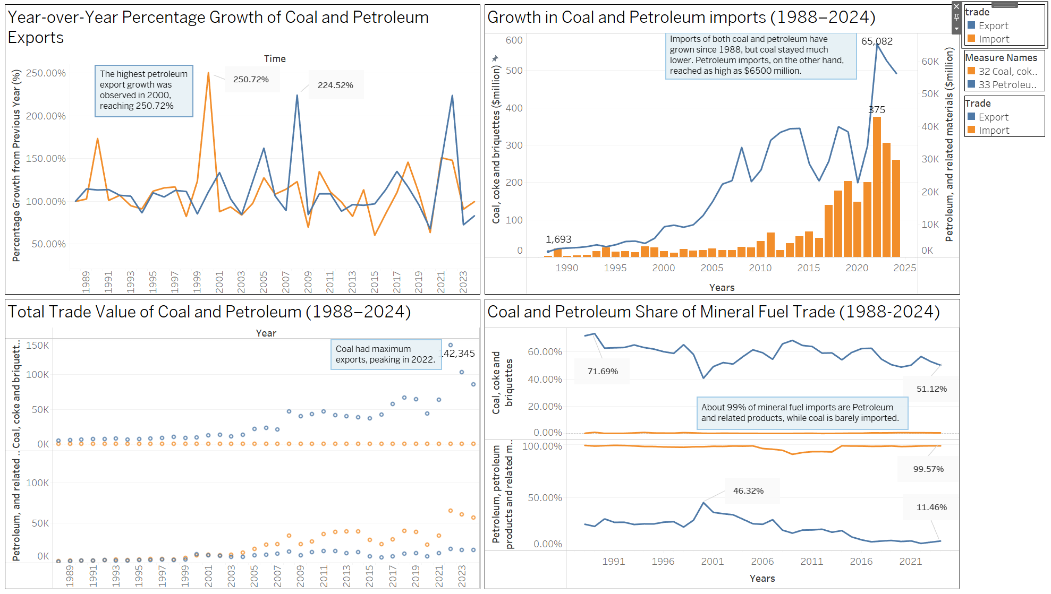
Chart 10: Dashboard
The dashboard shows several clear patterns. In the "Year-over-Year Percentage Growth" chart, petroleum exports had large ups and downs, with a major spike in 2000 reaching 250.72%. This suggests sharp changes in global demand or prices that year. In contrast, coal showed smaller but more steady growth over time. The "Growth in Imports" chart shows that imports of both petroleum and coal increased, but petroleum imports rose much faster, peaking at $65,082 million in 2022, while coal saw a slower rise. This suggests that petroleum is much more important when it comes to import needs. The "Total Trade Value" chart shows that coal exports reached their highest point in 2022, while petroleum trade stayed more steady and lower, possibly due to a shift toward cleaner energy or more local production. The "Share of Mineral Fuel Trade" chart shows that petroleum makes up nearly all imports (99.57%), while coal accounts for a larger share of exports (51.12% in 2023). This shows that petroleum plays a bigger role in imports, while coal is more important for exports. Overall, the dashboard highlights a trade imbalance where petroleum drives import dependency, and coal remains a major export.
Below are the explanations of each dashboard sheet, showing what they are for and what insights they provide:
- Coal and Petroleum Share of Mineral Fuel Trade
This two-part chart shows what percentage of mineral fuel trade comes from coal and from petroleum between 1989 and 2023. One panel is for coal and the other is for petroleum. In the coal panel, the chart shows that coal exports made up a big part of mineral fuel trade for most of the years, usually between 40% and 70%. While the percentage changed from year to year, coal mostly stayed above 50%. In 2023, coal’s share was 51.12%, which is lower than the peak of 71.69% in the early 1990s but still shows coal's strong position in exports.
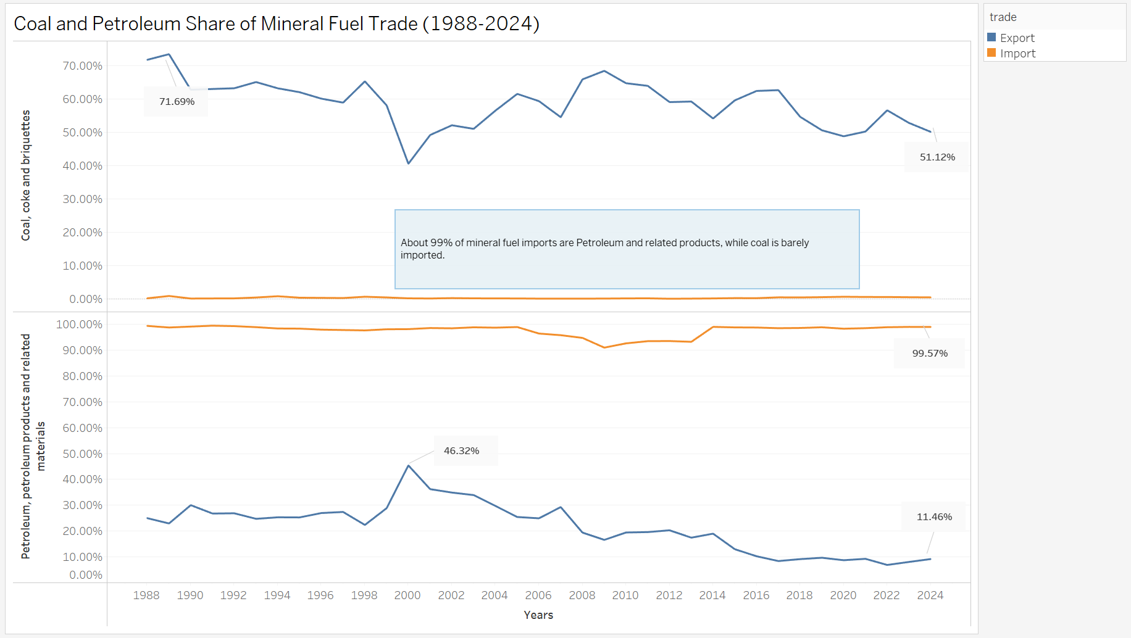
Chart 11: Coal and Petroleum Share of Mineral Fuel Trade(1988-2024)
The petroleum panel shows a very different story. Almost all of Australia’s mineral fuel imports—about 99%—are made up of petroleum and related products. This is shown by a note on the chart. Coal imports are almost nothing in comparison. Petroleum exports, however, are much smaller than coal’s. They stay under 50% of total mineral fuel exports and ended at just 11.46% in 2023. This big difference between coal and petroleum shows that Australia is a major exporter of coal but heavily depends on petroleum imports. Coal is the main mineral fuel that Australia sells to other countries, while petroleum is the main fuel it needs to buy.
- Growth in Coal and Petroleum Imports
The combo chart below combines a bar graph and a line graph to show how coal and petroleum imports changed from 1988 to 2024. The orange bars represent coal imports, and the blue line shows petroleum imports. The blue line rises steadily from 1988 to around 2014, when it reaches a high point of $65,082 million. After that, it goes up and down but generally trends lower by 2024. This pattern means that Australia has had steady and growing demand for petroleum over many years, even with some short-term ups and downs.
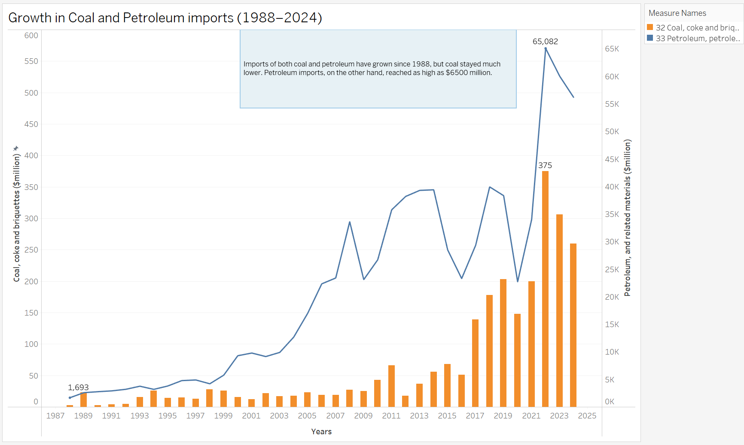
Chart 12: Growth in Coal and Petroleum Imports
On the other hand, coal imports have stayed very low during the whole time. The orange bars barely show on the graph, never rising much above $1,693 million. This makes it clear that Australia does not need to import much coal. Coal import values are very small compared to petroleum. This big difference shows that Australia mostly exports coal but needs to bring in petroleum to meet its fuel needs. It also highlights that petroleum plays a much bigger role in imports than coal does.
- Year-over-Year Percentage Growth of Coal and Petroleum Exports
This line chart shows how the export growth of coal (blue line) and petroleum (orange line) changed each year from 1989 to 2023. The most noticeable part of the chart is how much petroleum exports went up and down. There are huge spikes, like in the year 2000 when growth reached 250.72%, and again around 2014 with a peak of 224.52%. The orange line for petroleum has sharp rises and drops, showing that petroleum exports were very unstable over time. These big changes could be caused by things like price swings, changing demand, or supply issues.
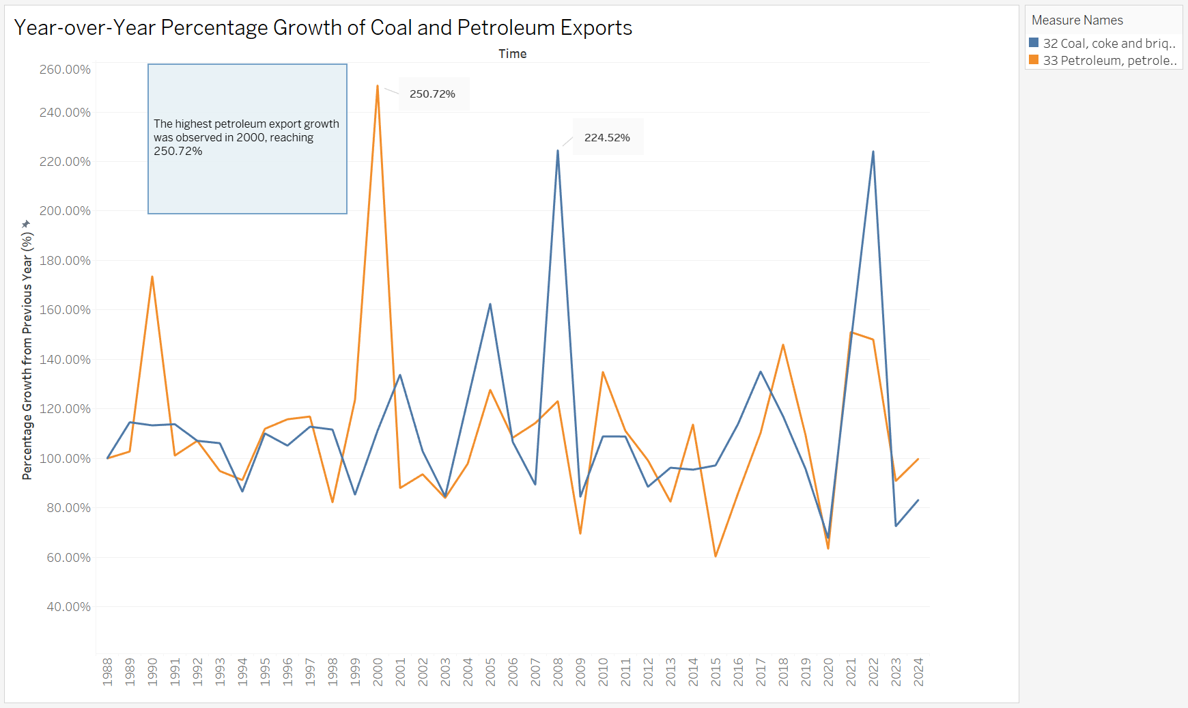
Chart 13: Year-over-Year Percentage Growth of Coal and Petroleum Exports
In comparison, coal export growth is steadier. The blue line still goes up and down, but not as wildly. Most of the time, coal export growth stays between 50% and 150%, though there are times when it drops below that range. While coal exports are not perfectly stable, they are more predictable than petroleum. In some years, both coal and petroleum follow similar patterns, which may reflect changes in the overall economy. Still, petroleum shows far more dramatic changes than coal, making it less stable overall.
- Total Trade Value of Coal and Petroleum
The scatter plot below shows how much money Australia made from coal and petroleum trade over 35 years, from 1988 to 2023. Each dot represents the total value for a year, with coal shown in blue and petroleum in orange. The coal dots show a big increase over time, especially after 2003. Coal trade values go from very small in the late 1980s to a high of $142,345 million in 2022. The pattern shows that coal exports grew faster and faster over time, especially in the 2000s and 2010s.
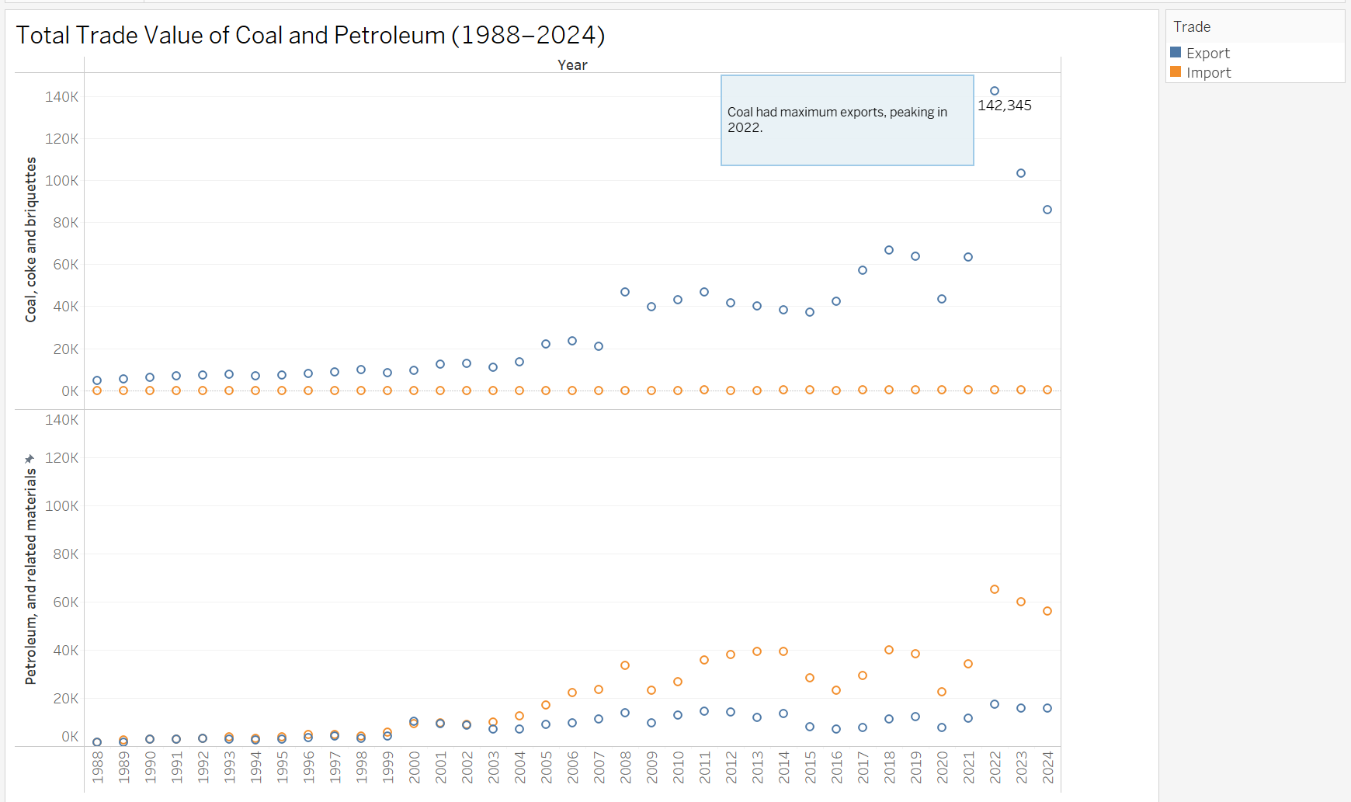
Chart 14: Total Trade Value of Coal and Petroleum
Petroleum trade values, shown with orange dots, are much lower overall. Most of them stay under $50,000 million. The petroleum line does increase slowly over the years, but not nearly as fast or as high as coal. When you compare the two, it’s clear that coal has become a much bigger part of Australia’s trade. By the end of the period, coal exports are far more valuable than petroleum exports.

6. Storyboard: Subcategory Trend Narrative
The storyboard is made up of different stories, each showing a key insight about the chosen category “Coal, coke and briquettes” and its relationship with the other subcategories of mineral fuels. Below is explanation of what each story in the dashboard shows.
- Story 1
This stacked bar chart shows how Australia’s trade in mineral fuels changed from 1988 to 2024, focusing on three subcategories: coal, petroleum, and gas. The chart uses colours to show exports (blue) and imports (orange), helping to compare trade flows over time. It highlights how Australia grew from a small fuel trader in the late 1980s to a major exporter, with total trade reaching over 300,000 million dollars by 2022—a fifteen-fold increase.

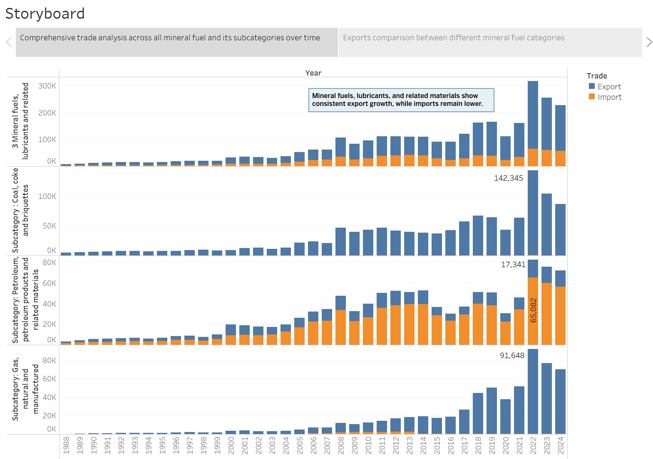
Chart 15: story 1
The chart provides a clear view of overall trade—both exports and imports—for the main mineral fuels category and its three subcategories: coal, petroleum, and gas. One of the key trends shown is the sharp rise in coal exports starting around 2003–2005. The chart helps highlight such major changes over time, making it easy to see how each subcategory contributed to Australia’s trade growth.
- Story 2
This bar chart below provides a clear visual comparison of Australia’s export earnings from three different mineral fuel categories: coal, petroleum, and gas. Each category is represented by a distinct colored bar—orange for coal, blue for petroleum, and green for gas—making it easy to differentiate between them at a glance. The vertical axis shows the earnings in millions of dollars, and each bar has a label at the top indicating the exact export value.
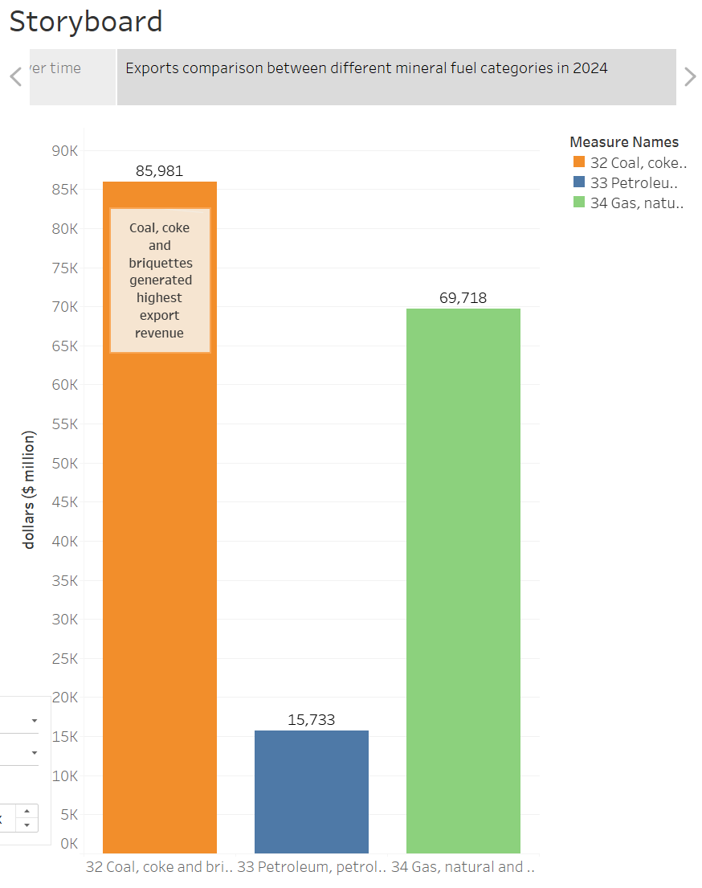
Chart 16: story 2
Coal, represented by the tall orange bar, stands out as the highest-earning category with export revenue of $85,981 million. It dominates the chart, showing a significantly larger contribution compared to the other two categories. Gas, shown with the green bar, is the second-highest earner at $69,718 million. While it is shorter than the coal bar, it is still noticeably higher than the petroleum bar. Petroleum, displayed in blue, has the smallest export value at $15,733 million. The big difference in height between this bar and the others makes it clear that petroleum contributes much less to total mineral fuel exports.
- Story 3
The line chart shows how trade patterns for coal and gas have changed over time. Coal exports have grown a lot from very low in 1988 to a peak of $142,345 million in 2022. Gas exports also grew strongly, especially after 2010, reaching $91,648 million. The chart has two separate panels, one for coal, one for gas, with blue lines showing exports and orange lines showing imports. This makes it easy to compare both subcategories. A note highlights that "99% of mineral fuel imports are petroleum, while coal is barely imported," which helps explain Australia's trade focus.
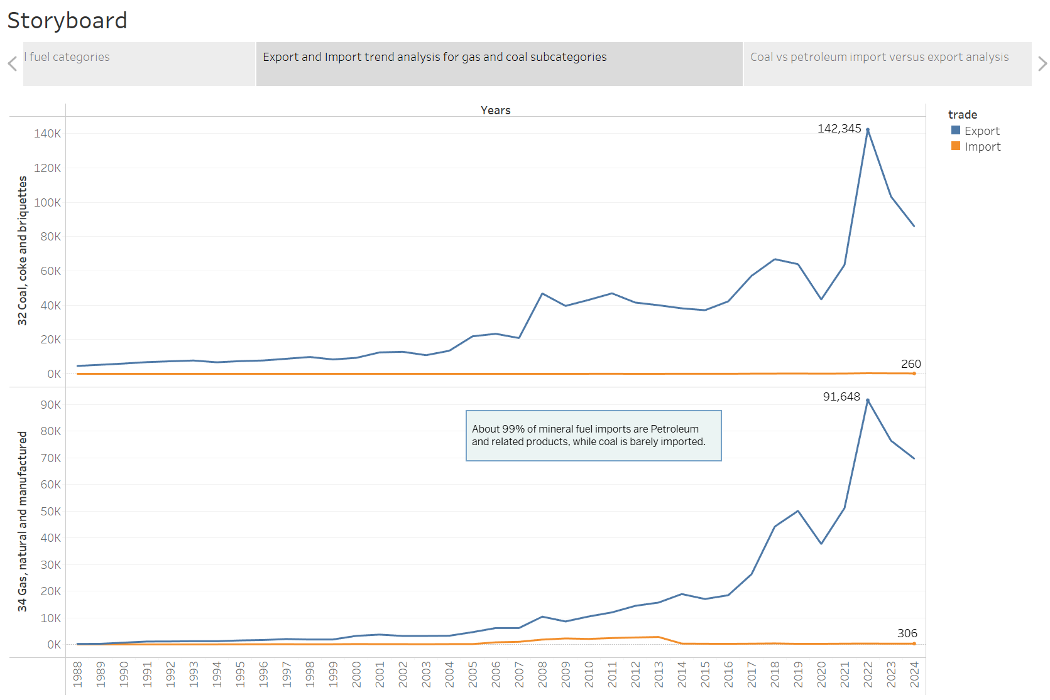
Chart 17: story 3
Coal exports went through three phases: slow growth (1988–2003), rapid growth (2003–2012), and high but volatile levels (2012–2024). Gas exports started increasing later but did so quickly. Coal and gas imports stayed very low—$260 million and $306 million—which shows that Australia mostly uses its own production for domestic needs and focuses on exporting large amounts.
- Story 4
This combo chart provides a visual comparison of coal and petroleum trade over time, using two types of graphs: a bar chart for coal exports and a line chart for petroleum imports. The horizontal axis represents the years, covering a period from around 1988 to 2024, while two separate vertical axes are used to display the values for coal and petroleum trade in millions of dollars. The use of two different graph styles and axes helps clearly show the differences in scale and trend between the two fuel types.
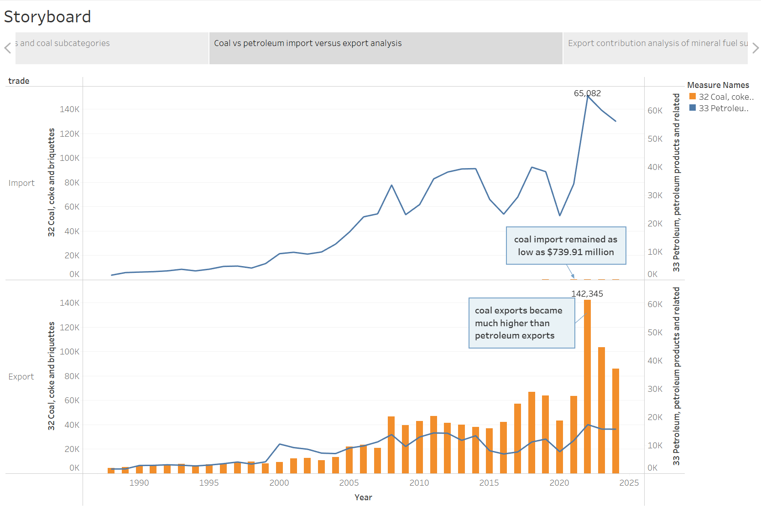
Chart 18: story 4
According to the chart, coal exports have experienced a significant increase over the years, reaching a peak value of $142,345 million. The orange bars show a consistent rise in coal exports, especially from the mid-2000s onward, with notable spikes after 2015. In contrast, petroleum imports, represented by the blue line, have remained at relatively high levels across the same period, peaking at $65,082 million. However, the chart also shows that coal imports have stayed very low, with a minimum value recorded at just $739.91 million.
- Story 5
The area chart below shows how coal, petroleum, and gas have each contributed to Australia’s total mineral fuel exports from 1988 to 2024. It uses colour coding—pink for coal, yellow for petroleum, and purple for gas—to show their percentage shares over time. The chart clearly shows that coal has been the dominant export for most of the period, often making up 60% to 100% of the total. An annotation in the chart highlights this key point: “Coal holds the largest share of total mineral exports.”

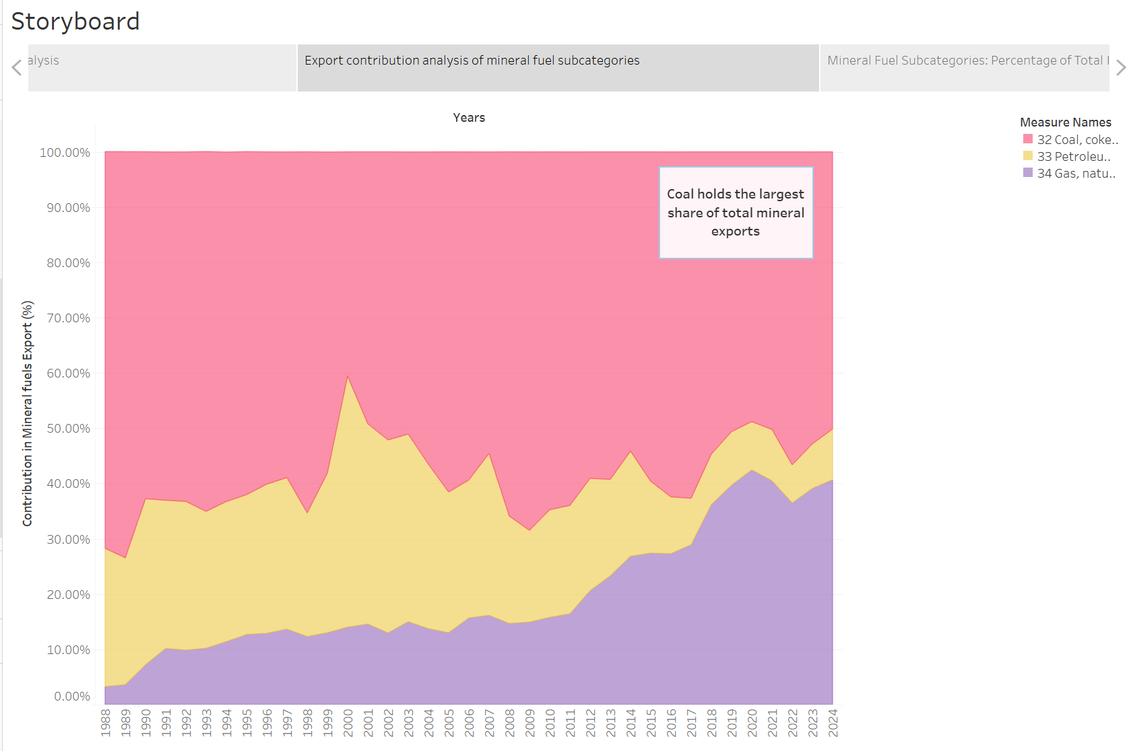
Chart 19: story 5
Looking at the timeline, there are three main phases. From 1988 to 1995, coal almost entirely dominated exports. Between 1995 and 2010, gas and petroleum became more important, likely due to changes in technology and global demand. From 2010 onward, coal returned to being the largest share, although with more ups and downs. These changes reflect fluctuations in energy demand. Overall, while gas and petroleum have grown, coal still makes up the bulk of exports.
- Story 6
The chart below is a line graph showing the percentage breakdown of Australia's mineral fuel imports from 1988 to 2024. It also uses colours, yellow for petroleum, red for coal, and purple for gas. Unlike exports, petroleum dominates imports with about 99% of the total over the whole period. The chart includes a label pointing out this fact, and mentions that coal is rarely imported, which shows a clear difference between what Australia exports and what it imports.

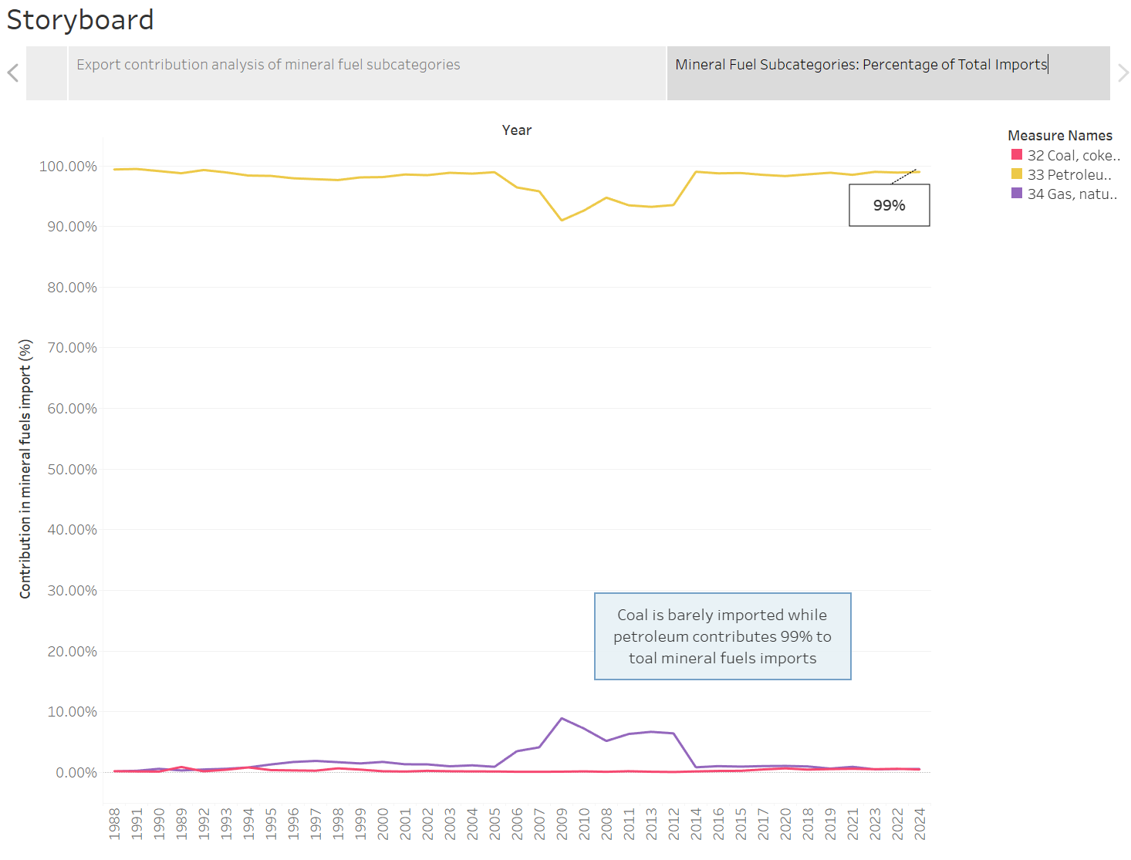
Chart 20: story 6
Coal imports have remained very low, consistently staying under 1%, while gas imports have generally stayed below 9%. This pattern shows that Australia produces enough coal and natural gas within the country to meet most of its own needs without having to rely heavily on imports. In contrast, petroleum imports are much higher, which highlights a key difference in the country’s energy supply. The high level of petroleum imports suggests that Australia does not have enough local facilities to refine crude oil into usable fuels. Because of this limited refining capacity, Australia depends a lot on other countries to supply these processed petroleum products.

7. Product Trend Analysis and Forecast
For this section, Petroleum and related products from the Mineral Fuels category was selected, focusing specifically on imports from 2015 to 2024. The bar chart shows the growth of petroleum imports over this ten-year span, highlighting fluctuations. From 2015 to 2017, import values remained moderate, ranging from roughly 24K to 30K million. A notable jump occurred in 2018 and 2019, with values peaking at around 40K million, before dropping significantly in 2020. Recovery is evident from 2021 onward, with petroleum imports soaring to their highest point in 2022, exceeding 65K million. Although there’s a slight decline in 2023 and 2024, values remain much higher than in the first half of the decade.
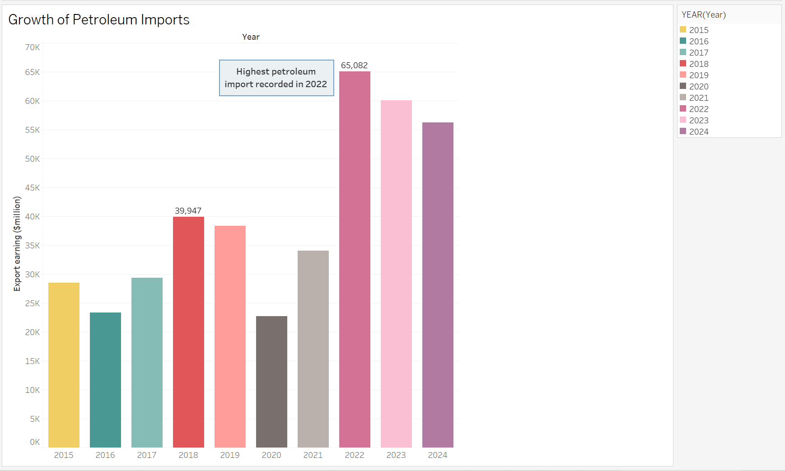
Chart 21: Growth of Petroleum Imports
From 2025 to 2029, Australia should focus on managing petroleum imports better and reducing how much it depends on other countries for fuel. It’s important to avoid big changes in how much petroleum is imported or how much it costs, because steady and reliable imports help keep the economy stable and make it easier for businesses to plan. To do this, Australia should try to make better trade deals so it can get petroleum at good prices and from dependable sources. Another helpful step would be to invest in more local fuel refining, which would lower the need to import already-refined fuels and help the country rely more on its own energy. By working on these areas, Australia can manage petroleum imports more effectively, reduce risks, and build stronger long-term energy security.

8. Graphical Techniques & Visualisation Discussion
During the visualisation process, several chart types and techniques were applied to highlight trends, patterns, and insights from the Australian International Trade dataset. Tableau was the primary tool used to create interactive dashboards and storyboards. Line charts were used to track changes in import and export values across the 35-year period, helping to identify both long-term trends and short-term fluctuations. Bar charts and stacked bar charts were useful for comparing trade values across main categories and subcategories, showing which sectors consistently contributed more to total trade volumes. Combo charts, which combined bar and line elements, were used to compare two different measures on the same graph for clearer interpretation. Furthermore, area charts were used to visualize cumulative totals over time to better see the increase and proportion of individual subcategories within the overall dataset. Besides, dashboard made it easy to explore the data, and the storyboard helped explain the story and compare subcategories. Overall, the chosen visualisation methods were picked for their clarity, interactivity, and efficacy in facilitating data-driven storytelling.

9. Insights and Recommendations
Australia’s trade has changed a lot over the last 35 years. By 2024, mineral fuels like coal, gas, and other raw materials made up nearly 60% of all exports. Coal is still the biggest export, but it faces risks from price changes and environmental rules. While Australia exports a lot of coal and gas, it imports most of its petroleum products. This shows the country relies too much on other countries for fuel because it does not have enough local refineries. This can be a problem for energy security.
To fix this, Australia should not focus only on coal. It should invest in clean energy, important minerals, and businesses that can turn raw materials into more valuable products. Building more refineries at home would mean less need to buy refined fuels from other countries. This would help lower fuel costs and make energy supplies more reliable. Australia should also improve transport systems, like ports, railways, and pipelines, to move goods more easily and cheaply.
In the future, Australia should get ready for cleaner energy by developing new exports like hydrogen and critical minerals. It also needs to support people in coal areas to find new kinds of work. Increasing food exports and making farming more efficient can also bring in more money and improve food security. Finally, having flexible trade rules and using data better can help Australia react faster to global changes, reduce risks, and find new chances to grow. This will make the trade system stronger and more prepared for the future.

10. Evaluation of Dashboard and Storyboard Methodologies
The dashboard has various benefits, such as interactivity, the capacity to compare various data points simultaneously, and visualisations that enable users to delve into trends and patterns. It enables users to customize their view and reveal insights using different charts and annotations. Among its drawbacks are the potential for cluttered layout, and the requirement for the user to interpret and correlate the data on their own, something that may be difficult for non-experts.
In contrast, the storyboard is good at showing a clear, step-by-step story that helps users understand the main points. It works well for sharing information with policymakers or others who want a simple, easy-to-follow explanation. The disadvantage is that storyboards are not as interactive and limit user-driven discovery of the data. Generally, dashboards are best for deep analysis and storyboards are more powerful for clear, focused communication. Using both approaches together offers a balanced solution for data visualisation.

11. Conclusion
This report explored over 35 years of Australian international trade data using Excel for statistical analysis and Tableau for visualisation. By focusing on Mineral fuels, lubricants and related materials, it identified key trends, turning points, and possible causes. Visual tools like line graphs, bar charts, area chart and combo charts made the patterns easy to understand, while dashboards allowed for interactive exploration and storyboards helped present a clear narrative. The findings highlighted Coal, coke and briquettes’ role in trade and suggested useful recommendations. Overall, visual analytics made complex trade data easier to interpret and more useful for decision-making.

