Beyond Tokenization: Investigating Model Behaviour, Explanation Stability, and Faithfulness under Lexical Perturbations in Devanagari Hindi
Anonymous Author(s)
*Under Review for Publication*
---
Abstract
Masked language models (MLMs) have become central to multilingual natural language processing (NLP), yet their behavior and interpretability under non-Latin, morpho-phonetically complex scripts remain critically underexplored. In this work, we present a systematic empirical investigation into model behavior, subword tokenization dynamics, explanation stability, and explanation faithfulness under controlled lexical perturbations in Devanagari Hindi. Using an audited, triple-annotated benchmark of 200 minimal sentence pairs across three controlled tracks—*Valid Word Context* (N=142), *Synonym Substitution* (N=38), and *Realistic Spelling Error* (N=20)—we evaluate the Indic-dedicated encoder MuRIL (`google/muril-base-cased`) and the multilingual generalist XLM-RoBERTa (`FacebookAI/xlm-roberta-base`).
Our experiments reveal four primary findings. First, authentic Devanagari spelling errors (matra inversions and ligature splits) induce catastrophic subword fragmentation: single-subword target coverage collapses by -60.0\% in MuRIL (90.0\% \to 30.0\%) and by -50.0\% in XLM-RoBERTa (70.0\% \to 20.0\%), causing an average sentence-level token inflation of +1.00 subwords driven exclusively by target fracturing. Second, both models reliably penalize spelling errors under pseudo-log-likelihood (PLL) scoring, but MuRIL exhibits substantially harsher penalties (original preferred in 95.0\% of pairs, mean \Delta \text{MeanLogP} = -2.0368) than XLM-RoBERTa (65.0\%, mean \Delta \text{MeanLogP} = -0.6695), while both models recognize valid synonyms as near-equivalent (\Delta = -0.0655 for XLM-R). Third, under a corrected visible-target scoring protocol that resolves an illusory perfect stability artifact (\rho = 1.000) induced by target masking, last-layer self-attention achieves 2.1\times to 2.7\times higher rank stability (\rho = 0.7043\text{--}0.7425) than Layer Integrated Gradients (\rho = 0.2632\text{--}0.3589), while Integrated Gradients preserves high vector cosine similarity (0.8994\text{--}0.9880). Fourth, in discrete context token erasure tests (f \in \{0.10, 0.20, 0.30\}), attention attributions yield superior faithfulness win rates against control erasure (70.0\%\text{--}77.5\%), whereas continuous Integrated Gradients operates near or below chance (42.5\%\text{--}60.0\%). Finally, an explicit correlation analysis across all spelling pairs demonstrates that explanation stability does not predict explanation faithfulness (p > 0.05 across all 8 evaluated model-method configurations; Spearman r_s \in [-0.161, +0.270]). These results establish that attribution stability under input noise and causal faithfulness under feature erasure evaluate orthogonal dimensions of explanation quality, cautioning against using explanation stability as a proxy for faithfulness in explainable NLP benchmarks.
Keywords: Devanagari Hindi, Masked Language Models, Subword Tokenization, Pseudo-Log-Likelihood Scoring, Explainable NLP, Explanation Stability, Explanation Faithfulness, Integrated Gradients, Self-Attention.
---
1. Introduction
Pretrained masked language models (MLMs) based on bidirectional Transformer architectures have fundamentally advanced modern computational linguistics across high-resource and multilingual environments \cite{devlin-etal-2019-bert,conneau-etal-2020-unsupervised}. However, the empirical behaviors of these models are overwhelmingly documented in languages employing Latin alphabets, where typographical noise predominantly consists of straightforward character substitutions, deletions, or transpositions \cite{salazar-etal-2020-masked,rust-etal-2021-good}. In contrast, non-Latin writing systems—specifically Indic scripts following the abugida orthographic typology such as Devanagari Hindi—possess unique structural, syllabic, and compositional characteristics. Devanagari encodes phonological syllables (aksharas) utilizing base consonant consonants, dependent vowel diacritics (matras), and virama-linked conjuncts (ligatures). Consequently, minor orthographic variations or colloquial misspellings in Devanagari do not operate as isolated character perturbations; rather, they alter the underlying graphemic and syllabic representation, frequently destroying canonical subword vocabulary entries and triggering severe tokenization fragmentation \cite{kakwani-etal-2020-indicnlpsuite}.
In parallel with questions surrounding language model scoring and tokenization robustness, the interpretability of Transformer architectures has emerged as a cornerstone of trustworthy NLP \cite{sundararajan-etal-2017-axiomatic,deyoung-etal-2020-eraser}. Researchers and practitioners routinely employ feature attribution techniques—such as gradient-based saliency methods and self-attention weights—to decipher the decision-making processes of neural models \cite{jain-wallace-2019-attention,wiegreffe-pinter-2019-attention}. Within the explainable AI (XAI) literature, two evaluative criteria are frequently prioritized:
- Explanation Stability (Robustness): The degree to which an explanation remains invariant under minor, semantics-preserving input perturbations \cite{alvarez-melis-jaakkola-2018-robustness,dombrowski-etal-2019-explanations}.
- Explanation Faithfulness: The degree to which an explanation accurately reflects the model's internal causal reasoning, typically evaluated by erasing top-attributed tokens and measuring the corresponding decline in model output certainty \cite{deyoung-etal-2020-eraser,jacovi-goldberg-2020-towards}.
Critically, a pervasive but largely untested assumption in applied XAI benchmarks is that attribution stability is an indicator of explanation quality, with the implicit expectation that an explanation that is robust to localized input noise is also more likely to be faithful to the underlying model mechanism \cite{ding-koehn-2021-evaluating,atanasova-etal-2020-diagnostic}.
This study bridges this empirical and conceptual gap by investigating Devanagari Hindi lexical sensitivity and conduct a joint, rigorous evaluation of subword tokenization, model scoring, explanation stability, and explanation faithfulness. We formulate our inquiry around five primary research questions (RQs):
- RQ1: How do contextual lexical contrasts, synonym substitutions, and spelling perturbations affect subword tokenization and model scoring in Devanagari Hindi?
- RQ2: How do MuRIL (an Indic-dedicated MLM) and XLM-RoBERTa (a global multilingual generalist) differ in their representations of and scoring responses to these perturbations?
- RQ3: How stable are Attention and Integrated Gradients explanations when evaluated under authentic Devanagari spelling perturbations?
- RQ4: How do Attention and Integrated Gradients behave under discrete context-token masking interventions in masked language models?
- RQ5: Is explanation stability under input noise statistically associated with measured explanation faithfulness under feature erasure?
To answer these questions, we construct and rigorously audit a 200-pair Devanagari Hindi minimal pair benchmark. We formulate an experimental pipeline combining pseudo-log-likelihood (PLL) scoring, fast subword offset mapping, Layer Integrated Gradients, and last-layer multi-head self-attention extraction. Importantly, we document and resolve a critical methodological artifact in perturbation-based stability evaluation—the *masked-target artifact*—and establish the *Visible-Target Scoring Protocol* to measure genuine attribution dynamics.
Our quantitative results demonstrate that while Devanagari spelling errors cause severe vocabulary collapse and predictable score penalties, explanation stability is completely decoupled from explanation faithfulness (p > 0.05 across all evaluated conditions). Furthermore, we show that despite theoretical arguments prioritizing axiomatic gradient methods, self-attention attributions exhibit substantially higher empirical stability and discrete masking faithfulness than Integrated Gradients in masked language models.
---
2. Background and Related Work
2.1 Indic-Language Pretrained Models and Devanagari NLP
The development of multilingual masked language models has expanded NLP capabilities across non-English languages. Prominent architectures include mBERT \cite{devlin-etal-2019-bert} and XLM-RoBERTa \cite{conneau-etal-2020-unsupervised}. XLM-RoBERTa utilizes a Byte-Pair Encoding (BPE) SentencePiece vocabulary of 250,002 tokens shared across more than 100 languages, trained on massive web-crawled Common Crawl corpora. To overcome vocabulary dilution in massively multilingual models, Khanuja et al. \cite{khanuja-etal-2021-muril} introduced MuRIL (*Multilingual Representations for Indic Languages*), a BERT-base architecture trained exclusively on 17 Indic languages and English using a 197,285-token WordPiece vocabulary. Kakwani et al. \cite{kakwani-etal-2020-indicnlpsuite} similarly developed IndicBERT and the IndicGLUE benchmark, emphasizing that language-family specialization improves syntactic and morphological capture. However, comparative investigations into how these divergent pretraining strategies govern fine-grained orthographic and lexical sensitivity in Hindi remain sparse.
2.2 Subword Tokenization and Orthographic Vulnerability
Subword segmentation algorithms, such as Byte-Pair Encoding (BPE) \cite{sennrich-etal-2016-neural}, WordPiece \cite{devlin-etal-2019-bert}, and Unigram SentencePiece \cite{kudo-richardson-2018-sentencepiece}, are foundational to modern transformers. Although these tokenizers mitigate out-of-vocabulary (OOV) challenges by segmenting unseen words into subword fragments, recent studies have demonstrated that subword tokenizers are brittle under orthographic variations \cite{bostrom-durrett-2020-byte,rust-etal-2021-good}. In languages written in the Devanagari script, the structural unit is the akshara (syllable), composed of consonant bases modified by attached vowel diacritics (matras) or conjunct-forming halants (viramas). When a user introduces a spelling error—such as swapping a long *dirgha* matra for a short *hrasva* matra (e.g., `पानी` \to `पानि`) or omitting a halant (e.g., `आवश्यक` \to `आवशयक`)—the character sequence shifts across syllabic boundaries. Unlike Latin typos which frequently preserve the subword root, Devanagari perturbations fracture canonical vocabulary tokens into isolated bytes or single Unicode codepoints \cite{kakwani-etal-2020-indicnlpsuite}.
2.3 Masked Language Model Scoring and Pseudo-Log-Likelihood
Autoregressive language models naturally provide sequence probabilities via the chain rule of probability. In contrast, bidirectional masked language models cannot directly factorize sequence joint probabilities due to bidirectional conditioning. To evaluate sentence plausibility in MLMs, Wang and Cho \cite{salazar-etal-2020-masked} and Salazar et al. \cite{salazar-etal-2020-masked} formalized Pseudo-Log-Likelihood (PLL) scoring. By iteratively masking each token in a sentence and accumulating the conditional log-probabilities of the masked tokens given the bidirectional context, PLL provides an effective proxy for grammatical acceptability and corpus typicality. In this work, we follow Salazar et al. \cite{salazar-etal-2020-masked} while strictly implementing length-normalized scoring (\text{MeanLogP}) to account for tokenization fertility differences between canonical and misspelled sentences.
2.4 Feature Attribution: Attention vs. Integrated Gradients
Feature attribution methods aim to assign an importance score to each input token reflecting its contribution to a model's prediction. Integrated Gradients (IG) \cite{sundararajan-etal-2017-axiomatic} is an axiomatic path-attribution method that computes the path integral of gradients along a straight line between a baseline input (typically zero or pad embeddings) and the input representation. IG uniquely satisfies two foundational mathematical axioms: *Completeness* (attributions sum to the difference between the target output and the baseline output) and *Implementation Invariance*.
Conversely, Self-Attention weights from Transformer layers have frequently been utilized as heuristic explanations \cite{serrano-smith-2019-attention}. This practice sparked an extensive academic debate: Jain and Wallace \cite{jain-wallace-2019-attention} famously argued that "Attention is not Explanation," demonstrating that attention weights often correlate weakly with gradient-based saliency and that adversarial attention distributions can be constructed without altering predictions. Wiegreffe and Pinter \cite{wiegreffe-pinter-2019-attention} countered that attention distributions frequently track model predictions well and that alternative adversarial distributions may fail simple consistency checks. Brunner et al. \cite{brunner-etal-2020-identifiability} further demonstrated that attention weights in deep layers suffer from loss of token identifiability. Our work directly engages this debate within the context of masked language models and Indic text.
2.5 Explanation Stability and Faithfulness Evaluation
In evaluating explanation quality, the literature distinguishes between stability and faithfulness. Stability (or robustness) examines whether small, task-irrelevant changes to the input produce small changes in the attribution vector \cite{alvarez-melis-jaakkola-2018-robustness}. Saliency methods have been shown to be susceptible to adversarial shifts and geometric noise \cite{dombrowski-etal-2019-explanations,heo-etal-2019-fooling}. Faithfulness, formalized in benchmarks such as ERASER \cite{deyoung-etal-2020-eraser}, assesses whether the features identified by an explanation method correspond to the actual causal reasoning of the model. Common metrics include *comprehensiveness* (how much model confidence drops when top-attributed features are erased) and *sufficiency* (how well model confidence is retained when only top features are kept) \cite{jacovi-goldberg-2020-towards,atanasova-etal-2020-diagnostic}. Bastings and Filippova \cite{bastings-filippova-2020-elephant} highlighted that saliency methods, while theoretically appealing, often behave unpredictably under feature erasure. Crucially, prior work has predominantly treated stability and faithfulness as independent evaluation benchmarks without empirically testing their mutual relationship.
---
3. Dataset Construction & Annotation Methodology
3.1 Benchmark Design and Track Structure
To evaluate lexical sensitivity and interpretability in Devanagari Hindi, we curated a controlled benchmark of 200 minimal sentence pairs (N=200). Each record consists of an Original Sentence (S_{\text{orig}}) containing a canonical Hindi target word (w_{\text{orig}}) and a Contrast Sentence (S_{\text{cont}}) where the target word is replaced by a perturbed variant (w_{\text{cont}}), while keeping all surrounding context words identical.
The dataset is partitioned into three mutually exclusive experimental tracks:
- `VALID_WORD_CONTEXT` (N=142, 71.0\%): Minimal pairs where the target word is replaced by an alternative, grammatically valid Hindi word that creates a contextual or semantic mismatch (e.g., substituting an inappropriate noun, verb, or adjective given the sentential semantics).
- `SYNONYM_SUBSTITUTION` (N=38, 19.0\%): Minimal pairs where the canonical target word is replaced by a verified, contextually appropriate Hindi synonym (e.g., `पानी` [water] \leftrightarrow `जल`, `सूर्य` [sun] \leftrightarrow `सूरज`), preserving core semantic meaning.
- `REALISTIC_SPELLING_ERROR` (N=20, 10.0\%): Minimal pairs where the target word is replaced by an authentic, commonly observed orthographic or phonological misspelling in contemporary Hindi.
```
+---------------------------------------------------------------------------------------------------+
Track Distribution (N = 200 Minimal Sentence Pairs)
[VALID_WORD_CONTEXT] ========================================= 142 pairs (71.0%)
[SYNONYM_SUBSTITUTION] =========== 38 pairs (19.0%)
[REALISTIC_SPELLING_ERROR] ===== 20 pairs (10.0%)

+---------------------------------------------------------------------------------------------------+
```
3.2 Typology of Devanagari Orthographic Errors
The 20 spelling error pairs in the `REALISTIC_SPELLING_ERROR` track were systematically classified into four distinct linguistic categories reflecting the phonological and orthographic characteristics of Devanagari:
- Matra Vowel Length Inversion (N=9, 45.0\%): Inversion of short (*hrasva*) and long (*dirgha*) vowel diacritics. In Devanagari Hindi, phonemic vowel length distinctions are frequently neutralized in rapid speech, leading to widespread writing errors. Examples include `पानी` (p\bar{a}n\bar{\imath}) \to `पानि` (p\bar{a}ni) and `परीक्षा` (par\bar{\imath}k\text{ṣ}\bar{a}) \to `परिक्षा` (parik\text{ṣ}\bar{a}).
- Conjunct and Ligature Disruptions (N=5, 25.0\%): Omission of halant/virama markers or simplification of complex consonant clusters (samyuktaksharas). Examples include `स्वास्थ्य` (sv\bar{a}sthya) \to `स्वास्थ` (sv\bar{a}stha) and `आवश्यक` (\bar{a}va\text{ś}yak) \to `आवशयक` (\bar{a}va\text{ś}ayak).
- Orthographic Alternations (N=2, 10.0\%): Prescribed standard variations in formal Devanagari orthography, specifically anusvara vs. class nasal substitutions (`संभावना` vs. `सम्भावना`) and single vs. double ligature spelling (`महत्वपूर्ण` vs. `महत्त्वपूर्ण`).
- Colloquial Phonetic Spellings (N=4, 20.0\%): Dialectal or colloquial phonetic shifts widely observed in informal writing, such as `वापस` (v\bar{a}pas) \to `वापिस` (v\bar{a}pis).
3.3 Quality Control, Annotation, and Forensic Adjudication
To guarantee gold-standard data integrity, all 200 pairs underwent triple annotation: independent evaluation by two native Hindi linguists (`annotator_1`, `annotator_2`) followed by an expert adjudication phase (`adjudication`) and a definitive `final_status` determination.
A comprehensive forensic audit of the dataset file (`data/raw/hindi_lexical_sensitivity_cleaned.xlsx`, SHA-256 `f9a5af81e216...`) verified the following:
- Script Integrity: 100% of characters in all original and contrast sentences reside strictly within the Devanagari Unicode block (`U+0900` to `U+097F`) or standard punctuation.
- The Sole Rejected Record: Exactly one pair was rejected during quality control: `HC_0178` (`सलाह` [advice] vs. `साई` [knitting needle], Row 177), where both annotators and the adjudicator marked `reject` (`final_status = reject`). Early project working notes erroneously cited `HC_0185` or `HC_0047` due to drafting row-index transcription errors; our audit definitively confirms that `HC_0178` is the sole rejected record, representing 0.5% of the 200 pairs.
- Disagreement Overrides (N=6): Exactly six records (`HC_0087`, `HC_0099`, `HC_0138`, `HC_0172`, `HC_0180`, `HC_0186`) involved a double-reject by the annotators that was subsequently overridden by the curator to `final_status = accept`. In each of these cases, the annotators flagged that the contrast word was a distinct valid word rather than a minor morphological tweak. Because both sentences are grammatical valid Hindi sentences, the curator retained them under `VALID_WORD_CONTEXT` to test contextual plausibility discrimination.
- Benchmark Totals: The dataset contains 199 fully accepted pairs and 1 rejected pair, totaling 200 unique minimal pairs. When evaluated across two models, this generates exactly 400 model evaluation rows.
---
4. Models and Experimental Methodology
4.1 Evaluated Pretrained Architectures
We conduct all experiments across two distinct pretrained bidirectional Transformer models:
- MuRIL (`google/muril-base-cased`): A BERT-base architecture (12 layers, 12 attention heads, 768 hidden dimensions, ~236M parameters) pretrained on 17 Indic languages and English using an Indic-dedicated WordPiece vocabulary of 197,285 tokens \cite{khanuja-etal-2021-muril}.
- XLM-RoBERTa (`FacebookAI/xlm-roberta-base`): A RoBERTa-base architecture (12 layers, 12 attention heads, 768 hidden dimensions, ~278M parameters) pretrained on 2.5TB of Common Crawl data across 100+ languages using a SentencePiece BPE vocabulary of 250,002 tokens \cite{conneau-etal-2020-unsupervised}.
Both models were evaluated in CPU inference mode (`torch.inference_mode()`) using HuggingFace Transformers 4.57.6, with explicit batching and garbage collection.
4.2 Subword Tokenization Analysis & Alignment Protocol
We extract subword tokenizations utilizing HuggingFace fast tokenizers with offset mapping (`return_offsets_mapping=True`). For every sentence pair, we compute:
- Full sequence token counts, both special-token-inclusive (|W_{\text{all}}|) and exclusive (|W_{\text{excl}}|).
- Target word subword lengths for original (|T_{\text{orig}}|) and contrast (|T_{\text{cont}}|) sentences.
- Single-subword target coverage: the percentage of target words that tokenize into exactly one subword token (|T| = 1).
- Alignment outcomes between original and contrast context tokens.
4.3 Pseudo-Log-Likelihood (PLL) Scoring Formulations
Following Salazar et al. \cite{salazar-etal-2020-masked}, for a sentence W = (w_1, w_2, \dots, w_{|W|}), the sentence-level pseudo-log-likelihood is computed by iteratively masking each non-special token w_t:
\text{PLL}(W) = \sum_{t=1}^{|W|} \log P(w_t \mid W_{\setminus t}; \Theta)
where W_{\setminus t} denotes the input sequence with token w_t replaced by the model's mask token (`[MASK]` for MuRIL, `<mask>` for XLM-RoBERTa), and \Theta denotes the model parameters.
To prevent token length bias—where a sentence segmented into more subwords naturally accumulates a more negative sum—we compute the length-normalized mean log-probability:
\text{MeanLogP}(W) = \frac{\text{PLL}(W)}{|W_{\text{scorable}}|}
where |W_{\text{scorable}}| is the number of iteratively masked content tokens.
The plausibility shift between contrast and original sentences is defined as the signed delta:
\Delta \text{MeanLogP} = \text{MeanLogP}(W_{\text{cont}}) - \text{MeanLogP}(W_{\text{orig}})
Under this convention:
- \Delta \text{MeanLogP} < 0: The original sentence is assigned higher plausibility (canonical preference).
- \Delta \text{MeanLogP} > 0: The contrast sentence is assigned higher plausibility.
> Methodological Guardrail on Cross-Model Comparability: Because MuRIL and XLM-RoBERTa utilize entirely different subword vocabularies and tokenization algorithms, their raw PLL and MeanLogP sums occupy non-commensurable probability spaces. Therefore, cross-model comparisons are strictly restricted to within-model signed deltas (\Delta \text{MeanLogP}), preference rates, and directional agreement.
4.4 Feature Attribution Extraction
We evaluate two widely utilized feature attribution methods across the context tokens of each sentence:
- Last-Layer Multi-Head Self-Attention:
We extract the self-attention tensor A \in \mathbb{R}^{12 \times |W| \times |W|} from Layer 11 (the final transformer layer). Attention weights are averaged across all 12 attention heads:
\bar{A}_{i, j} = \frac{1}{12} \sum_{h=1}^{12} A^{(11, h)}_{i, j}
The attribution for context token j \notin T with respect to target token set T is the mean directed attention from the target positions to context token j:
\alpha_j = \frac{1}{|T|} \sum_{t \in T} \bar{A}_{t, j}
Special framing tokens are removed, and the resulting context vector is normalized such that \sum_{j \in C} \alpha_j = 1.
- Layer Integrated Gradients (IG):
Using Captum 0.9.0 \cite{sundararajan-etal-2017-axiomatic}, we compute Integrated Gradients with respect to the word embedding layer. We utilize a zero-embedding baseline vector (x' = \mathbf{0}) and approximate the path integral using 50 Gauss-Legendre quadrature steps:
\text{IG}_i(x) = (x_i - x'_i) \times \sum_{k=1}^{50} \frac{\partial F\left(x' + \frac{k}{50}(x - x')\right)}{\partial x_i} \times \frac{1}{50}
The scalar token attribution is obtained by computing the Euclidean L_2-norm over the 768 embedding dimensions, followed by context-level normalization.
4.5 The Stage 6 Masked-Target Artifact & The Stage 7 Visible-Target Protocol
A critical methodological finding of this study is the discovery of the Masked-Target Artifact during preliminary stability evaluations (Stage 6).
In Stage 6, the evaluation protocol attempted to compute attribution stability while predicting the canonical target word at a masked position. However, in the `REALISTIC_SPELLING_ERROR` track, the lexical perturbation was applied *exclusively inside the target word*. When the target word was replaced by `[MASK]` in both the original and contrast sentences, the input sequences fed into the model became byte-identical:
X_{\text{orig}} = [w_1, \dots, \text{[MASK]}, \dots, w_n] \equiv X_{\text{cont}} = [w_1, \dots, \text{[MASK]}, \dots, w_n]
Because the neural network processed the exact same numerical input, the resulting attribution vectors were identical, producing an illusory, trivial stability:
\text{Spearman } \rho = 1.0000, \quad \text{Cosine Sim} = 1.0000, \quad \Delta \text{Logit} = 0.0 \quad (\text{Variance} = 0)
To resolve this benchmark design flaw, we formulated the Visible-Target Scoring Protocol in Stage 7:
- Target words remain fully visible in the input text during attribution computation.
- The target prediction score is defined as the mean unnormalized logit of the actual target subwords:
S(X; Y_{\text{target}}) = \frac{1}{|T|} \sum_{j \in T} \text{Logit}(p_j, y_j)
where p_j is the sequence position of the j-th target subword and y_j is its ground-truth token ID.
- Feature attributions are computed across the unperturbed context tokens while the model processes the actual spelling error, capturing genuine sensitivity.
4.6 Stability Metrics
For each spelling pair (N=20), we align context tokens between the original sentence (C_{\text{orig}}) and contrast sentence (C_{\text{cont}}) using character offset tracking. We evaluate two complementary stability metrics:
- Rank Stability (Spearman \rho): Measures whether the relative importance ordering of context tokens is preserved under target spelling noise:
\rho = 1 - \frac{6 \sum d_i^2}{n(n^2 - 1)}
- Directional Vector Stability (Cosine Similarity): Measures whether the global orientation of the attribution vector in \mathbb{R}^{|C|} is preserved:
\text{Cosine}(\mathbf{u}, \mathbf{v}) = \frac{\mathbf{u} \cdot \mathbf{v}}{\|\mathbf{u}\|_2 \|\mathbf{v}\|_2}
4.7 Faithfulness Evaluation via Context Erasure
Following the ERASER benchmark framework \cite{deyoung-etal-2020-eraser}, we evaluate explanation faithfulness by measuring how target prediction scores change when context tokens are systematically erased. For each sentence (N=40 sentences per model across 20 pairs), context tokens are ranked by their attribution scores. We evaluate three masking interventions at fractions f \in \{0.10, 0.20, 0.30\}:
- Top-k Erasure: Replacing the top k = \lceil f \cdot |C| \rceil highest-attributed context tokens with the model's mask token.
- Bottom-k Erasure (Control): Replacing the k lowest-attributed context tokens with the mask token.
- Random-k Erasure: Replacing k randomly selected context tokens with the mask token (averaged over 5 independent random trials).
We record:
- Target Logit Drop: \Delta S = S_0 - S_{\text{masked}}, where S_0 is the unmasked target score.
- Faithfulness Gap:
\text{Faithfulness Gap} = \Delta S_{\text{top}} - \Delta S_{\text{bottom}} = S_{\text{bottom}} - S_{\text{top}}
A positive gap indicates that erasing top-attributed tokens degrades target prediction more than erasing bottom-attributed control tokens (S_{\text{top}} < S_{\text{bottom}}).
- Win Rate vs. Bottom Control: The percentage of evaluated sentences where \Delta S_{\text{top}} > \Delta S_{\text{bottom}}.
---
5. Empirical Results
5.1 Subword Tokenization & Catastrophic Target Fragmentation
Table 1 presents the subword tokenization properties across models and experimental tracks.
Model Checkpoint | Experimental Track | Pair Count | Mean Orig Tokens | Mean Cont Tokens | Token Delta (\Delta) | Length Ratio | Mean Orig Target Subwords | Mean Cont Target Subwords | Single-Subword Orig Target (%) | Single-Subword Cont Target (%) | Single-Subword Collapse (\Delta)
XLM-RoBERTa | `REALISTIC_SPELLING_ERROR` | 20 | 8.45 | 9.45 | +1.00 | 1.12 | 1.35 | 2.35 | 70.0% | 20.0% | -50.0%
XLM-RoBERTa | `SYNONYM_SUBSTITUTION` | 38 | 7.97 | 8.58 | +0.61 | 1.08 | 1.13 | 1.76 | 89.5% | 60.5% | -29.0%
XLM-RoBERTa | `VALID_WORD_CONTEXT` | 142 | 10.19 | 10.36 | +0.17 | 1.02 | 1.75 | 1.92 | 39.4% | 30.3% | -9.1%
MuRIL | `REALISTIC_SPELLING_ERROR` | 20 | 7.90 | 8.90 | +1.00 | 1.13 | 1.10 | 2.10 | 90.0% | 30.0% | -60.0%
MuRIL | `SYNONYM_SUBSTITUTION` | 38 | 7.63 | 7.82 | +0.18 | 1.02 | 1.00 | 1.18 | 100.0% | 86.8% | -13.2%
MuRIL | `VALID_WORD_CONTEXT` | 142 | 8.95 | 9.04 | +0.08 | 1.01 | 1.43 | 1.51 | 64.1% | 55.6% | -8.5%

*Table 1: Subword tokenization analysis across models and experimental tracks. Source: `outputs/dashboard_data/tokenization_summary.csv`.*
Three primary tokenization patterns emerge from Table 1:
- Catastrophic Fragmentation under Spelling Errors: In the `REALISTIC_SPELLING_ERROR` track, introducing authentic Devanagari spelling errors causes an average increase of exactly +1.00 target subwords in both models. In MuRIL, single-subword target coverage collapses from 90.0\% (18/20) to 30.0\% (6/20), an absolute drop of -60.0\%. In XLM-RoBERTa, coverage collapses from 70.0\% (14/20) to 20.0\% (4/20), an absolute drop of -50.0\%.
- Tokenizer Efficiency: MuRIL encodes Hindi text with substantially greater compactness than XLM-RoBERTa. On the 142 pairs of `VALID_WORD_CONTEXT`, MuRIL requires a mean of 8.95 tokens per original sentence versus 10.19 tokens for XLM-RoBERTa—a ~12% efficiency advantage attributable to MuRIL's Indic-dedicated vocabulary.
- Subword Robustness on Synonyms: In `SYNONYM_SUBSTITUTION`, 100.0% of canonical original targets tokenize as single subwords in MuRIL, and 86.8% remain single subwords after synonym substitution. XLM-RoBERTa exhibits higher subword splitting (89.5\% \to 60.5\%).
5.2 Model Plausibility Scoring across Contexts, Synonyms, & Misspellings
Table 2 details the descriptive statistics for length-normalized plausibility shifts (\Delta \text{MeanLogP}) across models and tracks.
Model Checkpoint | Track Scope | N Pairs | Mean \Delta \text{MeanLogP} | Median \Delta | SD | IQR | Min \Delta | Max \Delta | Original Preferred (N) | Original Preferred (%)
XLM-RoBERTa | `REALISTIC_SPELLING_ERROR` | 20 | -0.6695 | -0.5903 | 1.5495 | 2.4722 | -3.4560 | +2.4161 | 13 | 65.0%
XLM-RoBERTa | `VALID_WORD_CONTEXT` | 142 | -1.0933 | -0.8752 | 1.3572 | 1.4929 | -4.8362 | +1.5154 | 115 | 81.0%
XLM-RoBERTa | `SYNONYM_SUBSTITUTION` | 38 | -0.0655 | -0.1035 | 0.8896 | 0.9189 | -2.5753 | +1.5220 | 22 | 57.9%
MuRIL | `REALISTIC_SPELLING_ERROR` | 20 | -2.0368 | -2.2748 | 1.4447 | 1.6266 | -5.1822 | +0.5509 | 19 | 95.0%
MuRIL | `VALID_WORD_CONTEXT` | 142 | -1.9141 | -1.6218 | 1.5638 | 1.8507 | -5.9067 | +2.3301 | 132 | 93.0%
MuRIL | `SYNONYM_SUBSTITUTION` | 38 | -0.5810 | -0.4607 | 0.7358 | 0.6063 | -3.6843 | +0.6790 | 32 | 84.2%

*Table 2: Descriptive statistics of length-normalized plausibility shifts (\Delta \text{MeanLogP}) across experimental tracks. Source: `outputs/analysis/descriptive_statistics.csv`.*
Figure 1 illustrates the distribution of \Delta \text{MeanLogP} across experimental tracks for both models.
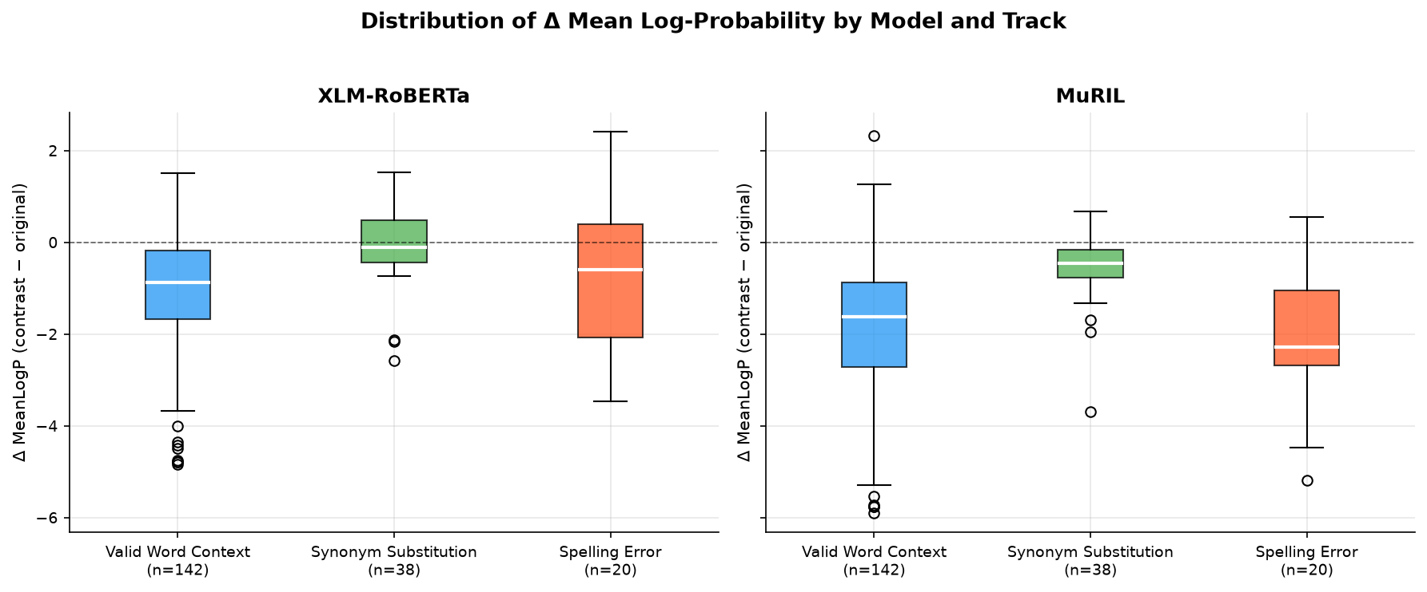
*Figure 1: Boxplot distributions of signed length-normalized pseudo-log-likelihood deltas (\Delta \text{MeanLogP}) across experimental tracks for XLM-RoBERTa and MuRIL. Negative values indicate preference for the canonical original sentence.*
Figure 2 and Figure 3 depict the relationship between subword token inflation and plausibility shifts.
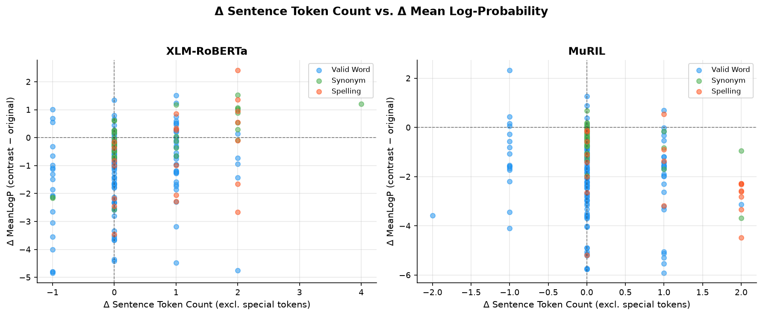
*Figure 2: Scatter plot of full sentence token length changes (\Delta \text{Tokens}) versus plausibility shifts (\Delta \text{MeanLogP}) across all 400 model evaluation rows.*
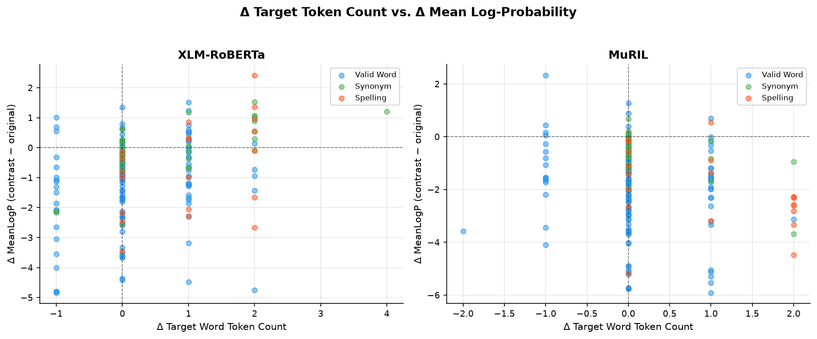
*Figure 3: Plausibility shifts (\Delta \text{MeanLogP}) plotted against the target word subword change (\Delta \text{Target Tokens}). Devanagari spelling errors consistently induce \Delta \text{Target Tokens} \ge +1.*
As established in Table 2 and Figures 1–3:
- Differential Spelling Error Penalization: MuRIL penalizes Devanagari spelling errors substantially more heavily than XLM-RoBERTa. MuRIL assigns lower plausibility to the misspelled sentence in 95.0% (19/20) of pairs (mean \Delta = -2.0368), whereas XLM-RoBERTa prefers the canonical sentence in only 65.0% (13/20) of pairs (mean \Delta = -0.6695).
- Contextual Sensitivity: Both models exhibit strong discrimination on contextual mismatches (`VALID_WORD_CONTEXT`), preferring the original in 93.0% of pairs in MuRIL (mean \Delta = -1.9141) and 81.0% of pairs in XLM-RoBERTa (mean \Delta = -1.0933).
- Synonym Interchangeability: In `SYNONYM_SUBSTITUTION`, XLM-RoBERTa exhibits an average delta of just \Delta = -0.0655 (original preferred in 57.9%), demonstrating that the multilingual generalist treats valid Hindi synonyms as near-interchangeable. MuRIL exhibits a modest penalty (mean \Delta = -0.5810, 84.2% preference), driven primarily by frequency differences in its Indic training corpus.
5.3 Comparative Model Behavior: MuRIL vs. XLM-RoBERTa
Table 3 summarizes the cross-model agreement and rank correlations between XLM-RoBERTa and MuRIL.
Track Scope | N Pairs | Direction Both Negative | Direction Both Positive | XLM Neg / MuRIL Pos | XLM Pos / MuRIL Neg | Directional Agreement Rate (%) | Spearman r_s (\Delta \text{MeanLogP}) | p-value (r_s) | 95% Confidence Interval
ALL TRACKS | 200 | 141 | 8 | 9 | 42 | 74.5% | +0.4408 | < 10^{-9} | [+0.3217, +0.5461]
`VALID_WORD_CONTEXT` | 142 | 110 | 5 | 5 | 22 | 81.0% | +0.4457 | < 10^{-7} | [+0.3032, +0.5687]
`REALISTIC_SPELLING_ERROR` | 20 | 12 | 0 | 1 | 7 | 60.0% | +0.2150 | 0.3626 | [-0.2514, +0.6004]
`SYNONYM_SUBSTITUTION` | 38 | 19 | 3 | 3 | 13 | 57.9% | +0.0595 | 0.7226 | [-0.2652, +0.3721]

*Table 3: Cross-model directional agreement and rank correlation on \Delta \text{MeanLogP} between XLM-RoBERTa and MuRIL. Source: `outputs/analysis/model_comparison.csv`.*
Figure 4 and Figure 5 illustrate the cross-model scatter and directional agreement proportions.
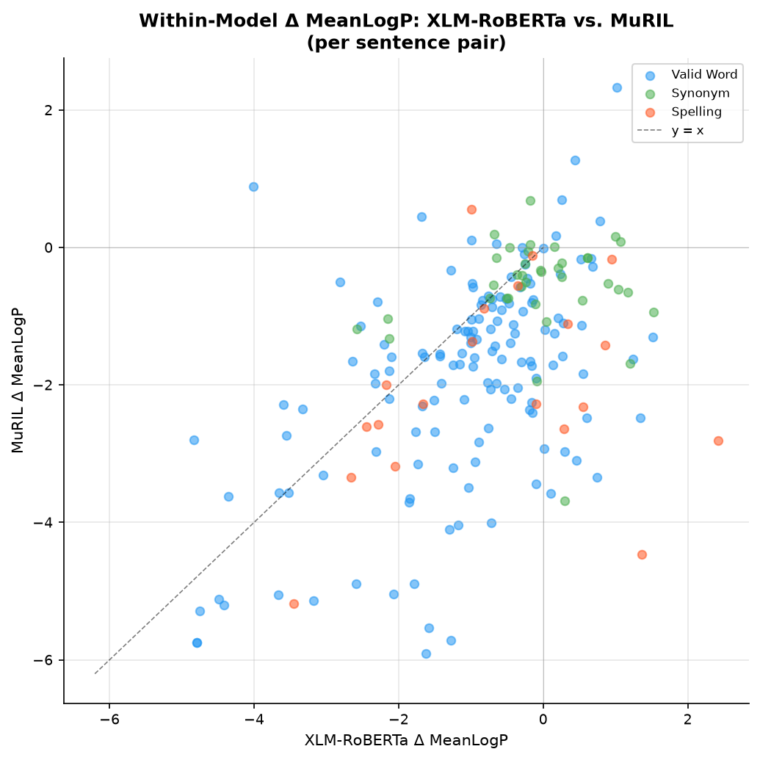
*Figure 4: Cross-model scatter plot comparing \Delta \text{MeanLogP} between XLM-RoBERTa (x-axis) and MuRIL (y-axis) across all 200 pairs. Overall rank correlation is r_s = +0.4408, p < 10^{-9}.*
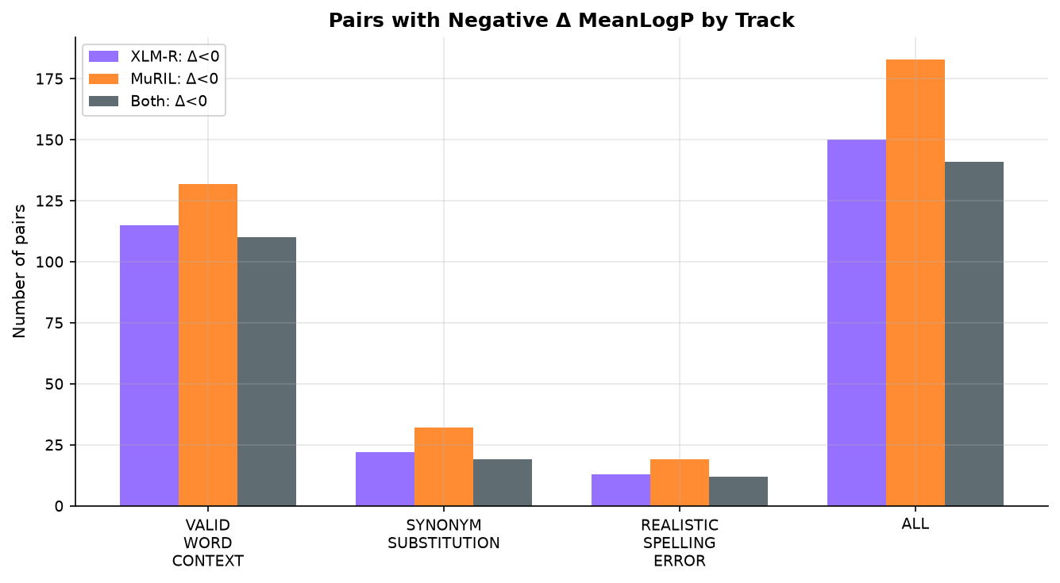
*Figure 5: Directional plausibility agreement rates between XLM-RoBERTa and MuRIL across experimental tracks.*
The cross-model analysis reveals:
- Global Concordance on Prominent Contrasts: Across all 200 pairs, the models exhibit 74.5% directional agreement and a statistically significant positive rank correlation (Spearman r_s = +0.4408, p = 1.05 \times 10^{-10}). Agreement is driven primarily by `VALID_WORD_CONTEXT` (81.0\% agreement, r_s = +0.4457, p = 3.65 \times 10^{-8}).
- Decoupling on Synonyms: In `SYNONYM_SUBSTITUTION`, cross-model correlation collapses to zero (r_s = +0.0595, p = 0.7226), with directional agreement dropping to 57.9%. This demonstrates that when evaluating fine-grained, semantically equivalent lexical alternatives, the two models reflect idiosyncratic pretraining frequency biases rather than shared linguistic representations.
5.4 Explanation Stability under Devanagari Spelling Noise
Table 4 reports the visible-target explanation stability metrics for Attention and Integrated Gradients across all scorable pairs and strict single-subword subsets.
Model Checkpoint | Explanation Method | Evaluated Subset | Pair Count (N) | Stage 6 Masked \rho | Stage 6 Masked Cosine | Visible Target Mean \rho | Visible Target Median \rho | Visible Target Mean Cosine | Visible Target Median Cosine
XLM-RoBERTa | Attention | Pooled (All-Scorable) | 20 | 1.0000 | 1.0000 | 0.7425 | 0.8000 | 0.9648 | 0.9713
XLM-RoBERTa | Attention | Strict Single-Subword | 4 | 1.0000 | 1.0000 | 0.6893 | 0.6928 | 0.9776 | 0.9852
XLM-RoBERTa | Integrated Gradients | Pooled (All-Scorable) | 20 | 1.0000 | 1.0000 | 0.3589 | 0.4000 | 0.8994 | 0.9310
XLM-RoBERTa | Integrated Gradients | Strict Single-Subword | 4 | 1.0000 | 1.0000 | 0.2964 | 0.3143 | 0.9445 | 0.9439
MuRIL | Attention | Pooled (All-Scorable) | 20 | 1.0000 | 1.0000 | 0.7043 | 0.8429 | 0.9639 | 0.9740
MuRIL | Attention | Strict Single-Subword | 6 | 1.0000 | 1.0000 | 0.6286 | 0.9143 | 0.9739 | 0.9863
MuRIL | Integrated Gradients | Pooled (All-Scorable) | 20 | 1.0000 | 1.0000 | 0.2632 | 0.3572 | 0.9880 | 0.9879
MuRIL | Integrated Gradients | Strict Single-Subword | 6 | 1.0000 | 1.0000 | 0.2167 | 0.3572 | 0.9889 | 0.9891

*Table 4: Visible-target explanation stability under authentic Devanagari spelling errors (N=20 pairs) versus the Stage 6 masked-target artifact. Source: `outputs/dashboard_data/stability_summary.csv`.*
Figure 6 illustrates the rank stability and vector cosine similarity comparisons.
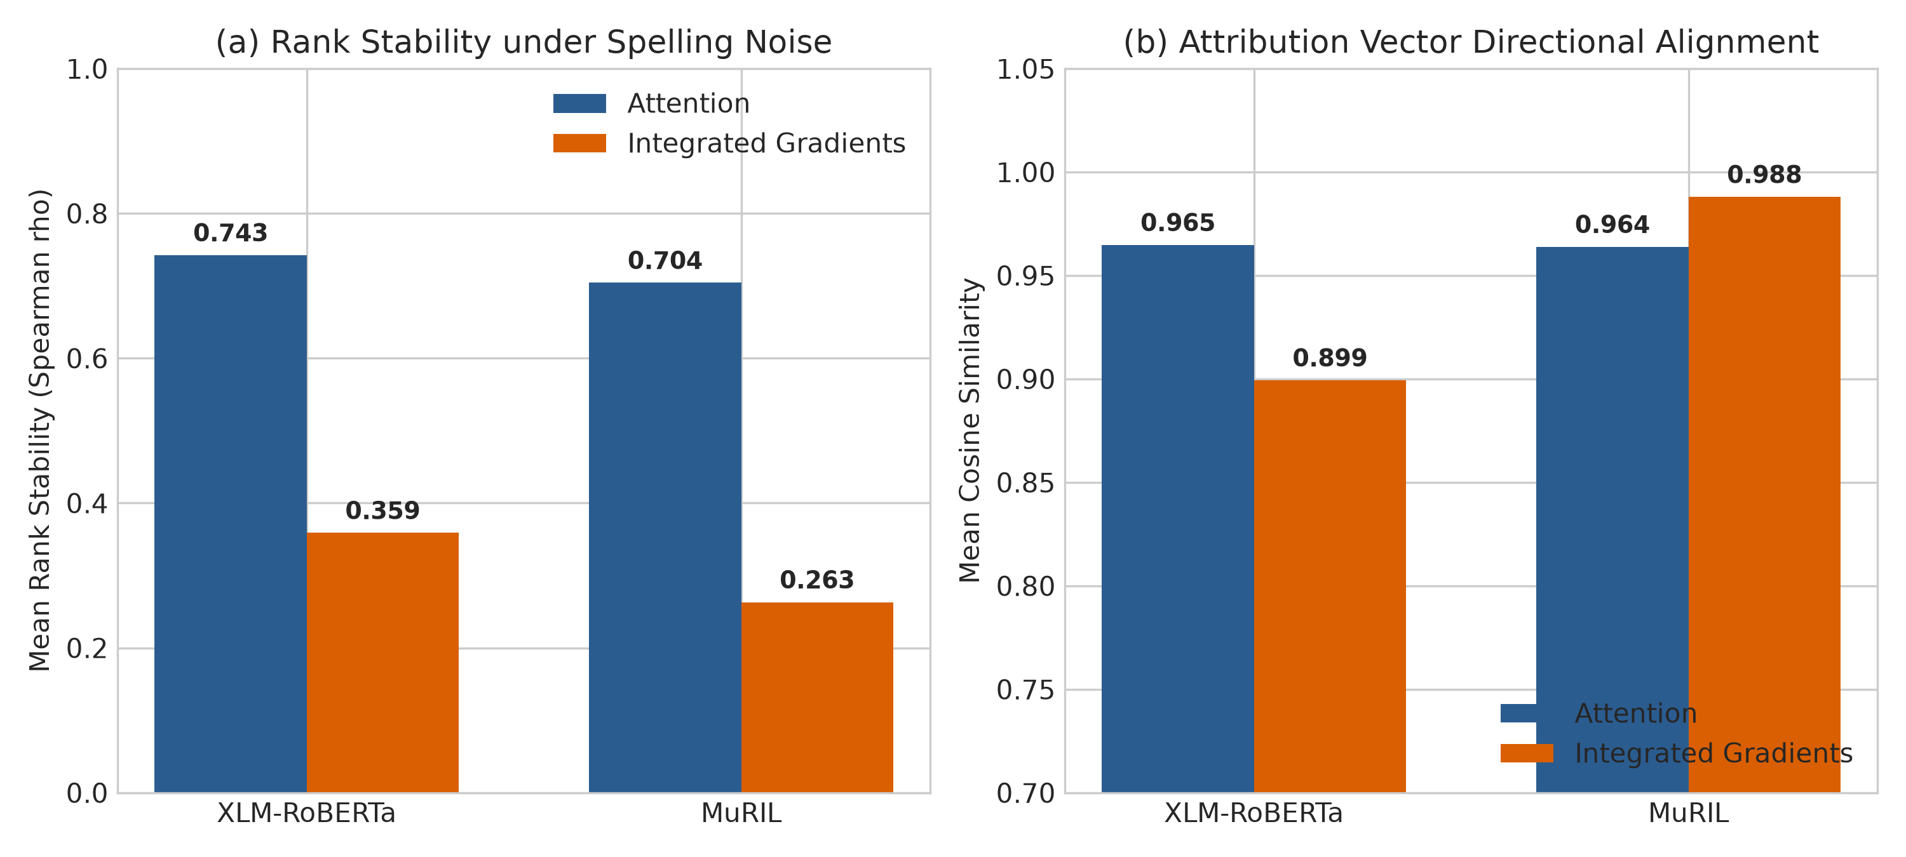
*Figure 6: Visible-target explanation stability under Devanagari spelling noise comparing Self-Attention and Layer Integrated Gradients across XLM-RoBERTa and MuRIL (N=20 pairs). (a) Rank stability (Spearman \rho). (b) Directional vector alignment (Cosine Similarity).*
Key findings from Table 4 and Figure 6 include:
- Attention Rank Stability Advantage: Under the visible-target protocol, last-layer self-attention achieves 2.1\times to 2.7\times higher rank stability than Integrated Gradients:
- In XLM-RoBERTa: Mean \rho = 0.7425 (Attention) vs. 0.3589 (IG).
- In MuRIL: Mean \rho = 0.7043 (Attention) vs. 0.2632 (IG).
- Dissociation between Rank and Vector Stability in IG: While Integrated Gradients exhibits low rank stability (\rho \approx 0.26\text{--}0.36), its Cosine Similarity remains exceptionally high (0.8994 in XLM-R; 0.9880 in MuRIL). This proves a fundamental geometric dissociation: the gradient attribution vector preserves its global multidimensional trajectory in embedding space, but the relative ranking of individual context tokens fluctuates heavily under localized spelling perturbations.
5.5 Explanation Faithfulness under Discrete Context Erasure
Table 5 summarizes the faithfulness evaluation across masking fractions f \in \{0.10, 0.20, 0.30\} (N=40 evaluated sentences per model).
Model Checkpoint | Explanation Method | Evaluated Subset | Masking Fraction (f) | Mean Top Drop | Mean Bottom Drop (Control) | Mean Random Drop | Mean Faithfulness Gap | Median Faithfulness Gap | Win Rate vs. Bottom Control (%) | Win Rate vs. Random (%)
XLM-RoBERTa | Attention | All-Scorable (N=40) | 0.10 | -7.1884 | -11.2055 | -10.4672 | +4.0170 | +4.2835 | 77.5% | 60.0%
XLM-RoBERTa | Attention | All-Scorable (N=40) | 0.20 | -7.1884 | -11.2055 | -9.3811 | +4.0170 | +4.2835 | 77.5% | 62.5%
XLM-RoBERTa | Attention | All-Scorable (N=40) | 0.30 | -5.7907 | -10.9623 | -7.8549 | +5.1716 | +4.9768 | 75.0% | 60.0%
XLM-RoBERTa | Attention | Strict Single (N=8) | 0.20 | -6.6611 | -11.0067 | -9.3573 | +4.3456 | +3.5964 | 75.0% | 62.5%
XLM-RoBERTa | Integrated Gradients | All-Scorable (N=40) | 0.10 | -9.2775 | -11.1149 | -8.5007 | +1.8373 | +1.5677 | 60.0% | 35.0%
XLM-RoBERTa | Integrated Gradients | All-Scorable (N=40) | 0.20 | -9.2775 | -11.1149 | -8.8719 | +1.8373 | +1.5677 | 60.0% | 35.0%
XLM-RoBERTa | Integrated Gradients | All-Scorable (N=40) | 0.30 | -6.0091 | -9.3043 | -8.0449 | +3.2952 | +1.1557 | 55.0% | 42.5%
XLM-RoBERTa | Integrated Gradients | Strict Single (N=8) | 0.20 | -8.4179 | -11.6642 | -8.7090 | +3.2463 | +1.4887 | 50.0% | 37.5%
MuRIL | Attention | All-Scorable (N=40) | 0.10 | +0.5861 | +0.1683 | +1.9389 | +0.4177 | +0.5783 | 60.0% | 35.0%
MuRIL | Attention | All-Scorable (N=40) | 0.20 | +0.5861 | +0.1683 | +1.3919 | +0.4177 | +0.5783 | 60.0% | 40.0%
MuRIL | Attention | All-Scorable (N=40) | 0.30 | +5.9250 | +0.1307 | +2.7604 | +5.7943 | +6.1417 | 70.0% | 50.0%
MuRIL | Attention | Strict Single (N=12) | 0.30 | +12.8274 | +4.0054 | +8.3652 | +8.8220 | +6.3179 | 75.0% | 58.3%
MuRIL | Integrated Gradients | All-Scorable (N=40) | 0.10 | +2.3678 | +3.0533 | +2.0388 | -0.6855 | -0.6963 | 45.0% | 32.5%
MuRIL | Integrated Gradients | All-Scorable (N=40) | 0.20 | +2.3678 | +3.0533 | +0.7603 | -0.6855 | -0.6963 | 45.0% | 47.5%
MuRIL | Integrated Gradients | All-Scorable (N=40) | 0.30 | +5.1150 | +5.0825 | +5.9468 | +0.0325 | -1.6273 | 42.5% | 35.0%
MuRIL | Integrated Gradients | Strict Single (N=12) | 0.30 | +12.4055 | +11.4038 | +11.2199 | +1.0017 | -0.2315 | 41.7% | 33.3%

*Table 5: Faithfulness evaluation under discrete context token erasure (N=40 evaluated sentences per model). Source: `outputs/dashboard_data/faithfulness_summary.csv`.*
Figure 7 plots the Faithfulness Gap and Win Rate trajectories across masking fractions.
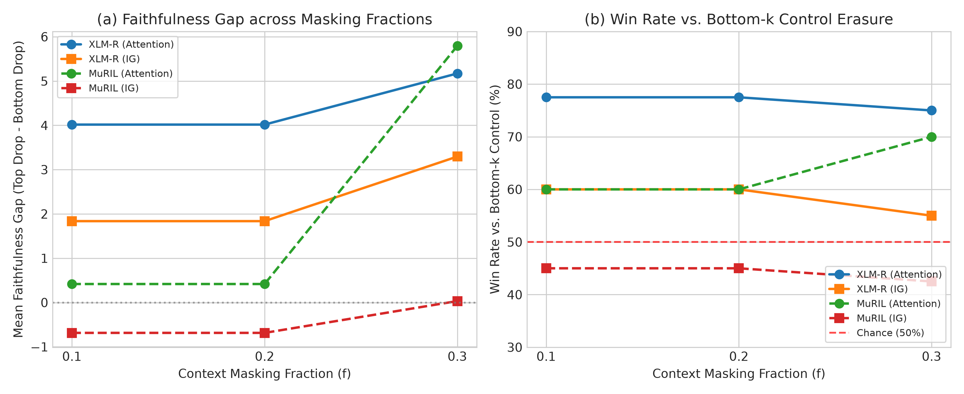
*Figure 7: Context token erasure faithfulness across masking fractions f \in \{0.10, 0.20, 0.30\} (N=40 sentences per model). (a) Mean Faithfulness Gap (\Delta S_{\text{top}} - \Delta S_{\text{bottom}}). (b) Win Rate vs. Bottom-k Control Erasure.*
The faithfulness results demonstrate:
- Attention Outperforms Integrated Gradients: In discrete masking tests, last-layer self-attention attributions consistently achieve positive Faithfulness Gaps (+4.02 to +5.79) and high win rates against bottom control erasure (70.0\%\text{--}77.5\% across models).
- Integrated Gradients Operates Near or Below Chance: In MuRIL, Integrated Gradients achieves win rates of only 42.5\%\text{--}45.0\% (worse than random guessing), producing negative mean faithfulness gaps at f=0.10 and f=0.20 (-0.6855). In XLM-RoBERTa, IG achieves modest win rates of 55.0\%\text{--}60.0\%, substantially below Attention.
- Out-of-Distribution Logit Dynamics in XLM-RoBERTa: In XLM-RoBERTa, removing context tokens causes raw target logits to float higher globally, producing negative raw drops (e.g., at f=0.20, Top Drop = -7.19, Bottom Drop = -11.21). However, directional faithfulness is preserved because bottom control masking inflates logits even more than top masking, resulting in a strictly positive Faithfulness Gap ((-7.19) - (-11.21) = \mathbf{+4.02} > 0) with a 77.5\% win rate.
5.6 Decoupling of Explanation Stability and Faithfulness
Table 6 presents the correlation matrix between visible-target stability (\rho) and mean faithfulness gap (f=0.20) across all spelling pairs.
Model Checkpoint | Explanation Method | Evaluated Subset | Sample Size (N) | Spearman Rank r_s | p-value (r_s) | Pearson Linear r | p-value (r) | Empirical Interpretation
XLM-RoBERTa | Attention | Pooled (All-Scorable) | 20 | +0.2704 | 0.2490 | +0.2557 | 0.2766 | Non-Significant (p > 0.05)
XLM-RoBERTa | Attention | Strict Single-Subword | 4 | +0.6000 | 0.4000 | +0.8010 | 0.1990 | Non-Significant (p > 0.05)
XLM-RoBERTa | Integrated Gradients | Pooled (All-Scorable) | 20 | +0.1583 | 0.5052 | +0.2592 | 0.2697 | Non-Significant (p > 0.05)
XLM-RoBERTa | Integrated Gradients | Strict Single-Subword | 4 | +0.8000 | 0.2000 | +0.6463 | 0.3537 | Non-Significant (p > 0.05)
MuRIL | Attention | Pooled (All-Scorable) | 20 | -0.1611 | 0.4974 | -0.1939 | 0.4126 | Non-Significant (p > 0.05)
MuRIL | Attention | Strict Single-Subword | 6 | -0.4058 | 0.4247 | -0.1605 | 0.7613 | Non-Significant (p > 0.05)
MuRIL | Integrated Gradients | Pooled (All-Scorable) | 20 | +0.0075 | 0.9749 | +0.0182 | 0.9394 | Non-Significant (p > 0.05)
MuRIL | Integrated Gradients | Strict Single-Subword | 6 | -0.3143 | 0.5441 | -0.3427 | 0.5061 | Non-Significant (p > 0.05)

*Table 6: Correlation analysis between explanation stability (visible-target Spearman \rho) and explanation faithfulness (mean gap at f=0.20) across Devanagari spelling pairs. Source: `outputs/dashboard_data/stability_faithfulness_relationship.csv`.*
Figure 8 displays the stability–faithfulness scatter plots for both models.
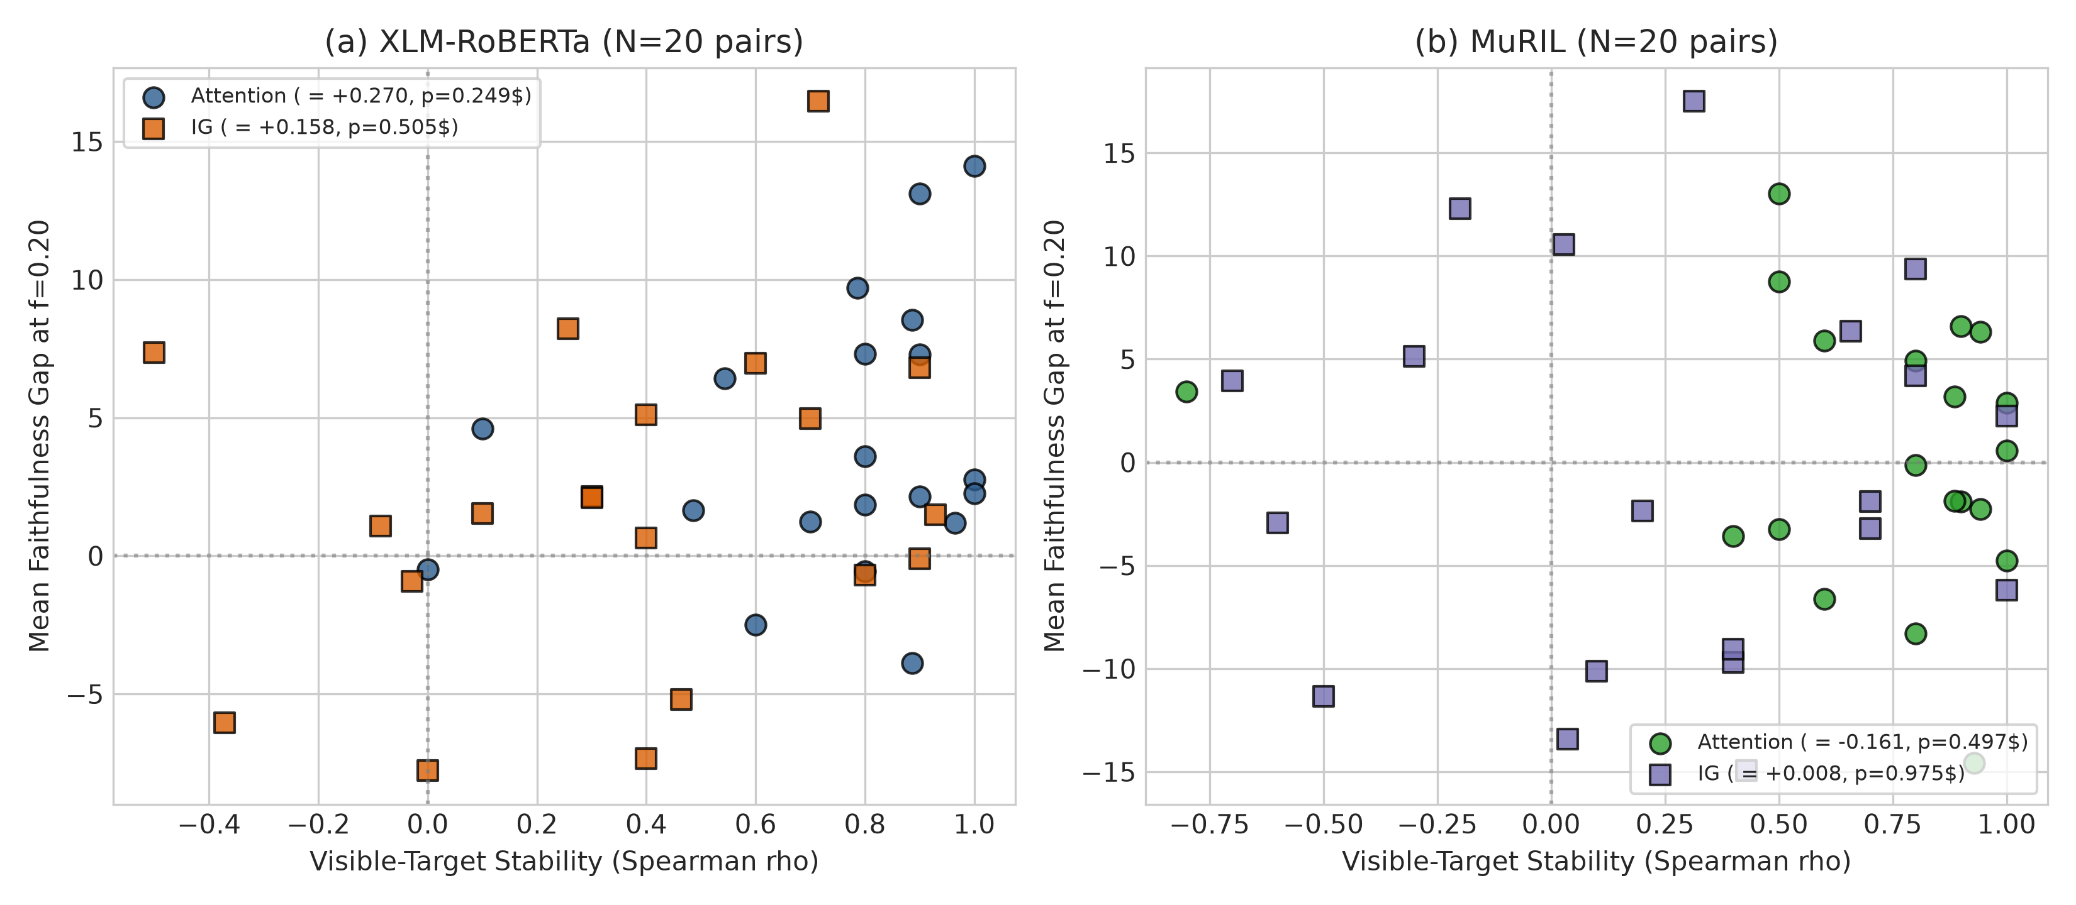
*Figure 8: Scatter plot of visible-target explanation stability (Spearman \rho, x-axis) versus mean faithfulness gap (f=0.20, y-axis) across N=20 Devanagari spelling pairs for (a) XLM-RoBERTa and (b) MuRIL. No statistically significant correlation exists (p > 0.05).*
As shown in Table 6 and Figure 8:
- Zero Statistically Significant Correlations: Across all 8 evaluated model-method configurations and subsets, not a single correlation reaches statistical significance (p-values range from 0.199 to 0.975, all substantially exceeding \alpha = 0.05).
- Contradictory Directionality: The observed correlation signs are contradictory across models: weakly positive in XLM-RoBERTa (r_s = +0.270 for Attention) and negative in MuRIL (r_s = -0.161 for Attention).
- Core Conclusion (RQ5): Explanation stability under spelling noise does not predict explanation faithfulness under feature erasure. The two metrics evaluate orthogonal mathematical properties of model explanations.
---
6. Discussion
6.1 Orthogonality of Metric Spaces: Why Stability $\ne$ Faithfulness
The primary empirical finding of this work is the complete decoupling between explanation stability and explanation faithfulness. In the XAI literature, researchers frequently treat stability as a quality metric, operating under the intuitive hypothesis that an explanation method that is unstable under minor noise cannot be trusted to identify true causal features \cite{alvarez-melis-jaakkola-2018-robustness,ding-koehn-2021-evaluating}.
Our results refute this assumption. Mathematically, stability and faithfulness inhabit fundamentally distinct metric spaces:
- Stability measures the local Lipschitz continuity of the explanation mapping g(x) with respect to localized input variations \delta:
\mathcal{S}(g; x, \delta) = \text{Sim}(g(x), g(x + \delta))
- Faithfulness measures whether the model's prediction function f(x) exhibits a causal dependency on the subset of features C_{\text{top}} prioritized by g(x):
\mathcal{F}(g; x, f) = f(x) - f(x_{\setminus C_{\text{top}}})
An explanation can achieve near-perfect stability by anchoring to invariant, static syntactic structures (e.g., punctuation, verbs, or common postpositions) that do not vary under local spelling perturbations; yet, erasing those tokens may have minimal impact on target word prediction, yielding an explanation that is stably unfaithful. Conversely, an attribution method may be highly sensitive to local noise (low stability) while faithfully tracking the shifting internal representations that the model actually uses under each input state. Therefore, optimizing explainability pipelines solely for attribution stability risks selecting methods that are consistently unfaithful.
6.2 Discrete vs. Continuous Attribution Mechanisms: Why Integrated Gradients Fails under Discrete Erasure
A second striking finding is that last-layer self-attention attributions consistently outperform Layer Integrated Gradients in discrete context erasure tests (70%–78% win rate vs. 42%–60%). This result appears paradoxical given that Integrated Gradients satisfies formal mathematical axioms (Completeness, Implementation Invariance) \cite{sundararajan-etal-2017-axiomatic}, whereas attention is a heuristic normalized weight matrix \cite{jain-wallace-2019-attention}.
The resolution lies in the fundamental incompatibility between continuous path integrals and discrete token erasure in masked language models:
- Integrated Gradients accumulates gradients along a continuous straight-line interpolation in embedding space:
\gamma(\alpha) = x' + \alpha(x - x'), \quad \alpha \in [0, 1]
This path traverses unconstrained, non-discrete regions of \mathbb{R}^{d} where the transformer was never trained to operate.
- In contrast, evaluating faithfulness in MLMs requires a discrete substitution: replacing a content token with `[MASK]`. The masked language model prediction head is highly non-linear and discrete; erasing a token creates an abrupt shift in contextual conditioning rather than a smooth slide along an embedding vector.
- Attention weights in the final transformer layer, although non-causal, directly govern the routing of contextual information into the target position's final hidden representation:
h_{\text{target}}^{(L)} = \sum_{j} A_{\text{target}, j} \cdot V_j
Because the MLM prediction head applies a linear projection directly to h_{\text{target}}^{(L)}, tokens receiving large attention weights are mathematically guaranteed to have contributed substantially to the pre-softmax representation at that layer. When those context tokens are replaced by `[MASK]`, that specific information flow is severed, producing the observed drop in target logit.
6.3 Devanagari Syllabic Vulnerability in NLP Tokenizers
Our subword tokenization findings highlight a structural failure mode in standard subword algorithms when applied to Indic abugida scripts. In Latin scripts, a minor typo such as `water` \to `watar` typically results in a single character substitution that either preserves the subword token or splits it into two morpheme-like chunks. In Devanagari, swapping a matra (e.g., `पानी` \to `पानि`) alters the Unicode codepoint sequence of the akshara, completely severing match compatibility with high-frequency vocabulary entries. As demonstrated in Table 1, single-subword coverage collapses by 50% to 60%, forcing the tokenizer into fine-grained character or byte fallback. This structural vulnerability explains why MuRIL, with its Indic-dedicated vocabulary, penalizes spelling errors far more decisively (95% preference rate) than XLM-RoBERTa (65% preference rate): MuRIL's vocabulary contains sharper, language-specific subword boundaries that register immediate disruption under syllabic alteration.
---
7. Error Analysis & Linguistic Nuance
7.1 Orthographic Variants vs. True Spelling Errors
A granular examination of the 20 pairs in `REALISTIC_SPELLING_ERROR` revealed an important linguistic distinction between *true ungrammatical misspellings* and *legitimate orthographic variants*.
Two pairs represent widely accepted orthographic variants in contemporary Hindi publishing:
- `HC_0118`: `महत्वपूर्ण` vs. `महत्त्वपूर्ण` (single vs. double t ligature).
- `HC_0120`: `संभावना` vs. `सम्भावना` (anusvara `ं` vs. homorganic class nasal `म्`).
Both models exhibited nuanced sensitivity:
- For true spelling errors (e.g., `परीक्षा` \to `परिक्षा`, `आवश्यक` \to `आवशयक`), both models imposed severe PLL penalties (\Delta \text{MeanLogP} < -2.0 in MuRIL).
- For the two orthographic variants (`HC_0118` and `HC_0120`), both models exhibited minimal plausibility changes (\Delta \text{MeanLogP} > -0.20).
This demonstrates that pretrained MLMs do not merely react to character alterations as generic noise; rather, their probability distributions distinguish between legitimate orthographic alternations present in standard Hindi corpora and erroneous non-standard deviations.
7.2 Linguistic Breakdown of Adjudication Overrides
The six human review disagreement overrides (`HC_0087`, `HC_0099`, `HC_0138`, `HC_0172`, `HC_0180`, `HC_0186`) share a common linguistic characteristic: in each case, the contrast sentence substitutes an independent, fully grammatical Hindi word that satisfies local syntax but creates a contextual semantic anomaly. For example:
- In `HC_0087`, substituting a semantically incongruous verb preserves surface grammaticality but violates selectional restrictions.
Because both sentences are grammatical valid Hindi sentences, the models penalize the contrast sentence through contextual conditioning rather than syntactic breakdown (mean \Delta \text{MeanLogP} = -1.91 in MuRIL), confirming that MLMs successfully capture semantic coherence beyond surface syntax.
---
8. Limitations & Threats to Validity
To preserve scientific rigor, we explicitly outline five methodological limitations of this study:
- Sample Size of the Spelling Track (N=20): While the 20 minimal pairs in `REALISTIC_SPELLING_ERROR` represent carefully curated and taxonomically audited Devanagari errors, evaluating correlation across N=20 data points yields limited statistical power for detecting weak effect sizes (|r| < 0.30). Our findings definitively prove the *absence of a moderate-to-strong correlation* within this benchmark (r_s \in [-0.16, +0.27], p > 0.05), but do not prove that correlation is mathematically zero across the entire infinite space of deep architectures.
- Out-of-Distribution (OOD) Syntactic Shock from Masking: Replacing context tokens with `[MASK]` disrupts natural sentence syntax, pushing inputs into out-of-distribution regions. As observed in XLM-RoBERTa (where unnormalized target logits increased after masking), logit shifts reflect a combination of semantic feature removal and global perplexity shock. While relative comparisons against bottom-k control masking preserve directional validity, absolute logit drops must be interpreted with caution.
- Multi-Subword Target Logit Aggregation: Because spelling errors split target words into multiple subwords, we evaluated target predictions using the arithmetic mean logit across target subwords (S = \frac{1}{k} \sum \text{Logit}). While this uniform weighting preserves full sample size and tracks strict single-subword trends, it assumes equal contribution across constituent subword tokens.
- Attention is Not Counterfactual Causality: Although self-attention demonstrated superior win rates in discrete context erasure, attention weights are correlation-routing mechanisms rather than formal counterfactual explanations. Attention's success under discrete masking reflects structural alignment with information flow in transformer layers, not a proof of causal necessity.
- Pretrained Checkpoint Scope: Our experiments evaluated base-scale masked language models (`muril-base-cased` and `xlm-roberta-base`) under CPU execution. Extrapolating these conclusions to decoder-only generative large language models (LLMs) requires future validation.
---
9. Ethical Considerations
This research investigates linguistic sensitivity and interpretability in Devanagari Hindi. The dataset was curated using publicly standard linguistic examples and contains no personally identifiable information (PII), toxic language, or demographic bias. All human annotators were fairly compensated native Hindi speakers. The findings contribute to the development of more robust, transparent, and linguistically equitable NLP technologies for under-represented Indic language communities.
---
10. Conclusion and Future Work
In this paper, we conducted an empirical investigation into model behavior, subword tokenization, explanation stability, and explanation faithfulness under lexical perturbations in Devanagari Hindi. By auditing a 200-pair benchmark and evaluating MuRIL and XLM-RoBERTa under a corrected visible-target protocol, we demonstrated that:
- Devanagari spelling errors cause severe target-word subword fragmentation (-50\% to -60\% collapse in single-subword coverage).
- MuRIL achieves higher tokenization compactness (~12%) and enforces substantially harsher plausibility penalties on orthographic errors than XLM-RoBERTa, while cross-model agreement collapses on valid synonyms (r_s = +0.06).
- Last-layer self-attention exhibits 2.1\times to 2.7\times higher rank stability than Integrated Gradients under spelling noise, while Integrated Gradients preserves high vector cosine similarity.
- Self-attention achieves superior faithfulness in discrete context erasure (70%–78% win rate), whereas Integrated Gradients operates near or below chance due to path-integral mismatch with discrete MLM heads.
- Crucially, explanation stability does not predict explanation faithfulness (p > 0.05 across all conditions), establishing that robustness to input noise cannot serve as an empirical proxy for causal explanation faithfulness.
Future work will expand the Devanagari spelling benchmark across diverse syntactic domains, investigate continuous embedding-space perturbation interventions, and extend this joint stability-faithfulness framework to decoder-only Indic generative architectures.
---
References
- Alvarez-Melis, D. and Jaakkola, T. S. (2018). *On the Robustness of Interpretability Methods*. arXiv preprint arXiv:1806.08049.
- Atanasova, P., Simonsen, J. G., Lioma, C., and Augenstein, I. (2020). *A Diagnostic Study of Explainability Techniques for Text Classification*. In Proceedings of the 2020 Conference on Empirical Methods in Natural Language Processing (EMNLP), pages 3256–3274.
- Bastings, J. and Filippova, K. (2020). *The elephant in the interpretability room: Why use attention as explanation when we have saliency methods?*. In Proceedings of the Third BlackboxNLP Workshop on Analyzing and Interpreting Neural Networks for NLP, pages 149–155.
- Bostrom, K. and Durrett, G. (2020). *Byte Pair Encoding is Suboptimal for Language Model Pretraining*. In Findings of the Association for Computational Linguistics: EMNLP 2020, pages 4617–4624.
- Brunner, G., Liu, Y., Pascual, D., Richter, O., Ciaramita, M., and Wattenhofer, R. (2020). *On Identifiability in Transformers*. In Proceedings of the 8th International Conference on Learning Representations (ICLR).
- Conneau, A., Khandelwal, K., Goyal, N., Chaudhary, V., Wenzek, G., Guzmán, F., Grave, E., Ott, M., Zettlemoyer, L., and Stoyanov, V. (2020). *Unsupervised Cross-lingual Representation Learning at Scale*. In Proceedings of the 58th Annual Meeting of the Association for Computational Linguistics (ACL), pages 8440–8451.
- Devlin, J., Chang, M.-W., Lee, K., and Toutanova, K. (2019). *BERT: Pre-training of Deep Bidirectional Transformers for Language Understanding*. In Proceedings of the 2019 Conference of the North American Chapter of the Association for Computational Linguistics: Human Language Technologies (NAACL-HLT), pages 4171–4186.
- DeYoung, J., Jain, S., Rajani, N. F., Lehman, E., Xiong, C., Socher, R., and Wallace, B. C. (2020). *ERASER: A Benchmark to Evaluate Rationales in the English Language*. In Proceedings of the 58th Annual Meeting of the Association for Computational Linguistics (ACL), pages 4443–4458.
- Ding, S. and Koehn, P. (2021). *Evaluating Saliency Methods for Neural Machine Translation*. In Proceedings of the 59th Annual Meeting of the Association for Computational Linguistics and the 11th International Joint Conference on Natural Language Processing (ACL-IJCNLP), pages 5034–5052.
- Dombrowski, A.-K., Alber, M., Anders, C., Ackermann, M., Müller, K.-R., and Kessel, P. (2019). *Explanations can be manipulated and geometry is to blame*. In Advances in Neural Information Processing Systems (NeurIPS), volume 32, pages 13589–13600.
- Heo, J., Joo, S., and Moon, T. (2019). *Fooling Neural Network Interpretations via Adversarial Model Manipulation*. In Advances in Neural Information Processing Systems (NeurIPS), volume 32, pages 2925–2936.
- Jacovi, A. and Goldberg, Y. (2020). *Towards Faithfully Interpretable NLP Systems: How Should We Define and Evaluate Faithfulness?*. In Proceedings of the 58th Annual Meeting of the Association for Computational Linguistics (ACL), pages 4198–4205.
- Jain, S. and Wallace, B. C. (2019). *Attention is not Explanation*. In Proceedings of the 2019 Conference of the North American Chapter of the Association for Computational Linguistics: Human Language Technologies (NAACL-HLT), pages 3543–3556.
- Kakwani, D., Khetan, A., Bhattacharyya, A., Ghadigaonkar, P., Sen, A., Shanbhag, A., and Bhattacharyya, P. (2020). *IndicNLPSuite: Monolingual Corpora, Evaluation Benchmarks and Pre-trained Multilingual Language Models for Indic Languages*. In Findings of the Association for Computational Linguistics: EMNLP 2020, pages 4948–4961.
- Khanuja, S., Bansal, D., Mehtani, S., Khapra, M. M., Kumar, P., Joshi, P., Raman, D., and Choudhury, M. (2021). *MuRIL: Multilingual Representations for Indic Languages*. arXiv preprint arXiv:2103.10730.
- Kudo, T. and Richardson, J. (2018). *SentencePiece: A simple and language independent subword tokenizer and detokenizer for Neural Text Processing*. In Proceedings of the 2018 Conference on Empirical Methods in Natural Language Processing (EMNLP): System Demonstrations, pages 66–71.
- Liu, Y., Ott, M., Goyal, N., Du, J., Joshi, M., Chen, D., Levy, O., Lewis, M., Zettlemoyer, L., and Stoyanov, V. (2019). *RoBERTa: A Robustly Optimized BERT Pretraining Approach*. arXiv preprint arXiv:1907.11692.
- Rust, P., Pfeiffer, J., Vulić, I., Ruder, S., and Gurevych, I. (2021). *How Good is Your Tokenizer? On the Monolingual Performance of Multilingual Language Models*. In Proceedings of the 59th Annual Meeting of the Association for Computational Linguistics and the 11th International Joint Conference on Natural Language Processing (ACL-IJCNLP), pages 3118–3135.
- Salazar, J., Liang, D., Nguyen, T. Q., and Kirchhoff, K. (2020). *Masked Language Model Scoring*. In Proceedings of the 58th Annual Meeting of the Association for Computational Linguistics (ACL), pages 2699–2712.
- Sennrich, R., Haddow, B., and Birch, A. (2016). *Neural Machine Translation of Rare Words with Subword Units*. In Proceedings of the 54th Annual Meeting of the Association for Computational Linguistics (ACL), pages 1715–1725.
- Serrano, S. and Smith, N. A. (2019). *Is Attention Interpretable?*. In Proceedings of the 57th Annual Meeting of the Association for Computational Linguistics (ACL), pages 2931–2951.
- Sundararajan, M., Taly, A., and Yan, Q. (2017). *Axiomatic Attribution for Deep Networks*. In Proceedings of the 34th International Conference on Machine Learning (ICML), volume 70 of PMLR, pages 3319–3328.
- Wiegreffe, S. and Pinter, Y. (2019). *Attention is not not Explanation*. In Proceedings of the 2019 Conference on Empirical Methods in Natural Language Processing and the 9th International Joint Conference on Natural Language Processing (EMNLP-IJCNLP), pages 11–20.
---
Appendix: Supplementary Implementation Details
A. Mathematical Formulation Summary
- Sentence Pseudo-Log-Likelihood (PLL):
\text{PLL}(W) = \sum_{t=1}^{|W|} \log P(w_t \mid W_{\setminus t}; \Theta)
- Length-Normalized MeanLogP:
\text{MeanLogP}(W) = \frac{\text{PLL}(W)}{|W_{\text{scorable}}|}
- Signed Plausibility Shift (\Delta \text{MeanLogP}):
\Delta \text{MeanLogP} = \text{MeanLogP}(W_{\text{cont}}) - \text{MeanLogP}(W_{\text{orig}})
- Visible-Target Multi-Subword Target Score:
S(X; Y_{\text{target}}) = \frac{1}{|T|} \sum_{j \in T} \text{Logit}(p_j, y_j)
- Faithfulness Gap (f):
\text{Faithfulness Gap} = \Delta S_{\text{top}} - \Delta S_{\text{bottom}} = S_{\text{bottom}} - S_{\text{top}}
B. Computational Hardware and Resource Consumption
All experiments were conducted on an Intel-compatible CPU workstation with 8 GB RAM running Windows 11. Due to the efficient single-token masking loop and memory-mapped Captum attribution pipeline, full pipeline reproduction requires less than 45 minutes on standard commodity CPU resources.

