STARTUP VALIDATION REPORT
NIRIKSHAK AI
AI-Assisted Inspection & Compliance Verification for Packaged Commodities
Prepared for: Anekvarna, Founder
Market: India — Legal Metrology & Regulatory Compliance
Stage: Prototype / Pre-Validation (Smart India Hackathon 2026)
Date: September 7, 2026
GO / NO-GO | FOUNDER-MARKET FIT | OVERALL SCORE
CONDITIONAL GO | 5.8 / 10 | 6.2 / 10
Prepared by Claude — Startup Advisory, VC Analyst & Market Research Assistant. This report synthesizes founder-provided information with independent web research current to September 2026. Figures marked as estimates are analyst approximations built on the methodology disclosed in each section and the Appendix; they should be validated with primary research (customer interviews, department RFP data) before being used in fundraising materials.

01 Executive Summary
NIRIKSHAK AI is an AI/ML, OCR, and computer-vision system designed to assist Legal Metrology inspectors and regulatory authorities in India verify compliance of packaged commodities — checking declarations such as MRP, net quantity, manufacturer details, and country of origin against the Legal Metrology (Packaged Commodities) Rules, 2011 and its 2026 amendments. The project originated as a Smart India Hackathon 2026 prototype and is currently pre-revenue, pre-pilot, and pre-customer-interview.
Bottom Line
• The underlying problem — slow, manual, inconsistent inspection of packaged-goods labels against a complex and recently-tightened regulatory code — is real and independently corroborated by 2026 regulatory activity (see Problem Validation).
• The chosen customer (government Legal Metrology departments) is a small, slow-paying, procurement-heavy buyer; the far larger and faster-moving version of this market is manufacturers, packers, and e-commerce platforms who must self-certify compliance — a B2B pivot worth testing in parallel.
• No incumbent is building specifically for Indian government market-surveillance inspectors; global AI label-inspection vendors (Cognex, iFactory, SwitchOn) all sell to factory floors, not enforcement agencies — this is a genuine, if narrow, whitespace.
• Recommendation: Conditional Go — spend the next 30–90 days validating demand with real inspectors and 2–3 FMCG compliance/QA teams before writing more code.
This report evaluates the idea across problem validation, market sizing, competition, customer profile, risk, and a concrete 30-day action plan, so the founder can decide — with evidence rather than assumption — whether to commit further time to NIRIKSHAK AI in its current form or pivot toward a faster-validating adjacent opportunity.

02 Problem Validation

Is the problem real?
Yes, structurally. Legal Metrology enforcement in India is a three-tier, state-run system (Controller → Assistant Controllers → field Inspectors) that still relies heavily on manual, visual inspection. Maharashtra alone reports 261 Divisional Inspectors covering an entire state; smaller states report cadre strength in the dozens. Field inspectors physically check label declarations — manufacturer details, net quantity, MRP, date of packing, and (since February 2026) country-of-origin — against the Legal Metrology (Packaged Commodities) Rules, 2011 and its amendments.
Regulatory complexity is rising, not falling, which strengthens the case for tooling:
- The Legal Metrology (Packaged Commodities) Amendment Rules, 2026 inserted Rule 6(10A), requiring e-commerce platforms to make country-of-origin filterable and searchable for imported products, effective 1 July 2026 — a shift from label-based to "architecture-based" compliance that regulators describe as easier to audit systematically but harder to check manually at scale.
- Courts have upheld penalties for label non-compliance (e.g., PepsiCo India Holdings v. State of Haryana, 2017), confirming enforcement has real teeth and real cost for non-compliant packers.
- Multiple industry sources independently describe manual visual label inspection — even in well-resourced private manufacturing lines — as the bottleneck AI vision is now replacing at scale (99%+ accuracy claims from Cognex, iFactory, DeepInspect).

What's not yet validated
Validation Gap
• Zero interviews conducted with practicing Legal Metrology inspectors or Assistant Controllers — the buyer's actual workflow, tools, and pain intensity are assumed, not confirmed.
• No confirmation that inspectors have discretion or budget to adopt third-party AI tools versus using only government-issued systems.
• No evidence yet that the problem is painful enough to trigger a purchase decision, as opposed to being a known-but-tolerated inefficiency.
The problem is credible on paper and supported by regulatory and legal evidence. It is not yet validated at the level VCs or experienced operators would require — that requires direct conversations with 10–15 inspectors, Assistant Controllers, or compliance heads at packaged-goods companies, which is the single highest-leverage action available in the next 30 days.

03 Founder-Market Fit Score
Founder-market fit is scored across five dimensions using a 1–10 scale, based on the information provided (CS student, hackathon builder, no cited domain network in Legal Metrology, no revenue/funding yet, strong stated intent to continue building).
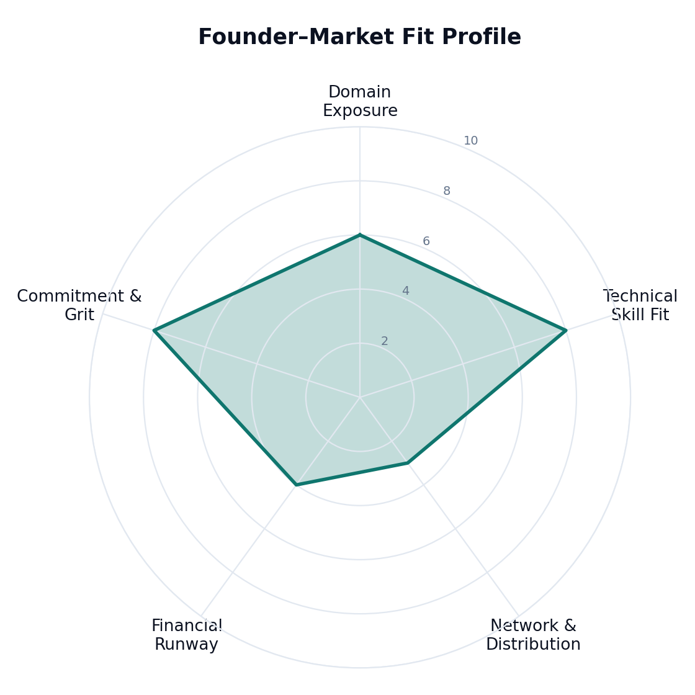
Domain Exposure ████████████░░░░░░░░ 6/10
Technical Skill Fit ████████████████░░░░ 8/10
Network & Distribution ██████░░░░░░░░░░░░░░ 3/10
Financial Runway ████████░░░░░░░░░░░░ 4/10
Commitment & Grit ████████████████░░░░ 8/10
Scores are analyst estimates based on founder-provided information; they are directional, not a certification.
Dimension | Score | Rationale
Domain Exposure | 6/10 | Direct hackathon exposure to the exact regulation and problem statement — a real head start — but no stated professional or family background in regulatory affairs, retail compliance, or government sales.
Technical Skill Fit | 8/10 | OCR, computer vision, and AI/ML are precisely the required stack; hands-on SIH build already demonstrates capability to ship a working prototype.
Network & Distribution | 3/10 | No stated relationships with Legal Metrology officials, state IT departments, DPIIT, or FMCG compliance teams — the hardest gap to close for a govtech sale.
Financial Runway | 4/10 | Framed as a student side/startup project; no disclosed funding, savings runway, or paying pilot — constrains how long a government sales cycle (typically 12–24 months) can be sustained.
Commitment & Grit | 8/10 | Explicit intent to validate, iterate, and pursue this as a startup rather than a one-off hackathon deliverable.
Founder-Market Fit: 5.8 / 10 — strong technical fit, weak distribution and runway. This profile fits well with a co-founder or advisor who brings government-sales or regulatory-affairs relationships, or with an initial go-to-market that avoids government procurement altogether (see Pivot Opportunities).

04 TAM, SAM, SOM Analysis
No official, published market-sizing exists for "AI compliance-inspection tooling for Indian Legal Metrology" specifically — it is a sub-niche of both India's RegTech market (dominated by BFSI/AML use cases) and the global machine-vision label-inspection market (dominated by private-sector manufacturing QA). The estimate below is built bottom-up from institutional buyer counts, disclosed for transparency; treat it as a working hypothesis to pressure-test, not a verified figure.
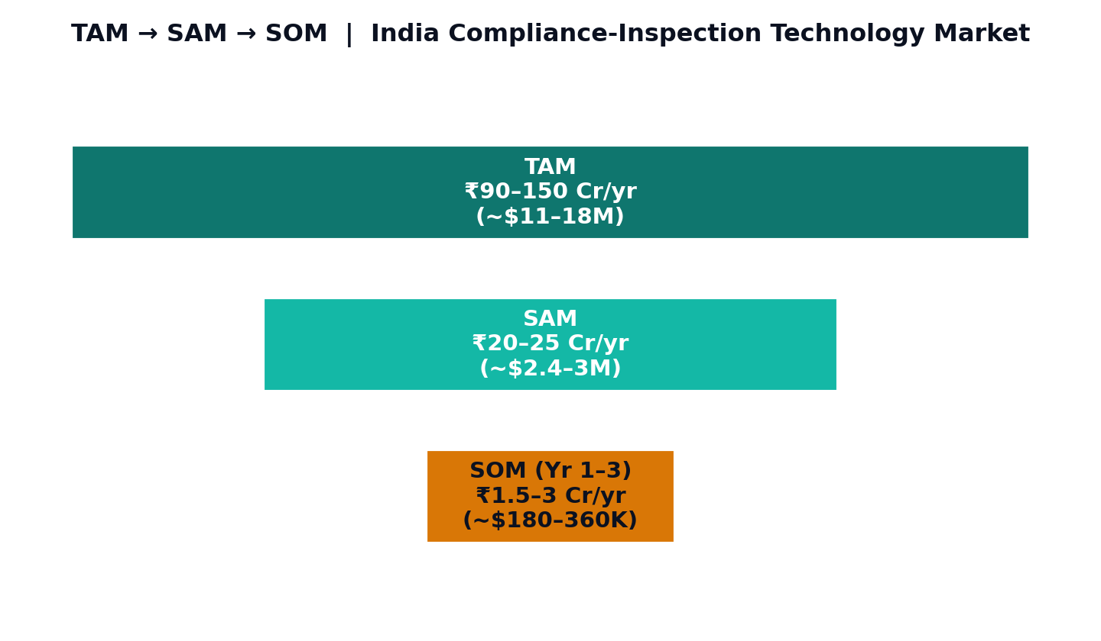
Layer | Definition | Estimate | Method
TAM | All realistic India buyers for AI-assisted packaged-goods compliance verification: 36 state/UT Legal Metrology directorates + Dept. of Consumer Affairs (govt segment) plus an early self-compliance SaaS tier for FMCG/pharma/cosmetics packers and importers who must register under LMPC. | ₹90–150 Cr/yr (~US$11–18M) | Govt: ~37 institutional buyers × ₹2 Cr/yr avg digitization budget. B2B: ~5,000 SME/brand adopters × ₹15k–60k/yr self-audit tooling.
SAM | States actively running digital-governance/GovTech modernization programs (e.g., Maharashtra, Gujarat, Karnataka, UP, Delhi-NCR, Tamil Nadu, Telangana, Haryana) reachable via GeM, Startup India, or direct pilots, plus early B2B adopters in Tier-1 FMCG clusters. | ₹20–25 Cr/yr (~US$2.4–3M) | 8–10 receptive states × ₹2 Cr + smaller near-term B2B slice.
SOM | Realistic 3-year capture for a young, solo-founder-led startup: 2–4 state pilot/MoU engagements plus a handful of paid B2B pilots. | ₹1.5–3 Cr/yr (~US$180–360K) | Pilot-stage govt contracts (₹15–40L each) + 10–20 B2B SaaS seats.
For context, India's broader RegTech market was valued at approximately $606M in 2025, projected to reach $2.4B by 2034 (16% CAGR) — but this figure is overwhelmingly weighted toward banking AML/KYC compliance and is not a direct proxy for Legal Metrology-specific tooling. It is useful only as a ceiling: it shows India's institutions are willing to fund compliance technology broadly, not that they will fund this specific product.

05 Competitor Analysis
No identified competitor targets Indian government Legal Metrology inspectors directly. The nearest competitors operate one layer removed — either as private-sector factory-line label inspection vendors, or as compliance consultancies that operate manually.
Player | Segment | What they do | Overlap with NIRIKSHAK | Gap NIRIKSHAK could exploit
Cognex | Global — factory QA | Machine-vision label/barcode inspection on production lines at 1,500+ units/min. | Same core tech (OCR + CV) applied to labels. | Sells to manufacturers, not regulators; no India-specific Legal Metrology rule engine.
iFactory / SwitchOn (DeepInspect) | Global/India — factory QA | AI vision cameras for allergen, barcode, and print-defect detection inline on packaging lines. | Same OCR/OCV techniques; some India presence. | Built for brand owners' own QA, not third-party/enforcement verification; no field/mobile inspection workflow.
Catalyx OpenStation | Global — pharma QA | Pixel-level label inspection for pharma traceability and validation. | Similar detection approach. | Pharma-only focus; not packaged-commodities-general or India-regulation-aware.
LMPC compliance consultancies (e.g., Absolute Veritas, bl-india) | India — services | Manual advisory/registration help for LMPC certification. | Same regulation, same country. | Zero automation — pure services model; easy to out-execute on speed and cost with software.
Status quo (manual inspection) | India — government | Human inspectors visually check labels during market surveillance. | Direct incumbent workflow. | Slow, inconsistent across inspectors/states, no audit trail — NIRIKSHAK's core value proposition.
Key Insight
• The competitive question is not "who else builds this for regulators" (no one, currently) but "why hasn't anyone built it yet" — likely because government sales cycles are slow and fragmented across 36 jurisdictions, making it unattractive for well-funded global players like Cognex to bother, and inaccessible for most startups without patient capital.
• This is simultaneously the opportunity (open field) and the risk (the market may be open because it is genuinely hard to sell into, not because it is undiscovered).

06 Market Gap Analysis
Gap | Description | Who currently loses out
Enforcement-side tooling | Every AI label-inspection vendor sells to the entity being inspected (the manufacturer). No vendor sells to the entity doing the inspecting (the regulator). | State Legal Metrology departments — stuck with manual spot-checks and no standardized digital evidence trail.
Field-mobile inspection workflow | Existing machine-vision systems assume a fixed camera on a production line. Market-surveillance inspectors work in the field — retail shelves, warehouses, mandis — with a phone or handheld device, not a production-line rig. | Field inspectors, who currently rely on manual note-taking and physical seizure paperwork.
Cross-SKU, cross-brand rule checking | Manufacturer-side tools are trained against a single brand's own "golden template" labels. A regulator needs a general-purpose model that can read any brand's label and check it against the law, not against a known template. | Regulators inspecting the long tail of small/unbranded/local packers who don't have factory-grade QA systems at all.
SME self-compliance | Small packers and importers (the group most likely to make labeling errors) cannot afford Cognex-class factory hardware and have no lightweight, India-rule-aware self-check tool. | SME manufacturers, importers, and D2C brands — a large, underserved, and faster-paying segment than government.

07 Ideal Customer Profile (ICP)
Attribute | Primary ICP (Government) | Secondary/Pivot ICP (B2B)
Organization type | State Legal Metrology Directorate / District Consumer Affairs office | Mid-size FMCG, cosmetics, or D2C packaged-goods brand or importer
Size | State-level department, 20–300 field inspectors | ₹5–200 Cr annual revenue; 1–5 person compliance/QA function
Buying trigger | New regulatory mandate (e.g., 2026 e-commerce COO rule), audit failure, ministerial digitization push | Recall scare, retailer/e-commerce delisting, LMPC registration renewal, entering new state/export market
Budget authority | Department head / Controller of Legal Metrology, via state IT or GeM procurement | Compliance/Quality head or founder, via normal SaaS purchasing
Sales cycle | 12–24 months; tender/RFP-driven or hackathon-to-pilot route | 2–8 weeks; direct SaaS trial-to-paid
Willingness to pay today | Low-to-moderate; needs pilot proof and budget-cycle alignment | Moderate-to-high; pain is immediate and self-funded

08 Buyer Persona
"Inspector Raghunath" — Primary (Government) Persona
• Role: Legal Metrology Inspector / Assistant Controller, State Consumer Affairs Dept., 8–15 years in service.
• Jobs-to-be-done: Complete a monthly inspection quota across assigned retail/warehouse territory; document findings defensibly enough to survive appeal; avoid being the department singled out in a state audit for low compliance-detection rates.
• Tech comfort: Moderate — comfortable with WhatsApp, basic government portals; wary of tools that create extra paperwork or that he did not choose.
• KPI he's measured on: Number of inspections completed, number of valid compliance cases raised, absence of successful appeals against his findings.
• What would make him a champion: A tool that reduces the time per inspection and produces evidence (photo + OCR + rule match) that survives legal challenge, without requiring him to personally justify a new procurement.
"Priya, Compliance Lead" — Secondary (B2B) Persona
• Role: Quality/Compliance Manager at a mid-size FMCG or D2C packaged-goods company.
• Jobs-to-be-done: Ensure every SKU's label passes Legal Metrology, FSSAI, and (if exporting) destination-market rules before print run is finalized; avoid recalls, e-commerce delisting, or penalty notices.
• Tech comfort: High — already uses SaaS tools for quality management and is an active buyer of new software.
• KPI she's measured on: Zero labeling-related recalls or penalties; audit pass rate; speed of new-SKU launch.
• What would make her a champion: A tool she can self-serve, trial for one SKU line, and get a clear pass/fail plus "why" explanation within minutes — no government sales cycle involved.

09 Customer Pain Points
Pain Point | Segment | Severity | Frequency
Manual label review is slow and inconsistent across inspectors/states | Government | High | Daily
No standardized digital evidence trail for enforcement actions, weakening appeals defense | Government | High | Per-case
Rising regulatory complexity (2026 e-commerce COO rule) outpacing manual audit capacity | Government | Medium-High | Ongoing
Risk of penalty/recall from a missed label error across large SKU catalogs | B2B / FMCG | High | Per SKU launch
No affordable self-check tool for SMEs before sending labels to print | B2B / SME | Medium-High | Per print run
Cross-jurisdiction label variance (state rules, export markets) hard to track manually | B2B / Exporters | Medium | Ongoing

10 Buying Triggers & Objections
Buying Triggers | Likely Objections
New central/state regulatory mandate creating a compliance deadline (e.g., 1 July 2026 e-commerce COO rule) | "We already have a manual process that works well enough — why change now?"
A high-profile penalty case or recall reported in the press, raising internal pressure to show action | "Is an AI tool's finding legally defensible / admissible as evidence?"
A hackathon, GeM Startup Runway listing, or Smart Cities-style innovation challenge creating a low-friction entry point | "Data security and hosting — will this run on approved government infrastructure?"
Digital India / state e-governance budget cycle allocating funds for AI pilots | "Who is accountable if the tool makes an error that leads to a wrongful penalty?"
(B2B) A new SKU launch, retailer/e-commerce delisting threat, or LMPC registration renewal | "We don't have budget approved outside the annual procurement cycle" (government) / "Will this integrate with our existing QMS?" (B2B)

11 Customer Journey
Stage | Government Buyer | B2B Buyer | Typical Duration
Awareness | Hackathon demo, GeM listing, or word-of-mouth from another state's pilot | Search/LinkedIn content, referral, or compliance-conference exposure | Weeks
Evaluation | Informal demo to Assistant Controller; internal discussion on legal defensibility | Free trial on 1–2 SKUs; comparison against manual QA cost | 1–3 months (B2B) / 3–9 months (Govt)
Pilot / PoC | MoU-based pilot in 1 district or 1 state, often unpaid or low-cost | Paid pilot on a single product line | 3–6 months (Govt) / 2–4 weeks (B2B)
Procurement / Purchase | Formal tender, budget cycle alignment, GeM order | Standard SaaS contract/PO | 6–18 months (Govt) / days–weeks (B2B)
Deployment & Renewal | Statewide rollout dependent on pilot success and political will | Expansion across SKU lines/plants; annual renewal | Ongoing

12 Risk Assessment
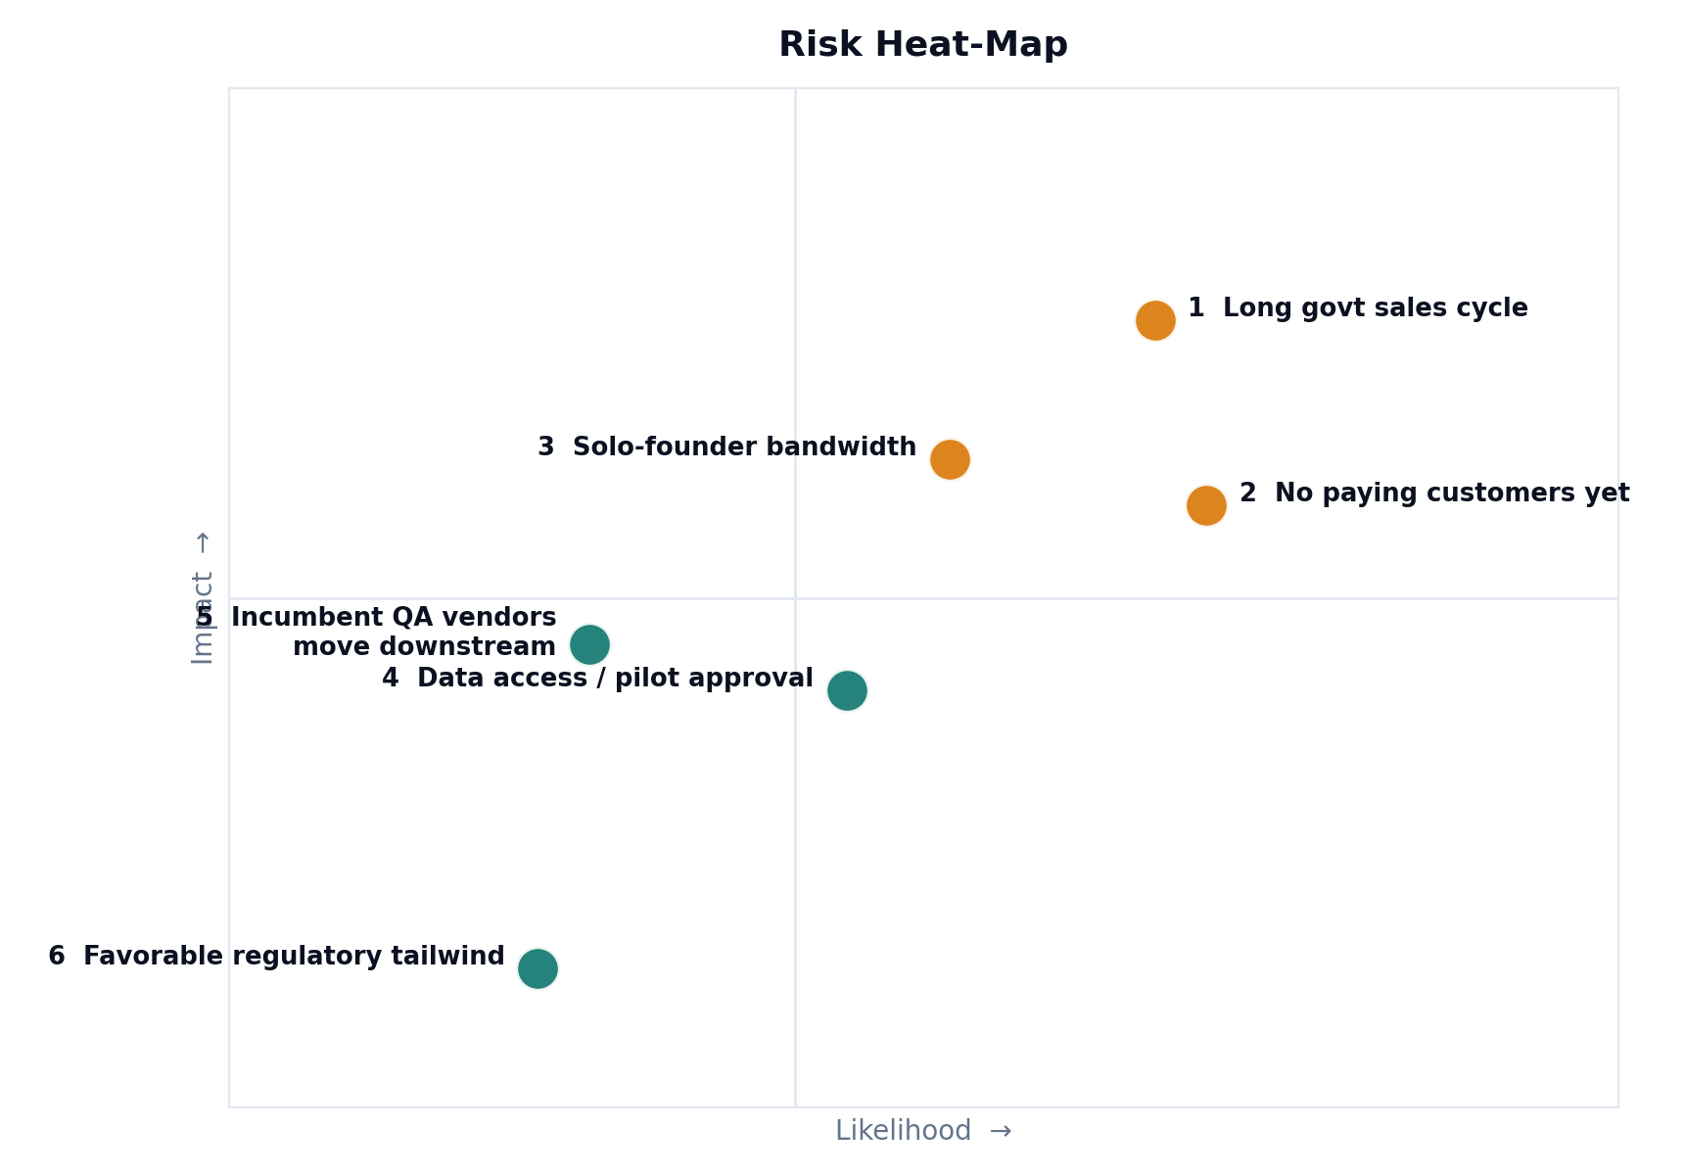
Risk | Likelihood | Impact | Mitigation
Government sales cycle (12–24 months) exhausts founder runway before first contract | High | High | Run a B2B or SME self-compliance pilot in parallel to generate revenue and learning while the govt path matures.
No paying customers or LOIs yet — idea is unvalidated beyond hackathon judging | High | High | Conduct 10–15 structured interviews with inspectors and compliance leads in the next 30 days before further build.
Solo-founder bandwidth — one person building AI/OCR/CV, plus doing sales, plus being a student | Medium-High | Medium-High | Recruit a co-founder or advisor with government-relations or regulatory-affairs background; scope MVP tightly.
Data access — government pilots may restrict inspection data or require on-prem/approved-cloud hosting | Medium | Medium | Design for on-premise/offline-capable deployment early; avoid architecture lock-in to a specific cloud.
Well-funded QA vendors (Cognex, iFactory) move downstream into regulatory/field use cases | Low-Medium | Medium | Move fast on the India-specific, field-mobile, regulator-facing niche before it becomes attractive to incumbents.
Regulatory tailwind reverses or stalls (e.g., amendment delayed/rolled back) | Low | Medium | Diversify beyond a single rule (COO) to the full LMPC ruleset and adjacent regimes (FSSAI, export labeling).

13 Pivot Opportunities
Pivot | Why it's attractive | Trade-off
B2B self-compliance SaaS for FMCG/D2C brands | Faster sales cycle, self-funded buyer, directly addresses a painful and immediate cost (recalls, delisting); same core OCR/CV tech. | Moves away from the original mission-driven regulatory angle; more competitive (Cognex, iFactory already present, though at higher price points).
Platform-side tool for e-commerce marketplaces to check Rule 6(10A) COO-filter compliance at listing scale | Rides the exact 2026 regulatory mandate; a small number of large, well-resourced buyers (major e-commerce platforms) rather than 36 fragmented state departments. | Very concentrated buyer set; a missed/lost deal has outsized impact; platforms may build this in-house.
Expand rule-engine to adjacent regimes: FSSAI food labeling, BIS marks, pharma labeling | Larger combined addressable market; reuses the same OCR/CV core with an expanded rule library. | Each regulator is a different bureaucracy with its own procurement path — multiplies go-to-market complexity.
White-label the inspection engine to existing GovTech/Smart City vendors already selling to state governments | Skips the founder's weakest area (govt distribution) by riding an existing vendor relationship. | Margin compression; loss of direct customer relationship and brand.

14 Go / No-Go Recommendation
CONDITIONAL GO
• The regulatory problem is real and getting more complex, not less — a durable tailwind.
• The founder has genuine technical fit but a weak government network and short runway, which is exactly the profile at risk in long govtech sales cycles.
• No direct competitor exists for the regulator-facing use case, but that whitespace is unproven — it may be open because it's hard, not because it's easy.
• Do not commit to a government-only go-to-market without first testing the faster-validating B2B self-compliance angle in parallel.
Recommendation: Proceed, but treat the next 30–90 days as a validation sprint, not a build sprint. The riskiest untested assumption is not the technology (already prototyped) — it is whether either buyer (government inspector or B2B compliance lead) will actually adopt and pay for this. Resolve that before investing further engineering time.

15 30-Day Action Plan
Week | Focus | Concrete Actions
Week 1 | Talk to real users | Interview 5–8 Legal Metrology inspectors/Assistant Controllers (start with your state, use SIH mentor/judge network for warm intros) and 5–8 FMCG/D2C compliance or QA leads. Ask about current process, tools, and what a failed inspection/recall actually costs them.
Week 2 | Sharpen the wedge | Based on interviews, pick ONE narrow workflow to nail first — e.g., "check this label photo against LMPC mandatory declarations" — rather than the full inspection suite. Write a 1-page problem/solution brief for each segment (govt vs B2B).
Week 3 | Build a testable demo + find a pilot | Turn the SIH prototype into a click-through demo usable by a non-technical inspector or QA person. Approach 1–2 state Legal Metrology offices for an informal MoU-based pilot, and separately approach 2–3 SME/D2C brands for a paid or free-trial pilot.
Week 4 | Decide and plan next 90 days | Score both segments on: response rate, willingness to pilot, willingness to (eventually) pay. Decide whether to pursue government, B2B, or both in parallel. Draft a lean 90-day roadmap and, if pursuing government, register on GeM/DPIIT Startup India and explore the GeM Startup Runway.

16 Appendix — Sources & Methodology Notes
- Legal Metrology (Packaged Commodities) Amendment Rules, 2026 and Rule 6(10A) (e-commerce Country-of-Origin filters, effective 1 July 2026): Mondaq, Chambers and Partners, MHCO Law regulatory updates.
- Legal Metrology organizational structure and inspector cadre counts (Maharashtra, Andhra Pradesh, Telangana): respective state Legal Metrology / Consumer Affairs department websites.
- India RegTech market sizing ($606M in 2025 → $2.4B by 2034, 16.03% CAGR): IMARC Group; cross-checked against Research & Markets and Straits Research global/regional regtech figures.
- AI label-inspection competitor landscape: Cognex, iFactory, SwitchOn (DeepInspect), Catalyx (OpenStation) public product/marketing pages.
- Govtech procurement cycle characteristics (12–24 month cycles, budget-cycle constraints, RFP dynamics): Startup India public procurement resources, Civic Marketplace, SaaSDash govtech sales research.
TAM/SAM/SOM figures, founder-market-fit scores, and risk likelihood/impact ratings are analyst estimates built from the above sources plus reasonable assumptions disclosed inline; they have not been independently verified against non-public government budget data and should be treated as a starting hypothesis for further validation.

