CST 370 – Summer A 2020

Homework 3

Due: 05/12/2020 (Tuesday) (11:55 PM)

Name:____Andrew Bell__________________

ID: ______1138___________

How to turn in?

Write your answer to the questions from 1 to 6 on a PDF file and submit it on the iLearn. Note that we accept only a PDF file. Do not submit a different file format. Also, don’t forget to write your name and class ID at the top of your homework document.

For the questions 7, 8, and 9, you should submit three source programs on the iLearn.

Thus, you have to submit total four files (one PDF file and three source files) on the iLearn.

1. Based on the definitions of O, Θ, and Ω, determine whether the following assertions are true or false.
(a) 2n³ + 5n + 1 ∈ O(n²) (true/false) False
(b) n * n * (n + 1) + 7 * n * n ∈ Θ(n²) (true/false) False
(c) 2 * n * (n – 1) ∈ Ω(n*log n) (true/false) True
(d) 4 * (n * n ) + 3 * n ∈ O(n²) (true/false) True

2. Consider the following recursive algorithm.
Algorithm Q(n)
// Input: A positive integer n
if n = 1
return 1
else
return Q(n - 1) + 2 * n - 1

(a) Present the return value for Q(1).
1

(b) Present the return value for Q(2).
4

(c) Present the return value for Q(3).
9

(d) Determine what the algorithm computes for a general number n.
it finds the square of n

3. (a) Consider the following recursive algorithm. What does this algorithm compute?

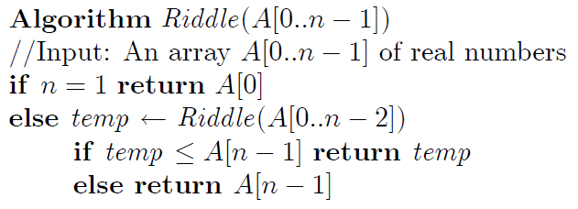
Linear search through an array for the smallest value

(b) Assume that your program conducts the binary search for a value in a sorted array. The time efficiencies of best case and worst case of the program are the same. (True/False).
False,
Best case is order 1
Worst case is logn

4. In the class, you learned the recurrence relation and backward substitution to get the time complexity of a recursive algorithm. To remind the topic, read the Google document again at https://goo.gl/HmoUNQ
Now, this is the example of backward substitution you learned in the class.

M(n) = M(n-1) + 1 // Recurrence relation
M(0) = 0 // Initial condition

M(n) = M(n-1) + 1 // Replace M(n-1) with “M(n-2) + 1”
= [M(n-2) + 1] + 1
= M(n-2) + 2 // Replace M(n-2) with “M(n-3) + 1”
= [M(n-3) + 1)] + 2
= M(n-3) + 3
…
= M(n-i) + i
…
= M(n-n) + n
= M(0) + n
= 0 + n
= n ∈ θ(n)

For the homework, solve the following recurrence relation as described above. You have to present intermediate steps and time complexity as described above.

M(n) = 2*M(n – 1) // recurrence relation
M(1) = 3 // initial condition

=2*M(n – 2) + 2
=2*(M(n – 3) + 1) + 2
=2*M(n – 3) + 4
…
=2(M(n-i)) + 2i
=2(M(n-(n-1))) + 2(n-1)
=2(M(1)) + 2(n-1)
=6 + 2n – 2  (n)

5. Consider the following recursive algorithm. Set up a recurrence relation and an initial condition for the comparison operation “if n = 1” in the line number 3.

[Hint] Use C(n) to indicate the number of comparisons for the array A with the size n. Then, the initial condition would be either C(1) or C(0).]

C(n) = C(n-1) + 3
C(1) = 1

6. [Puzzle] Assume that you have 10 identical-looking balls and a two-pan balance scale with no weights. One of the balls is a fake, but you don’t know whether it is lighter or heavier than the genuine balls, which all weigh the same. Describe your idea to determine in the minimum number of weighings whether the fake ball is lighter or heavier than the others. In the problem, you don’t need to identify the fake ball itself. It’s good enough for you to just say “It’s heavier or lighter”. Present the minimum number of weighings and your answer clearly.

3 Weighings
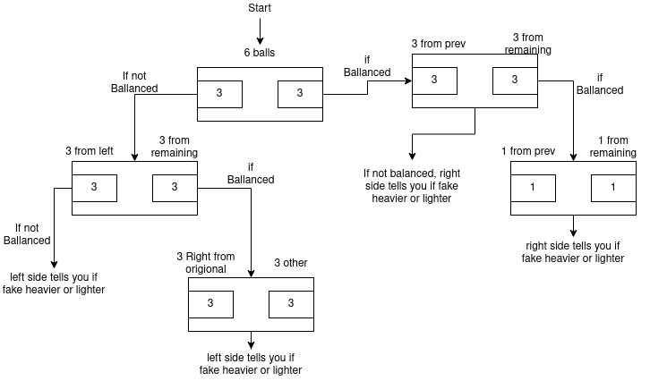

===========================================================================

This is the HackerRank link: https://www.hackerrank.com/cst370-su20-hw3

7. Write a C++ (or Java) program named hw3_1.cpp (or hw3_1.java) which checks if an input string is a palindrome or not. In the problem, a palindrome means an alphanumeric string which reads the same front to back. For the problem, you should ignore case and remove all non-alphanumeric characters in the input string. For example, “Race car”, “I did, did I?”, “7...8 Don't nod 87.” are all palindromes. But “CSUMB” is not a palindrome.
In this program, you have to use a recursive function to check the palindrome. For the grading, we will read your source code. If you do not use a recursive function, you will get zero even if your program passes all test cases.

Sample Run 0: Assume that the user typed the following one line

Race car

This is the correct output of your program.

TRUE

Sample Run 1: Assume that the user typed the following one line

7...8 Don't nod 78.

This is the correct output of your program.

FALSE

8. Write a C++ program called hw3_2.cpp (or hw3_2.java) that reads a number of elements in a set and then read the elements of the set. After that, your program should display all possible binary numbers and corresponding subsets one by one. For the program, you can assume that the number of elements in a set is less than 10.

Sample Run 0: Assume that the user typed the following input in which there are three elements of A, B, and C.

3
A B C

This is the correct output.

000:EMPTY
001:C
010:B
011:B C
100:A
101:A C
110:A B
111:A B C

The first line shows that the binary number is “000”. Note that the first bit ‘0’ is for the element ‘A’, the second bit ‘0’ for the element B, and the last bit ‘0’ for the element C. Since all three bits are ‘0’, the binary number “000” means the empty set.

The next line indicates that the binary number is “001” and it corresponds to the subset {C} because only the last bit is ‘1’. Similarly, the last line indicates that the binary number is “111” and it corresponds to the subset {A, B, C} because all bits are ‘1’.

Sample Run 1: Assume that the user typed the following input.

2
CST238 CST370

This is the correct output.

00:EMPTY
01:CST370
10:CST238
11:CST238 CST370

Sample Run 2: Assume that the user typed the following input.

0

This is the correct output of your program.

0:EMPTY

9. Write a C++ program named hw3_3.cpp (or hw3_3.java) which partitions n positive integers into two disjoint sets with the same sum. Of course, the problem does not always have a solution.

Input format: This is a sample input from a user.
4
2 3 7 8

The first number (= 4 in the example) indicates that there will be four integer values in the input. Then, all values in the second line (= 2, 3, 7, and 8 in the example) are actual numbers. Thus, your program should read them and present one equal set which includes the smallest number of the input values. Because the input values can have two equal sets of {2, 8} and {3, 7}, your program should display 2 and 8 on the screen. Note that the sum of {2, 8} is 10 and the sum of {3, 7} is also 10. For the problem, you can assume that the max number of input integer values is 15. Also, you can assume that the input values are all distinct.

Sample Run 0: Assume that the user typed the following two lines

4
2 3 7 8

This is the correct output of your program.

Equal Set: 2 8

Note that the sequence of output values is important. Your program has to display the set with the smallest value in the input. So, the correct set is {2, 8}. For the set, your program should display it in the ascending order. Thus, the correct answer is 2 and then 8.

Sample Run 1: Assume that the user typed the following two lines

3
7 5 1

This is the correct output of your program.

Equal Set: 0

Since it is not possible to have two equal sets from the input, your program should display just “0” on the screen.

Sample Run 2: Assume that the user typed the following two lines

6
3 5 20 7 1 14

This is the correct output of your program.

Equal Set: 1 3 7 14

Sample Run 3: Assume that the user typed the following two lines

5
10 8 6 4 2

This is the correct output of your program.

Equal Set: 0

[Hint] You can use hw3_2.cpp (or hw3_2.java) for this problem. In other words, you can consider all possible subsets of the input numbers to solve the problem.
For example, in the case of “Sample Run 0”, you have to consider all 16 subsets such as {}, {2}, {3}, {7}, {2, 3}, {2, 7}, … {2,3,7,8}. For each subset, you can use the binary representation as you did in hw3_1.
For instance, let’s say that you have a binary number 1001. The first and last digits of the binary number are ones, and second and third digits are zeros. Thus, you have two subsets of ones and zeroes. Using this information, you can compare the sums of two subsets.

