## CS307 – Software Engineering

## Design Document

## Vowb.net

## Team 2 Members:

## Mason Everett, Rhys Howell, Rashmi Iyer, Stephen Kramer, Dae Wook (Pascal) Lee, Eric Theller

**Table of Contents**

1. Purpose
2. General Priorities
   1. Usability
   2. Security
   3. Performance
   4. User Interface
3. Design Outline
4. Design Issues
5. Design Details
   1. Components
      1. Client
      2. Server
      3. Database
   2. Security
6. UI Mockups
7. Roles and Structure

**Purpose**

Currently, there are very few voice chat services for a general user. Our goal is to create a client based in the web browser to make it as easy as sending someone a link to be able to chat with them. This eliminates the need to install a new program every time one wishes to chat with a new friend group. Additionally, we will be incorporating discussion boards for short and long term discussions, user profiles, and friend lists. Current applications try to emulate this, but do not succeed and lack proper functional user interfaces.

The functional requirements of this application will include the following items:

**Lobby:** A lobby is a chat room where the voice discussions will take place, along with a system of handling text based communications. A lobby can either be public or private. When a lobby is public, any user can join but when it’s private only those with the password can join.

1. As a guest, I would like
   1. to anonymously join public and private lobbies.
   2. to anonymously voice chat with others in the lobby.
   3. to mute other users and guests.
2. As a user, I would like
   1. to join public and private lobbies.
   2. to voice chat with others in the lobby.
   3. to mute other users and guests.
   4. to post in a thread.
   5. to create a thread on the forum.
   6. to customize my profile and account information.
   7. to have a badge representing my hours logged in chat.
   8. to create and own lobbies, becoming a lobby owner for those lobbies.
3. As a lobby moderator, I would like
   1. *to have all the capabilities of a user.*
   2. to add, remove and ban users from the lobby.
   3. to globally mute users of the same position or lower.
4. As a lobby owner, I would like
   1. *to have all the capabilities of a moderator*.
   2. to delete lobbies that I own.
   3. to promote users to moderators and demote them.
   4. to globally mute users of the same position or lower.
   5. to only own a maximum of 4 lobbies.

**Forum:** The long term discussion boards. Only text discussions will happen, and anything posted will remain until it is removed by it’s poster or a moderator.

1. As a user, I would like
   1. to post in a thread.
   2. to create a thread on the forum.
   3. to delete my own posts and threads.
   4. to send private messages to another user.
   5. to add and remove friends from my friend list
   6. to customize my profile and account information.
2. As a forum moderator, I would like
   1. to delete posts in threads and threads themselves.
   2. to ban users from threads.
3. As a forum administrator, I would like
   1. to create and delete topic categories for threads.
   2. to create and delete sub categories for thread.
   3. to reset a user’s or moderator’s password.
   4. to ban a user’s or moderator’s account.
   5. to promote forum users and demote moderators.

**General Priorities**

**Usability**

One of our main priorities will be usability as the most popular voice chat services today are not very user friendly. The most frequently used services will be available immediately and intuitively easy to find for new users.

**Security**

We don’t want people to be able to retrieve data or information from lobbies which have a password. We also want to make sure user profiles can only be modified by the users who created them. In addition, we are limiting the number of lobbies that user can create to prevent system crashes and malfunctions.

**Performance**

Vowb will have a fast audio response time. Good quality is preferred, but the

response time is the main focus. Most existing voice chat services exhibit a decent level of

performance, and performance usually only becomes an issue when it is visibly lacking. Vowb

will aspire to exceed other similar competitors for performance.

**User Interface**

Unlike the user interface of other popular web voice chat clients, Vowb will have the feel of

modern software and will look attractive to its users. It will have the sleek, minimal design that

most popular VoIP desktop clients have. All immediately needed functionalities will be visible

while other options are still readily available but a click away.

**Design Outline**

Vowb.net will utilize a Model-View-Controller design pattern. We would like to separate the user design aspects from the back-end server and make them as independent as possible. The application will also use a client-server model to ensure the server can process communications as fast as possible. The server will connect to multiple clients, enabling them to transfer voice data through the server.

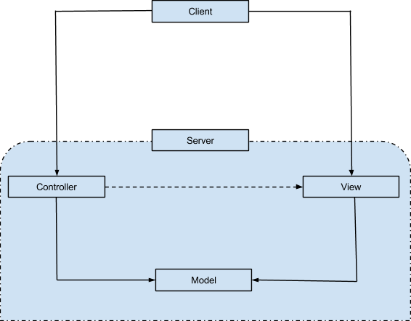

The client is the web browser. It will wait for the Lobby information from the Server and will draw the corresponding image based off of it. The client will also inform the server of changes in the user state. The server is made up of 3 components: the model, view and controller. The view is the application interface the server sends to the client, the model is the database the server accesses to retrieve information and also some of the lobby information stored on the server. The controller is the server’s instance of Node.js and socket I/O.

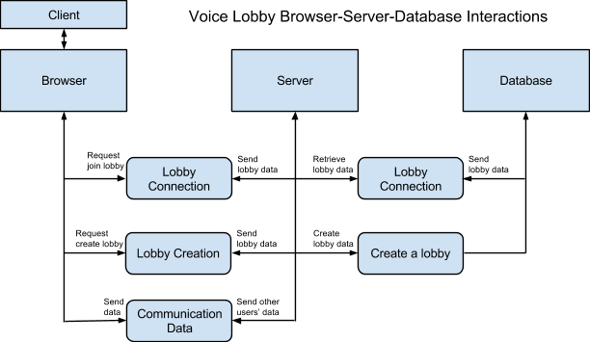

**Browser**

The client’s view will be inside the browser. The view will be implemented using HTML, CSS, and JavaScript. The user interface streamlines the user’s experience and enables them to navigate voice chat lobbies and the forums with ease. Furthermore the browser contains some aspects of the controller which interacts with the server to send, receive, and request data and updates the view accordingly.

**Server**

The server controls the client’s browser’s view. It sends and receives data from the client in order to facilitate the purpose of the application. The server retrieves and records database information. The server also connects the users to the different lobbies and then transmits their communication data (auditory or textual) to the other users in the lobby.

**Database**

The database will hold all of the long-term information about activities on the site. The database will be created using a typical SQL database server, which will allow for easy access through queries. In a typical SQL implementation, the database houses variable tables, and the tables house information stored by the program. Vowb’s database will have tables such as a Forums table, a Lobbies table, and a Users table. There will also be tables for interior class components such as Profiles, Threads, and Posts. The specific column names for the variables in these tables will be very similar to the class fields presented in the class diagram in the *Design Details* section.

**Design Issues**

* **Issue 1:** Should a lobby disappear if the owner leaves?
  + **Option A:** Lobby is deleted.
  + **Option B:** Lobby is deleted if owner is inactive for a given amount of time.
  + **Option C:** Lobby is not deleted and owner position is given to another user in the lobby.
  + **Decision**: **Option B.** Lobbies will not be deleted when the owner leaves, but will be deleted if the owner is inactive for a given amount of time. The point of the lobbies is to allow for discussion among groups of people, and to continue these discussion even if the original creator of the lobby is gone for some time.This gives lobbies a useful lifespan, but prevents them from lasting indefinitely.
* **Issue 2:** Should we have moderators?
  + **Option A:** Moderators exist to assist owners in policing lobbies..
  + **Option B:** Moderators will not exist because they are unnecessary.
  + **Decision**: **Option A.** Moderators will exist to assist owners. This gives the option of giving a user more power without giving them all the power. Moderators can also ensure some level of order is maintained when the owner is offline.
* **Issue 3:** How many lobbies can we allow a user to create in a given amount of time?
  + **Option A:** Lobby count is unlimited
  + **Option B:** Lobby count is slightly limited(4-25)
  + **Option C:** Lobby count is heavily limited(1-3)
  + **Decision**: **Option B.** Users will be limited to owning only 4 public lobbies at one time. Even if ownership is transferred from one user to another, at any given time a single user is only allowed to own 4 public lobbies. **Option A** would allow for spamming the site with useless/redundant lobbies, while **Option C** is so small it doesn’t offer enough utility for the users.
* **Issue 4:** Should we have a general sub-lobby for each lobby that users are automatically connected to?
  + **Option A:** Users automatically join a general sub-lobby when they join a lobby
  + **Option B:**There is no general sub-lobby and users can only chat in the lobby
  + **Decision: Option B.** When joining a lobby, users do not need to join a general chat room. **Option A** requires an additional sub-lobby to be created that may not be used, wasting additional resources.
* **Issue 5:** How connected are lobbies and the forums?
  + **Option A:** Lobbies and forums are not connected at all.
  + **Option B:** The larger lobbies and forums contain links to the other.
  + **Option C:** Related lobbies and forums are grouped together.
  + **Decision: Option B.** Including links between the main forums and lobbies would be extremely useful for users. It would allow users to easily transition from post to post communication on the forums, to a real time voice discussion in the lobbies.
* **Issue 6:** How should we deal with users who disobey the website’s policies?
  + **Option A:** Ban them from the use of the Vowb permanently.
  + **Option B:** Give a warning for the first instance then ban them permanently.
  + **Option C:** Give multiple warnings and temporary bans, then ban them permanently.
  + **Decision: Option C.** Depending on the severity of the violation, users should be banned temporarily anywhere from a couple hours to several days. Repeated offenders or serious offenders will receive a permanent ban on their profile.
* **Issue 7:** Should SQL be used for the database?
  + **Option A:** Use a database implementation that allows SQL queries.
  + **Option B:** Use a different database implementation, such as MongoDB or other NoSQL database systems.
  + **Decision: Option A.** SQL databases are more common, and our team members have slightly more experience using this type of database. Choosing something that the team already knows how to work with will put us a step ahead as we begin to implement the database needed for Vowb.

**Design Details**

Class Design

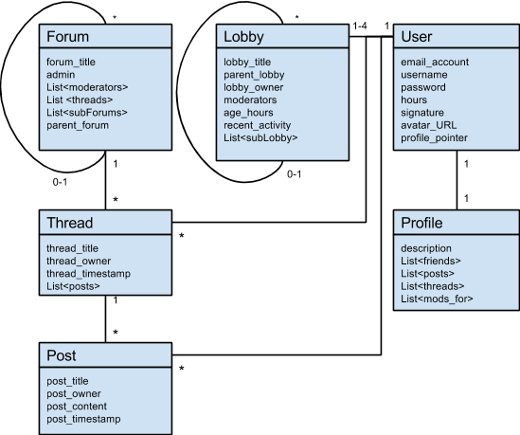

B. Description of classes and models

User:

* This encompasses every user except guests (admins, moderators, and users)
* It contains information about the users such as their emails, signatures to be displayed on forum posts, their avatar/profile pictures to be displayed in both forums and lobbies, and pointers to their profiles.

Profile:

* This contains more of the social aspect of the user, mainly used on the forums.
* It contains multiple lists, such as post and thread histories, sub-forums they are moderators for, and a description to be displayed by those viewing the profile.

Lobby:

* The lobby entity containing all information for voice chat.
* It contains information such as whether or not it is a sub-lobby or parent lobby, number of users in the lobby, it’s moderators and owner, and it’s age of the lobby.

Forum:

* Entity which is categorical in nature, it is used to separate threads into more specific and relevant topic categories.
* Similar to a Folder

Thread:

* Entity which is where forum posts are placed.
* It is a specific topic held within Forums and sub-Forums.
* Similar to a specific document or file in a folder

Post:

* Entity which contains the content of a user’s message
* Similar to the actual content within the file.

**Components**

**Client**

The client will provide the user interface to our system in web browsers. It will provide an easy way for users to interact with other clients through the server.

We will use typical web development tools to implement the client side of our system, such as HTML, CSS, and JavaScript. We will use jQuery to assist us in our JavaScript programming.

**Server**

Our server will use Node.js to remain lightweight and efficient in the face of real time applications. The server will maintain real time connections with the users using socket I/O. Socket I/O will help users stay up to date on the current state of the lobby, when users disconnect or join sub lobbies.

**Database**

For our system to work well, there is data that we must keep track of, so we will be using a database. We plan to use SQL Server to keep track of lobby, user, and forum information.

**Security**

Security is important, but it is not a main focus in our project. First, users will have their own usernames that will be public, but their passwords will be protected. Also, private lobbies will have their own passwords and they can only be accessed by those who are invited or have the correct password to that lobby. In addition, we will limit the number of lobbies that users can create in a defined amount of time to prevent software crashes and malfunctions due to malicious users.

**Account Creation Diagram**

The diagram below displays the logic to create a new account in our system. 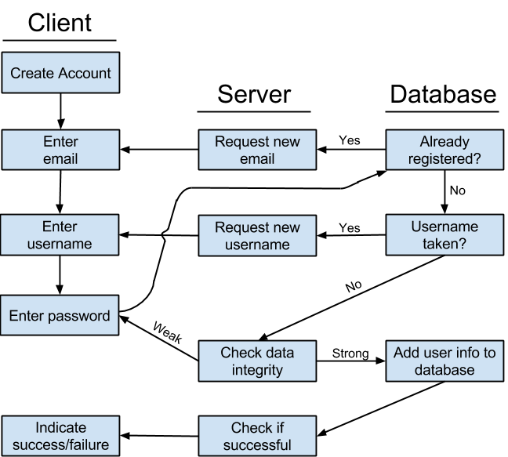

**UI Mockups**

**User Profile UI Mockup:**

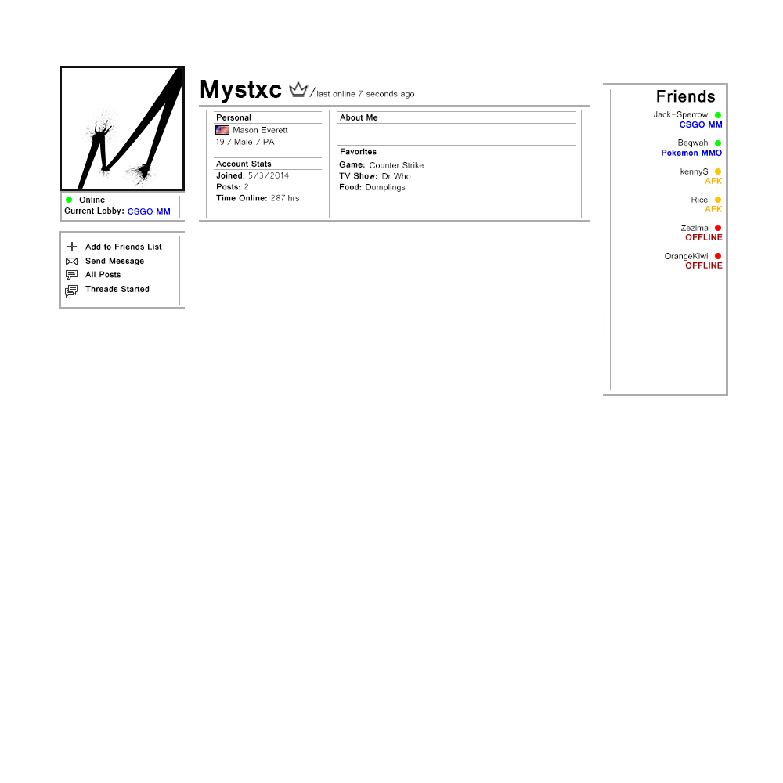

**Lobby Directory UI Mockup:**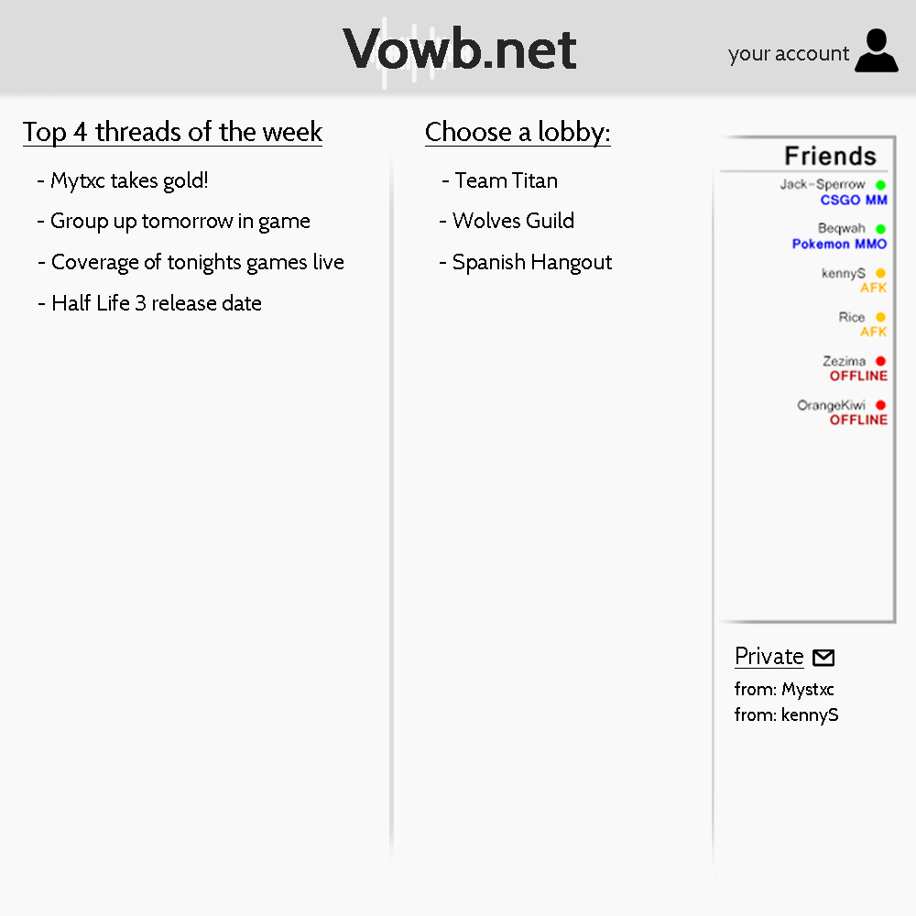

**Voice Chat UI Mockup:**

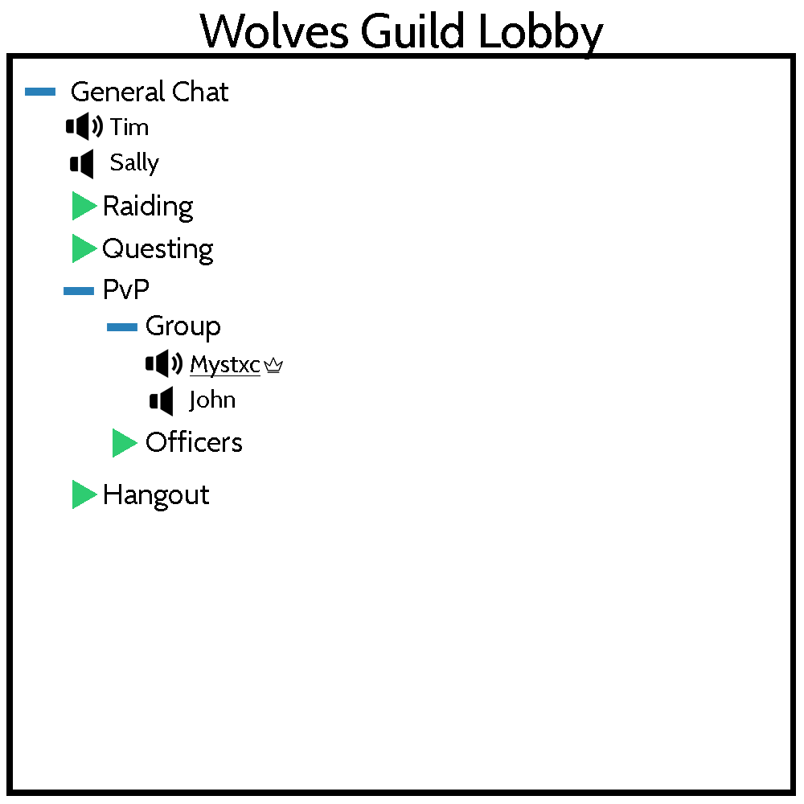

**Text Chat UI Mockup:**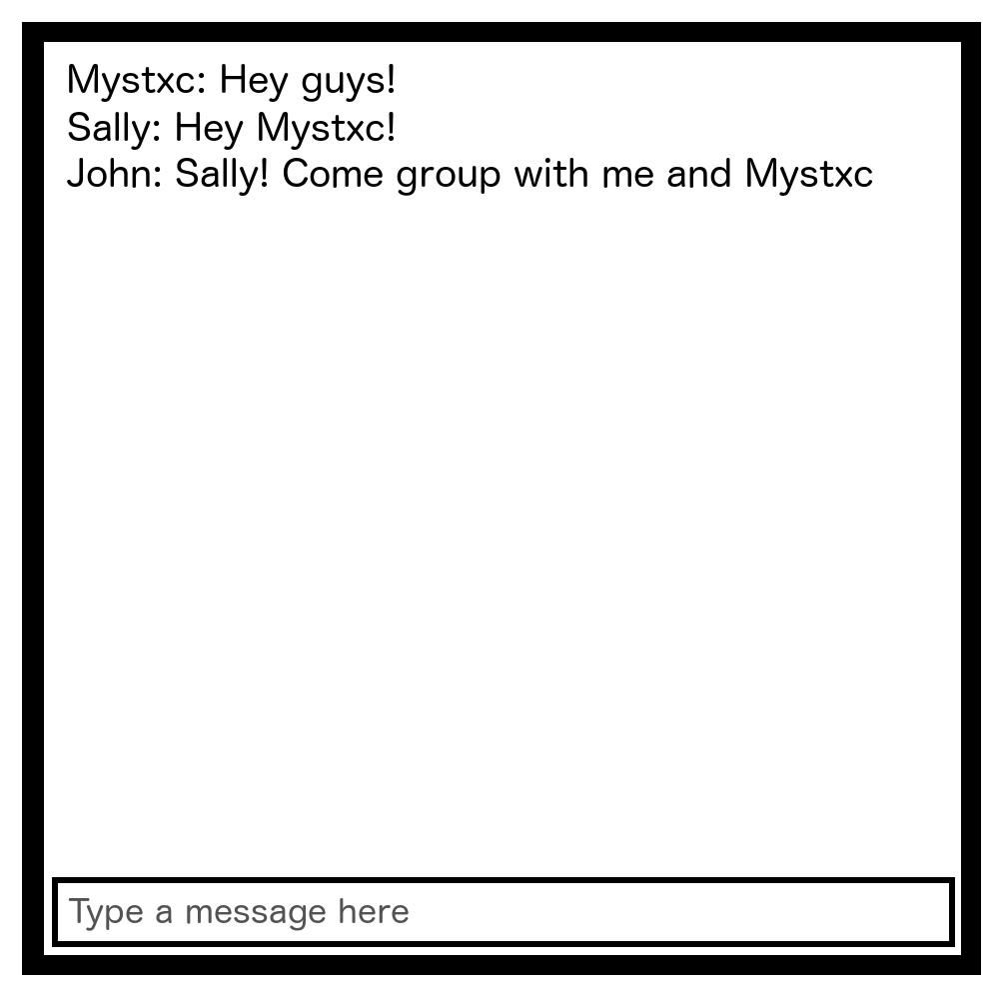

**Roles & Structure:**

**Hierarchy of Vowb Users:** 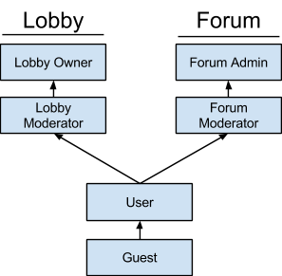

**Roles of a Guest:**

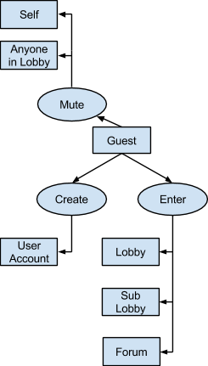

**Roles of a User:** 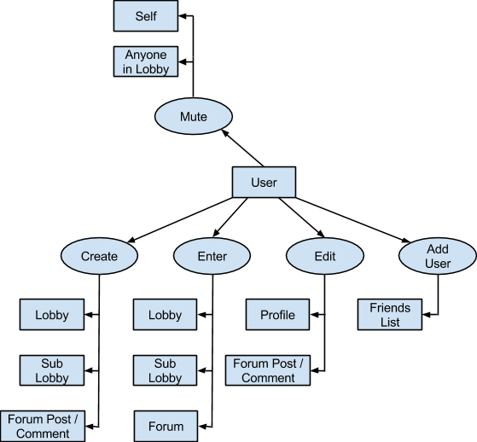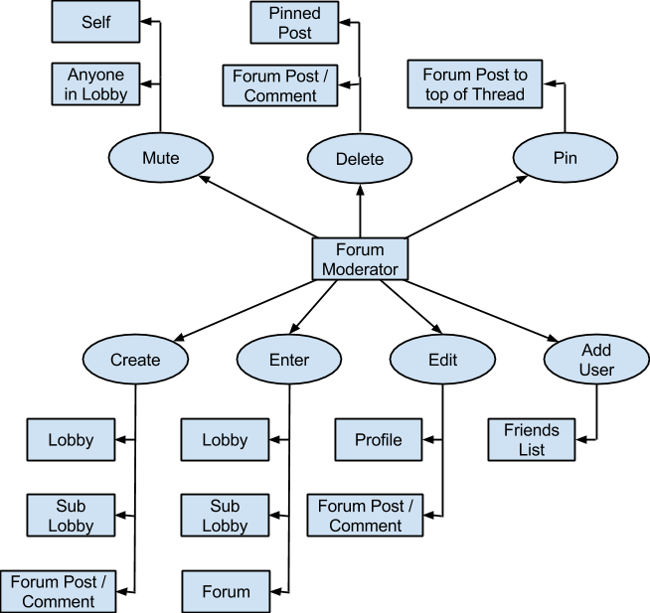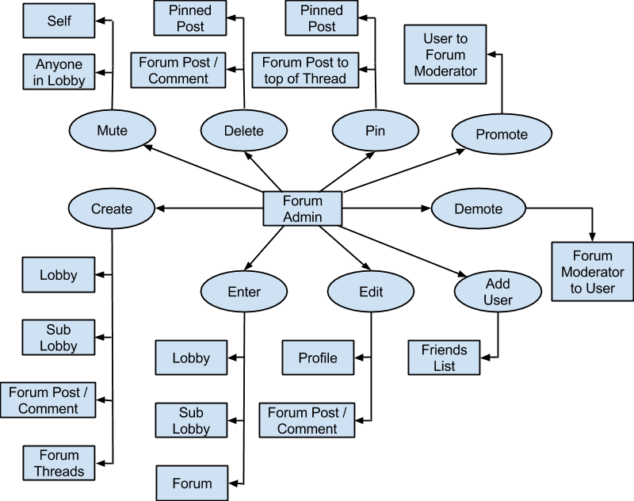

**Roles of a Lobby Moderator:**

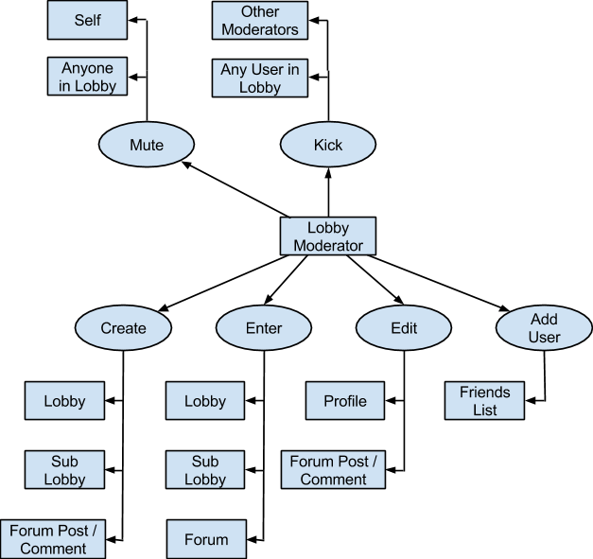

**Roles of a Lobby Owner:**

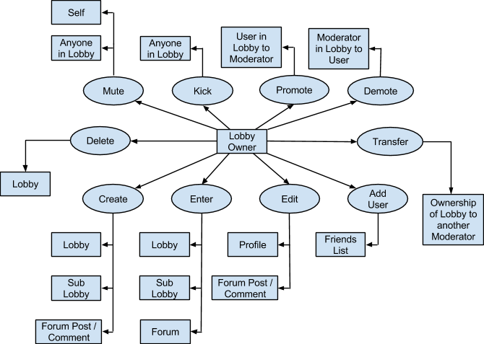

**Roles of a Forum Moderator: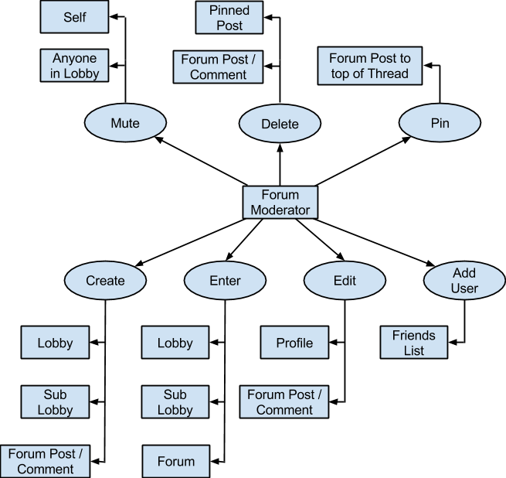Roles of a Forum Administrator:**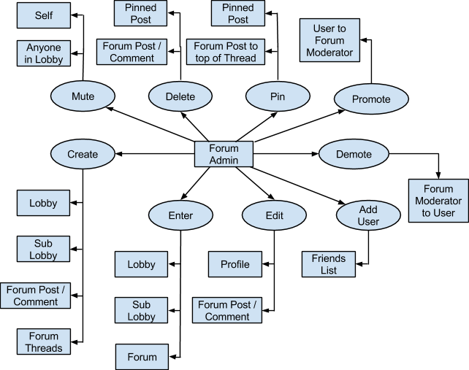

**Structure of a Lobby Directory:**

