**1. What are escape characters, and how do you use them?**

An escape character is a backslash \ followed by the character you want to insert.

To insert characters that are illegal in a string, use an escape character.

Use the backslash character to escape a single character or symbol. Only the character immediately following the backslash is escaped.

In Python strings, the backslash "" is a special character, also called the "escape" character. It is used in representing certain whitespace characters: "\t" is a tab, "\n" is a newline, and "\r" is a carriage return

**2. What do the escape characters n and t stand for?**

"\t" is a tab, "\n" is a newline

**3. What is the way to include backslash characters in a string?**

Use double backslash \\ or put @ at the start of your string

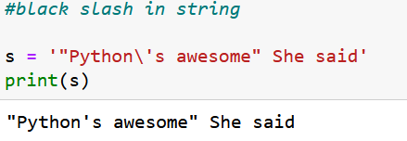

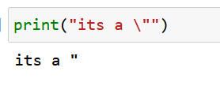

**4. The string "Howl's Moving Castle" is a correct value. Why isn't the single quote character in the word Howl's not escaped a problem?**

The single quote in Howl's is not a problem because we’ve used double quotes to mark the beginning and end of the string.

**5. How do you write a string of newlines if you don't want to use the n character?**

can print strings without adding a new line with end = <character> , which <character> is the character that will be used to separate the lines.

Multiline strings allow you to use newlines in strings without the \n escape character

**6. What are the values of the given expressions?**

**'Hello, world!'[1] 🡪** e

**'Hello, world!'[0:5] 🡪** Hello

**'Hello, world!'[:5] 🡪** Hello

**'Hello, world!'[3:] 🡪**lo, world!

**7. What are the values of the following expressions?**

**'Hello'.upper() 🡪** HELLO

**'Hello'.upper().isupper() 🡪** True

**'Hello'.upper().lower() 🡪** hello

**8. What are the values of the following expressions?**

**'Remember, remember, the fifth of July.'.split()**

**'-'.join('There can only one.'.split())**

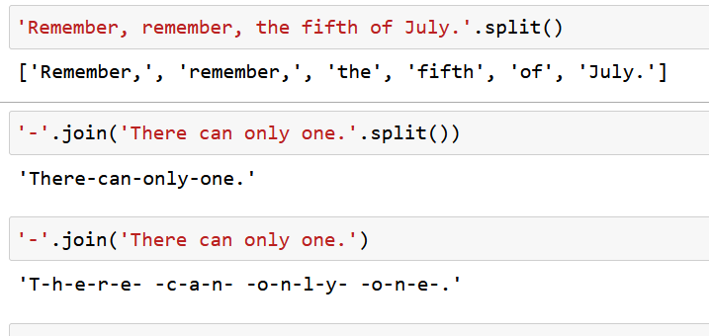

**9. What are the methods for right-justifying, left-justifying, and centering a string?**

# ljust(), rjust(), center()

This function **center aligns** the string according to the width specified and fills remaining space of line with blank space if ‘ fillchr ‘ argument is not passed.

**Syntax :**  
center( len, fillchr )

**Parameters :**  
**len :** The width of string to expand it.  
**fillchr (optional):** The character to fill in remaining space.

**ljust()**

This function ***left aligns*** the string according to the width specified and fills remaining space of line with blank space if ‘ *fillchr* ‘ argument is not passed.

**Syntax :**  
ljust( len, fillchr )

**Parameters :**  
**len :** The width of string to expand it.  
**fillchr (optional):** The character to fill in remaining space.

**rjust()**

This function **right aligns** the string according to the width specified and fills remaining space of line with blank space if ‘ *fillchr* ‘ argument is not passed.

**Syntax :**  
rjust( len, fillchr )

**Parameters :**  
**len :** The width of string to expand it.  
**fillchr (optional) :** The character to fill in remaining space.

**Return Value :**  
The resultant right aligned string expanding the given width.

**10. What is the best way to remove whitespace characters from the start or end?**

* **strip()** removes both leading and trailing white spaces from a string. stripLeading() removes leading white spaces but leaves trailing white spaces.
* Python has three built-in methods for trimming leading and trailing whitespace and characters from strings.
* .strip()
* .lstrip()
* .rstrip()
* 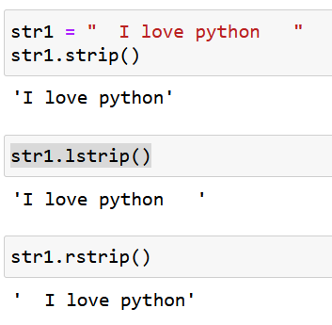
* Use the . strip() method to remove whitespace and characters from the beginning and the end of a string. Use the . lstrip() method to remove whitespace and characters only from the beginning of a string. Rstrip() method to remove whitespace and characters only from the ending of a string.