

**ECE501- DIGITAL IMAGE PROCESSING**

# **WEEKLY REPORT – Week 2: (11-10-2025)**

## **Project No.: 6**

## **Project Title: Image Inpainting for Object Removal**

**Group Name: 12**

| **Group Details:** | | |
| --- | --- | --- |
| **Sr No** | **Name** | **Enrollment No:** |
| 1 | Sakina Jambughodawala | AU2340114 |
| 2 | Prina Patel | AU2340040 |
| 3 | Aneri Maniar | AU2340080 |
| 4 | Nidhee Adesara | AU2340196 |

**Problem Definition:**

The goal of this project is to fill the missing regions using the information of surrounding texture and color so that the image looks natural.

Image inpainting is the process in which an image whose parts are lost are reconstructed based on information of remaining context  
  
**Objective of the Week:**

1. To prepare for the presentation and make ppt.
2. To study the diffusion-based techniques that we finalised ([Filling in by joint interpolation of vector fields and gray levels](https://ieeexplore.ieee.org/stamp/stamp.jsp?tp=&arnumber=935036&tag=1)) by referring to various research papers related to it.
3. To start looking at the database that we are going to use.

**Literature / Background Study:**

• Studied different methods of diffusion based techniques for image inpainting:

1. PDE-based regularization or diffusion

* Smoothly fills missing regions by spreading pixel values according to partial differential equations while preserving edges.

1. Isotropic Diffusion: It spreads pixel values evenly in all directions, good for smooth regions but bad for edges
2. Anisotropic diffusion: It modifies the equation to control the spreading more along certain directions (like along an edge), preserving sharp features
3. Image local geometry

* Uses the structure like edges, gradients, and orientations of nearby pixels so that it helps in the inpainting direction for natural continuation.

1. Variational-based

* It fills the missing parts by finding the smoothest and most natural-looking image that fits best with the surrounding areas.

### **Example of Input images and its respective output that we might receive:**

| INPUT | OUTPUT |
| --- | --- |
|  |  |
|  |  |
|  |  |
|  |  |

Images from-

<https://conservancy.umn.edu/items/47520aec-c5aa-49c2-a425-84da859c3a26>

### **Main Goal:**

To achieve smooth and visually consistent restored image using mathematical models, especially PDE and diffusion techniques, for applications like:

* Removing scratches or text
* Repairing old or damaged photos
* Restoring lost image data

## **FLOWCHART:**

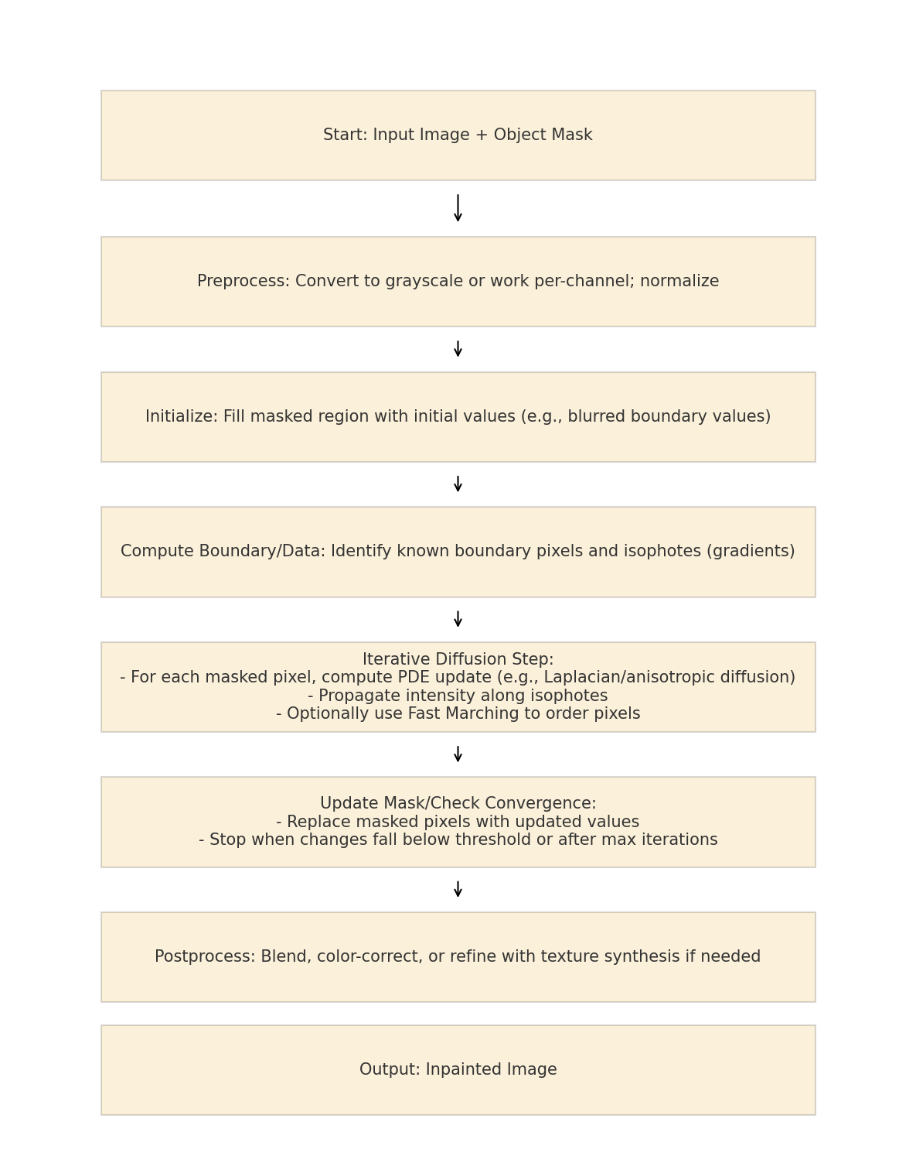

## **Plan for Next Week:**

* A working Python code for basic diffusion inpainting.
* Then, modify the code as per the requirement after checking the code with some sample outpu