

ECE501- DIGITAL IMAGE PROCESSING

WEEKLY REPORT – Week 5: (8-11-2025)

Project No.: 6

Project Title: Image Inpainting for Object Removal
Group Name: 12
Group Details:
Sr No | Name | Enrollment No:
1 | Sakina Jambughodawala | AU2340114
2 | Prina Patel | AU2340040
3 | Aneri Maniar | AU2340080
4 | Nidhee Adesara | AU2340196

Problem Definition:
The goal of this project is to fill the missing regions using the information of surrounding texture and color so that the image looks natural.
Image inpainting is the process in which an image whose parts are lost are reconstructed based on information of remaining context
Objective of the Week:
- Implementing code further.

CODE:
https://colab.research.google.com/drive/1AytkHn8dnT6OlFW3RPJ5PDxyGpO1CBqV?usp=sharinghttps://colab.research.google.com/drive/1AytkHn8dnT6OlFW3RPJ5PDxyGpO1CBqV?usp=sharing

OUTPUT:
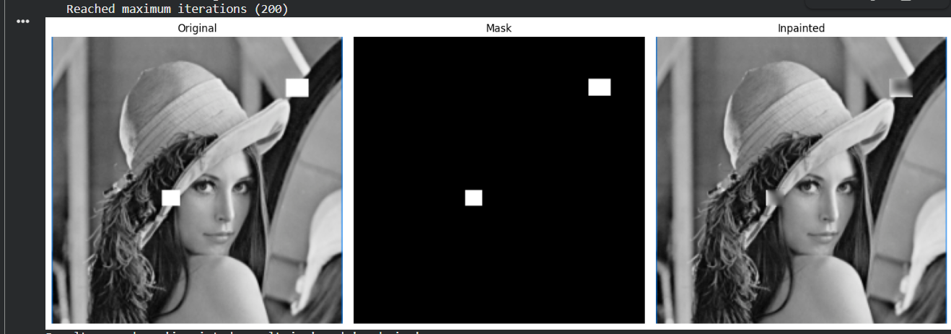

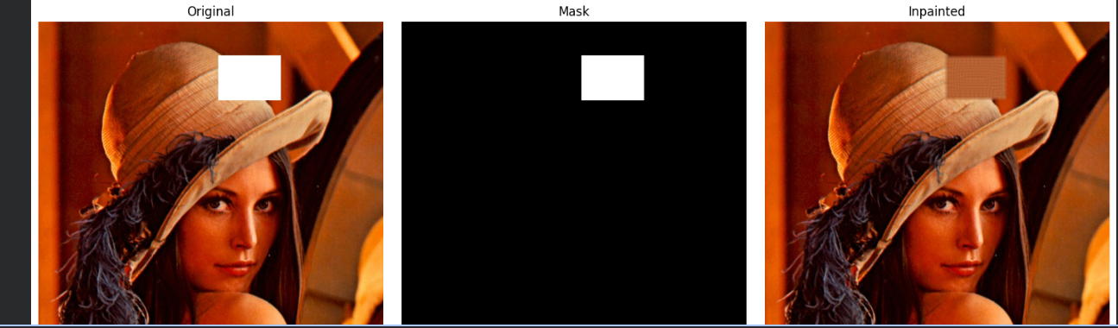

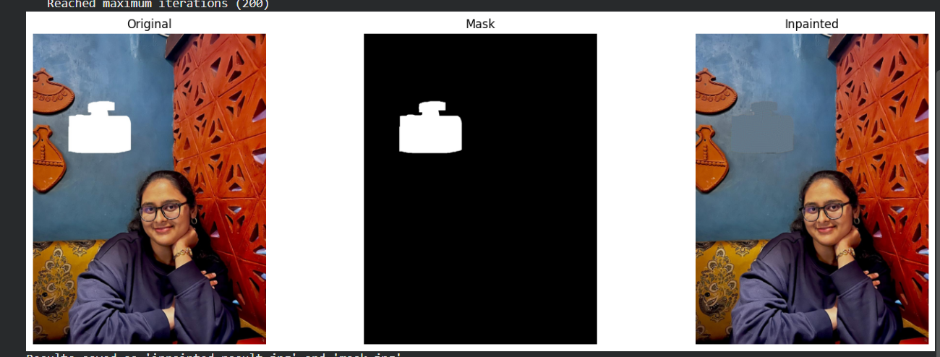

METHEDOLOGY:

1. Initialization (__init__): Sets algorithm parameters like max_iter: iteration limit, dt: update rate, alpha: smoothness control, tolerance: stop condition, mask_threshold: for damaged region detection.
2. Image Display (show_img): Displays color or grayscale images using Matplotlib after optional color conversion.

3. Automatic Mask Creation (create_mask_auto):

Normalize the image to [0,1] if needed.
Create a binary mask -pixels -> threshold -> part of the mask.
Clean mask using morphological open and close operations.
Display the mask for visualization.
Print mask

4. Gradient Computation (compute_gradient)
Finds image gradients (x, y) and their magnitude using Sobel filters(for edge detection).
Compute gradient magnitude = √(grad_x² + grad_y²).

5. Gradient Direction (compute_gradient_directions)
Normalizes gradients to unit direction vectors for diffusion guidance.
Add a small epsilon to avoid division by zero.
Normalize:
theta_x = grad_x / magnitude,
theta_y = grad_y / magnitude.

6. Divergence (compute_divergence)
Calculates divergence of gradient fields -key for updating pixel values.
Apply Sobel again to get derivatives of direction fields and add x and y derivatives total divergence.

7. Laplacian (laplacian)
Computes second-order derivatives to smooth pixel intensities.

8. Band Initialization (initialize_band)
Creates a narrow band around the damaged area to guide the diffusion process.
Dilate the mask slightly to expand it. Define “band” as a dilated area minus the mask.

9. Visualization of Band (visualize_band)
Marks hole (red) and surrounding band (green) for visual reference.

Red (Damaged Region – Mask): Marks the missing or damaged pixels that need inpainting.
Colored red ([0,0,255]) to clearly show where reconstruction will occur.

Green (Surrounding Region – Band): Marks the boundary area around the damaged region.
Colored green ([0,255,0]) to show where information will diffuse into the red area.

10. Inpainting Core (inpaint_channel)
Initialize band and fill mask with mean of band values and compute gradient and direction fields.
For each iteration:
Save an old image
Compute Laplacian and divergence
Update pixel values inside mask using result += dt * (laplacian - div_theta)
Restore original pixels outside the mask and recompute gradients
Check convergence (mean change < tolerance). Stop when converged or max iterations reached

11. Gradient Visualization (visualize_gradient_fields)
Displays gradient X, Y, and magnitude maps for analysis.

12. Process Flow (process_image)
Loads image -> Converts to grayscale -> Applies Notch Filter for noise removal -> Creates filtered image
13. Notch Filter (apply_notch_filter)
Convert image to frequency domain (FFT) -> Create two Gaussian notch filters centered at ±(u_k, v_k) -> Multiply filter mask with FFT to remove noise frequencies -> Apply inverse FFT to get filtered image
14. Main Program
Run the pipeline: input - image with the object removed.
Major Improvement from last week:
- Output improved
- We tried our code for realistic images and it gave good output
- Also, we added notch filter to remove noise

Plan for Next Week:

- Improved texture continuity
- Reduced flat/blurry patch artifacts
- Stronger structural and visual quality in restored areas

