

ECE501- DIGITAL IMAGE PROCESSING

WEEKLY REPORT – Week 6: (15-11-2025)

Project No.: 6

Project Title: Image Inpainting for Object Removal
Group Name: 12
Group Details:
Sr No | Name | Enrollment No:
1 | Sakina Jambughodawala | AU2340114
2 | Prina Patel | AU2340040
3 | Aneri Maniar | AU2340080
4 | Nidhee Adesara | AU2340196

Problem Definition:
The goal of this project is to fill the missing regions using the information of surrounding texture and color so that the image looks natural.
Image inpainting is the process in which an image whose parts are lost are reconstructed based on information of remaining context
Objective of the Week:
- Finalizing the code.
- Making PPT for the final presentation.
- Report for project.

CODE:
https://colab.research.google.com/drive/1cAgGz5wiPY_crp7o1d-0AedI6Xc0bWeD?usp=sharing

OUTPUT:

INPUT | MASK | OUTPUT
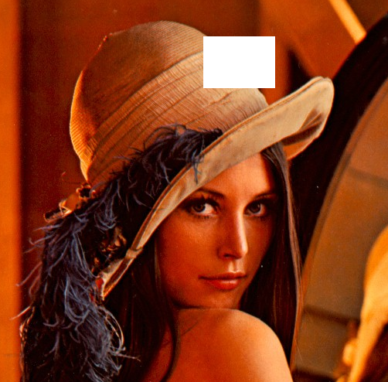 | 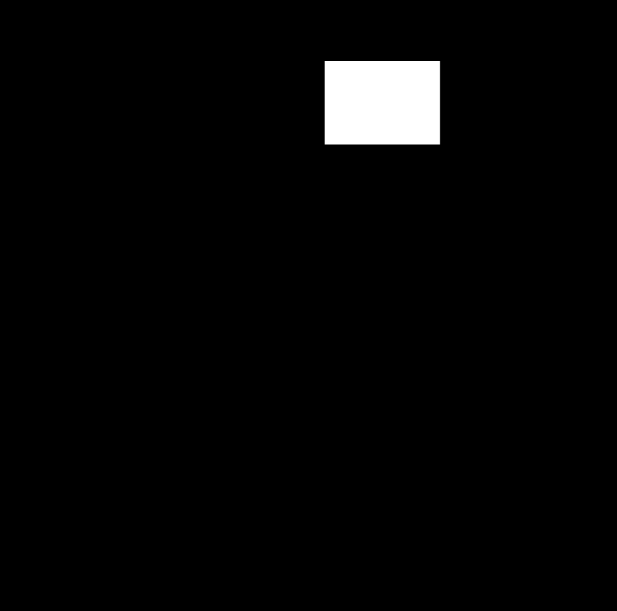 | 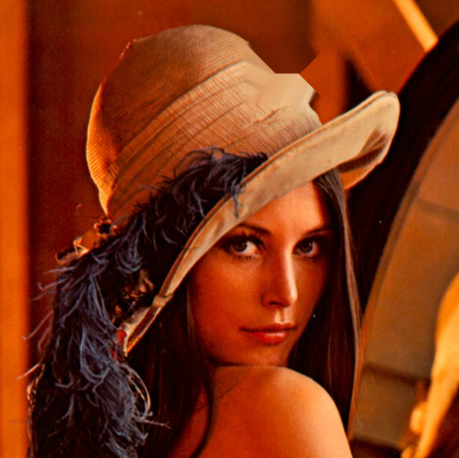
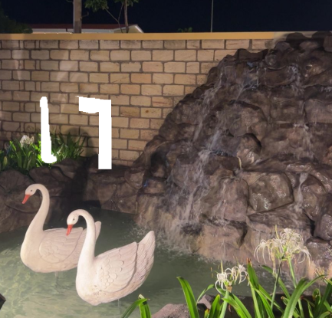 | 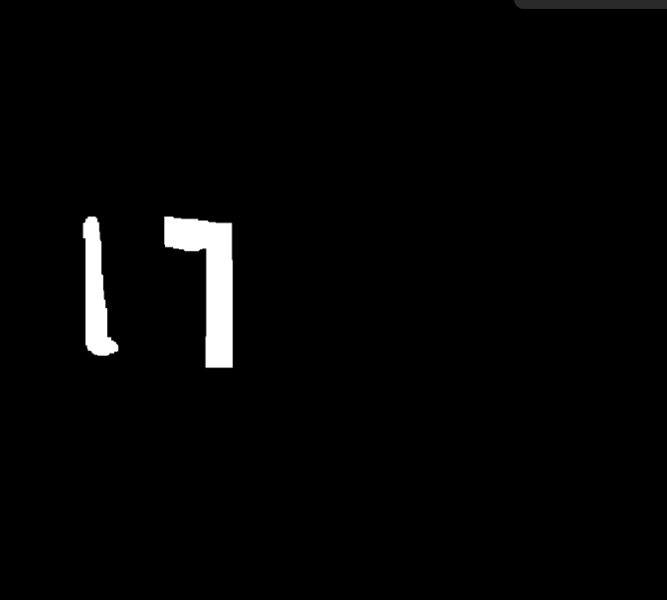 | 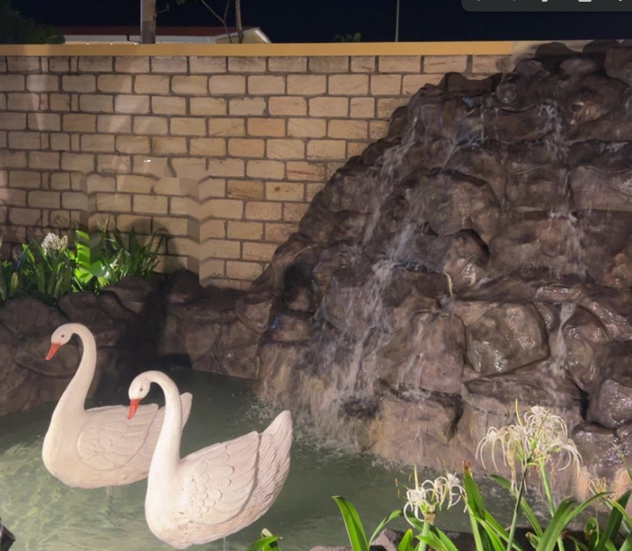

METHEDOLOGY:

1) Create Mask

- Convert image to grayscale.
- Threshold to detect very bright/white areas.
- Apply morphological cleanup so the mask becomes smooth.
- Result: mask = 1 for missing regions, 0 for known regions.

2) Set Up States for Fast-Marching

- Three states:
KNOWN = pixels outside mask
INSIDE = pixels inside mask
BAND = mask pixels that touch known pixels
- Compute distance transform so each mask pixel knows how far it is from known region.
- Push all BAND pixels into a priority queue ordered by distance (fast-marching).

3) Compute Image Gradients (Edges)

- Use Sobel to compute horizontal gradient gx and vertical gradient gy.
- These gradients tell the direction of edges (isophotes).

4) Define Telea-style Weight

- Uses these formulas:

Directional derivative

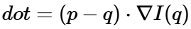

Distance decay
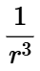 ​

Final weight
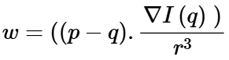 ​

In the final weight keep positive weights only

This prefers neighbors whose gradient direction continues the structure into the hole.

5) Fast-Marching Fill (PDE-style)

For each pixel popped from the priority queue:

- Look at neighbors that are KNOWN.

- Compute Telea weights for each known neighbor.

- Compute weighted average of their RGB values:

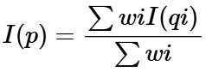

If no positive weights exist, use the median of known neighbors and mark pixels as known.

Add its inside neighbors to the band and push to the queue. This fills the image from the boundary inward.

6) Prepare for Perona–Malik Diffusion:

- Build a grayscale luminance of the filled image.
- This grayscale will control diffusion strength.

7) Apply Perona–Malik Anisotropic Diffusion

Equation used:
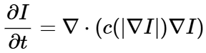
Conductance function

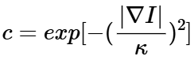

- Compute gradients and compute conductance c.
- For each pixel inside the mask, compute flux from 4 directions:

​

- Update only pixels inside mask and also update grayscale reference for next iteration.
- Repeats for a given number of iterations.

8) Final Output

Flow Chart
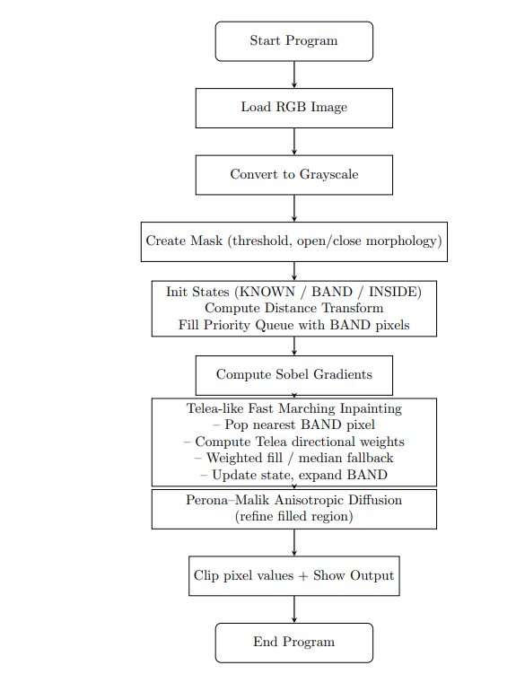

Modification Done:
- Complete rewrite from variational PDE → fast marching + anisotropic diffusion
- Introduced weighted isophote continuation
- Added distance transform + priority queue narrow band
- Replaced variational PDE with Perona–Malik (Anisotropic Diffusion)
- Removed notch filter and divergence-of-direction PDE

References:
https://www.sci.utah.edu/~gerig/CS7960-S2010/materials/Perona-Malik/PeronaMalik-PAMI-1990.pdf

