

ECE501- DIGITAL IMAGE PROCESSING

WEEKLY REPORT – Week 4: (1-11-2025)

Project No.: 6

Project Title: Image Inpainting for Object Removal
Group Name: 12
Group Details:
Sr No | Name | Enrollment No:
1 | Sakina Jambughodawala | AU2340114
2 | Prina Patel | AU2340040
3 | Aneri Maniar | AU2340080
4 | Nidhee Adesara | AU2340196

Problem Definition:
The goal of this project is to fill the missing regions using the information of surrounding texture and color so that the image looks natural.
Image inpainting is the process in which an image whose parts are lost are reconstructed based on information of remaining context
Objective of the Week:
- Implementing code further.

CODE:
https://colab.research.google.com/drive/1cUKX0nvCecygz_GQZ1YQ8j1VF2weWXdi?usp=sharing

import numpy as np
import cv2
import matplotlib.pyplot as plt
from scipy import ndimage

class TraditionalInpainting:
def __init__(self, max_iter=500, dt=0.1, alpha=1.0, tolerance=1e-4, mask_threshold=0.97):
self.max_iter = max_iter
self.dt = dt
self.alpha = alpha
self.tolerance = tolerance
self.mask_threshold = mask_threshold

def show_img(self, title, img, cmap=None):

plt.figure(figsize=(8, 6))
if len(img.shape) == 3:
plt.imshow(cv2.cvtColor(img, cv2.COLOR_BGR2RGB))
else:
plt.imshow(img, cmap=cmap if cmap else 'gray')
plt.title(title)
plt.axis('off')
plt.tight_layout()
plt.show()

def create_mask_auto(self, gray_img, threshold=0.97):

print(" Step 2: Mask creation (auto)...")

if gray_img.max() > 1:
gray_normalized = gray_img.astype(np.float32) / 255.0
else:
gray_normalized = gray_img.astype(np.float32)

mask_bin = (gray_normalized > threshold).astype(np.uint8)

kernel = np.ones((3, 3), np.uint8)
mask_bin = cv2.morphologyEx(mask_bin, cv2.MORPH_OPEN, kernel)
mask_bin = cv2.morphologyEx(mask_bin, cv2.MORPH_CLOSE, kernel)

self.show_img("Step 2 – Auto Mask", mask_bin * 255)

white_pct = 100.0 * mask_bin.mean()
print(f" Step 2 done. Mask white fraction = {white_pct:.3f}%")
print(f"Mask shape: {mask_bin.shape}, White pixels: {np.sum(mask_bin)}")

return mask_bin.astype(bool) # Convert to boolean for easier indexing

def compute_gradient(self, img):

img_float = img.astype(np.float64)
grad_x = cv2.Sobel(img_float, cv2.CV_64F, 1, 0, ksize=3)
grad_y = cv2.Sobel(img_float, cv2.CV_64F, 0, 1, ksize=3)
magnitude = np.sqrt(grad_x**2 + grad_y**2)
return grad_x, grad_y, magnitude

def compute_gradient_directions(self, grad_x, grad_y):

magnitude = np.sqrt(grad_x**2 + grad_y**2)
epsilon = 1e-8
theta_x = grad_x / (magnitude + epsilon)
theta_y = grad_y / (magnitude + epsilon)
return theta_x, theta_y

def compute_divergence(self, field_x, field_y):

grad_xx = cv2.Sobel(field_x, cv2.CV_64F, 1, 0, ksize=3)
grad_yy = cv2.Sobel(field_y, cv2.CV_64F, 0, 1, ksize=3)
return grad_xx + grad_yy

def laplacian(self, img):

return cv2.Laplacian(img.astype(np.float64), cv2.CV_64F)

def initialize_band(self, mask, width=5):

kernel = cv2.getStructuringElement(cv2.MORPH_ELLIPSE, (width*2+1, width*2+1))
dilated = cv2.dilate(mask.astype(np.uint8), kernel)
band = (dilated > 0) & (~mask)
return band

def visualize_band(self, img, mask, band):

visual = img.copy()
if len(visual.shape) == 2:
visual = cv2.cvtColor(visual, cv2.COLOR_GRAY2BGR)

visual[mask] = [0, 0, 255] # Red for hole
visual[band] = [0, 255, 0] # Green for band

self.show_img("Step 3 – Band (Green) and Hole (Red)", visual)

band_pct = 100.0 * np.mean(band)
print(f"Band covers {band_pct:.3f}% of image")
return visual

def inpaint_channel(self, channel, mask):

print(f" Inpainting channel (range: {channel.min():.1f}-{channel.max():.1f})...")

channel_float = channel.astype(np.float64)

band = self.initialize_band(mask)

band_values = channel_float[band]
if len(band_values) > 0:
initial_value = np.mean(band_values)
else:
initial_value = np.mean(channel_float)

result = channel_float.copy()
result[mask] = initial_value

grad_x, grad_y, _ = self.compute_gradient(result)
theta_x, theta_y = self.compute_gradient_directions(grad_x, grad_y)

print(" Iterating to minimize energy functional...")
progress_interval = max(1, self.max_iter // 10)

for iteration in range(self.max_iter):
old_result = result.copy()

laplacian_val = self.laplacian(result)
div_theta = self.compute_divergence(theta_x, theta_y)

update = laplacian_val - div_theta
result += self.dt * update

result[~mask] = channel_float[~mask]

grad_x, grad_y, magnitude = self.compute_gradient(result)
theta_x, theta_y = self.compute_gradient_directions(grad_x, grad_y)

result = np.clip(result, 0, 255)

change = np.mean(np.abs(result - old_result))
if iteration % progress_interval == 0:
print(f" Iteration {iteration:4d}, Change: {change:.6f}")

if change < self.tolerance and iteration > 10:
print(f" Converged after {iteration} iterations")
break

if iteration == self.max_iter - 1:
print(f" Reached maximum iterations ({self.max_iter})")

return result.astype(np.uint8)

def visualize_gradient_fields(self, gray_img):

print(" Visualizing gradient fields...")

grad_x, grad_y, grad_mag = self.compute_gradient(gray_img.astype(np.float64))

plt.figure(figsize=(15, 5))

plt.subplot(131)
plt.imshow(grad_x, cmap='coolwarm')
plt.title('Gradient X')
plt.colorbar()
plt.axis('off')

plt.subplot(132)
plt.imshow(grad_y, cmap='coolwarm')
plt.title('Gradient Y')
plt.colorbar()
plt.axis('off')

plt.subplot(133)
plt.imshow(grad_mag, cmap='hot')
plt.title('Gradient Magnitude')
plt.colorbar()
plt.axis('off')

plt.tight_layout()
plt.show()

return grad_x, grad_y, grad_mag

def process_image(self, image_path):

print("=" * 60)
print("TRADITIONAL VARIATIONAL IMAGE INPAINTING")
print("=" * 60)

print(" Step 1: Loading image...")
img = cv2.imread(image_path)
if img is None:
raise ValueError(f" Could not load image from {image_path}")

print(f" Image loaded: {img.shape}")
self.show_img("Step 1 – Original Image", img)

if len(img.shape) == 3:
img_gray = cv2.cvtColor(img, cv2.COLOR_BGR2GRAY)
else:
img_gray = img

mask = self.create_mask_auto(img_gray, self.mask_threshold)

img_with_hole = img.copy()
if len(img.shape) == 3:
for i in range(3):
img_with_hole[:,:,i][mask] = 0
else:
img_with_hole[mask] = 0

self.show_img("Step 2b – Image with Hole", img_with_hole)

print(" Step 3: Creating band region...")
band = self.initialize_band(mask)
self.visualize_band(img, mask, band)

self.visualize_gradient_fields(img_gray)

if len(img.shape) == 3:

print(" Step 4: Processing color channels...")
channels = []
for i, color in enumerate(['Blue', 'Green', 'Red']):
print(f" Processing {color} channel...")
channel_img = img[:,:,i].astype(np.float64)
channel_result = self.inpaint_channel(channel_img, mask)
channels.append(channel_result)

result = np.stack(channels, axis=2).astype(np.uint8)
else:
print(" Step 4: Processing grayscale image...")
result = self.inpaint_channel(img_gray.astype(np.float64), mask)

print(" Step 5: Displaying final results...")
plt.figure(figsize=(15, 5))

plt.subplot(131)
if len(img.shape) == 3:
plt.imshow(cv2.cvtColor(img, cv2.COLOR_BGR2RGB))
else:
plt.imshow(img, cmap='gray')
plt.title('Original Image')
plt.axis('off')

plt.subplot(132)
if len(img.shape) == 3:
plt.imshow(cv2.cvtColor(img_with_hole, cv2.COLOR_BGR2RGB))
else:
plt.imshow(img_with_hole, cmap='gray')
plt.title('Image with Hole')
plt.axis('off')

plt.subplot(133)
if len(result.shape) == 3:
plt.imshow(cv2.cvtColor(result, cv2.COLOR_BGR2RGB))
else:
plt.imshow(result, cmap='gray')
plt.title('Inpainted Result')
plt.axis('off')

plt.tight_layout()
plt.show()

print(f" Inpainting completed!")
print(f" Result shape: {result.shape}, dtype: {result.dtype}")

return result, mask

def simple_inpainting(image_path, threshold=0.97):

print("Loading image...")
img = cv2.imread(image_path)
if img is None:
raise ValueError(f"Cannot load image: {image_path}")

gray = cv2.cvtColor(img, cv2.COLOR_BGR2GRAY)

mask = (gray > (threshold * 255)).astype(np.uint8)

result = cv2.inpaint(img, mask, 3, cv2.INPAINT_TELEA)

plt.figure(figsize=(15, 5))
plt.subplot(131)
plt.imshow(cv2.cvtColor(img, cv2.COLOR_BGR2RGB))
plt.title('Original')
plt.axis('off')

plt.subplot(132)
plt.imshow(mask, cmap='gray')
plt.title('Mask')
plt.axis('off')

plt.subplot(133)
plt.imshow(cv2.cvtColor(result, cv2.COLOR_BGR2RGB))
plt.title('Inpainted')
plt.axis('off')

plt.tight_layout()
plt.show()

return result, mask

if __name__ == "__main__":

try:
inpainter = TraditionalInpainting(
max_iter=200, # Reduced for testing
dt=0.05, # Smaller time step for stability
alpha=1.0,
mask_threshold=0.95 # Slightly lower threshold
)

image_path = '/content/orig_bgr.png' # Change this to your image path
result, mask = inpainter.process_image(image_path)

cv2.imwrite('inpainted_result.jpg', result)
cv2.imwrite('mask.jpg', mask.astype(np.uint8) * 255)

print("Results saved as 'inpainted_result.jpg' and 'mask.jpg'")

except Exception as e:
print(f" Error in main method: {e}")
print("Trying simplified version...")

try:
image_path = 'try_girl.png'
result, mask = simple_inpainting(image_path)
cv2.imwrite('inpainted_simple.jpg', result)
cv2.imwrite('mask_simple.jpg', mask * 255)
print(" Simple inpainting completed!")
except Exception as e2:
print(f" Error in simple method: {e2}")

INPUT | OUTPUT
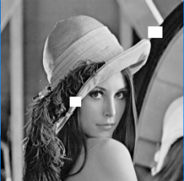 | 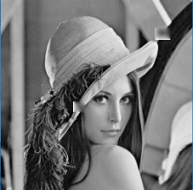

Mask generated
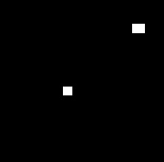

Gradient Field-

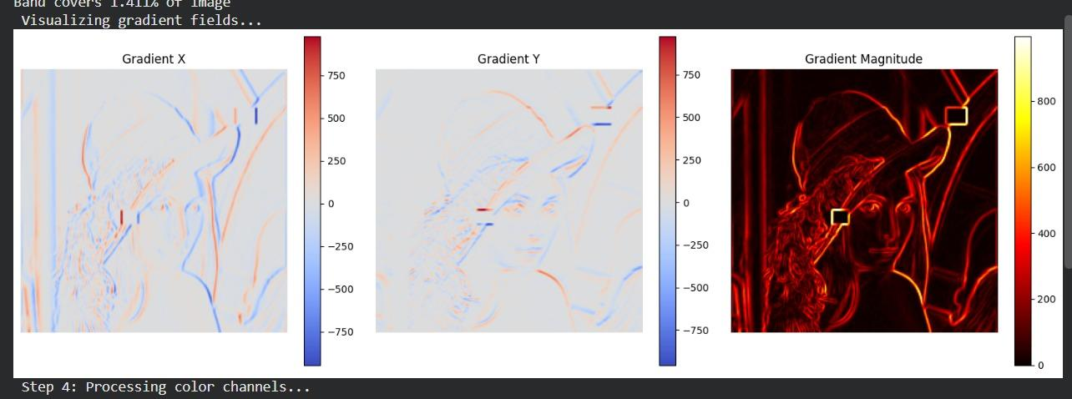

METHEDOLOGY:
1. Image Loading: Read the damaged image in RGB and grayscale format.
2. Mask Creation: Generate a binary mask that marks the damaged or missing regions to be inpainted.
3. Initialization: Initialize the inpainting process using the original image and mask.
4. Gradient Computation: Compute image gradients in x and y directions to find intensity changes.
5. Curvature Calculation: Calculate the curvature and divergence to guide smooth diffusion of pixels.
6. Diffusion Update: Iteratively update pixel values inside the masked area using PDE (Partial Differential Equation) diffusion.
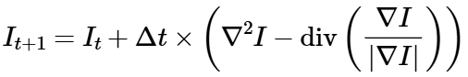
laplacian_val = self.laplacian(result)
div_theta = self.compute_divergence(theta_x, theta_y)

update = laplacian_val - div_theta
result += self.dt * update

7. Boundary Preservation: Ensure pixel values at the boundary of the mask remain stable to maintain edges.
8. Iteration Loop: Repeat diffusion updates until the image is visually restored or convergence is achieved.
9. Result Display: Display and compare the final inpainted image with the original input.

Major Improvement from last week:
- Added Variational PDE formulation for realistic inpainting.
- Introduced gradient, divergence, and Laplacian computations for spatial smoothness.
- Added band initialization to limit updates near hole boundaries.
- Improved mask creation using morphological refinements.

Plan for Next Week:

- We will work on our python code further and will do the further improvements needed.

