Solidity Vote program

Ethereum Blockchain

- (Parth Mehta)

**Please refer my github repository :**<https://github.com/Parthkm78/Ethereum_Solidity>

You will get below files from GitHub

**File - Voter.sol**

It include very basic voting fuctionality. One user can vote by id of candidate as much he/she want per address.

**File - One_vote_per_Address.sol**

One user can vote only one time by id of candidate per address.

**File - Vote_by_name_and_number_&_One_vote_per_Add.sol**

Use can vote by id as well name of candidate and user can vote single time per address. It handles below restriction

1. Single vote per user
2. if use try to vote second time then it throw error and show the error message
3. it checks all parameters send by users are correct then only proceed , if not correct or anything goes wrong then it automatically refund remainig gas to consumers.

**Download remix IDE or open online remix IDE :**[**https://remix.ethereum.org/**](https://remix.ethereum.org/)

Below instruction are for Vote_by_name_and_number_&_One_vote_per_Add.sol

* Create new file and paste code inside Vote_by_name_and_number_&_One_vote_per_Add.sol
  + 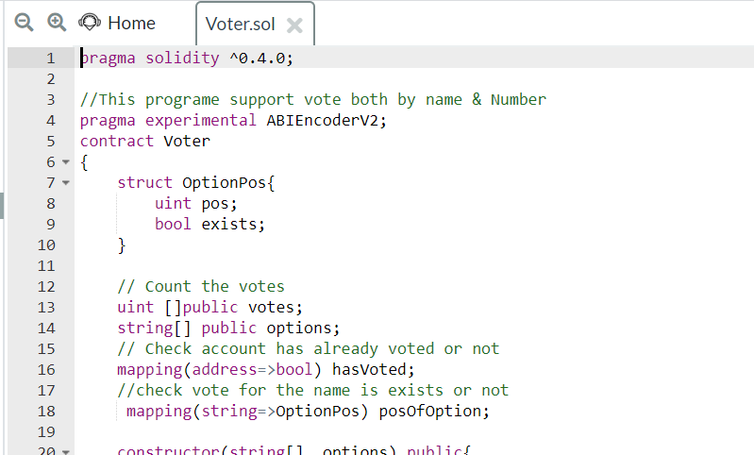
* Select complier option and compile smart contract
  + 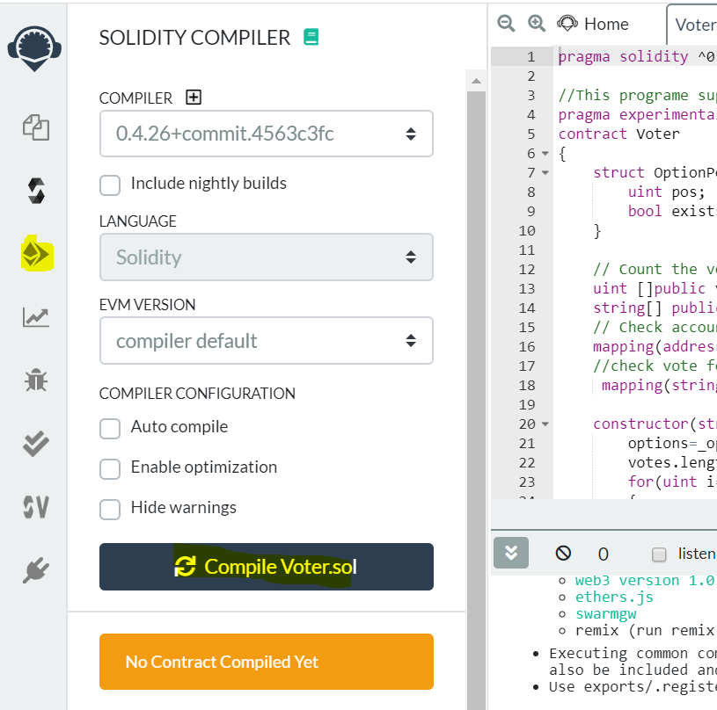
* Select Deploy & Run transection and choose Environment option mentioned in screen shot. Deploy contract by providing below arguments
  + 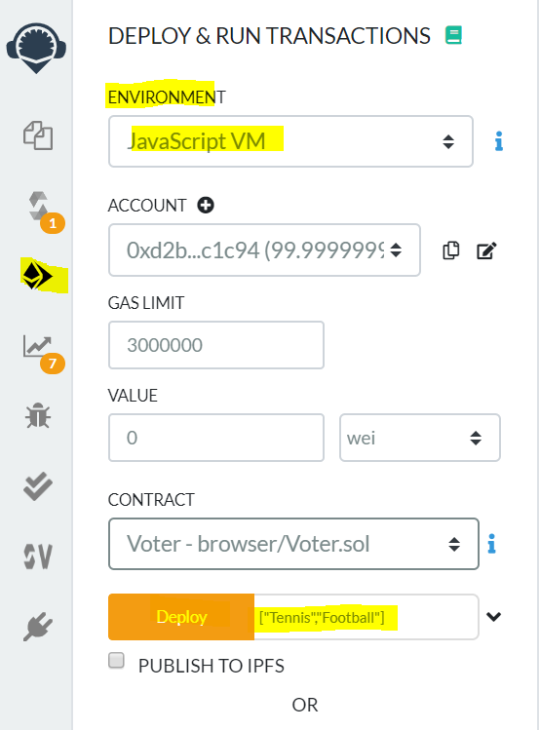
  + It well create voting between Tennis & Football
* You will se below deployed contract
  + 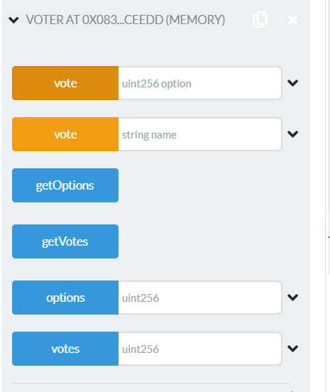
* If you select getOptions, you will get list of candidates
  + 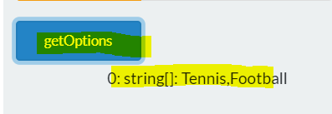
* There are the two way you can provide vote, by Id & Name
  + Tennis: 0, FootBall:1
* Lets Vote, I have provided vote to Tennis by name
  + 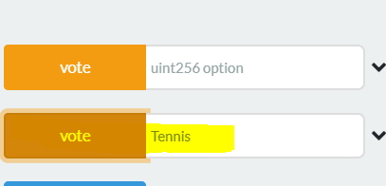
* Now lets check number of votes, click on GetVotes button
  + 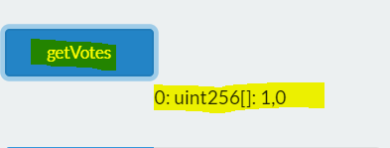
  + Tennis: 1 vote
* Lets vote by Id, I have voted as 1(Football), click on Vote button
  + I will get below error and custom message I have provided by that error because we have already voted by this Account(Address)
  + 
* Lets change address, by default remix will provide you few addresse
  + Change address from Account option
  + 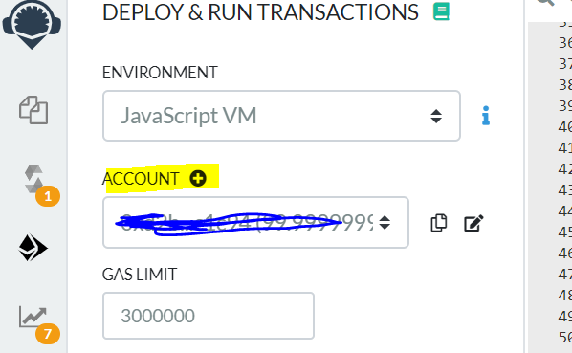
  + Vote to Football by Id
  + 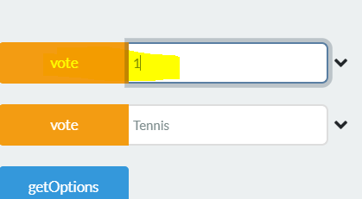
* Lets check total number of vote, now both have one- one votes
  + 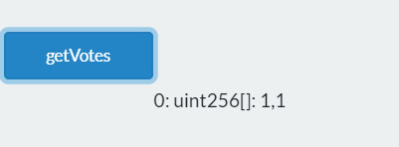
* Lets try with providing wrong input
  + 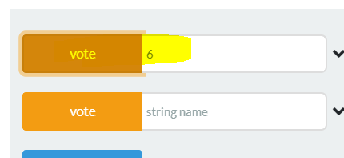
  + Throw below error with custom message
    - 

Thank you!!!!