Subject: Grocery List Calculation using Python

This tutorial will help you learn about writing a program called Grocery List Calculation which functions as a grocery calculator. This program will help them learn how to write a program, how to ask users for some text input, how to make a grocery list and calculate the cost. The program will help you understand the basic concept of python programming. The program will take approximately 10 to 15 minutes to complete. The only supply needed to write this program is the access to a computer running with a network connection and Python 3.7 installed.

**Step-1: Open Python**



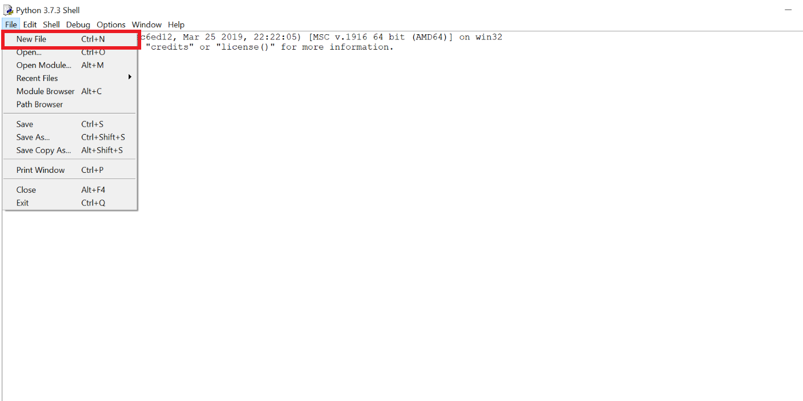

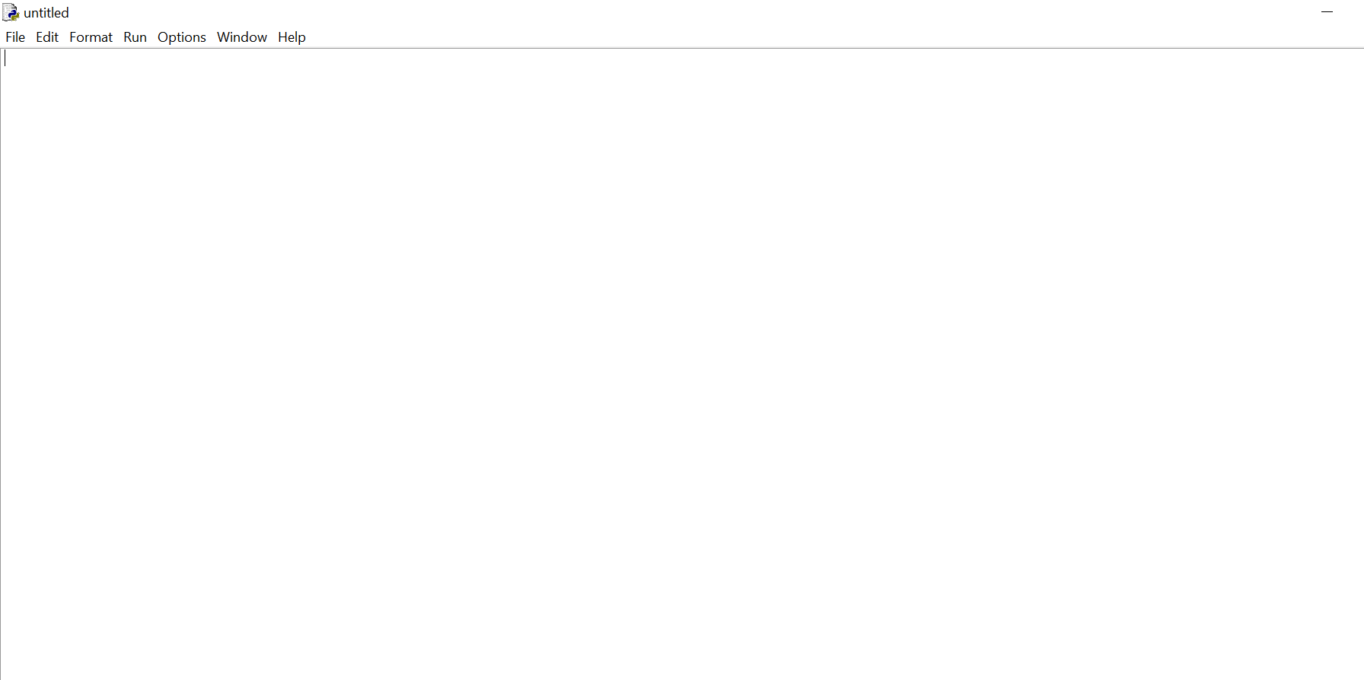

* In the search bar besides Windows icon, write IDLE and open Python 3.7. You will get a shell window from where you can start a new file as you can see in the image. Once you have a blank page, we’re ready to start writing the program.

**Step-2: Write a function named GroceryListCalculation()**

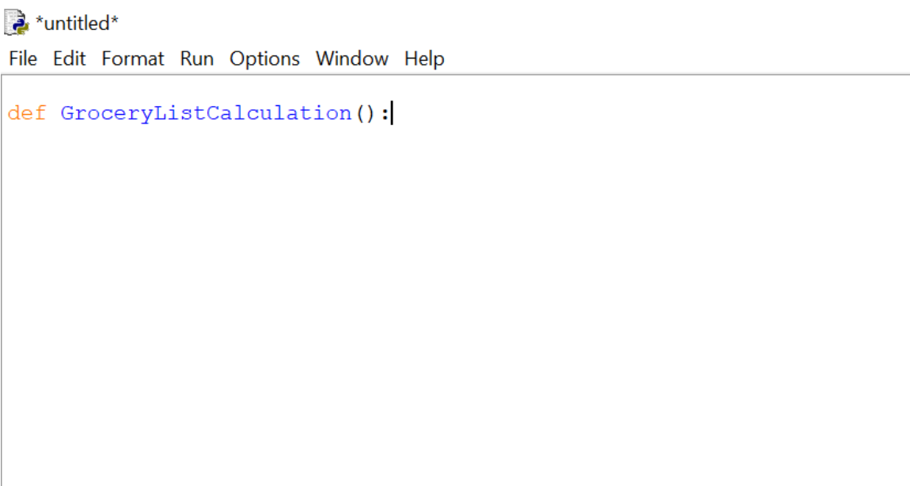

* A function in Python is defined as def statement. Write a function named GroceryListCalculation() in the blank page as shown in the image. We don’t need to write anything in the parenthesis because we are going to ask the user to input the product name, quantity of the product, and the cost of the product.

**Step-3: Construct (Create) an empty dictionary and list**

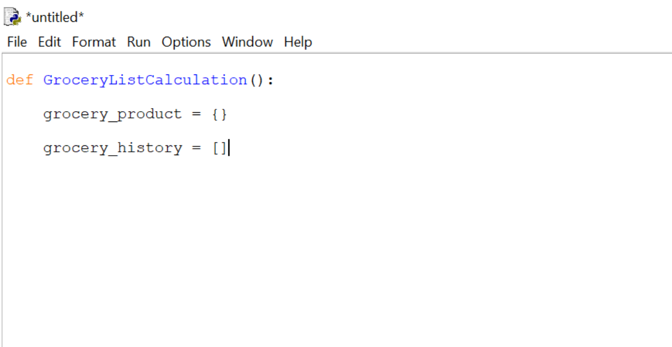

* Construct a dictionary named grocery_product to store product name, quantity, and cost. Dictionary separates key and value with colon (:) and separates each pair with commas (,). To store grocery_product for future use or to store all the items of the dictionary make a list name grocery_history. All the elements of the list is separated by commas (,).

**Step-4: Make while loop**

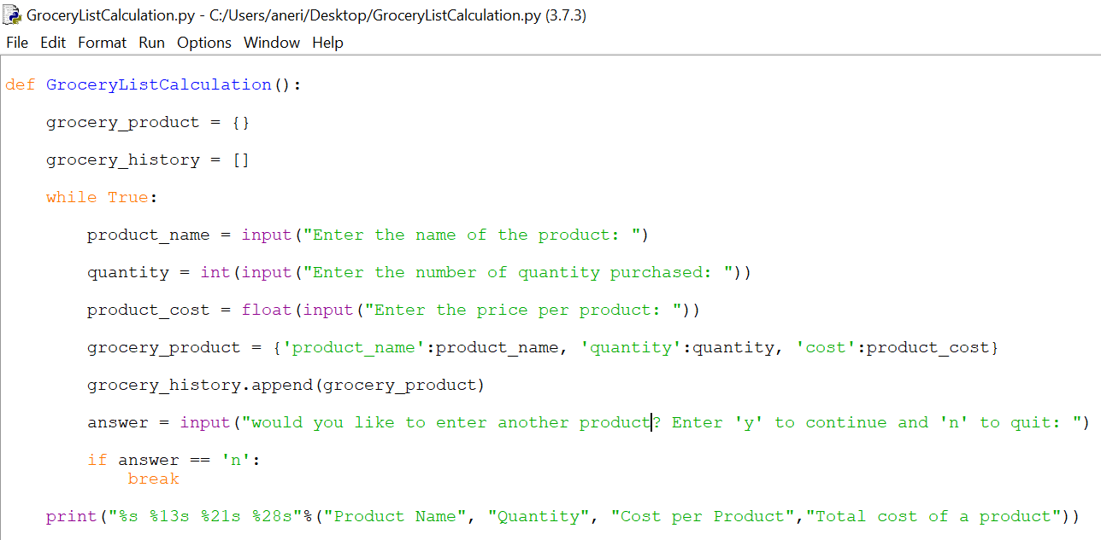

* While True (first line of while loop) means loop forever. The While statement takes an expression and executes the loop body while the expression evaluates to (Boolean) “true”. True always evaluates to Boolean “true” and thus executes the loop body indefinitely. Then, write three input functions which lets us ask a user for some text input and assign those three input functions to three different variables as shown in the image. Then in the grocery_product (dictionary) assign those three variable (values) to the keys grocery_name, quantity, and cost. Then use grocery_history (list) to append (add) grocery_product (dictionary) in the existing list. Then, write another input function and assign it to a variable answer to ask the user if he/she wants to add another product or not. If the answer is equal to ‘y’ then we will ask the user to enter product name, quantity, cost, and if the user wants to add another product or not. We will ask again and again until the user enters ‘n’. Then, use ‘if statement’, if the answer is equal to ‘n’ then that means the user doesn’t want to add any additional product. Break means exit from the loop. Then we will write the ‘for loop’ to calculate the grand total of a product and product total.

**Step-5: Make for loop**

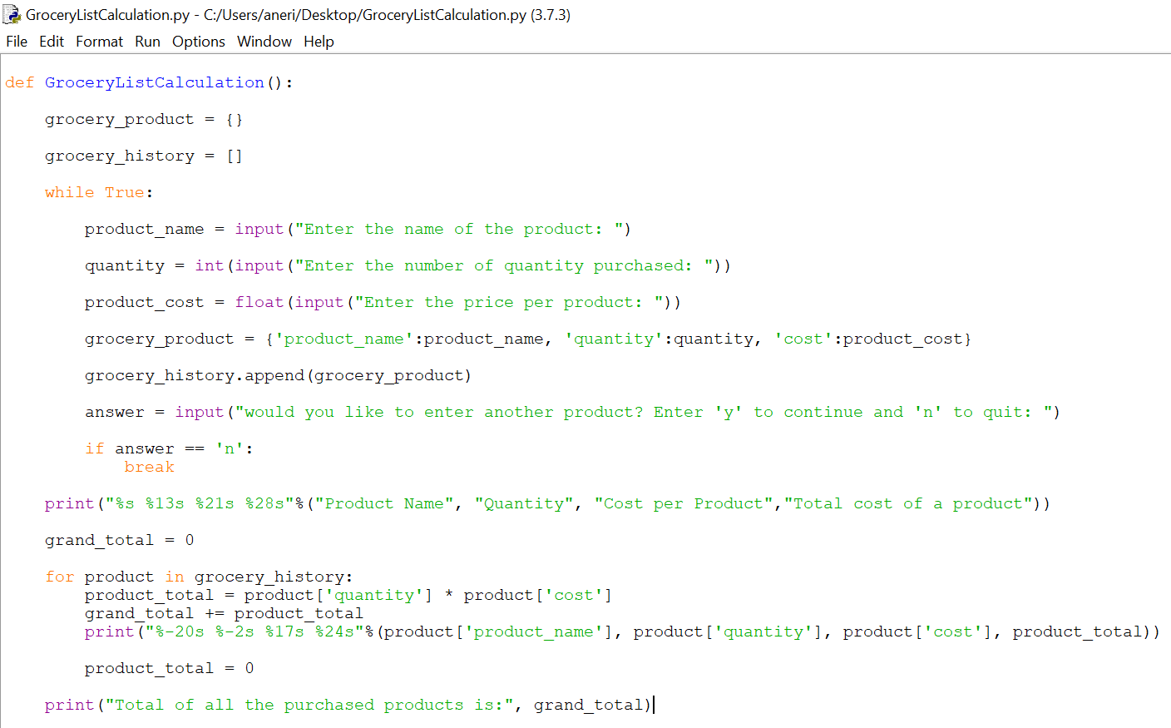

* Make a variable called grand_total and assign it to 0. grand_total is the total of all the product purchased. Write ‘for loop’ to calculate the grand_total and product_total. product_total counts the total of a product. Then add the product_total to grand_total. Then print product_name, quantity, cost, and product_total. Make product_total zero to calculate the total of other products, if there is any other product purchased. Then outside of the ‘for loop’, print the grand_total.

**Step-6: Running the program**

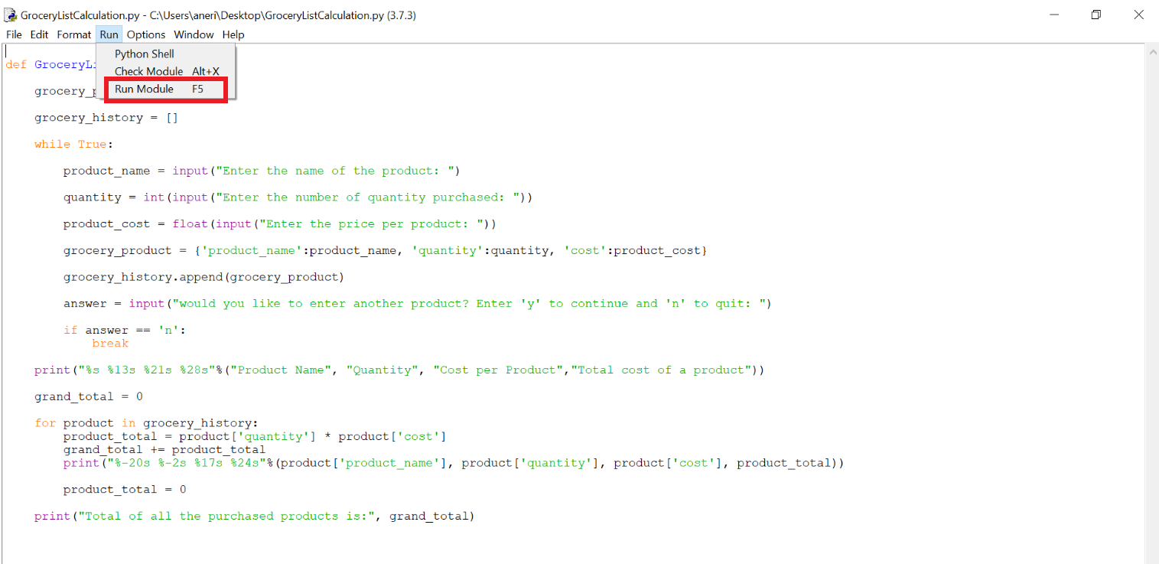

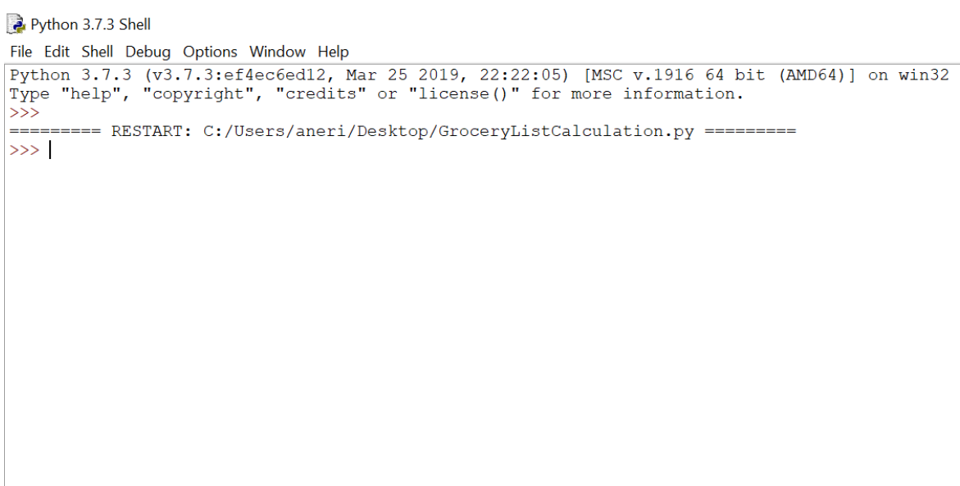

* Once the program is complete and ready, running the program is very simple. Under the run tab up top on IDLE, select “Run Module”. Clicking on “Run Module” will give you a new window where the program is running. Here you can write the name of the program to run it and test the program.

**Step-7: Run the program (part-1)**

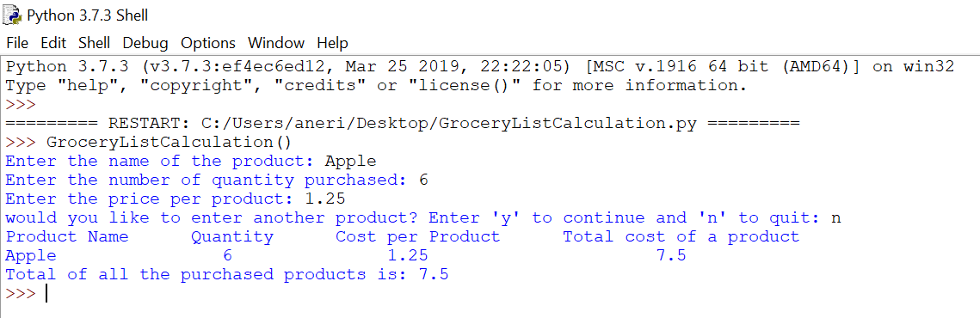

* Enter the name of the program (GroceryListCalculation()) and hit enter. When you hit enter, the question will appear and it will ask the user to enter the name of the product the user had purchased. After entering the name of the product, hit enter. Then, the next question will appear and it will ask the user to enter the quantity of the product. After entering the quantity to purchase, hit enter. After hitting enter the next question will appear and it will ask the user to enter the price of a product. After entering the price for product hit enter. Then, the last question will appear and it will ask the user the question if the user wants to add another product or not. If the user enters ‘n’ and hits enter, no more questions will appear. The user will get the output. In the output, the user will get the cost of the product and the grand total.

**Step-8: Run the program (part-2)**

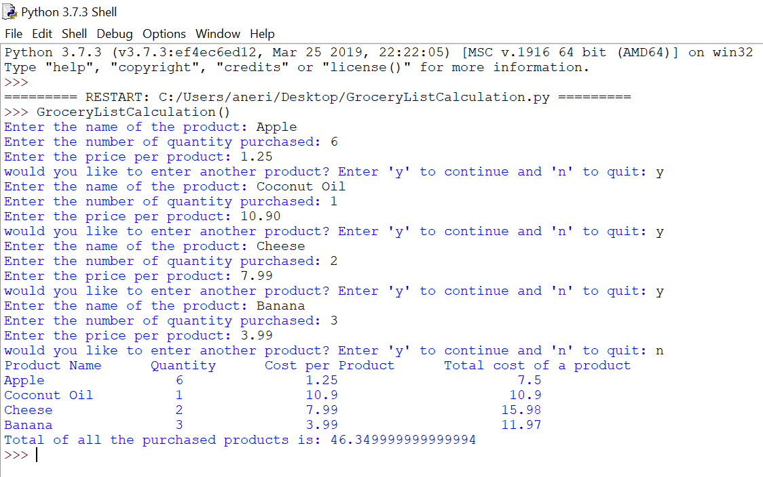

* Enter the name of the program (GroceryListCalculation()) and hit enter. When the user hits enter, three lines will appear one by one and it will ask the user to enter the name of the product, quantity, and the cost of the product. And then, one question will appear and it will ask the user the question, if the user wants to add another product or not. If the user enters ‘y’ then all three lines will appear again and it will again ask the user to enter the name of the product, quantity, and the cost of the product. All these three input lines will appear again and again until the user doesn’t want to add any more products. And then the user will get the cost of the product and the grand total as an output.

In short, this program takes product name, quantity, and cost of the product and will return the product total and grand total. This program is very useful to make a grocery list and to calculate grocery. From here, you will have a better understanding of how to write a program and how to use the input function in the program. Congratulations on learning to solve the program.