WEB CRAWLER

Project Overview

This website focuses on displaying the scraped data from various e-commerce websites. Along with displaying the crawled data it also has the functionality of searching for a particular data item and comparing that item with all the deals available for the same product on different e-commerce websites.

.

Problem and Solution Statement

As there are a lot of e-commerce websites available today,a user needs to scroll through various e-commerce websites in order to find a perfect deal for themselves. Our website focuses on solving this problem by scraping different products from various e-commerce websites and showcase them on a single platform.

Benchmark (How this solution is better?)

This website focuses on displaying the scraped data from various e-commerce websites. Along with displaying the crawled data it also has the functionality of searching for a particular data item and comparing that item with all the deals available for the same product on different e-commerce websites.

Implementation strategy

Project Flow:

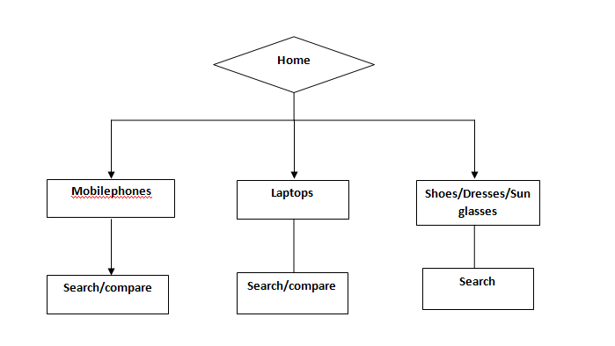

Implementation environment:

It is an HTML, PHP, CSS based website can run in device with internet excess.

We have used python package known as beautiful soup 4 in order to scrape and crawl the data.

It is easy to use and can give information with no internet requirement.

Contributors

|  |  |  |  |
| --- | --- | --- | --- |
| Name | Roll no | Contact No | Email |
| Devanshi Patel | 16it068 | 7043031700 | 16it068@charusat.edu.in |
| Aneri Mehta | 16it053 | 7016512386 | 16it053@charusat.edu.in |

GITHUB LINK of PROJECT:

https://github.com/AneriMehat/WebCrawler1