A

PROJECT REPORT ON

**Online Blog System**

**By**

**DHRUVI SHERATHIYA (CE - 126) (20CEUOS006)**

**B. Tech CE Semester VI Subject: Advance Technology**

**Subject Code: CS515**

**Guided by:**

Prof. Ankit P. Vaishnav



**Faculty of Technology Department of Computer Engineering**

**Dharmsinh Desai University**



**Faculty of Technology Department of Computer Engineering**

**Dharmsinh Desai University**

**CERTIFICATE**

This is to certify that the practical / **term work** carried out in the subject of

**Web Service Development** and recorded in this journal is the bonafide work of

**DHRUVI SHERATHIYA (CE - 126) (20CEUOS006)**

of B. Tech semester **VI** in the branch of **Computer Engineering**

during the academic year **2022-2023**.

Prof. Siddharth P. Shah Dr. C. K. Bhensdadia,

Assistant Professor, Head,

Dept. of Computer Engg., Dept. of Computer Engg.,

Faculty of Technology Faculty of Technology

Dharmsinh Desai University, Dharmsinh Desai University,

Nadiad Nadiad

Contents

ABSTRACT 4

INTRODUCTION 5

SOFTWARE REQUIREMENTS SPECIFICATIONS (SRS) 6

DESIGN

ER DIAGRAM …8

USE CASE DIAGRAM 8

DATA DICTIONARY 9

IMPLEMENTATION DETAILS 11

TESTING 15

SCREENSHOTS 21

CONCLUSION 26

LIMITATIONS AND FUTURE ENHANCEMENT 26

REFERENCES 26

## Abstract

The Blogque project is designed to provide a platform for users to create, share, and read blog articles. The site includes a user registration and login system to ensure security and privacy of user data. Users can view blog articles posted by other users and can also create, edit, and delete their own blog articles. The site is built with a user-friendly interface, allowing users to easily navigate and search for content. The project is ideal for bloggers who want to showcase their writing skills and connect with like-minded individuals in an online community.

## Introduction

Blogque is built using ASP .NET Web API and React, and provides a platform for users to engage with various topics and interact with like- minded individuals through blogging. Users can easily register, login, and browse through a wide range of blog posts covering diverse topics, including technology, business, travel, lifestyle, and more. The site also enables users to create, edit, and publish their own blog posts, complete with multimedia content and commenting features. User security and privacy are prioritized through robust authentication mechanisms. Overall, the platform offers a seamless and user-friendly experience for individuals seeking to express themselves through writing and connect with a community of like-minded individuals.

### Technology

Backend

* ASP .NET Core WEB API(C#)

### Frontend

* React.js
* Bootstrap
* CSS

### Database

* MS SQL Server

### Tools

* Visual Studio Code
* Visual Studio
* GitHub
* Any Browse

## Software Requirement Specification (SRS)

### Functional Requirements

#### Authentication

* 1. **Create Account**

Description: Only those who already have accounts on our site are eligible to create new blogs. Yet, anyone may read blogs without logging in. To sign up as a new user, the user must enter their username and password. A unique id would be generated and these details would be kept in a database. Input: Username, Password

Output: Unique user id

#### Login into System

Description: Registered user can login into the site by entering their email address and password. After successful login users would be redirected to the homepage of the site. Input: Username, password

Output: Home Screen

#### Logout

Description: For security reasons, users can log out of their sessions after browsing a website.

Output: Logout successful message.

#### Manage Blog

* 1. **View Blog**

Description: Any user can read the available blogs on this site. There is no need to login for view blogs.

Output: Blogs List

#### Create a blog

Description: With this website, users may easily establish new blogs by entering the blog's title, category, banner url, and content.

Input: Blog details

Output: Success message

#### Edit blog

Description: Author of the blog can edit blog in future if he/she things that there was a mistake in it.

Input: Details to be update Output: Blog List

#### Delete a blog

Description: On this website, users can delete the blog which was previously created by him/her.

Input: Delete confirmation

### Non-functional Requirements

**N.1: Database:** A data base management system that is available free of cost in the public domain should be used.

**N.2: Data integrity**: Data integrity refers to maintaining and assuring data accuracy and consistency over its entire lifecycle. If this factor is corrupted, data is lost due to a database error.

**N.3: Platform:** Windows, Unix and Mac versions of software need to be developed.

**N.4: Web-support:** It should be possible to invoke the query book functionality from any place by using web browser.

**N.5: Performance:** System performance defines how fast a system can respond to a particular user’s action under a certain workload.

## Design

# ER DIAGRAM

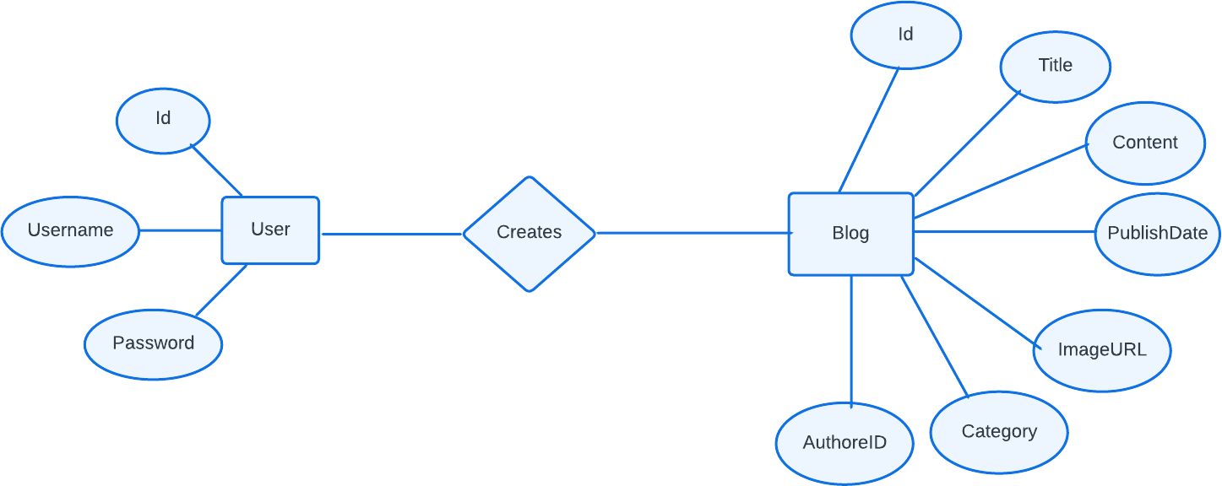

# USE CASE DIAGRAM

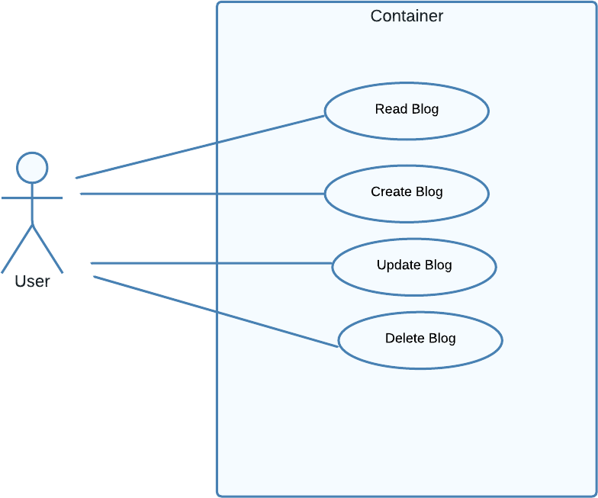

## Data Dictionary

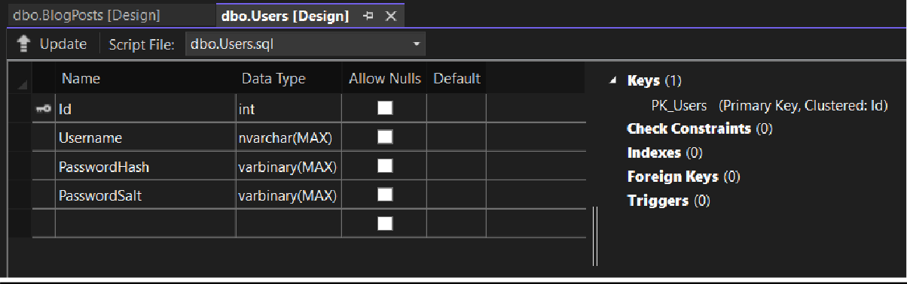

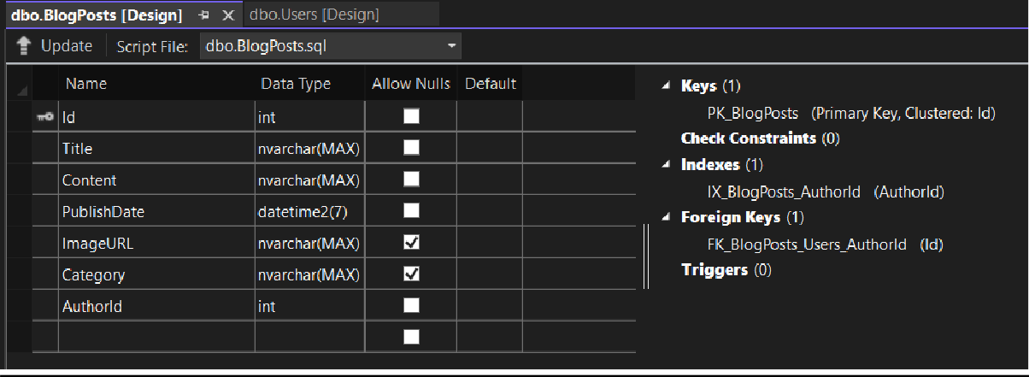

User Model

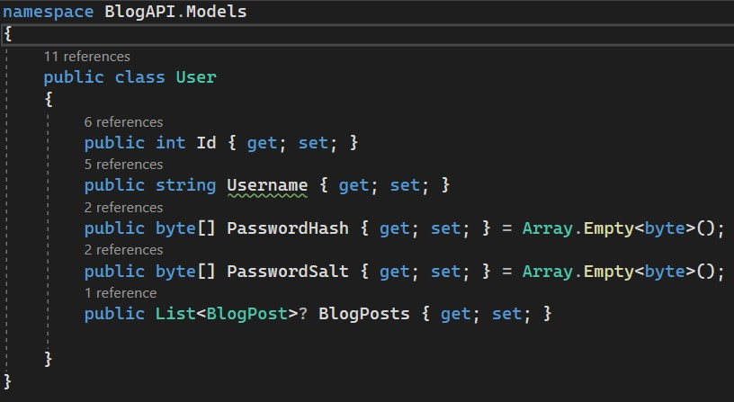

BlogPost Model

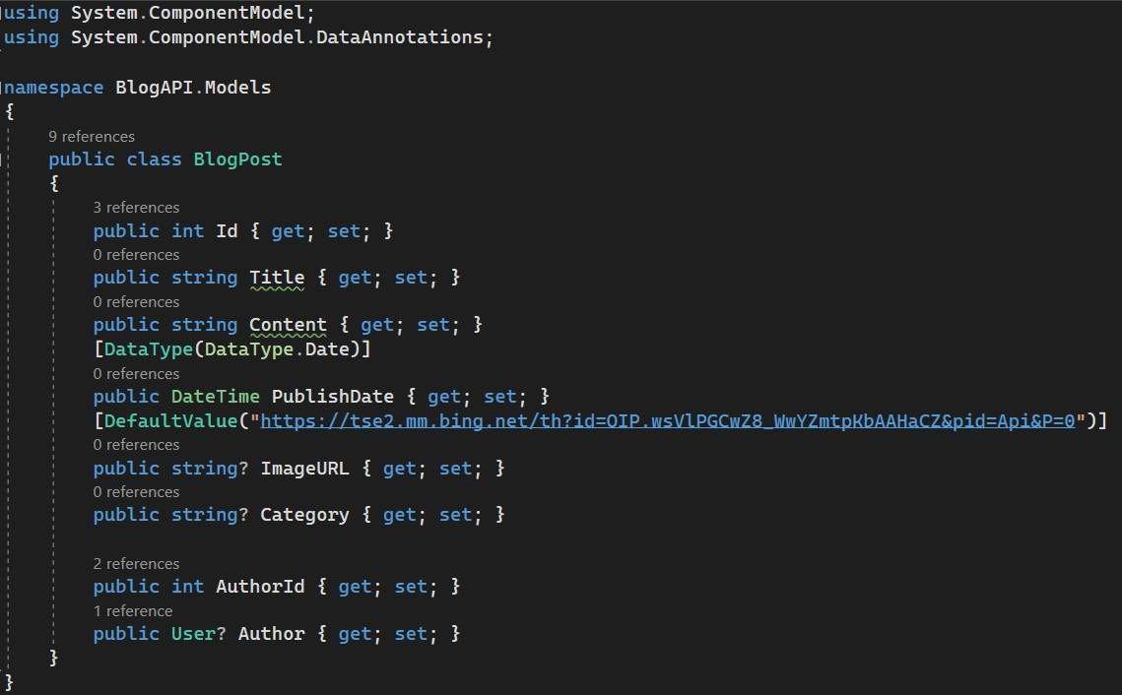

BlogDbContext

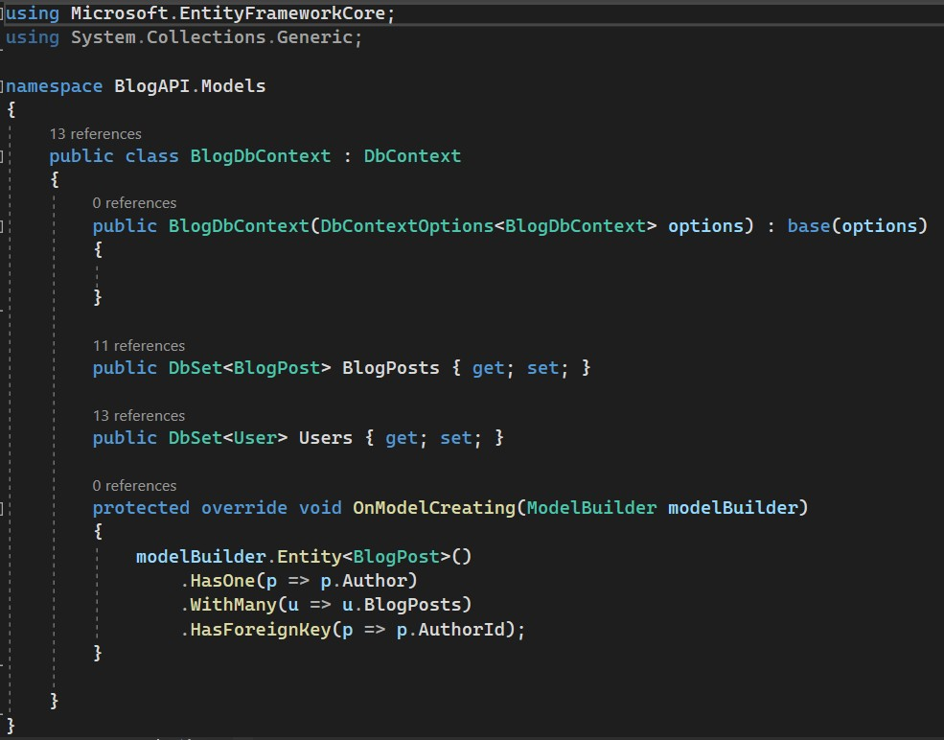

## Implementation Details

This project consists of 2 major modules.

* User Module
* Blog Module

Each module consists of several methods to implement the required functionality.

### User Module

There are basically two functionalities in this module. Create a new user and login to existing user. This module is the base for authentication and authorization. Here we have used JWT token for the authentication.

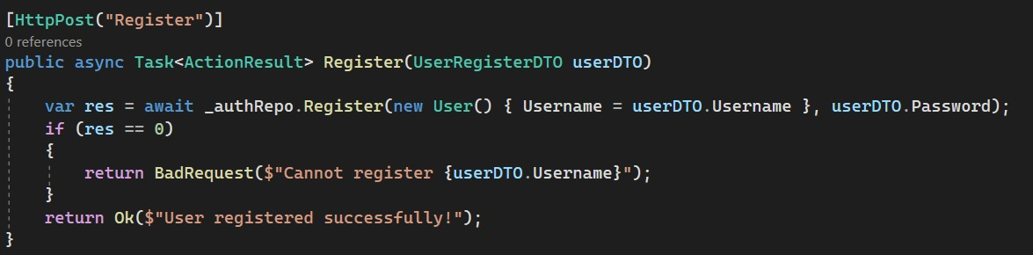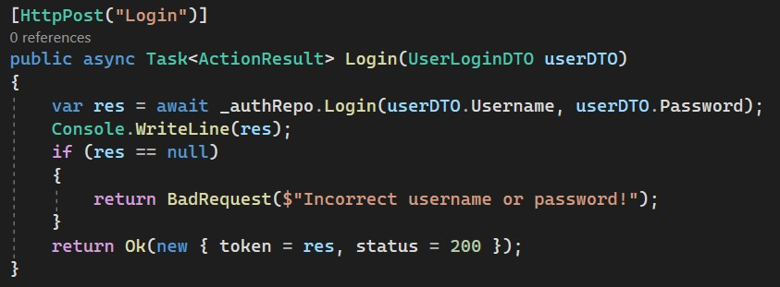

### Blog Module

There are mainly four things can be done with blogs. First, we can fetch all the blogs, create a new blog, edit existing blog and delete blog.

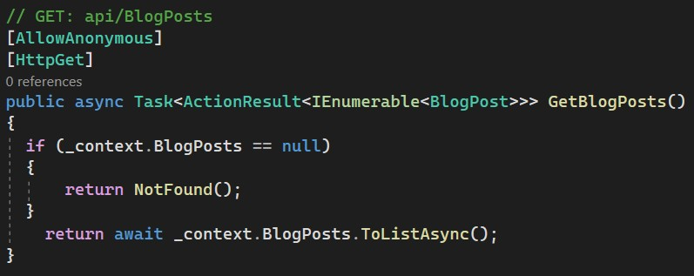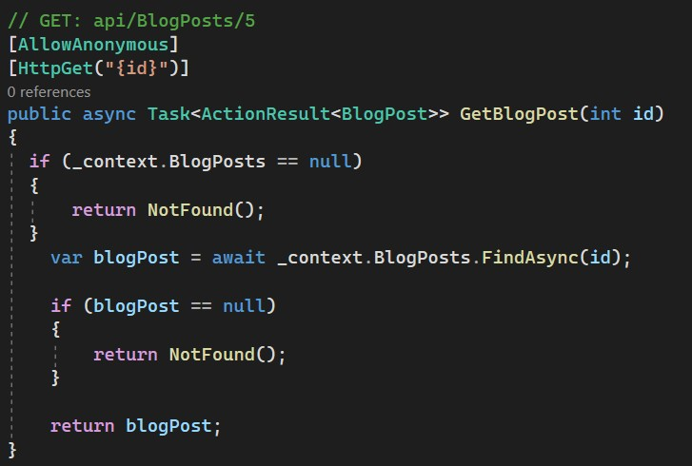

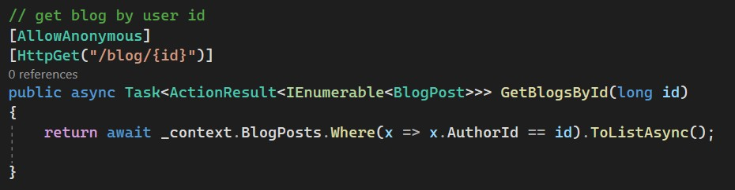

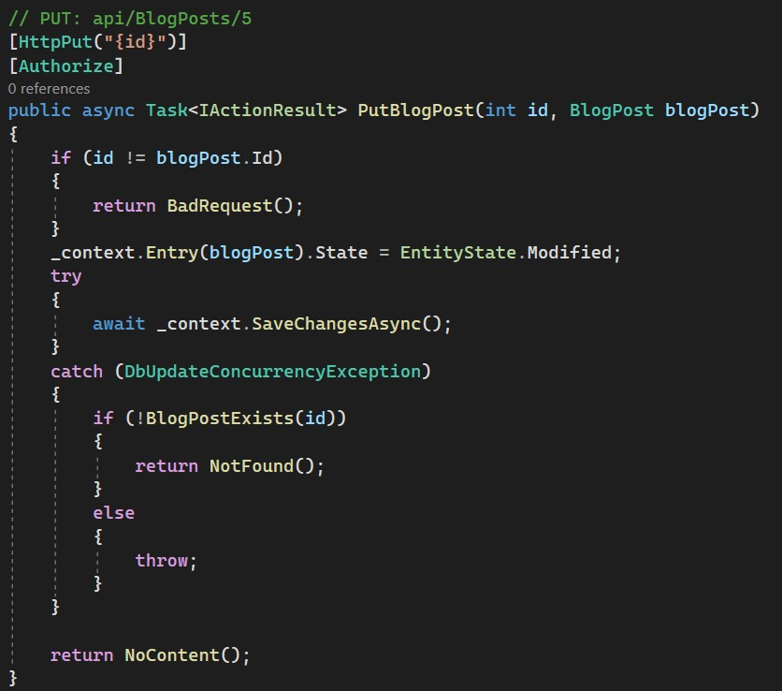

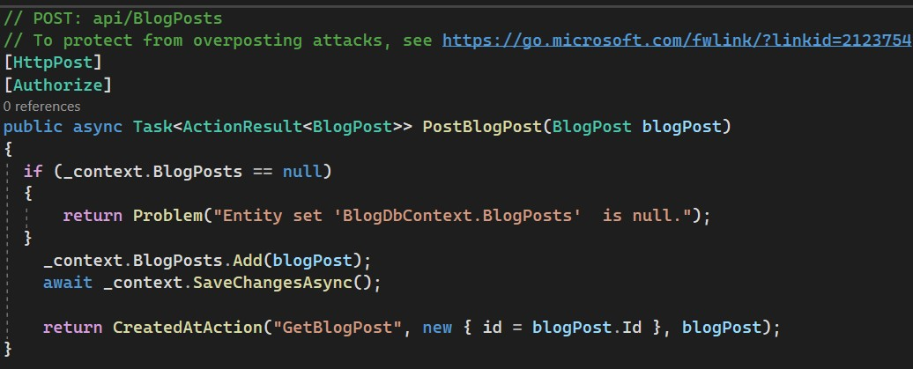

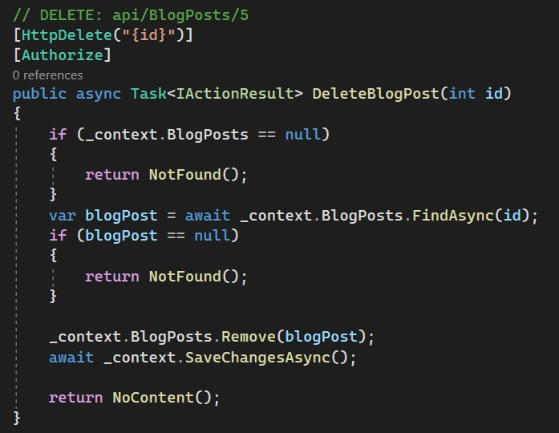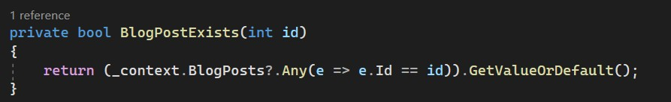

## Testing

|  |  |  |  |  |  |
| --- | --- | --- | --- | --- | --- |
| **Test**  **Case Id** | **Test Case Objective** | **Input Data** | **Expected Output** | **Actual Output** | **Status** |
| **TC-01** | Add new  User into system | Credential | User Added | User Added | Pass |
| **TC-02** | Add user with already exists  username | Credential | User already exists | User already exists | Pass |
| **TC-03** | Login into System | Credential | Token | Token | Pass |
| **TC-04** | Login into System with  wrong credential | Wrong Credential |  |  | Pass |
| **TC-05** | Logout  from system | Logout Button | Home Screen | Home Screen | Pass |
| **TC-06** | Blog List | - | Blogs | Blogs | Pass |
| **TC-07** | Blog Detail | Select Blog | Blog Content | Blog Content | Pass |
| **TC-08** | Create Blog | Blog Details | Blog added on home screen | Blog added on home screen | Pass |
| **TC-09** | Update Blog | Blog ID  along with new data | Updated Blog | Updated Blog | Pass |
| **TC-10** | Delete Blog | Blog ID | Blog removed from site | Blog removed from site | Pass |

Testing our backend with Swagger

TC-01: Add new user into system

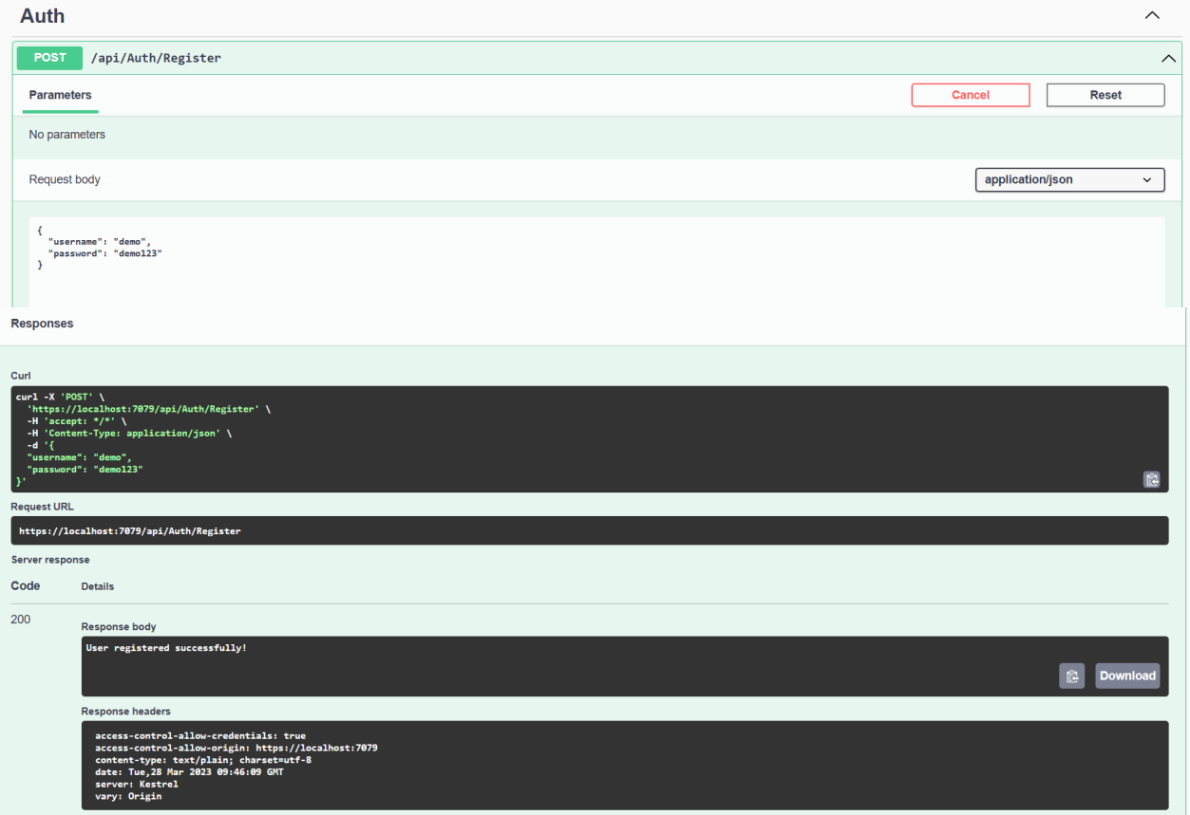

TC-02: Trying to register with already exists username

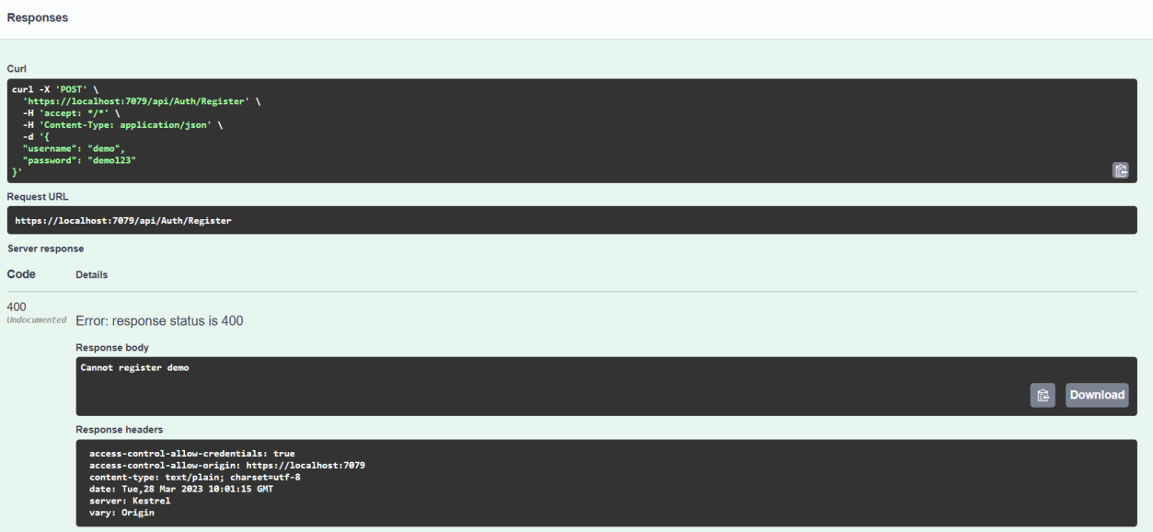

TC-03: Login into system

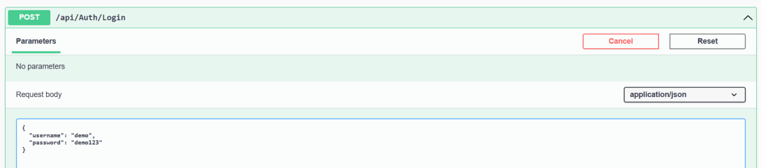

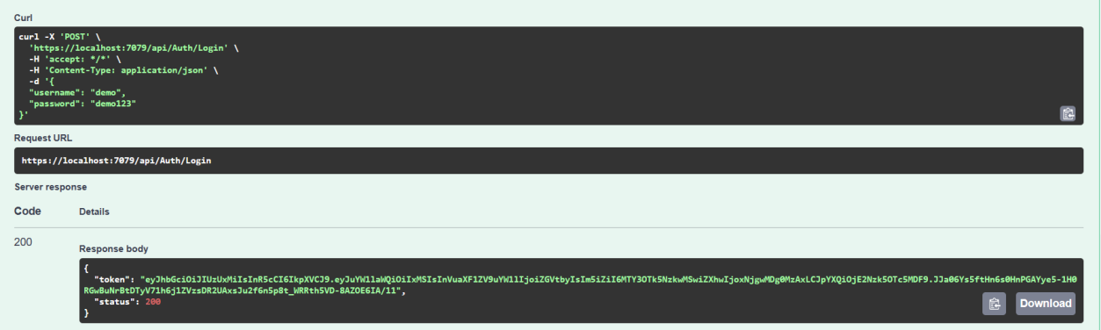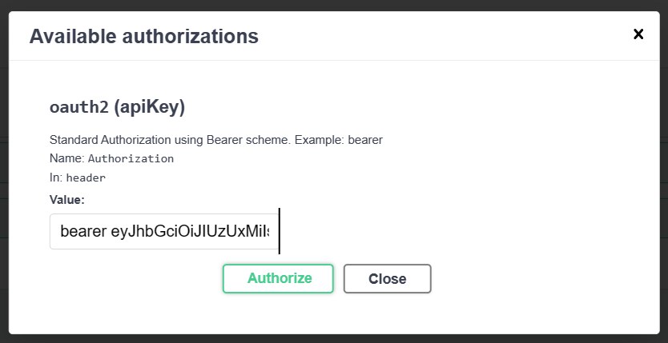

TC-04: Trying to login with wrong credentials

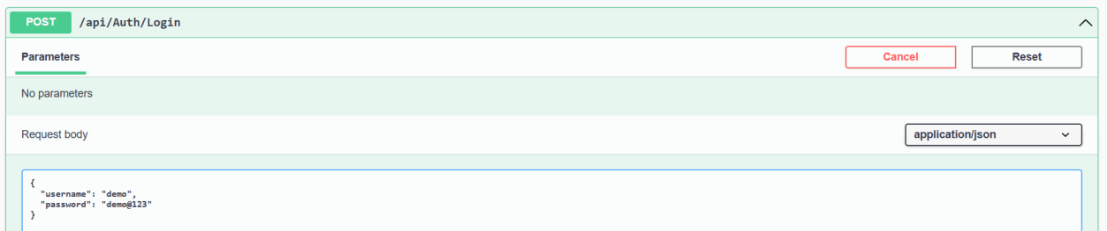

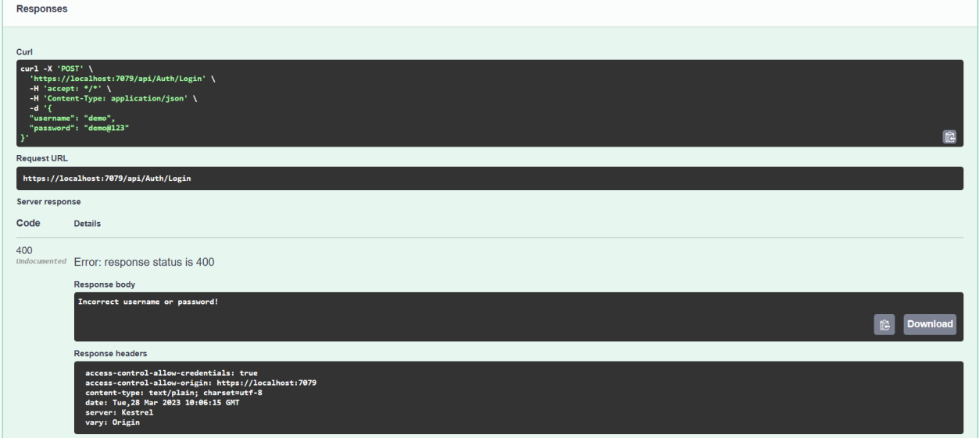

TC-05: Logout from system

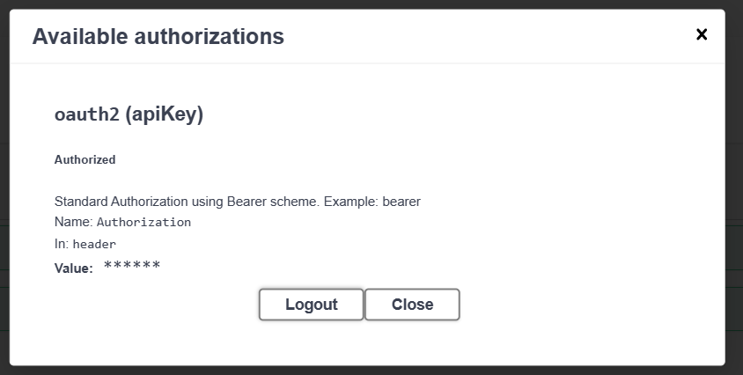

TC-06: Get all Blogs

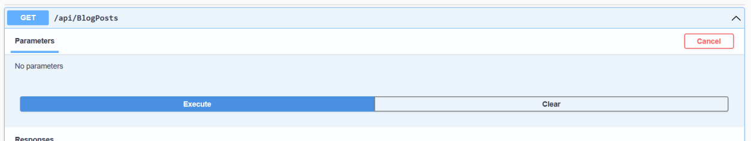

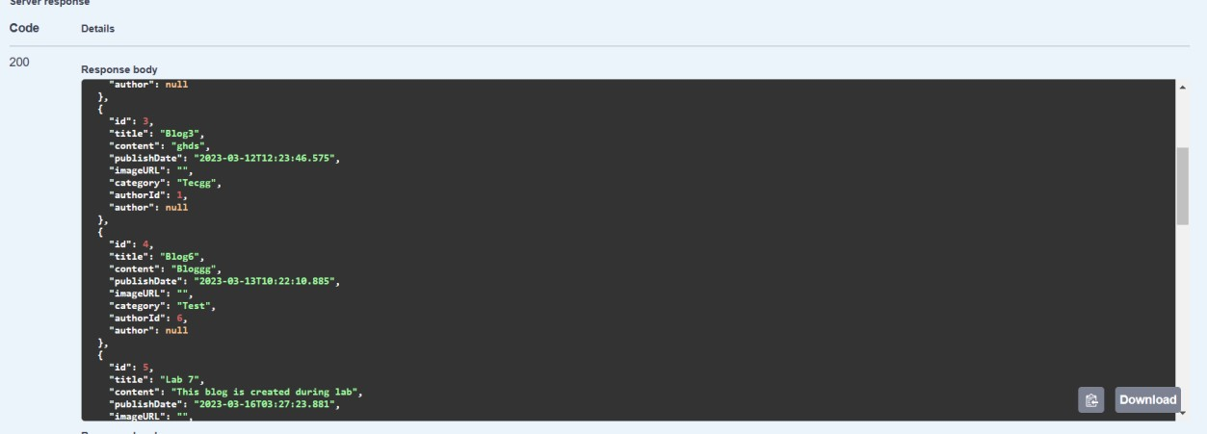

TC-07: Add new user into system

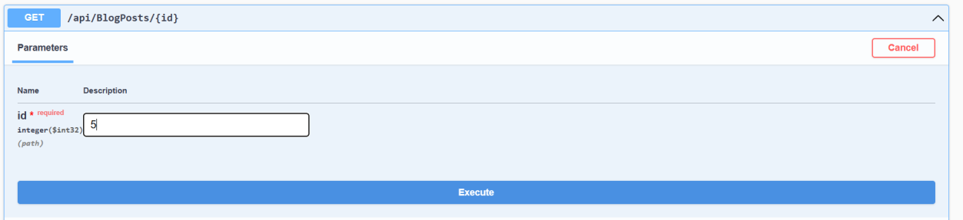

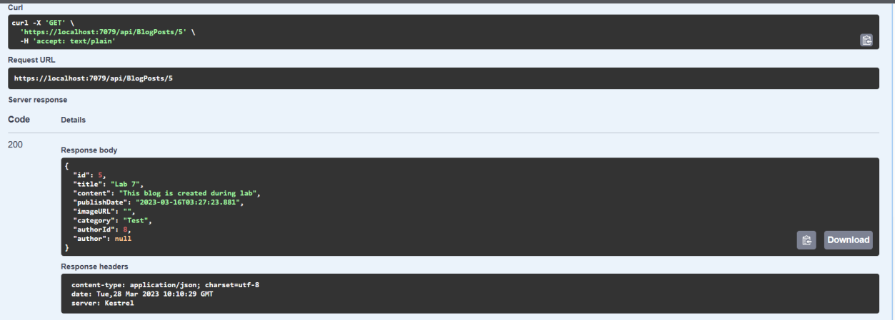

TC-08: Create new blog

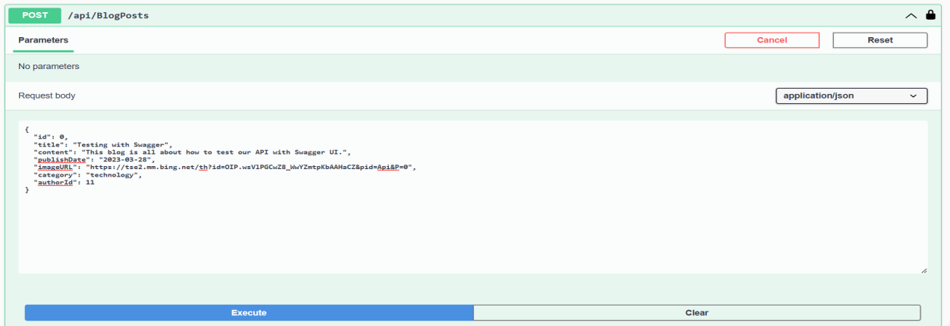

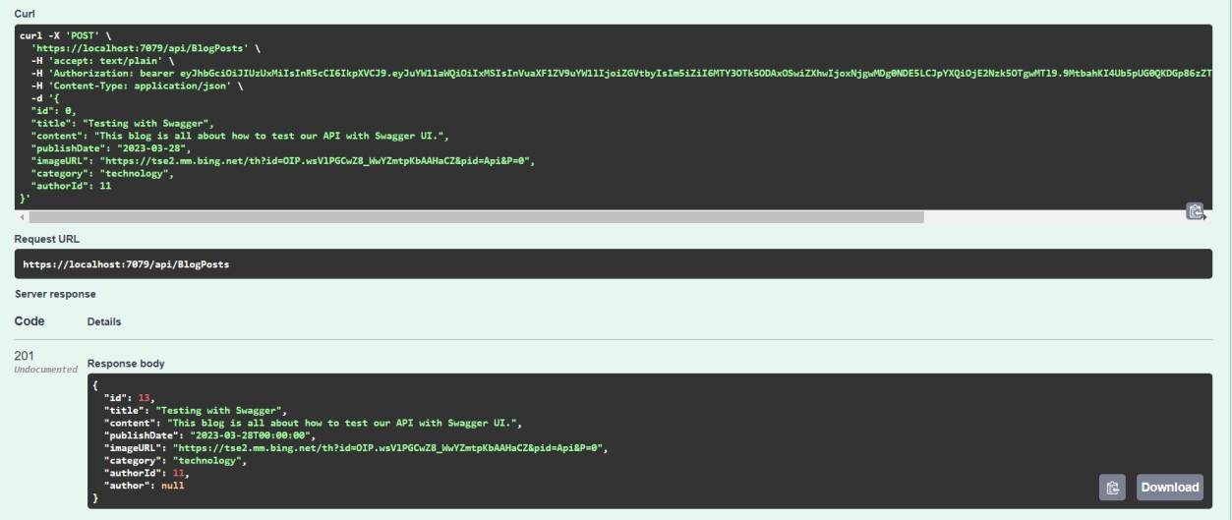

TC-09: Update existing blog

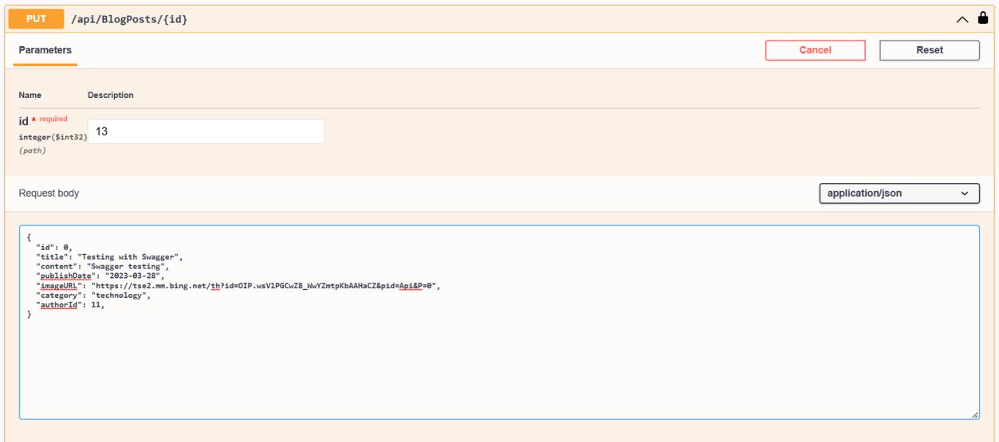

TC-10: Delete a blog

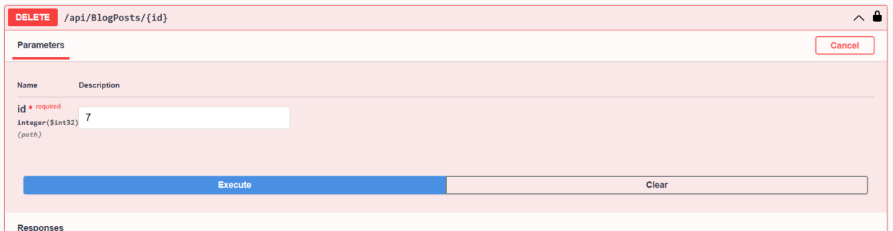

## Screenshots

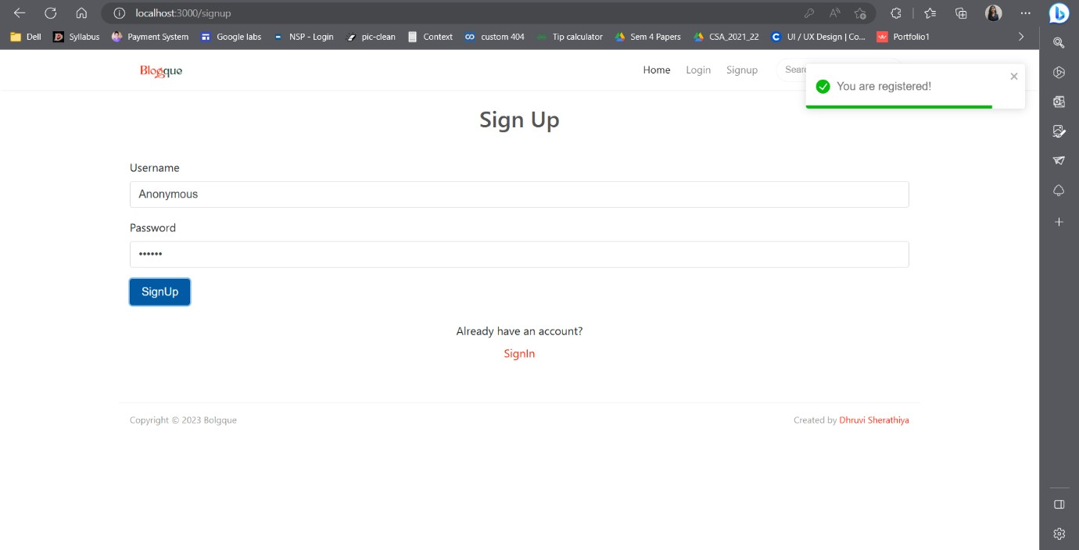TC-01: Register new user into site

TC-04: Trying to login into system with wrong credentials

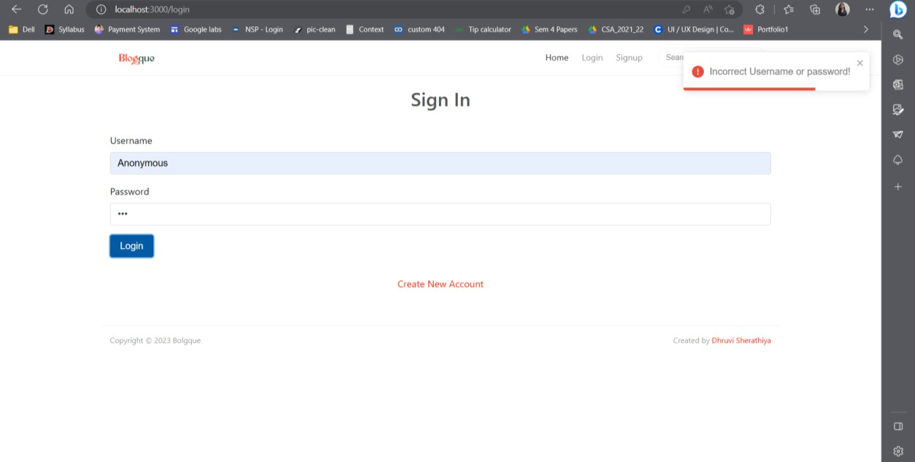

TC-06: Read all blogs without logged-in into system.

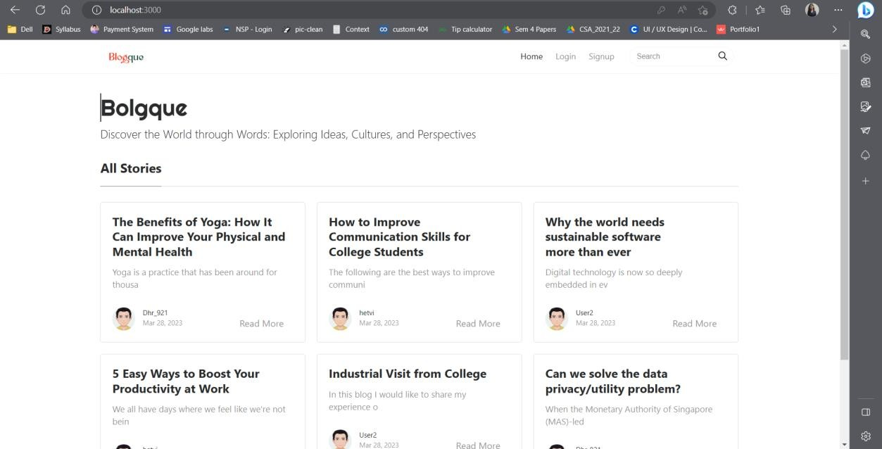

Home Screen after login,

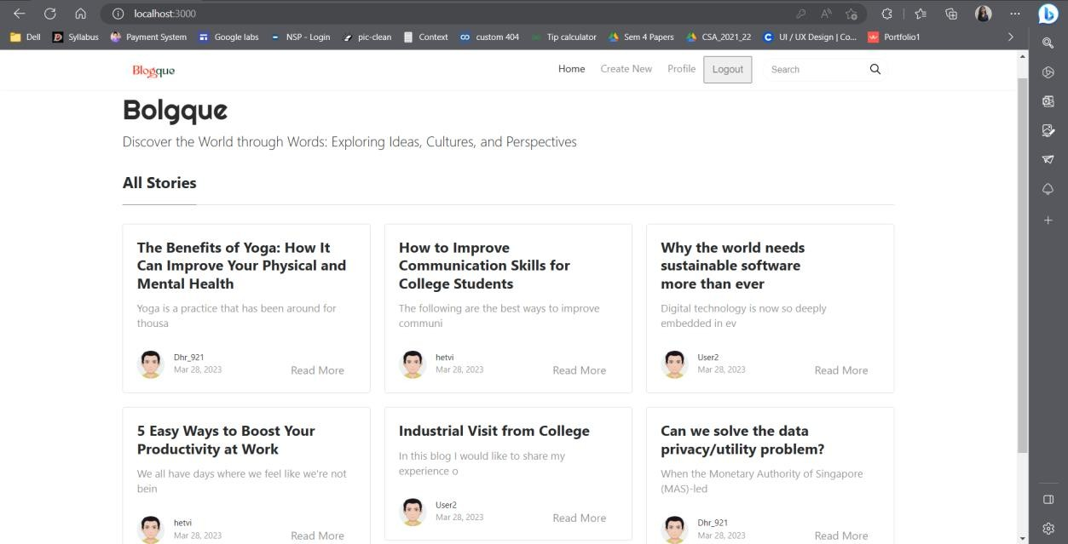

In profile section, user can see all blogs created by him/her.

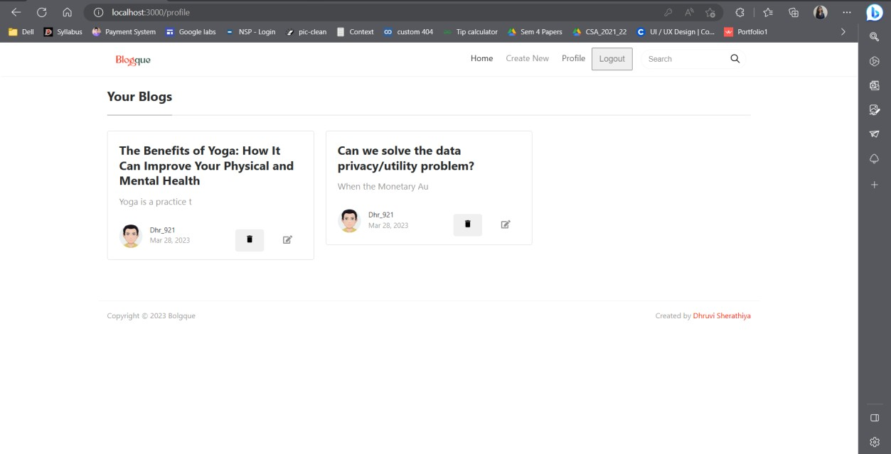

TC-07: Blog details

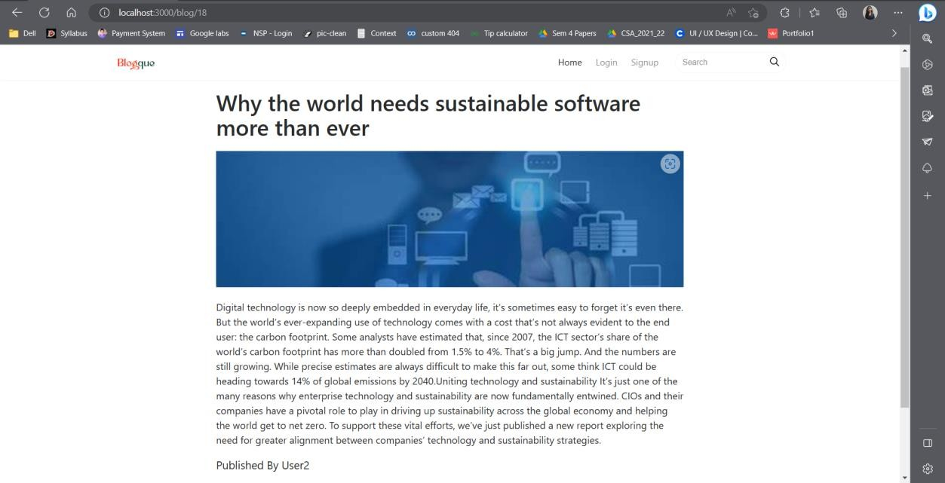

TC-08: Create a Blog

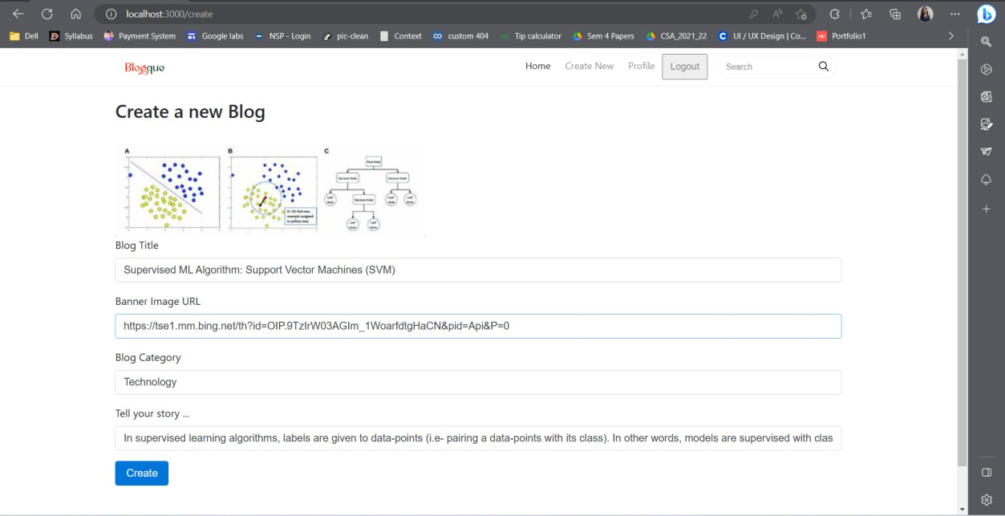

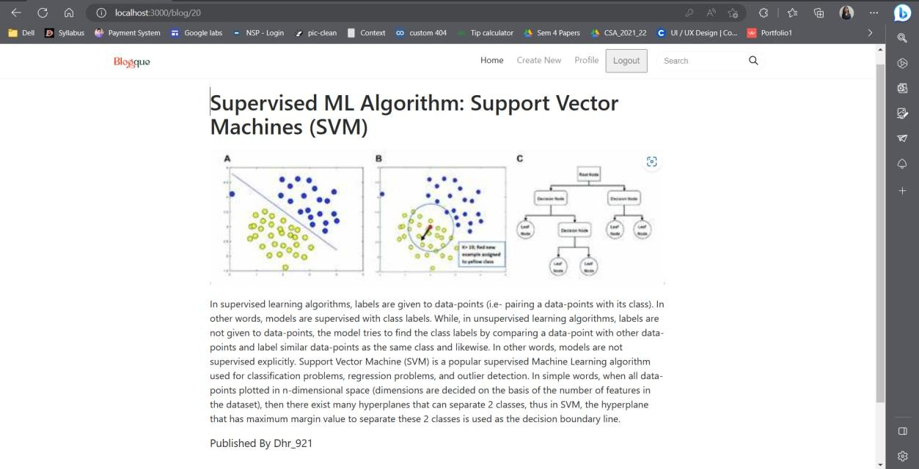

TC-09: Update a blog

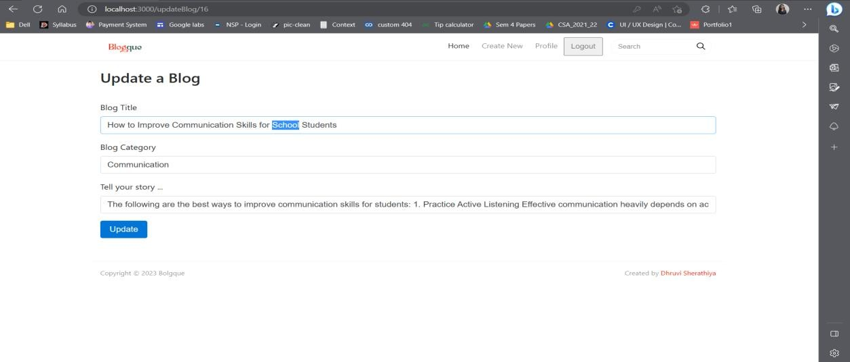

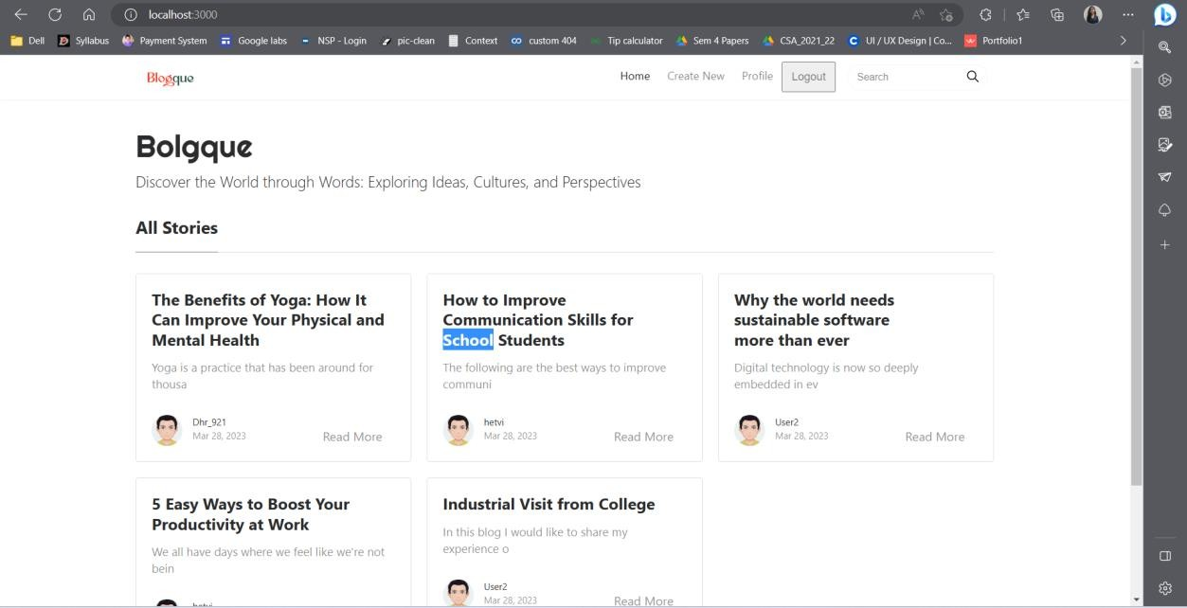

TC-10: Delete a Blog

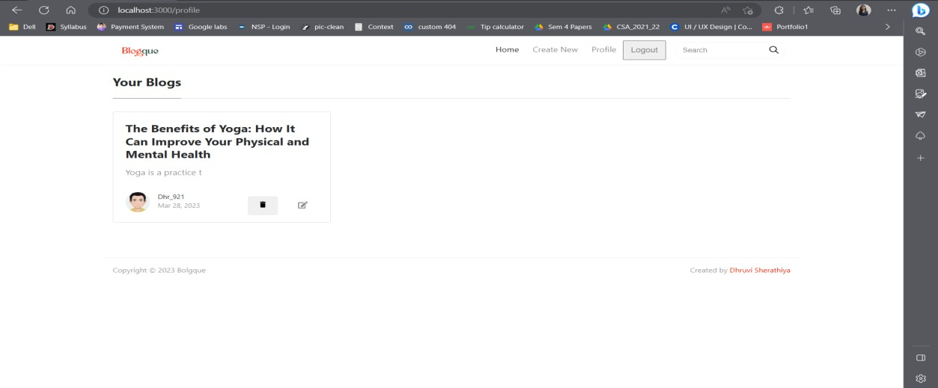

## Conclusion

The functionalities are implemented in system after understanding all the system modules according to the requirements. Functionalities that are successfully implemented in the system are:

* User Registration
* User Login / Logout
* Read all blogs
* Create new blog
* Update blog
* Delete a blog
* Read full blog

## Future Enhancement

Below are some future extensions to this project in order to improve the project.

* Commenting System
* Image Integration
* Category Filtering
* Search Functionality

## References

Following links and websites were referred during the development of this project.

* + Stack overflow
  + Microsoft Documentation
  + React
  + Bootstrap