pausality
High-Performance
Autonomic Coaching
for Motorsport
Prepared for Mossimo
Cup Series Development Program

Jason Fields Head of Product & Design
Randy Graybeal, CRNA Head of Clinical Science

Somnistics Research Labs | March 2026

The Opportunity
You're stepping up to cup cars. The machine is faster. The field is tighter. And the margin between podium and pack isn't horsepower; it's physiology.
What you described (elevated heart rate before the race, difficulty recovering after) isn't a weakness. It's your autonomic nervous system doing exactly what it's built to do under threat. The problem is that nobody has taught it to do anything else. You've tried to fix this from the outside. We train it from the inside.
This proposal outlines a six-week coaching engagement that gives you measurable control over pre-race activation, in-race composure, and post-race recovery. Not relaxation. Regulation: the ability to shift between states on demand, at the speed your sport requires.

Why This Matters in Motorsport
At 180 mph, your heart rate can exceed 170 bpm for sustained periods. The physiological demands of motorsport are comparable to elite endurance athletics, but with a critical difference: cognitive load. You're making hundreds of split-second decisions per lap while your body is in a sustained sympathetic stress response.
The research is clear on what happens next:
- Elevated pre-race heart rate narrows peripheral vision and delays reaction time by 50 to 200ms. At race speed, that's an eternity.
- Sympathetic dominance degrades the prefrontal cortex's capacity for strategic decision-making, pushing you toward reactive driving.
- Poor post-race recovery means your nervous system carries residual activation into the next session, compounding fatigue across a season.
- Heart rate variability (HRV) is the gold standard biomarker for autonomic flexibility. Drivers with higher HRV show better lap consistency, faster reaction times, and longer career durability.
The drivers who win at the cup level aren't just faster. They're more regulated. They can downshift their nervous system between sessions and upshift it precisely when the lights go green.

The Science Behind the Program
This program is built on the clinical neuroscience of autonomic regulation, informed by 28 years of anesthesia practice managing human physiology under the highest-stakes conditions in medicine. The same principles that keep patients alive during surgery (titration to effect, minimum effective dose, state transition management) apply directly to what your body does in a race car.

Resonant Breathing Frequency
Every individual has a unique breathing rate, typically between 4.5 and 6.5 breaths per minute, at which the heart, lungs, and baroreflex system lock into resonance. At this rate, your heart rate variability reaches its maximum amplitude. This is the single most powerful lever for autonomic control, validated by over two decades of research (Lehrer et al., 2000; Zaccaro et al., 2018). We will identify your personal resonant frequency in the intake session and build your entire breathing protocol around it.

Cardiac-Anchored Breathing
Most breathing apps pace you to an external clock: inhale for 4 seconds, exhale for 6. That ignores the fact that your optimal rhythm changes with your autonomic state, fatigue level, and circadian phase. Our approach anchors your breath pacing to your own cardiac oscillation using real-time wearable data. Your body sets the rhythm. You learn to listen to it, then modulate it. This is the difference between following instructions and developing a skill.

State Transition Training
The critical moments aren't during the race; they're the transitions: grid to green, caution to restart, race to recovery. These are the windows where your nervous system is most plastic and most vulnerable. We train these transitions specifically, using structured 60-second protocols (NeuroMinutes™) designed to shift your autonomic state in the time it takes to roll from pit lane to the grid.

Nasal Breathing Under Load
Mouth breathing during high-intensity effort floods the system with CO₂ inefficiently and keeps the sympathetic nervous system locked on. Nasal breathing, even partial nasal breathing during exertion, activates the parasympathetic brake, improves oxygen exchange efficiency, and trains CO₂ tolerance. We'll build your nasal breathing capacity progressively, starting with low-intensity workouts and scaling to race-simulation loads using the same progressive protocol structure that Brian McKenzie pioneered.

The Program: Six Weeks to Autonomic Edge

Week 0: Diagnostic Intake (2 Hours)
Before we train anything, we understand everything. Full autonomic assessment:
- Baseline HRV assessment : resting RMSSD, SDNN, and respiratory sinus arrhythmia via wearable + clinical-grade ECG
- Respiratory mechanics evaluation : inhale/exhale duration, breath-hold capacity (BOLT score), nasal vs. oral breathing ratio, diaphragmatic engagement
- Resonant frequency identification : live biofeedback session to find your optimal breathing rate
- Stress response profiling : pre-race activation patterns, recovery timeline, sleep quality, and what you've already tried
- Race context mapping : your specific state transitions from morning-of through evening recovery
- Interoceptive awareness screen (MAIA-2 adapted) : how well you currently read your own body's signals

Weeks 1 through 6: Training Protocol
One hour per week: coaching + practice + review. Between sessions, daily breathing protocols (5 to 10 minutes) and a nasal breathing progression during training.
WEEK | FOCUS | DELIVERABLES
1 | Foundation | Resonant breathing protocol, BOLT score baseline, diaphragmatic awareness drills, daily 5-breath practice
2 | Nasal Breathing | Progressive nasal breathing for workouts, CO₂ tolerance training, breathing tape protocol for sleep
3 | Pre-Race Activation | Custom pre-race state transition protocol, grid-to-green NeuroMinute™, visualization + breath integration
4 | In-Race Composure | Caution-period reset protocol, micro-regulation techniques at speed, in-helmet breathing cues
5 | Post-Race Recovery | Parasympathetic recovery protocol, post-race debrief breathing sequence, sleep optimization
6 | Integration | Full protocol integration, custom Pausality dashboard delivery, maintenance plan, race-day playbook

Your Custom Pausality Dashboard
Jason designs and builds you a personalized high-performance physiology dashboard: a digital cockpit for your nervous system that mirrors the telemetry you already use for the car. Jason's design approach treats biometric data the way race engineers treat vehicle telemetry: clear, actionable, zero noise. This isn't a generic wellness app. It's built for your physiology, your sport, your race calendar.
- Real-time HRV tracking synced from Apple Watch, Whoop, or Oura. See your autonomic state shift in real time.
- Pre-race readiness score based on morning HRV, sleep quality, and respiratory metrics.
- Post-race recovery timeline showing your parasympathetic rebound curve vs. baseline.
- Season-over-season trending as your autonomic capacity builds. The data that proves the training is working.
- Race-day playbook with your specific protocols at each transition point, accessible from your phone.

Investment
COMPONENT | INVESTMENT
Autonomic Coaching: 6 weekly sessions with Randy (1 hour each) | $6,000
Diagnostic Intake Session (2 hours) | Included
Custom Pausality Dashboard (designed and built by Jason Fields) | $4,000
Daily Breathing Protocols (personalized) | Included
Nasal Breathing Progression Plan | Included
Race-Day Playbook | Included
Between-Session Support (text/voice) | Included
TOTAL ENGAGEMENT | $10,000

Payment: $1,000 per week, invoiced at the start of each coaching week.

Sponsorship Partnership
Beyond coaching, we see a compelling partnership opportunity. Pausality™ on your car isn't just a sticker; it's a story. A race car driver who doesn't just train his body and his machine but trains his nervous system. That's a narrative nobody else in motorsport is telling.
We'd like to explore a co-branding arrangement: Pausality logo placement on your car in exchange for content collaboration. Race-day HRV data stories, behind-the-scenes protocol footage, and co-created content showing what high-performance autonomic training looks like at 180 mph. This is the kind of proof-of-concept that turns heads in both motorsport and the broader performance market.
Details to discuss in person. The coaching engagement stands on its own regardless.

Who We Are
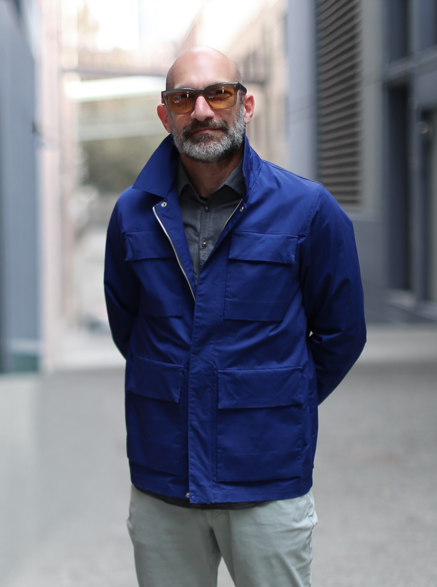
Jason Fields
Co-Founder, Head of Product and Technology
Former Amazon/Audible Head of Design. Jason brings deep expertise in UX, data visualization, branding, and product development at scale. He leads Pausality's product strategy, technology architecture, and the design language that makes complex physiology feel intuitive. For this engagement, Jason designs and builds your custom Pausality dashboard: translating raw biometric data into a race-day-ready cockpit that gives you the same clarity about your nervous system that your telemetry gives you about the car. His design philosophy: the interface disappears, leaving only the insight.

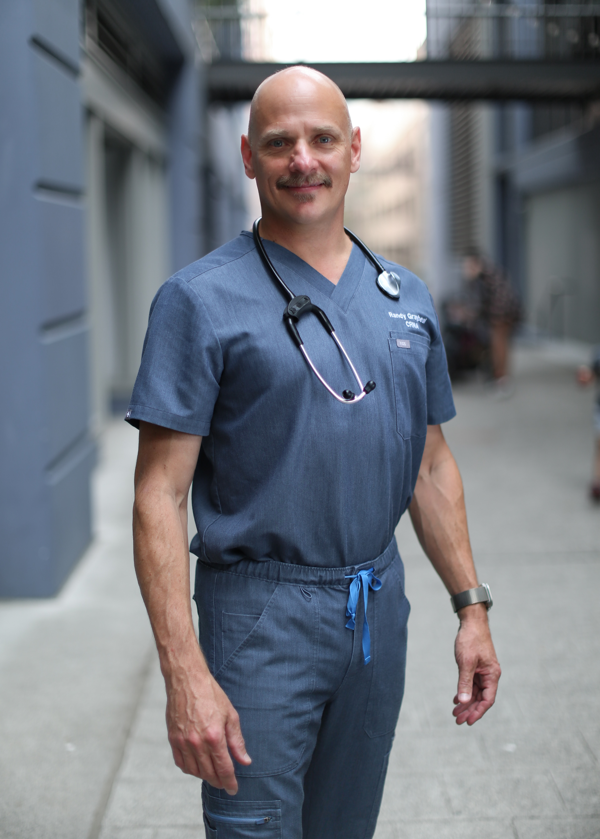
Randy Graybeal, MSN, CRNA
Co-Founder, CEO, Head of Content and Clinical Science
28 years as a Certified Registered Nurse Anesthetist, managing human autonomic physiology in the most high-stakes environment in medicine. Creator of the Pausality™ platform and the Gap Moment Training™ methodology. Randy has spent three decades watching what happens when nervous systems are pushed to their limits, and has developed the clinical protocols to train them to perform under pressure. The science in this program comes directly from his clinical practice: the same titration-to-effect principles that keep patients alive during surgery, applied to performance under the G-forces and cognitive load of motorsport.

Somnistics Research Labs
Evidence-based tools and protocols for autonomic regulation: the science of training your nervous system to shift between states on demand. Rooted in clinical neuroscience, not wellness marketing. We measure everything. We titrate to effect. We train the body's own regulatory systems rather than masking symptoms.

Next Step
Schedule the 2-hour diagnostic intake. We'll come to you: at the track, at the shop, wherever makes sense. Bring your wearable data. Leave with your resonant breathing frequency, your BOLT score, and a clear picture of what six weeks of training will look like.

randy@somnistics.com | pausality.health

