Untitled

Introduction to R for Public Health Researchers

Table of Contents

This is an R Markdown document. Markdown is a simple formatting syntax for authoring HTML, PDF, and MS Word documents. For more details on using R Markdown see <http://rmarkdown.rstudio.com>. **bold** *italicize* When you click the **Knit** button a document will be generated that includes both content as well as the output of any embedded R code chunks within the document. You can embed an R code chunk like this:

library(stringr)  
library(plyr)  
library(pander)  
  
bl = read.csv("http://johnmuschelli.com/intro_to_r/data/Bike_Lanes.csv", as.is =TRUE)  
bl2 = bl  
bl2$numLanes = factor(bl2$numLanes)  
mod2 = lm(length ~ numLanes, data = bl2)  
  
mod = lm(length ~ factor(numLanes), data = bl)  
smod = summary(mod)  
ci = confint(mod)  
mat = cbind(smod$coefficients[, "Estimate"], ci)  
mat = data.frame(mat)  
colnames(mat) = c("Beta", "Lower", "Upper")  
mat$CI = paste0("(", round(mat$Lower, 2),   
 ", ", round(mat$Upper, 2), ")")  
mat = mat[, c("Beta", "CI")]  
mat$Variable = rownames(mat)  
rownames(mat) = NULL  
mat$Variable = str_replace(mat$Variable, fixed("factor(numLanes)"), "Number of Lanes: ")  
mat = mat[, c("Variable", "Beta", "CI")]  
mat$Variable = plyr::revalue(mat$Variable, c("(Intercept)" = "B0"))

# I am a section

## I am a subsection

pander(mat)

|  |  |  |
| --- | --- | --- |
| Variable | Beta | CI |
| B0 | 308.4 | (189.53, 427.22) |
| Number of Lanes: 1 | -30.48 | (-150.7, 89.75) |
| Number of Lanes: 2 | -50.83 | (-171.42, 69.76) |

pander(smod)

|  |  |  |  |  |
| --- | --- | --- | --- | --- |
|  | Estimate | Std. Error | t value | Pr(>|t|) |
| **factor(numLanes)1** | -30.48 | 61.29 | -0.4972 | 0.6191 |
| **factor(numLanes)2** | -50.83 | 61.48 | -0.8267 | 0.4085 |
| **(Intercept)** | 308.4 | 60.59 | 5.09 | 4.006e-07 |

Fitting linear model: length ~ factor(numLanes)

|  |  |  |  |
| --- | --- | --- | --- |
| Observations | Residual Std. Error | $R^{2}$ | Adjusted $R^{2}$ |
| 1631 | 277.7 | 0.001564 | 0.0003378 |

pander(mod)

Fitting linear model: length ~ factor(numLanes)

|  |  |  |  |  |
| --- | --- | --- | --- | --- |
|  | Estimate | Std. Error | t value | Pr(>|t|) |
| **factor(numLanes)1** | -30.48 | 61.29 | -0.4972 | 0.6191 |
| **factor(numLanes)2** | -50.83 | 61.48 | -0.8267 | 0.4085 |
| **(Intercept)** | 308.4 | 60.59 | 5.09 | 4.006e-07 |

You can also embed plots, for example:

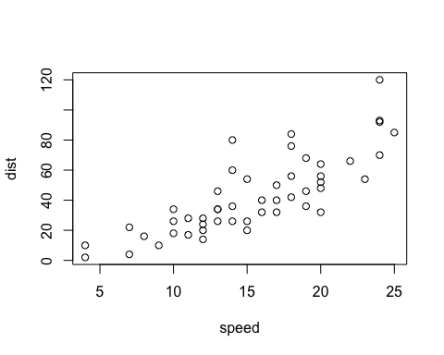

My number of cars are 50.

pvals =smod$coefficients[, "Pr(>|t|)"]  
pvals = ifelse(pvals < 0.001, "< 0.001", round(pvals, 2))

The beta coefficient was significant (308.3767969, p < 0.001)

Note that the echo = FALSE parameter was added to the code chunk to prevent printing of the R code that generated the plot.