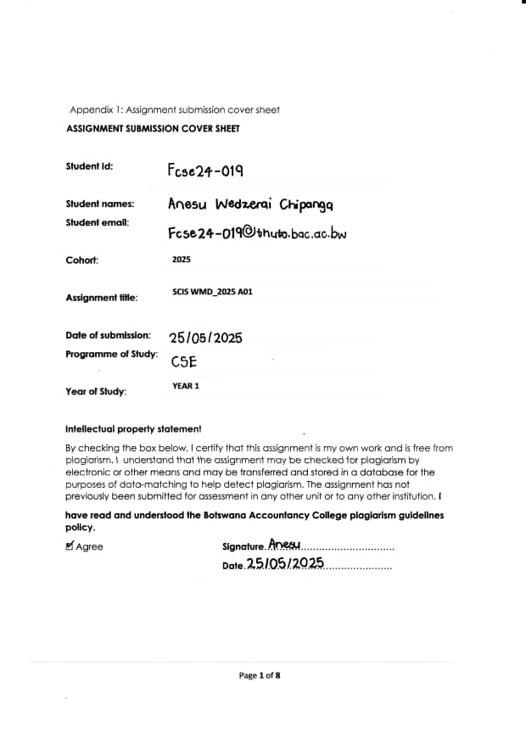

**1. Website Specifications**

**Objective:**  
The objective of this website is to serve as a fully functional e-commerce platform for Shopfinity a fictional online clothing shop specializing in trendy and affordable fashion for young adults. The website’s goal is to offer an online shopping service open 24hours, offer secure Payments, and make the shopping experience personal by providing recommendations, discount campaigns, and a user-friendly Interface.

**Business Goals:**

* Facilitate International shipping for customers across the globe
* Increase brand visibility and customer reach.
* Enable customer accounts and track orders.
* Collect user data for targeted products.
* Provide easy product returns as well as refunds.

**Target Audience:**  
The target audience is Gen-Z customers who are fashion-conscious and between the ages of 18–35. This group of people is very active on mobile and social platforms and like fast and responsive interfaces. The population tally includes include:

* **Age Range:** 18–35
* **Gender:** All genders, with an emphasis on female shoppers
* **Location:** Urban areas with internet access, primarily Botswana, and later expanding Worldwide
* **Technical Level of use of devices:** Comfortable with digital payments, mobile browsing, and online shopping platforms (Tech savvy)

**Type of Website:**  
This is a **commercial e-commerce website**. Content will include:

* Product listings (with filters)
* A shopping cart and checkout system
* News section for trends and promotions
* User account dashboard
* Contact and feedback form

**2. Information Design & Taxonomy**

**Information Architecture & Navigation:**  
The website will follow a hierarchical structure, ensuring intuitive navigation with minimal user effort. All pages will be accessible within **3 clicks** from the homepage.

**Proposed Navigation Structure:**

* **Home**
* **Shop (Which will have all the products)**
* **About Us**
* **Blog**
* **About**
* **Contact or Feedback**

**Sitemap (Storyboard Flowchart):**

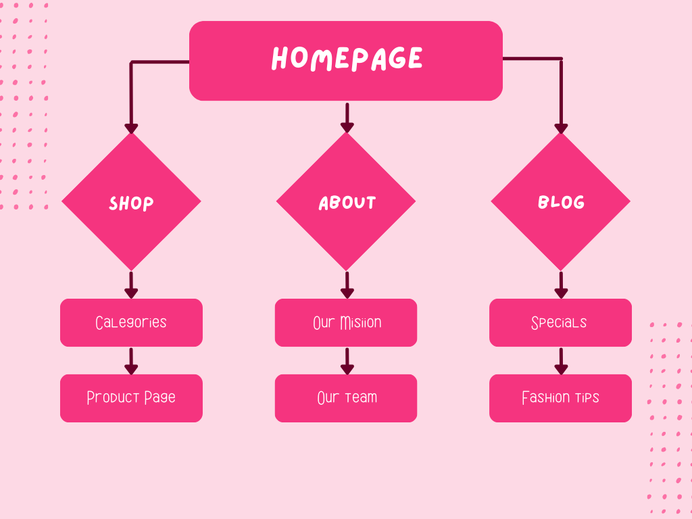

**3. Page Template Design (Wireframes)**

Wireframes provide a visual guide to the content structure and layout.

**Homepage Wireframe (example):**

| LOGO | MENU: Home | Shop | Blog | Contact |

| Hero Banner – Promotional Image |

| Featured Products |

| [Product 1] [Product 2] [Product 3] [Product 4] |

| Newsletter Signup | Footer Links | Social Media |

**Product Page Wireframe:**

| Category >Name |

| Product Image | Product Name |

| | Description, Price, Size Selector |

| | Add to Cart Button |

| Related Products Carousel |

Each wireframe ensures **active white space**, **clear call-to-actions**, and a **mobile-friendly layout**.

**4. Technical Brief**

**Technologies & Tools:**

* **Frontend:**
  + HTML5 for page structure
  + CSS3 for styling (including Flexbox/Grid)
  + JavaScript for interactivity (sliders, toggle menu, form validation)
* **Responsive Framework:**
  + Bootstrap 5 for grid and responsiveness
* **Version Control & Hosting:**
  + Git & GitHub for code versioning
  + GitHub Pages for deployment
* **Design & Media Tools:**
  + GIMP for editing images, banners, and logos
  + Google Fonts for typography
  + Favicon Generator for branding
* **Other Resources:**
  + FontAwesome for icons
  + W3C Markup Validator for standards compliance
  + Mobile Emulators & DevTools for testing

**5. Quality Assurance (Testing)**

A range of tests will ensure browser and device compatibility. The following methods and results will be documented:

**1. Browser Compatibility:**

* ✅ Chrome (Windows & Android) – Passed
* ✅ Firefox (Windows) – Passed

**2. Mobile Responsiveness:**

* ✅ Samsung Galaxy S10 (Android) – Responsive
* ✅ iPhone XR – Responsive
* ✅ iPad – Responsive
* ✅ Desktop Full HD (1920x1080) – Responsive
* ✅ Low-resolution (800x600) – Scrollable layout maintained

**3. Accessibility Testing:**

* All images include **ALT tags**
* Sufficient contrast ratio maintained
* Tab key navigation works across all pages

**4. Form Testing:**

* All required fields trigger browser-based validation
* Invalid inputs are flagged and cannot be submitted

(Screenshots of each test will be included in the final report)

**6. Publishing & Promotion**

**Hosting Platform:** GitHub Pages

**Steps Taken:**

1. Initialized Git repository using:
2. git init
3. git add .
4. git commit -m "Initial commit"
5. git remote add origin https://github.com/[username]/elysian-threads.git
6. git push -u origin main
7. Published via GitHub Pages using the main branch.
8. Website is live at:  
   **https://[username].github.io/elysian-threads/**

**Promotion Strategies:**

* SEO-optimized metadata
* Social media integration
* Submission to online directories
* Integration with email newsletter

**7. Future Developments & Recommendations**

The following improvements are suggested for future versions:

* **Integrate a secure payment gateway** (e.g., PayPal, Stripe)
* **Add user authentication** for personal order tracking
* **Install analytics tools** for visitor tracking and performance
* **Implement live chat support**
* **Expand content with fashion blogs, video lookbooks, and user reviews**
* **Use a CMS like WordPress** for non-developers to easily manage content