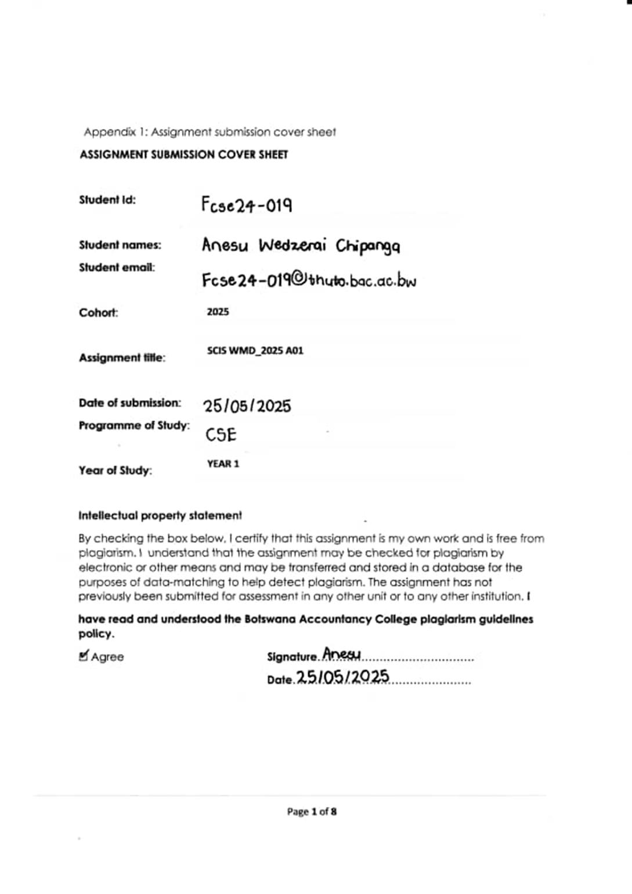

**1. Website Specifications**

**a. Objective and Goals**

The objective of the Amélie Fashion Collection website is to establish a digital presence for a growing boutique brand that focuses on modern, elegant, and sustainable fashion for women and men. The website will serve as both a branding platform and an e-commerce storefront. Its main goals are to:

* Promote the unique identity and values of the Amélie brand.
* Provide an intuitive shopping experience with a catalogue of fashion items.
* Allow customers to make secure online purchases.
* Share fashion tips, blog updates, and styling ideas.
* Engage with customers through a newsletter and feedback forms.

By launching this site, Amélie Fashion Collection aims to increase market reach, build a loyal online community, and drive sales through a professionally designed and functional platform.

**b. Target Audience**

The website targets fashion-conscious men and women especially the youth aged 18 to 35 who are interested in chic, sustainable clothing. These customers are mostly:

* People leaving in urban areas with access to the internet.
* Social media users and online shoppers who are familiar with using mobile and web platforms.
* Technologically adept, using smartphones and browsers like Chrome, Safari, and Firefox.
* Often influenced by fashion blogs, influencers, and lifestyle media.

**c. Website Type**

The website will be a **brand-focused fashion e-commerce site**. It will include:

* A home/landing page (index.html)
* A product catalogue page
* An about us page
* A fashion blog or lookbook
* A contact/feedback page

The site will integrate multimedia content (images, banners, videos) to enhance the user experience and highlight the fashion products effectively.

**2. Information Design & Taxonomy**

The website's information architecture has been designed to ensure ease of use, minimal clicks, and intuitive navigation. The site map and content flow follow a hierarchical structure with consistent navigation across all pages.

**Site Map:**

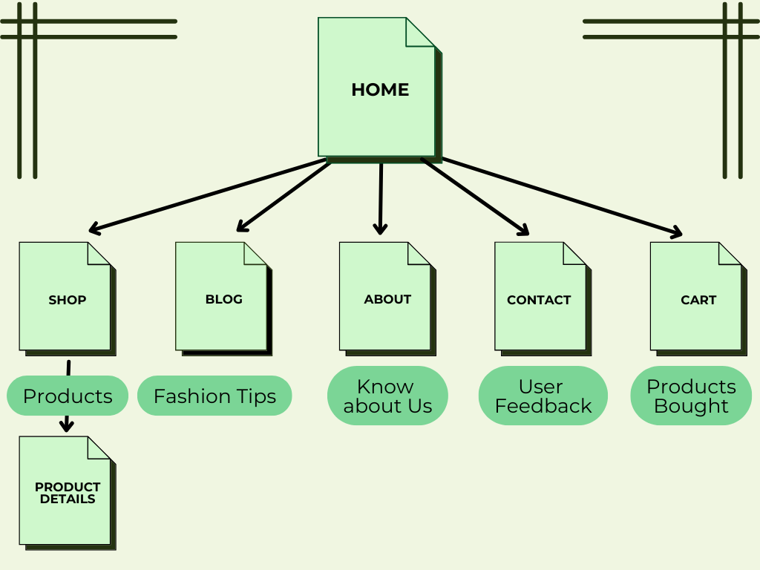

**Navigation Strategy:**

* Main navigation bar at the top of every page.
* Call-to-action buttons such as “Shop Now” or “Learn More” on the homepage.
* Footer navigation with links to social media, contact info, newsletter signup and

This layout ensures the "three-click rule" is adhered to, allowing users to find any information within three clicks or less.

**3. Page Template Design**

The wireframes for the Amélie Fashion Collection website reflect a minimalist and elegant layout that mirrors the brand's aesthetic. Each page follows a consistent layout structure:

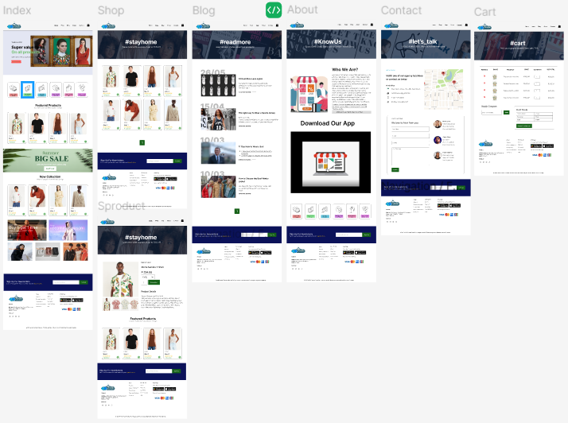

* **Header:** Logo, navigation menu, and search bar.
* **Main Content:** Product grids, featured images, or blog excerpts.
* **Sidebar (if needed):** Filters, categories, or social media widgets.
* **Footer:** Contact information, social links, terms & privacy.

**Homepage wireframe highlights:**

* Hero banner with a promotional image.
* Scrolling product carousel.
* Featured blog section.
* Newsletter signup call-to-action.

All wireframes were created using Figma, showing content placement, white space utilization, and responsive behaviour.

**4. Technical Brief**

The following technologies and tools will be used for the development of the website:

**Development Tools:**

(HTML5) For webpage structure and semantic elements.

(CSS3) For styling, layout, and responsive design.

(JavaScript) For interactivity such as image sliders and form validation.

**Frameworks/Libraries:**

(Bootstrap 5) To streamline responsive grid layout and components.

(Google Fonts) To apply custom typography that aligns with the brand image.

**Software Tools:**

(Visual Studio Code) For writing and managing code.

(CANVA) For editing images, creating banners, and logo design.

(Git & GitHub) For version control and deployment.

(GitHub Pages) For hosting the live website.

The combination of these tools ensures the project is scalable, visually appealing, and optimized for various devices.

**5. Quality Assurance**

A thorough testing process will be implemented to ensure cross-browser and cross-device compatibility.

**Tests Performed:**

1. Browser Compatibility Tests **-** Chrome (latest version), Firefox, Safari, Opera and Microsoft Edge
2. Mobile Responsiveness Tests **-** Android Chrome and Chrome developer tools responsive view
3. Validation Tests **-** HTML and CSS will be validated using [W3C Validator](https://validator.w3.org/) and JavaScript console checks to detect errors or warnings.

**Screenshots:**

* This screenshot is showing the site functioning across different devices and screen resolutions.

iPhone SE View iPad Pro View Galaxy Z-fold 5 View

**6. Publishing & Promotion**

The website will be hosted using **GitHub Pages**, which offers a free and reliable hosting service for static websites.

**Steps Followed:**

1. **GitHub Repository Setup:**

Repository named using SCIS format (e.g., ABC25-001).

1. **Version Control:**

Git installed and initialized in local project folder.

Regular commits using:

git init

git add .

git commit -m "Initial commit"

git push origin main

1. **Deployment:**

The repository is connected to GitHub Pages from the "Settings" tab.

Main branch is published as the GitHub Pages site.

1. **Live Link Example:**
2. <https://anesu123456.github.io/fcse24-019/>

**Promotion:**

* Social media platforms will be used to share the GitHub Pages link.
* QR codes will be generated for print marketing.
* The brand will link the site from Instagram bio and WhatsApp business profiles.

**7. Future Developments & Recommendations**

The website can be enhanced in the following ways:

Product Filtering**:** Add advanced filtering by size, price, color, and style.

Live Chat**:** Integration of tools like Tawk.to for real-time customer support.

User Accounts**:** Allow registered users to track orders and receive exclusive offers.

Blog Expansion**:** Regularly update blog posts to boost SEO and customer engagement.

SEO Optimization**:** Implement meta tags, alt texts, and performance improvements for better search engine visibility.