DIGITAL PORTFOLIO

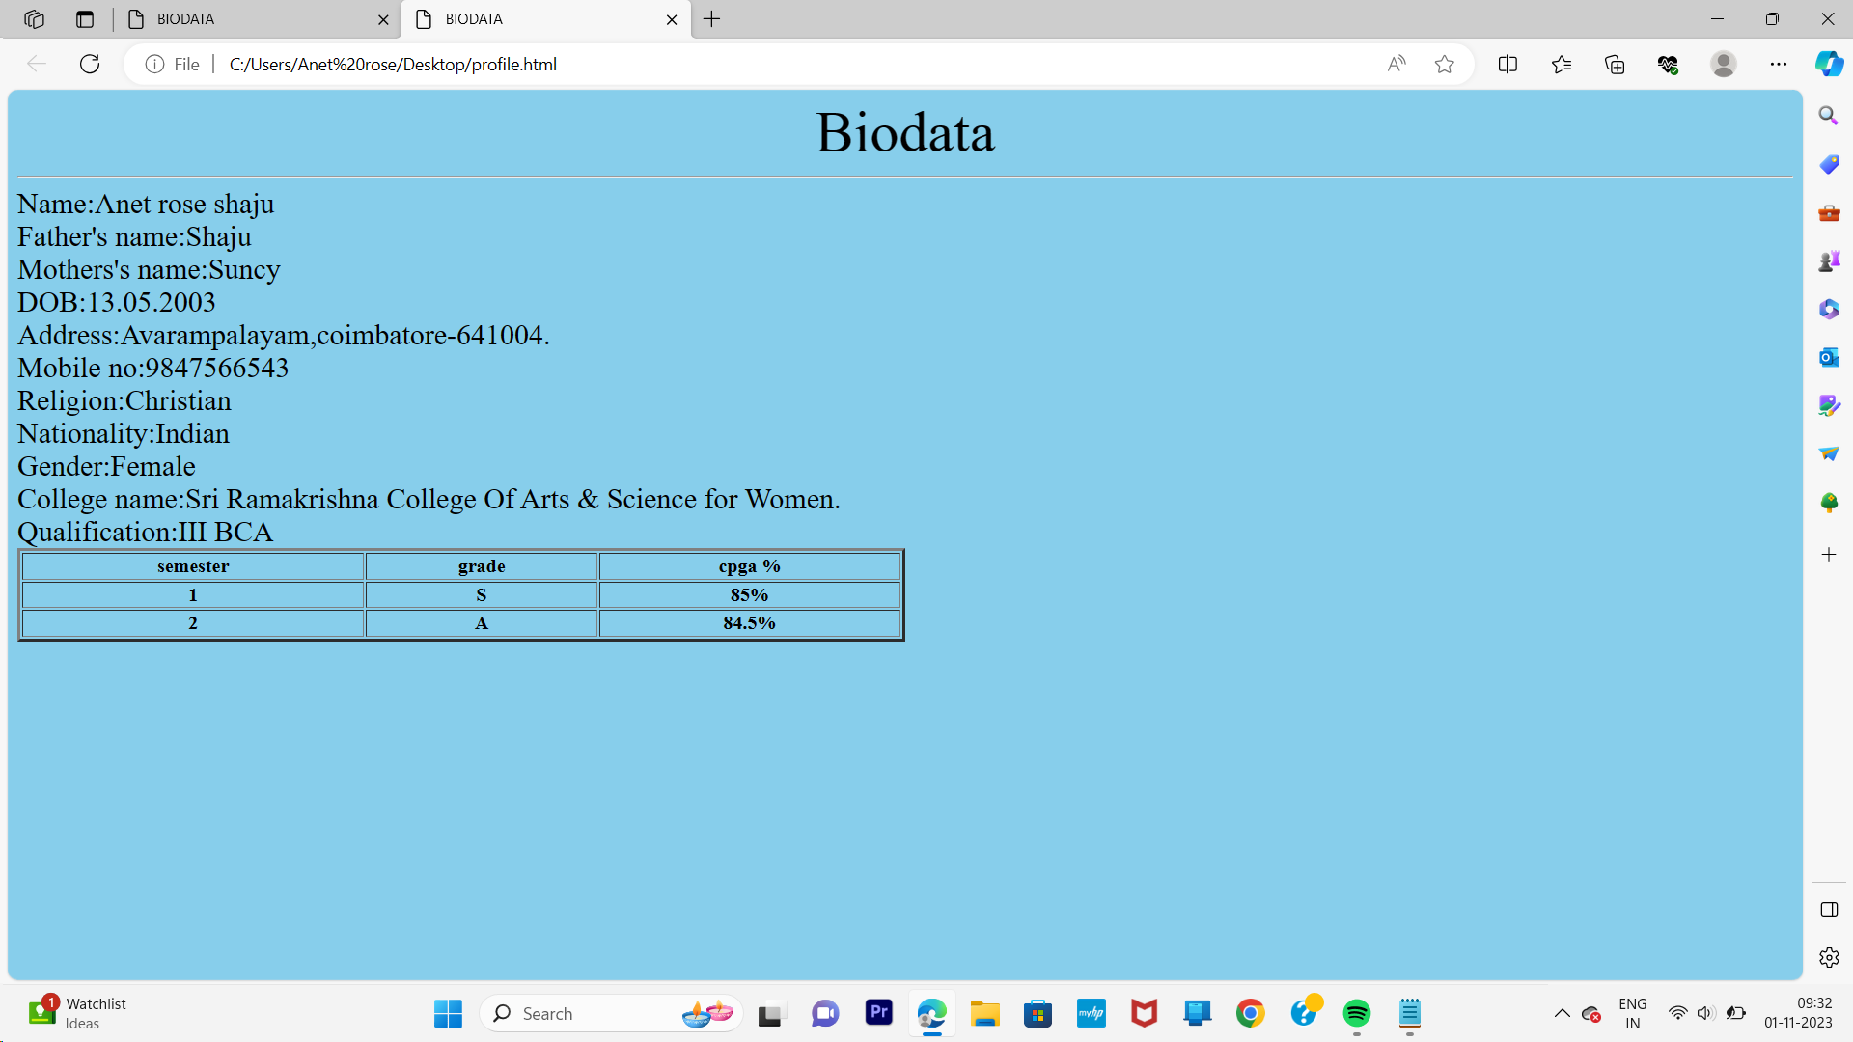

<html>

<head>

<title>BIODATA</title>

</head>

<CENTER>

<body bgcolor="skyblue"><font color="black"><font size=30>Biodata</font>

</CENTER>

<hr>

<body><font size=5><font color="black">

Name:Anet rose shaju<br>

Father's name:Shaju<br>

Mothers's name:Suncy<br>

DOB:13.05.2003<br>

Address:Avarampalayam,coimbatore-641004.<br>

Mobile no:9847566543<br>

Religion:Christian<br>

Nationality:Indian<br>

Gender:Female<br>

College name:Sri Ramakrishna College Of Arts & Science for Women.<br>

Qualification:III BCA<br>

<table style="width:50%"border=3>

<tr>

<th>semester</th>

<th>grade</th>

<th>cpga %</th>

</tr>

<tr>

<th>1</th>

<th>S</th>

<th>85%</th>

</tr>

<tr>

<th>2</th>

<th>A</th>

<th>84.5%</th>

</tr>

</body>

</html>