Backend aws

Step 1 — Open EC2
- Go to AWS Console
- Log in.
- At the top, make sure the region is Mumbai (ap-south-1).
- In the AWS search bar at the top, type:
EC2
- Click EC2 — Virtual Servers in the Cloud.

Step 1 — Name
Under Name and tags:
ai-lab-backend
Step 2 — OS Image
Under Application and OS Images (Amazon Machine Image):
- Select Amazon Linux
- Select Amazon Linux 2023
- If there is a Free tier eligible label, that's the one to prefer.
Step 3 — Instance type
Scroll down to Instance type.
Look for a small instance such as:
t3.micro
or whatever instance AWS currently marks as eligible under your account's free-tier/credit offer.
Don't select a larger instance just because it looks faster. Your Node/Express backend doesn't need much compute for this deployment.
Step 4 — Key pair
Continue to Key pair (login).
Click:
Create new key pair
Use:
Key pair name: ai-lab-key
Key pair type:
RSA
Private key format:
.pem
Click Create key pair.
A .pem file will download.
⚠️ Do not upload this file to GitHub. Do not delete it.
Step 5 — Network settings
Find Network settings → Edit.
Set/check:
- VPC → leave the default VPC.
- Subnet → leave the default subnet.
- Auto-assign public IP → Enable.
- Firewall / Security group → choose Create security group.
Add these inbound rules:
Type | Port | Source
SSH | 22 | My IP
Storage
Your screenshot shows:
8 GiB gp3
Leave that as it is. ✅
5. Launch
After changing SSH from Anywhere → My IP, your settings should be:
SSH 22 My IP ✅
HTTP 80 unchecked ❌
HTTPS 443 unchecked ❌
Then click the orange Launch instance button.

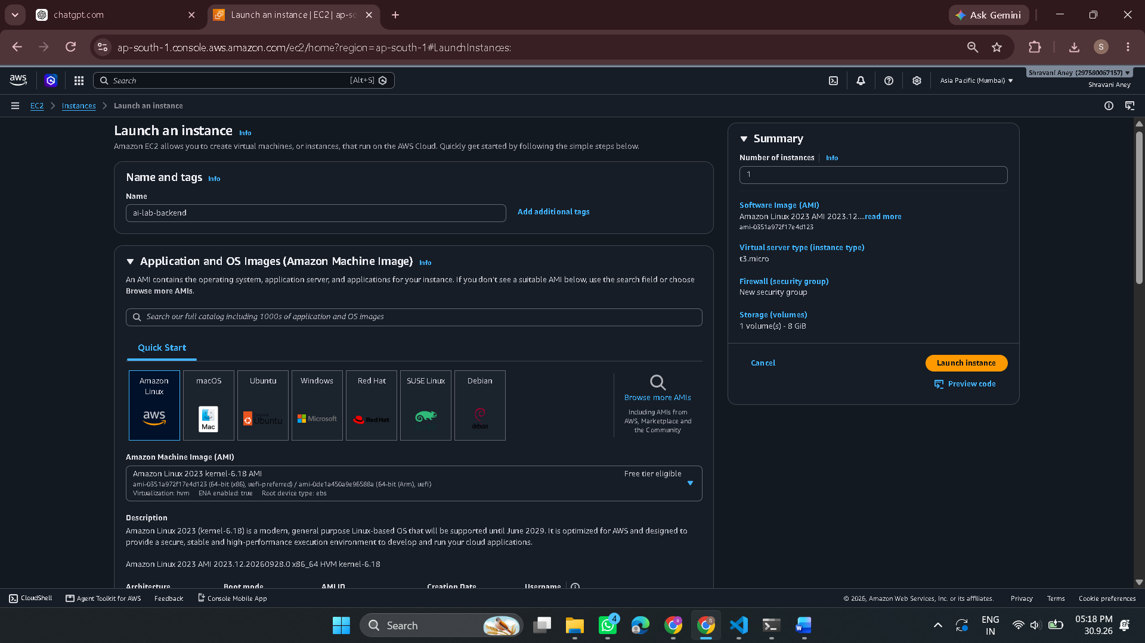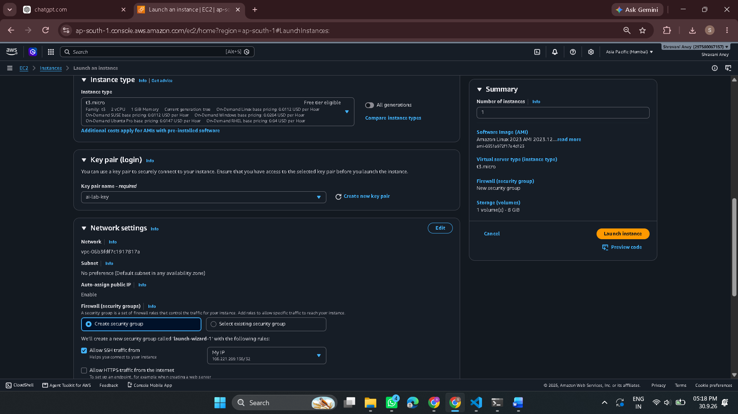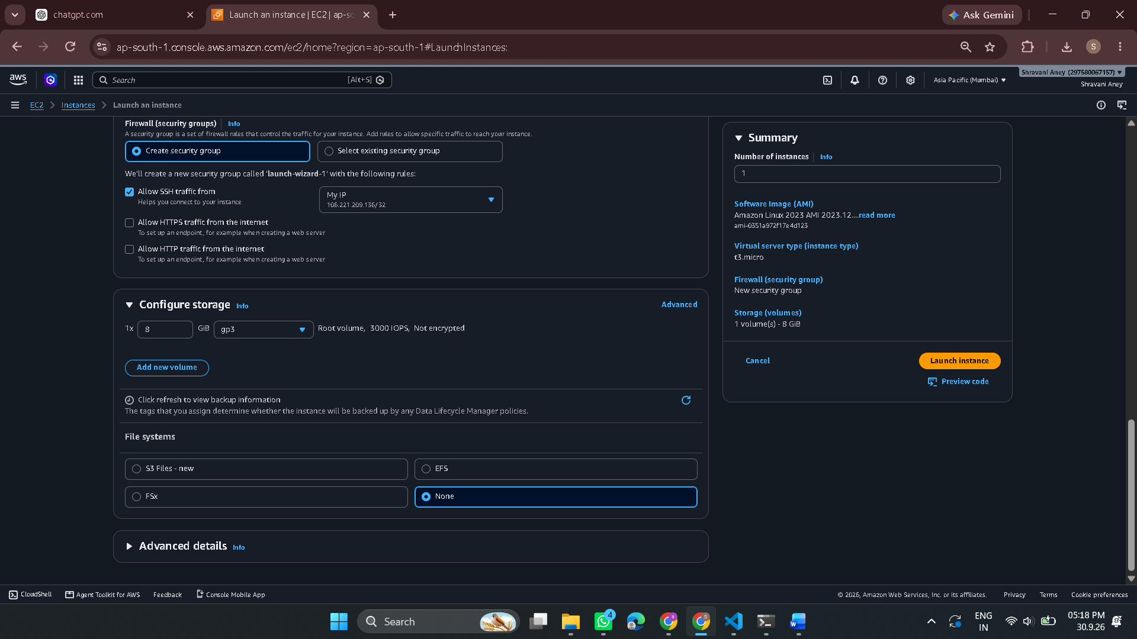

Perfect. Your EC2 instance is running, t3.micro, Amazon Linux 2023, and the key pair ai-lab-key is attached. ✅
Now do only the security-group step.
Step 1 — Find the Security Group
On this same EC2 instance page:
- Scroll down to the Security section.
- Look for Security groups.
- You should see something like:
launch-wizard-1
- Click the security group name.
Step 2 — Add port 5000
You'll reach the Security Group page.
- Click Inbound rules.
- Click Edit inbound rules.
- Click Add rule.
- Set:
Type: Custom TCP
Port range: 5000
Source: Anywhere-IPv4
It should display:
0.0.0.0/0
- Click Save rules.
Your final inbound rules should be
SSH TCP 22 My IP
Custom TCP TCP 5000 Anywhere-IPv4
Leave HTTP/HTTPS out for now.
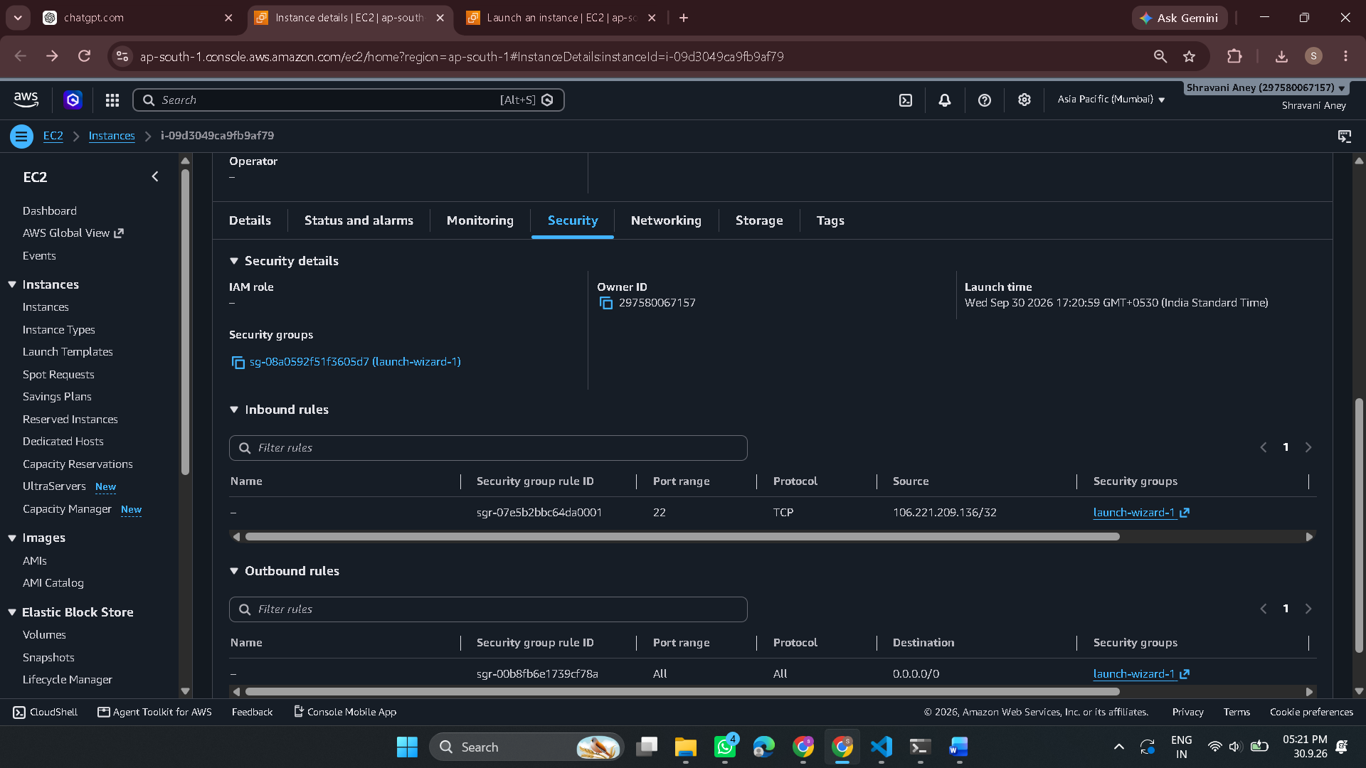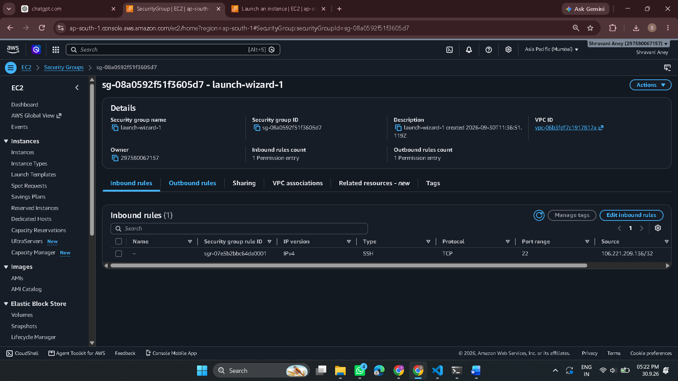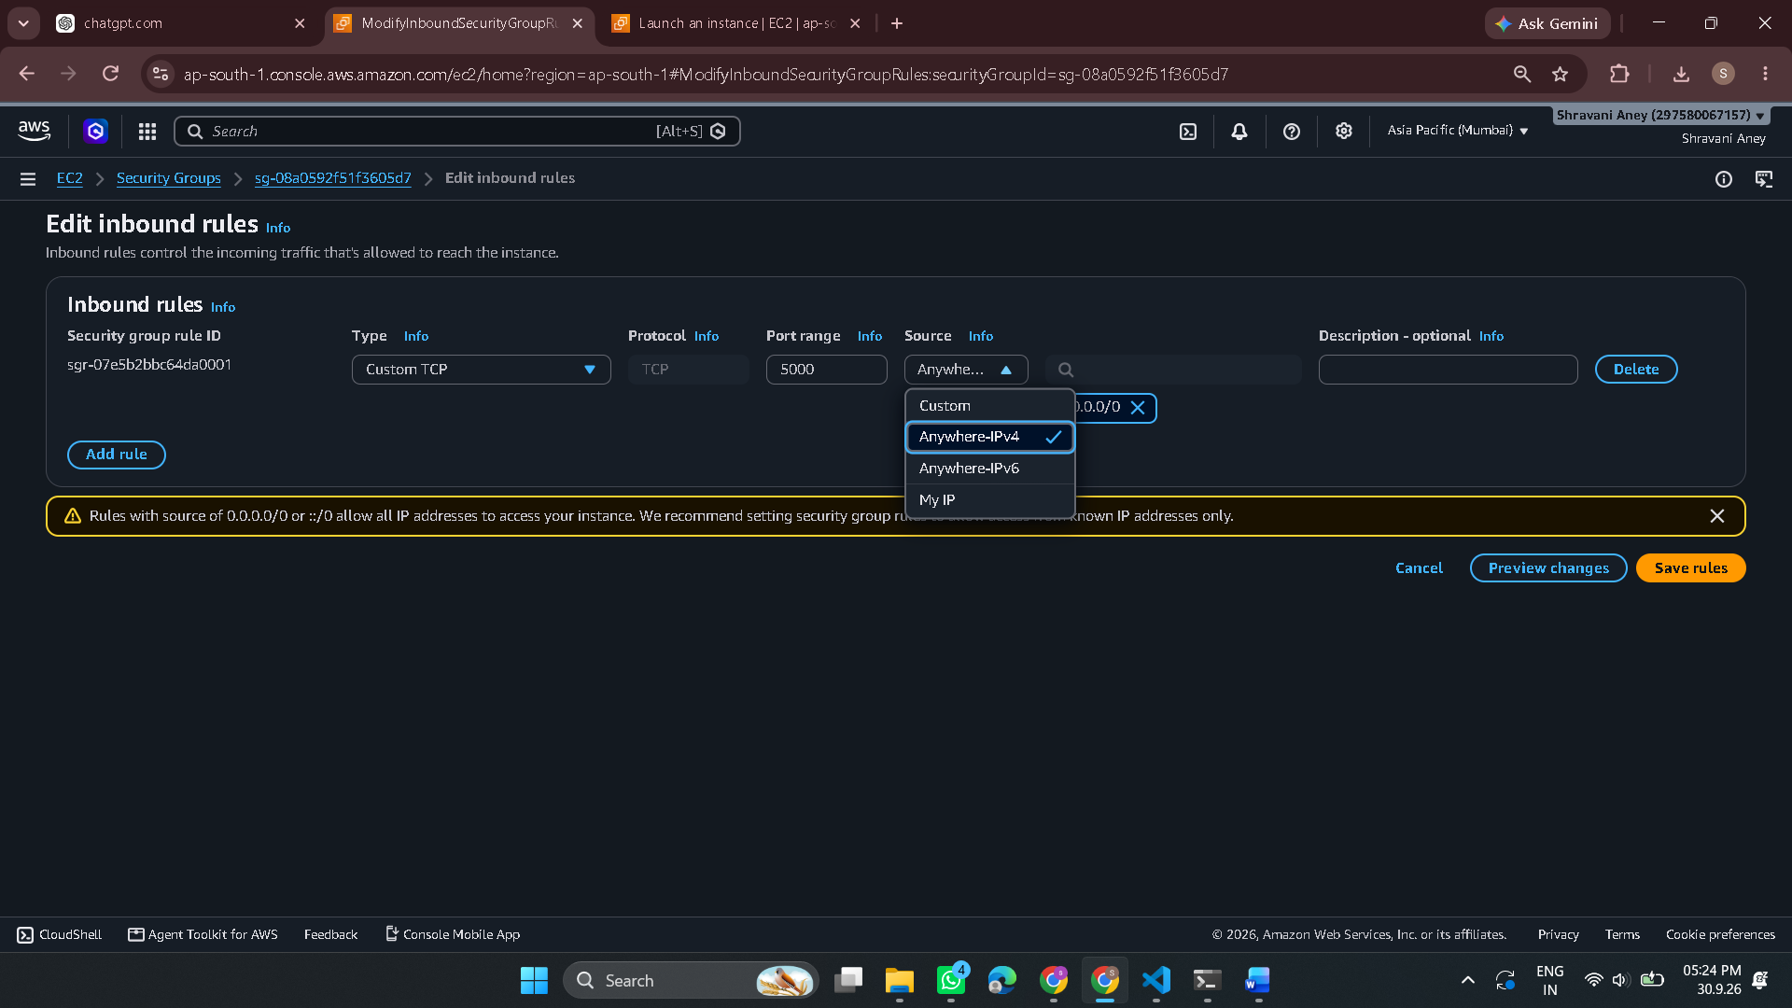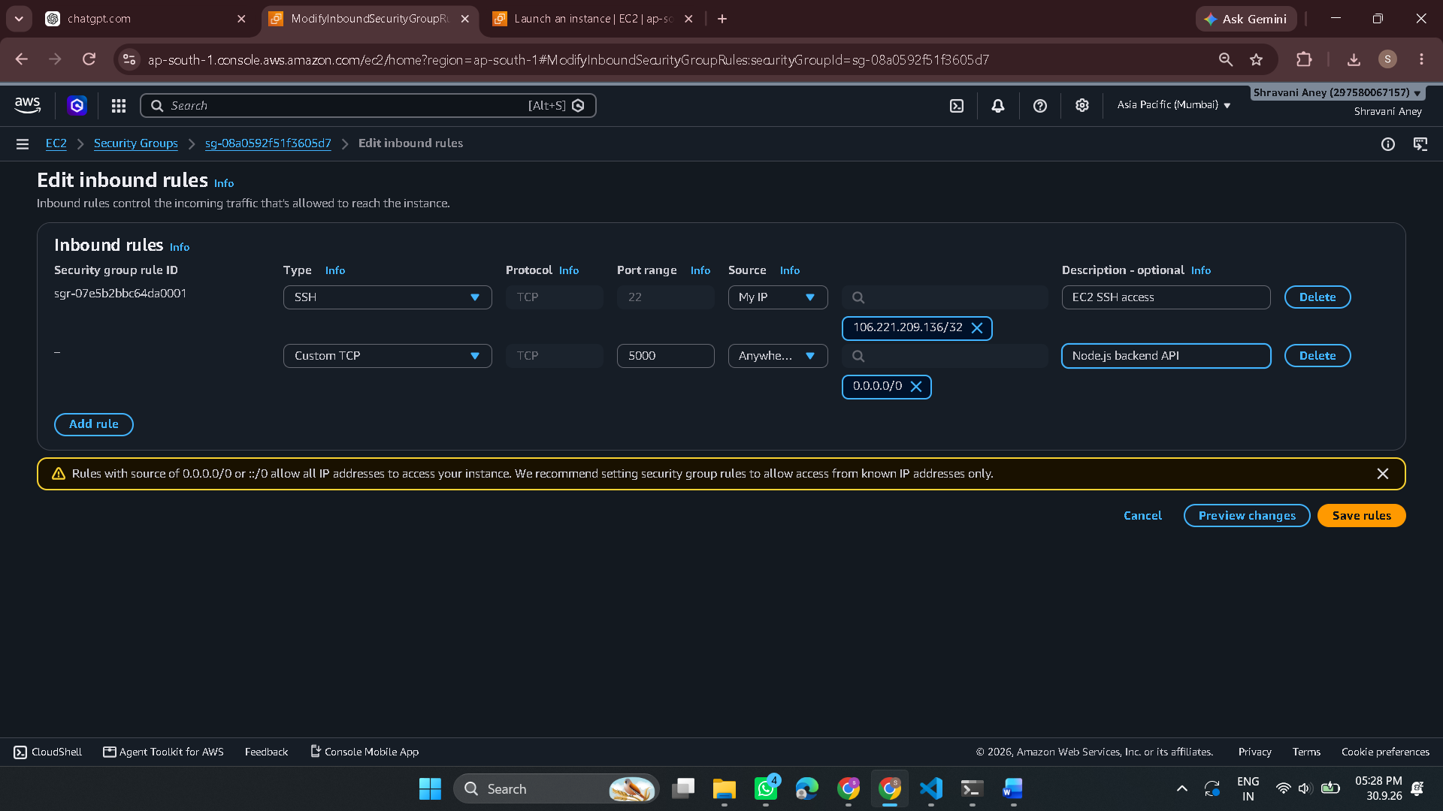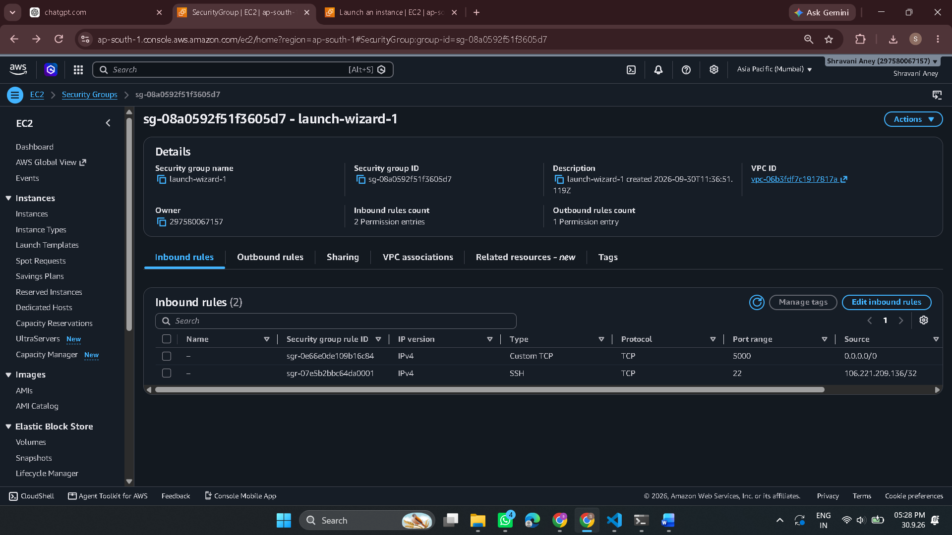Where to get the EC2 terminal
You don't get it from the Security Group page. Go to:
AWS Console → EC2 → Instances
Then:
- Find the running EC2 instance you created for this deployment.
- Select it.
- Click Connect at the top.
- You'll see several connection options.
- Choose EC2 Instance Connect.
- Click Connect.
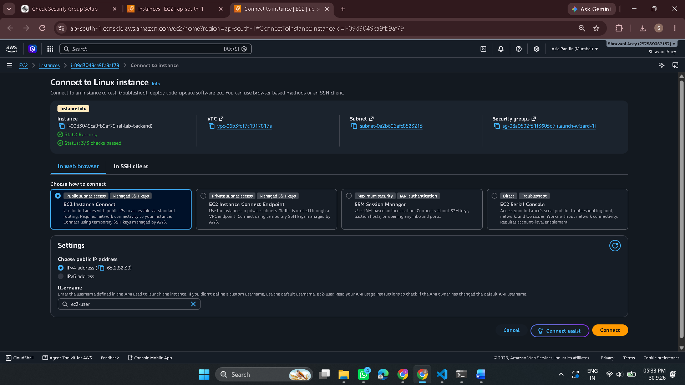

Sure. From the moment the terminal started, we did this:
- Connected to EC2
  - Successfully connected to your Amazon Linux EC2 instance.
  - Terminal showed:
[ec2-user@...]
- Checked the server
  - Current location:
/home/ec2-user
- Found the project folder
aws-cloud-web-deployment
- Checked Node.js
  - Initially Node/npm were missing.
  - Installed Node.js.
  - Now:
- Node v18.20.8
npm 10.8.2
- Entered the project
cd ~/aws-cloud-web-deployment
- Initially saw only README
  - We checked Git and discovered the EC2 copy was on an old commit.
- Fetched the latest GitHub version
git fetch origin
  - Git showed the main branch had been force-updated.
- Pulled the latest project
git pull origin main
  - Now the complete project appeared:
admin/
backend/
docs/
- Entered backend
cd backend
- Checked package.json
- Confirmed it's a Node.js + Express + MongoDB backend.
- Start command:
npm start
Where we are NOW
We're inside:
~/aws-cloud-web-deployment/backend
Next step: install backend dependencies with:
npm install
Then we'll configure the backend and run it on EC2.

After:
Next step: install backend dependencies with:
npm install
add this:
12. Installed backend dependencies
npm install
- Installed all required Node.js dependencies for the backend.
13. Configured environment variables
- Created the .env file on the EC2 instance.
- Added the required backend configuration:
  - MongoDB Atlas connection
  - JWT secret
  - Server port
  - SMTP configuration
  - Other application settings
- Secrets were kept in .env and were not uploaded to GitHub.
14. Connected backend to MongoDB Atlas
- Configured the backend to use the MongoDB Atlas cluster:
  - Cluster: darkninjas-BE
- Verified that the EC2 backend could connect successfully.
15. Initial backend startup issue
When running:
npm start
the backend initially failed with:
ReferenceError: crypto is not defined
- The issue occurred inside the MongoDB/Mongoose dependency stack.
- The project uses Mongoose 9, which requires a newer Node.js runtime.
16. Upgraded Node.js
- Initial Node.js version:
v18.20.8
- Installed Node.js 22 using NVM.
Final version:
v22.23.3
Then reinstalled dependencies:
npm install
17. Successfully started the backend
Ran:
npm start
Result:
✅ MongoDB Connected Successfully
Server running on port : http://localhost:5000
18. Configured AWS Security Group
Added an inbound rule for:
Type: Custom TCP
Port: 5000
Source: 0.0.0.0/0
This allowed external testing of the backend API.
19. Tested external connectivity
From Windows PowerShell:
Test-NetConnection 65.2.82.30 -Port 5000
Result:
TcpTestSucceeded : True
20. Tested the deployed API
Opened:
http://65.2.82.30:5000
Backend response:
BE is running
21. Final deployment status
AWS EC2 ✅ Running
Node.js 22 ✅
Express Backend ✅
MongoDB Atlas ✅ Connected
Environment Configuration ✅
Security Group ✅
Port 5000 ✅
External API Test ✅
📸 Screenshots
Then at the bottom of the document, add:
## Deployment Screenshots

1. EC2 Instance
2. Security Group
3. Backend Running
4. MongoDB Atlas
5. Port Connectivity Test
6. API Test
And put the six images in:
docs/aws-deployment/screenshots/
This gives you a complete story from EC2 setup → dependency installation → problem → troubleshooting → successful deployment → external testing, which is much stronger for your GitHub project and interviews.

For the github
01-ec2-instance.png
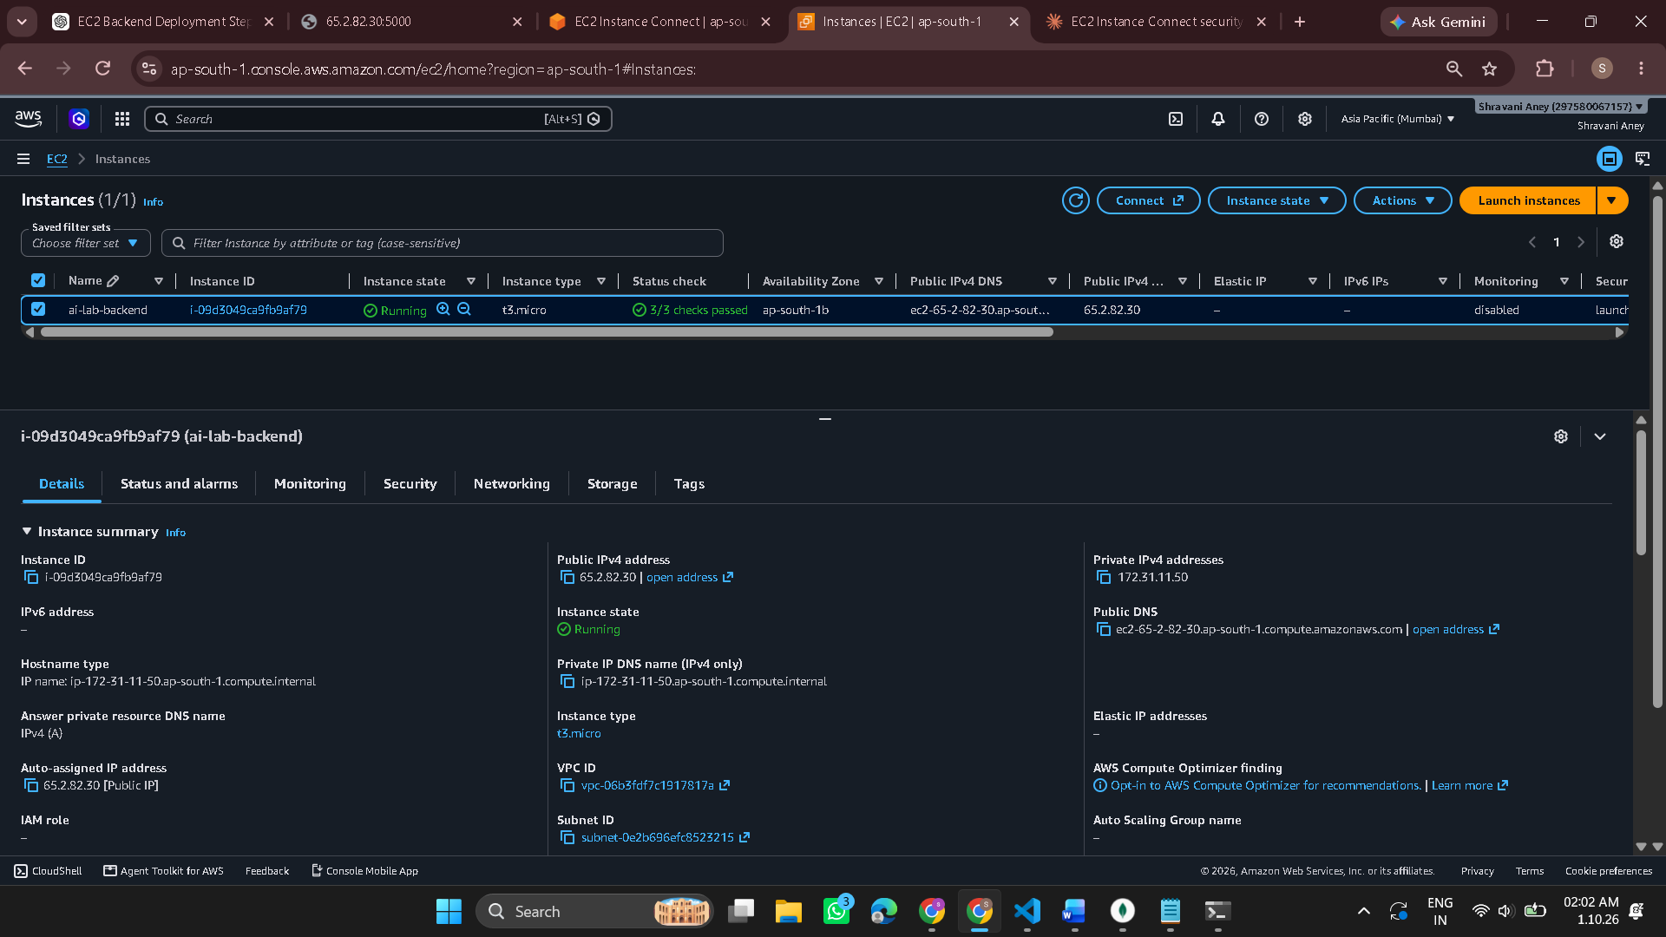
02-security-group.png
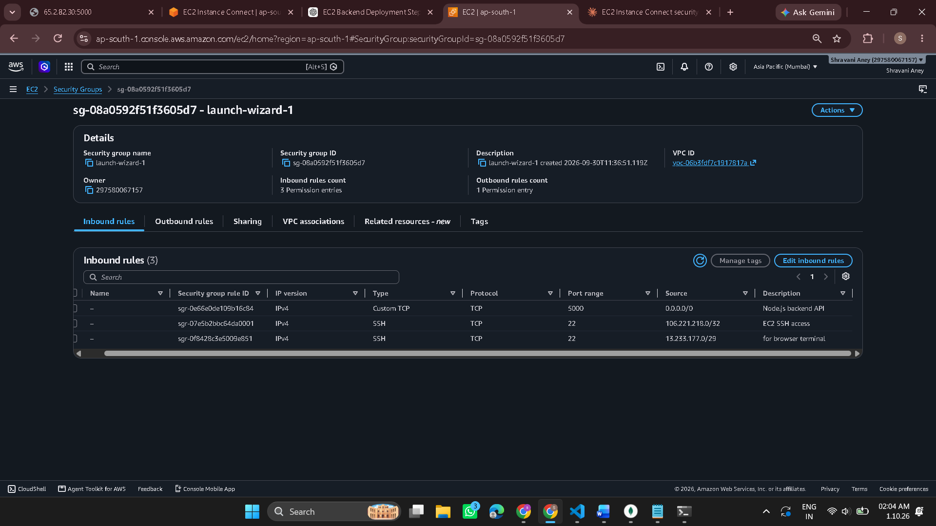

03-backend-running.png
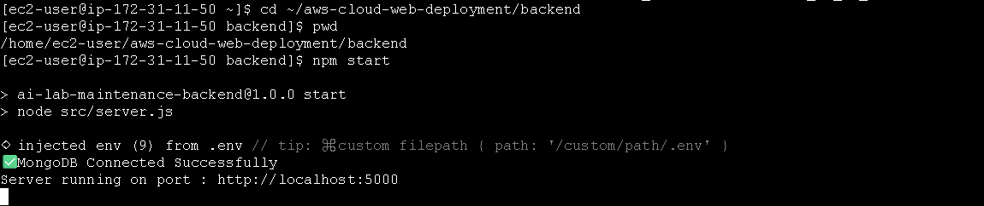
04-mongodb-atlas.png
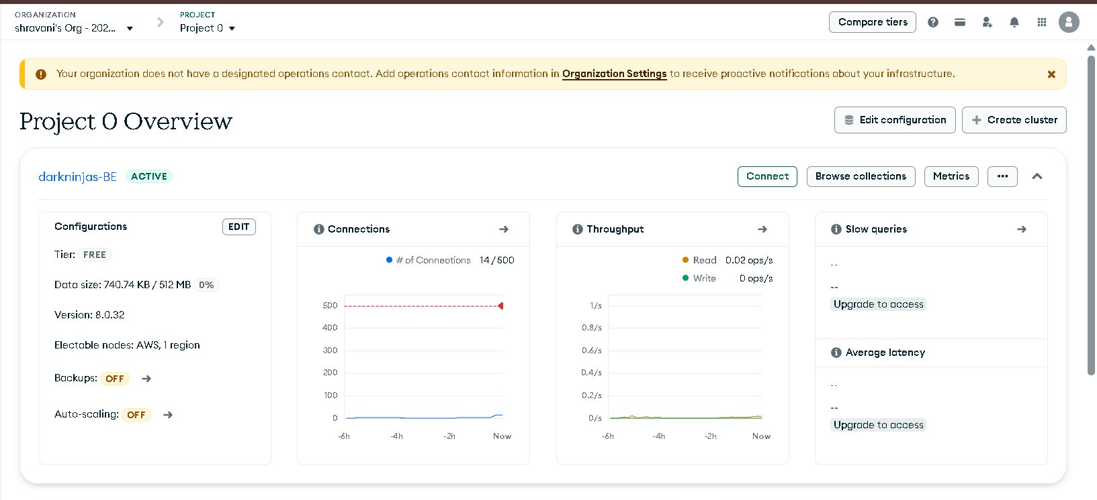05-port-test.png
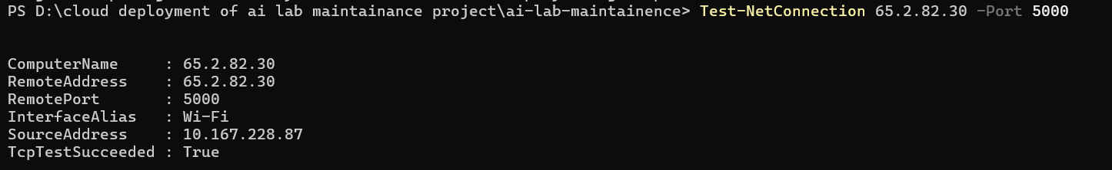

06-api-test.png
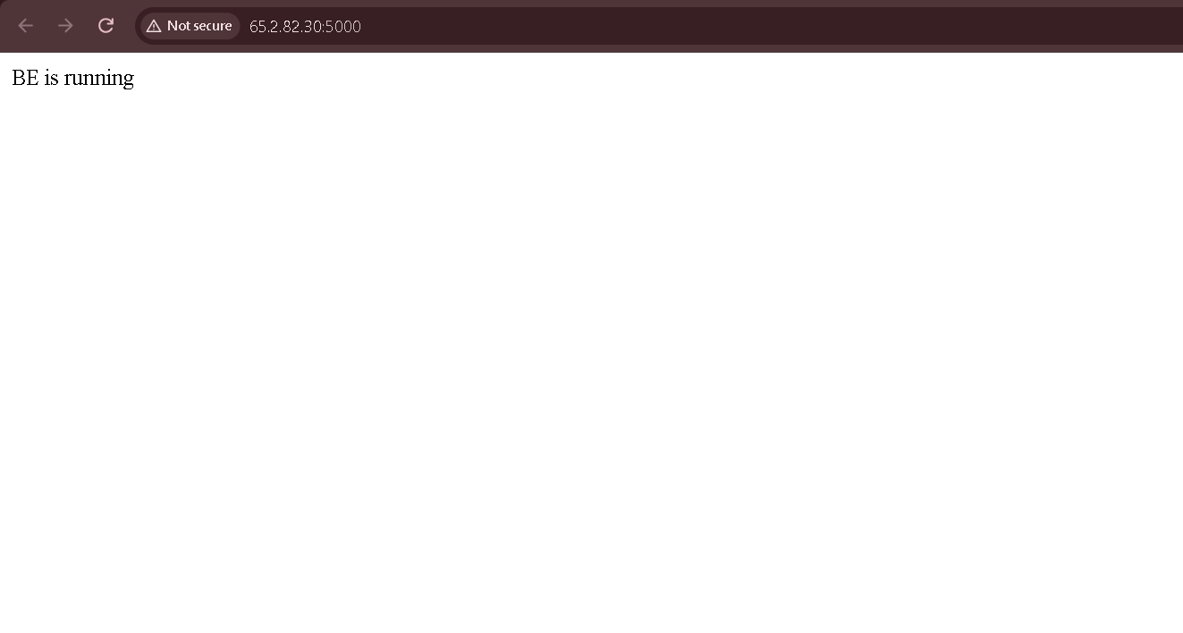

Frontend

Sure. So far, for the frontend + AWS backend connection, we did:
- Opened the admin frontend folder
  - Confirmed React/Vite frontend structure.
- Checked .env.example
  - Found frontend was using:
http://localhost:5000/api
- Created admin/.env
  - Changed the API URL to the EC2 backend:
VITE_API_URL=http://13.127.216.14:5000/api
- Tested frontend
  - Frontend initially couldn't connect to backend.
- Checked EC2 backend
  - Found backend was running only on localhost:5000.
- Changed backend to listen publicly
  - Changed:
app.listen(PORT, '0.0.0.0', ...)
- Tested EC2 API
  - http://13.127.216.14:5000/api reached the backend successfully.
- Fixed MongoDB database connection
  - EC2 was connecting to the wrong/default database.
  - Updated MONGO_URI to use:
ai-lab-maintenance
- Restarted backend
  - MongoDB connected successfully.
  - Frontend login started working.
Current status
✅ Frontend runs locally
✅ Frontend connects to EC2 backend
✅ Backend connects to MongoDB
✅ Login works
✅ Website pages/data are visible
Next: build the frontend for production, then deploy it to AWS.
01-ec2-instance.png
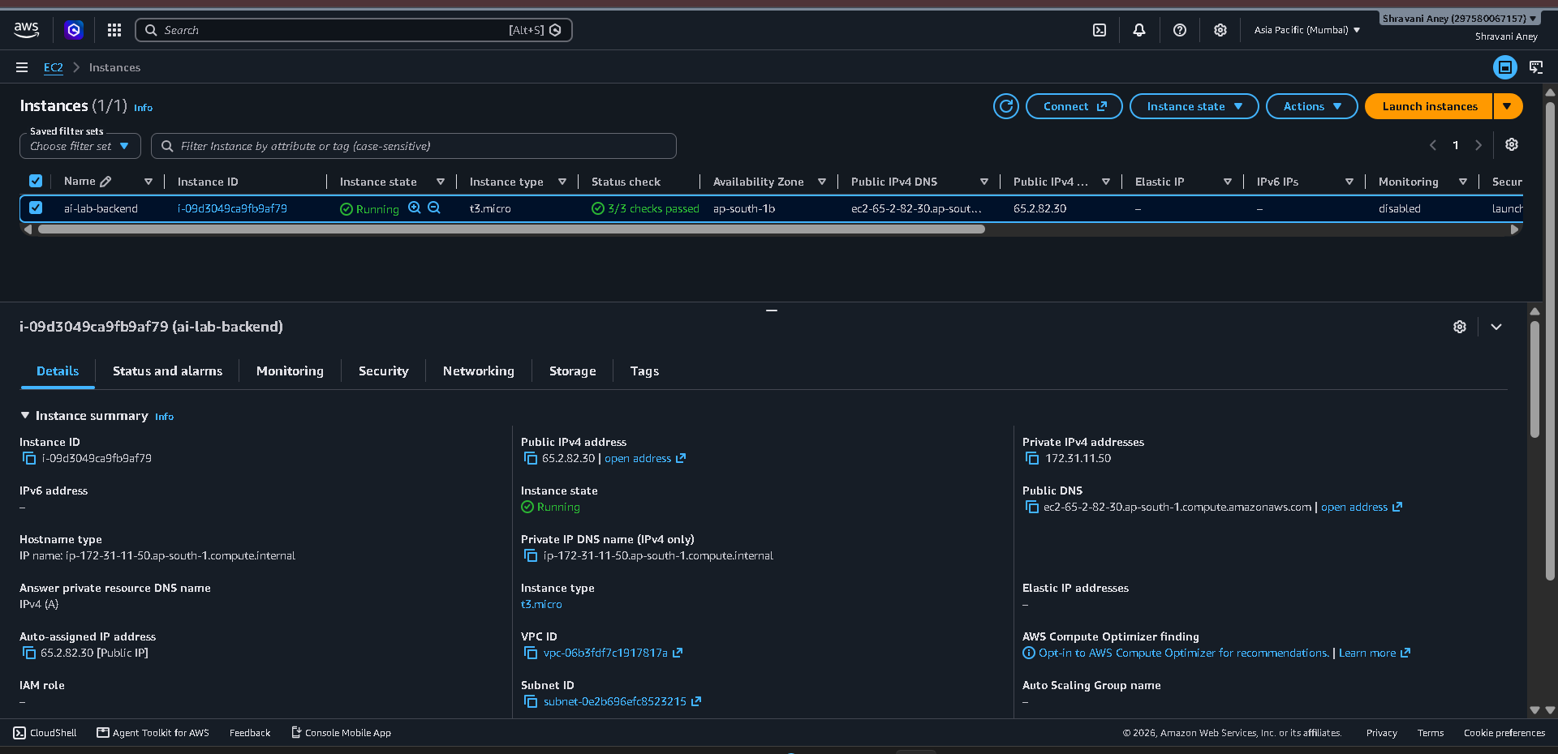

02-ec2-backend-running.png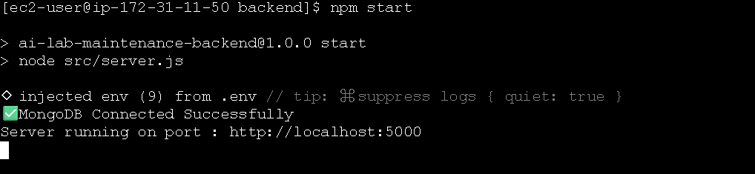

03-backend-public-api.png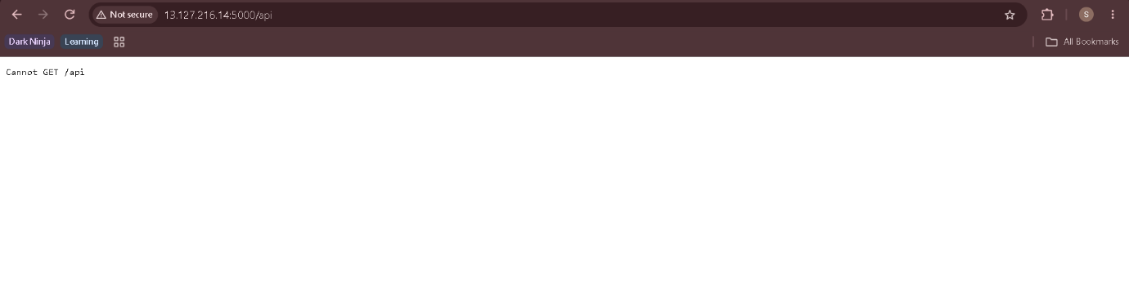

04-frontend-local.png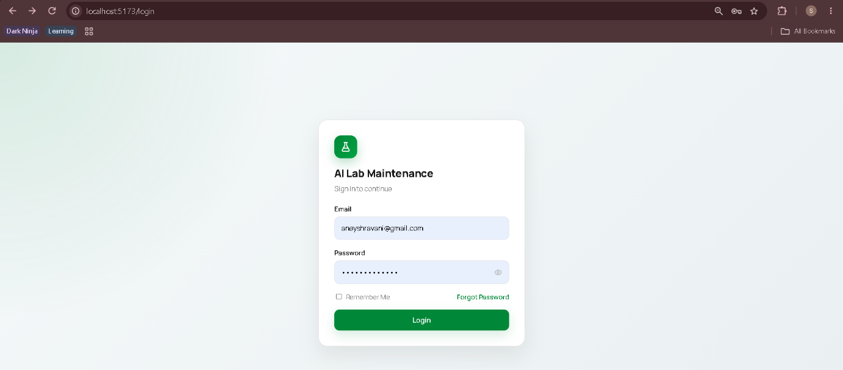
05-frontend-backend-connection.png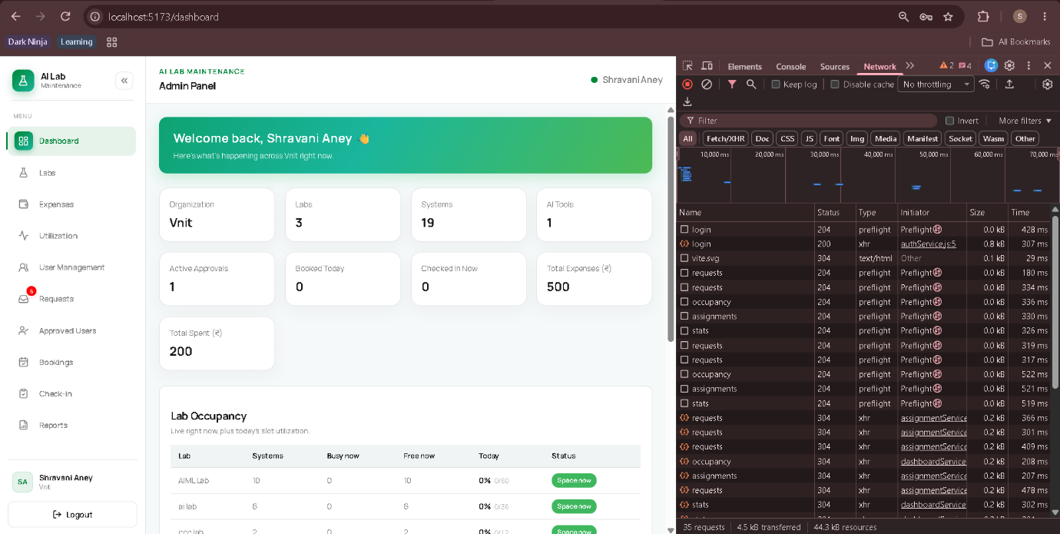
06-full-application.png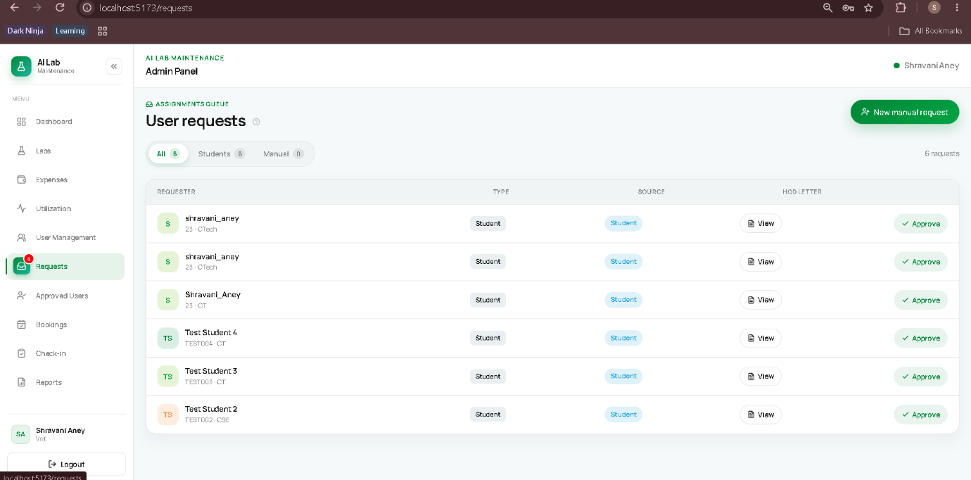

Frontend S3
1. Created S3 bucket ✅
Created:
aws-cloud-web-frontend-shravani
Region:
ap-south-1
Asia Pacific (Mumbai)
Purpose:
Host the React frontend

2. Configured public access ✅
During bucket creation, we:
- Disabled Block all public access
- Accepted AWS's public-access warning
This is required for the simple S3 static website setup we're using.

3. Enabled Static Website Hosting ✅
In:
S3 → Bucket → Properties → Static website hosting
We configured:
Static website hosting: Enabled
Hosting type: Bucket hosting
The bucket website endpoint is:
http://aws-cloud-web-frontend-shravani.s3-website.ap-south-1.amazonaws.com

4. Checked the frontend technology ✅
Your frontend is:
React
Vite
From package.json:
"dev": "vite"
"build": "vite build"
"preview": "vite preview"
Therefore the production build will be created using:
npm run build

5. Checked frontend → backend configuration ✅
We searched the frontend for localhost.
We found that the frontend uses:
VITE_API_URL
And your actual frontend configuration is already:
VITE_API_URL=http://13.127.216.14:5000/api
So we did not need to change it.

6. Verified the EC2 backend independently ✅
We discovered the backend had stopped running.
We started it again with:
npm start
Then tested:
http://13.127.216.14:5000
And got:
BE is running
So the backend is publicly reachable.

Current status
S3 bucket ✅
S3 public access ✅
S3 website hosting ✅
Frontend API URL ✅
EC2 backend ✅
EC2 public API connectivity ✅

Production frontend build ⏳ NEXT
Upload dist/ to S3 ⏳
Open deployed frontend ⏳
Frontend → EC2 API test ⏳
Final end-to-end test ⏳

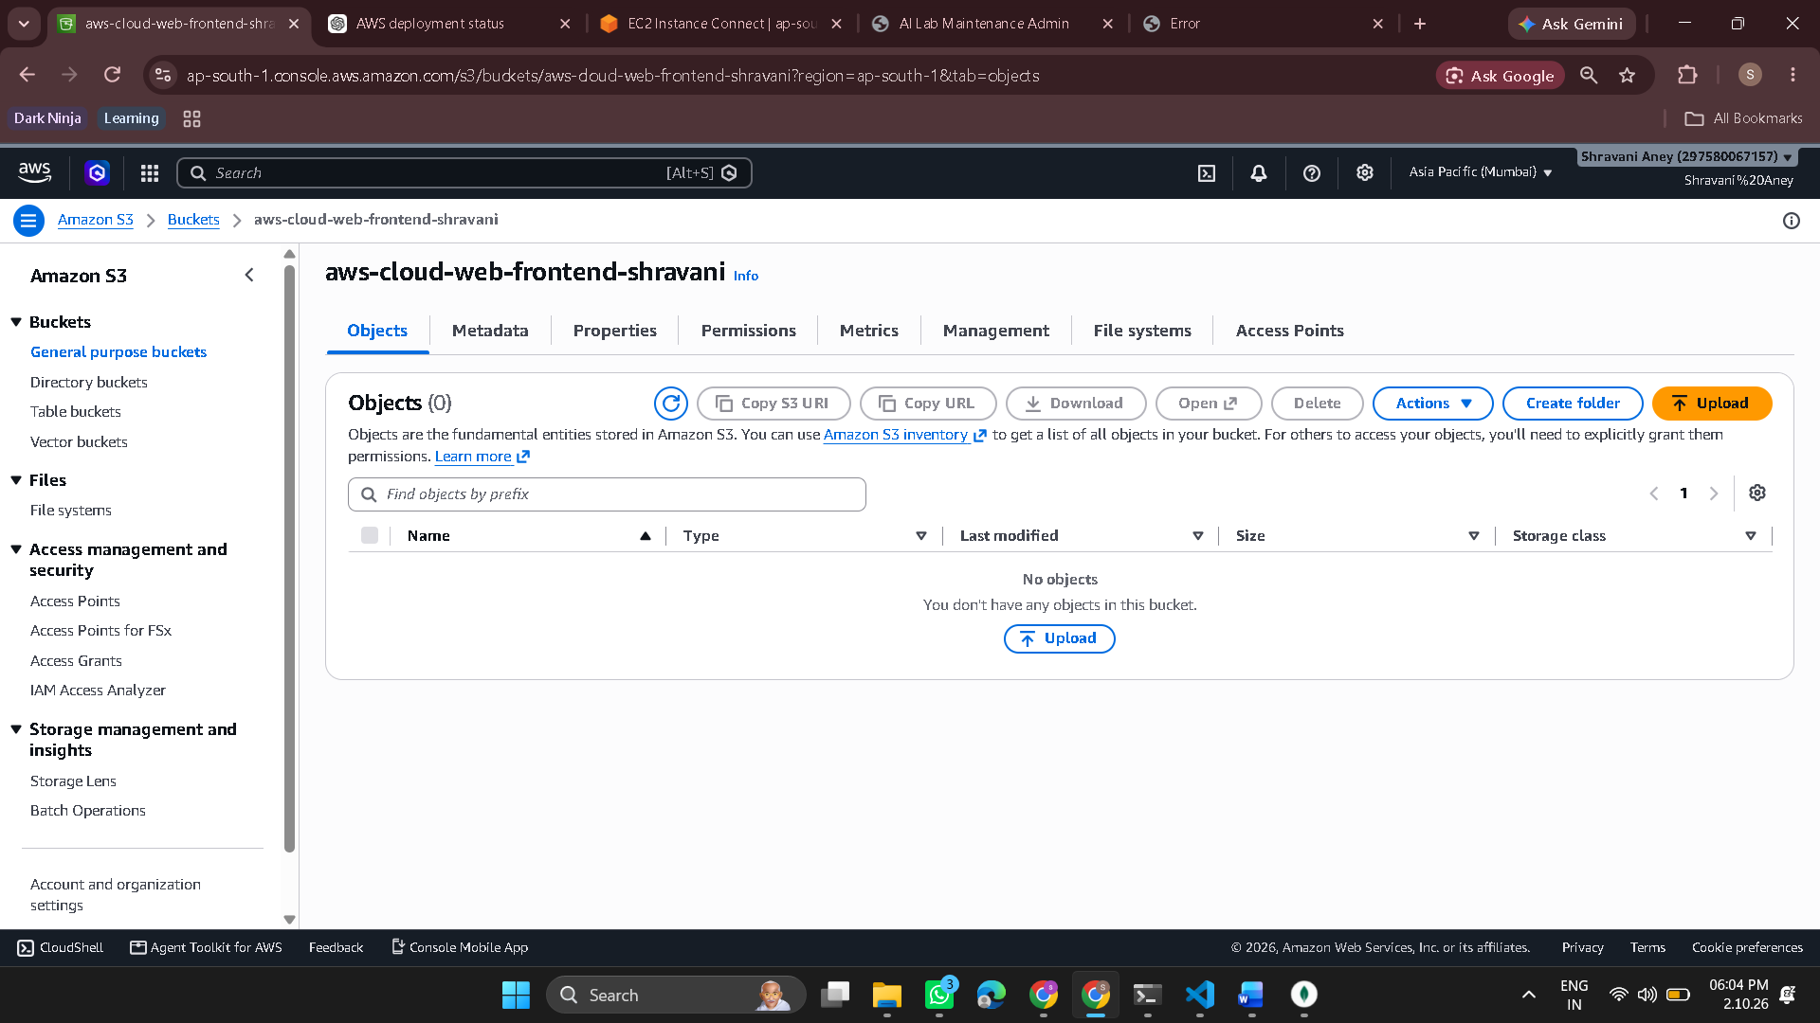
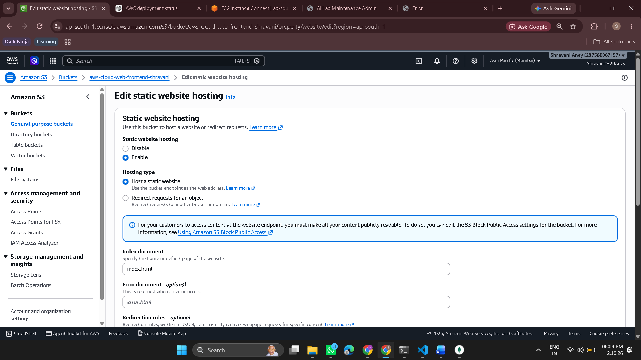
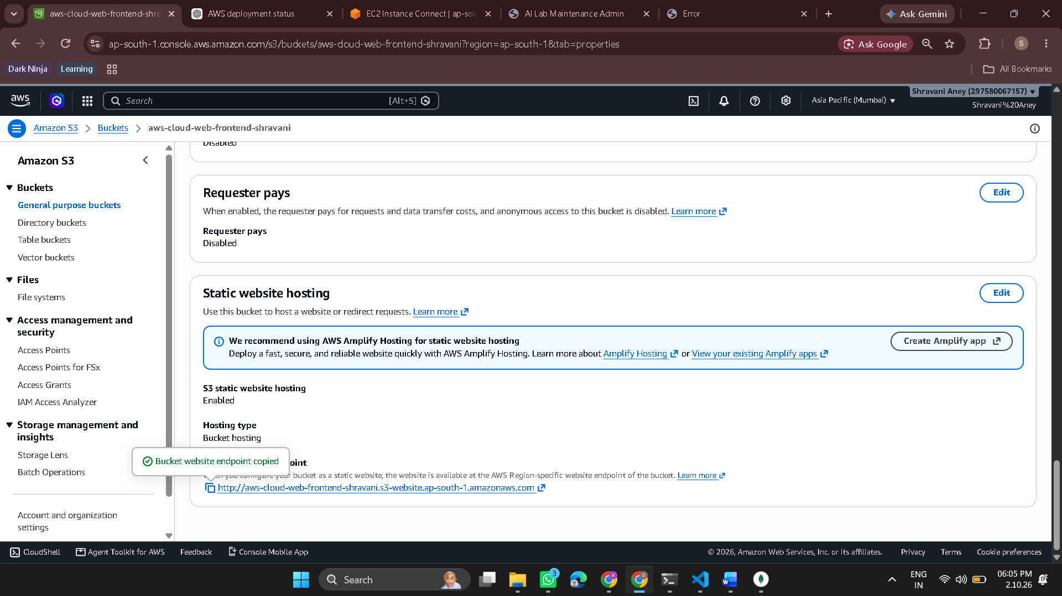
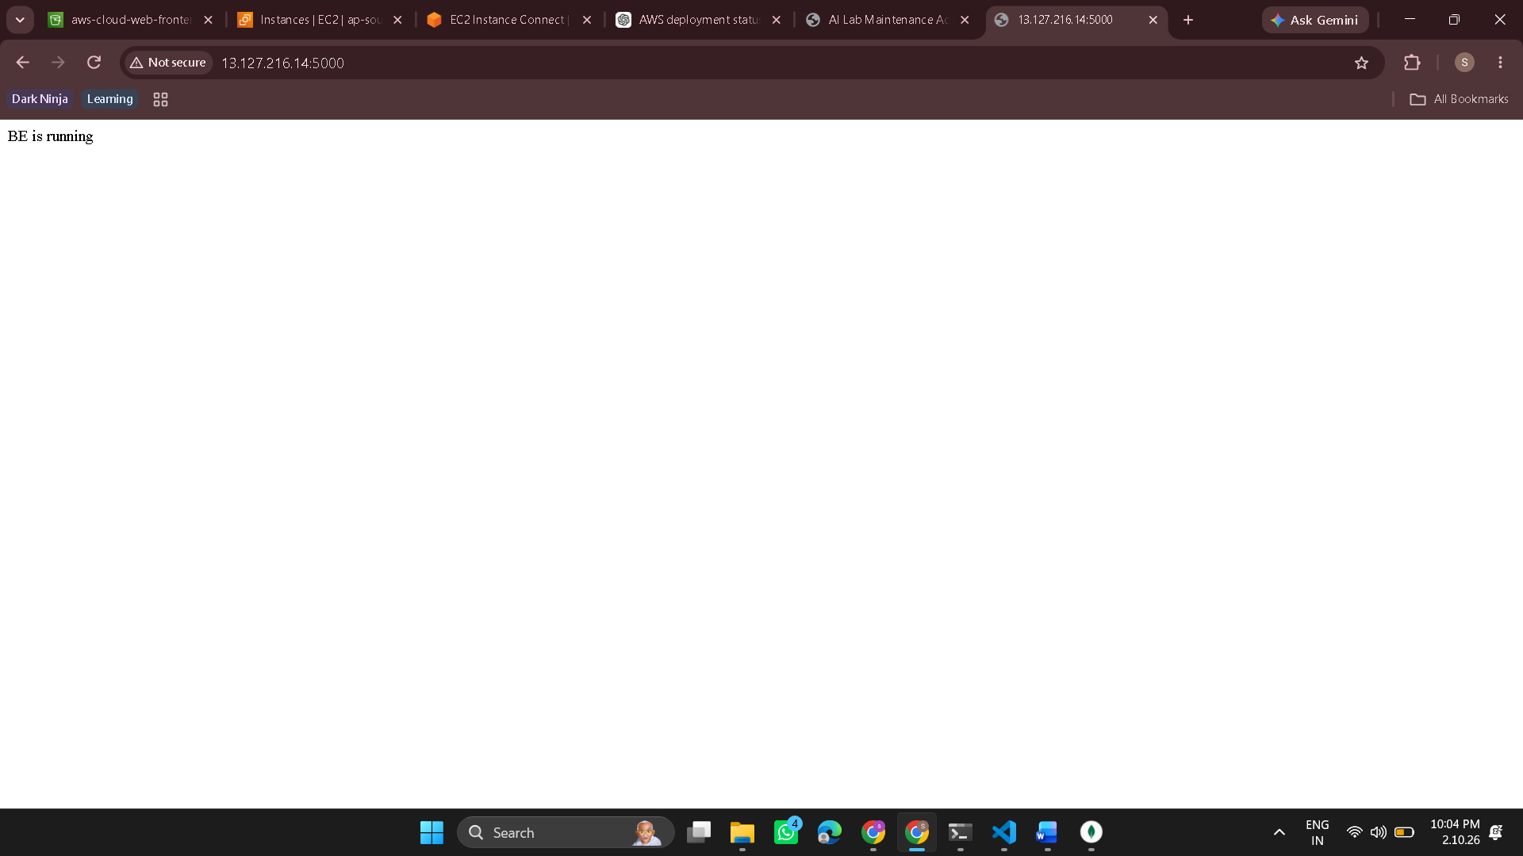
Step 7 → Build the React frontend
In your VS Code terminal, inside:
ai-lab-maintainence/admin
run:
npm run build
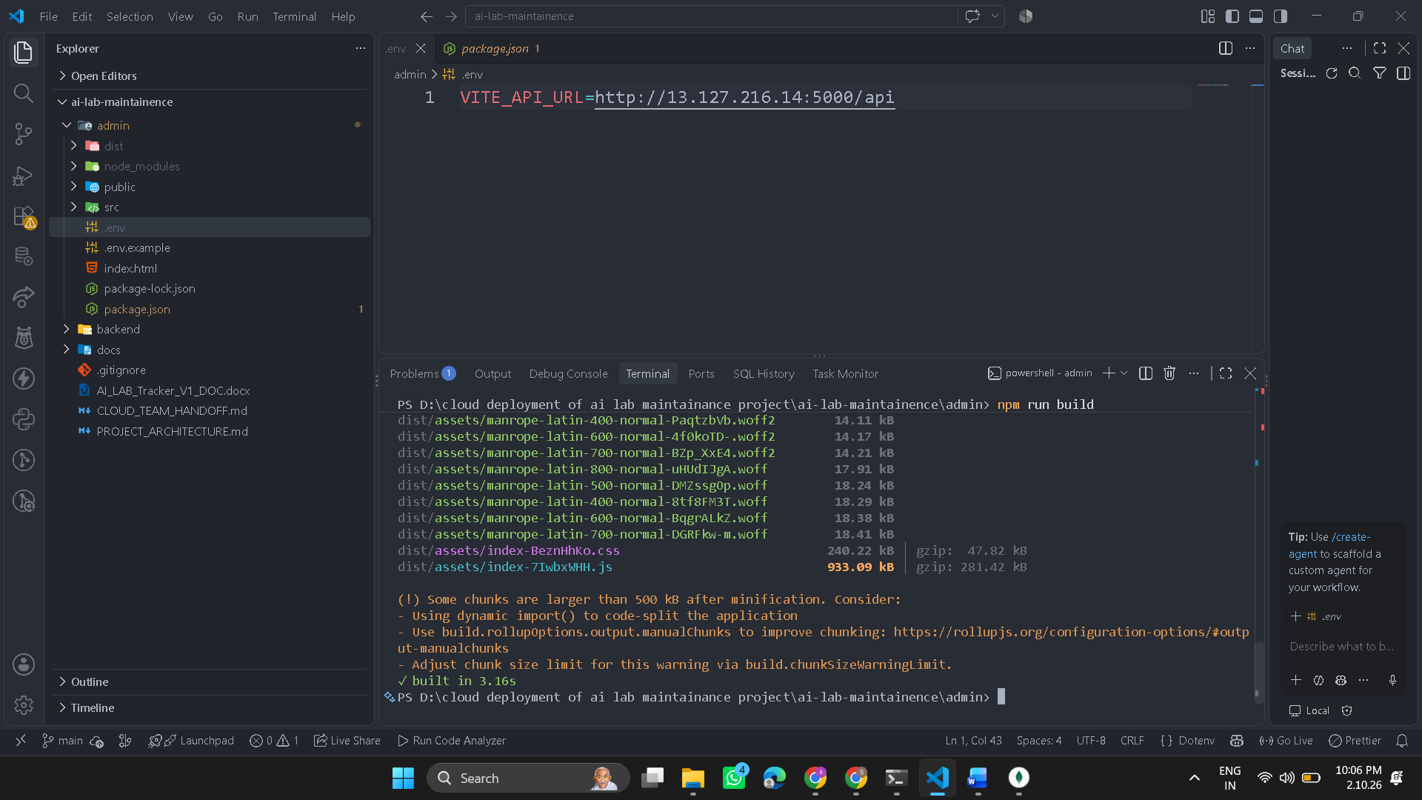
Step 6 — Upload dist contents to S3
Now go back to:
AWS Console → S3 → aws-cloud-web-frontend-shravani → Objects
- Click Upload.
- Open this folder on your PC:
D:\cloud deployment of ai lab maintainance project\ai-lab-maintainence\admin\dist
- Select everything INSIDE dist:
  - index.html
  - assets folder
⚠️ Important: Don't upload the dist folder itself.
You want S3 to look like:
aws-cloud-web-frontend-shravani/
├── index.html
└── assets/
├── index-....js
├── index-....css
└── ...
Not:
aws-cloud-web-frontend-shravani/
└── dist/
├── index.html
└── assets/
- Click Upload.
- Wait until AWS says the upload succeeded.
Stop after the upload.
Step 6A — Upload them
Before clicking anything, verify the AWS page shows:
Files and folders: 53 total
Destination: s3://aws-cloud-web-frontend-shravani
Then click:
Upload

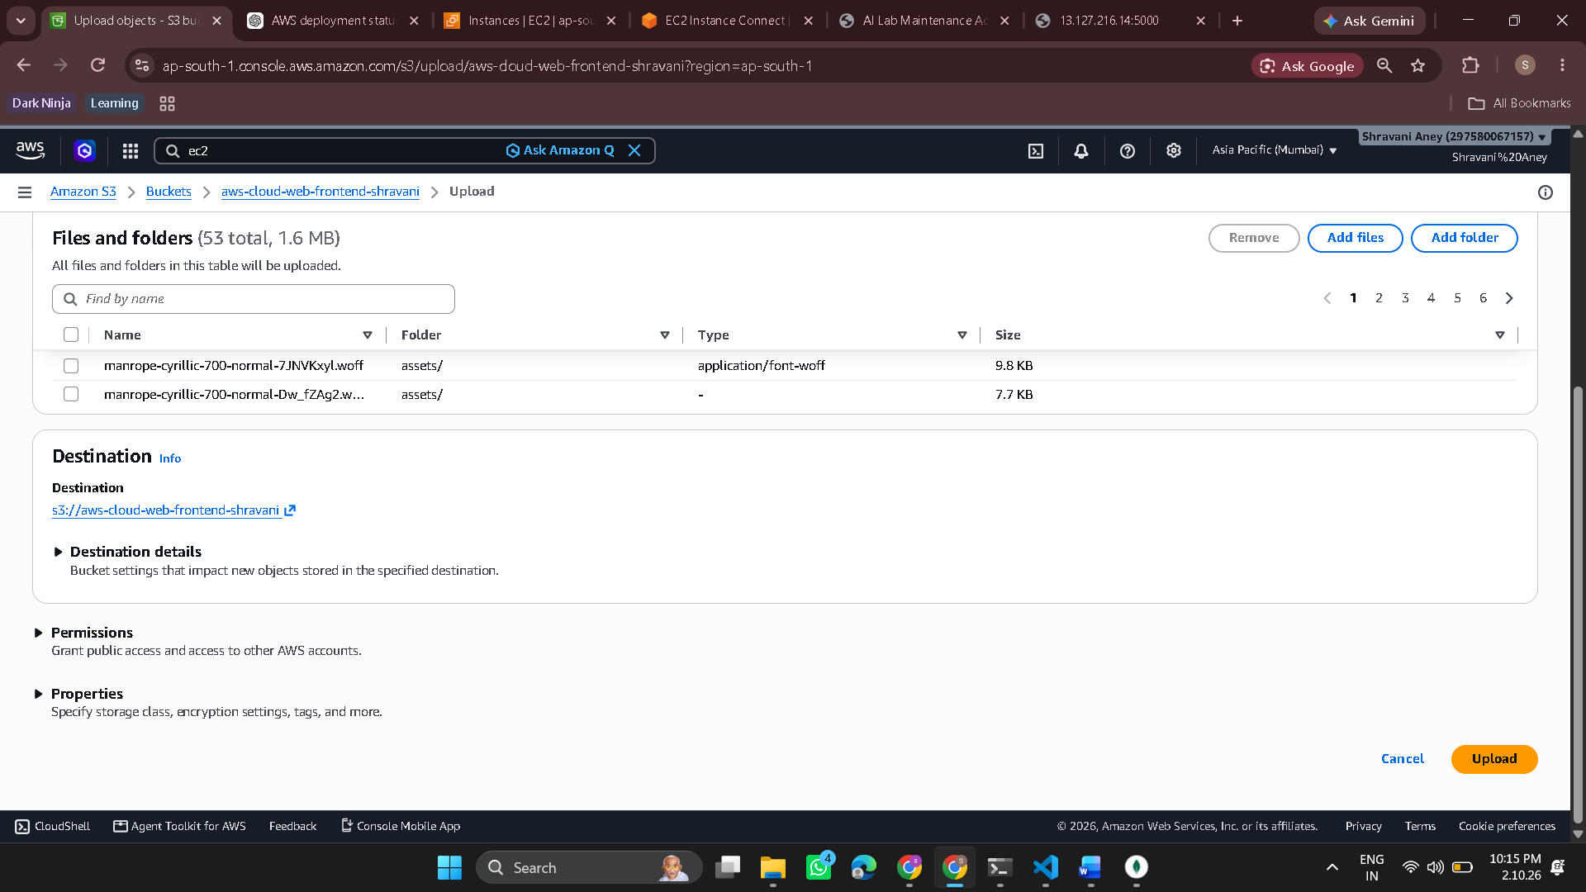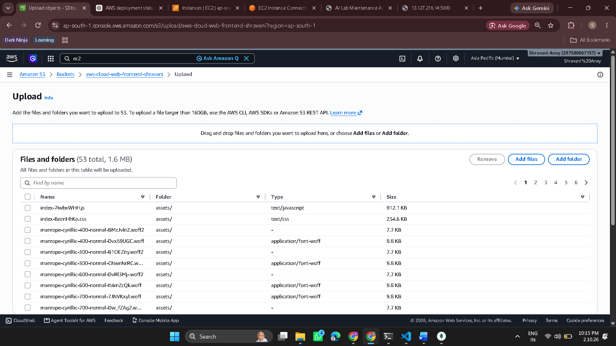
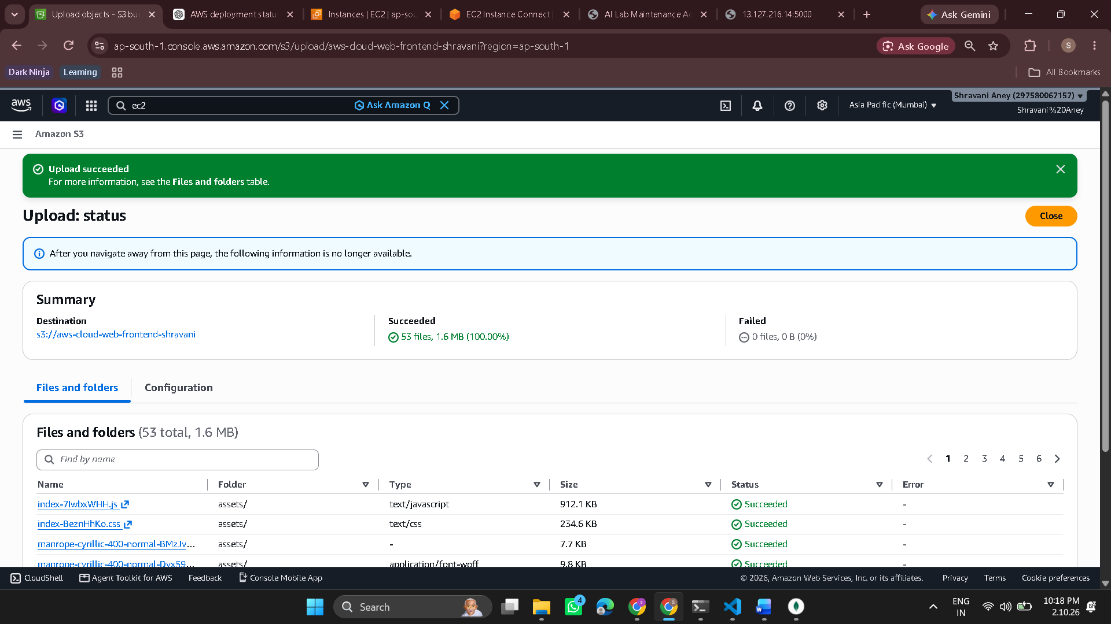
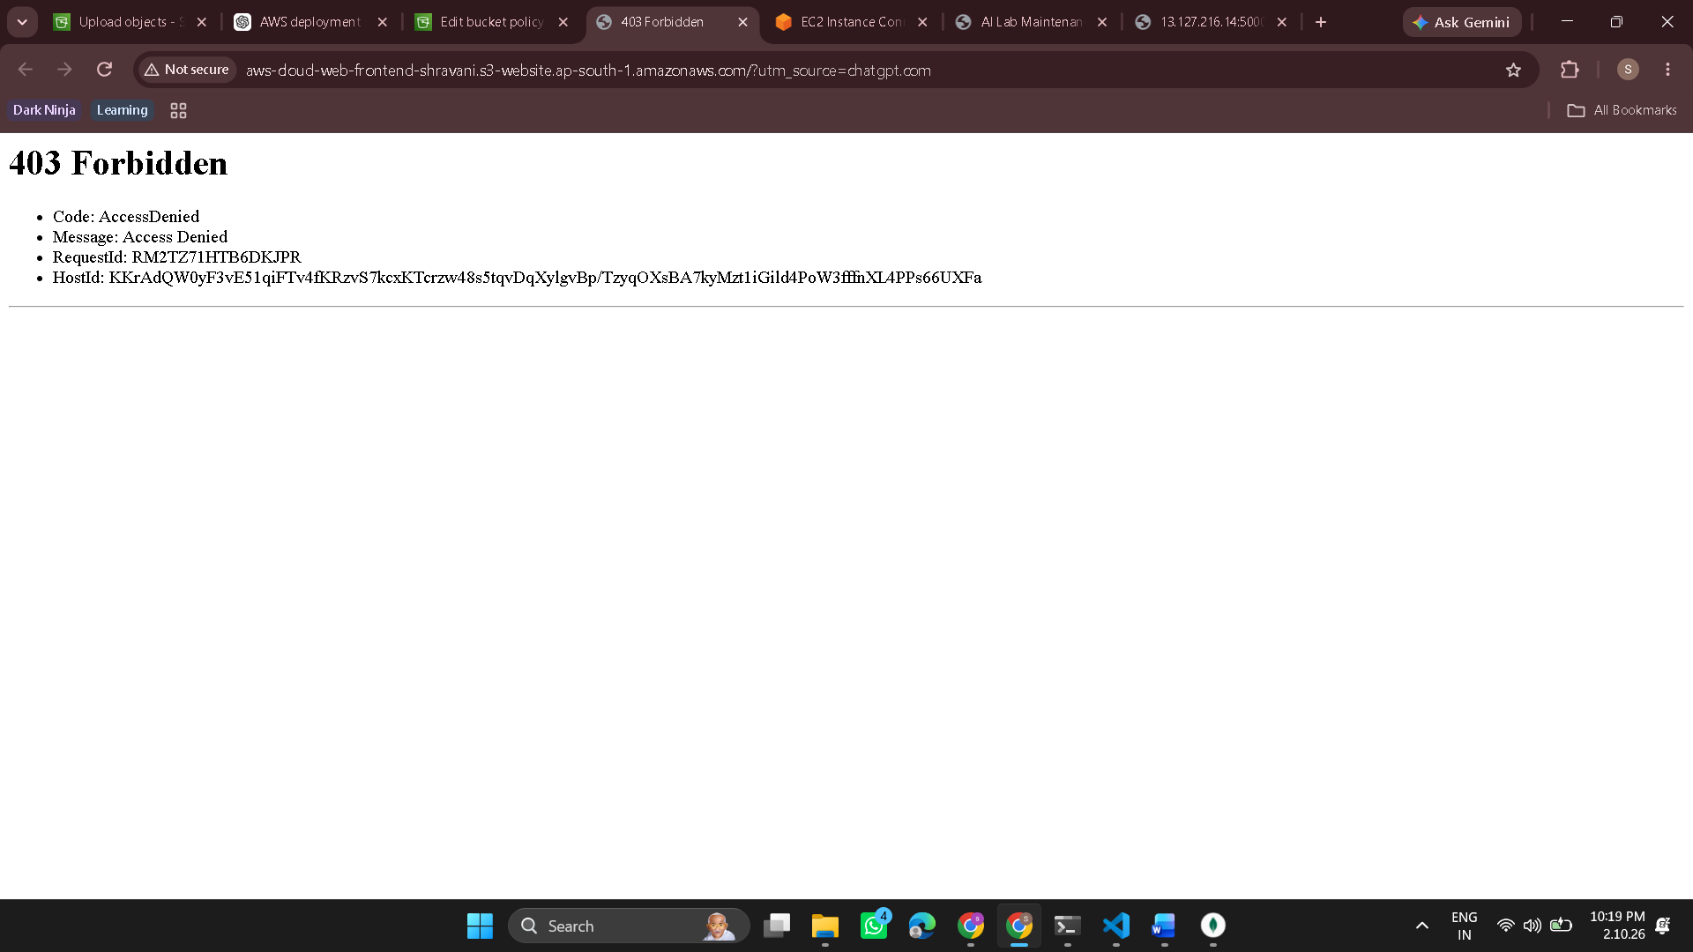
Yes — 403 AccessDenied means the S3 bucket is not allowing public read access yet. We need to add a bucket policy.
Step 1 — Open the bucket
In AWS Console:
S3 → General purpose buckets → aws-cloud-web-frontend-shravani
Then:
Permissions tab → scroll down to Bucket policy → Edit
You should see a large policy text box.
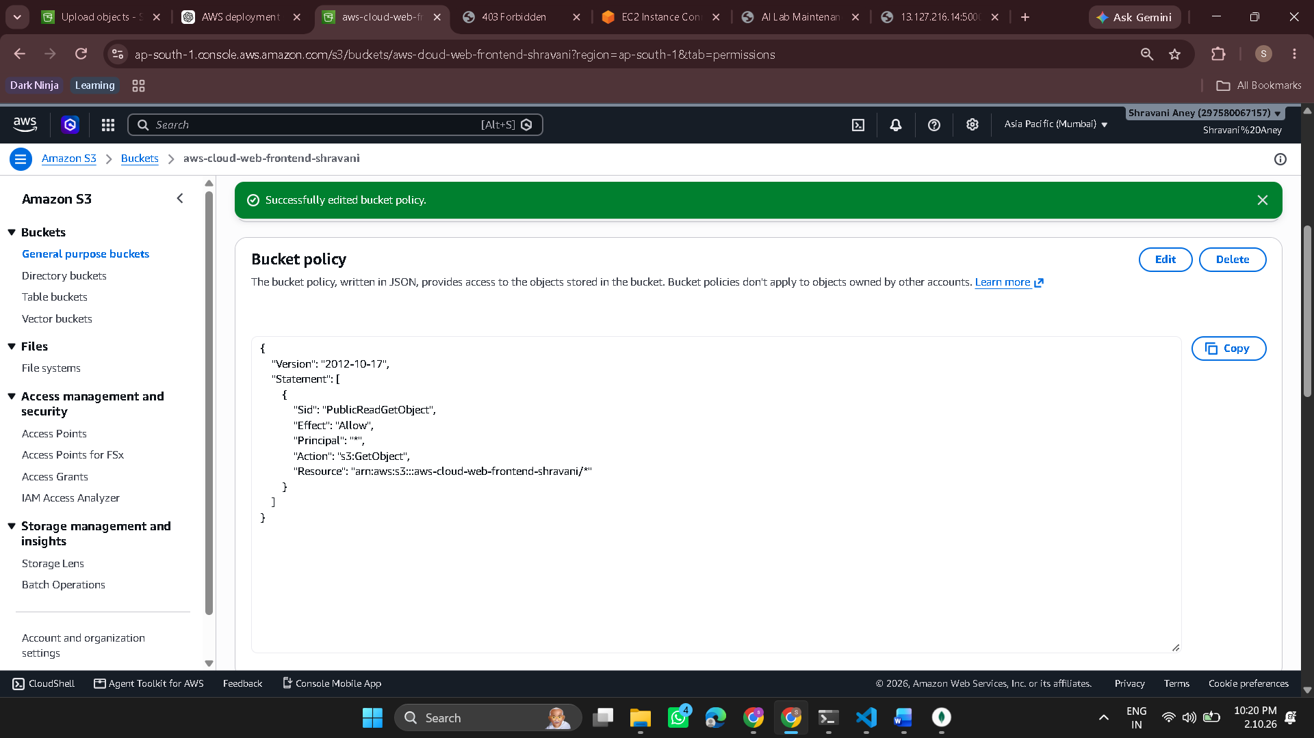
Step 2 — Paste this policy
In the Bucket policy → Edit box, paste:
{
"Version": "2012-10-17",
"Statement": [
{
"Sid": "PublicReadGetObject",
"Effect": "Allow",
"Principal": "*",
"Action": "s3:GetObject",
"Resource": "arn:aws:s3:::aws-cloud-web-frontend-shravani/*"
}
]
}
Then click Save changes.
Step 3
Open your S3 website endpoint again:
http://aws-cloud-web-frontend-shravani.s3-website.ap-south-1.amazonaws.com
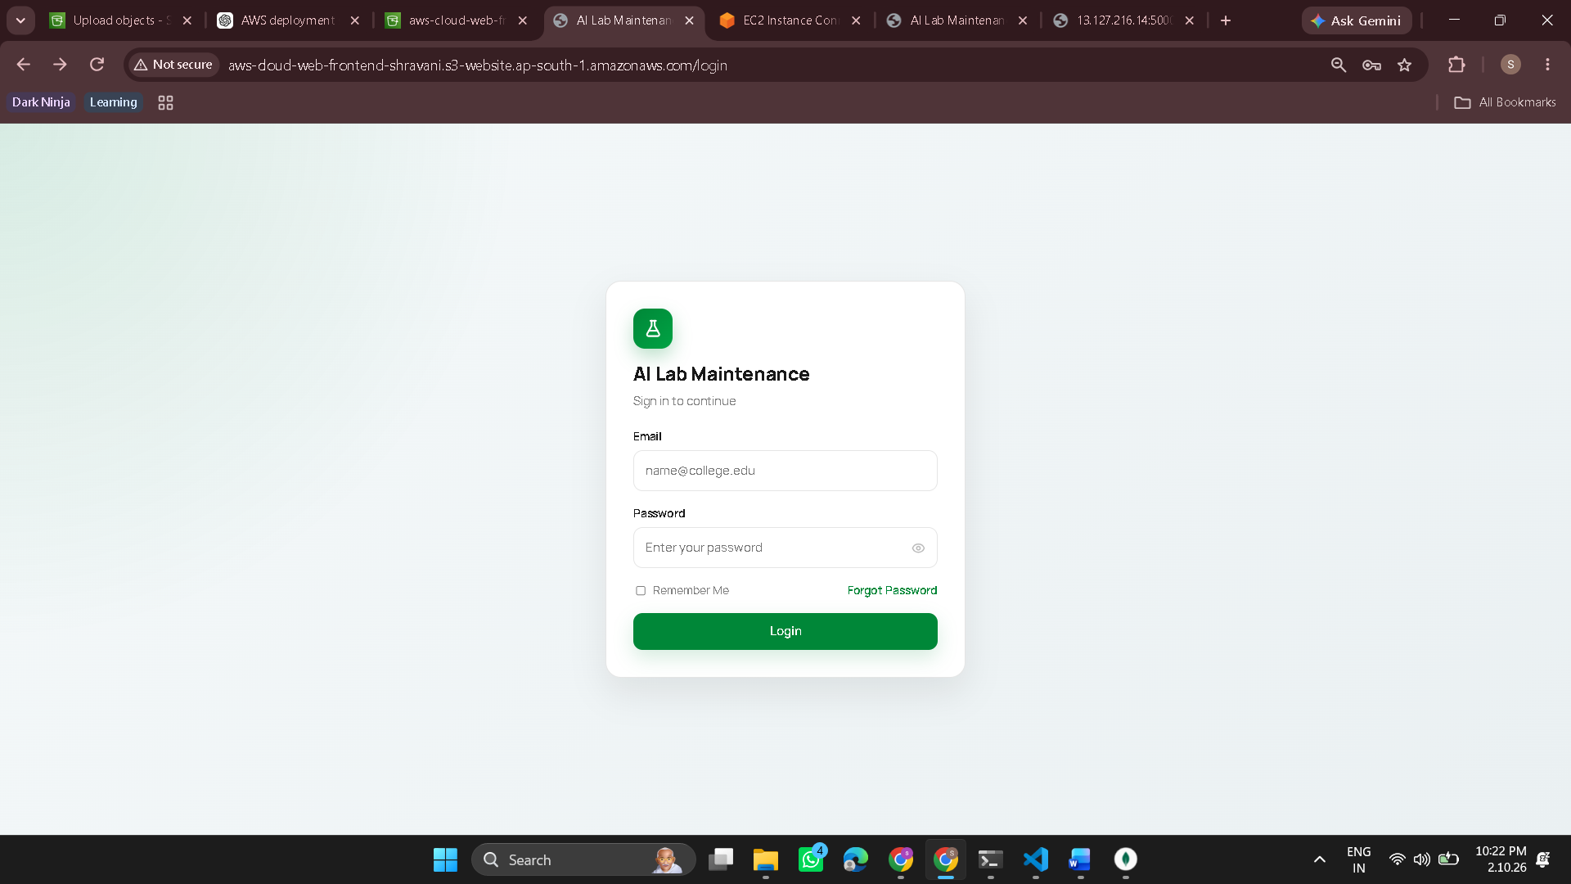
AWS deployment status
Component | Status
React frontend | ✅ Built
S3 hosting | ✅ Working
S3 public access | ✅ Working
EC2 backend | ✅ Running
MongoDB Atlas | ✅ Connected
Frontend → Backend API | ✅ Working
Login/authentication | ✅ Working
Application data | ✅ Loading
So yes — your complete application is now deployed on AWS. 🎉

AWS EC2 Backend — PM2 Persistent Deployment
Step 1 — Keep the existing backend running
In Terminal 1, your backend should already be running:
Server running on port : http://localhost:5000
Do not press Ctrl+C yet.
Open a second PowerShell/SSH terminal and connect to the same EC2 instance.
You should see:
[ec2-user@ip-172-31-11-50 ~]$

Step 2 — Install PM2
In Terminal 2:
npm install -g pm2
Verify installation:
pm2 -v

Step 3 — Navigate to the backend
cd ~/aws-cloud-web-deployment/backend
Check the location:
pwd
Expected:
/home/ec2-user/aws-cloud-web-deployment/backend

Step 4 — Start the backend with PM2
Run:
pm2 start npm --name "ai-lab-backend" -- start
Then:
pm2 status
Expected:
name status
ai-lab-backend online
This means PM2 is now managing your backend process.

Step 5 — Save the PM2 process list
Run:
pm2 save
Expected:
[PM2] Successfully saved
Then:
pm2 status
Make sure:
ai-lab-backend online

Step 6 — Verify PM2 is actually serving the backend
Run:
curl http://localhost:5000
Expected:
BE is running
This proves the PM2-managed process is responding.

Step 7 — Stop the original npm start
Now go to Terminal 1, where the original backend was running.
Press:
Ctrl + C
This stops the original manually started process.
Do not close Terminal 2.

Step 8 — Prove PM2 took over
Return to Terminal 2:
curl http://localhost:5000
Expected:
BE is running
This is an important deployment proof.
It demonstrates that the backend doesn't depend on Terminal 1 remaining open.

Step 9 — Configure PM2 to start after EC2 reboot
Run:
pm2 startup
PM2 will give you a command specific to your system.
For your EC2 instance, it produced:
sudo env PATH=$PATH:/home/ec2-user/.nvm/versions/node/v22.23.3/bin /home/ec2-user/.nvm/versions/node/v22.23.3/lib/node_modules/pm2/bin/pm2 startup systemd -u ec2-user --hp /home/ec2-user
Run the exact command PM2 displays.
Expected result includes:
Created symlink /etc/systemd/system/multi-user.target.wants/pm2-ec2-user.service
and:
[PM2] [v] Command successfully executed.

Step 10 — Save the process list again
After configuring startup:
pm2 save
Expected:
[PM2] Successfully saved in /home/ec2-user/.pm2/dump.pm2
Then:
pm2 status
Expected:
ai-lab-backend online

Final architecture
Your backend is now:
Internet
↓
AWS EC2
↓
Node.js / Express
↓
PM2
↓
ai-lab-backend
↓
MongoDB Atlas
And PM2 is configured as:
EC2 starts
↓
systemd
↓
PM2 starts
↓
ai-lab-backend starts
What you can now claim in your project
You have actually implemented:
- AWS EC2 backend deployment
- Node.js/Express backend hosting
- MongoDB Atlas connectivity
- Environment configuration
- Security-group port configuration
- PM2 process management
- PM2 automatic startup using systemd
- Persistent backend process after SSH terminal closure
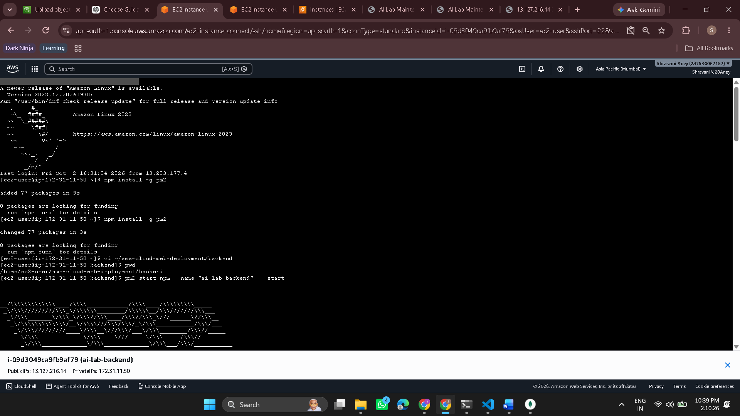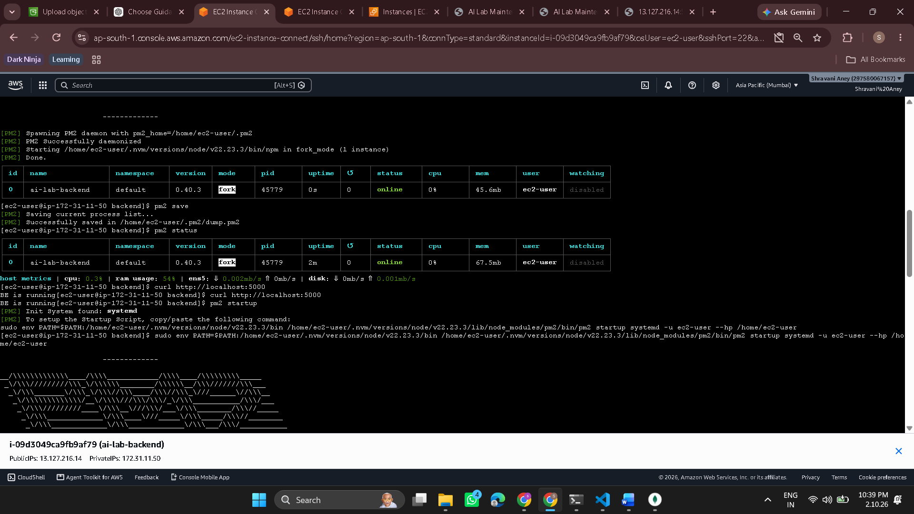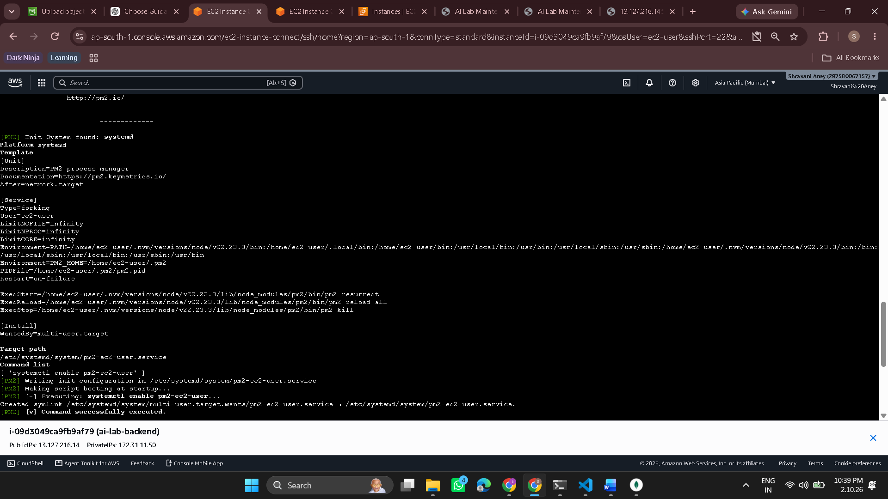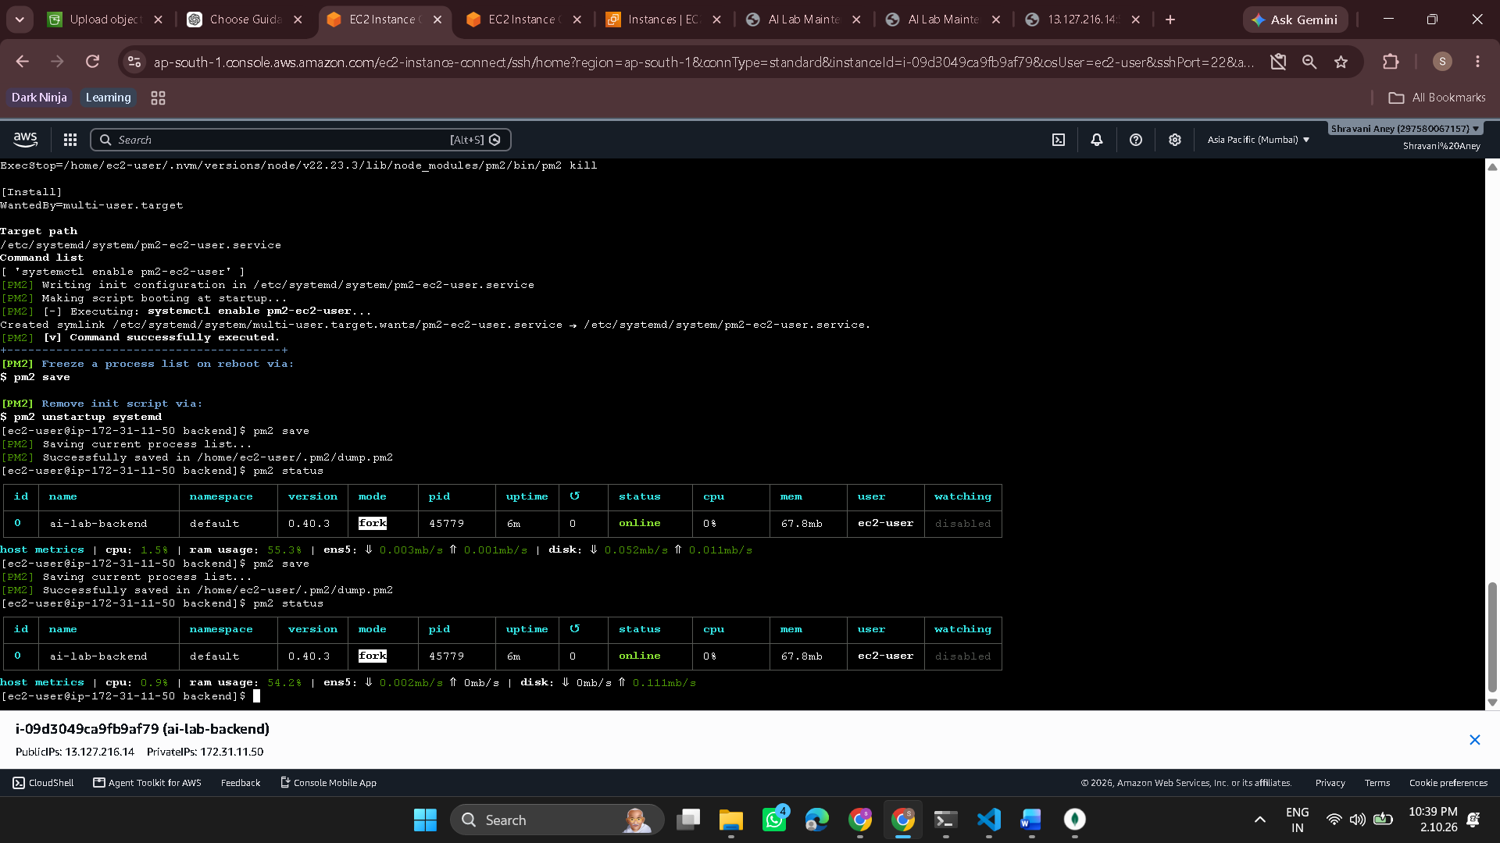

PM2
**PM2 is a process manager for Node.js applications.**

Think of it like a **supervisor for your backend**.

Without PM2:

```text
You run:
npm start

↓

Node.js backend runs

↓

You close SSH / terminal
↓
Backend may stop ❌
```

With PM2:

```text
PM2
↓
Node.js backend
↓
Keeps it running
```

### What PM2 does for your project

You used:

```bash
pm2 start npm --name "ai-lab-backend" -- start
```

This tells PM2:

> "Run my backend's `npm start` command and manage it under the name `ai-lab-backend`."

Then:

```bash
pm2 status
```

shows:

```text
ai-lab-backend online
```

### The important benefits

**1. Keeps the backend running**

You don't need to keep an SSH terminal displaying `npm start`.

**2. Restarts the application if it crashes**

PM2 can automatically restart a managed Node.js process.

**3. Starts it after server reboot**

We configured:

```text
EC2 reboot
↓
systemd
↓
PM2
↓
ai-lab-backend
```

So the backend can automatically come back after an EC2 reboot.

**4. Gives you process monitoring**

For example:

```bash
pm2 status
```

shows status, PID, uptime, CPU and memory.

You can also see logs with:

```bash
pm2 logs
```

---

### Interview answer

If an interviewer asks:

> **"Why did you use PM2?"**

Don't say only *"to run the backend."*

Say:

> **"PM2 is a Node.js process manager. I used it to keep my Express backend running on EC2, automatically restart it if it fails, monitor the process, and configure it to start automatically when the EC2 instance reboots."**

That's the level of understanding you should have for this project.

