Decision Memo: The Smart Reminder Experiment
To: Injaz Product Lead | From: Data Science | Re: National launch decision

Recommendation: Ship nationally
The smart reminder should be rolled out to all eligible Injaz users. In a properly randomized experiment (n = 8,262, 5-day horizon), the reminder raised session completion by 12.32 percentage points (95% CI [10.31, 14.34], p < 0.0001) — the lower bound of the interval alone clears the pre-agreed 2 pp practical-significance bar by a wide margin. The guardrail metric, support-call volume, moved in the acceptable direction, and every design-credibility check we could run on this dataset came back clean.

The decision, the estimand, and the design
The question: should Injaz turn the reminder on for everyone, or hold? The estimand is the average treatment effect of the reminder on the probability a user completes the service session they started, for the population of Injaz users who begin an online session (sampled from the 20,000-user pool; the experiment itself randomized 8,262 of them). We could not answer this by comparing an opt-in toggle's users to non-users before/after: users who opt in are also the users who already complete more (prior_completion_rate is a strong pre-treatment confounder of both who opts in and who finishes), so that comparison conflates selection with the reminder's effect. We instead ran a completely randomized experiment — an independent coin flip per user — which severs that confounding path by design and requires no covariate adjustment to be valid. See the DAG below.
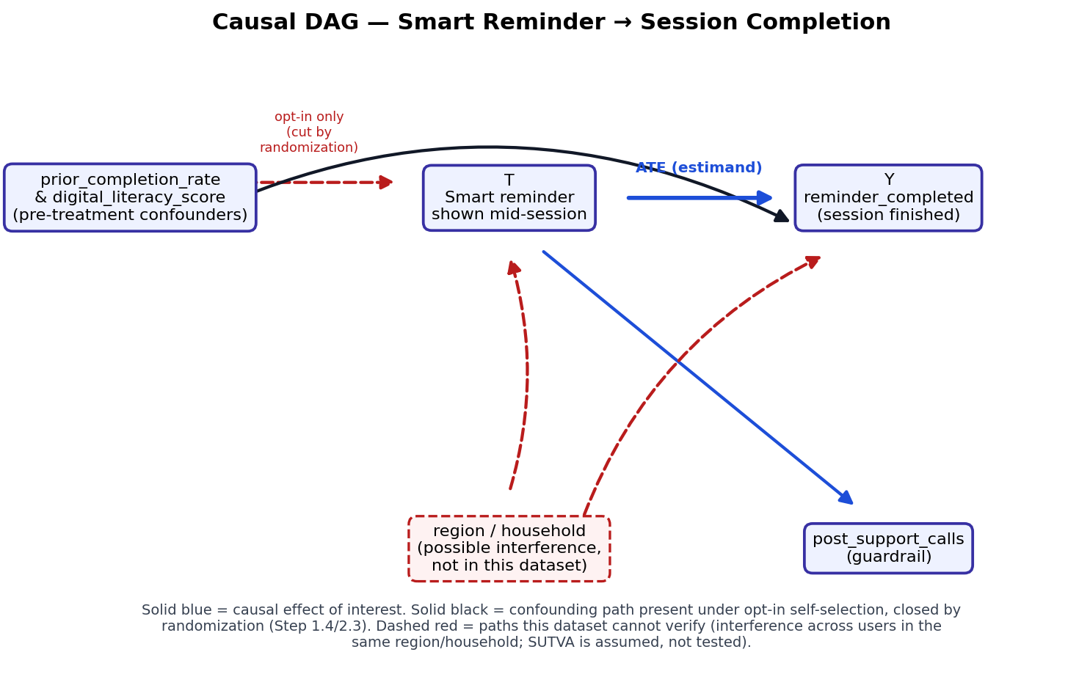

Results at a glance
Metric | Estimate (95% CI) | Read
Primary (OEC): completion lift | +12.32 pp [+10.31, +14.34] p<0.0001 | Clears the 2 pp practical bar at the CI lower bound
Guardrail: support calls (CUPED) | -0.173 [-0.208, -0.138] | Moves the right way (fewer calls)
Covariate balance | max |SMD| = 0.025 | Well under the 0.10 rule of thumb
Pipeline checks | SRM p=0.64, A/A p=1.00 | No mismatch, no spurious win
Sensitivity (E-value) | 2.27 (point), 2.08 (CI bound) | Confounding this strong is implausible under randomization

Threats to this conclusion
Threat | Status | Evidence
Sample-ratio mismatch | Clean | Chi-square p = 0.644
Covariate imbalance | Clean | Max |SMD| = 0.025 across 6 covariates
Peeking / optional stopping | Controlled | Naive peeking FPR 14.8%; always-valid boundary brings it to 1.0%
Multiple comparisons | Controlled | One pre-registered OEC + one guardrail; subgroup checked was pre-registered
Interference (SUTVA) | NOT verifiable | Same-region/household spillover cannot be ruled out from this data
Novelty / primacy effects | NOT verifiable | Effect measured over a single ~5-day window

Before a national launch, we recommend a short staggered rollout (e.g., by region, one week apart) to give a cheap read on interference and novelty effects without re-running the full experiment.

Why the earlier opt-in number would have been the wrong one to bring here
An opt-in “early access” comparison of the reminder produced a +16.20 pp difference — a 1.28x overstatement of the true effect — because users who opted in already had much higher prior completion rates (standardized mean difference 0.588 between opt-in and non-opt-in groups) than users who didn't. That comparison has its own p-value, but the p-value answers “do these two groups differ,” not “did the reminder cause it.” Randomization is what lets those two questions coincide, which is why only the randomized estimate belongs in this memo.

Open question for next time
Injaz also wants to know whether its already-live digital-literacy training program is helping the users who took it — but nobody was randomized into that program, so an A/B-style estimate isn't available. That calls for an observational causal method; doubly-robust estimation would be the first choice, since it stays consistent if either the enrollment (propensity) model or the outcome model is correctly specified, rather than betting the entire analysis on one functional form.

