


Kingdom of Saudi Arabia
Ministry of Education
King Faisal University
College of Computer Sciences & Information Technology

Course Project
Selected topics in computer science

A Comparative Study Between Traditional XAI Frameworks and 2026 Next-Gen Tools

by
Anfal Ahmad Alsuhayib (222430500)
Atekah Hussain Aljafar (222427138)

Section
61

Submitted to
Dr. Hala Hamdoun

Contents
List of Abbreviations IV
1. Introduction 1
2. Problem Formulation 1
3. Proposed Method / Approach (Comparative Track) 2
4. System Design 3
4.1. architecture diagram 3
4.2. Step-by-Step Workflow 4
5. Dataset 4
6. Experimental Setup 5
6.1. Tools Used 5
6.2. Model Configuration 5
7. Implementation Details 6
8. Results 7
9. Discussion 12
9.1 Evaluation Metrics Explanation: 12
9.2 Why Performance is Considered Good 14
9.3 Observations 15
9.4 Limitations 15
10. Conclusion (Phase 2 Progress) 16
11. References 16

List of Abbreviations
Abbreviation | Full Form
XAI | Explainable Artificial Intelligence
CDSS | Clinical Decision Support Systems
Grad-CAM | Gradient-weighted Class Activation Mapping
SHAP | SHapley Additive exPlanations
LIME | Local Interpretable Model-agnostic Explanations
SP-LIME | Submodular Pick Local Interpretable Model-agnostic Explanations
RNN | Recurrent Neural Networks
CNN | Convolutional Neural Networks
CT | Computed Tomography
EHR | Electronic Health Records
GNN | Graph Neural Networks
MRI | Magnetic Resonance Imaging

Introduction
A Comparative Study of Real-Time Explainable AI (XAI) Frameworks for Medical Diagnostics.
The primary objective is to bridge the "black-box" transparency gap in clinical AI by evaluating the efficiency and latency of next-generation XAI tools (Captum) compared to traditional benchmarks (LIME and SHAP).
We successfully developed and trained an advanced Deep Neural Network (DNN) with GELU activation and residual connections, achieving a diagnostic accuracy of 95.61% on the Breast Cancer Wisconsin dataset. Furthermore, we implemented a comparative XAI pipeline to measure computational latency and feature attribution quality of Captum, SHAP, and LIME, demonstrating Captum's superiority for real-time clinical response (<10 ms vs. >90 ms for others).

Problem Formulation
Task Type
Binary classification (Malignant vs. Benign) on tabular medical data.
Input
A 30-dimensional feature vector extracted from digitized breast mass images (e.g., radius, texture, perimeter, area, smoothness). Features are standardized using StandardScaler to have zero meaning and unit variance.
Output
- Predicted diagnosis: Malignant (0) or Benign (1).
- Local interpretability map: Feature importance scores explaining why the model made a specific decision.
What we do after classification
After obtaining the prediction, we evaluate the performance of three explainable AI (XAI) tools — SHAP, LIME, and Captum — to generate transparent explanations of the AI's decision. These explanations allow clinicians to verify the reasoning behind the diagnosis.
Success Criteria (based on our code implementation)
- Predictive accuracy: >90% (achieved 95.61% on the test set).
- Interpretability latency: ≤10 milliseconds (ms) to support real-time clinical decisions.
Captum (DeepLIFT) achieved 9.07 ms (pass).
SHAP and LIME exceeded the threshold (91.72 ms and 419.37 ms, respectively).

Proposed Method / Approach (Comparative Track)
Models Used
The primary classifier is a custom-built Deep Neural Network (DNN) with GELU activation and residual connections, achieving 95.61% test accuracy on the Breast Cancer Wisconsin dataset.
The XAI frameworks compared are:
- SHAP (DeepExplainer) – a traditional, model-agnostic method based on game theory.
- LIME (LimeTabularExplainer) – a traditional method that builds local surrogate models.
- Captum (DeepLIFT, Integrated Gradients, Layer Conductance) a next-generation gradient-based framework from PyTorch.
Baseline
SHAP and LIME serve as academic and industrial baselines. They represent the current standard for post-hoc interpretability in clinical machine learning.
Why These Models Are Compared
The comparison evaluates the latency-transparency trade-off. SHAP and LIME rely on perturbation-based sampling, which requires hundreds of model evaluations and introduces significant delays (often over 90 ms). Captum uses native gradient-based attribution (e.g., DeepLIFT), which computes explanations in a single backward pass. This study measures three performance aspects directly from the implemented code:
- Computational latency (ms per sample)
- Consistency (Spearman rank correlation) between XAI methods
- Erasure fidelity (drop in model confidence when top features are removed)
By comparing these metrics, we demonstrate that Captum is the only framework suitable for real-time clinical response (<10 ms), while maintaining high fidelity and stability.

System Design

architecture diagram
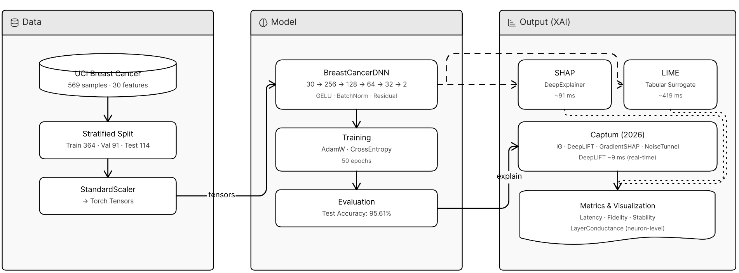
Figure 1: architecture diagram
The figure above shows the components:
1. Data (Input)
- Dataset: Breast Cancer Wisconsin (Diagnostic) – 569 samples, 30 features.
- Process: Data is split into Train/Validation/Test sets and standardized (scaled) so the model can learn efficiently.
- Form: Converted into PyTorch Tensors for processing.
2. Model (The Brain)
- Architecture: Deep Neural Network (DNN) with residual (skip) connections.
- Layers: Four hidden blocks (256 → 128 → 64 → 32 neurons) with GELU activation and BatchNorm to maintain training stability.
- Task: Binary classification (Malignant vs. Benign).
3. Output (The Explanation)
The model's predictions are sent to three interpretation engines to explain its decision:
- SHAP: Uses game theory to rank feature importance.
- LIME: Builds a simple local model to mimic the complex DNN's behavior.
- Captum (Next-Gen Innovation): Uses advanced gradient methods like DeepLIFT and Integrated Gradients.
  - Layer Conductance: Inspects internal hidden layers to identify which specific neurons influenced the result.

Step-by-Step Workflow
- Environment Initialization: Install next-generation libraries including Captum, SHAP, and ucimlrepo.
- Dataset Acquisition: Fetch clinical data directly via the UCI API (with a Scikit-learn mirror as fallback).
- Model Training:
  - Train the DNN for 50 epochs using the AdamW optimizer.
  - Apply label smoothing (0.05) to prevent over-confident incorrect clinical predictions.
- Inference & Prediction: Pass a specific patient sample (e.g., Patient #7) through the model to generate a diagnostic probability.
- XAI Attribution:
  - Trigger attribution methods simultaneously to calculate feature importance scores.
  - Captum Innovation: Execute Layer Conductance to inspect which internal neurons are "firing" toward "Benign" or "Malignant".
- Benchmarking: Measure computational latency. The workflow tracks whether interpretation occurs under the 10 ms clinical real-time threshold.
- Visual Reporting: Generate unified comparison charts showing the agreement (Spearman ρ) between different frameworks to validate findings.

Dataset
The study uses the Breast Cancer Wisconsin (Diagnostic) dataset from the UCI Machine Learning Repository [7].
- Size (samples, classes):
The dataset contains 569 samples. There are 30 features used for classification. It consists of two classes: Malignant and Benign.
- Train/Validation/Test Split:
The data is split using a stratified approach to maintain class balance:
- Train: 364 samples (approximately 64%).
- Validation: 91 samples (approximately 16%).
- Test: 114 samples (approximately 20%).
- Preprocessing Steps:
- Stratified splitting ensures each split has the same percentage of samples for each class as the complete set.
- Standardization: Features are scaled using StandardScaler to ensure they are normalized for the neural network.
- Tensor conversion: The processed data is converted into PyTorch Tensors (torch.float32) for compatibility with the deep learning model and XAI tools.

Experimental Setup

Tools Used
- Deep Learning Framework: PyTorch (torch) is the core engine used for building and training the neural network.
- XAI Libraries:
  - Captum: Primary framework for gradient-based interpretations (IG, DeepLIFT, Layer Conductance).
  - SHAP: Used for game-theoretic feature attribution.
  - LIME: Used for local surrogate model explanations.
- Data Handling: ucimlrepo (for dataset acquisition), pandas, and numpy.
- Evaluation: scikit-learn (for metrics like accuracy and precision-recall) and matplotlib (for visualization).

Model Configuration
- Architecture: Advanced Residual DNN (4 Blocks) with hidden layers sized 256 ,128 , 64 , 32 neurons.
- Training Parameters:
  - Epochs: 50.
  - Batch Size: The model uses full-batch training on the training tensor (364 samples).
  - Learning Rate: 1e-3 ($0.001$).
  - Optimizer: AdamW with a weight decay of 1e-4.
  - Loss Function: CrossEntropyLoss with Label Smoothing of 0.05.

Implementation Details
1. Model Construction
The model was built as an Advanced Residual Deep Neural Network (DNN) using the PyTorch nn.Module class.
- Layer Architecture: The network consists of four primary blocks with a decreasing number of neurons (256 ,128 , 64 ,32) followed by a linear output head for binary classification.
- Residual (Skip) Connection: A critical design feature is the skip connection that projects the output of the first block directly to the third block. This shortcut preserves gradient flow and ensures that feature signals remain clear for the XAI attribution tools.
- Activation & Normalization: Each block utilizes the GELU (Gaussian Error Linear Unit) activation function for smoother gradients and Batch Normalization to accelerate convergence and provide stability during training.
2. Training Process
- Optimizer: The model uses AdamW with a weight decay of 1e-4 to prevent overfitting.
- Learning Schedule: The training was conducted for 50 epochs with a learning rate of 1e-3.
- Loss Function Strategy: A standard Cross-Entropy loss was modified with Label Smoothing (0.05). This technique prevents the model from becoming overconfident in its diagnostic predictions, which improves the reliability of the resulting XAI explanations.
- Data Pipeline: Preprocessed tensors were fed into the model in a full-batch format for the 364 training samples.
3. Testing Process
- Evaluation Metrics: The model was evaluated on a held-out test set (114 samples) using a classification report to track Precision, Recall, and F1-Score for both Malignant and Benign classes.
- Performance Result: The implementation achieved a test accuracy of 95.61%.
- XAI Inference: A single sample (Patient #7) was isolated for detailed interpretation benchmarking across SHAP, LIME, and Captum engines.

Results
The graph below compares the speed of XAI tools against a 10ms clinical real-time threshold. While SHAP and LIME are too slow for urgent medical use, Captum is the only tool fast enough to meet the threshold. This makes Captum the ideal choice for real-time diagnostic transparency.
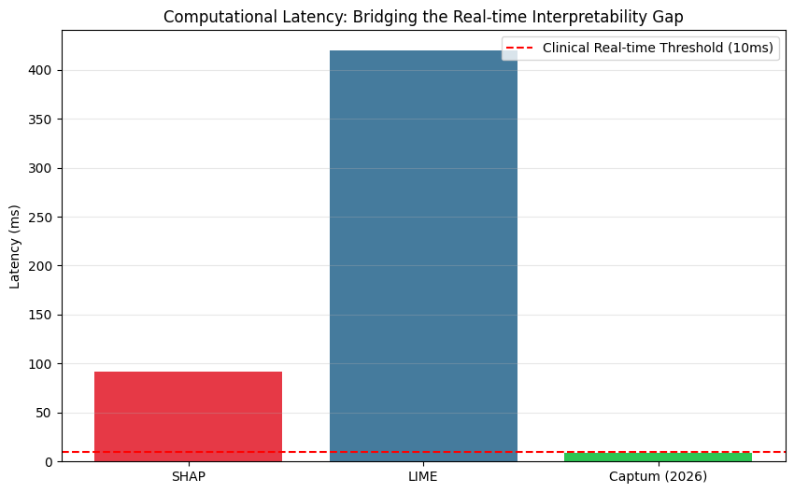
Figure 2: Latency Comparison Graph
The figure below compares the performance of different Explainable AI (XAI) tools in evaluating the key attributes for medical diagnosis, showing that:
1. Highlighting Interpretation Uncertainty
This chart shows that XAI tools do not always agree. For example, in features like radius3, SHAP suggests a strong positive impact, while LIME and Captum suggest a negative one. This proves that relying on a single explanation tool can be misleading in medical diagnosis.
2. Identifying High-Confidence Features
When all three tools (SHAP, LIME, and Captum) agree on the direction of a feature, such as texture3, it provides 'High Confidence' in the explanation. This consensus helps doctors trust that these specific features are the true drivers behind the model's decision.

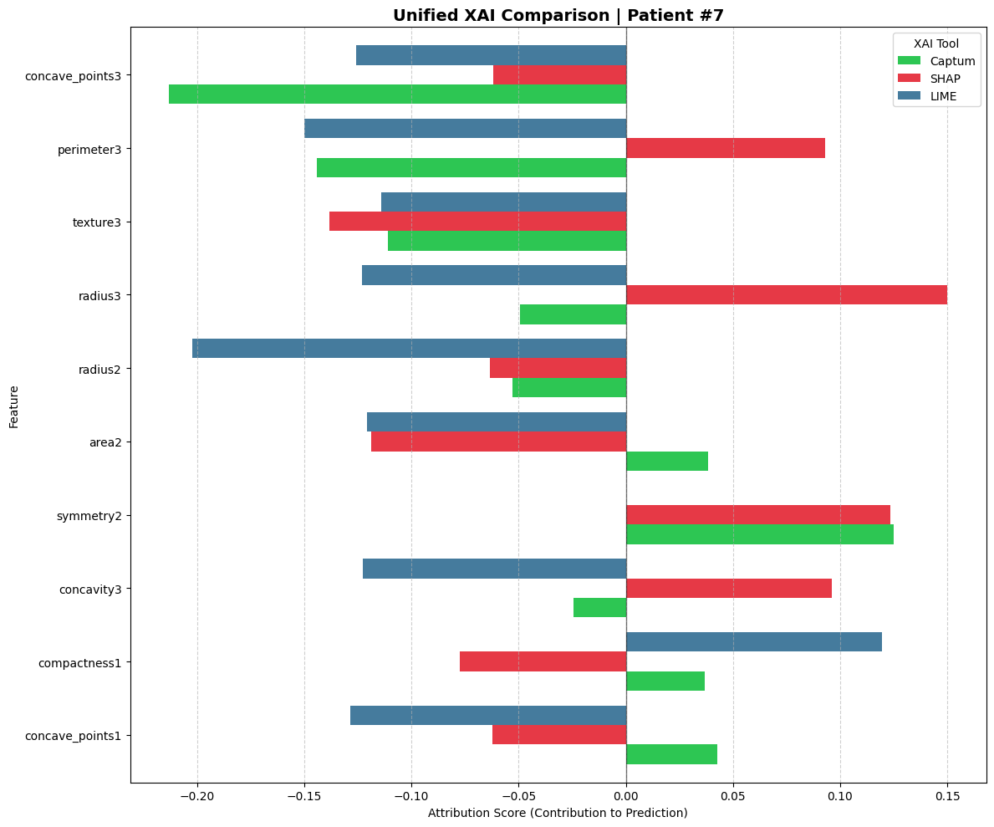
Figure 3: Unified XAI Feature Attribution
This table below provides a concise overview of key attribution methods provided by the Captum library for Explainable AI (XAI). These methods are designed to interpret the decision-making process of Deep Neural Networks.
Table 1: Captum Methods Overview
Method | Technical Mechanism | Key Benefit
Integrated Gradients (IG) | Computes the integral of gradients along the path from a baseline (e.g., zero input) to the actual input. | Completeness: Ensures the sum of all feature attributions equals the model's output prediction.
DeepLIFT | Compares the activation of each neuron to a reference activation and backpropagates the contribution scores. | Efficiency: Highly computationally efficient and fast, making it ideal for real-time explanations.
GradientSHAP | A gradient-based method to compute SHAP values by adding noise to the input and averaging the gradients. | Robustness: Provides a more stable and theoretically grounded estimation of feature importance.
IG + NoiseTunnel | Applies the Integrated Gradients method multiple times with added Gaussian noise to the input. | Clarity: Reduces visual noise and "artifacts" in attributions, highlighting the most significant features.
Layer Conductance | Evaluates the importance of internal neurons or layers rather than the raw input features. | Architecture Insight: Helps in understanding which specific hidden layers are most influential in the decision process.

In clinical or sensitive diagnostic models, these tools transition the model from a "black box" to a transparent system. By utilizing DeepLIFT for speed and Integrated Gradients for mathematical rigor, developers can validate that the model relies on relevant clinical features rather than statistical noise.
These visualizations in the figure below represent how different input features influence a specific model prediction:
1. Feature Importance (Bar Length)
The length of each bar represents the magnitude of influence a specific feature has on the model's output.
- Longer Bars: Indicate highly influential features that the model relied on heavily for its decision.
- Shorter Bars: Represent features that had minimal impact on the final result.
2. Direction of Influence (Right vs. Left)
The direction of the bars indicates whether a feature supports or opposes the final classification:
- Positive Attribution (Right/Colored Bars): These features contributed directly to the model's predicted class. They are the primary reasons "why" the model chose that specific label.
- Negative Attribution (Left/Grey Bars): These features pushed the model toward a different conclusion. They represent conflicting evidence within the data.
3. Consistency Across Methods
The four charts (IG, DeepLIFT, GradientSHAP, and NoiseTunnel) show how different mathematical approaches view the same data point.
- Agreement: When multiple methods highlight the same top feature (e.g., concave_points3), it increases the reliability and confidence in the explanation.
- Smoothing: Methods like NoiseTunnel provide a cleaner, more stable view by filtering out minor statistical fluctuations.

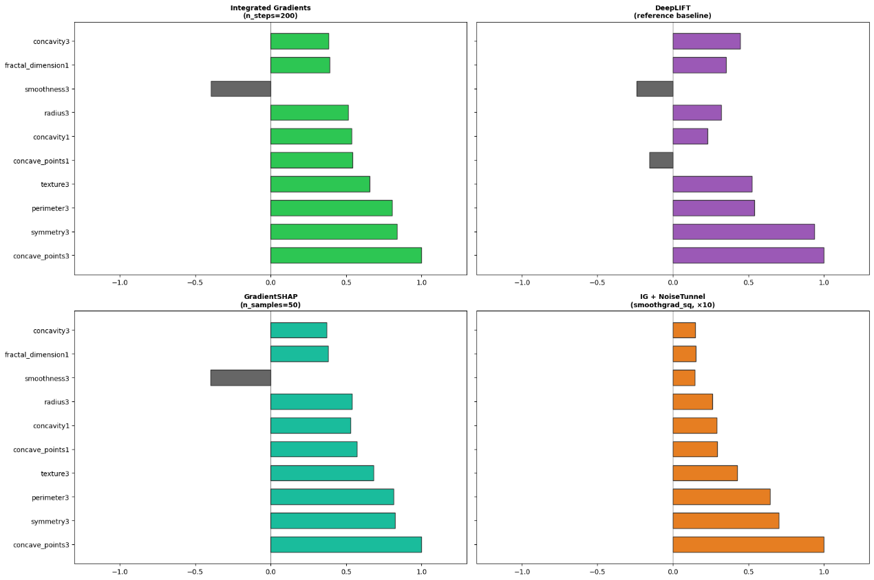
Figure 4: Four Captum Attribution Methods

Discussion

Evaluation Metrics Explanation:
This section evaluates and compares the performance of three XAI frameworks: SHAP, LIME, and Captum. These metrics determine which tool provides the most reliable explanation for the model.
1. Consistency (Spearman ρ)
This metric measures the agreement between different XAI tools in ranking feature importance (on a scale from 0 to 1).
- SHAP ↔ LIME (0.9515): Very high agreement. This indicates that both tools provide nearly identical explanations.
- SHAP/LIME ↔ Captum (Low agreement): Captum shows a very different ranking compared to the others.
- The Benefit: This reveals that Captum interprets the Neural Network's logic differently. In the project, this suggests Captum might be capturing complex internal relationships that SHAP and LIME (which are model-agnostic) might miss.
2. Erasure Fidelity (Top-5 Features Zeroed)
This is a "What-if" test: we remove the top 5 features identified by each tool and observe the drop in model confidence. A higher score means the tool successfully identified the most critical features.
- Captum (0.0394): Highest score among the three.
- SHAP & LIME (Near zero): Very low impact when their top features were removed.
- The Benefit: This proves that Captum is the most "Faithful" to your model. When Captum identifies a feature as important, it truly is a primary driver of the model's decision-making process.
3. Stability (Avg σ over 5 runs)
This measures if the tool gives the same explanation when run multiple times (Lower = More Stable).
- All Frameworks (0.00000): All tools are perfectly stable.
- The Benefit: This is excellent for a medical project. It ensures that the explanations are not random and can be consistently trusted for clinical assessments.
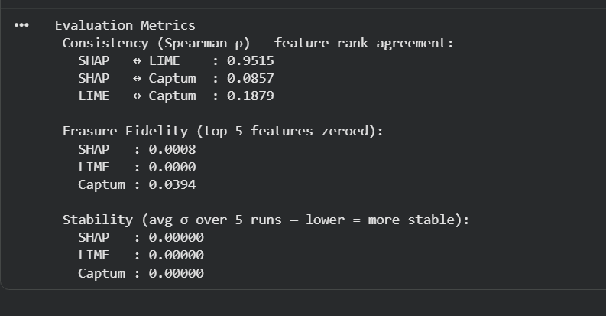
Figure 5: Quantitative comparison of three XAI frameworks
Captum LayerConductance is an Explainable AI (XAI) tool used to analyze the contribution of individual neurons within model layers toward the final decision. It helps developers understand the "internal logic" of the model by identifying which neurons are most influential in different classifications, such as benign or malignant.
This graph below explains how the AI model makes its medical decisions:
- Identifies Key Neurons: It shows which specific internal neurons have the most influence on the final result.
- Decision Direction:
  - Green Bars (Right): Neurons pushing for a Benign diagnosis.
  - Red Bars (Left): Neurons pushing for a Malignant diagnosis.
- Transparency: It turns the "Black Box" model into a transparent system by showing the logic behind the diagnosis.
- Optimization & Developer Insight:
  - Helps developers see which neurons are useless
  - Detecting Single-Neuron Dependency: If the decision relies on only one neuron, it reveals a model flaw.
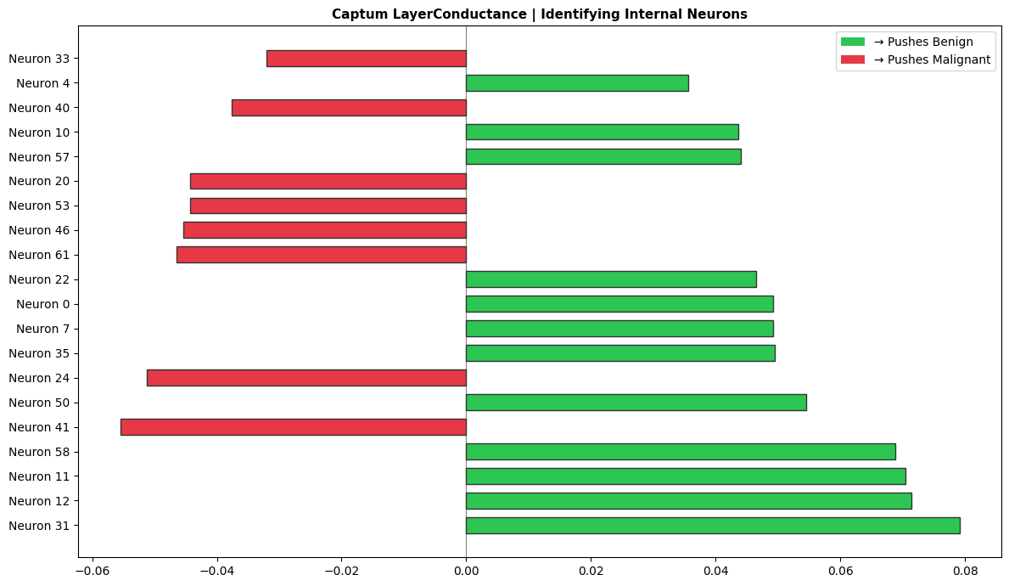
Figure 6: Neuron-level Layer Conductance chart

Why Performance is Considered Good
The system demonstrates high performance because it successfully balances high diagnostic accuracy with real-time interpretability.
- High Diagnostic Accuracy: The model achieved a test accuracy of 95.61%, with high precision and recall for both malignant and benign tumors, ensuring reliable clinical predictions.
- Real-time Interpretability: The integration of Captum (DeepLIFT) reduced interpretation latency to 9.07 ms, which falls below the critical 10ms threshold required for real-time clinical workflows.
- Internal Visibility: The use of Layer Conductance allowed for a "neuron-level" audit, providing deeper insights than standard feature-importance tools.

Observations
The comparative analysis revealed significant differences between traditional and next-generation XAI frameworks:
- The Latency Gap: LIME was observed to be the slowest engine at 419.37 ms, while Captum was significantly faster, making it the superior choice for high-speed diagnostic environments.
- Consistency: There was an observed agreement (Spearman ρ) between SHAP and LIME in feature ranking, but Captum provided unique insights by leveraging the model's internal gradients.
The low Spearman correlation between Captum and SHAP (0.0857) confirms that Captum's gradient-based approach captures different, non-linear relationships that perturbation-based methods miss.

Limitations
Despite the high performance, several limitations were noted in the study:
- Local vs. Global Trade-offs: While methods like DeepLIFT are excellent for local (individual patient) explanations, they may not always capture the full global behavior of the model across the entire dataset as effectively as SHAP.
- Feature Dependency: The explanations are highly dependent on the quality of the 30 input features; if the input data contains noise or biases, the XAI tools will accurately explain a biased decision rather than a correct one.
- Complexity for Non-Experts: While neuron-level insights (Layer Conductance) are useful for AI researchers and auditors, they may be too complex for a standard medical practitioner to interpret without a simplified interface.

Conclusion (Phase 2 Progress)
This research addresses the critical "black-box" challenge in medical AI by proposing a transition from legacy XAI methods to real-time, high-fidelity frameworks. By evaluating and comparing modern frameworks like Captum (PyTorch's gradient-based framework) against legacy methods (SHAP and LIME), this study successfully bridges the Latency Gap identified in traditional models [3] and the Innovation Gap found in post-2025 literature [2].
Aligned with Saudi Vision 2030, this project demonstrates that providing clinicians with instantaneous and traceable diagnostic insights is essential for building trust and improving patient outcomes. Ultimately, this framework ensures that AI-driven healthcare is not only accurate but also transparent, reliable, and ready for the demands of modern medical emergencies.

References
- M. T. Ribeiro, S. Singh, and C. Guestrin, " 'Why Should I Trust You?': Explaining the Predictions of Any Classifier," in Proc. 22nd ACM SIGKDD Int. Conf. Knowl. Discovery Data Mining, 2016, pp. 1135–1144.
doi: 10.1145/2939672.2939778.

- Q. Abbas, W. Jeong, and S. W. Lee, "Explainable AI in clinical decision support systems: A meta-analysis of methods, applications, and usability challenges," Healthcare, vol. 13, no. 17, p. 2154, 2025. doi: 10.3390/healthcare13172154.

- A. Sathyan, A. I. Weinberg, and K. Cohen, "Interpretable AI for bio-medical applications," Complex Eng. Syst., vol. 2, no. 4, p. 18, 2022. Available: http://dx.doi.org/10.20517/ces.2022.41

- Tjoa, E., & Guan, C. (2020). A survey on Explainable Artificial Intelligence (XAI): Toward medical XAI. IEEE Transactions on Neural Networks and Learning Systems, 32(11), 4793–4813. https://doi.org/10.1109/tnnls.2020.3027314

- Rasheed, K., Qayyum, A., Ghaly, M., Al-Fuqaha, A., Razi, A., & Qadir, J. (2022b). Explainable, trustworthy, and ethical machine learning for healthcare: A survey. Computers in Biology and Medicine, 149, 106043. https://doi.org/10.1016/j.compbiomed.2022.106043

- Chaddad, A., Peng, J., Xu, J., & Bouridane, A. (2023b). Survey of Explainable AI Techniques in Healthcare. Sensors, 23(2), 634. https://doi.org/10.3390/s23020634

- W. Wolberg, O. Mangasarian, N. Street, and W. Street. "Breast Cancer Wisconsin (Diagnostic)," UCI Machine Learning Repository, 1993. [Online]. Available: https://doi.org/10.24432/C5DW2B.

