### What is Machine Learning?

$$ \text{data} + \text{model} \rArr \text{prediction}$$

* $data$: observations, could be actively or passively acquired (meta-data).
* $model$: assumptions, based on previous experience (other data! transfer learning etc), or beliefs about the regularities of the universe. Inductive bias.
* $prediction$: an action to be taken or a categorization or a quality score.

### Two important Gaussian Properties

* Sum of Gaussianv
* Sum of Gaussian variables is also Gaussian.

$$y_{i}∼N(μ_{i},σ_{i}^{2})$$

And the sum is distributed as

$$∑y_{i}∼N(∑μ_{i},∑σ_{i}^{2})$$

Aside: As sum increase, sum of non-Gaussian, finite variance variables is also Gaussian because of **central limit theorem**. - Scaling a Gaussian Scaling a Gaussian leads to a Gaussian.

$$ω*y∼N(ωμ,ω^{2}σ^{2})$$

The **central limit theorem** (CLT) establishes that, in some situations, when independent random variables are added, their properly normalized sum tends toward a normal distribution (informally a “bell curve”) even if the original variables themselves are not normally distributed.

### Prior Distribution

* Bayesian inference requires a prior on the parameters.
* The prior represents your belief *before* you see the data of the likely value of the parameters.
* For linear regression, consider a Gaussian prior on the intercept:

$$c∼N(0,α_{1})$$

### Posterior Distribution

* Posterior distribution is found by combining the prior with the likelihood.
* Posterior distribution is your belief *after* you see the data of the likely value of the parameters.
* The posterior is found through **Bayes’ Rule**
$$p(c|y)=\frac{p(y|c)p(c)}{p(y)}$$

* The $p(y|c)$ likelihood is not a density over $c$, it’s a function of $c$. Here, $c$ is a parameter of this density. The normalization step, e.g. find the suitable way to compute the $p(y)$ is the most difficult setp.

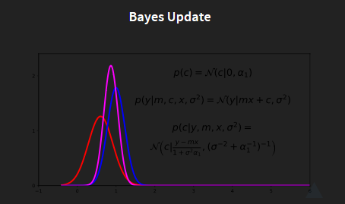

Bayes Update

The red line describe the probablity for $c$ with:

$$p(c)=N(c|0,α_{1})$$

the blue line stands for the observation, with:

$$p(y|m,c,x,σ^{2})=N(y|mx+c,σ^{2})$$

Note that, this is a likelihood function over $c$ not a distribution. based on the bayes’rule, the posterior could be written as:

$$P(c|y,m,x,σ^{2})=N(c|\frac{y−mx}{1+σ^{2}}α,(σ^{−2}+α_{1}^{−1})^{−1})$$

Math Trick:

$$p(c)=\frac{1}{\sqrt{2πα_{1}}}exp\left(−\frac{1}{2α_{1}}c^{2}\right)$$

$$p(y|x,c,m,σ^{2})=\frac{1}{{\left(2πσ^{2}\right)}^{\frac{n}{2}}}exp\left(−\frac{1}{2σ^{2}}\sum_{i=1}^{n}{(}y_{i}−mx_{i}−c)^{2}\right)$$

$$p(c|y,x,m,σ^{2})=\frac{p(y|x,c,m,σ^{2})p(c)}{p(y|x,m,σ^{2})}$$

$$p(c|y,x,m,σ^{2})=\frac{p(y|x,c,m,σ^{2})p(c)}{∫p(y|x,c,m,σ^{2})p(c)dc}$$

$$p(c|y,x,m,σ^{2})∝p(y|x,c,m,σ^{2})p(c)$$

$$\begin{matrix}logp(c|y,x,m,σ^{2})= & −\frac{1}{2σ^{2}}\sum_{i=1}^{n}{(}y_{i}−c−mx_{i})^{2}−\frac{1}{2α_{1}}c^{2}+const \\ = & −\frac{1}{2σ^{2}}\sum_{i=1}^{n}{(}y_{i}−mx_{i})^{2}−\left(\frac{n}{2σ^{2}}+\frac{1}{2α_{1}}\right)c^{2} \\ & +c\frac{\sum_{i=1}^{n}{(}y_{i}−mx_{i})}{σ^{2}},\end{matrix}$$

complete the square of the quadratic form to obtain

$$logp(c|y,x,m,σ^{2})=−\frac{1}{2τ^{2}}(c−μ)^{2}+const$$

where

$$τ^{2}={\left(nσ^{−2}+α_{1}^{−1}\right)}^{−1}$$

and

$μ=\frac{τ^{2}}{σ^{2}}\sum_{i=1}^{n}{(}y_{i}−mx_{i})$.

Piror comes from the model, where we think about it. And likelihood is coming from the data.

### Stages to Derivation of the Posterior

* Multiply likelihood by prior
  + they are “exponentiated quadratics”, the answer is always also an exponentiated quadratic because
$$exp(a^{2})exp(b^{2})=exp(a^{2}+b^{2})$$

* Complete the square to get the resulting density in the form of a Gaussian.
* Recognise the mean and (co)variance of the Gaussian. This is the estimate of the posterior.

### Multivariate Regression Likelihood

* Noise corrupted data point
$$y_{i}=w^{T}X_{i,:}+ϵ_{i}$$

* Multivariate regression likelihood:
$$p(y|X,w)=\frac{1}{(2πσ^{2})}exp(−\frac{1}{2σ^{2}}∑(y_{i}−w^{T}x_{i,:})^{2})$$

* Multivariate Gaussian piroi:

$$p(w)=\frac{1}{(2πσ^{2})^{p/2}}exp(−\frac{1}{2σ^{2}}w^{T}w)$$

The independent multivariate Gaussian could be seen as the independent Gaussian and multiple them and rotate the results.

#### Independent Gaussians:

$$p(w,h)=\frac{1}{\sqrt{2πα_{1}}\sqrt{2πα_{2}}}exp(−\frac{1}{2}(\frac{(w−μ_{1})^{2}}{σ_{1}^{2}}+\frac{(h−μ_{2})^{2}}{σ_{2}^{2}}))$$

and we can write it with linear algebra form:

$$p(w,h)=\frac{1}{\sqrt{2πα_{1}}\sqrt{2πα_{2}}}exp(−\frac{1}{2}(\left[\begin{matrix}w \\ h\end{matrix}\right]−\left[\begin{matrix}u_{1} \\ u_{2}\end{matrix}\right])^{T}(\left[\begin{matrix}σ_{1} & 0 \\ 0 & σ_{2}\end{matrix}\right]\left[\begin{matrix}w \\ h\end{matrix}\right]−\left[\begin{matrix}u_{1} \\ u_{2}\end{matrix}\right]))$$

and then, rename it:

$$p(y)=\frac{1}{|2π*D|^{\frac{1}{2}}}exp(−\frac{1}{2}(y−μ)^{T}D^{−1}(Y−μ))$$

$|D|$ means the determinant of the matrix.

#### Correlated Gaussian

Form correlated from original by rotating the data space using matrx R.

$$p(y)=\frac{1}{|2π*D|^{\frac{1}{2}}}exp(−\frac{1}{2}(R^{T}y−R^{T}μ)^{T}D^{−1}(R^{T}Y−R^{T}μ))$$

$$p(y)=\frac{1}{|2π*D|^{\frac{1}{2}}}exp(−\frac{1}{2}(y−μ)^{T}RD^{−1}R^{T}(Y−μ))$$

this gives a covariance matric:

$$C^{−1}=RD^{−1}R^{T}$$

which in some view is the result of the principal compoment.

### Multivariate Consequence

if

$$x \sim \mathcal{N}(\mu,\varSigma)$$

and

$$y=Wx$$

then

$$y\sim \mathcal{N}(W\mu,W\varSigma W^T)$$

we can say the first equaption is the prior of $x$, the second is the likelihood, the last is the marginal of $y$. If we set $\mu = 0, \varSigma = I$, so it is just the inverse of PCA.

## Prediction with Correlated Gaussians

* Prediction of $f_{*}$ from $f$ requires multivariate *conditional density*.
* Multivariate conditional density is *also* Gaussian.
$$p(f_{*}|f)=N\left(f_{*}|K_{*,f}K_{f,f}^{−1}f,K_{*,*}−K_{*,f}K_{f,f}^{−1}K_{f,*}\right)$$

* Here covariance of joint density is given by

$$K=\left[\begin{matrix}K_{f,f} & K_{*,f} \\ K_{f,*} & K_{*,*}\end{matrix}\right]$$

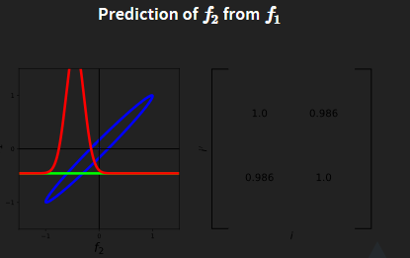  
Take the picture as the example:

since that example is in 1D, all the values are scalar. $f=f1=−0.4$, $K_{f,f}=1,K_{*,f}=0.98,K_{*,*}=1$, so

$$p(p_{2}|p_{1})=N(p_{2}|0.98*1*(−0.4),1−0.98*1*0.98)$$

$$p(p_{2}|p_{1})=N(p_{2}|−0.392,0.0396)$$

the variance is 0.0396, and the standard variance is 0.2.

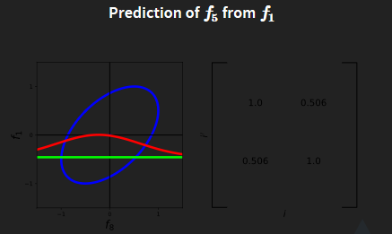

Prediction