AHDS - STM32L0 MODULAR DEVELOPMENT
& PROTOTYPING PLATFORM
Full Embedded Hardware & Software Project Documentation
Main MCU Board + DB37 Connection Board + STM32 Firmware + C# PC Configuration Tool

A reusable STM32L0 development platform combining custom hardware, embedded C firmware, a UART command protocol, persistent configuration, and a Windows PC configuration/diagnostic application.
Primary MCU | STM32L062K8T6 (LQFP32)
Platform concept | Reusable STM32L0 hardware, firmware and PC-software development system
Hardware status | Schematics and PCBs completed; boards assembled and used
Expansion | 37-pin board-to-board connection to a dedicated breakout / connection PCB
Main interfaces | SWD, USB, UART, SPI, I2C, GPIO, ADC, DAC, EXTI
Project scope | Hardware documentation, STM32 firmware, UART protocol and Windows PC terminal

Project positioning
A full embedded development project combining a reusable STM32L0 hardware platform, DB37 expansion, public STM32 firmware, UART configuration protocol, Windows PC software and technical documentation.

1. Project Purpose
The platform was created to avoid rebuilding the same MCU support circuitry for every prototype. Instead, the main board provides a reusable STM32L0 core with common interfaces and analog resources already available, while a separate DB37 connection board makes the signals easy to access during laboratory work and firmware development.
The assembled implementation uses the STM32L062K8T6. The design concept can also be used with other STM32L0 devices that are pin-compatible with the selected LQFP32 footprint. Exact device substitution should be checked against the specific MCU datasheet and alternate-function mapping before use.
System Concept

MAIN MCU BOARD  STM32L0 core  Power regulation  Analog conditioning  USB / SWD / UART / SPI / I2C  Jumpers and local peripherals | DB37 INTERCONNECT  37-pin link  Carries MCU and peripheral signals  Keeps the main board reusable | CONNECTION BOARD  Breaks signals into accessible groups  GPIO / ADC / DAC  UART / SPI / I2C  SWD / USB  Power rails and test connections

2. Main Hardware Functions
MCU core: STM32L062K8T6 with GPIO and alternate-function access routed for prototyping.
Programming and debug: Dedicated ST-LINK/SWD connection using SWCLK, SWDIO, 3.3 V and GND.
Digital communication: USART, SPI and I2C signals available for external modules and firmware experiments.
USB: USB D+ and D- lines are available on the platform.
Analog section: Multiple ADC paths, DAC access and operational-amplifier stages based on TLV2374/TLV2372 devices.
I/O expansion: PCA9654 I2C GPIO expander provides additional digital I/O resources.
Sensors and modules: Connections include a motion sensor input, IR receiver and a JDY communication-module interface.
Clocking and system support: 32.768 kHz crystal provision, reset circuitry, BOOT0 control and configurable jumpers.
Power: 12 V input with on-board 3.3 V regulation and local decoupling for the MCU and peripherals.

3. Prototyping and Configuration Strategy
The platform is designed around configurable routing rather than a single fixed application. Jumpers and 0-ohm links allow selected MCU pins to be connected to analog channels, sensor functions, or external connectors as required. This makes the same assembled board useful across different firmware and hardware experiments.
Area | Examples | Purpose
Analog routing | PA0, PA1, PA4, PA5, PA6 / ADC and DAC paths | Select direct GPIO or analog-function routing.
Sensor routing | PA7 / motion input | Reuse the same MCU pin for different test configurations.
I2C | SCL1 / SDA1 and optional pull-up connection | Support external I2C devices while avoiding duplicate pull-ups when necessary.
Expansion I/O | P4-P7 from the I2C expander | Add accessible digital I/O without consuming additional MCU pins.
Board-to-board access | DB37 plus grouped external connectors | Bring MCU and peripheral signals to the connection board for practical laboratory access.

4. Embedded Firmware and Real-Project Use
The hardware platform has already been used in a real engineering application, demonstrating that the design moved beyond schematic and PCB development into practical use. The original employer-related firmware is proprietary and is intentionally excluded from this public project.
The public version instead includes independently developed firmware for the same STM32L0 platform. This firmware provides a practical motion-control example using the STM32L062, with a motion-sensor input, DAC output control, RTC-based timing, internal Data EEPROM, status/heartbeat functions, and a UART command interface for configuration and diagnostics.
Public repository note
Only hardware files and source code that are independently owned and safe to publish are included. The original employer-related application firmware remains excluded; the GitHub repository uses the independent STM32L0 motion-control firmware and the independently developed PC terminal instead.

5. Firmware Architecture and UART Configuration Protocol
The public firmware is written in C for STM32L0 using the STM32 HAL. It is designed around non-blocking peripheral services and runtime configuration rather than a single hard-coded operating point. The motion input is handled through EXTI, brightness is controlled through the DAC, hold timing is maintained with the RTC WakeUp timer, and selected operating parameters are stored in the STM32L0 internal Data EEPROM.
Firmware area | Implementation | Project role
Motion input | PB1 / EXTI with debounce and refractory timing | Detect motion while reducing false or repeated triggers.
Output control | 12-bit DAC with logical High / Low scaling | Apply programmable output levels for the motion-control example.
Timing | RTC WakeUp timer at 1 Hz | Maintain a configurable hold interval without blocking the main application.
Persistent settings | STM32L0 Data EEPROM | Store device ID, hold duration, Low level, High reference and motion mode.
UART protocol | <,CMD,ARG,...,> ASCII command frames | Read, modify and verify operating parameters from a PC terminal.
Diagnostics | INFO, HELP, status, heartbeat and test commands | Support bring-up, service and functional testing.
Example command frames
<,INFO,>
<,SETDUR,MM,> / <,GETDUR,>
<,SETHI,PP,> / <,GETHI,>
<,SETDIM,PP,> / <,GETDIM,>
<,SETID,NNNNNNNN,> / <,GETID,>
<,MOTION,MODE,INV|NORM[,SAVE],>
<,DAC,PP,> / <,DACTEST,TT,>

6. Windows PC Configuration and Diagnostic Tool
A dedicated Windows application was developed in C# with Visual Studio / Windows Forms to communicate with the STM32 board through a serial COM port. The application is not a firmware flasher; it is a configuration, test and diagnostic tool that exchanges commands with the running STM32 firmware and can modify parameters that the MCU stores in Data EEPROM.
PC terminal function | Implementation / purpose
Serial setup | COM port, baud rate, parity, stop bits and data-bit selection.
Terminal modes | Text / Hex transmission, optional CR / LF, manual Send, console display and zoom.
Predefined command groups | General commands, motion programming, motion tests, DAC tests, heartbeat/SystemTick tests and logic-mode changes.
Board configuration panel | Read / Write controls for device ID, High level, hold time and Low level.
Response parsing | The application recognizes MCU responses such as DUR, DIM, HI and programmed ID and updates the GUI automatically.
Verification | After writing settings, the application can issue GET commands and wait asynchronously for returned values.
Diagnostics | INFO-based communication check to confirm that the selected COM port can reach the MCU.
Logs | Console history can be cleared or saved to a timestamped text file.
System-level architecture
Sensor / I/O  Motion sensor and external peripherals | STM32L0 Hardware  Custom main board + DB37 expansion | Embedded Firmware  EXTI / DAC / RTC / EEPROM / UART | Serial Link  ASCII command protocol over COM / UART | PC Application  C# configuration, test and diagnostics
Together, the custom hardware, STM32 firmware and Windows application form a complete development chain: physical I/O and sensors are handled by the MCU, operating parameters are retained in EEPROM, and the PC software provides a practical service interface for configuration and testing.

7. GitHub Repository and Source-Code Availability
The GitHub repository for this project is intended to contain the complete public project package: hardware documentation, the independently developed STM32L0 firmware, and the Visual Studio C# terminal source code. This allows the platform to be reviewed as a complete embedded system rather than as a schematic-only project.
- Main STM32L0 board schematic and hardware documentation.
- DB37 connection / breakout board schematic, pinout and jumper documentation.
- Independent STM32L0 firmware source files for the motion-control example.
- Visual Studio / C# PC configuration and diagnostic terminal source files.
- UART command protocol examples and project documentation.
- Future examples can be added without changing the core platform hardware.

8. Assembled Hardware Platform
The photographs below show the manufactured and assembled prototype hardware. The main STM32L0 controller board and the dedicated DB37 connection / breakout board are shown both as separate modules and as a complete connected system.
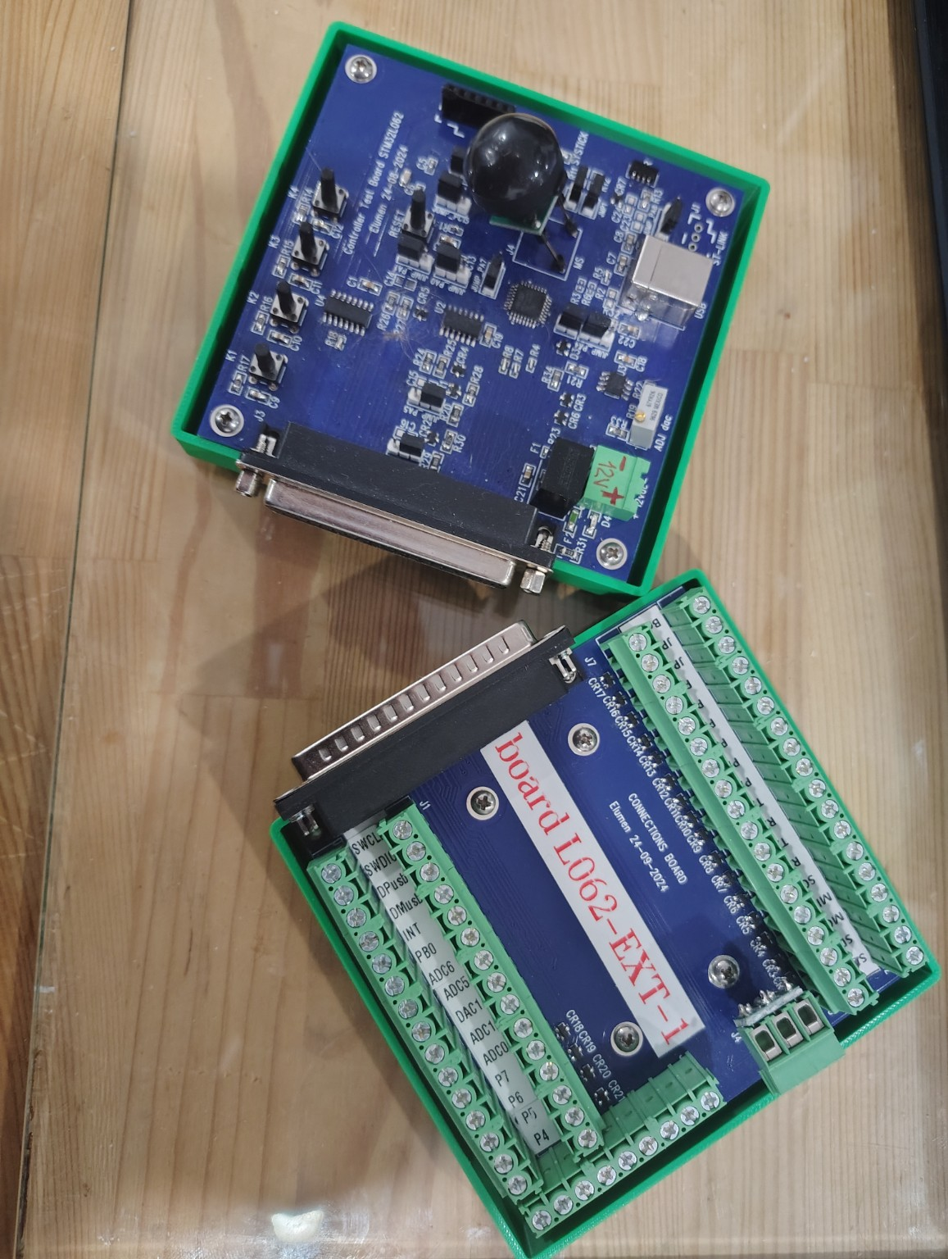  Main controller board and DB37 connection / breakout board as separate assembled modules. | 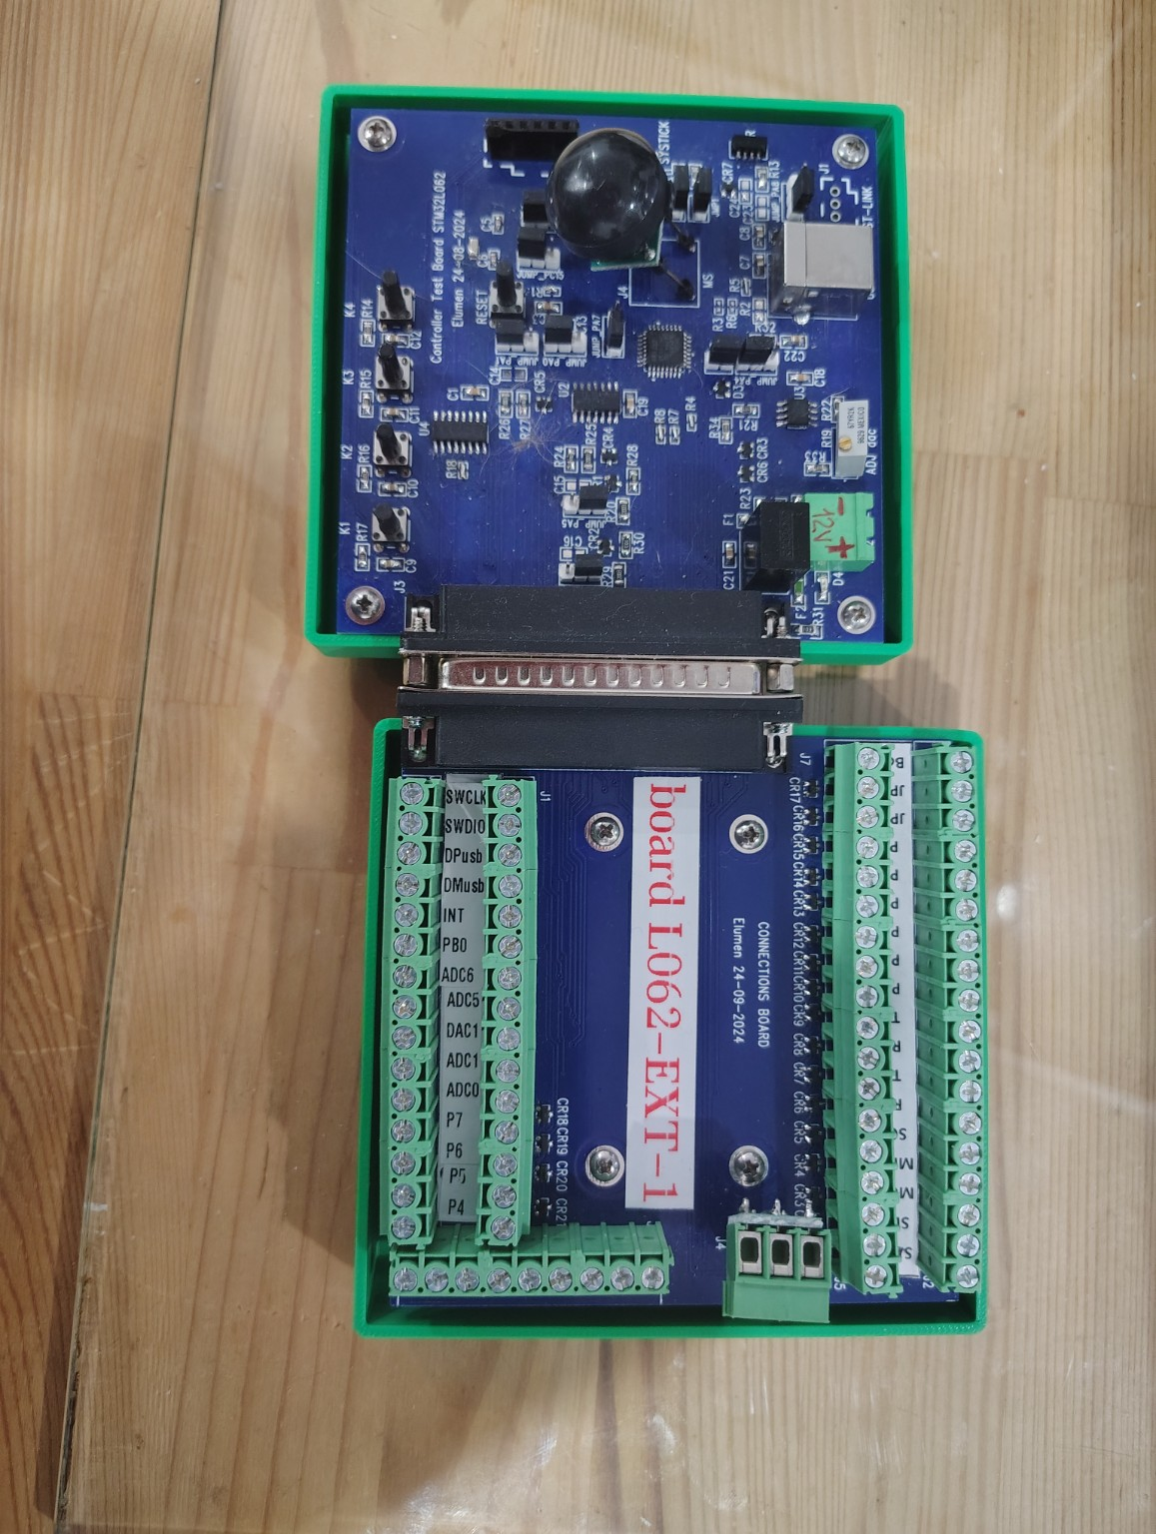  Complete platform connected through the DB37 interface for direct access to MCU and peripheral signals.
The assembled hardware confirms that the project progressed from schematic and PCB design to a physical, reusable development platform.
Appendix A - Main STM32L0 Board Schematic
Main controller board centered on STM32L062K8T6 with power, analog, communication, programming and expansion circuitry.
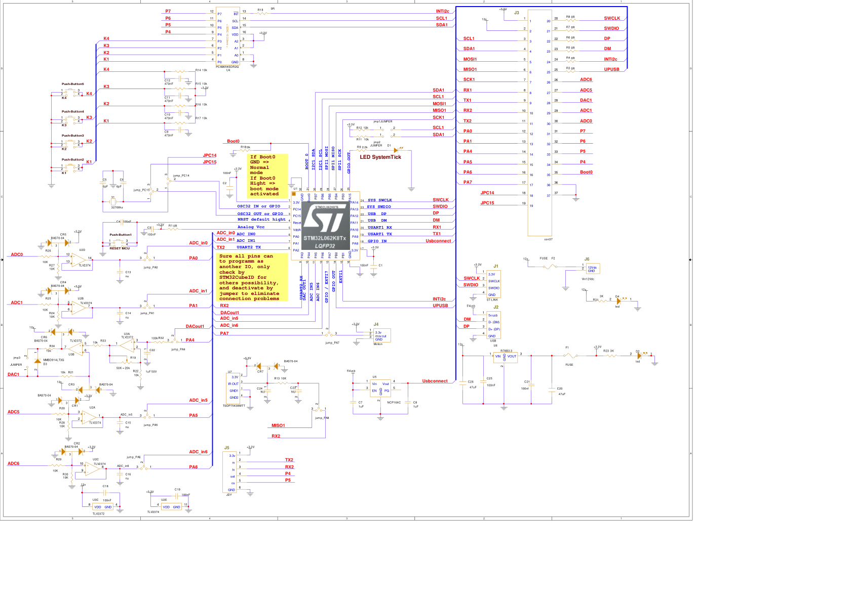
Main-board schematic. The large 37-pin connector provides the link to the separate connection / breakout board.

Appendix B - Connection Board Schematic
DB37 signal distribution, grouped external connectors, protection components and optional I2C pull-up access.
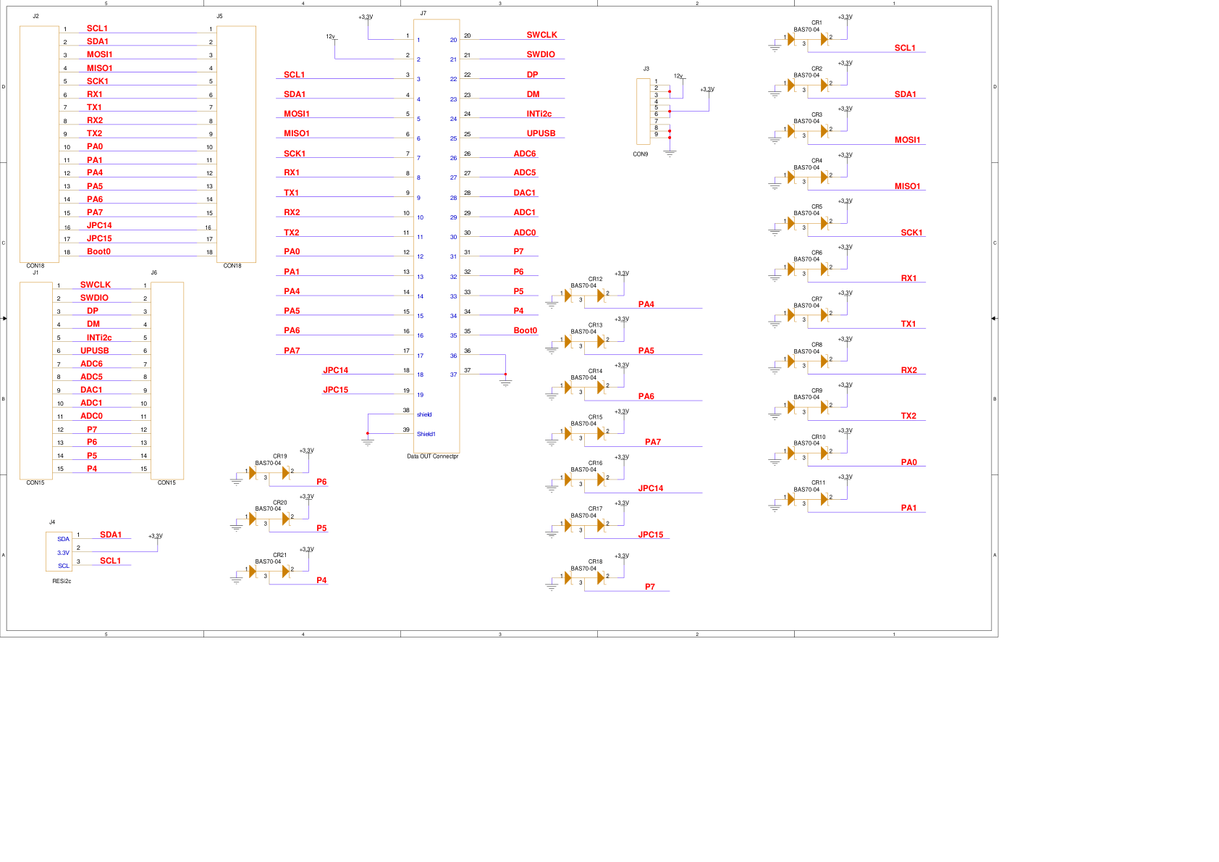
Connection-board schematic - signal distribution from the DB37 interface to accessible external connectors.

Appendix C - Connection Board Pinout
Pin mapping for STM32L062 signals, analog functions, communication interfaces, power rails and I2C-expander outputs.
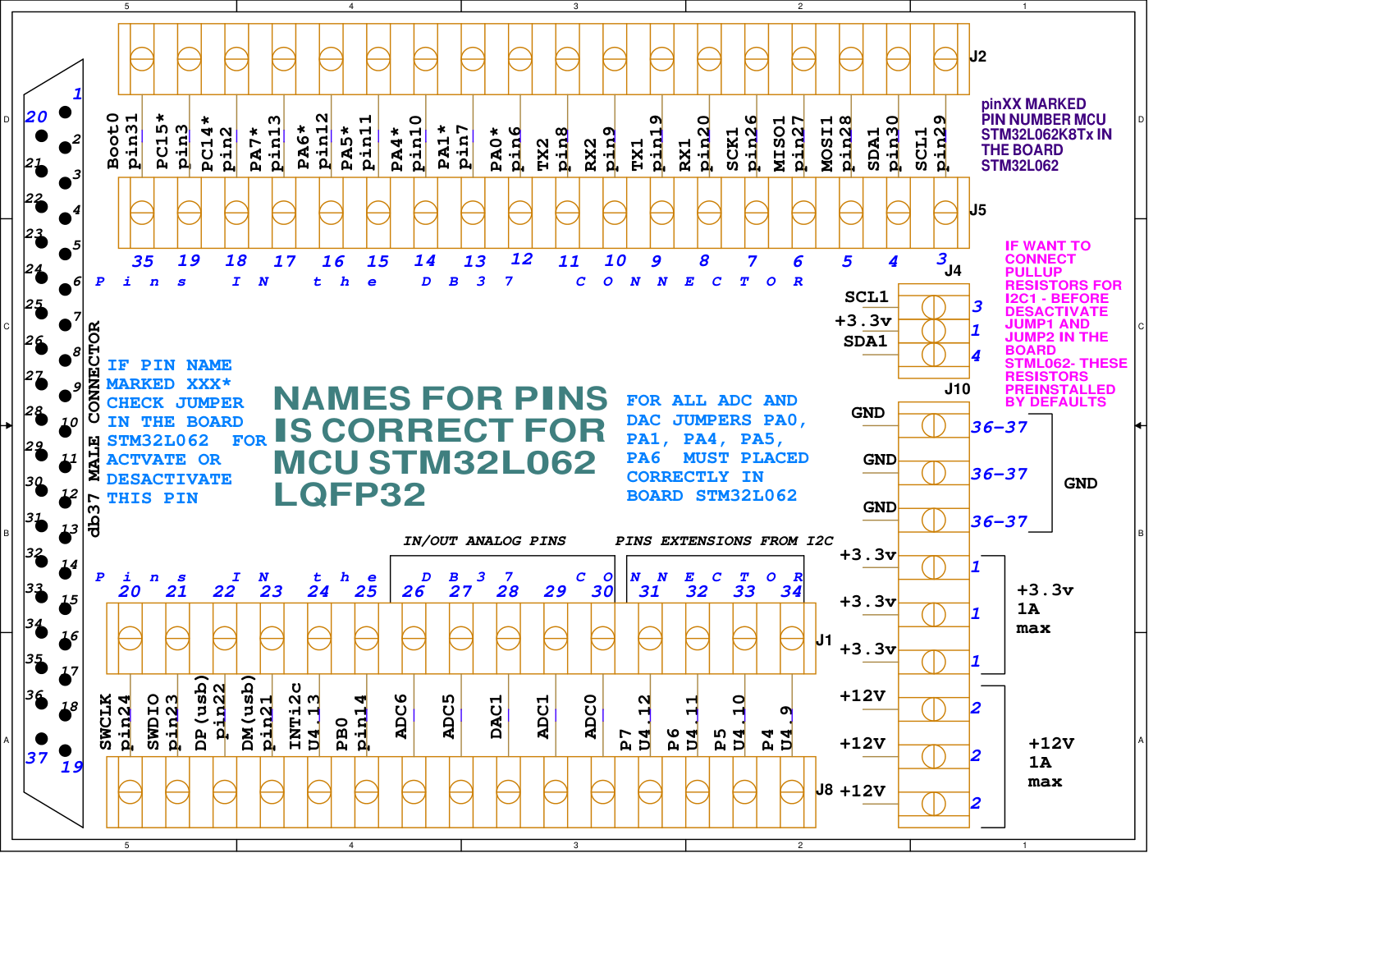
Connection-board pinout and connector mapping.

Appendix D - Jumper and Button Configuration
Configuration reference for jumpers, analog routing, motion input and local push buttons.
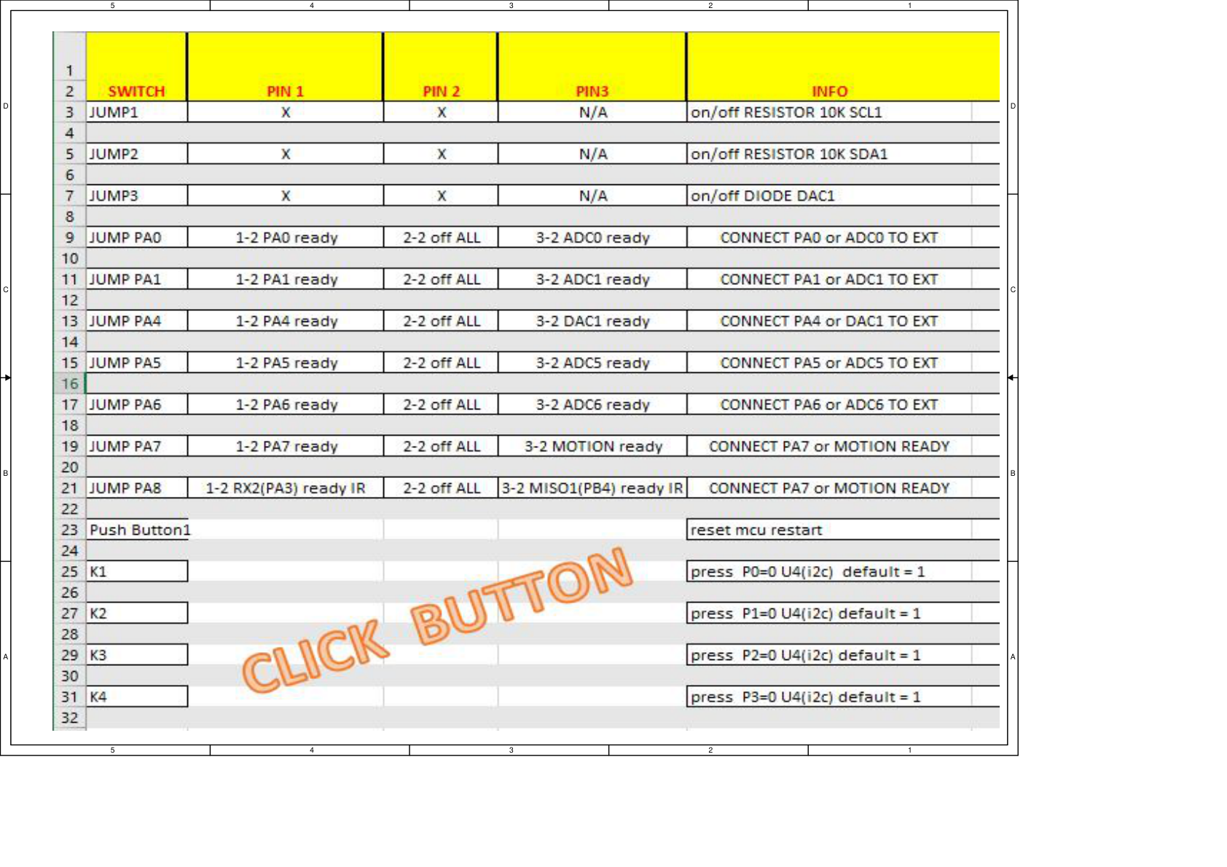
Jumper / switch configuration table used when adapting the platform to different prototype setups.

9. Project Status and Next Steps
The hardware platform is already designed, manufactured and assembled. The public project package now combines the hardware documentation, photographs of the assembled two-board system, an independently developed STM32L0 motion-control firmware example, and a C# Windows configuration / diagnostic application. The original employer-related firmware remains excluded from the public repository.
- Add additional close-up, test-bench and application photographs as the project evolves.
- Add a concise bring-up guide covering power, SWD, firmware load, UART connection and first configuration test.
- Maintain the independent STM32L062 firmware example and document future revisions.
- Add further application examples, such as ADC acquisition, I2C peripherals, SPI devices or additional sensor tests.
- Keep the main platform reusable so that future firmware and PC-tool examples can be added without redesigning the core hardware.

Project classification: Full Embedded Hardware Project - STM32L0 Modular Development & Prototyping Platform with Firmware and PC Configuration Tool

Prepared as project documentation for GitHub, LinkedIn technical portfolio use, and future STM32L0 development examples.

