STM32L0 MODULAR DEVELOPMENT
& PROTOTYPING PLATFORM
Full Hardware Project Documentation
Main MCU Board + DB37 Connection / Breakout Board + Firmware-ready Platform

A reusable STM32L0 hardware platform designed for firmware development, peripheral experiments, sensor integration, interface testing, and rapid prototyping.
Primary MCU | STM32L062K8T6 (LQFP32)
Platform concept | Reusable STM32L0 development and prototyping system
Hardware status | Schematic completed, PCB completed, board assembled and used
Expansion | 37-pin board-to-board connection to a dedicated breakout / connection PCB
Main interfaces | SWD, USB, UART, SPI, I2C, GPIO, ADC, DAC, EXTI
Documentation scope | Main board schematic, connection board schematic, pinout, and jumper configuration

Project positioning
This is a full hardware development project rather than a small demonstration board. The platform combines the MCU core, power circuitry, analog conditioning, communication interfaces, configurable routing, a dedicated connection board, and supporting documentation.

1. Project Purpose
The platform was created to avoid rebuilding the same MCU support circuitry for every prototype. Instead, the main board provides a reusable STM32L0 core with common interfaces and analog resources already available, while a separate DB37 connection board makes the signals easy to access during laboratory work and firmware development.
The assembled implementation uses the STM32L062K8T6. The design concept can also be used with other STM32L0 devices that are pin-compatible with the selected LQFP32 footprint. Exact device substitution should be checked against the specific MCU datasheet and alternate-function mapping before use.
System Concept

MAIN MCU BOARD  STM32L0 core  Power regulation  Analog conditioning  USB / SWD / UART / SPI / I2C  Jumpers and local peripherals | DB37 INTERCONNECT  37-pin link  Carries MCU and peripheral signals  Keeps the main board reusable | CONNECTION BOARD  Breaks signals into accessible groups  GPIO / ADC / DAC  UART / SPI / I2C  SWD / USB  Power rails and test connections

2. Main Hardware Functions
MCU core: STM32L062K8T6 with GPIO and alternate-function access routed for prototyping.
Programming and debug: Dedicated ST-LINK/SWD connection using SWCLK, SWDIO, 3.3 V and GND.
Digital communication: USART, SPI and I2C signals available for external modules and firmware experiments.
USB: USB D+ and D- lines are available on the platform.
Analog section: Multiple ADC paths, DAC access and operational-amplifier stages based on TLV2374/TLV2372 devices.
I/O expansion: PCA9654 I2C GPIO expander provides additional digital I/O resources.
Sensors and modules: Connections include a motion sensor input, IR receiver and a JDY communication-module interface.
Clocking and system support: 32.768 kHz crystal provision, reset circuitry, BOOT0 control and configurable jumpers.
Power: 12 V input with on-board 3.3 V regulation and local decoupling for the MCU and peripherals.

3. Prototyping and Configuration Strategy
The platform is designed around configurable routing rather than a single fixed application. Jumpers and 0-ohm links allow selected MCU pins to be connected to analog channels, sensor functions, or external connectors as required. This makes the same assembled board useful across different firmware and hardware experiments.
Area | Examples | Purpose
Analog routing | PA0, PA1, PA4, PA5, PA6 / ADC and DAC paths | Select direct GPIO or analog-function routing.
Sensor routing | PA7 / motion input | Reuse the same MCU pin for different test configurations.
I2C | SCL1 / SDA1 and optional pull-up connection | Support external I2C devices while avoiding duplicate pull-ups when necessary.
Expansion I/O | P4-P7 from the I2C expander | Add accessible digital I/O without consuming additional MCU pins.
Board-to-board access | DB37 plus grouped external connectors | Bring MCU and peripheral signals to the connection board for practical laboratory access.

4. Firmware and Real-Project Use
The hardware platform has already been used in a real engineering application, demonstrating that the design moved beyond schematic and PCB development into practical use. The original employer-related firmware is not included in this public project documentation.
For a public GitHub repository, an independently developed firmware example can be provided instead. A suitable demonstration can exercise the STM32L062 peripherals and the board resources, for example GPIO, ADC, DAC, UART, I2C, SPI, buttons, interrupts and the motion-sensor input.
Public repository note
The public repository should contain only hardware files and firmware that are owned and safe to publish. Proprietary application code should remain excluded.

Appendix A - Main STM32L0 Board Schematic
Main controller board centered on STM32L062K8T6 with power, analog, communication, programming and expansion circuitry.
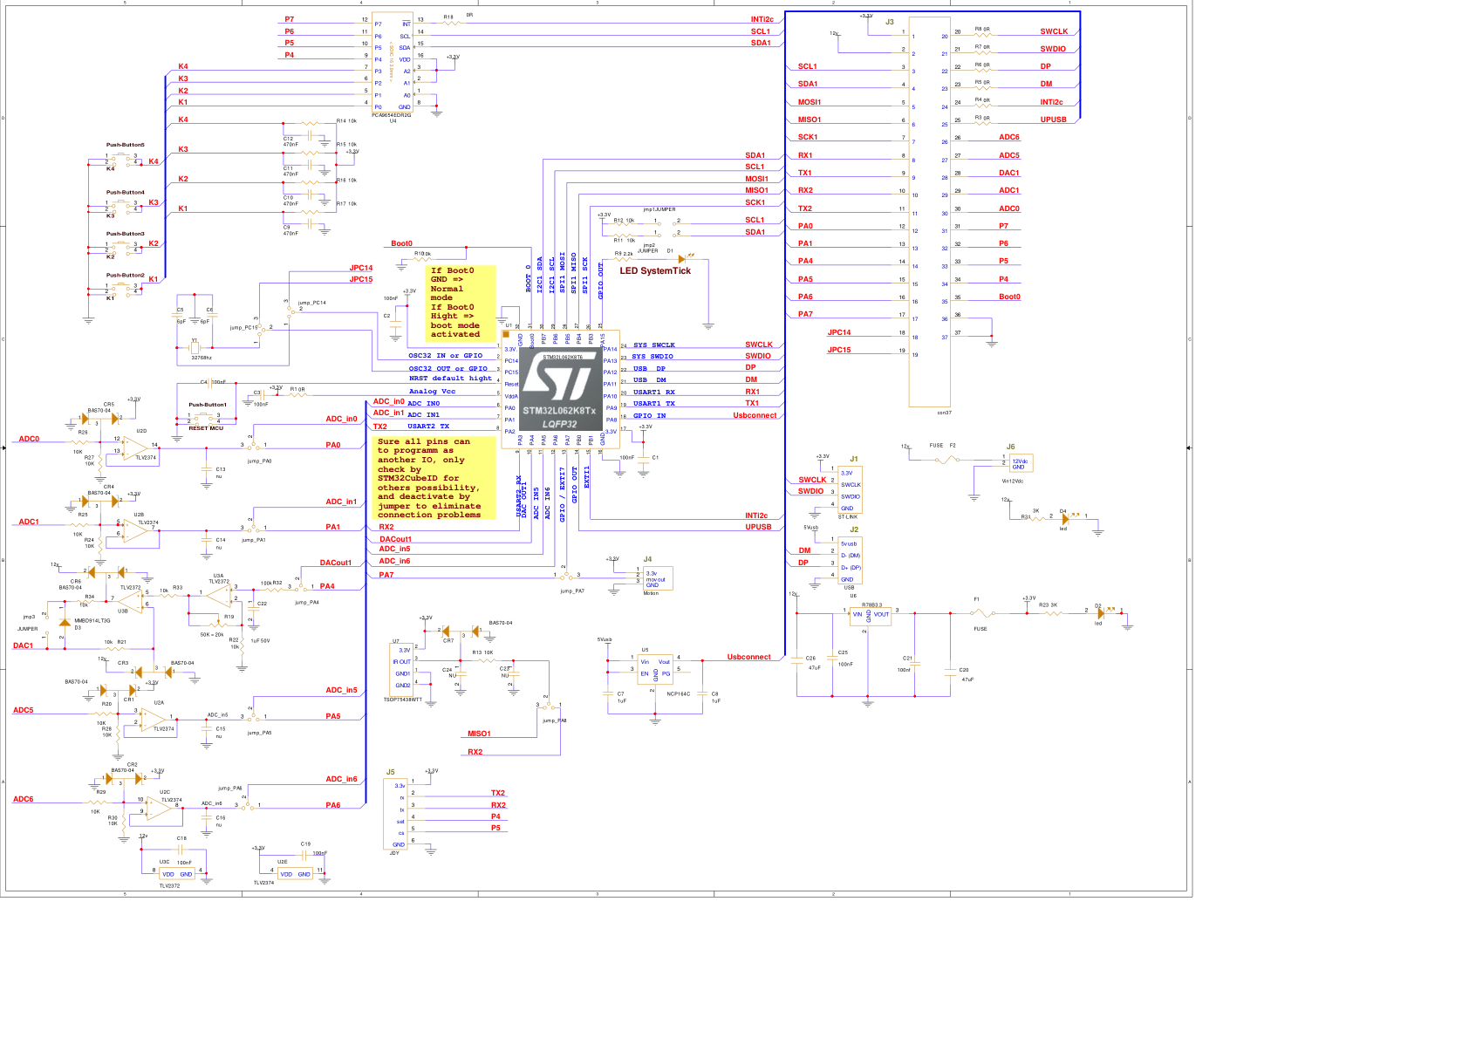
Main-board schematic. The large 37-pin connector provides the link to the separate connection / breakout board.

Appendix B - Connection Board Schematic
DB37 signal distribution, grouped external connectors, protection components and optional I2C pull-up access.
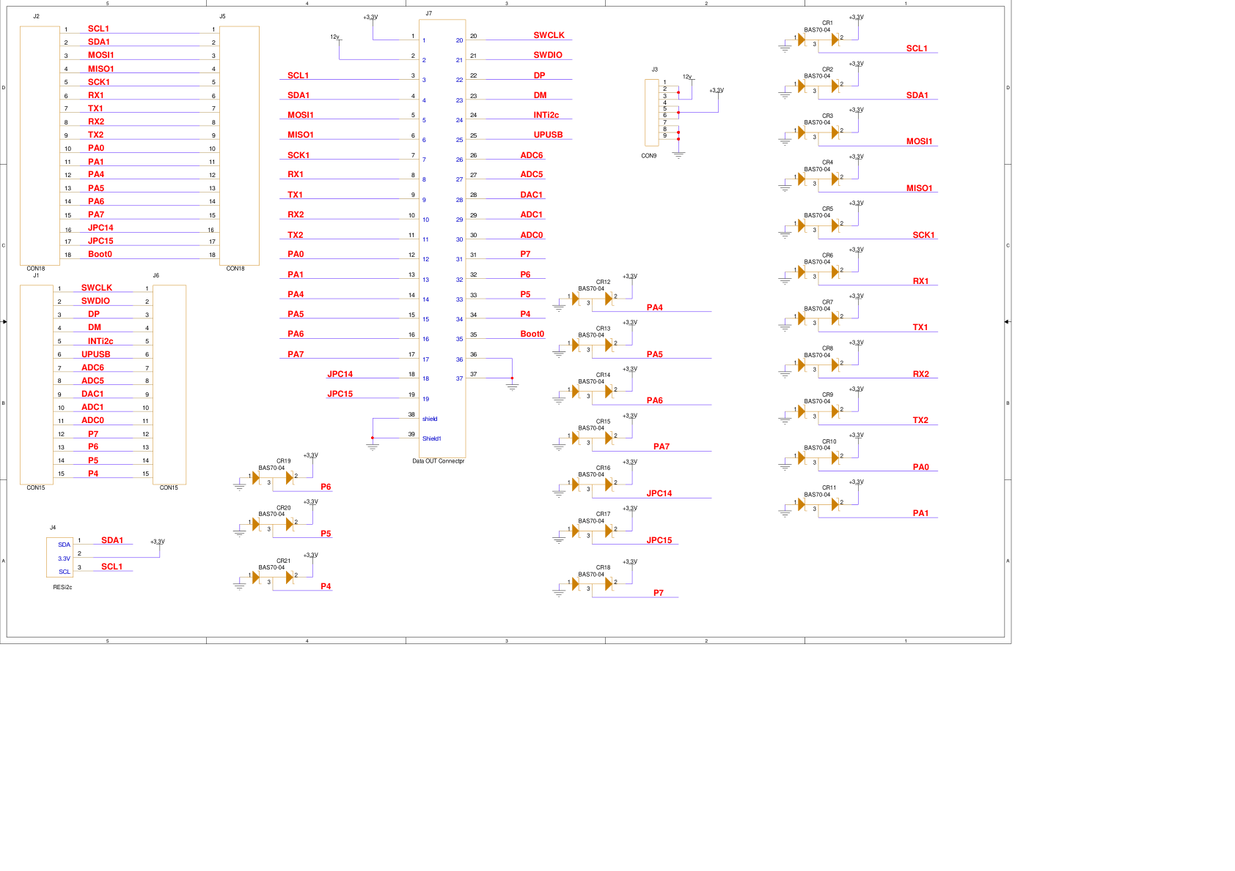
Connection-board schematic - signal distribution from the DB37 interface to accessible external connectors.

Appendix C - Connection Board Pinout
Pin mapping for STM32L062 signals, analog functions, communication interfaces, power rails and I2C-expander outputs.
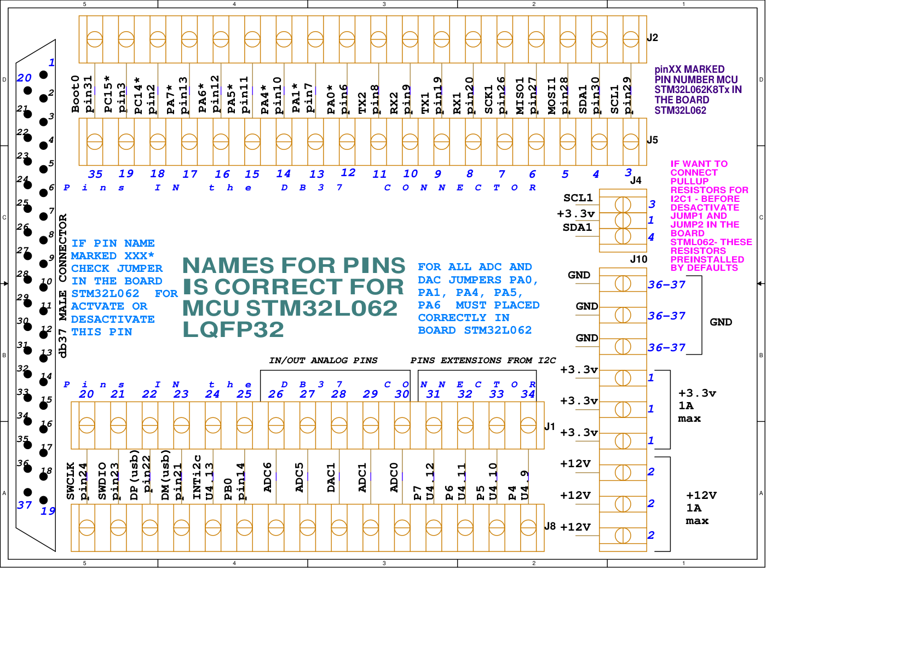
Connection-board pinout and connector mapping.

Appendix D - Jumper and Button Configuration
Configuration reference for jumpers, analog routing, motion input and local push buttons.
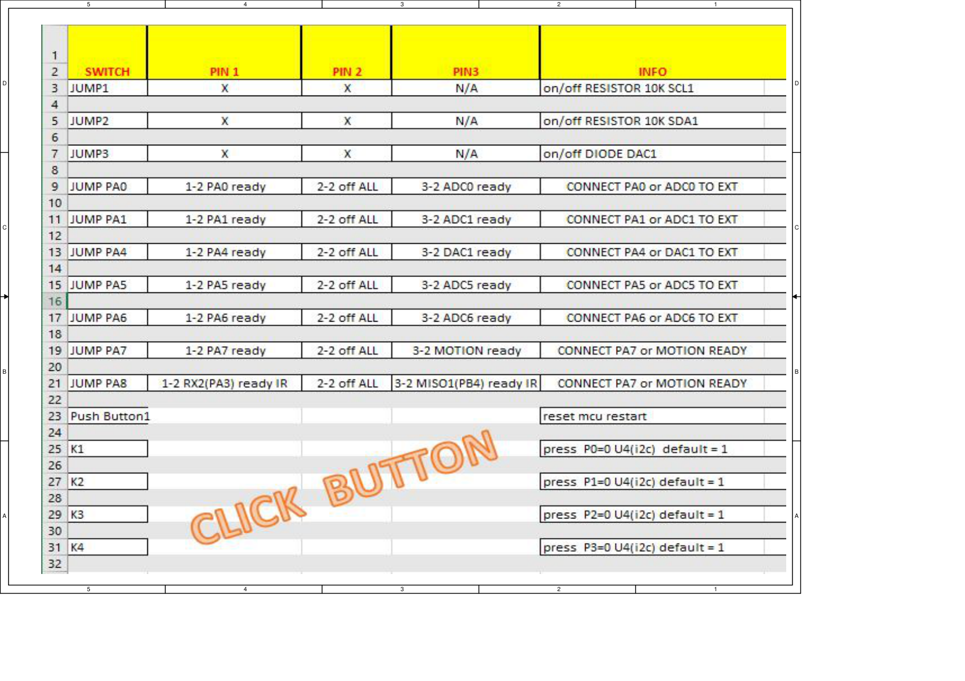
Jumper / switch configuration table used when adapting the platform to different prototype setups.

6. Project Status and Next Steps
The hardware platform is already designed, manufactured and assembled. The next public-development step is to package the hardware documentation together with an independent firmware demonstration and photographs of the assembled boards.
- Add photographs of the assembled main board and connection board.
- Add a short bring-up procedure: power, SWD connection, COM / UART test and initial firmware load.
- Publish independent demonstration firmware for the STM32L062.
- Document one or more practical examples, such as the motion-sensor input, ADC acquisition or an I2C peripheral test.
- Keep the main platform reusable so that future examples can be added without redesigning the core hardware.

Project classification: Full Hardware Project - STM32L0 Modular Development & Prototyping Platform

Prepared as project documentation for GitHub and technical portfolio use.

