**Reasoning behind components.**

SPH0641LM4H-1

* A device that trains dogs is nothing new. Dog whisltes was invented in 1876 by Francis Galton. It is used for the purpose of behaviour modification. The range of frequencies the whistle emits are from 23kHz to 54kHz. From this, I decided to find a transducer that would pick up frequencies in this range.
* The SPH0641LM4H-1 is an ultrasonic microphone. It consists of an acoustic sensor, a low noise input buffer, and a sigma-delta modulator.
* According to the frequency response curve of the SPH0641LM4H-1 below, there is flat response between 23kHz to 54kHz, which is suitable for this application for training dogs.
* Voltage output of 1.62V to 3.6V on standard performance mode.

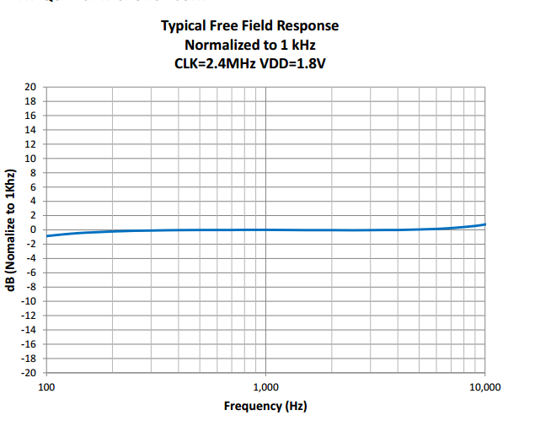

TMS320VC5507

* Fixed point digital signal processor
* Low power mode
* 200Mhz maximum frequency
* Used in audio processing and medical applications
* In this application it would implement a digital band pass filter, which will attenuate frequencies outside the range of 24kHz to 54khz, the range of frequencies dogs are trained at using a dog whistle.
* Also implements a digital dynamic range compression reduces the volume of loud sounds or amplifies quiet sounds by compression the incoming audio signal’s dynamic range.

# ADS831

# 8 bit resolution

# 80M samples per second

# Input channels 1

# (3.6V – 1.62)/2^8 = 0.007734V/bit

# Large sampling rate much higher than the Nyquist frequency.

# High resolution to ensure accurate representation of the sound coming from the transducer.