*Note: this draft of the rules does explain everything in unambiguous terms, but it is way too long (important) and not appealingly formatted (low priority for a demo). Could use a rework.*

Shahull Strife

*In the not-so-distant future of Earth, humanity has clumped together into overpopulated, tightly packed megacities. While the lands outside lay mostly barren save for the enormous industrial energy and food plants required for human survival, these cities are a bustling hub of activity, commerce and so, so much political power. No wonder then that in Shahull, like any other city of its size, many factions are vying for control of it’s different districts, resources and trade routes to gain power. It’s just that recently, these conflicts in Shahull have taken on a more violent nature.*

*Truly, the crowded, violent streets of Shahull are not a place most people would want to live. But not you. You belong to one of the many factions involved in the brawls. You are the one who gets to lead their special ops teams, bands of thugs, or any other muscle your superiors could get their hands on into the fray. And you’ll be damned if that ain’t a thrill.*

*So join that government task force, shady crime syndicate or vigilante justice group, and contribute to the strife!*

*Shahull Strife* is a collectible card game, programming game and card battler. Of course that means you’ll be playing cards against each other, but what do those other words mean?

A card battler is a game in which both players use their own deck of cards to fight each other, dealing damage until one side has no life left and therefore loses. Since you’ll be playing as an entire team of characters in *Shahull Strife*, you only lose once none of them have any life left.

The collectible part means that this game is easily expandable with extra decks and expansions to keep things fresh. No matter what decks you pair up against each other, it’ll always be a fair fight! If this is your first experience with *Shahull Strife*, you don’t need to worry about any expansion decks yet though – this starter kit contains everything you need to learn and play the game.

Finally, a programming game is a game where you first plan out a sequence of actions, typically within a limited time and resolve their effects later. The exact mechanics of this in *Shahull Strife* will be further explained below.

# Overview

In *Shahull Strife*, two players brawl it out as the field teams for various factions in the city of Shahull.  
To start the game, both players pick a team that will determine their deck, abilities and health pools for the game. All teams are unique, so change which team you play every once in a while between games!

During the game, players will be playing out a hand of eight cards into a combo in front of them from left to right, trying to finish their combo faster than the other player. Be careful though, since you’ll often need to balance speed with efficiency – sometimes it’s worth taking a few extra moments to think to prevent yourself from making any stupid mistakes, or to squeeze out that extra bit of damage.  
After both players have finished their combo for that turn, the effects of all cards played are resolved. A good combo will see you dealing lots of damage to your opponent’s character, while blocking as much incoming damage as you can.

If one of your characters is reduced to zero health or below, they die and their cards are no longer usable that game. Once your final character dies, it’s game over.

# Materials

Each player will need:

* A *team reference card*
* The associated *character reference cards*
* That team’s *action deck*
* The *finisher cards* for that deck
* Some *HP & momentum trackers*

Additionally, a chronometer-style timer is required to play this game. A chronometer app on your phone will do, as will a watch.

# Anatomy of a card

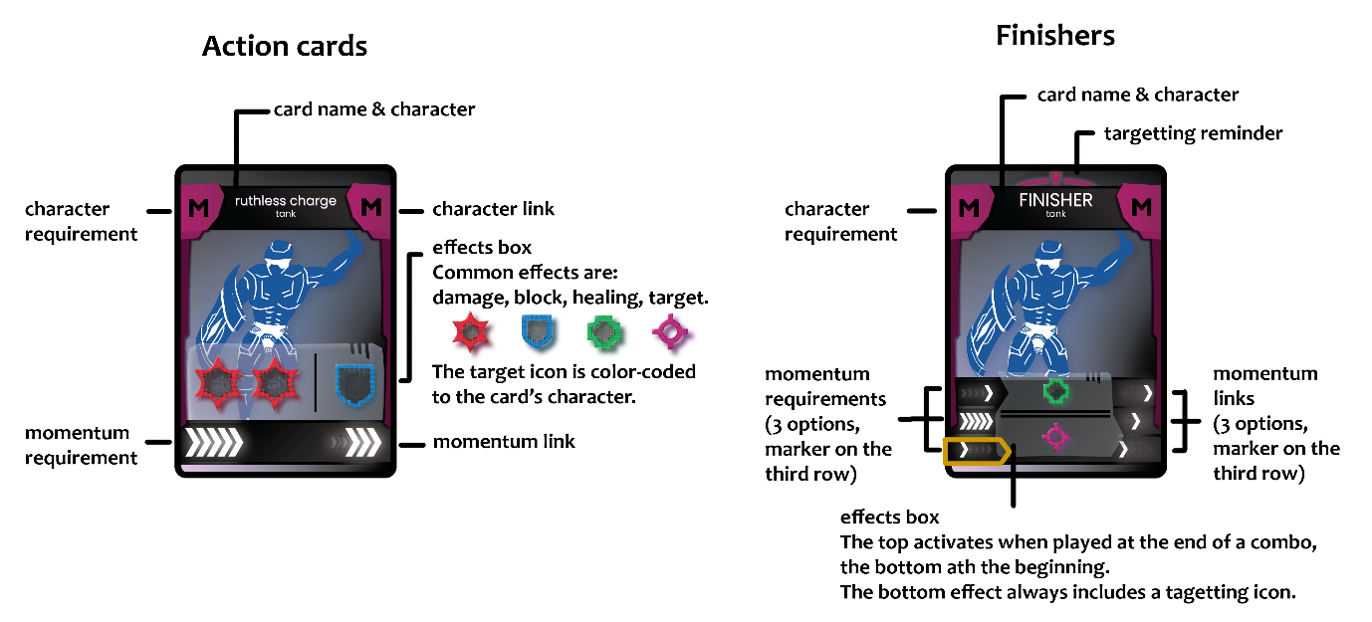

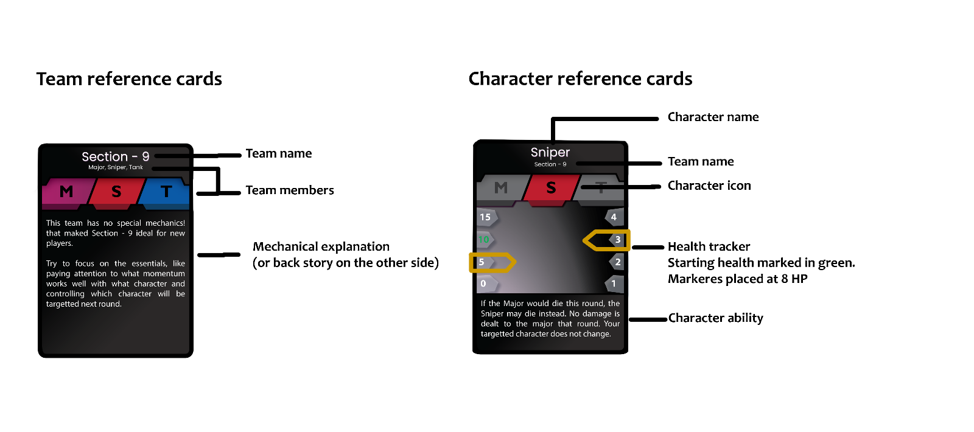

# Setup

Before the game starts, both players pick a team in a way they can both agree on.

Take your teams reference card, which will list all the characters in it. Take all associated character refence cards and action cards. You can also refer to the team icon to find cards associated with your team.

Read up on you team’s unique mechanics and your characters’ abilities on their respective reference cards. Note that the back side of these cards contains a brief description of their place in the larger world of *Shahull Strife* for those who want it.

Place HP markers on the character reference cards to mark their starting HP. For most characters, this will be less than the maximum HP of 20. Place each character’s finisher by their reference card.

Have a look through your team’s action cards if you want, then shuffle them into a face-down deck.

Finally, pick any finisher card, put a momentum tracker on any of the three options, and place it as the start of your first combo. If both players have done this and both are familiar with the rules, you are ready to start the first round of combat.

# Flow of play

The game is played over multiple rounds. Each round consists of a combo building phase, followed by a combo resolution phase.

During combo building, you play cards into your own combo from left to right while taking care not to make any mistakes, but their effects do not happen yet. Choices presented on cards are not locked in yet.

During combo resolution, you make all choices that may be present on card you played, and resolve the effects of all cards in your combo. Resulting damage is dealt to the currently targeted character on both sides.

Once both phases are completed, move on to the next round.

## Combo building

At the start of the round, draw eight cards but don’t look at them yet. Once both players are ready to start, you may look at your hand and start playing cards.  
Combo building happens in real-time, meaning that from this moment until your combo is done, you can both play cards simultaneously without having to wait for each other.

You build your combo by playing cards from your hand one at a time from left to right. At any point, you are allowed to take back the most recent card you played if you change your mind, but not any cards played before that.

Each card you play must chain from the previous card. The mechanics of this are explained further below.

At any point while building your combo, you may discard all cards remaining in your hand and draw as many from your deck. Note that discarded cards do not go back into your deck, so they are lost for this round. If your deck does not contain enough cards to draw, you still discard your entire hand and just draw what remains of your deck.

At any point during combo building, you may play a finisher card that chains with your last played card. Doing so marks the end of combo building for you, but your opponent may still continue.  
If your finisher for this combo was also this combo’s starting card, simply move it to the end of the combo and remember this.  
Note that finishers can have multiple rows of momentum requirements & links, you may choose any row for which the requirement is met. Place a momentum marker on that row. Next round, you’ll be starting from the momentum link in that same row.

Whoever played their finisher first immediately starts a timer. Stop the timer once the other player plays their finisher. Set this timer aside without resetting it.

### Chaining

Whenever you play a card into your combo, it must chain with the previous card. Specifically, the left edge (requirements) of the new card must match with the right edge (links) of the previous card.  
Note that even for the first action card in your combo, you already have a finisher to chain from (see “Finishers”).  
There are two requirements for cards to chain: character and in momentum. For a card to be playable, both of these must match as described below & shown in the examples.

Character is indicated at the top of every action and finisher card next to its name. All characters chain to themselves. The ‘?’ symbol means “any character”.

Momentum is indicated at the bottom, below the effects box (or to its side for finishers).

The normal system for chaining momentum between cars is simple: As long as there is at least one tick shared between the previous card’s momentum link and the new card’s requirement, the cards chain.

Some cards do not follow the standard format for requirements and links when it comes to momentum. These cards instead inherit the previous one’s momentum link, possibly with some modification. This is called carrying momentum.   
These cards are recognisable by a line across the momentum bar and a symbol to indicate the exact effect: “+ +” Shifts all ticks right by one, “- -" shifts all ticks left and “= = ” doesn’t modify the momentum link.  
Note that momentum cannot go out of the range pictured on the cards. Any ticks that would be modified to go further left than the first tick or further right than the fifth simply stay in place instead.

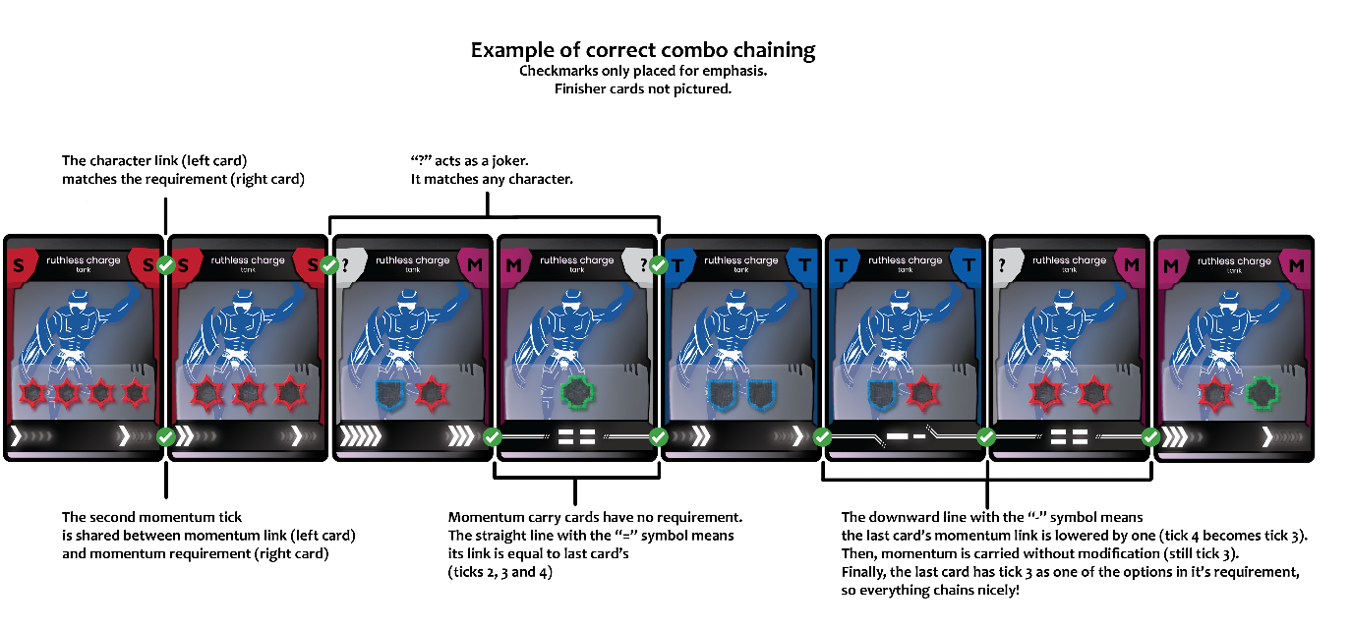

### Finishers

Every combo both starts and ends in a finisher. Typically, the finisher at the end of your combo this round will be the one you have to start from next.

Character chaining for finishers works exactly the same as for action cards. Typically, a team will include one finisher for each character so there is always one that matches.

Momentum chaining for finishers is slightly different, as finishers can have up to three different momentum bars presented in rows. You must choose one of these rows that would, on its own, chain with the previous cards and place a momentum marker there.  
Placing a marker like this can be done after you have played the finisher. It is playing a finisher, not placing a marker or choosing a momentum row, that finishes the combo building phase for you.  
Typically, every momentum tick occurs at least once in the requirements of every finisher, so any finisher can chain momentum with any card.

Since every combo must end with a finisher, all teams are designed so that there is always at least one finisher playable in any situation.  
If the specific finisher you played did not chain from the card before it this is not terrible. See “broken chains” for how to resolve this.

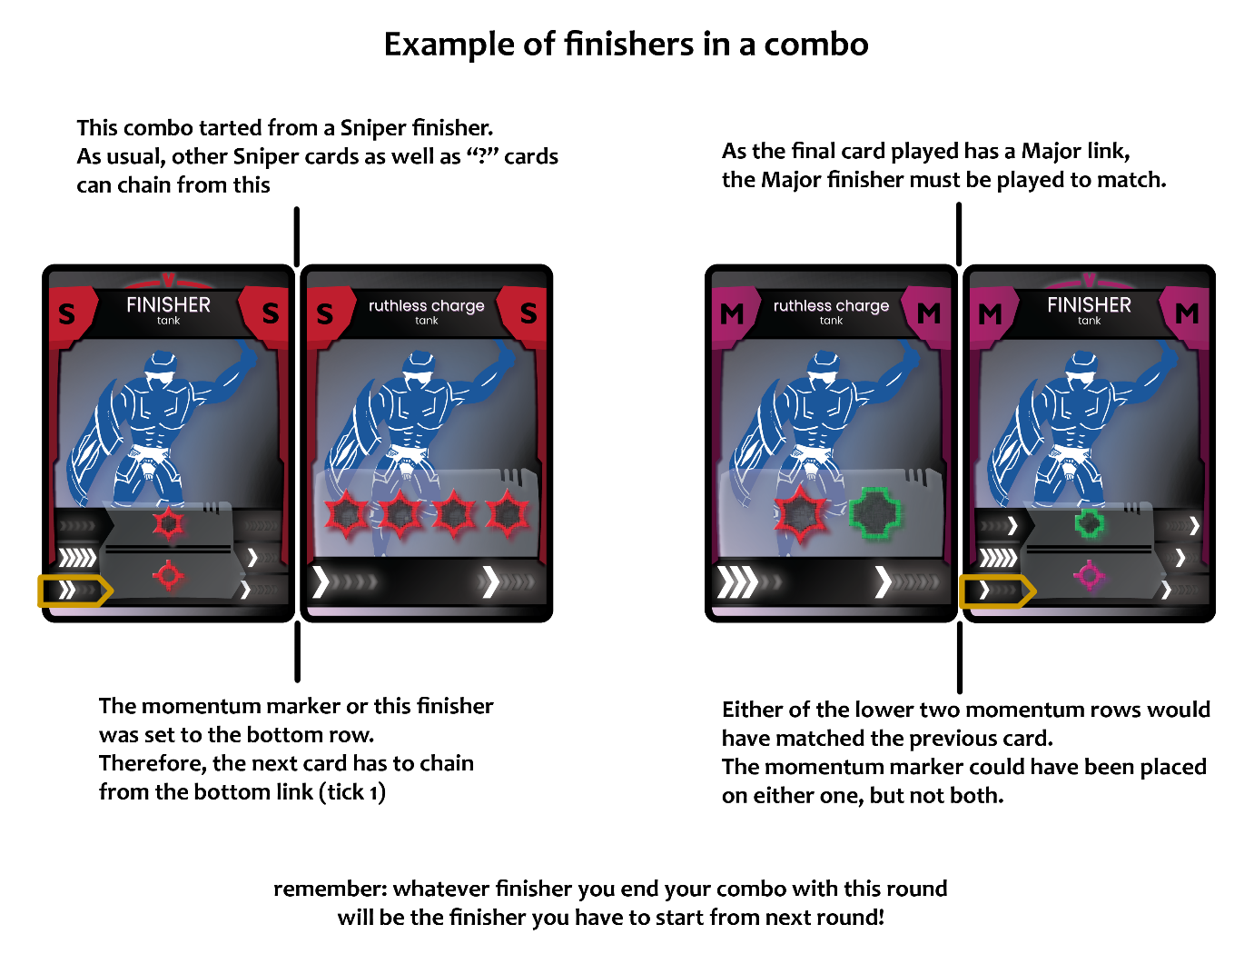

## Combo resolution

First, both players should double-check that their cards form a legal combo according to the chaining rules above. If this is not the case, see the “broken chains ” section.

Starting with the player who finished combo building last, decide which option you’ll be using for every card you played that presents a choice. Choices are indicated by a line drawn between different effects.

Then, identify which of your character is targeted this round. This is determined by the most recently played card in your combo with a TGT icon. The character corresponding to that card will be taking all incoming DMG this round.  
Note that the finisher at the start of your combo always has a TGT icon in its effect. Finishers do not usually activate their TGT ability when played at the end of your combo.

Next, count the total amount of DMG, HEAL and BLK granted by your combo. Note that finishers have a different effect depending on whether they’re the first or last card in your combo (see “anatomy of a card”). If the same finisher that was the first card is also the last, you get both effects.  
Remember to also count fury damage dealt by the player who finished combo building first (see “fury”).

HEAL gained heals any of your non-targeted living characters up to at most 20 HP. This can be divided among your non-targeted living characters as you please.

Finally, your targeted character’s HP is lowered by the opponent’s DMG minus your own BLK. The final damage dealt this way cannot be negative. If a character dies, excess damage is simply ignored.

### Fury

The player that finished first gains an extra 2 DMG do deal that round, plus another 2 DMG for every 10 seconds on the timer.

Once fury damage has been dealt, reset the timer for next round.

For beginning players, it is recommended to play without fury damage first. After a few rounds, you can introduce the 2 damage gained from fury before finally adding in the timer a little later again.

### Starting the next round

Before the next round starts, remember to double-check that you placed a momentum marker on your finisher.  
Take all action cards you played or discarded this rounds, and shuffle them back into your deck.

# Character death and end of game

If at any point one of your characters has zero HP or less remaining, they die. Before the next round starts, remove all of their cards from your deck for the rest of the game. Note that this only happens after all the effects of that round’s combo are resolved.

If the finisher you played belongs to a character that is now dead, you may instead pick any finisher from one of your living characters and any momentum option on that finisher to start from next round, similar to the start of the game.

Once your opponent’s last character dies, you have won the game. In case this happens on the same round for both players, the game ends in a tie.

# Broken chains

If you play a card whose requirements are not met and notice in the moment, you can take it back as long as it is your most recently played card. This is following the normal rules of combo building.

If you notice during combo resolution that you played an illegal finisher, simply swap it out for the correct one. The new finisher still has its effect.

If the illegally played card is an action card and you don’t notice in time, this will be resolved at the start of the combo resolution phase. The illegally played card is removed from your combo. If the card after that would also not have been a legal play, remove it as well. Keep going until the first card in your combo that would have been legal to play In that position. If you get to the finisher before this happens, replace it as stated above. This process results in a legal combo, but often a much weaker one.

You never gain anything from intentionally breaking your combo like this. If you find this happening by accident a lot, this can be frustrating as the way broken combos are resolved can feel very punishing. Try to take next turn a little slower and you will usually do much better in that regard.  
Remember, Shahull Strife is not only about speed, it’s about balancing speed with accuracy.

# Team mechanics & character abilities

Many teams have unique mechanics, described on their team reference cards. Similarly some characters have their own abilities that can have an effect as long as the character is alive.

These extra rules are crucial to playing those teams and may even allow you to break some rules presented in this document.  
Make sure that before playing a game, both players know about the unique twists of both decks.

# Credits

Senne Lauwers – playtesting

Joren Van Borm – game design, copy (rules & story), graphic design (cards), card art

Ellys Van Vlierberghe – playtesting, card art