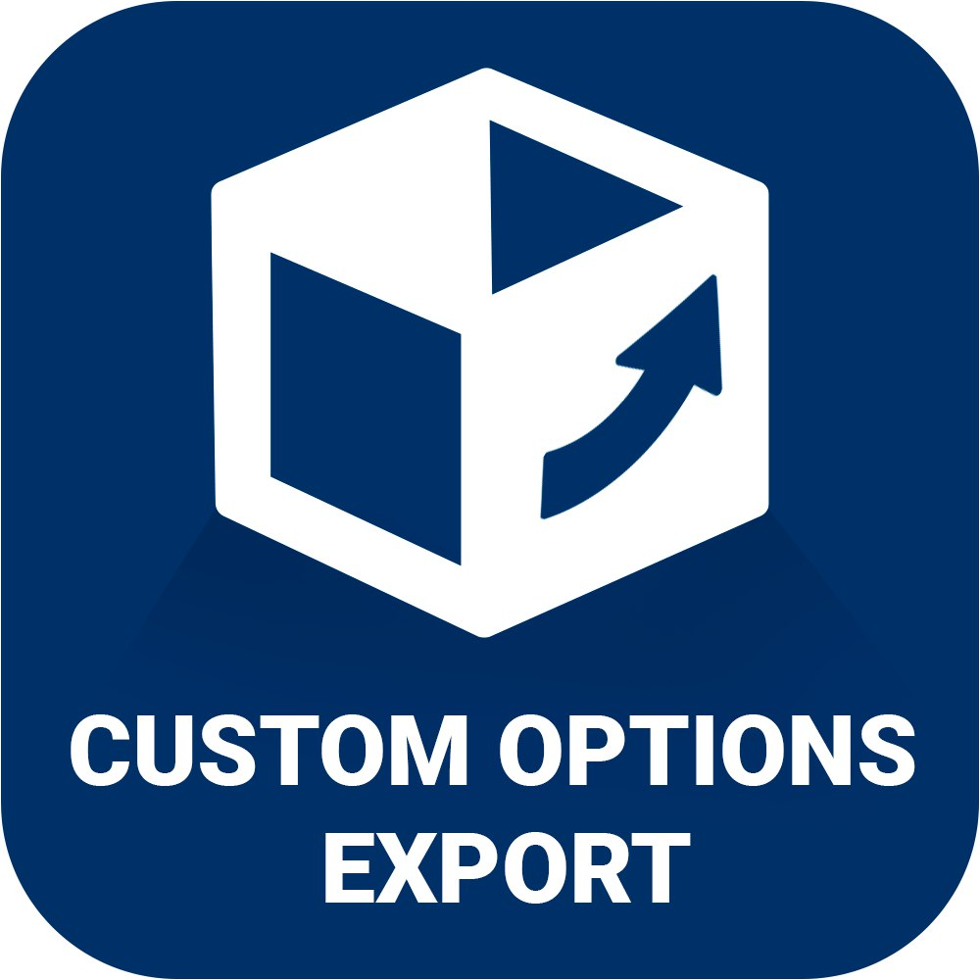

**Extension for Magento 2**

Testing on Magento 2.1 with Sample Data.

Version 1.0 (23.04.17)



**Custom Options Export**

The export custom product options extension allows you to create product сustom options export files and export them into any CRM application or software to manage products.

The main functions of the module are:

* very fast export, which uses only one request to the database;
* export options in xml or csv files
* support all types of product custom options
* options available as the export of one commodity or group of commodities through the admin panel or by using the console.

**Installation:**

* Copy the folder with the module at the root of your site;
* run the following command:

php bin/magento setup:upgrade

php bin/magento setup:di:compile

php bin/magento setup:static-content:deploy

php bin/magento cache:clean

* after they are completed, you should see in the app/etc/config.php this module.

**Use:**

Go to the product list. Mark the checkbox product options that you want to upload. On the Actions menu, select the format for export.

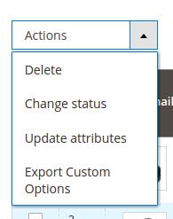

To export individual product options, click on the edit product. In the Options section, select the export format and click "run".

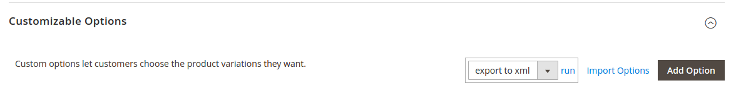

To export the console, see the command: php bin/magento customoptions:export

**Note: The extension can override the files that you already use. Make sure**

**that there are no conflicts with your modules before using this module. The**

**module has been tested on Magento 2.1 with Sample Data.**