

**DATABASE MANAGEMENT SYSTEM TASK 2**

**GROUP ASSIGNMENT**

**Course code:** (112023-LCP)

**Intake code:** UCDF2307ICT(SE)

**Lecturer: Ms. Lai Chew Peng**

|  |  |
| --- | --- |
| **Group Members** | **Student TP Number** |
| Denesh A/L Sellasamy | TP076723 |
| Chan Zyanne | TP075156 |
| Ang Jianming | TP076671 |
| Shim Yong Lin | TP076209 |

Table of Contents

1.0 Database Schema 3

1.1 Updated Entity Relationship Diagram (ERD) 3

1.2 Database Diagram 4

2.0 SQL-Data Definition Language (DDL) 5

Menu 5

Member 7

Rating 9

Manager 11

Chef 11

DispatchWorker 12

Cart 13

CartDetail 14

Order 16

OrderDetail 18

Delivery 19

3.0 SQL-Data Manipulation Language (DML) 20

Workload Matrix 28

# 1.0 Database Schema

## 1.1 Updated Entity Relationship Diagram (ERD)

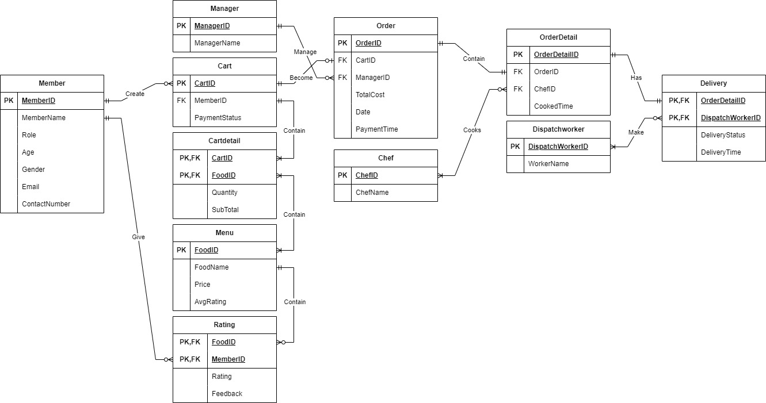

Order – OrderDetail

One order is handled by one manager and sent to one chef in order detail.

Exam –

Provided paper to draw ERD

- 1.2 Database Diagram

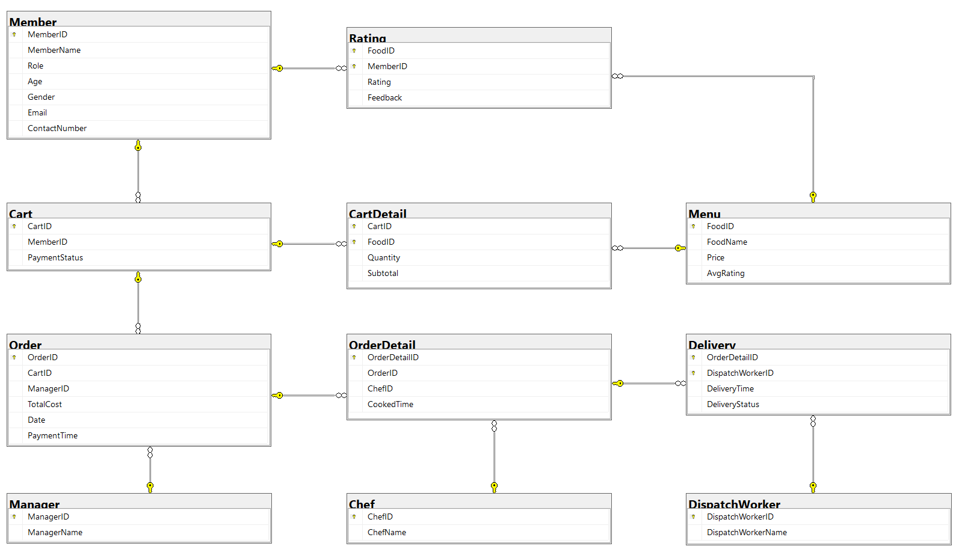

# 2.0 SQL-Data Definition Language (DDL)

## Menu

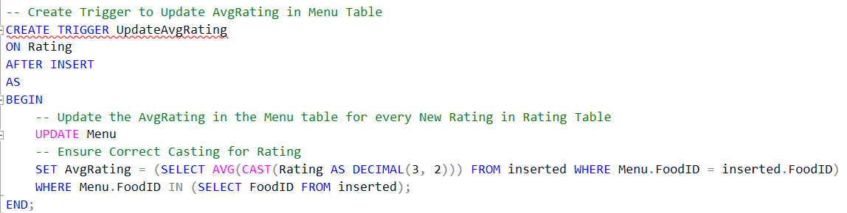

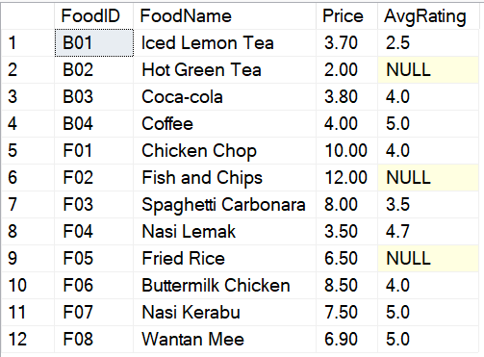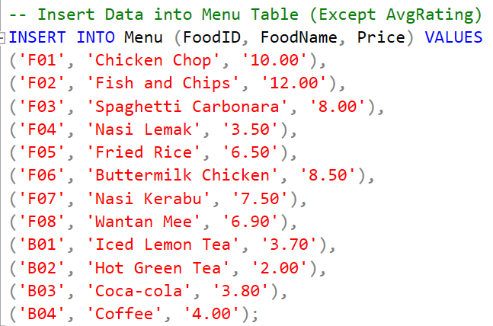

Menu Table

## Member

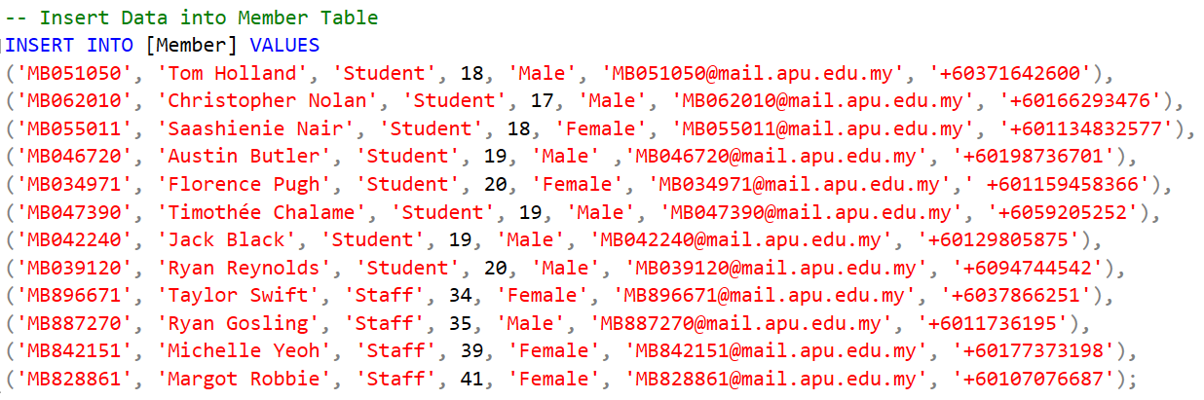

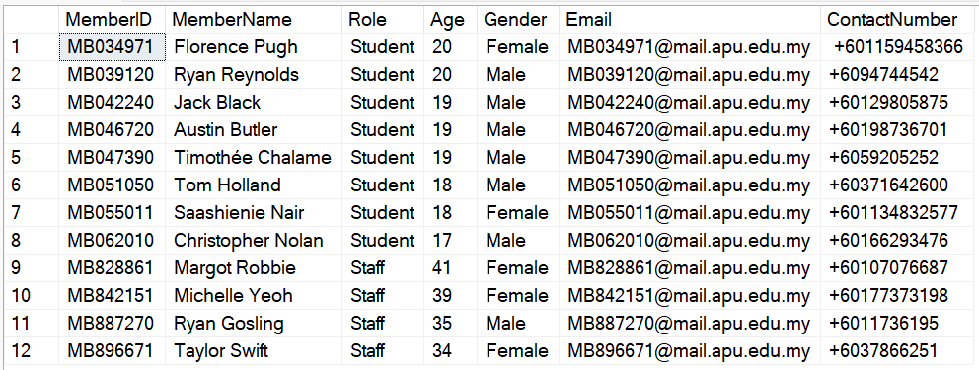

Member Table

## Rating

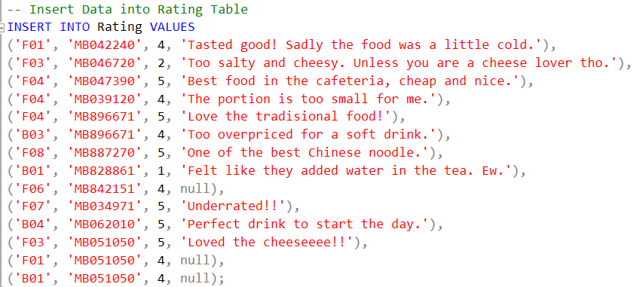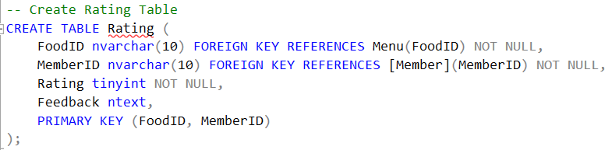

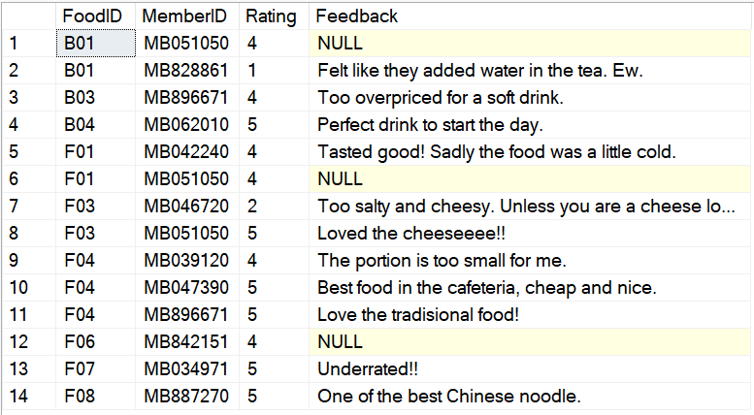

Rating Table

## Manager

**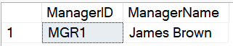******

Manager Table

## Chef

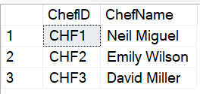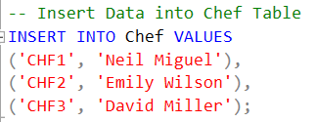

Chef Table

## DispatchWorker

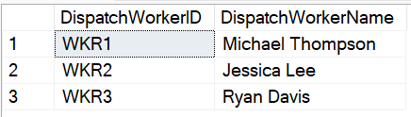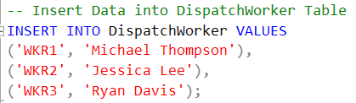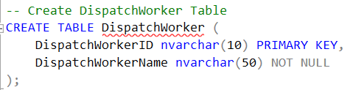

DispatchWorker Table

## Cart

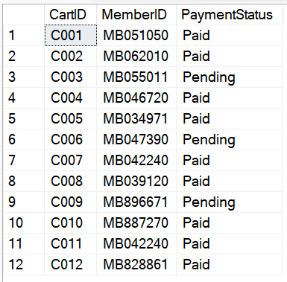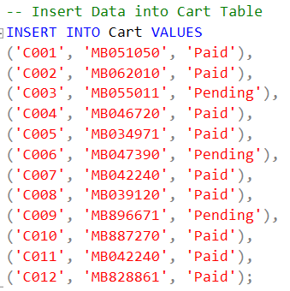

Cart Table

## CartDetail

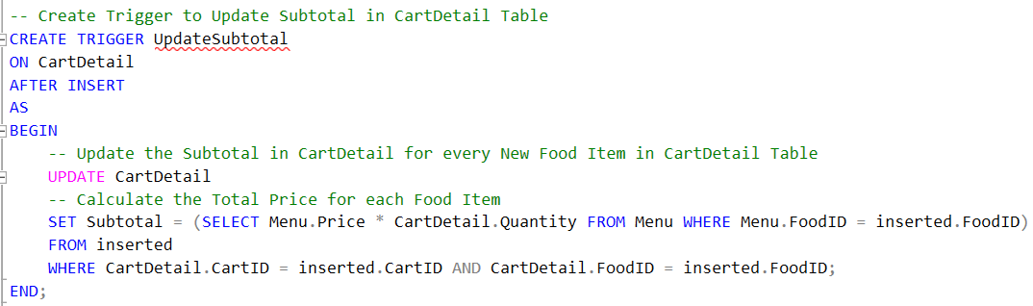

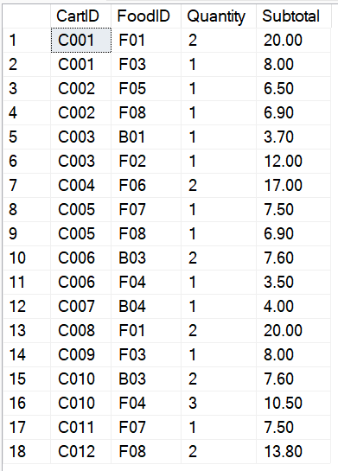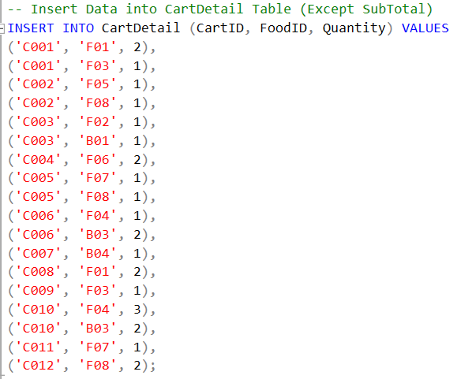

CartDetail Table

## Order

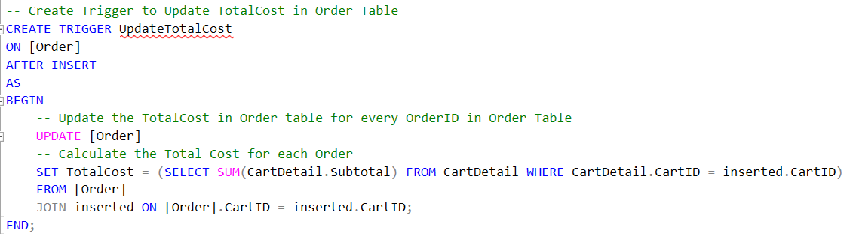

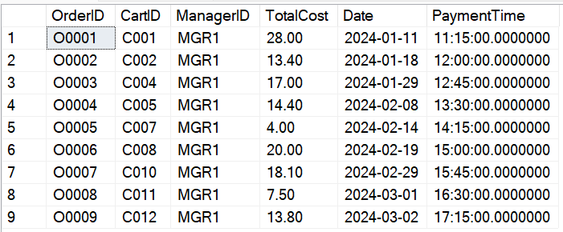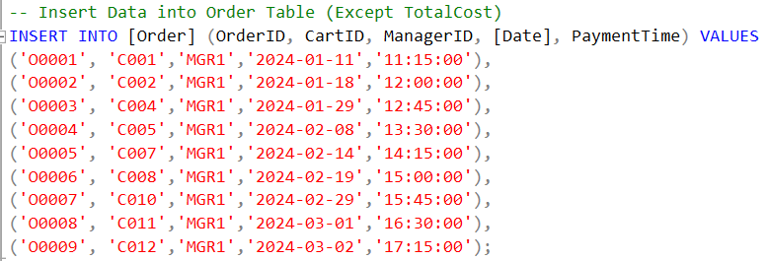

Order Table

## OrderDetail

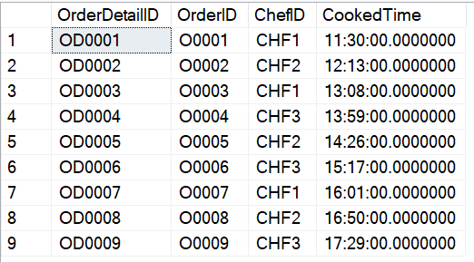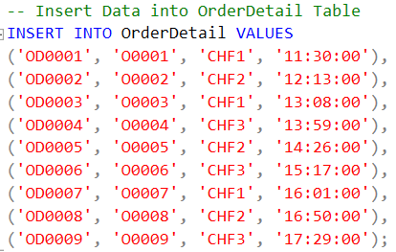

OrderDetail Table

## Delivery

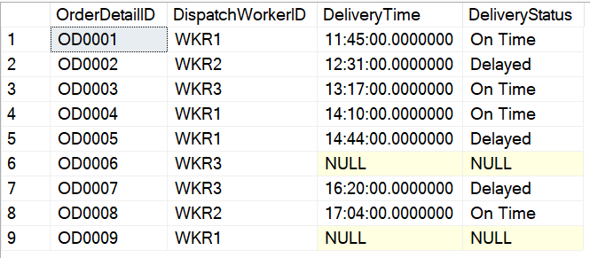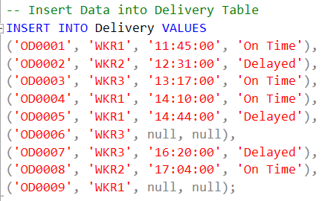

Delivery Table

# 3.0 SQL-Data Manipulation Language (DML)

Answer for Question i

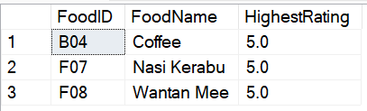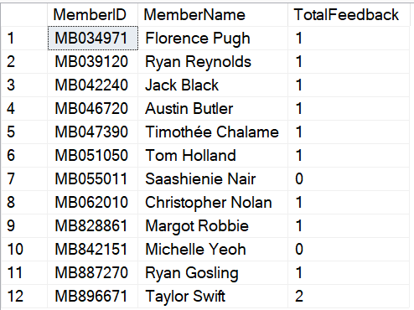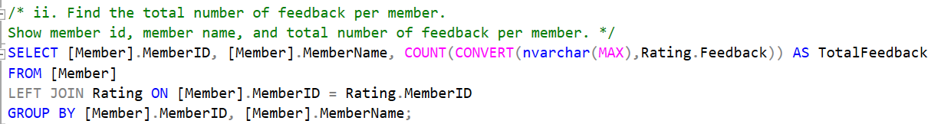

Result for Question i

Result for Question ii

Answer for Question ii

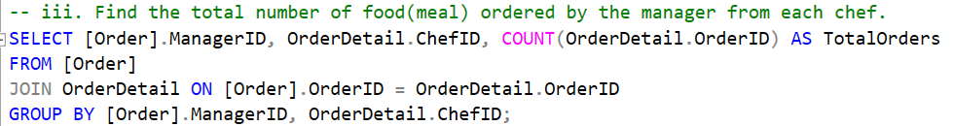

Answer for Question iii

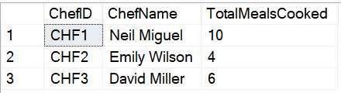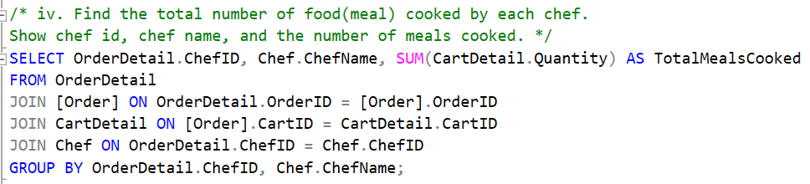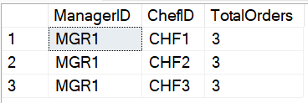

Result for Question iv

Answer for Question iv

Result for Question iii

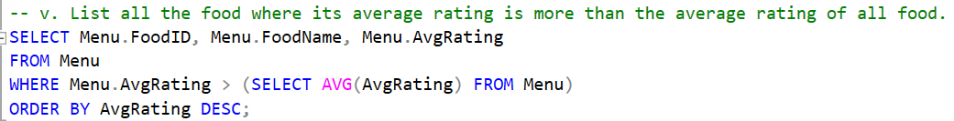

Answer for Question v

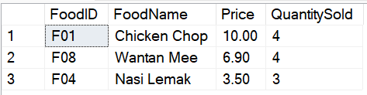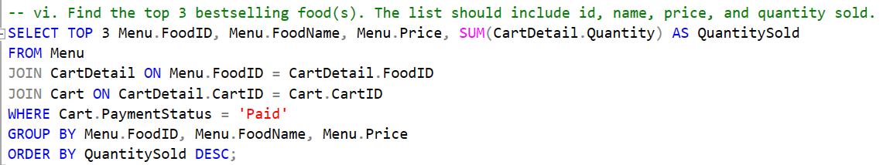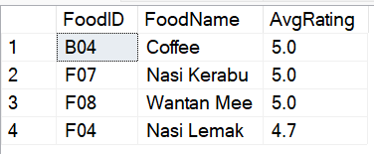

Answer for Question vi

Result for Question vi

Result for Question v

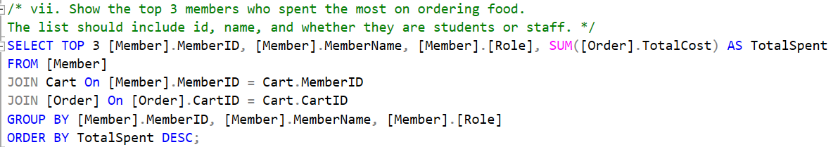

Answer for Question vii

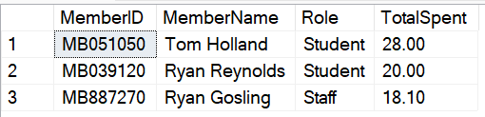

Result for Question vii

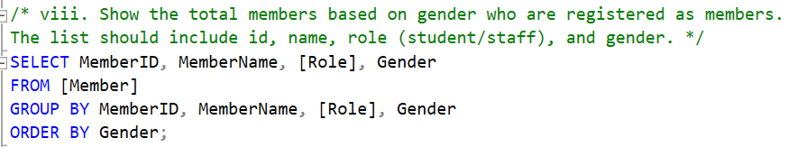

Answer for Question viii

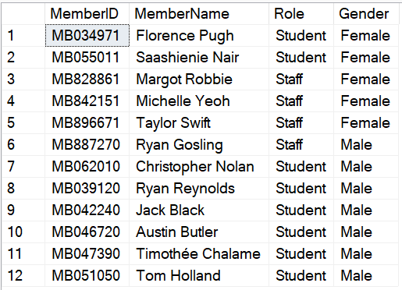

Result for Question viii

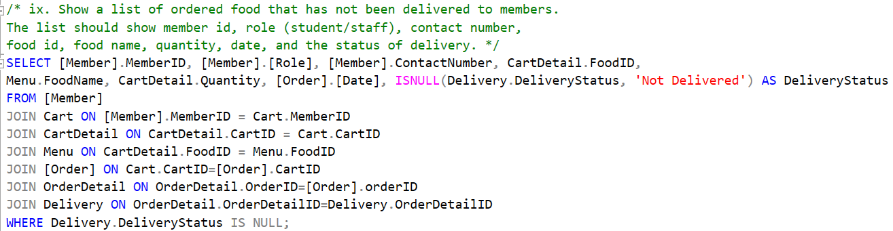

Answer for Question ix



Result for Question ix

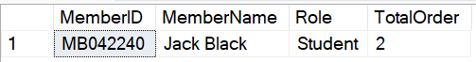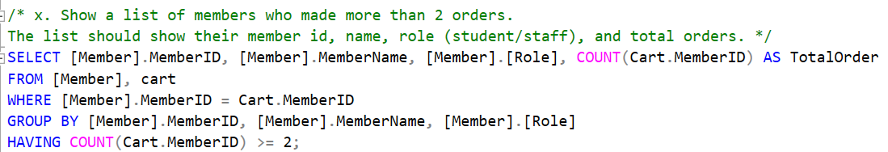

Result for Question x

Answer for Question x

# Workload Matrix

|  |  |  |  |  |  |  |
| --- | --- | --- | --- | --- | --- | --- |
| **Part** | **Component** | **Student 1 Name: Danesh** | **Student 2 Name: Chan Zyanne** | **Student 3 Name: Ang Jianming** | **Student 4 Name: Shim Yong Lin** | **Total** |
| **1** | 1. Database and Database Management System | **5** | **5** | **45** | **45** | **100%** |
| **1** | 1. Business Rules & Normalization | **5** | **85** | **5** | **5** | **100%** |
| **1** | 1. Entity Relationship Diagram | **70** | **20** | **5** | **5** | **100%** |

|  |  |  |  |  |  |  |
| --- | --- | --- | --- | --- | --- | --- |
| **Part** | **Component** | **Student 1 Name: Danesh** | **Student2 Name: Chan Zyanne** | **Student 3 Name: Ang Jianming** | **Student 4 Name: Shim Yong Lin** | **Total** |
| **2** | 1. Database Schema | **40** | **40** | **10** | **10** | **100%** |
| **2** | 1. DDL | **45** | **45** | **5** | **5** | **100%** |
| **2** | 1. DML | **5** | **10** | **40** | **45** | **100%** |