Campaign Plan: Skincare - With Generated Images

Generated on: September 21, 2025 at 06:29 PM

# Campaign Strategy & Timeline

Focus on creating engaging and relatable content that resonates with young people across different cultures in Malaysia. Utilize social media platforms like Instagram, TikTok, and Facebook to reach the target audience. Collaborate with influencers from Chinese, Malay, and Indian backgrounds to increase authenticity and reach. Highlight the brand's commitment to inclusivity and diversity. Leverage Malaysia Day to create special promotions and content that celebrate the nation's unity in diversity.

# Visual Elements Generated

The following visual elements were generated for this campaign:

1. vibrant skincare bottle with multicultural patterns

2. youthful faces showcasing diverse skincare routines

3. pastel-colored infographic highlighting product benefits

4. energetic live Q&A session with dermatologist

5. Malaysia Day celebration with traditional decor and skincare products

# Generated Images

## Element 1: vibrant skincare bottle with multicultural patterns

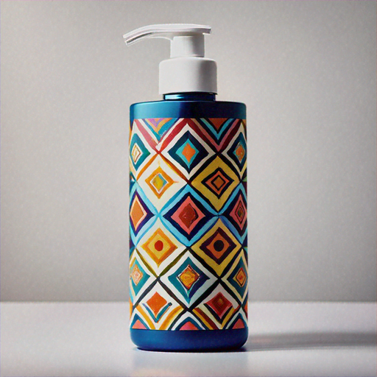

## Element 2: youthful faces showcasing diverse skincare routines

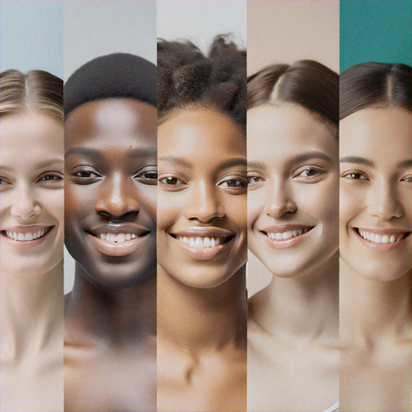

## Element 3: pastel-colored infographic highlighting product benefits

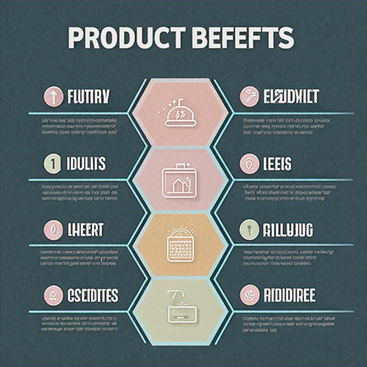

## Element 4: energetic live Q&A session with dermatologist

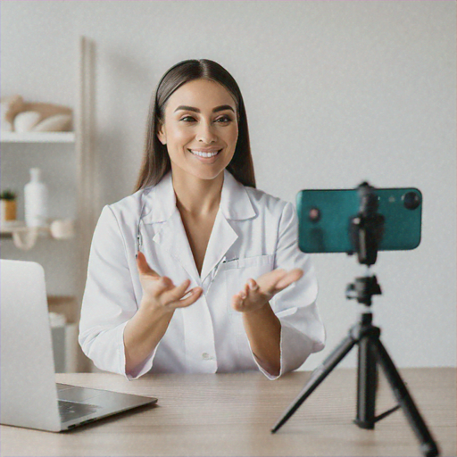

## Element 5: Malaysia Day celebration with traditional decor and skincare products

