2026 (2026.09 Grad.) Summary of Master Thesis

G30 Automotive Engineering
Name | Karl Raymond Dela Cruz Roque | Dept./  Lab. | Department of Electrical Engineering  Power Electronics Laboratory (Yamamoto Laboratory)
Title | Implementation of Flatwise Windings for Improved Thermal Management in Transformers for Solid State Transformer (SST) Applications
Increased energy generation and consumption are imminent as economies develop and the drive towards electrification intensifies. To keep up with the increasing energy demands of society, the Solid State Transformer (SST) is a critical and rising technology to facilitate energy conversion and distribution, replacing the traditional line frequency transformer to achieve higher power density and advanced functions, made possible by the advent of fast-switching wide band-gap (WBG) semiconductor devices. However, effective thermal management for the transformer in the isolation stage of the SST is one of the primary design bottlenecks for high-power transformers as current methods can compromise the power density of the converter.

This study investigates a contrasting design approach that prioritizes intrinsic thermal performance of the transformer utilizing rectangular windings, which has the potential to reduce reliance on conventional cooling systems. While rectangular windings offer high fill factors and current capabilities, research comparing the thermal characteristics of different winding orientations remains limited. This paper proposes a low-profile transformer utilizing flatwise windings, characterized by rectangular conductors stacked radially from their broad face, as shown in Figure 1a. This configuration creates a fundamentally lower thermal resistance path by enabling direct, simultaneous, and parallel heat extraction from every turn as compared to its conventional, edgewise counterpart (Figure 1b). A thermomagnetic FEM analysis under the same magnetizing inductance, window area, wire geometry, and current density comparing the proposed design against an edgewise structure at 1 kW demonstrates a peak temperature reduction of 10.9°C (56.0°C vs. 66.9°C) under natural cooling and 13.4°C (30.2°C vs. 43.6°C) under forced air cooling (see Figure 2). The results also confirm that the proposed flatwise-wound transformer ensures a uniform heat distribution. Moreover, the consistency of the performance was evaluated spatially through the variation of conductor thickness.

A representative edgewise-wound (Figure 3a) and flatwise-wound (Figure 3b) transformer with a square window area was implemented in a 100 V:100 V, 1-kW CLLC bidirectional resonant converter at 28.5 kHz switching frequency for experimental comparison under natural and forced-air cooling conditions. The experimental results in both cooling conditions validated the thermal superiority of the flatwise structure, demonstrating lower peak winding temperatures and reduced thermal gradients between the winding and the outer surfaces of the transformer (see Figure 4). These results validate the superior thermal performance of the flatwise structure, paving the way for more compact, power-dense transformers.

Key figures are shown below:
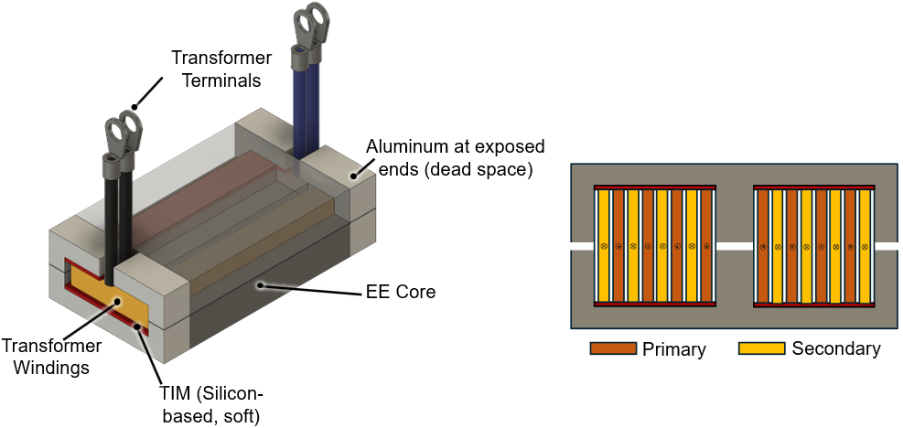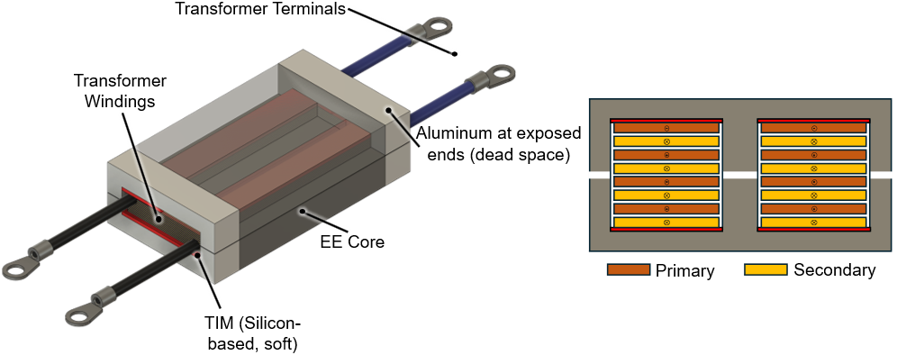
- (b)
Figure 1. Representative models of the transformers with a mockup (top half of the EE core transparent) and their cross-sectional views: (a) flatwise-wound (proposed) transformer and (b) edgewise-wound (conventional).
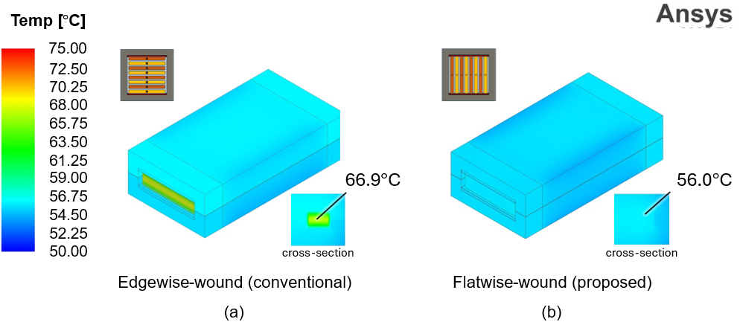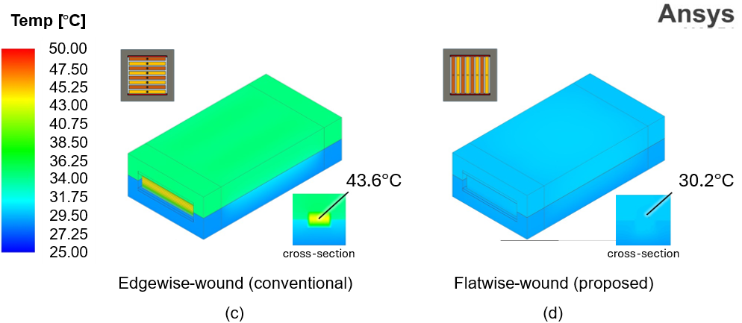
Figure 2. Electro-thermal simulation results from Ansys: (a) edgewise-wound (conventional) and (b) flatwise-wound (proposed) transformers examined in this paper at 28.5 kHz, under natural cooling, at 25.0°C ambient temperature; (c) edgewise-wound (conventional) and (d) flatwise-wound (proposed) under forced-air cooling through a heat sink.
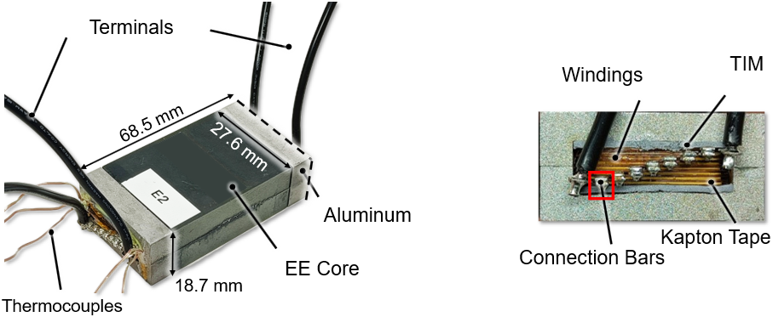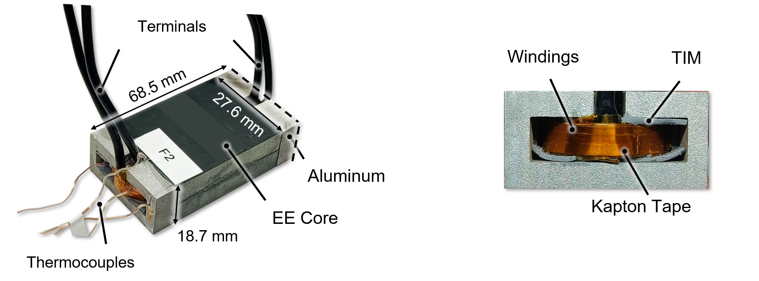
- (b)
Figure 3. (a) Prototype edgewise-wound (conventional) transformer representing Tr2E with its cross-section; (b) Prototype flatwise-wound (proposed) transformer representing Tr2F with its cross-section.
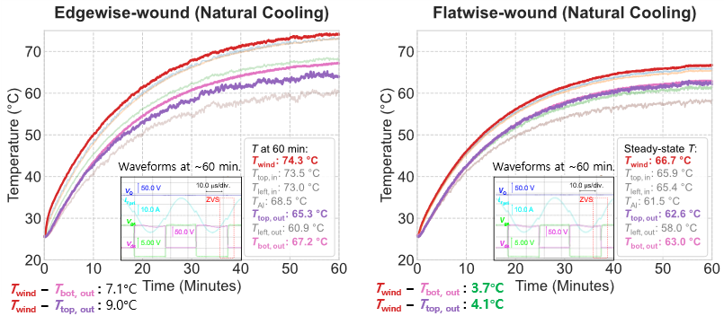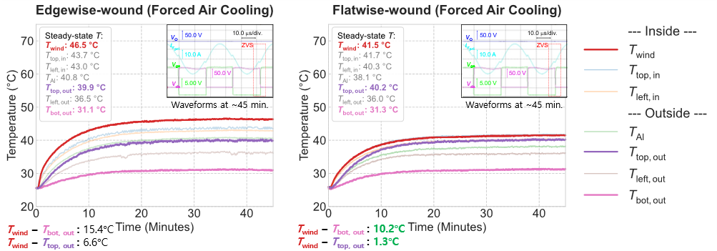
- (b) (c) (d)
Figure 4. Temperature profiles of the transformers under natural cooling: (a) edgewise-wound transformer, (b) flatwise-wound transformer; and forced-air cooling through a heat sink: (c) edgewise-wound transformer, (d) flatwise-wound transformer. The gradients between the winding temperature T_{wind} and the upper and bottom surface temperatures, T_{top, out} and T_{bot, out} are highlighted.

