**Task 1**

**Part 1: Simulating Geometric Brownian Motion**

After running the code in file “gbm”, we get following output :

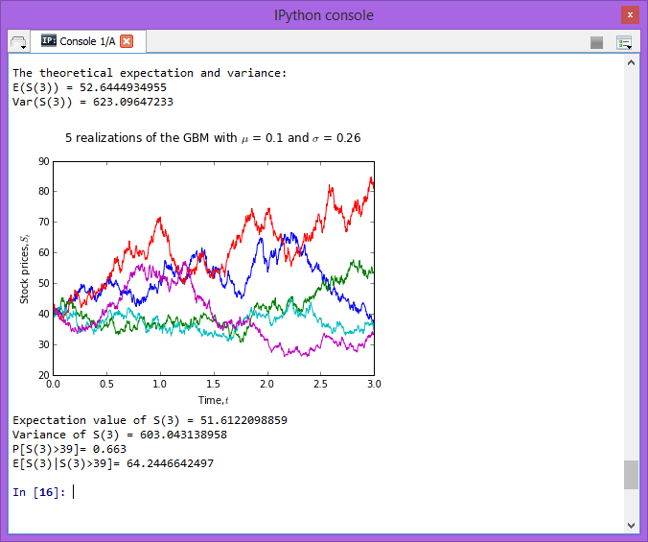

We get the theoretical expectation value and variance. These values are calculated by using formula :  
Expectation value of S(3) = $E\left[S\left(t\right)\right]=S\left(0\right)e^{\left(ut\right)}$

= $E[S\left(3\right)]=39e^{\left(0.1(3)\right)}$

= 52.6444934955

Variance of S(3) = $Var\left(S\left(t\right)\right)={S\left(0\right)}^{2}e^{2μt}\left(e^{σ^{2}t}-1\right)$

= $Var\left[S\left(3\right)\right]={39}^{2}e^{2(0.1)(3)}\left(e^{{(0.26)}^{2}(3)}-1\right)$

= 623.09647233

Then , given following geometric Brownian motion (GBM),

dS(t) = 0.1 dt + 0.26 dB(t); S(0) = 39

we can know the parameter mu=0.1 , sigma=0.26 and initial S(0)=39. We then stimulate 1000 runs of GBM for 0<t<3 for 1000 paths. We then plot the 5 realization of GBM paths with proper labelling.

In order to calculate the expectation and the variance of S(3) based on stimulation , we generate an array of stock at time 3 (S3) and extract the stock price at the last column by using S[:,-1]. Next, we use the np.mean to calculate expectation value of S(3), and np.var to calculate variance of S(3) .

In order to calculate P[S(3)> 39], we simply assign variable ‘a’ be position of value that are greater than 39, true will be returned, then we can calculate the P[S(3)> 39] by dividing the sum of ‘a’ by length of ‘a’.

In order to calculate E[S(3) | S(3) > 39], we simply assign variable ‘c’ be the multiplication between array S3 and variable ‘a’. Then we can calculate E[S(3) | S(3) > 39] by dividing sum of ‘c’ by sum of ‘a’.

**Part 2. Simulating mean reversal process**

After running the code in file “mr”, we get following output :

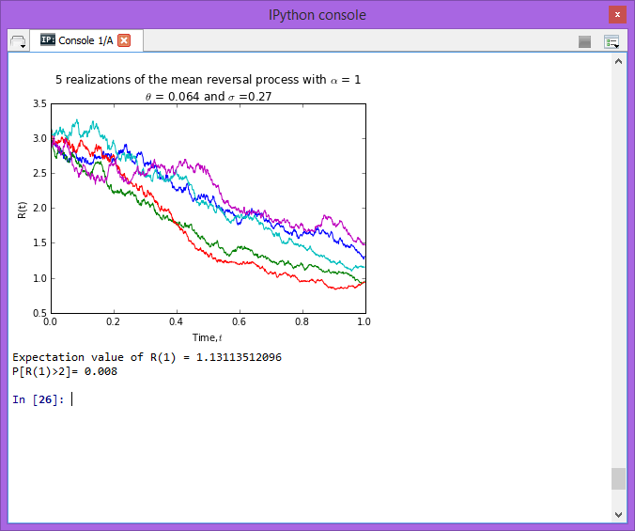

We define parameters needed such as t, sigma, theta, alpha, n_path , n and R0. Then, we plot the 5 realizations of mean reversal process with proper labeling.

In order to calculate the expectation value of R(1), we first take only the last row of array R and assign it to variable R1. Then , we can calculate the expectation value of R(1) by using np.mean command.

In order to calculate P[R(1)> 2], we assign variable ‘a’ be the position of value that R1 greater than 2, true will be returned, then we can calculate P[R(1)> 2] by dividing sum of ‘a’ by length of ‘a’.

**Task 2**

**Part 1 - FTSE Bursa Malaysia KLCI Index**

1. How many components stocks are there?

There are 30 components stocks.

2. Create a table list the following information for all the component stocks: Stock Name, Stock Code, Stock Sector, Weightage in FTSEKLCI, PE Ratio, Net Market Capital.

|  |  |  |  |  |  |
| --- | --- | --- | --- | --- | --- |
| **Stock Code** | **Stock Name** | **Stock**  **Sector** | **Weightage**  **(%)** | **PE**  **Ratio** | **Net Market Capital**  **(MYR in millions)** |
| 1295 | PUBLIC BANK BERHAD | Finance | 11.60 | 16.31 | 73682.979 |
| 1155 | MALAYAN BANKING BERHAD | Finance | 9.32 | 13.07 | 87750.513 |
| 1023 | CIMB GROUP HOLDINGS BERHAD | Finance | 5.76 | 14.97 | 46524.058 |
| 1082 | HONG LEONG FINANCIAL GROUP BERHAD | Finance | 0.64 | 11.20 | 16654.790 |
| 1015 | AMMB HOLDINGS BERHAD | Finance | 2.38 | 9.94 | 17723.408 |
| 5819 | HONG LEONG BANK BERHAD | Finance | 1.67 | 12.02 | 25265.977 |
| 1066 | RHB CAPITAL BERHAD | Finance | 1.06 | 9.67 | 19698.345 |
| 5347 | TENAGA NASIONAL BERHAD [S] | Trading/ Services | 9.28 | 10.79 | 69754.896 |
| 6888 | AXIATA GROUP BERHAD [S] | Trading /Services | 5.62 | 23.60 | 55544.741 |
| 4197 | SIME DARBY BERHAD [S] | Trading/ Services | 5.51 | 15.91 | 53354.208 |
| 5218 | SAPURAKENCANA PETROLEUM BERHAD [S] | Trading/ Services | 1.98 | 9.88 | 14153.159 |
| 3182 | GENTING BERHAD | Trading/ Services | 3.68 | 20.77 | 31068.523 |
| 5681 | PETRONAS DAGANGAN BERHAD [S] | Trading/ Services | 1.21 | 40.88 | 20504.891 |
| 5246 | WESTPORTS HOLDINGS BERHAD [S] | Trading/ Services | 0.93 | 32.98 | 14356.10 |
| 6012 | MAXIS BERHAD [S] | Trading/ Services | 3.45 | 28.46 | 48883.526 |
| 6399 | ASTRO MALAYSIA HOLDINGS BERHAD | Trading /Services | 1.22 | 30.45 | 15813.168 |
| 5225 | IHH HEALTHCARE BERHAD [S] | Trading /Services | 3.28 | 63.97 | 48251.265 |
| 4677 | YTL CORPORATION BERHAD | Trading /Services | 1.63 | 11.11 | 17270.384 |
| 4863 | TELEKOM MALAYSIA BERHAD [S] | Trading/ Services | 2.96 | 30.22 | 25140.584 |
| 4715 | GENTING MALAYSIA BERHAD | Trading/ Services | 2.50 | 20.18 | 23985.949 |
| 3816 | MISC BERHAD [S] | Trading/ Services | 2.45 | 16.28 | 35888.904 |
| 2445 | KUALA LUMPUR KEPONG BERHAD [S] | Plantation | 2.28 | 24.76 | 24552.615 |
| 1961 | IOI CORPORATION BERHAD | Plantation | 2.99 | 8.25 | 27837.135 |
| 4065 | PPB GROUP BERHAD [S] | Consumer | 1.80 | 19.45 | 17829.920 |
| 4162 | BRITISH AMERICAN TOBACCO (MALAYSIA) BERHAD | Consumer | 1.70 | 21.08 | 19016.298 |
| 4588 | UMW HOLDINGS BERHAD [S] | Consumer | 1.37 | 18.21 | 11869.867 |
| 5235SS | KLCC PROPERTY HOLDINGS BERHAD [S] | REITS | 0.63 | 15.31 | 12637.331 |
| 6947 | DIGI.COM BERHAD [S] | IPC | 4.16 | 20.71 | 42062.750 |
| 5183 | PETRONAS CHEMICALS GROUP BERHAD [S] | Industrial Products | 3.55 | 20.77 | 51200.000 |
| 6033 | PETRONAS GAS BERHAD [S] | Industrial Products | 3.40 | 22.91 | 42226.141 |

**Part 2 - Downloading data**

I had chosen Public Bank Berhad with code 1295as my counter and downloaded its daily data from 01/01/2011 to 01/05/2015 from Yahoo!Finance. After running the code in file “download_data”, we get following output :

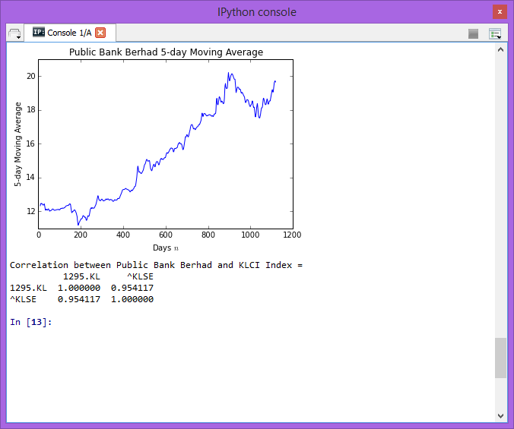

The 5-day moving average can be calculated by taking the sum of closing price of Public Bank Berhad for 5 days, and divide it by 5. After each calculation, one number will be stored. All numbers will be stored by “rolling_mean” command from pandas function, and assign it into variable “moving_average”. Next, we plot the moving average with proper labeling using matplotlib.pyplot function.

Besides, we also downloaded the daily data of FTSEKLCI for same duration to find the correlation between the Public Bank Berhad and the FTSEKLCI.