MUTUAL FUND ANALYTICS PLATFORM

Bluestock Fintech Capstone Project

Submitted By -
ANGAD SHUKLA

Bluestock Fintech Pvt. Ltd.

June 2026

TABLE OF CONTENTS

1. Executive Summary
2. Data Sources
3. ETL Pipeline Design
4. Exploratory Data Analysis
5. Performance Analytics
4. Dashboard Development
5. Recommendations
6. Limitations

- EXECUTIVE SUMMARY
The Mutual Fund Analytics Platform was developed as part of the Bluestock Fintech Capstone Project. The objective of this project was to build a complete data analytics solution for analysing Indian mutual fund performance, investor behaviour, risk metrics, and market trends.
The project utilized ten datasets containing mutual fund schemes, historical NAV values, SIP inflows, AUM information, investor transactions, portfolio holdings, benchmark indices, and performance metrics.
Python, Pandas, NumPy, SQLite, SQL, Jupyter Notebook, Power BI, and GitHub were used throughout the project lifecycle. The project involved data ingestion, cleaning, database design, exploratory data analysis, performance analytics, advanced analytics, and dashboard development.
The final solution includes an interactive Power BI dashboard, multiple analytical notebooks, risk-performance calculations, investor cohort analysis, and a fund recommendation engine.
The project successfully analysed 40 mutual fund schemes, 46,000 NAV records, and more than 32,000 investor transactions while generating actionable business insights.
PROJECT OBJECTIVES
The primary objective of this project was to develop a comprehensive Mutual Fund Analytics Platform capable of processing, analysing, and visualising large-scale mutual fund data.
The key objectives of the project were:
• Build an automated ETL pipeline for mutual fund datasets.
• Design a structured SQLite database using a normalized schema.
• Perform Exploratory Data Analysis (EDA) on NAV, SIP, AUM, and investor datasets.
• Compute risk and performance metrics such as Sharpe Ratio, Sortino Ratio, Alpha, Beta, Maximum Drawdown, Value at Risk (VaR), and Conditional VaR (CVaR).
• Develop an interactive Power BI dashboard with multiple analytical views.
• Analyse investor demographics and transaction behaviour.
• Compare mutual fund performance against benchmark indices.
• Generate actionable insights and recommendations for investors.
- DATA SOURCES
The project utilised ten structured datasets covering mutual fund schemes, investor transactions, industry statistics, benchmark indices, and portfolio holdings.
Dataset Summary
- 01_fund_master.csv
Contains scheme details including AMFI code, fund house, category, benchmark, expense ratio, and risk category.
- 02_nav_history.csv
Contains 46,000 historical NAV records from January 2022 to May 2026.
- 03_aum_by_fund_house.csv
Quarterly Assets Under Management (AUM) data for top mutual fund houses.
- 04_monthly_sip_inflows.csv
Monthly SIP inflow data from January 2022 to December 2025.
- 05_category_inflows.csv
Category-wise mutual fund inflows and outflows.
- 06_industry_folio_count.csv
Growth in mutual fund folios across the industry.
- 07_scheme_performance.csv
Fund-level risk and performance metrics.
- 08_investor_transactions.csv
More than 32,000 transactions from 5,000 investors across India.
- 09_portfolio_holdings.csv
Equity fund holdings and sector allocations.
- 10_benchmark_indices.csv
Benchmark index data including Nifty 50, Nifty 100, Midcap, Smallcap, Liquid, and Gilt indices.
Key Dataset Statistics
• Total Mutual Fund Schemes Analysed: 40
• Fund Houses Covered: 10
• Historical NAV Records: 46,000
• Investor Transactions: 32,778
• Unique Investors: 5,000
• States Covered: 12
• SIP Data Period: January 2022 – December 2025
• Maximum SIP Inflow Observed: ₹31,002 Crore (December 2025)
- ETL PIPELINE DESIGN
The project follows a standard Extract–Transform–Load (ETL) architecture to process mutual fund datasets efficiently.
Extract Phase
Raw datasets were collected from AMFI and mfapi.in sources. The project includes ten datasets covering mutual fund schemes, NAV history, SIP inflows, benchmark indices, investor transactions, and portfolio holdings.
Transform Phase
Data cleaning and preprocessing operations were performed using Python and Pandas. The following transformations were applied:
• Missing value handling
• Duplicate record removal
• Date format standardisation
• Data type conversion
• Validation of AMFI codes
• Consistency checks across datasets
Load Phase
The cleaned datasets were loaded into a SQLite database using SQL scripts and Python automation. This enabled efficient querying and integration with analytical workflows.
ETL Tools Used
• Python
• Pandas
• NumPy
• SQLite
• SQLAlchemy
• Jupyter Notebook
The ETL pipeline successfully transformed raw mutual fund data into structured analytical datasets used throughout the project.
- CSV Files -> Data Cleaning -> SQLite Database -> Analytics -> Power BI Dashboard
DATABASE DESIGN
A relational database was designed using SQLite to store and manage mutual fund data efficiently.
The database schema consists of multiple fact and dimension tables enabling analytical querying and dashboard integration.
Major Tables
- Fund Master
Stores scheme details, fund house information, benchmark indices, and risk classifications.
- NAV History
Stores daily NAV values for all mutual fund schemes.
- AUM Data
Stores quarterly Assets Under Management values for major fund houses.
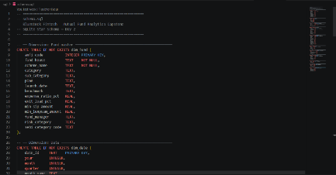
- SIP Inflows
Stores monthly SIP contribution statistics.
- Investor Transactions
Stores SIP, Lumpsum, and Redemption transactions.
- Portfolio Holdings
Stores stock-level holdings and sector allocations.
- Benchmark Indices
Stores benchmark performance data used for fund comparison.
Benefits of the Database Design
• Efficient storage of large datasets
• Fast analytical queries
• Easy integration with Power BI
• Reduced data redundancy
• Improved maintainability and scalability
The database served as the central repository for all subsequent analytical tasks performed during the project.
- EDA OVERVIEW
Exploratory Data Analysis
The exploratory data analysis phase was performed to understand trends, distributions, growth patterns, and relationships within the mutual fund ecosystem.
The analysis focused on:
• Industry growth trends
• Fund performance patterns
• SIP inflow behaviour
• Investor demographics
• Transaction activity
• Category-wise inflows
• Benchmark comparisons
• Sector allocations
More than 15 visualisations were created using Python libraries such as Matplotlib, Seaborn, and Plotly to derive meaningful business insights.
- PERFORMANCE ANALYTICS
INDUSTRY GROWTH & SIP ANALYSIS

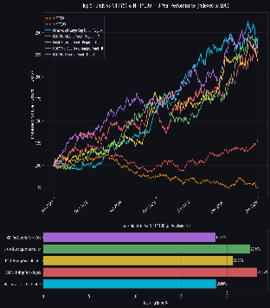
Industry Growth Analysis
Key observations:
• Mutual fund industry assets showed consistent growth between 2022 and 2025.
• SIP inflows increased significantly across the period.
• December 2025 recorded the highest SIP inflow of ₹31,002 crore.
• Retail participation in mutual funds continued to increase through systematic investments.
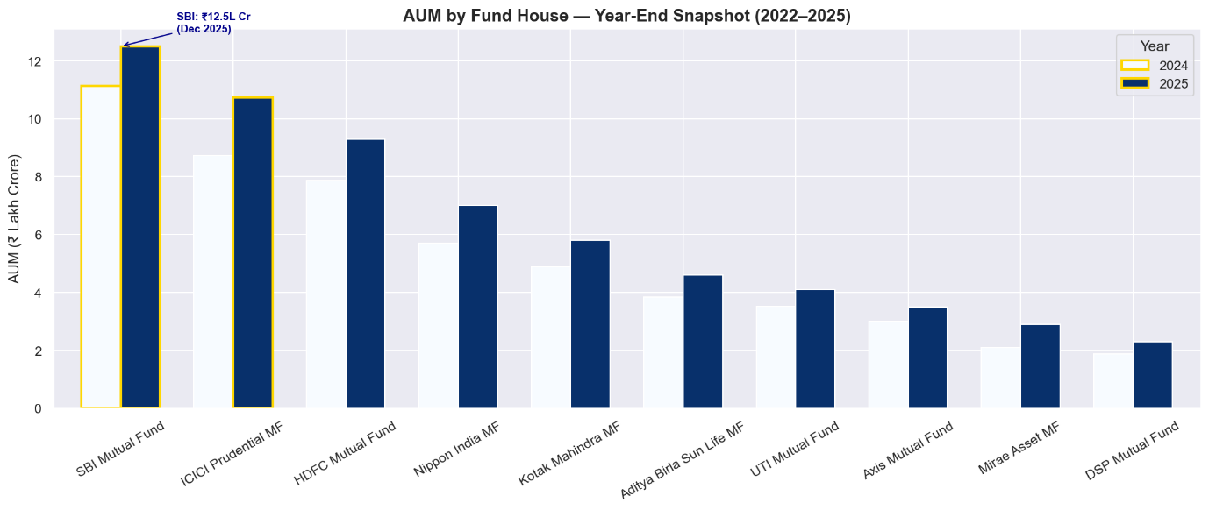
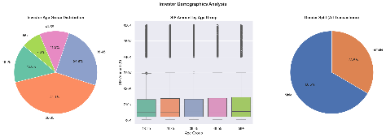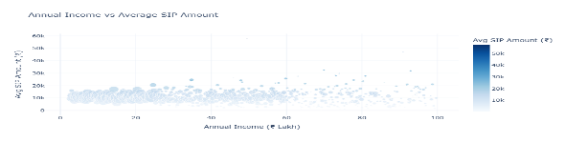
Investor Demographics Analysis
The transaction dataset consisted of 32,778 transactions generated by 5,000 investors across 12 Indian states.
Key Findings:
• Total Investors: 5,000
• States Covered: 12
• SIP Transactions: 19,716
• Lumpsum Transactions: 8,095
• Redemption Transactions: 4,967
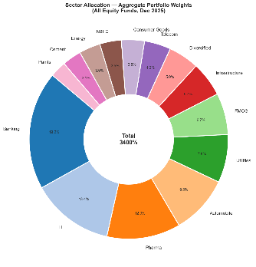
• Average SIP Amount: ₹11,018
• T30 Cities Contribution: 65.9%
• B30 Cities Contribution: 34.1%
Insights:
The majority of investments originated from T30 cities, indicating stronger mutual fund penetration in metropolitan regions. SIP remained the dominant investment method among investors.

CATEGORY & SECTOR ANALYSIS
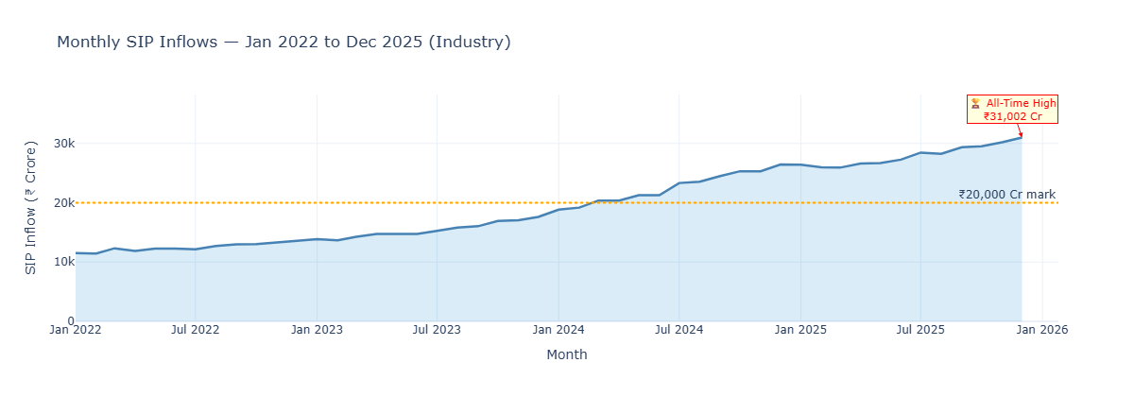

Category Inflow Analysis
The highest category-wise inflows during FY25 were observed in:
Category | Net Inflow (₹ Crore)
Liquid | 451,275
Sectoral/Thematic | 103,829
Flexi Cap | 63,989
Large & Mid Cap | 57,752
Short Duration | 55,530
Sector Allocation Analysis
The most prominent sectors across portfolio holdings were:
• Consumer Goods
• Diversified
• Information Technology
• Utilities
• FMCG
• Banking
• NBFC
• Pharma
This indicates broad diversification across major sectors of the Indian economy.
PERFORMANCE ANALYTICS OVERVIEW
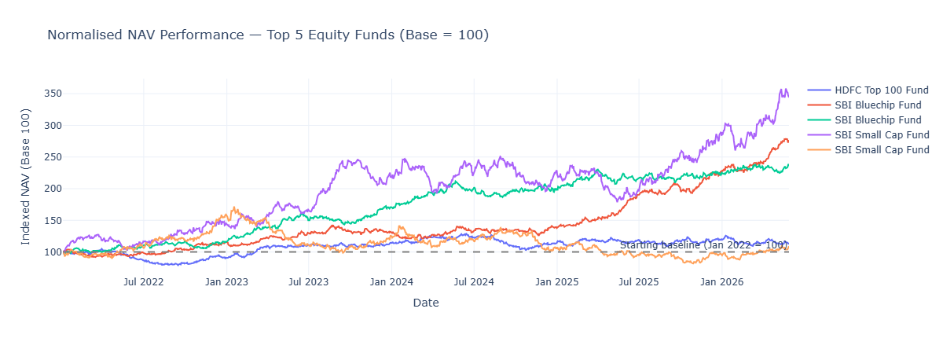
Performance Analytics
The performance analytics phase evaluated mutual fund returns and risk-adjusted performance using industry-standard metrics.
The following indicators were calculated:
• Sharpe Ratio
• Sortino Ratio
• Alpha
• Beta
• CAGR
• Maximum Drawdown
• Value at Risk (VaR)
• Conditional Value at Risk (CVaR)
These metrics helped identify funds delivering superior returns while maintaining acceptable levels of risk.
SHARPE, SORTINO, ALPHA & BETA
Risk Adjusted Performance Metrics
Sharpe Ratio was used to measure excess return generated per unit of total risk.
Sortino Ratio focused only on downside volatility, making it more suitable for evaluating mutual fund downside protection.
Alpha measured excess performance relative to benchmark expectations, while Beta measured sensitivity to market movements.
Key Findings
Metric | Observation
Average Equity Sharpe Ratio | 0.905
Average Alpha | 1.209
Average Beta | 0.963
Average 3-Year Return | 15.47%
Interpretation:
Most equity funds generated positive alpha while maintaining beta values close to 1, indicating market-aligned behaviour with moderate outperformance.
TOP PERFORMING FUNDS
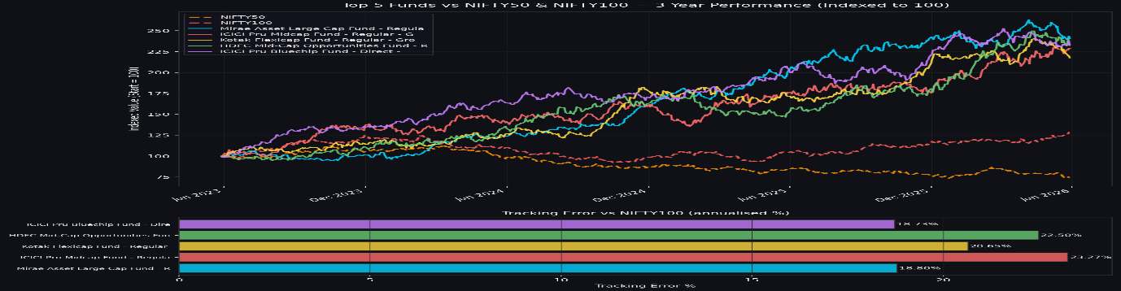
Top Funds by Sharpe Ratio
Fund | Sharpe Ratio
ICICI Pru Liquid Fund | 7.68
Kotak Liquid Fund | 6.18
ABSL Liquid Fund | 5.14
HDFC Short Term Debt Fund | 1.84
SBI Magnum Gilt Fund | 1.52
Top Funds by 3-Year Returns
Fund | 3-Year Return
SBI Small Cap Fund (Regular) | 23.39%
SBI Small Cap Fund (Direct) | 23.14%
ABSL Small Cap Fund | 22.38%
Axis Small Cap Fund |  | 20.98%
Nippon India Small Cap Fund |  | 20.15%
Observation:
Small-cap funds delivered the highest long-term returns, although they also carried significantly higher risk.
VAR, CVAR & DRAWDOWN ANALYSIS
Risk Analysis Using VaR and CVaR
Historical Value at Risk (VaR) was calculated using the 5th percentile of daily return distributions.
Conditional Value at Risk (CVaR) was calculated as the average loss beyond the VaR threshold.
Key Results
Most Risky Fund:
• SBI Small Cap Fund – Direct Plan
• VaR = -2.686%
Safest Fund:
• ICICI Pru Liquid Fund
• VaR = -0.022%
Worst Maximum Drawdowns
Fund | Max Drawdown
HDFC Top 100 Fund (Direct) | -33.50%
Mirae Asset Emerging Bluechip Fund | -33.15%
Axis Midcap Fund | -32.38%
Interpretation:
Small-cap and mid-cap funds experienced significantly larger downside risk compared to liquid and debt funds.
ADVANCED ANALYTICS (DAY 6)
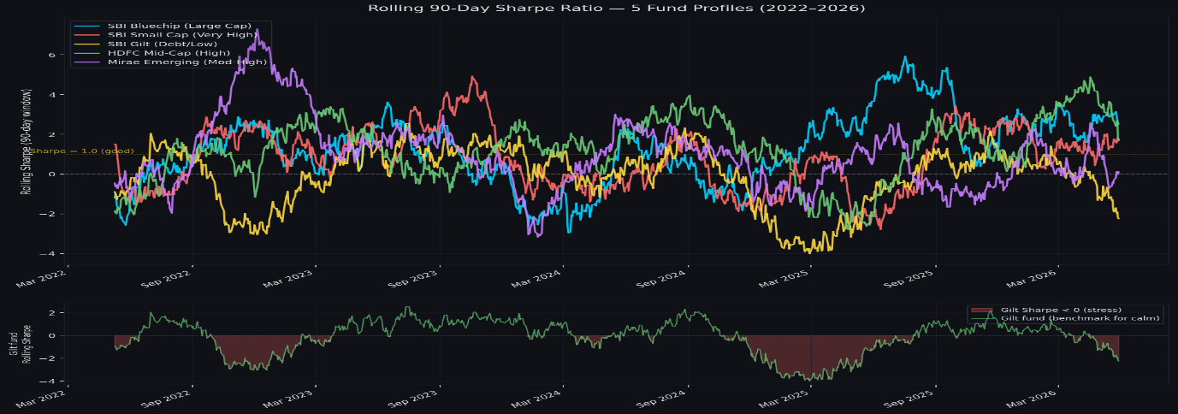
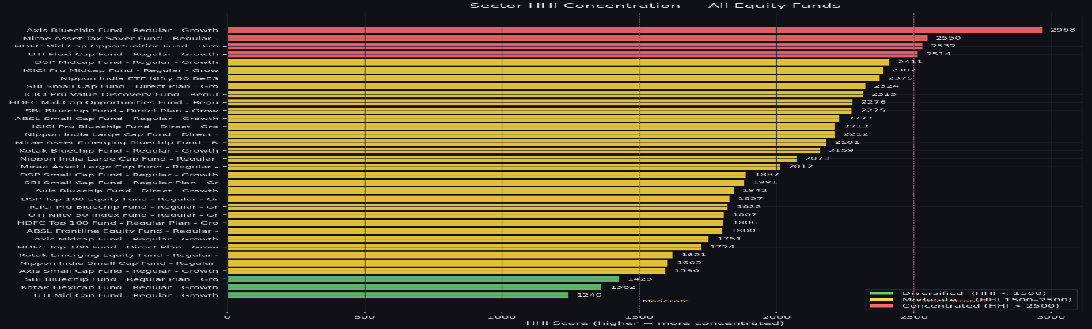
Advanced Analytics
Several advanced analytical models were developed to gain deeper insights into investor behaviour and portfolio risk.
Investor Cohort Analysis
2024 Cohort:
• 4,803 investors
• Average SIP Amount = ₹10,997
• Total Investment = ₹349.11 Crore
2025 Cohort:
• 197 investors
• Average SIP Amount = ₹13,505
• Total Investment = ₹3.05 Crore
SIP Continuity Analysis
• Investors with SIP Transactions = 4,762
• Investors with 6+ SIPs = 1,362
• At-Risk Investors = 1,332
• Continuity Rate = 2.2%
Sector Concentration Analysis
Highest HHI:
• Axis Bluechip Fund
• HHI = 2967.7
Most Diversified Fund:
• UTI Mid Cap Fund
• HHI = 1240.2
Fund Recommendation Engine
A rule-based recommendation model was developed using risk appetite categories:
• Low Risk
• Moderate Risk
High Risk
Recommendations were generated using Sharpe Ratio rankings within each risk category.
DASHBOARD OVERVIEW
- Interactive Dashboard
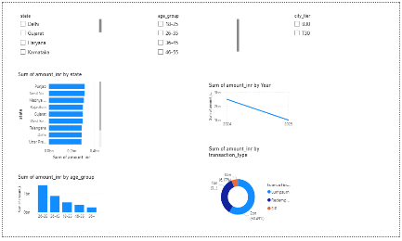
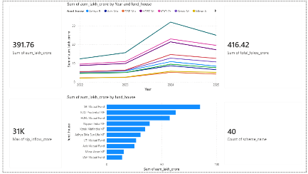
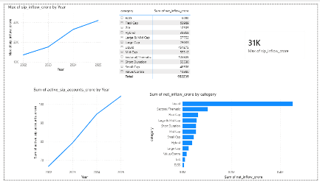
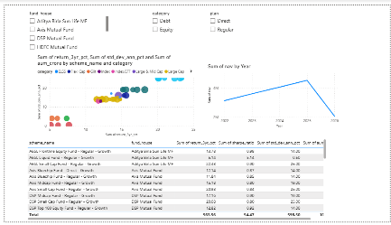

A four-page Power BI dashboard was developed to enable interactive exploration of mutual fund performance, investor behaviour, SIP trends, and portfolio exposure.
Key dashboard features:
• Dynamic slicers
• AMC filtering
• Fund category filtering
• Interactive KPI cards
• Drill-down visualisations
• Cross-filtering across reports
KEY FINDINGS
The project generated several important insights regarding mutual fund performance, investor behaviour, and industry growth.
- The mutual fund industry demonstrated strong growth between 2022 and 2025, supported by rising SIP inflows and increasing investor participation.
- SIP inflows reached a record ₹31,002 Crore in December 2025, indicating growing retail investor confidence.
- Small-cap funds generated the highest 3-year returns, with SBI Small Cap Fund achieving 23.39%.
- Liquid funds delivered the highest risk-adjusted performance, with ICICI Prudential Liquid Fund recording a Sharpe Ratio of 7.68.
- Investor activity was concentrated in T30 cities, which accounted for approximately 65.9% of transaction volume.
- Investor cohort analysis revealed that 2025 investors contributed higher average SIP amounts compared to the 2024 cohort.
- SIP continuity analysis identified a large proportion of investors as potentially at-risk due to long gaps between SIP transactions.
- Sector concentration analysis showed significant variation across funds, with some portfolios being highly concentrated while others remained diversified.
- The Power BI dashboard enabled efficient exploration of mutual fund trends, risk metrics, and investor behaviour.
- Advanced analytics and fund recommendation models successfully transformed raw data into actionable investment insights.
- RECOMMENDATIONS
Based on the analysis performed throughout the project, the following recommendations are proposed:
- Investors with higher risk tolerance may consider small-cap funds due to their superior long-term return potential.
- Conservative investors may prefer liquid and debt funds because of their lower volatility and stronger risk-adjusted performance.
- Asset management companies should continue promoting SIP investments, as systematic investing remains the dominant investment approach.
- Fund houses should focus on improving investor retention and SIP continuity through educational and engagement initiatives.
- Portfolio diversification should be encouraged to reduce sector concentration risk and improve long-term stability.
- Financial institutions can leverage investor demographic analysis to design more targeted investment products and marketing strategies.
- Dashboard-based monitoring should be adopted for real-time investment analytics and decision-making support.

- LIMITATIONS AND CONCLUSION
Limitations
The project was developed using a predefined dataset containing selected mutual fund schemes and investor records. While the dataset was sufficiently large for analytical purposes, it does not represent the entire Indian mutual fund industry.
Certain assumptions were required while calculating risk metrics and investor behaviour indicators. Real-world market conditions may produce different outcomes over time.
The recommendation engine implemented in this project uses a rule-based approach and does not incorporate machine learning or portfolio optimisation techniques.
Conclusion
The Mutual Fund Analytics Platform successfully achieved all project objectives. A complete analytics pipeline was developed, covering data ingestion, cleaning, database management, exploratory analysis, performance evaluation, advanced analytics, and dashboard visualisation.
The project processed 46,000 NAV records, 32,778 investor transactions, and data from 40 mutual fund schemes across 10 fund houses.
The final solution provides meaningful insights into fund performance, investor behaviour, risk management, and market trends while demonstrating practical applications of data analytics within the financial services domain.
This project highlights the importance of data-driven decision-making and showcases the value of analytical tools in the mutual fund industry.

