Game Design Document

Fill up the following document

1. Write the title of your project.

The Trials

1. What is the goal of the game?

The Player Character has to shoot the pots that come flying in the air.

1. Write a brief story of your game.

N1 stands before a task given to him by the matchmakers. He needs your help to complete this task. For if he fails the punishment will be death.

1. Which are the playing characters of this game?

* Playing characters are the ones who respond to the user based on the input from the user.
* Cars, monkeys, dinos, wizards, etc., are the playing characters in the game.

|  |  |  |
| --- | --- | --- |
| Number | Character Name | What can this character do? |
| 1 | N1 | He can shoot pots that come flying out of the ground. |
| 2 |  |  |
| 3 |  |  |
| 4 |  |  |
| 5 |  |  |
| 6 |  |  |
| 7 |  |  |
| 8 |  |  |

1. Which are the Non-Playing Characters of this game?

* Non-Playing characters are the ones that don't have an action or behavior when the user interacts with the game.
* Hurdles, stones, bananas, coins, etc., are non-playing characters in the game.

|  |  |  |
| --- | --- | --- |
| Number | Character Name | What can this character do? |
| 1 | Birds | They come flying towards the pots. If any of the bullets touch them they die so does the PC fail in his task. |
| 2 | Pots | They come flying from below the ground. |
| 3 | Clouds | They spawn randomly above the canvas |
| 4 |  |  |
| 5 |  |  |
| 6 |  |  |
| 7 |  |  |
| 8 |  |  |

Draw your imagination of this game. What does this game look like?

* Draw the game either on your computer or on paper.
* Add images of the game scenes to show each of the playing and non-playing characters at least once. 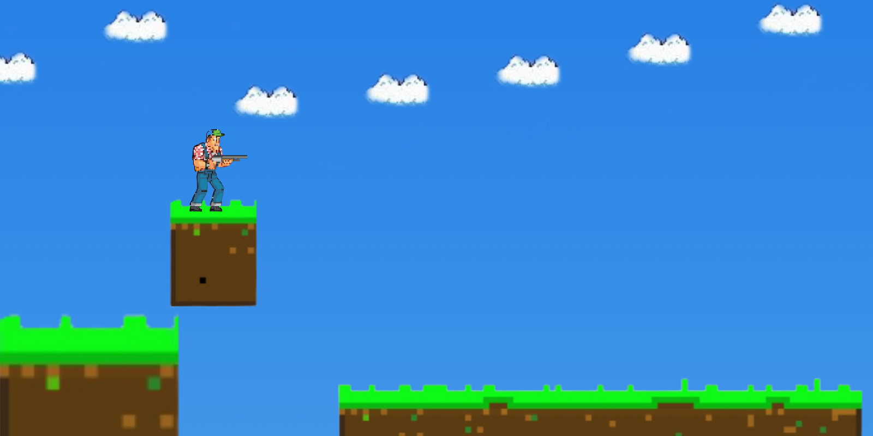

(This image was made by me and is not related to copy rights)

How do you plan to make your game engaging?

By adding a score, trying to keep the graphics as eye catching as possible and keeping moving yet pixelate NPC’s.