Домашнее задание 9

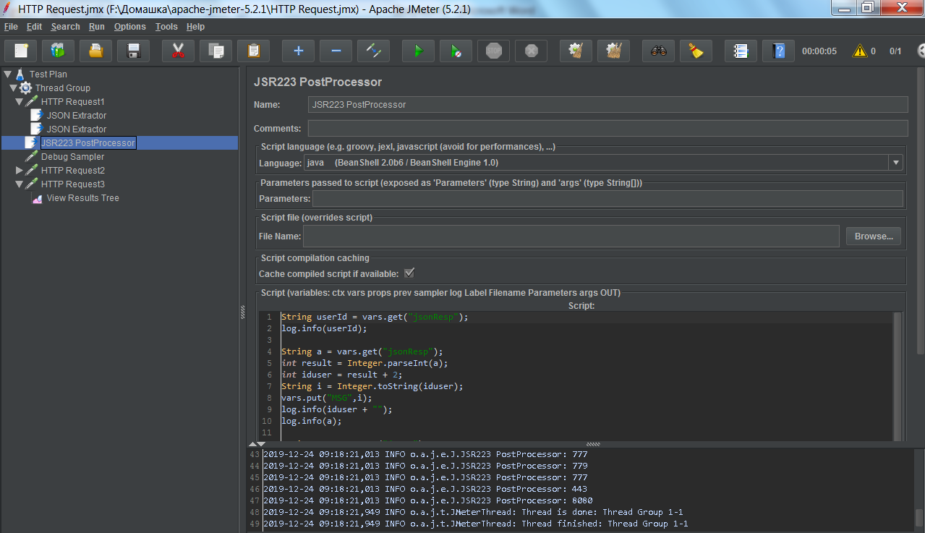

String userId = vars.get("jsonResp");

log.info(userId);

String a = vars.get("jsonResp");

int result = Integer.parseInt(a);

int iduser = result + 2;

String i = Integer.toString(iduser);

vars.put("MSG",i);

log.info(iduser + "");

log.info(a);

String X = vars.get("jsonX");

log.info (X);

int result = Integer.parseInt(X) + 7637;

String g = Integer.toString(result);

vars.put("result",g);

log.info(result + " ");