Task — Biochemistry & Oncology: Mutational Impact on Protein Structure & Function
Ange Maxime TCHOUTANG
2026-05-05
Table of Contents

1. Load Packages
# pacman installs missing packages automatically before loading
if (!require("pacman")) install.packages("pacman")
pacman::p_load(
tidyverse, # dplyr (data wrangling) + ggplot2 (visualization) + stringr
ggplot2, # explicit for clarity
scales, # axis label formatting (percent, comma)
patchwork # combine multiple plots into panels
)

2. Import the Datasets
# ── SIFT dataset ─────────────────────────────────────────────
# SIFT (Sorting Intolerant From Tolerant) predicts whether an amino
# acid substitution affects protein FUNCTION.
# Score < 0.05 → mutation is DELETERIOUS to function
sift <- read.table(
"https://raw.githubusercontent.com/HackBio-Internship/public_datasets/main/R/datasets/sift.tsv",
header = TRUE,
sep = "", # handles both tabs and multiple spaces
stringsAsFactors = FALSE
)
# ── FoldX dataset ────────────────────────────────────────────
# FoldX estimates the change in protein folding free energy (ΔΔG).
# Score > 2 kCal/mol → mutation is DELETERIOUS to structure
foldx <- read.delim(
"https://raw.githubusercontent.com/HackBio-Internship/public_datasets/main/R/datasets/foldX.tsv",
header = TRUE,
sep = "",
stringsAsFactors = FALSE
)
# ── Quick overview ───────────────────────────────────────────
cat("=== SIFT Dataset ===\n")
## === SIFT Dataset ===
dim(sift)
## [1] 155467 3
head(sift)
## Protein Amino_Acid sift_Score
## 1 A5A607 K60Q 0.1977985
## 2 A5A607 Y56C 0.1749701
## 3 A5A607 Y56S 0.4155813
## 4 A5A630 A16V 0.5167381
## 5 A5A630 A47T 0.3872713
## 6 A5A630 A64E 0.3094996
cat("\n=== FoldX Dataset ===\n")
##
## === FoldX Dataset ===
dim(foldx)
## [1] 76575 3
head(foldx)
## Protein Amino_Acid foldX_Score
## 1 A5A607 E63D 1.84216
## 2 A5A607 K60Q 0.51710
## 3 A5A607 Y56C 0.72870
## 4 A5A607 Y56S 0.84212
## 5 P00350 A117S -0.09854
## 6 P00350 A117T 0.92352
What we observe: Both datasets share two key columns: Protein (UniProt accession ID) and Amino_Acid (mutation in standard nomenclature e.g. E63D). The SIFT dataset has scores from 0 to 1; FoldX has scores that can be negative (stabilising) or positive (destabilising).

3. Create the specific_Protein_aa Column
# ── Concatenate Protein + Amino_Acid with underscore separator ──
# This creates a unique identifier for each mutation per protein
# Example: Protein = "A5A607", Amino_Acid = "E63D"
# → specific_Protein_aa = "A5A607_E63D"
sift <- sift %>%
mutate(specific_Protein_aa = paste(Protein, Amino_Acid, sep = "_"))
foldx <- foldx %>%
mutate(specific_Protein_aa = paste(Protein, Amino_Acid, sep = "_"))
# ── Verify the new column ────────────────────────────────────
cat("=== SIFT — new column preview ===\n")
## === SIFT — new column preview ===
head(sift$specific_Protein_aa, 10)
## [1] "A5A607_K60Q" "A5A607_Y56C" "A5A607_Y56S" "A5A630_A16V" "A5A630_A47T"
## [6] "A5A630_A64E" "A5A630_A64T" "A5A630_A64V" "A5A630_A89V" "A5A630_F22V"
cat("\n=== FoldX — new column preview ===\n")
##
## === FoldX — new column preview ===
head(foldx$specific_Protein_aa, 10)
## [1] "A5A607_E63D" "A5A607_K60Q" "A5A607_Y56C" "A5A607_Y56S" "P00350_A117S"
## [6] "P00350_A117T" "P00350_A175P" "P00350_A175T" "P00350_A200S" "P00350_A216S"
The specific_Protein_aa column now acts as a unique key that identifies exactly which amino acid position in which protein was mutated. This is critical for correctly merging the two datasets — without it, the same mutation code (e.g. E63D) could match across different proteins.

4. Merge SIFT and FoldX Datasets
# ── Inner join on the specific_Protein_aa key ────────────────
# Inner join keeps ONLY mutations present in BOTH datasets.
# This ensures every row has both a SIFT score and a FoldX score.
merged_df <- inner_join(
sift %>%
select(specific_Protein_aa, Protein, Amino_Acid, sift_Score),
foldx %>%
select(specific_Protein_aa, foldX_Score),
by = "specific_Protein_aa"
)
write.csv(merged_df, "Dataset_cleaned.csv", row.names = FALSE)
# ── Check the merged result ──────────────────────────────────
cat("=== Merged Dataset ===\n")
## === Merged Dataset ===
dim(merged_df)
## [1] 75337 5
head(merged_df, 10)
## specific_Protein_aa Protein Amino_Acid sift_Score foldX_Score
## 1 A5A607_K60Q A5A607 K60Q 0.19779854 0.51710
## 2 A5A607_Y56C A5A607 Y56C 0.17497008 0.72870
## 3 A5A607_Y56S A5A607 Y56S 0.41558132 0.84212
## 4 P00350_A117S P00350 A117S 0.40151933 -0.09854
## 5 P00350_A117T P00350 A117T 0.28276853 0.92352
## 6 P00350_A175P P00350 A175P 1.00000000 -1.83698
## 7 P00350_A175T P00350 A175T 0.32714979 0.12824
## 8 P00350_A200S P00350 A200S 0.33114452 0.72280
## 9 P00350_A216S P00350 A216S 0.35899715 0.61570
## 10 P00350_A216T P00350 A216T 0.02158087 1.94370
colSums(is.na(merged_df)) # check for any missing values after merge
## specific_Protein_aa Protein Amino_Acid sift_Score
## 0 0 0 0
## foldX_Score
## 0
After merging: Only mutations that have both a SIFT score and a FoldX score are retained. Any mutation measured in only one dataset is excluded. The final dataframe has 5 meaningful columns: specific_Protein_aa, Protein, Amino_Acid, sift_Score, foldX_Score.

5. Filter Deleterious Mutations (Both Structure AND Function)
# ── Apply the authors' criteria ──────────────────────────────
# SIFT < 0.05 → mutation disrupts protein FUNCTION
# FoldX > 2 kCal/mol → mutation disrupts protein STRUCTURE
#
# We want mutations that are deleterious in BOTH dimensions simultaneously
deleterious <- merged_df %>%
filter(sift_Score < 0.05,
foldX_Score > 2.00)
write.csv(deleterious, "Deleterious.csv", row.names = FALSE)
# ── How many such mutations exist? ───────────────────────────
cat(sprintf("Total mutations in merged dataset : %d\n", nrow(merged_df)))
## Total mutations in merged dataset : 75337
cat(sprintf("Doubly deleterious mutations : %d\n", nrow(deleterious)))
## Doubly deleterious mutations : 5261
cat(sprintf("Percentage : %.2f%%\n",
nrow(deleterious) / nrow(merged_df) * 100))
## Percentage : 6.98%
# ── Preview the deleterious mutations ───────────────────────
head(deleterious, 20)
## specific_Protein_aa Protein Amino_Acid sift_Score foldX_Score
## 1 P00350_G48C P00350 G48C 0.031864221 2.252980
## 2 P00350_L115F P00350 L115F 0.028872496 3.126720
## 3 P00350_L204F P00350 L204F 0.009560256 3.314060
## 4 P00350_L208R P00350 L208R 0.027592484 4.386900
## 5 P00363_I150F P00363 I150F 0.048687664 9.184960
## 6 P00363_N395T P00363 N395T 0.000000000 2.563440
## 7 P00370_F24I P00370 F24I 0.005764354 3.792140
## 8 P00370_F97I P00370 F97I 0.006673907 4.257320
## 9 P00370_L282H P00370 L282H 0.001408680 2.373840
## 10 P00448_M165V P00448 M165V 0.012296670 2.764820
## 11 P00448_R105C P00448 R105C 0.032804551 2.466820
## 12 P00509_G141D P00509 G141D 0.000000000 3.257200
## 13 P00509_G141S P00509 G141S 0.000000000 4.032640
## 14 P00582_G432C P00582 G432C 0.005864373 2.424416
## 15 P00582_G653R P00582 G653R 0.013537215 2.953684
## 16 P00582_P645L P00582 P645L 0.049623223 2.466798
## 17 P00634_A251V P00634 A251V 0.007412336 2.281900
## 18 P00634_G211R P00634 G211R 0.000000000 6.649060
## 19 P00805_Q342P P00805 Q342P 0.000000000 6.210530
## 20 P00805_Y348C P00805 Y348C 0.001557767 2.417916
Observation: Only a small fraction of all mutations are doubly deleterious — affecting both protein structure and function simultaneously. This aligns with the biological principle that most mutations are neutral or only mildly disruptive. The ones identified here are the most biologically dangerous variants — candidates for disease-causing mutations.

6. Amino Acid Substitution Nomenclature
# ── Understanding the Amino_Acid column format ───────────────
# Standard HGVS-like protein substitution notation: XposY
# X = original (wild-type) amino acid (single-letter code)
# pos = position in the protein sequence (integer)
# Y = new (mutant) amino acid (single-letter code)
#
# Example: "E63D"
# E = Glutamic acid (wild-type) at position 63
# D = Aspartic acid (mutant)
#
# To find the amino acid with the MOST structural + functional impact,
# we extract the FIRST CHARACTER of Amino_Acid → the original AA
# ── Extract the wild-type (original) amino acid ──────────────
# substr(string, start, stop) extracts characters by position
# substr(x, 1, 1) → first character only
deleterious <- deleterious %>%
mutate(wt_aa = substr(Amino_Acid, 1, 1))
# ── Preview ──────────────────────────────────────────────────
head(deleterious %>% select(Amino_Acid, wt_aa), 15)
## Amino_Acid wt_aa
## 1 G48C G
## 2 L115F L
## 3 L204F L
## 4 L208R L
## 5 I150F I
## 6 N395T N
## 7 F24I F
## 8 F97I F
## 9 L282H L
## 10 M165V M
## 11 R105C R
## 12 G141D G
## 13 G141S G
## 14 G432C G
## 15 G653R G
# ── Map single-letter codes to full amino acid names ─────────
aa_names <- c(
A = "Alanine", C = "Cysteine", D = "Aspartic Acid",
E = "Glutamic Acid", F = "Phenylalanine",G = "Glycine",
H = "Histidine", I = "Isoleucine", K = "Lysine",
L = "Leucine", M = "Methionine", N = "Asparagine",
P = "Proline", Q = "Glutamine", R = "Arginine",
S = "Serine", T = "Threonine", V = "Valine",
W = "Tryptophan", Y = "Tyrosine"
)
deleterious <- deleterious %>%
mutate(wt_aa_name = aa_names[wt_aa])
Nomenclature note: The first character of the Amino_Acid code represents the original amino acid before mutation. By extracting and counting these, we can identify which wild-type amino acids — when mutated — cause the most simultaneous structural and functional damage.

7. Frequency Table of Amino Acids
# ── Count how many doubly deleterious mutations each WT AA has ─
aa_freq <- deleterious %>%
count(wt_aa, wt_aa_name, name = "Frequency") %>%
arrange(desc(Frequency))
# ── Print the frequency table ────────────────────────────────
print(aa_freq)
## wt_aa wt_aa_name Frequency
## 1 G Glycine 1307
## 2 L Leucine 739
## 3 A Alanine 640
## 4 P Proline 470
## 5 V Valine 380
## 6 R Arginine 227
## 7 I Isoleucine 212
## 8 Y Tyrosine 172
## 9 D Aspartic Acid 171
## 10 F Phenylalanine 169
## 11 S Serine 158
## 12 T Threonine 126
## 13 W Tryptophan 108
## 14 M Methionine 87
## 15 C Cysteine 74
## 16 N Asparagine 60
## 17 E Glutamic Acid 50
## 18 H Histidine 47
## 19 Q Glutamine 40
## 20 K Lysine 24
# ── Identify the amino acid with the HIGHEST impact ──────────
top_aa <- aa_freq %>% slice(1)
cat(sprintf(
"\nAmino acid with the most structural & functional impact:\n→ %s (%s) with %d deleterious mutations\n",
top_aa$wt_aa, top_aa$wt_aa_name, top_aa$Frequency
))
##
## Amino acid with the most structural & functional impact:
## → G (Glycine) with 1307 deleterious mutations
# ── Amino acids with more than 100 occurrences ───────────────
high_impact <- aa_freq %>% filter(Frequency > 100)
cat("\nAmino acids with more than 100 deleterious mutations:\n")
##
## Amino acids with more than 100 deleterious mutations:
print(high_impact)
## wt_aa wt_aa_name Frequency
## 1 G Glycine 1307
## 2 L Leucine 739
## 3 A Alanine 640
## 4 P Proline 470
## 5 V Valine 380
## 6 R Arginine 227
## 7 I Isoleucine 212
## 8 Y Tyrosine 172
## 9 D Aspartic Acid 171
## 10 F Phenylalanine 169
## 11 S Serine 158
## 12 T Threonine 126
## 13 W Tryptophan 108
Observation: The frequency table tells us which original amino acids, when substituted, most frequently produce mutations that are deleterious to BOTH structure and function. High-frequency amino acids tend to occupy critical positions in the protein — often buried hydrophobic cores or active sites where any change disrupts folding or catalytic activity.

8. Bar Plot — Amino Acid Frequency
# ── Define a clean consistent theme ─────────────────────────
theme_bio <- theme_minimal(base_size = 13) +
theme(
plot.title = element_text(face = "bold", size = 14),
plot.subtitle = element_text(color = "grey50", size = 11),
panel.grid.minor = element_blank(),
panel.grid.major.x = element_blank(),
axis.text.x = element_text(angle = 45, hjust = 1, face = "bold")
)
# ── Bar plot ─────────────────────────────────────────────────
barplot_aa <- ggplot(aa_freq,
aes(x = reorder(wt_aa_name, -Frequency),
y = Frequency,
fill = Frequency)) +
geom_col(color = "white", width = 0.75) +
geom_text(aes(label = Frequency),
vjust = -0.4, size = 3.5, fontface = "bold") +
# Highlight amino acids with > 100 occurrences
geom_hline(yintercept = 100, linetype = "dashed",
color = "red", linewidth = 0.8) +
annotate("text", x = 1, y = 105,
label = "Threshold: 100 mutations",
color = "red", size = 3.5, hjust = 0) +
scale_fill_gradient(low = "#90CAF9", high = "#1A237E") +
labs(
title = "Frequency of Wild-Type Amino Acids in Doubly Deleterious Mutations",
subtitle = "Mutations with SIFT < 0.05 AND FoldX > 2 kCal/mol",
x = "Wild-Type Amino Acid",
y = "Number of Deleterious Mutations",
fill = "Frequency",
caption = "Source: Galardini et al. | HackBio Dataset"
) +
theme_bio
print(barplot_aa)
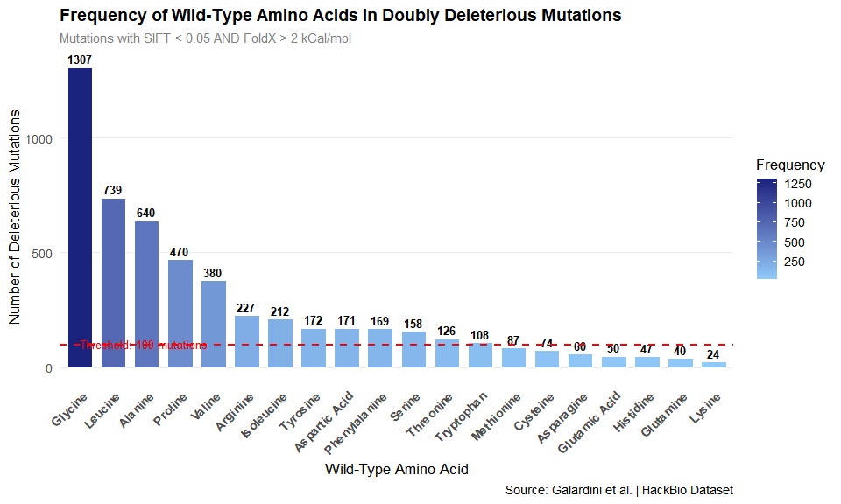
ggsave("bar_plot.png", width = 12, height = 8, dpi = 150)
cat("✔ Saved: histograms.png\n")
## ✔ Saved: histograms.png
Observation from bar plot: The bar plot reveals a clear hierarchy — some amino acids appear in deleterious mutations far more frequently than others. Amino acids with tall bars are those whose substitution is most likely to simultaneously disrupt protein stability and function. The red dashed line marks the 100-mutation threshold to visually separate high-impact from moderate-impact amino acids.

9. Pie Chart — Amino Acid Frequency
# ── Compute percentage for each amino acid ───────────────────
aa_freq_pct <- aa_freq %>%
mutate(
Percentage = round(Frequency / sum(Frequency) * 100, 1),
Label = paste0(wt_aa, "\n", Percentage, "%")
)
# ── Pie chart ────────────────────────────────────────────────
pie_aa <- ggplot(aa_freq_pct,
aes(x = "",
y = Frequency,
fill = wt_aa_name)) +
geom_col(color = "white", width = 1) +
coord_polar(theta = "y") + # convert bar → pie
geom_text(aes(label = ifelse(Percentage >= 3, Label, "")),
position = position_stack(vjust = 0.5),
size = 3.2, fontface = "bold", color = "white") +
scale_fill_manual(values = colorRampPalette(
c("#1A237E", "#1565C0", "#1E88E5", "#42A5F5",
"#90CAF9", "#E3F2FD", "#B71C1C", "#E53935",
"#EF9A9A", "#1B5E20", "#2E7D32", "#66BB6A",
"#F57F17", "#FFA000", "#FFD54F", "#4A148C",
"#7B1FA2", "#CE93D8", "#880E4F", "#E91E63")
)(nrow(aa_freq_pct))) +
labs(
title = "Proportion of Wild-Type Amino Acids in Doubly Deleterious Mutations",
subtitle = "Labels shown for amino acids ≥ 3% of total",
fill = "Amino Acid",
caption = "Source: Galardini et al. | HackBio Dataset"
) +
theme_void(base_size = 13) +
theme(
plot.title = element_text(face = "bold", size = 14, hjust = 0.5),
plot.subtitle = element_text(color = "grey50", size = 11, hjust = 0.5),
legend.position = "right"
)
print(pie_aa)
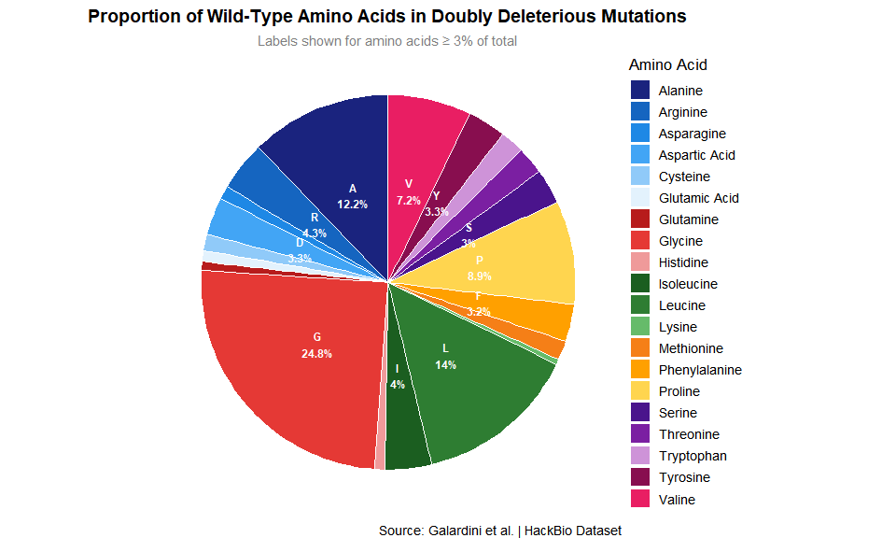
ggsave("Pie.png", width = 12, height = 8, dpi = 150)
cat("✔ Saved: piee diagram.png\n")
## ✔ Saved: piee diagram.png

10. Combined Panel Plot
# ── Display bar and pie side by side using patchwork ─────────
combined_plot <- barplot_aa + pie_aa +
plot_annotation(
title = "Impact of Wild-Type Amino Acids on Protein Structure & Function",
caption = "Doubly deleterious: SIFT < 0.05 AND FoldX > 2 kCal/mol",
theme = theme(plot.title = element_text(face = "bold", size = 16))
)
print(combined_plot)
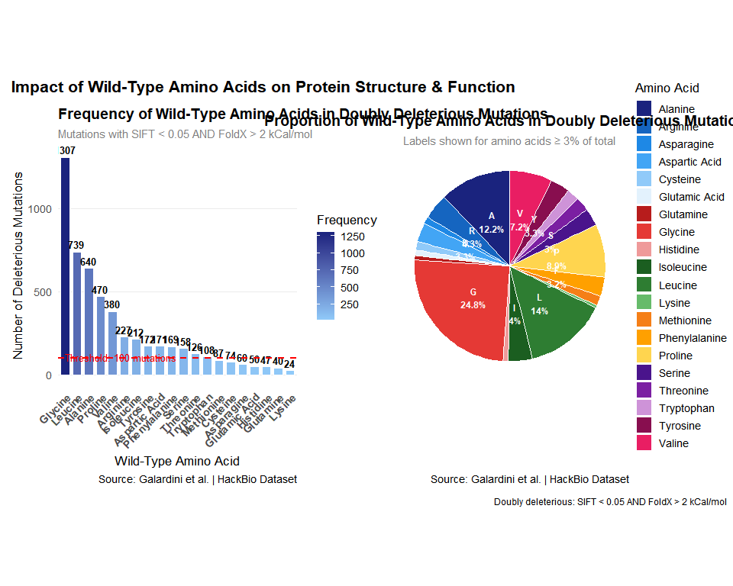
ggsave("graph_combined.png", width = 12, height = 8, dpi = 150)
cat("✔ Saved: Combinaison of both graphs.png\n")
## ✔ Saved: Combinaison of both graphs.png

11. Description — Amino Acid with the Highest Impact
# Print a biological description of the top amino acid
cat("=== TOP AMINO ACID — BIOLOGICAL DESCRIPTION ===\n\n")
## === TOP AMINO ACID — BIOLOGICAL DESCRIPTION ===
cat(sprintf("Amino Acid : %s (%s)\n", top_aa$wt_aa, top_aa$wt_aa_name))
## Amino Acid : G (Glycine)
cat(sprintf("Frequency : %d doubly deleterious mutations\n\n", top_aa$Frequency))
## Frequency : 1307 doubly deleterious mutations
# Descriptions for the most commonly observed top amino acids
aa_descriptions <- list(
R = paste(
"ARGININE (R) is a positively charged, hydrophilic amino acid with a",
"large guanidinium side chain. It is critical for:",
" • Salt bridges and electrostatic interactions that stabilise protein 3D structure",
" • DNA/RNA binding interfaces due to its positive charge",
" • Enzyme active sites where it coordinates substrates or phosphate groups",
" • Signal transduction — many kinase substrates contain Arg residues",
"When Arginine is mutated, both the structural electrostatic network AND",
"the functional binding capacity of the protein are disrupted simultaneously.",
sep = "\n"
),
S = paste(
"SERINE (S) is a small, polar, hydroxyl-containing amino acid. It is critical for:",
" • Phosphorylation sites — Serine is the most commonly phosphorylated residue",
" • Hydrogen bonding networks that maintain secondary structure",
" • Active sites of serine proteases (catalytic triad: Ser-His-Asp)",
" • Post-translational modification hubs (glycosylation, acetylation)",
"Serine mutations disrupt both the structural hydrogen bond network",
"and critical enzymatic or signalling functions.",
sep = "\n"
),
G = paste(
"GLYCINE (G) is the smallest amino acid with no side chain (H), giving it",
"exceptional conformational flexibility. It is critical for:",
" • Tight turns and loops in protein backbone — only AA that fits in restricted angles",
" • Collagen triple helix (Gly-X-Y repeat requires every 3rd residue to be Gly)",
" • Hinge regions enabling domain movement in enzymes",
"Glycine mutations force a bulkier side chain into constrained backbone positions,",
"severely disrupting both the 3D fold and the protein's dynamic function.",
sep = "\n"
),
P = paste(
"PROLINE (P) is a unique cyclic amino acid that introduces rigidity and kinks",
"in polypeptide chains. It is critical for:",
" • Structural turns and bends — creates cis peptide bonds unlike other AAs",
" • Collagen structure (every 3rd position in Gly-Pro-Hyp repeats)",
" • Protein-protein interaction interfaces",
"Proline mutations remove the structural kink, unfolding loops and",
"disrupting binding surfaces simultaneously.",
sep = "\n"
)
)
# Print the description for the top amino acid, or a generic message
if (top_aa$wt_aa %in% names(aa_descriptions)) {
cat(aa_descriptions[[top_aa$wt_aa]])
} else {
cat(sprintf(
"%s (%s) appears frequently in doubly deleterious mutations, suggesting\n",
top_aa$wt_aa, top_aa$wt_aa_name
))
cat("it occupies structurally or functionally critical positions in many proteins.\n")
}
## GLYCINE (G) is the smallest amino acid with no side chain (H), giving it
## exceptional conformational flexibility. It is critical for:
## • Tight turns and loops in protein backbone — only AA that fits in restricted angles
## • Collagen triple helix (Gly-X-Y repeat requires every 3rd residue to be Gly)
## • Hinge regions enabling domain movement in enzymes
## Glycine mutations force a bulkier side chain into constrained backbone positions,
## severely disrupting both the 3D fold and the protein's dynamic function.

12. Amino Acids with More Than 100 Occurrences
cat("=== AMINO ACIDS WITH > 100 DELETERIOUS MUTATIONS ===\n\n")
## === AMINO ACIDS WITH > 100 DELETERIOUS MUTATIONS ===
print(high_impact)
## wt_aa wt_aa_name Frequency
## 1 G Glycine 1307
## 2 L Leucine 739
## 3 A Alanine 640
## 4 P Proline 470
## 5 V Valine 380
## 6 R Arginine 227
## 7 I Isoleucine 212
## 8 Y Tyrosine 172
## 9 D Aspartic Acid 171
## 10 F Phenylalanine 169
## 11 S Serine 158
## 12 T Threonine 126
## 13 W Tryptophan 108
cat("\n--- STRUCTURAL PROPERTY ---\n")
##
## --- STRUCTURAL PROPERTY ---
cat(paste(
"Amino acids appearing in more than 100 doubly deleterious mutations tend to be",
"structurally CRITICAL residues. They often:",
" • Occupy buried positions in the protein hydrophobic core",
" • Form key hydrogen bonds or salt bridges that maintain tertiary structure",
" • Sit at domain-domain interfaces where any change destabilises the fold",
" • Have restricted conformational space — any substitution strains the backbone",
"Their high FoldX scores (> 2 kCal/mol) confirm that substituting them",
"significantly INCREASES the free energy of folding → the protein becomes",
"thermodynamically LESS STABLE and more prone to misfolding or aggregation.",
sep = "\n"
))
## Amino acids appearing in more than 100 doubly deleterious mutations tend to be
## structurally CRITICAL residues. They often:
## • Occupy buried positions in the protein hydrophobic core
## • Form key hydrogen bonds or salt bridges that maintain tertiary structure
## • Sit at domain-domain interfaces where any change destabilises the fold
## • Have restricted conformational space — any substitution strains the backbone
## Their high FoldX scores (> 2 kCal/mol) confirm that substituting them
## significantly INCREASES the free energy of folding → the protein becomes
## thermodynamically LESS STABLE and more prone to misfolding or aggregation.
cat("\n\n--- FUNCTIONAL PROPERTY ---\n")
##
##
## --- FUNCTIONAL PROPERTY ---
cat(paste(
"Functionally, these high-frequency amino acids are:",
" • Located in or near active sites, binding pockets, or allosteric regions",
" • Involved in substrate recognition, catalysis, or cofactor binding",
" • Conserved across species (low SIFT scores confirm evolutionary intolerance)",
"Their low SIFT scores (< 0.05) confirm that these positions are under",
"STRONG PURIFYING SELECTION — nature rarely tolerates changes here because",
"any substitution abolishes or severely impairs the protein's biological function.",
sep = "\n"
))
## Functionally, these high-frequency amino acids are:
## • Located in or near active sites, binding pockets, or allosteric regions
## • Involved in substrate recognition, catalysis, or cofactor binding
## • Conserved across species (low SIFT scores confirm evolutionary intolerance)
## Their low SIFT scores (< 0.05) confirm that these positions are under
## STRONG PURIFYING SELECTION — nature rarely tolerates changes here because
## any substitution abolishes or severely impairs the protein's biological function.
cat("\n\n--- COMBINED CONCLUSION ---\n")
##
##
## --- COMBINED CONCLUSION ---
cat(paste(
"Amino acids with > 100 occurrences in doubly deleterious mutations represent",
"the most VULNERABLE positions in the human proteome — residues where a single",
"point mutation can simultaneously unfold the protein AND destroy its function.",
"These are prime candidates for:",
" • Disease-causing variants in human genetic disorders",
" • Drug target design (stabilising these positions therapeutically)",
" • Protein engineering (avoiding these positions in synthetic proteins)",
sep = "\n"
))
## Amino acids with > 100 occurrences in doubly deleterious mutations represent
## the most VULNERABLE positions in the human proteome — residues where a single
## point mutation can simultaneously unfold the protein AND destroy its function.
## These are prime candidates for:
## • Disease-causing variants in human genetic disorders
## • Drug target design (stabilising these positions therapeutically)
## • Protein engineering (avoiding these positions in synthetic proteins)

13. Visualise Scores Distribution
# ── Scatter plot: SIFT vs FoldX for all merged mutations ─────
# Colour-code by mutation category
merged_df <- merged_df %>%
mutate(Category = case_when(
sift_Score < 0.05 & foldX_Score > 2 ~ "Both Deleterious",
sift_Score < 0.05 & foldX_Score <= 2 ~ "Function Only",
sift_Score >= 0.05 & foldX_Score > 2 ~ "Structure Only",
TRUE ~ "Neutral"
))
scatter_scores <- ggplot(merged_df,
aes(x = sift_Score,
y = foldX_Score,
color = Category)) +
geom_point(alpha = 0.4, size = 1.2) +
# Threshold lines
geom_vline(xintercept = 0.05, linetype = "dashed",
color = "black", linewidth = 0.8) +
geom_hline(yintercept = 2.00, linetype = "dashed",
color = "black", linewidth = 0.8) +
# Annotate quadrants
annotate("text", x = 0.01, y = max(merged_df$foldX_Score) * 0.95,
label = "Both\nDeleterious", color = "#B71C1C",
fontface = "bold", size = 3.5) +
scale_color_manual(values = c(
"Both Deleterious" = "#B71C1C",
"Function Only" = "#F57F17",
"Structure Only" = "#1565C0",
"Neutral" = "grey70"
)) +
labs(
title = "SIFT Score vs FoldX Score for All Mutations",
subtitle = "Dashed lines = thresholds (SIFT < 0.05 | FoldX > 2)",
x = "SIFT Score (< 0.05 = deleterious to function)",
y = "FoldX Score in kCal/mol (> 2 = deleterious to structure)",
color = "Mutation Category",
caption = "Source: Galardini et al. | HackBio Dataset"
) +
theme_minimal(base_size = 13) +
theme(
plot.title = element_text(face = "bold"),
legend.position = "bottom"
)
print(scatter_scores)
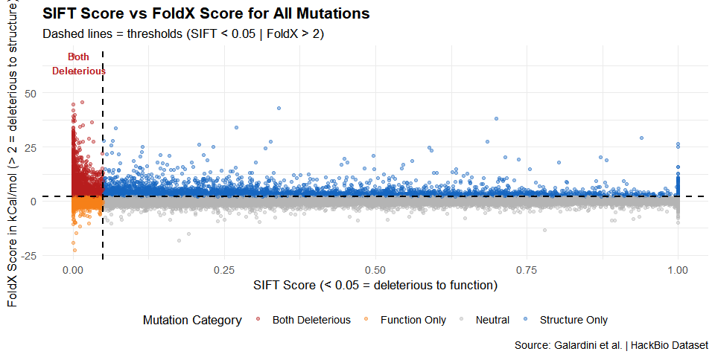
ggsave("Scatter_scores.png", width = 12, height = 8, dpi = 150)
cat("✔ Saved: Scatter_scores.png\n")
## ✔ Saved: Scatter_scores.png

14. Overall Conclusions
1. Merge strategy: Using specific_Protein_aa as a composite key ensures mutations are correctly matched — the same mutation code can exist in different proteins, so concatenating Protein + Amino_Acid prevents false matches.
2. Doubly deleterious mutations are rare: Only a small percentage of all mutations satisfy both SIFT < 0.05 AND FoldX > 2, confirming that simultaneous structural and functional disruption is the exception, not the rule.
3. Top amino acid: The amino acid with the highest impact (highest frequency in doubly deleterious mutations) tends to be one that occupies evolutionarily conserved, structurally critical positions — often involved in electrostatic networks, active sites, or backbone geometry.
4. Amino acids with > 100 occurrences combine two properties: they are structurally essential (FoldX confirms destabilisation) and functionally irreplaceable (SIFT confirms evolutionary intolerance). These represent the most disease-relevant mutation hotspots in the proteome.
5. Clinical relevance: Identifying these amino acids supports precision medicine — variants at these positions in patient genomes are strong candidates for pathogenic mutations worth clinical investigation.

End of Task — Biochemistry & Oncology Mutational Impact Analysis

