Auto-Indexing of Helical Diffraction pattern (AI-HEAD) Tutorial

A brief introduction of AI-HEAD
AI-HEAD is a program for the determination of helical parameters by diffraction patterns. This program can quickly and automatically conduct the indexing of the diffraction pattern according to the grayscale distribution of the diffraction pattern provided. Researchers can choose an ideal indexing result among various indexing methods and use it to calculate the helical parameters automatically. This would be a very helpful tool for beginners who conduct the helical reconstruction, as you only need to provide a projection of the helix (or a diffraction pattern of this helix) in mrc format.
Moreover, AI-HEAD provides a user-friendly interface, which the user could use various module in turn and simply conduct all of the jobs in it by clicking and entering.
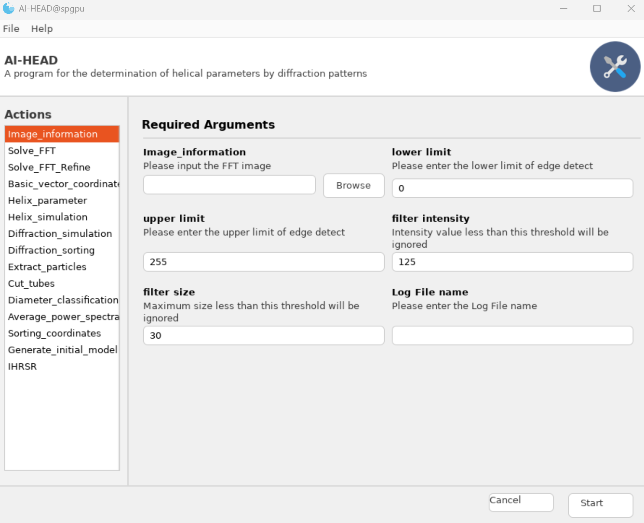
Input interface
Run the program
Module List
The interface of AI-HEAD_IHRSR
More details about this programs could be got at (doi:xxxxx).

What’s new
In the case of a helical assembly with a relatively uniform diameter distribution, we just need to get an average power spectrum and conduct the Auto-indexing to get a better result.
However, in some cases, helical assemblies tend to be more dynamic. For example, they can be assembled in different diameter sizes. In addition, helical assemblies assembled with different diameters often have different helical parameters. Therefore, for such dynamic samples, we need to classify them according to diameter in advance, and generate corresponding average power spectra according to different categories, and the conduct Auto-indexing to get helical parameters respectively.

The tutorial of diameter classification and ab-initial

Diameter classification

Extract the tubes according the coordinates (in EMAN2 format)
Now, let’s begin our work. Before we start working, you need to prepare the following data in advance:
- Micrographs metadata in star format (After CTF estimation in Relion)
- Filaments/Tubes coordinates in EMAN2 format (Picking by e2helixboxer.py)
There are 9 inputs in this module:
-Star_file: You need to load your metadata (in star format) in this interface.
-Micrographs: You need to set the folder path which contains the micrographs after motion correction.
-Coordinates: You need to set the folder path which contains the coordinates in EMAN2 format.
-CTF_multiply: Here you need to tell this program the whether to conduct CTF pre-multiply.
*If you just want to classify tubes in different diameters, just leave this option to “no”.
*If you want to use SPIDER/IHRSR to conduct the ab-initial model later, you need to set this option to “yes”, so as to get pre-CTF-corrected particles.
As we just conduct the classification now, so just leave this option to “no”.
-Box_size: Here to set the box size (in pixel) of particles.
-Step: Here to set the inner box distance of particles (in pixel) which means the length of the moving step when the tube is cut into particles.
-Pixel_size: Here to set the pixel size of particles.
-Extract_options: Here you need to tell this program whether to cut the tubes in particles.
*If you just want to classify tubes in different diameters, just leave this option to “no”.
*If you want to use SPIDER/IHRSR to conduct the ab-initial model later, you need to set this option to “yes”, so as to get pre-CTF-corrected particles.
As we just conduct the classification now, so just leave this option to “no”.
-Log file name: This is where you need to enter the name of the log file.
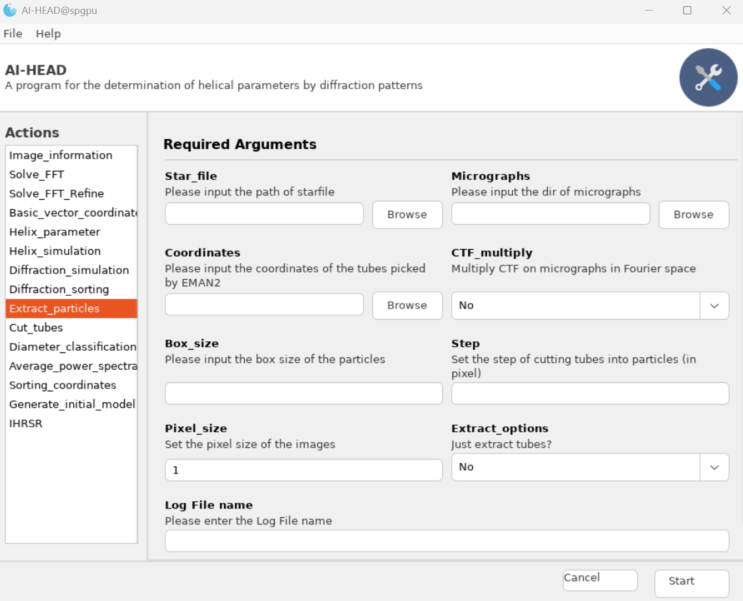
Extract the tubes/fiaments
Once we have entered all the information, we can click "Start" to run, and the program will generate a folder contains all of the tubes (in mrc format):

Extract_particles/(Log_file_name)/Tube

Diameter_classification
OK, now that we've get all of the tubes, let's move to “Diameter_classification” module and begin to classify these tubes by their diameters:
There are 3 inputs in this module:
-Tube_path: Just set the path of tube folder here.
-n_classes: You need to set the number of diameter classes for the classification. In general, the distance between classes should not exceed 2nm.
-Log file name: This is where you need to enter the name of the log file.
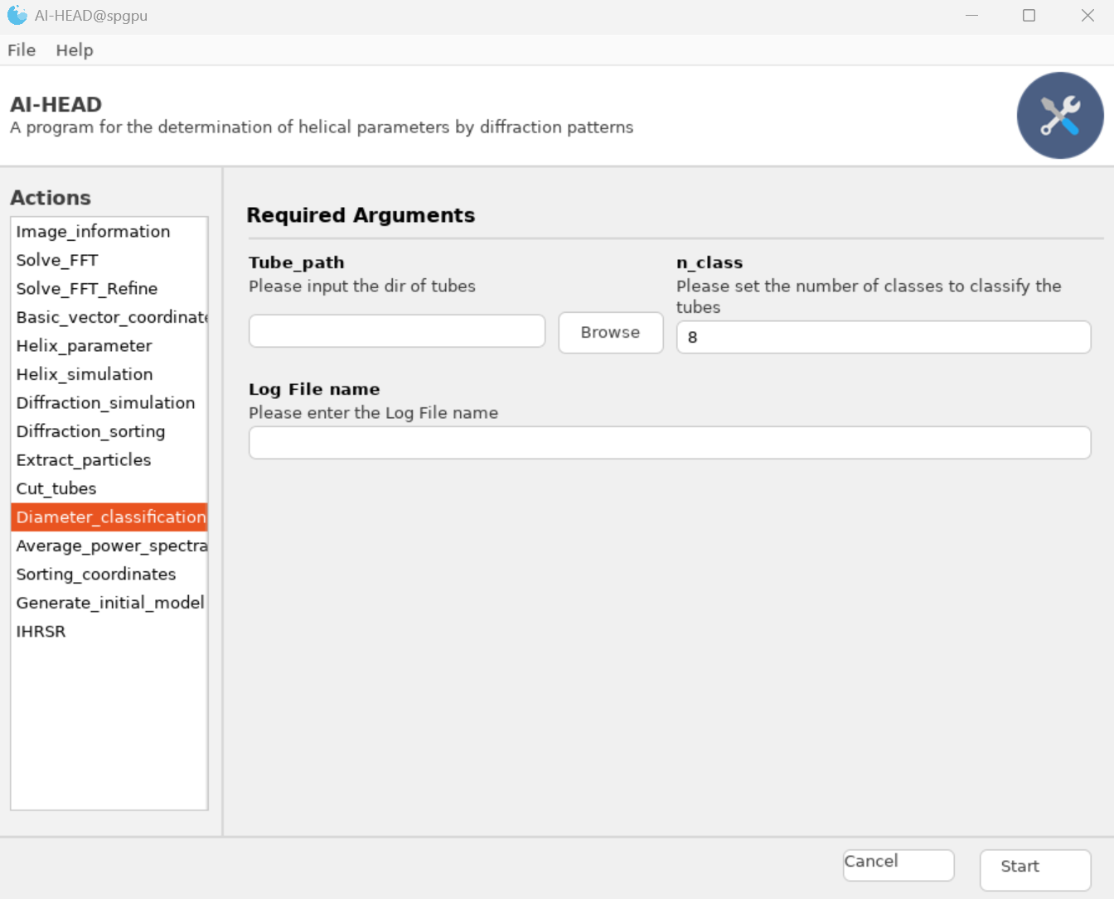
Diameter_classification

Sorting coordinates
OK, now that we've finished diameter classification, we need to select the coordinates of these tubes from all the coordinates.
There are 3 inputs in this module:
-Tube_path: You need to set the path of the tubes of a specific diameter class.
-Coordinate_path: You need to set the folder path which contains the coordinates in EMAN2 format.
-Log File name: This is where you need to enter the name of the log file.
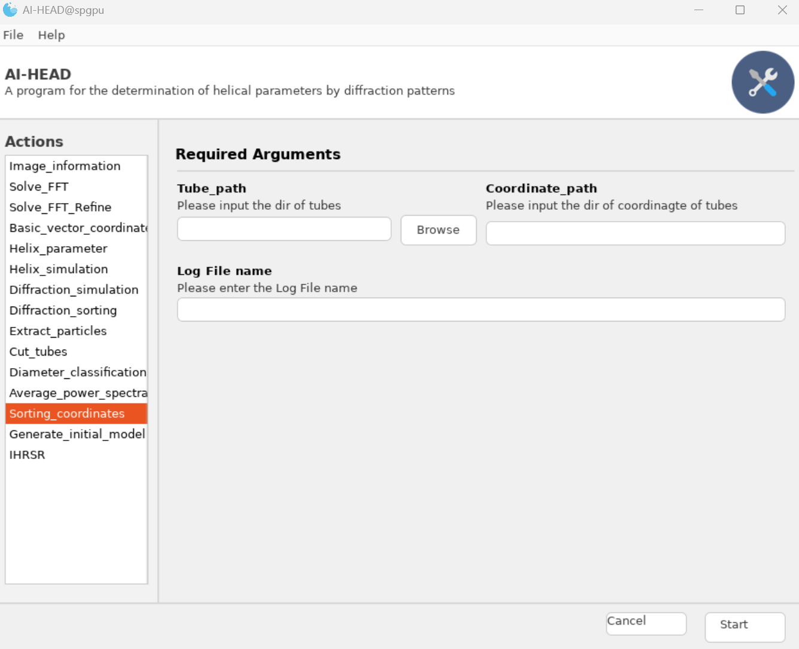
Sorting coordinates
After that, we obtained the coordinates of the tubes with a specific diameter. Next, we can use relion to extract particles based on these coordinates.
Then the particles are imported into CryoSPARC. After obtaining the average power spectrum using CryoSPARC, the helical parameters could be obtained by using AI-HEAD for Auto-indexing, and then obtain the Ab-initial model using relion or CryoSPARC by these parameters.

In addition to the above methods, AI-HEAD can be combined with SPIDER/IHRSR for parameter screening and the construction of the initial model by following steps:

Ab-initial by IHRSR

Average_power_spectra
OK, now that we've get all of the tubes, let's move to “Diameter_classification” module and begin to classify these tubes by their diameters:
There are 5 inputs in this module:
-Tube_path: Just set the path of tube folder here.
-Cut_length: Here to set the cut length (in pixel) of tubes which means that the tubes will be cut into stacks of the same length. In general, 1024 is usually work. You could try 512 if the tubes are not so long in some cases.
-Pad_size: Here to set the padding size (in pixel) which means cut stack will be padded with 0 in the real space to this scale. In general, 4096 is usually work.
-Cut_step: Here to set the inner box distance of particles (in pixel) which means the length of the moving step when the tube is cut into particles.
-Log file name: This is where you need to enter the name of the log file.
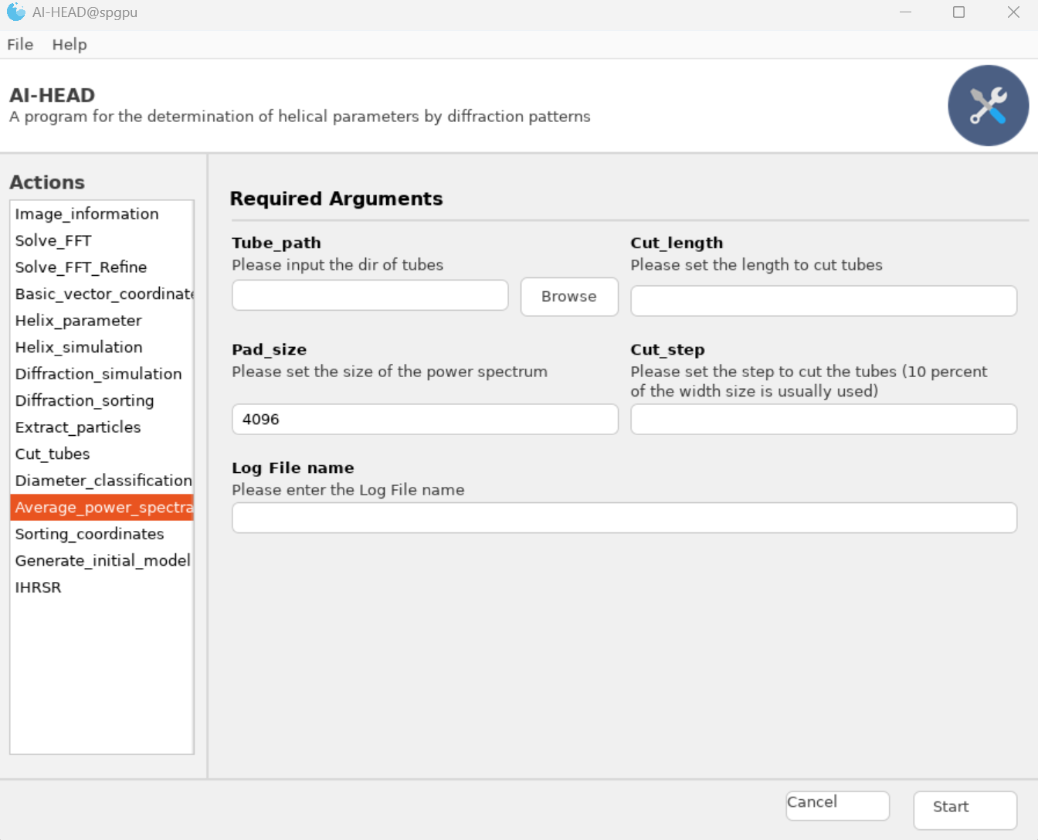
Average_power_spectra

Auto-indexing
After we get the average power spectrum, we could conduct Auto-indexing to obtain the helical parameters (More details could be found in AI-HEAD_Auto-indexing-Tutorial).

Re-extract particles
There are 9 inputs in this module:
-Star_file: You need to load your metadata (in star format) in this interface.
-Micrographs: You need to set the folder path which contains the micrographs after motion correction.
-Coordinates: You need to set the folder path which contains the coordinates in EMAN2 format.
-CTF_multiply: Here you need to tell this program the whether to conduct CTF pre-multiply.
*If you want to use SPIDER/IHRSR to conduct the ab-initial model later, you need to set this option to “yes”, so as to get pre-CTF-corrected particles.
As we need the pre-CTF-corrected particles now, so just leave this option to “Yes”.
-Box_size: Here to set the box size (in pixel) of particles.
-Step: Here to set the inner box distance of particles (in pixel) which means the length of the moving step when the tube is cut into particles.
-Pixel_size: Here to set the pixel size of particles.
-Extract_options: Here you need to tell this program whether to cut the tubes in particles.
As we pre-CTF-corrected particles now, so just leave this option to “Yes”.
-Log file name: This is where you need to enter the name of the log file.
Extract the tubes/fiaments
Once we have entered all the information, we can click "Start" to run, and the program will generate three folders just like this:

Extract_particles/(Log_file_name)/ctfm_Micrograhs (Contains pre-CTF-multiplied micrographs)
Extract_particles/(Log_file_name)/Tube (Contains pre-CTF-multiplied tubes)
Extract_particles/(Log_file_name)/Particles (Contains pre-CTF-multiplied particles)

Convert particles into SPIDER format
Once we got these particles, we could merge the particle stacks and transform them into one particle set in SPIDER format (.spi) by EMAN2.
e2proc2d.py Extract_particles/(Log_file_name)/Particles/*.mrc Bin1_particles.spi
Since the SPIDER program is not GPU-accelerated and we do not know the correct parameters during the abintial process. Therefore, in order to accelerate the rate of parameter screening, we can perform Bin4 or Bin2 down sampling on the particles at this step.
e2proc2d.py Bin1_particles.spi Bin2_particles.spi –meanshrink 2
e2proc2d.py Bin1_particles.spi Bin4_particles.spi –meanshrink 4

Generate_initial_model
Once we got these parameters, we could sort these parameters by conducting helical reconstruction one by one. Before that, we need to build a featureless initial model (Cylinder) by SPIDER. This step could be easily conducted by “Generate_initial_model” module.
There are 6 inputs in this module:
-Spider_path: Just set the path of spider program here.
-Box_size: Here to set the box size (in pixel) of particles.
-Pixel_size: Here to set the pixel size of particles.
-Radius: Here to set the radius of the cylinder (in Ang).
-Background: Here to set the density of background.
-Log file name: This is where you need to enter the name of the log file.
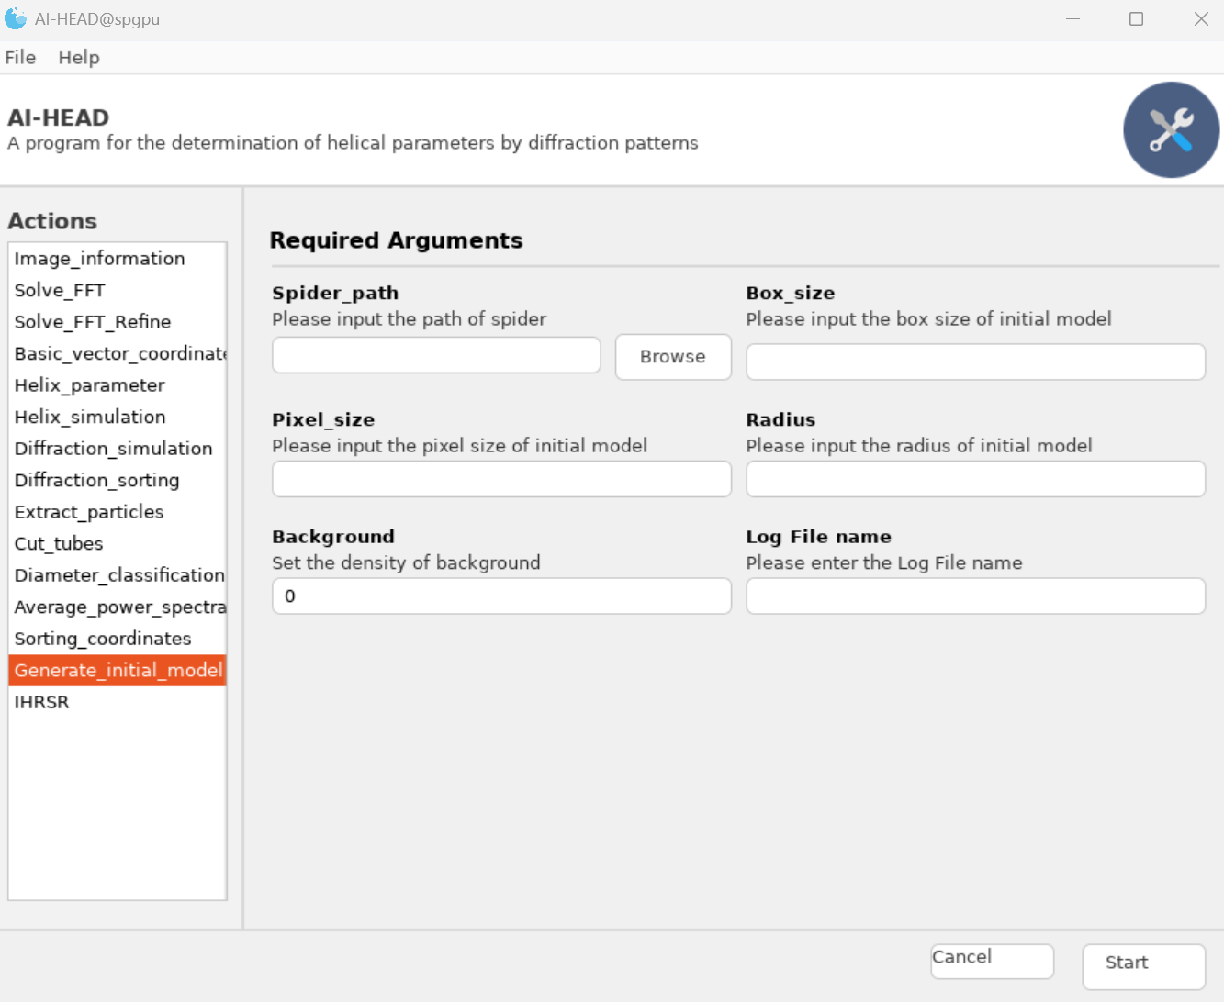

IHRSR
OK, now that we've get all of the tubes, let's move to “Diameter_classification” module and begin to classify these tubes by their diameters:
There are 5 inputs in this module:
-Spider_path: Just set the path of spider program here.
-Initial_model: Just set the initial model we got before.
-Helix_parameter: Just set the helical parameters we got before.
-Particle_set: Here to set the particles (in spi format).
-Particle_num: Here to set the number of particles.
-Pixel_size: Here to set the pixel size of particles.
-Box_size: Here to set the box size (in pixel) of particles.
-Angular_step: Here to set the angular step of IHRSR. In general, if your particles were downgrade into bin4 size, it’s recommended set this value to 4; bin2 could be set to 2; and bin1 could be set to 1.
-Iteration: Here to set the number of iterations. In general, we set it to 30. You could decrease this number but it's better not to be less than 10, especially in sorting step.
-Search_range: Here to set the search range between each resolution in Fourier space. In general, we set it to 5.
-Max_Search_range: Here to set the max search range in Fourier space. In general, it should be smaller than box_size//2- Search_range
-Inplane_angular: Here to set the deviation of inplane angular sampling. In general, we set it to 3
-Out_of_plane_tilt_range: Here to set the out of plane tilt range. it’s recommended set this value to 20.
-Cores: Here to set the number of CPU devices to run the SPIDER/IHRSR.
-Inner_radius: Here to set the inner radius of the cylinder (in Ang). Mostly, you could just set it to 0 at the begining.
-Outer_radius: Here to set the outer radius of the cylinder (in Ang).
-Parameter_step: Here to set the parameter step during the process of parameter refinement in IHRSR.
-Log file name: This is where you need to enter the name of the log file.
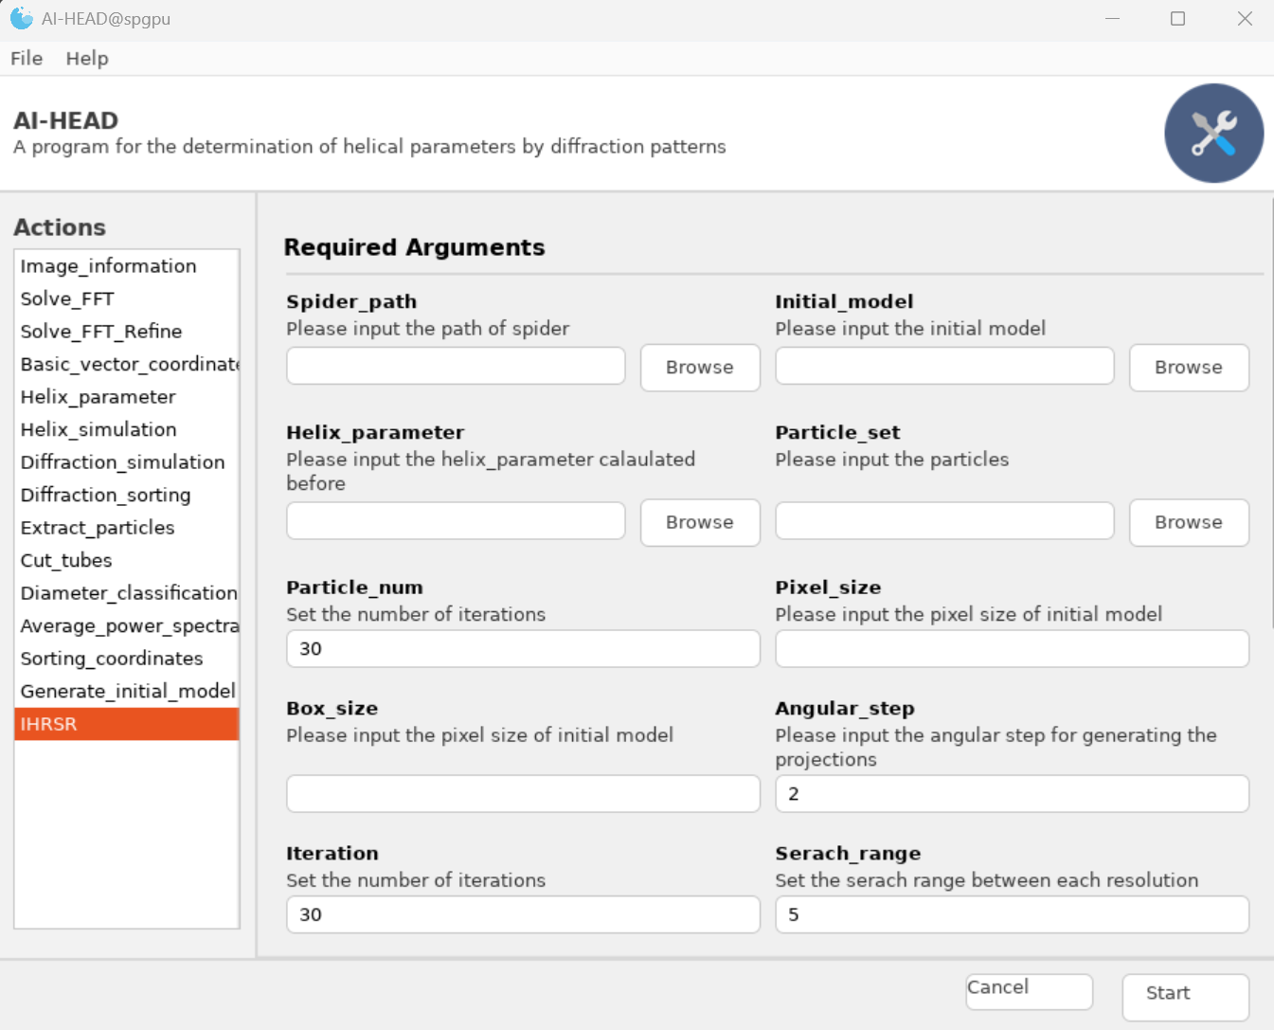
Then, you will get a set of folders contains the spider projects.
You could simply run the projects by:

cd (paramerter_file)
(Your spider path) spd/spi @ihrsr >ihrsr.log
You can also hang it in the background to prevent its unexpected termination:
nohup (Your spider path) spd/spi @ihrsr >ihrsr.log

