1. angel 算法案例

## LR-spark-on-angel输出

Spark Jobs 
User: root 
Total Uptime: 40 s 
scheduling MOde: FIFO 
Active Jobs: 1 
Completed Jobs: 4 
Event Timeline 
D Enable zooming 
Executors 
Added 
Removed 
Jobs 
Succeeded 
Running 
Active Jobs (1) 
Job Id • 
4 
Executor driver adde 
35 
24 JLIIY 11130 
Description 
count at 
count at LR_scala:60 
unt at LRscala:60 (Job 2) 
40 
Submitted 
2021/07/24 11131:07 
Submitted 
2021/07/24 1180 54 
2021/07/24 1180 39 
2021/07/24 1180 38 
2021/07/24 1180 36 
45 
50 
5 
count at LRscala: 
10 
Completed Jobs (4) 
Duration 
Duration 
13s 
14s 
0.4 s 
Is 
unt at (Job 3) 
55 
Stages: Succeeded/Total 
Stages: Succeeded/Total 
Job Id • 
3 
2 
Description 
count at LR.scala:60 
count at LR.scala:60 
count at LR.scala:60 
count at LR.scala:60 
take at LR_scaIa44 
take at LR_scala44 
reduce at 
reduce at 
24 JLIIY 11131 
Tasks (tor all stages): Succeeded/Total 
Tasks (tor all stages): Succeeded/Total 
Windows 

Active Stages: 1 
Completed Stages: 6 
Active Stages (1) 
Stage Id 
6 
Description 
count at LRscala:60 
*details 
(k ill) 
Submitted 
2021/07/24 1181135 
Completed Stages (6) 
Duration 
Duration 
15 s 
12 s 
13 s 
14 s 
0.4 s 
1.0s 
Tasks. 
• Succeeded/Total 
0/1 (1 running) 
Tasks: Succeeded/Total 
Input 
Input 
18.4 MB 
2.2 MB 
2.2 MB 
2.2 MB 
Output 
Output 
Shuttle Read 
Shuttle Read 
Shuffle Write 
Shuffle Write 
Stage Id 
5 
4 
3 
2 
Description 
count at LRscala:60 
count at LRscala:60 
count at LRscala:60 
count at LRscala:60 
take at scala:44 
reduce at ML Utilsscala:94 
+details 
+details 
+details 
+details 
+details 
+details 
Submitted 
2021/07/24 1181119 
2021/07/24 1181107 
2021/07/24 1180 54 
2021/07/24 1180 39 
2021/07/24 1180 38 
2021/07/24 1180 36 

Storage 
RDDs 
Storage Level 
Memory Deserialized Ix Replicated 
Cached Partitions 
14 
ROD Name 
MapPaÄitionsRDD 
Fraction Cached 
100% 
Size in Memory 
18.4 Ma 
Size on Disk 
0.0 B 2021-67-24 INFO DAGSchedu1er:54 - Job 6 finished: count at LR.sca1a:60, took 14.413341 s 
Final psw: -3.145793809668319 -2. 734502955790976 -1.1282908824426723 0.14695503427144563 -G. 97168586148775 
84 -5.780171236452497 -1.0922064141039884 0.5483966684828212 0.1903629669797665 -G. 43307023346002116 -0.27 
07010733469366 -€.014728486574047345 -0.002867079460685148 -1.9267962531612748 -1.307279131538734 -1.39102 
87081490074 -1.6581635690639562 -1.5500508132053237 0.24921659294082854 -1.9369122721759768 -o. 76254636158 
37405 -4.415509728658778 0.6419513568510005 -0.1628151783799163 -0.2785103385857125 -0.4499445981474694 -o 
. 6617659582161413 -0.22849453323194524 0.8787288176414493 -0.1624687848838925 -0.6619201602812887 0.483135 
5435420768 -0.3164385972738396 -0.04902427467497253 -3.2926032682932886 -4.415509728658778 -1.9369122721751 
9768 -0.44132551696562616 2.253032310975391 -1.4723047533079168 -1.383425458987495 -4.162171944321157 -0.3 
907877095682617 -0.2701321940717602 -0.1737264956035849 0.01923008074192807 0.02334542635401199 -2.0571435 
39468748 -1. 7430986631298406 -G. 478537395772169 1.4917348132736485 1.0090217360581686 -0.9166971593158904 
-1.248751121925872 -0.9278191518602288 -0.8935041234781897 -0.9676200752095068 -0.06786478051673697 -0.070 
37317110202611 -0.004810602381561278 0.9730182938997269 -2.1908402225894177 -2.3375297923185263 -2.5698517 
8 -0.16044645379563677 -1.0615478998443997 -2.548847109442658 -5.28447136567558 -9.996922190569682 2.16360 
3715451446 -8.604875887552446 0.7715574124342177 -2.8553627075575867 -0.6718664964175205 -4.86604981768126 
2 -0.02814914985876804 0.588109696396856 -6.516774151809466 9.687236998207224E-4 0.008416824496878177 -0.0 
6344886216382557 -1.0173314134125783E-4 2.468405691493855E-4 -€.€13274677249093318 0.005136833492125119 0.' 
015813978545428313 -€.010079574734538608 -0.033654889080940595 -0.027705879101773634 -0.021586525351106153( 
0.005228063653222276 -€.0€37256006282963315 -0.007133402576860126 -0.005300048846375055 -0.02737451703436 
81 -0.031156213189101244 -G. 044932840925091574 -0.5636132103164215 -G. 028469573960010805 -0.00448728621241 
6273 6.009255460443675157 -€.€519731233071449 -€.€10096333721815755 -0.015386815358562678 0.00848346442951 
8974 -G. 020193551365362668 -G. 047655441827465395 -G. 0055972600271190845 -G. 03542001352091763 -G. 0267785227 
7669599 -G. 0018606000293190142 -G. 006973644063175943 -2.49810097095543E-4 -G. 05881300819972214 -€.€1286155 
8804833566 -0.02018373965690278 -0.001792638913217515 -4.0663119334769296E-4 
stop heartbeat thread! 
2021-07-24 INFO PSAgent:399 

## Debug

1. netty-all-4.1.1.Final.jar与json4s-jackson\_2.11-3.4.2.jar版本问题

修改angel-ps与spark-on-angel的pom文件改为以上版本

1. 跑通项目的软件版本

apache-maven-3.8.1

hadoop-2.7.2

jdk1.8.0\_161

protobuf-2.5.0

scala-2.11.8

spark-2.3.0-bin-hadoop2.7

angel-2.4.0-bin

1. Pytorch on angel 算法案例
   1. **deepfm for torch on angel**输出

[**http://hadoop001:8088/cluster/apps**](http://hadoop001:8088/cluster/apps)

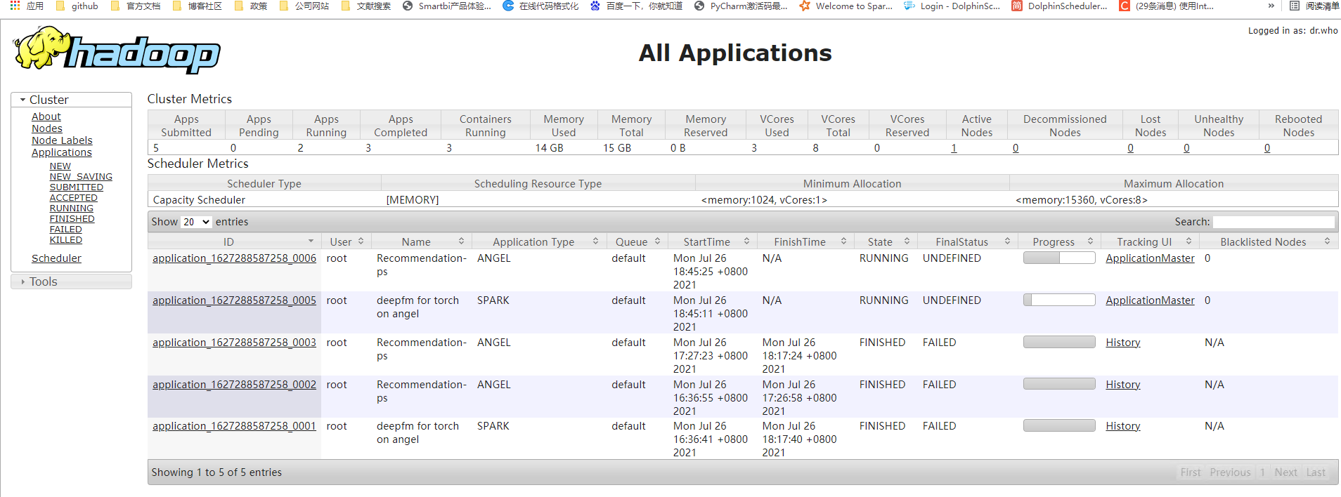

**ps log**

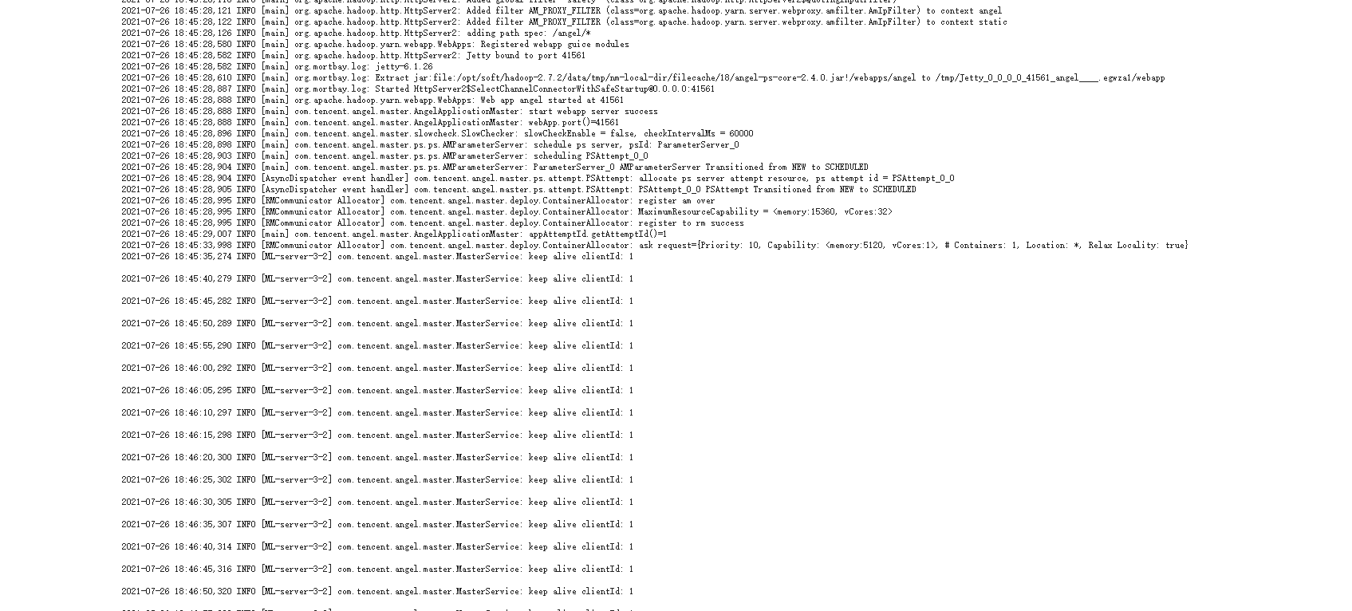

* 1. **Debug**

1. cmake报错

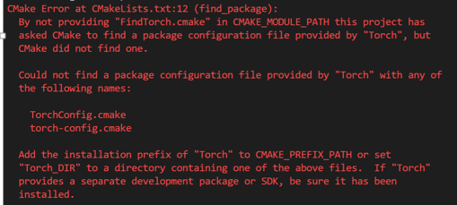

在dockerfile里面添加

ENV Torch\_DIR=/opt/libtorch/share/cmake/Torch

1. pytorch版本和torchvision版本不对应

在dokerfile文件里面添加torchvision=0.4.2

1. spark-submit提交脚本

source /home/liuqian/angel/angel/dist/target/angel-2.4.0-bin/bin/spark-on-angel-env.sh

4.内存问题

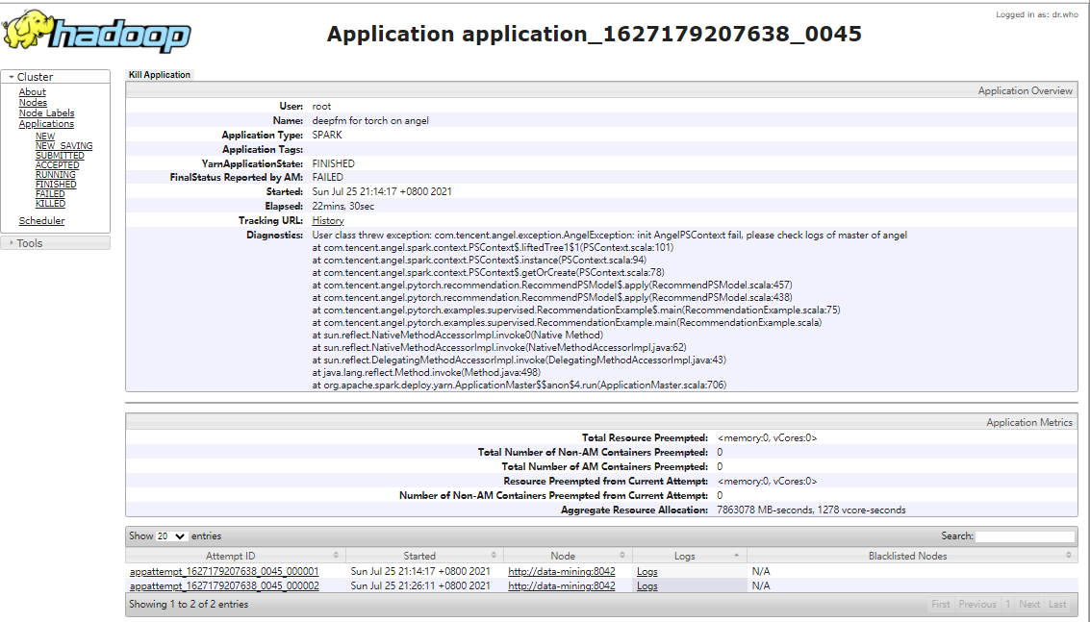

把yarn.scheduler.capacity.maximum-am-resource-percent调到0.6

5.提交脚本

