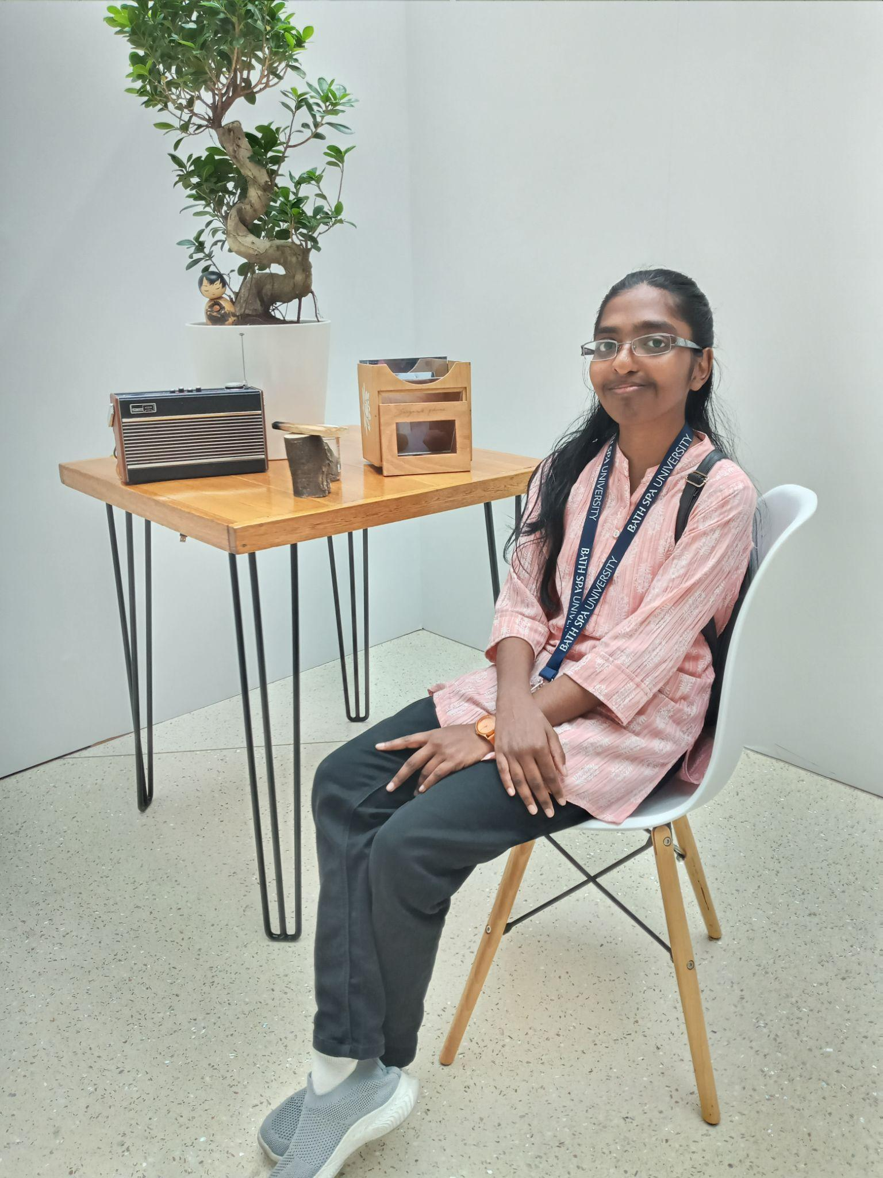
Education:

Angel Sara Mathew
Creative Computing Student

- Contact

- Email: angelsaramathew2004@gmail.com

- Phone:
+971581981921

- Language

- English
- Malayalam

- Skills

- Figma Design
- Canva Design
- Html and Css
- Data Visualization

- Hobbies

- Story writing & video creation
- Cooking
- Crafting
- Design

- 10th passed in 2021 at The Emirates National School, Sharjah
- 12th passed in 2023 at The Emirates National School, Sharjah
- BSc Creative Computing at Bath Spa University, Ras Al Khaimah.
Programming Language:
- Python,
- SQL,
- JavaScript,
- HTML,
- CSS
- Kotlin
Development tools:
- Figma,
- Canva,
- Tkinter,
- Visual Studio,
- GitHub,
- Android Studio
- Flourish
- Dialogflow
- React (Vite)

Experience in:
- Developed vending machine using Python
- Designed UI/UX using Figma and Canva
- Built websites using HTML, CSS, JavaScript and React Vite
- Created apps using Tkinter and Android Studio
- Developed chatbot using Dialogflow
- Created data visualization using flourish
- Created time-lapse videos
- Developed story game in Twine and Bitsy game
- Social media Advertising

YouTube link:
- https://www.youtube.com/@angelsaramathew2926 . Here, you can explore the projects I've completed.

Portfolio link:

- https://angel-sara-mathew-portfolio.netlify.app/

Linkedin link:
- https://www.linkedin.com/in/angel-sara-mathew-518321336

