**Date: 13/09/2025 Timing: 9:30 am to 4:15 pm**

**Long Hour Design (LHD) – Digital Circuit Layouts in Microwind**

**Task:**

**Design and implement the following digital circuits using the Microwind Tool by creating their transistor-level layouts, simulating functionality, and verifying outputs: CO2, CO3**

1. 4-bit Full Adder
2. 8×1 Multiplexer
3. 1-bit Magnitude Comparator
4. 4-bit Serial-In Serial-Out (SISO) Register

**Submission Requirements**

* Microwind project file (.msk) and screenshots of layout.
* Timing diagrams of functional verification.
* A short report (3–5 pages) containing:
* Circuit diagrams, truth tables, logic equations.
* Layout screenshots with annotations.
* Simulation results (timing diagram / waveform).
* Observations and conclusion.

**Rubric (30 Marks)**

|  |  |  |
| --- | --- | --- |
| Criteria | Description | Marks |
| 1. Circuit Understanding | Truth tables, logic design, and block diagrams showing clarity of each circuit. | 6 |
| 2. Layout Design in Microwind | Correct transistor-level layout, proper connections, and adherence to CMOS rules. | 10 |
| 3. Simulation & Results | Functional verification with waveforms and timing diagrams matching expected output. | 7 |
| 4. Documentation & Submission | Well-structured report with GitHub repository link containing .msk files, screenshots, and report. Neat presentation and timely submission. | 7 |
|  |  |  |

**Student Name: Angel Oza Enrollment No: 92301733063**

**Division: 5EK1**

1. 1-bit Magnitude Comparator

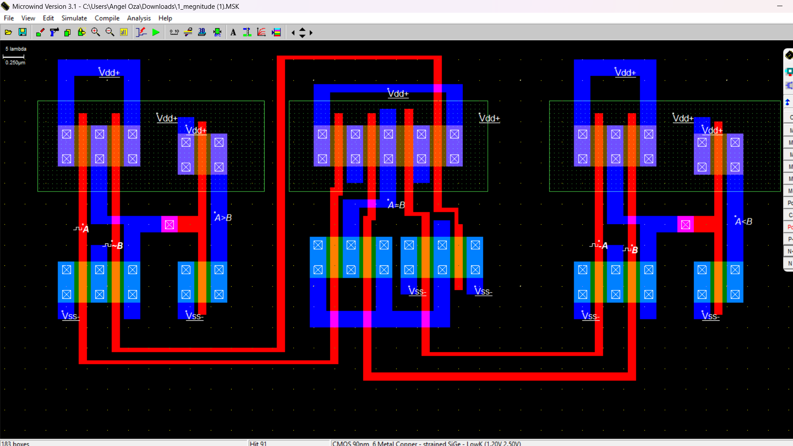

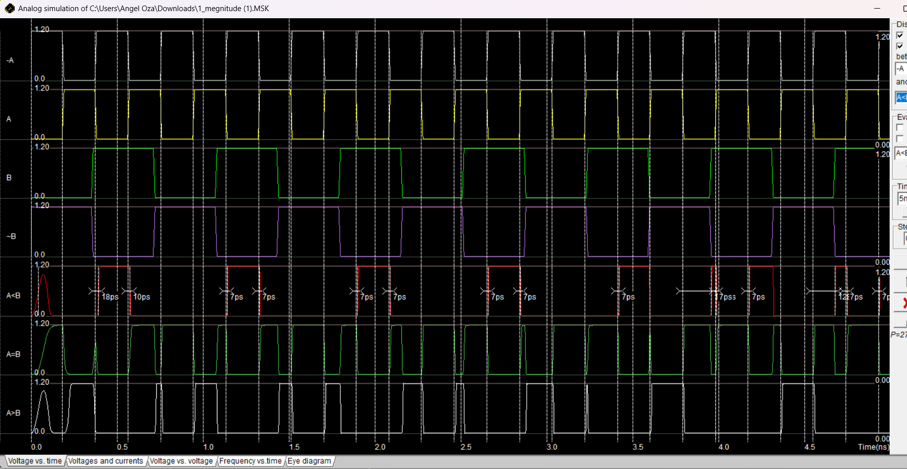

**Truth table**

| **A** | **B** | **A > B** | **A = B** | **A < B** |
| --- | --- | --- | --- | --- |
| **0** | **0** | **0** | **1** | **0** |
| **0** | **1** | **0** | **0** | **1** |
| **1** | **0** | **1** | **0** | **0** |
| **1** | **1** | **0** | **1** | **0** |

**logic equation**

**For inputs A and B:**

* **A > B = A · B′**
* **A < B = A′ · B**
* **A = B = A′·B′ + A·B**

**Results**

* **When A=0, B=0 → Only A=B=1**
* **When A=0, B=1 → Only A<B=1**
* **When A=1, B=0 → Only A>B=1**
* **When A=1, B=1 → Only A=B=1**

**Conclusion:**

**The 1-bit magnitude comparator circuit was successfully designed and implemented at the transistor level using Microwind. The layout was created with proper PMOS and NMOS arrangements, and each of the outputs A>B, A=B, and A<B was realized correctly. Functional verification through simulation confirmed that the circuit outputs matched the expected truth table values for all input combinations. The design demonstrates the correct working principle of a comparator and validates the effectiveness of CMOS-based implementation. This project not only strengthens the understanding of digital comparator design but also serves as a foundation for developing higher-bit comparators by cascading multiple 1-bit units.**